

Principles of Marketing

LCBB5015 -Component 1: Individual Report

Student Name: Ioan Saibel
Student ID: 2420427
Professor Name: Ivan Rodriguez Hernadez

Contents
Principles of Marketing 0
LCBB5015 -Component 1: Individual Report 0
1. Introduction 1
2. Situational Analysis – PESTEL Framework 1
3. Critical Analysis and Evaluation 2
4. Conclusion and Recommendations 2
References (Harvard) 2

1. Introduction
Tesco PLC is the largest grocery retailer in the United Kingdom, operating within the highly competitive fast-moving consumer goods (FMCG) sector. The company offers a wide range of products, including food, clothing, financial services, and online grocery delivery. Tesco holds a strong market-leading position in the UK, supported by its extensive store network and strong brand equity. The purpose of this report is to conduct a situational analysis of Tesco using the PESTEL framework, in order to assess the key external factors influencing the company’s strategic decision-making.

2. Situational Analysis – PESTEL Framework
Political factors significantly affect Tesco’s operations. Post-Brexit trade regulations, food safety policies, and government initiatives promoting healthier diets have influenced supply chain costs and product reformulation requirements.
Economic factors remain highly influential. Rising inflation and increased living costs have reduced consumer purchasing power, intensifying price competition within the grocery sector. Tesco has responded by expanding value ranges and price-matching strategies.
Social factors reflect changing consumer preferences, including increased demand for healthier, plant-based, and ethically sourced products. These trends require Tesco to continuously adapt its product offerings.
Technological factors play a critical role in Tesco’s competitive advantage. Investments in online grocery services, loyalty programmes, and data analytics enable personalised marketing and enhanced customer experience.
Environmental factors are increasingly important due to sustainability concerns. Tesco has committed to reducing carbon emissions, food waste, and plastic packaging, aligning with consumer expectations and regulatory pressure.
Legal factors include compliance with employment legislation, competition law, and data protection regulations such as the UK GDPR.
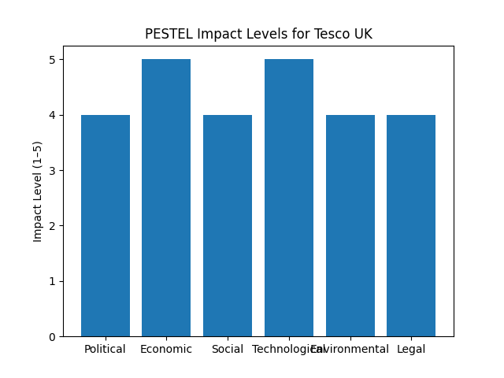
Figure 1: PESTEL impact levels affecting Tesco in the UK.
Source: Author’s own analysis using the PESTEL framework, 2026.

3. Critical Analysis and Evaluation
The PESTEL analysis indicates that economic and technological factors currently have the greatest impact on Tesco’s strategic decisions. While competitive pricing supports market share, overreliance on cost leadership may pressure profit margins. Therefore, Tesco must balance pricing strategies with differentiation through digital innovation and sustainability.

4. Conclusion and Recommendations
In conclusion, the PESTEL framework highlights the complex external environment in which Tesco operates. It is recommended that Tesco continues to invest in digital technologies, strengthens sustainability initiatives, and regularly conducts situational analyses to support effective strategic planning.

References (Harvard)
Chaffey, D. and Ellis-Chadwick, F. (2019) Digital Marketing. Pearson.
Johnson, G., Scholes, K. and Whittington, R. (2020) Exploring Strategy. Pearson.
Kotler, P. et al. (2021) Principles of Marketing. Pearson.
Mintel (2023) UK Grocery Retailing Report.
Statista (2024) Grocery market share in the UK.
Tesco PLC (2024) Annual Report.
BBC News (2024) UK inflation and consumer spending.
OECD (2023) Consumer market trends.
Porter, M.E. (2008) The Five Competitive Forces That Shape Strategy.
McKinsey & Company (2023) Retail trends in Europe.

