
Please note that this exercise is intended to provide students with experience of using the SolidWorks part and assembly modelling applications. The work undertaken is not intended to contribute towards the module grade.

TASK DESCRIPTION

Using the SolidWorks Computer Aided Engineering software, you are required to construct an assembly of the following parts:

- Crankshaft
- Piston
- Rod (conrod)
- Engine Cam (engine cam pulley)
- Cam Shaft
- Valve
- Cylinder Head (not given)
- Engine Block (not given)

The Crankshaft, Piston, Rod, Engine Cam, Cam Shaft and Valve geometry have already been modelled and should be downloaded from Moodle as separate part files. You are required to position and constrain each of the components within the assembly (using assembly ‘mates’) in order that the inter-part assembly geometry is correct.

You are required to build the Cylinder Head and Engine Block geometry around the other parts, paying due regard to their position, dimensions and form. You should evaluate/measure the existing components to determine the key or fixed dimensions of the Cylinder Head and Engine Block. You are free to establish appropriate dimensions for the remaining undefined features. It is therefore expected that each student will produce a unique model.

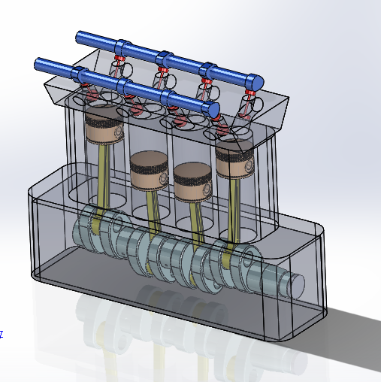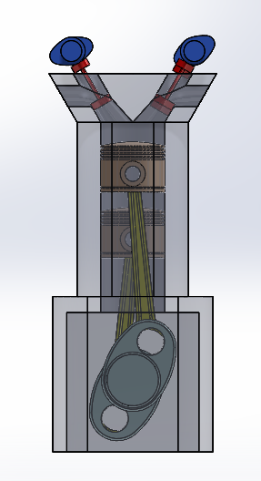

P.T.O.

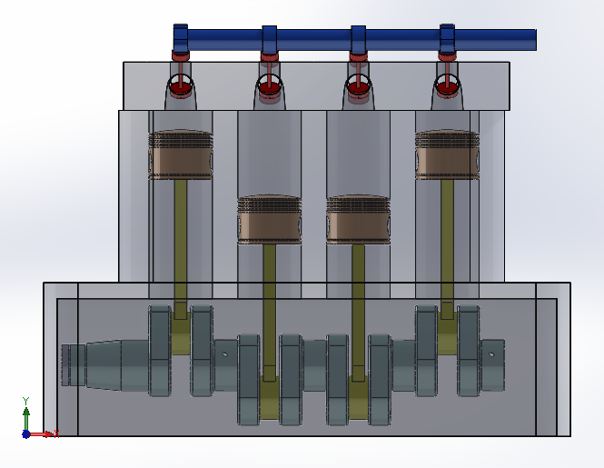

The Suggested Assembly Configuration

GUIDANCE FOR Students IN THE COMPLETION OF TASKS

You should aim to address the following points when completing this exercise:

- Create correct Part Geometry
- Use a range of appropriate tools when modelling
- Manage and organise the part structure
- Create a suitable assembly structure

