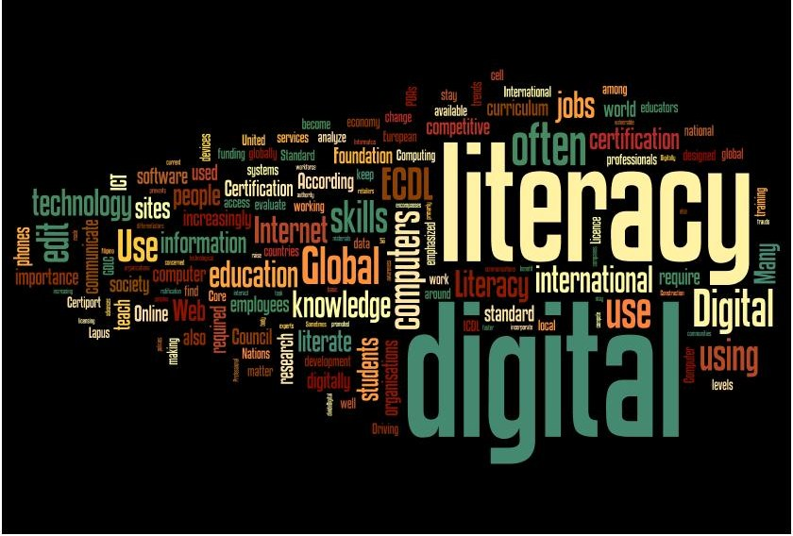  How i and others learn about business | Sinead hasleham  1910154  BMSP4003  Learning and collaboration for global citizenship  Dr Alex Bell

Introduction:
The Main purpose of this essay is to compare how myself and others learn about business. Equal weighting and acknowledgement will also be given to how my personal learning environment (PLE) compares to that of other student undergoing the same BA business and management degree programme. Thoughts of individual and collaborative learning will be discussed throughout this paper and an analysis of my own PLE will be provided. I will critically reflect on how my use of digital technology is put to use within my learning regime and to conclude this paper, I will include a small summary of my university learning programme thus far and provide advice for future students taking part in the same degree.

Personal learning environments and the comparisons involved:
A personal learning environment, or PLE for short, is a digital identity we build for ourselves that consists of digital and online technology and tools that changes the way we learn, work and even communicate. The technology we consume aids us in the creation of our very own personal learning environment, upon creating our PLE we can share this via social networking using web 2.0. The exchanging of knowledge using web 2.0 aids online collaboration where individuals can participate in learning 2.0; this is where an individual gathers knowledge from a different source rather than a stereotypical classroom or book, this could be anything ranging from online books, social networking, online communications, tagging, blogging or visual learning via YouTube et cetera. Learning 2.0 is all about the collaboration side of learning, where a user can communicate with other users and exchange knowledge. With the use of learning 2.0, this is where our own individual PLE’s are created and grown (Attwell, 2007). These new and developed ways of naming and identifying things as 2.0 are referred to as ‘buzz words’ by Tuominen (2007), he explains in his paper that a new literacy format is needed to tell apart the new from the old, as things are increasingly and rapidly changing, society needs to make room for these changes.
My own PLE is not as complex as some of the other students involved in the degree programme, I have always known that my use of digital technology is limited as I was out of education from the age of sixteen to the age of twenty six due to medical problems. It is incredible to think that ten years is not a long time to be out of education but on re-introducing myself into an educational setting and undergoing online diplomas such as A-level essential skills, I was amazed to find how different everything was in comparison to ten years previous. In hindsight I can predict that if I were able to continue my education at the age of sixteen without interruptions, then I would more than likely find that my PLE today would be on a much larger scale. This is the drive I needed to ensure I was to no longer fall behind with the ever-changing world or next time I might not be able to catch up.
My PLE contains basic applications such as YouTube for a visual learning experience, WhatsApp, Facebook messenger and Gmail for communicating. Google, Google scholar and UWTSD online library are used to fulfil all my required resource needs. In the diagram below I have provided a visual of what my PLE looks like:
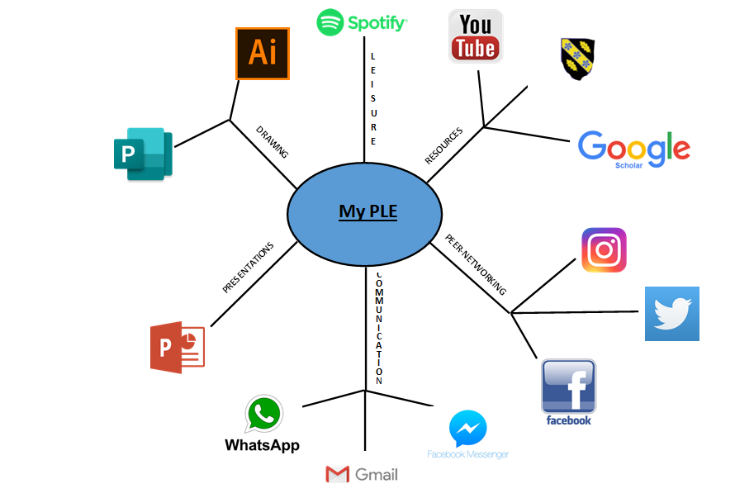
In comparison to other PLE diagrams provided by other students found within the forum, mine is basic, an example of a more in depth PLE by Clark (2020) can be seen below:
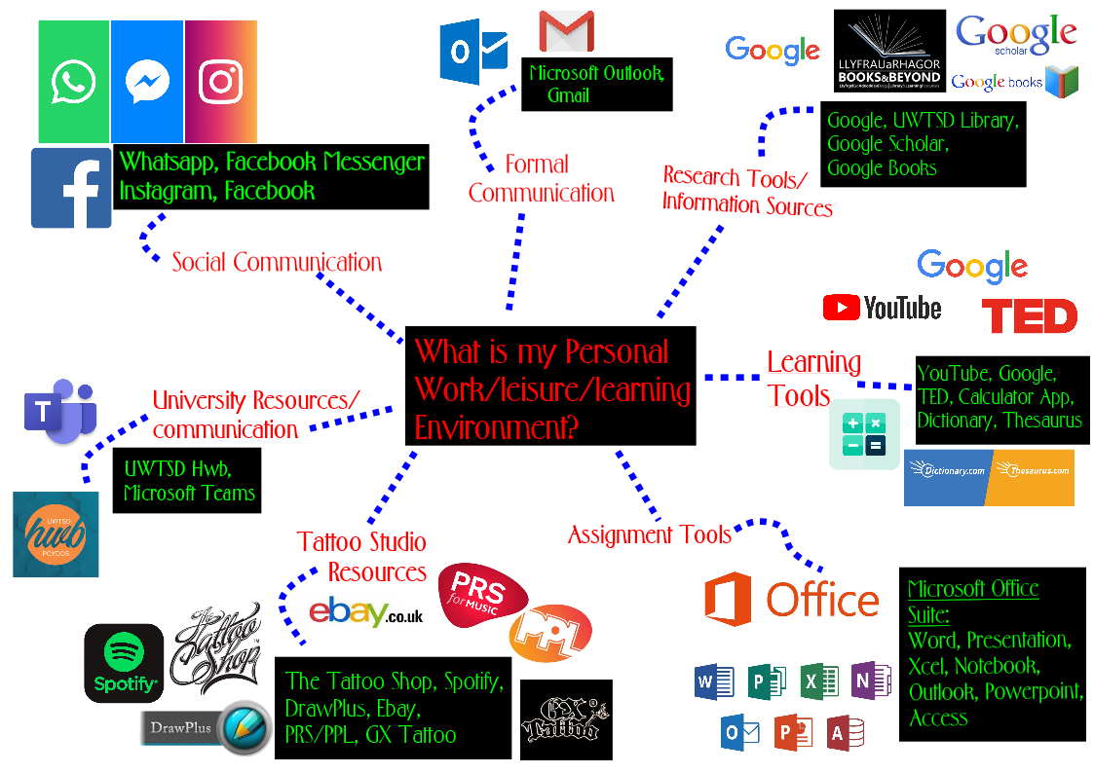
PLE’s of other individuals on the course included various other revision tools that I have never heard of such as Kahoot. One student described Kahoot as “a tool to help me remember facts” (Rossiter, 2020). There were numerous applications I discovered upon viewing the PLE’s of other students, another one being ‘Google books’, I already knew about google scholar and the original Google, but I had never heard about Google books before. I don’t feel that I am alone in respect to the fact that my own use of digital technology is limited, King (2020), describes her experience of digital learning as “I have never had much confidence with technology. Understanding more about technology would be a great help to me as this would help me to expand my confidence and allow me to explore more”, this is precisely how I feel personally, upon viewing other students PLE diagrams and how they intend to go about taking part in digital learning, the weekly forum has allowed me to gain knowledge from others and expand on applications that are available to aid my digital literacy that I didn’t know about previously.

Individual and collaborative learning:
To learn as an individual is to learn solely on your own, collaborative learning is when you work in a group where other individuals can input their own opinions about certain subjects.
My preferred learning approach is to learn as an individual, I have always convinced myself that to learn alone, to research alone and to complete tasks alone is the best way to achieve the desired outcome. I feel that if there is no collaboration upon completing a certain task then all work completed is your own, there for all grades achieved are solely your own. However, the previous statement actually contradicts my preferred method of learning, which is face to face and classroom based. I feel that a classroom-based lecture is more beneficial to me in the long run than an online lecture.
It wasn’t until I attended university that I recognised the flaws in my theory, previously I attended numerous online diplomas as my hunger for education was fulfilled after a ten year gap, I was pleased with the results of my online programmes but as I attended university something else was fulfilled that I didn’t even realise I had missed out on, this something else was collaboration and the long term benefits it has to my education and standard of work produced.
I feel that with individual learning you have the ability to reach your own limits and capabilities with no gratitude towards any other individual, this gives me a sense of satisfaction because if this form of work results in a good grade then it is entirely because of my own hard work, although working individually may make you oblivious to alternative perspectives that when taken into consideration, could possibly benefit those grades further.
Collaborative learning gives you the opportunity to gain knowledge from other individuals, upon gaining this knowledge you wouldn’t have known if working as an individual, this has the ability to prevent future mistakes as one student may know something that another student didn’t know, helping that student expand on their understanding. Bragg (2020) states that “The more something is discussed face to face with others around me, the more knowledge I go away with at the end of the day”. However, collaborative learning may not be for everyone, there are always going to be a mixture of personalities within a group setting, a stronger personality may out shine a quieter one and if two strong personalities disagree on a certain subject, this may result in a dispute or a debate.
A strong agreement seen throughout the weekly online forums was about the lack of face to face communication being the reason why individual’s progression has slowed.

A critical reflection of my use of digital technology:
Throughout my university learning programme, digital literacy and technology has been essential for most tasks including the completion and submission of all assignments, postings on the weekly forums for modules, communication with lecturers and collaboration with fellow students.
The tools I have used to aid me with my digital literacy have been limited and basic. However, I feel the choices I have made in regard to which digital literacy tools I use have been very beneficial. I have used applications such as Google, google scholar and the UWTSD library, all these are reliable resources that have been peer-reviewed as a secondary source. I am very careful with online communication applications and only use ones I know I can trust such as Gmail, messenger and WhatsApp. Marshal Mcluhan (1966) predicted how important the use of technology was going to be in future generations, however he discriminated the use of online collaboration and called it the ‘global village’, where there will be no more secrecy and everyone will be interested in anyone’s business.
All the choices I have made regarding my digital literacy that can be viewed in my PLE diagram above are used within my learning. For example, I use Google, Google scholar and the UWTSD library for academic resources, I know what to look for when searching for a reliable source as I have been advised on which websites are peer-reviewed and which ones are not beneficial to use as an academic resource. I do not use Wikipedia because it is accessible to any user who wants to change and update a specific page, therefor it is not reliable. Upon searching for resources I always try and find a website ending in .org, if there is no available websites that relate to my specific query ending in .org then I search for the next best one which is usually an academic site. It can be said that I am specific towards which resources I use to find the information I am looking for, this may in turn result in me losing out on the opportunity to find such knowledge as I myself am oblivious to other research options so I stick to what I know.
I understand that to develop my knowledge of digital literacy I must be sceptical but also trusting with applications, I find myself being too sceptical rather than trusting therefor I may possibly be losing out. As Cottrell (2017) states “Scepticism in critical thinking brings an element of polite doubt, if we can analyse clearly the basis of what we take as true, we are more able to discern when it is reasonable to be trusting and where it is useful to be sceptical”, I find myself without the rational thinking and instantly sceptical, this is due to lack of knowledge about digital literacy and it becomes a disadvantage to myself and my work when searching for resources or means to collaborate with others.

Advice for undergraduates in preparation for their degree:
If I were in a position to give new undergraduates preparing to undergo the bachelor’s in business and management degree any form of advice, it would be to ensure to maintain an open mind. The best thing a new student could do on their first day of attending university would be to leave all they know at the door upon entering that first lecture and to expect to learn things that contradict what you have been taught in the past. I would also advise new students to be patient in various modules as different lecturers have different requirements and preferences that sometimes contradict one another. An open mind for any student will ensure they do not dwell on their past knowledge and are open to expand or learn new things, even if it is not what was initially expected from the degree programme, in the end it works out very beneficial for us.

Conclusion:
Digital literacy and the use of technology has certainly changed the way people go about all aspects of their lives; people now learn, work and communicate differently to how they did in the past. With the use of web 2.0 and learning 2.0, individuals have the added benefit of collaboration which aids them to develop a better understanding of the concept in question. However, with more going on regarding learning, working and communicating online, this leaves less room for face to face learning. I have found that if you lack on the knowledge required to take part with online functions and you either don’t have the ability or interest to update yourself, then there is a high risk of falling behind with the times and possibly losing out.
If I had maintained an open mind upon entering university for the first time, then maybe my PLE would not be so basic. I never really understood the relevance of digital literacy or technology for my own personal goals as my objective is to run my own successful café, it is not all about cooking and pricing as I first thought, digital literacy will also be a huge part of my business such as using social networking to aid with marketing and promoting my business. Digital tools to help with sales, costing, profit and loss will also be very beneficial to me and then there is the online education programmes that are mandatory to any business such as health and safety, food hygiene, RIDDOR, COSHH; these are all a lot less time consuming when web 2.0 and learning 2.0 are used. Therefor I have discovered is is essential to develop skills using digital literacy as often as possible to maintain a good understanding of the changing world we live in.

Reference list:
Attwell, G. (2007). The personal learning environments-the future of eLearning? eLearning papers, vol.2, no.1. Retrieved from: http://citeseerx.ist.psu.edu/viewdoc/download?doi=10.1.1.97.3011&rep=rep1&type=pdf [Sourced on 06/04/20]
Bragg, N. (2020). Activity 3: Individual vs collaborative learning. Tutor group forum, week 3. Published on 25/03/20, [sourced on 06/04/20]. Permalink: https://moodle.uwtsd.ac.uk/mod/forum/discuss.php?d=18831
Clark, J. (2020). Activity 2: Your own PLE as a diagram. Tutor group forum, week 3. Published on 02/04/20, [sourced on 06/04/20]. Permalink: https://moodle.uwtsd.ac.uk/mod/forum/discuss.php?d=18417
Cottrell, S. (2017). Critical thinking skills- effective analysis, argument and reflection. P2, third edition, Published by red globe press
King, E. (2020). Activity 4: Yourself on the technology spectrum. Tutor group forum, week 1. Published on 28/02/20, [sourced on 03/04/20]. Permalink: https://moodle.uwtsd.ac.uk/mod/forum/discuss.php?d=17837#p29922
McLuhan, M. (1966) Our present as predicted half a century ago by Marshall McLuhan. YouTube, published on 18/04/13, Maker street network publications, [sourced on 21/02/20]
Rossiter, S. (2020). Activity 2: Your own PLE as a diagram. Tutor group forum, week 3. Published on 14/03/20, [sourced on 03/04/20]. Permalink: https://moodle.uwtsd.ac.uk/mod/forum/discuss.php?d=18417
Tuominen, K. (2007). Information literacy 2.01. Journal, Accessed from: https://moodle.uwtsd.ac.uk/pluginfile.php/148821/mod_resource/content/1/Information%20Literacy%202.0.pdf [Sourced on 06/04/20]

