
Assignment Two

BMSP4004

generating Business Data and analysis

Jessica Ellis
(1807462)
Contents

- Executive Summary
- Assignment Introduction
- Spreadsheets
- Stages of Modelling (Logic, Presentation & Data)
- Conclusion
- Bibliography

Executive Summary

This assignment involves the use of four spreadsheet files for analysis, interpretation, and a review of principles of spreadsheets for modelling.

Assignment Introduction
In order to be sustainable, organizations should use their data analysis to improve their economic future. By exercising the use of their data, businesses can see what works and what doesn’t, so they can improve in all aspects and evade future failures and scenarios. Data systems are imperitive for a business to achieve success, as they showcase the clarified internal intelligence and workings. To improve profitability, exercising descriptive analytics can fuel their projections, as well as assist decision making when analysing and monitoring past and present records and patterns. This can help them discover patterns, in example seasonal obstructions such as weather elements and consumer decline in favourability of products.
Nevertheless, data systems require a wealth of man – inputted information to operate. This can be time consuming to do and learn, and if manually inputted, there is a higher probability of producing errors. Furthermore, they need to be tailored to the organization and require maintainace to avert innaccurate or incorrect data. As the world is constantly developing, as does

technology. Data warehouses need to be as air – tight as possible so information can not be corrosively manipulated, as this could have a detrimental effect on a business.
There are various methods of business modelling for spreadsheets in which have become integral for organizations to survive. These methods consist of logical, data, and presention components that ensure the creation of an accurate and up to spreadsheet.
This is a report to analize the company consumer spreadsheet and data patterns to see how generate outputs, and when they are influenced by factors such as the season; culture; competitors; taxcodes… Etc.

Spreadsheets

In 1979, Software Arts was founded by Dan Bricklin, where he acted as Executive Vice President and Chairman of the board. Software Arts’ revolutionary creation, VisiCalc, transformed the PC industry by providing an electronic spreadsheet for corporate users. Visiscale was heavily responsible for the mass of sales in personal computers.
Dan Bricklin - Inventor of the first electronic spreadsheet in 1978. (Martellaro, 2011)

A spreadsheet is a 2 dimensional grid to enter text and data for the purpose of analysis. The use of spreadsheets enables the ability to summarise information from many sources, and display it in one place. The data needs to be reliable, relevant and valid in order to produce accurate results.

A spreadsheet’s function should be depicted from a framework, as suggested by Mather. A framework “encourages the efficient development of more effective models that are easy to use and easy to modify.” (Mather, 1999)

Pre – Processing
Pre-processing is a step used prior to analysing data. This irons out suplerfuous and innaccurrate data and prepares the spreadsheet for detailed analysis. Real life data can contain extreme and missing values, as well as redundant data and information requiring different formats to analyze.
In the case of the Prosumer file, there were 952 records at the beginning, and then the cleaning process removed over 2/3 of the duplicates. This process of cleaning the data was to remove redundant data such as double entires, which may have caused any formula to produce innaccurate results. This can be demonstrated in various ways followed by Ctrl and F and entering just the company name (in example ‘Canon’ as opposed to ‘www.canon.co.uk’) to double check that no duplicates remain. Should there be any duplicates remaining highlighted by this check, they should be removed. Following this method of pre-processing, it has resulted in 352 records remaining for data anaylsis.
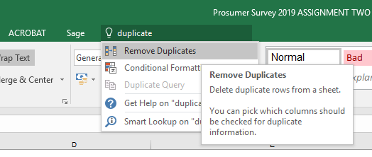
Using the below method, although this removes duplicates effectively, is not as accurate and reliable as the more manual methods.
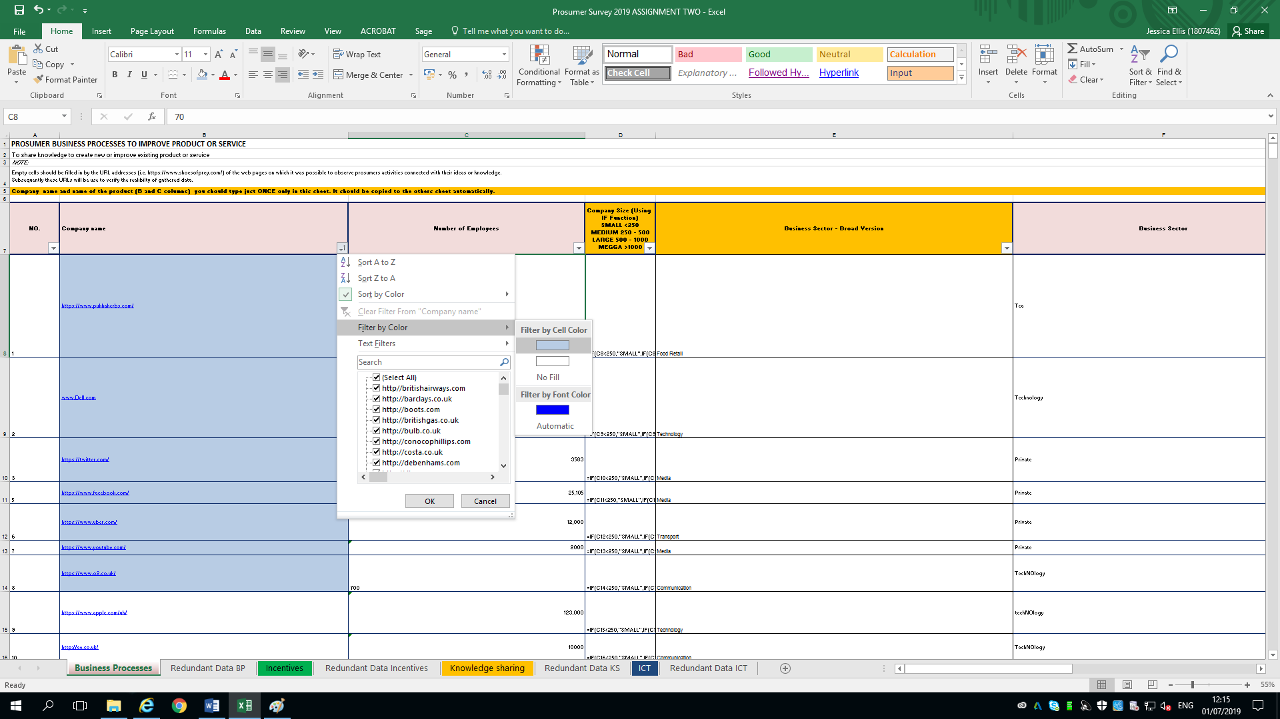
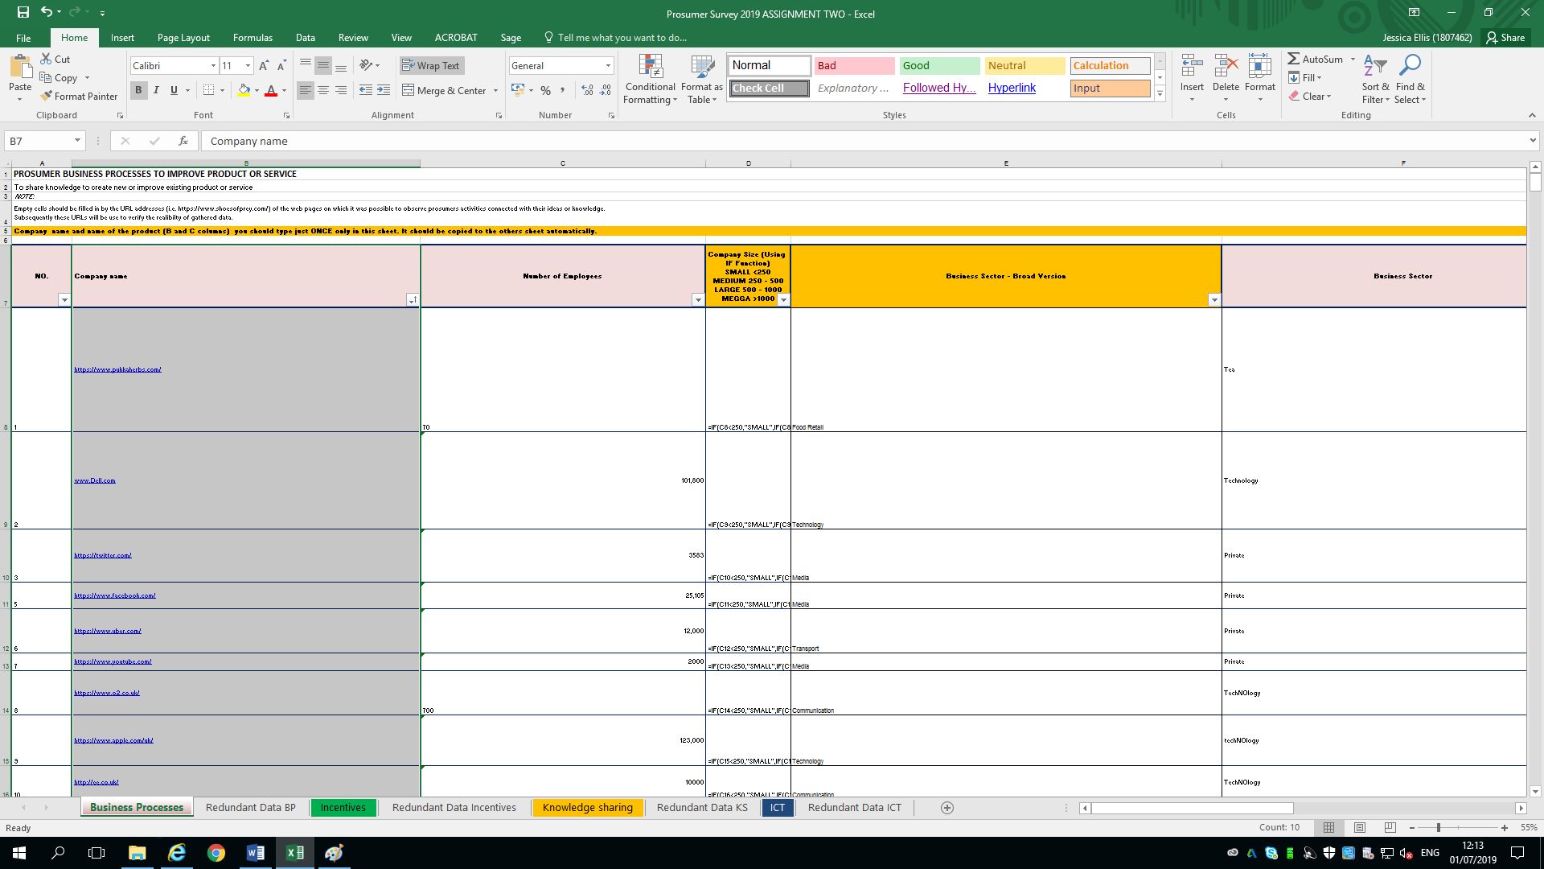
As well as removing the duplicates individually, an equally effective and time efficient method is to highlight the duplicates (using only column B/ Company Name), followed by ordering them to the top of the spreadsheet. By doing this, it enables the removal of the duplicates in bulk.
Figure 1:
Remove Duplicates (Excel)
Figure 3: Sort and order so that the highlighted cells are organized to the top together so that they can be moved together
Figure 2: Highlight the company name/ Column B (not all of the data)

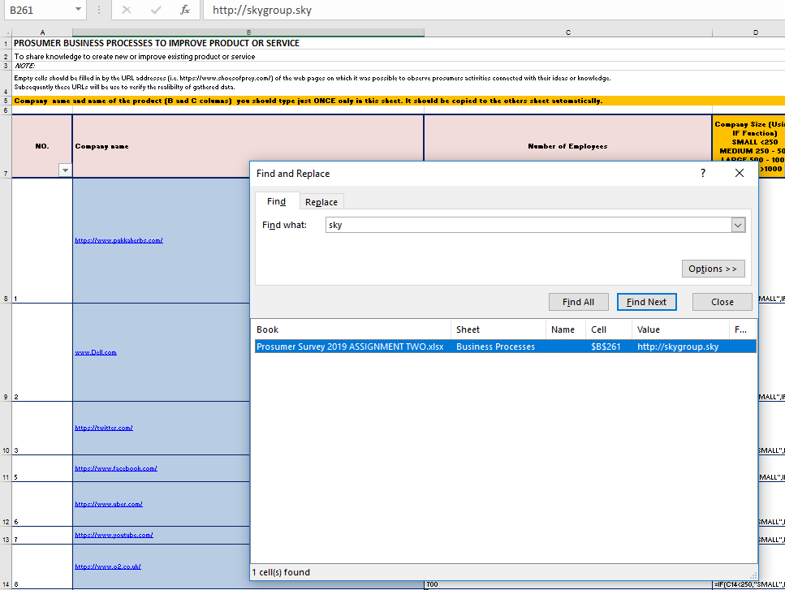

Figure 5: No duplicates remaining – Excel Prosumer file
Figure 4: Only select Column B and double check for duplicates via Control and F key – Excel Prosumer File

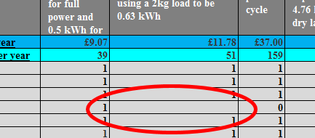
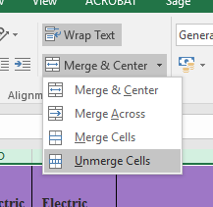

&

Figure 6: Ensure all empty cells have a value, and that all cells are unmerged – Excel Carbon Data List File

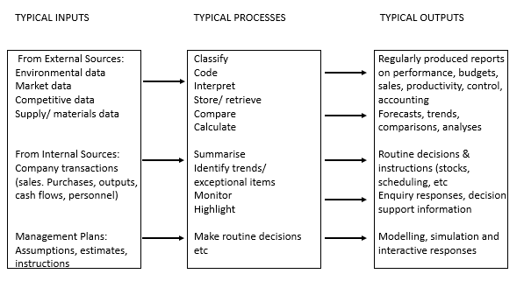
Stochastic – These are expectable systems, whereby the output can be predicted by using the inputted information.
Deterministic– This is when factual information is used.
Figure 7: A typical information – processing system (Lucey, 1997)

Figure 8: (O'Beirne, Proceedings of EuSpRIG 2008 Conference "In Pursuit of Spreadsheet Excellence", 2008)



Edward and Finlay (Edwards John S, 1997) describe spreadsheets as having three main components. They consist of:-
- Data
- Logic Use
- Presentation
Data models requires information from sources. In example, in the Weather Data File every cell is from a conducted survey that records evidence for sustainability.The spreadsheet then becomes a logic model when the information is manipulated into formula such as:
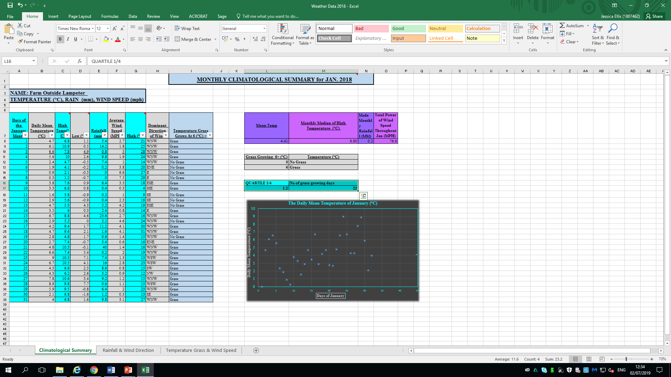

Figure 9: Excel Weather File

Presentation
Figure 9 showcases the data on the left, as well as exercising the presentation element on the right displayed as the graph. There are many graphs and charts facilitated by Excel, such as Line; Pivot; Pie; Block… It is important to select the most appropriate one to show the data. For example, by connecting a series of data points, an easy to construct line chart is highly beneficial for showing data covering a timeframe and shows positive and negative values. Using a line chart aids businesses in clearly identifying levels of key support and resistance, trends and distinguishable patterns, such as stock; profit margins; finances (etc). Nevertheless, exessive data makes the line chart challenging to interpret. Whereas, a pie chart is ideal for showing the fractional method, for example the percentage different ethnicities of the population.
In addition to the graph, the highlighted cells, title, axis location of the data contribute to the presentation model. In terms of convenience, clarity and efficiency, the presentation of a spreadsheet can enable the user and viewer to establish outputted information using variables, such as weather, trends and circumsances (eg settings of a machine; seasons; peak times of purchases; volume of train passengers… Etc). In spreadsheets, if decisions need to be made imminently or answers to questions are required, by seeing (and sometimes ordering or filtering) the highlighted cell/s in which the scenario relates to, helps the user find information fast– alike that of a book mark in the sense you know where to start, or when you access a dcitionary for a word starting with the letter ‘A,’ you have an indication of the area to start searching. A credit controller can simply refer to outstanding debtors by what data is in certain highlighted cells. When operating a spreadsheet, the user should be mindful of the colours used to highlight the cells, or where it is located on the page. The administrator should be mindful of the colours used. This is to ease eye strain or irrationan, especially from bright, neon type shades. The cells should all be easy to read with a somewhat uniform approach to the structuring, as opposed to different fonts and general inconsistency in font style; size and colour. This makes the spreadsheet appear clearer.
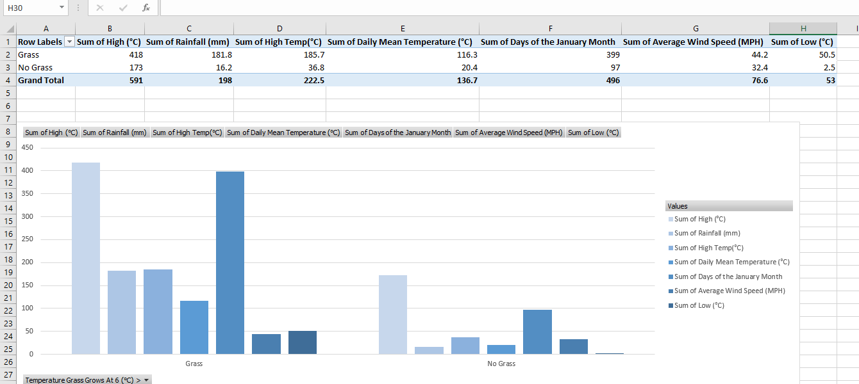

Figure 10: Pivot table using the data from Climatological Summary. By Rounding numbers to one or two decimal places, the data is more tidy and appears more concise.

The above graph shows the daily mean temperature over the course of January.The use of this graph would be beneficial to many, including to the substainability of a business concerned with rotatary crop planting and cycles. In respect of resources to aid crop manifestation, the volume of fertilizer; growth boosting substances, machinary use and need for manually watering can be projected, based on the previous data. As well as the visual appeal, and making data more engaging and accurate, there is the platform of responsibility as the information needs to be clear, so every decision is correct thus enabling business sustainability.
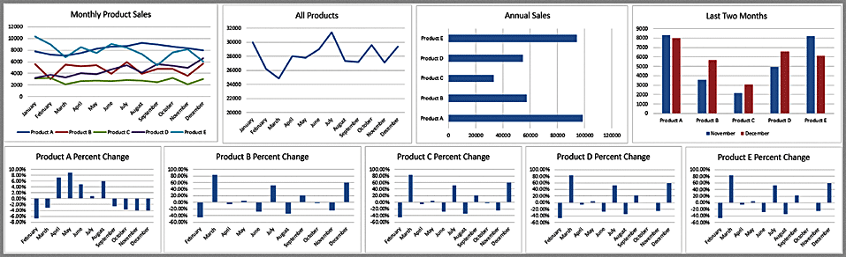
Figure 11: This Dashboard (derived from the resemblance of a vehichle’s control panel) provides an important synopses of key business data to help manage a business procedure, function and development.

Logic Model
A Logic Model is a visual diagram that illustrates how your program will function. In Logic models communicate an organization's projects, programs, operations, activities, and goals and connects various departments in an organization, enabling multiple viewers to be on the same page and helps to provide users to understand their responsibilities. Logic Models can be used in program forecasting, execution, conclusions, and communication, then the finding can be adapted to the real world.
The intension of logic models is to show a clear plan for the use of resources to achieve the desired goals and objectives.

There are:
Variable - A factor whose value changes freely
The ownership is a variable, due to some students owning some appliances and not all students owning appliances (under student cells).

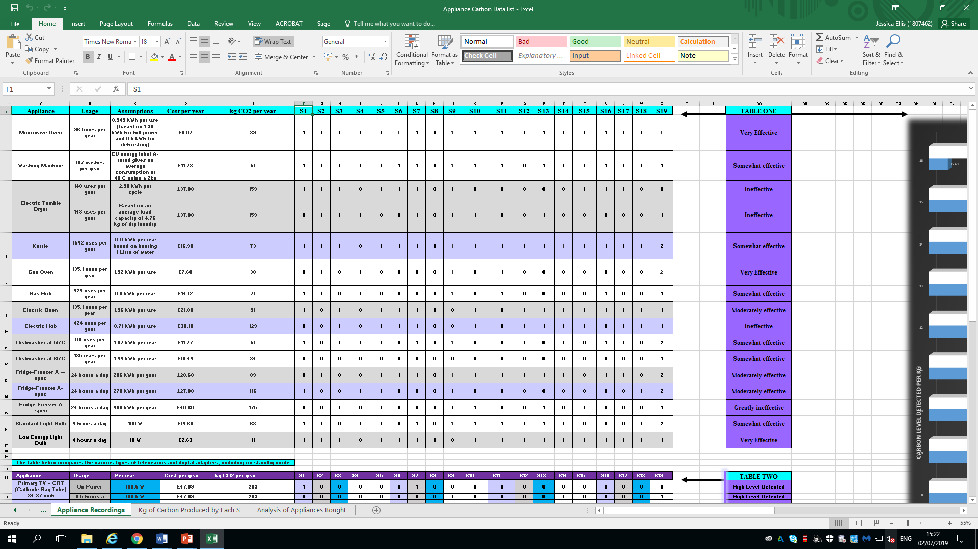

Figure 12: Excel - Swansea Business School
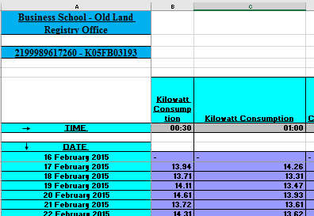
Constant A factor whose value does not change
The KWs that every appliance uses each time it is switched on does not change (Column C).

Figure 12: Excel – Swansea Business School

Parameter
A factor whose value is held constant and whereby the user can manipulate the search criteria into a formula to limit data output or specific measures.
This shows the constraints placed upon the data via VLOOKUP in order to determine the level of effectiveness.
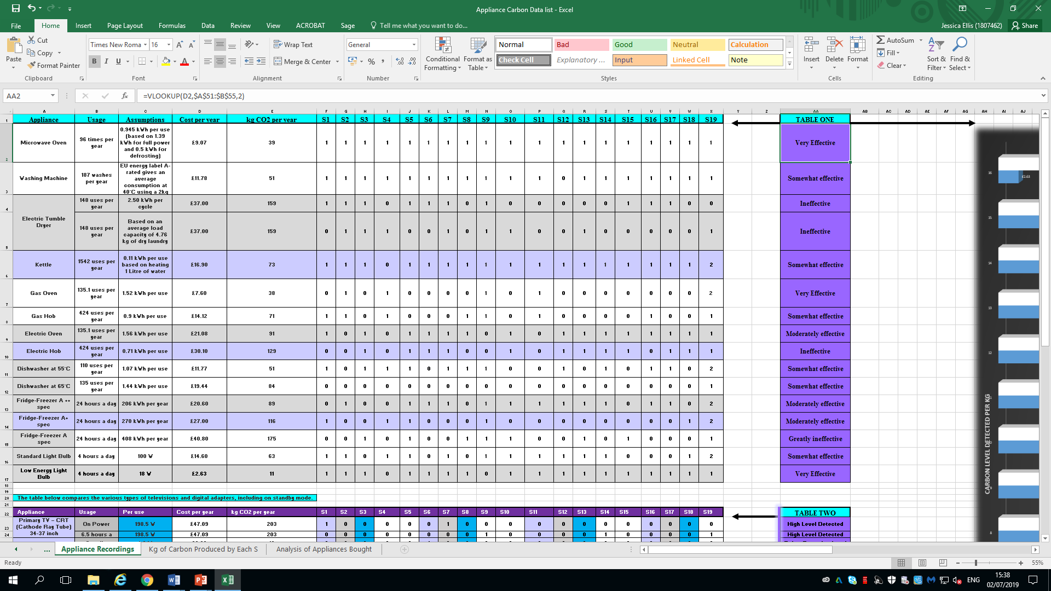

Figure 13: Excel – Swansea Business School

Coefficient A factor representing a relationship between multiple factors, in example ‘Carbon Cost per Year Vs. Power Output’ - they influence each other.
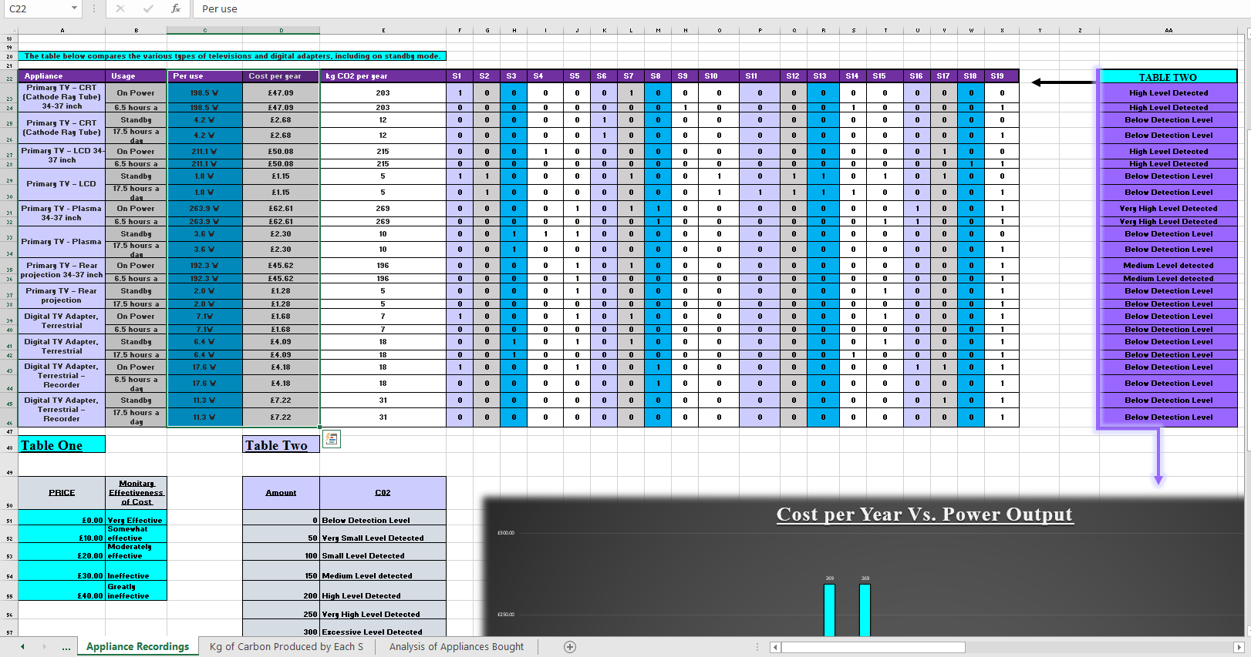
Figure 14: Excel – Swansea Business School

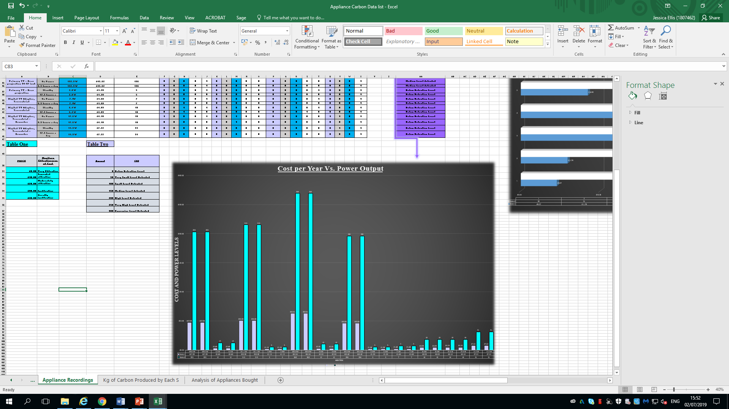

If this was a company they would be able to see which appliances have the highest output. This is useful for eliminating items with a high power consumption. For sustainability high energy use can be reduced to be more carbon efficient and to save on utility bills.

Figure 15: Excel – Swansea Business School

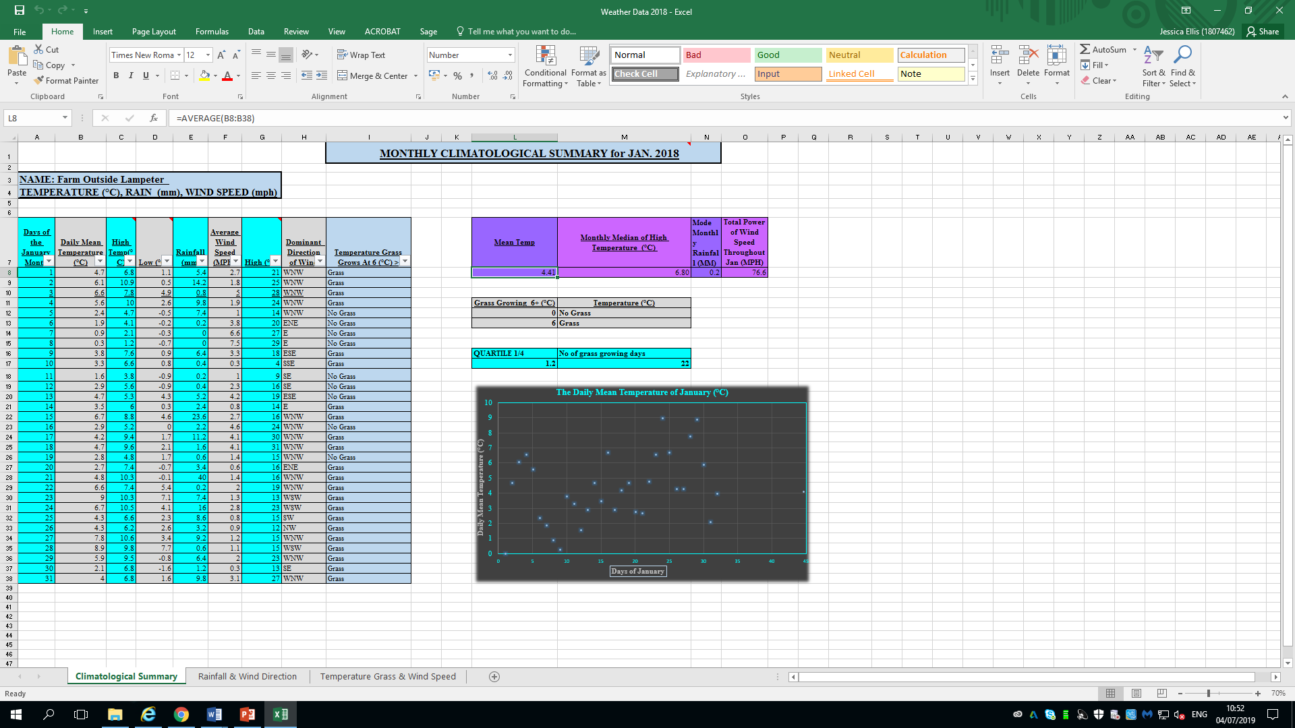

Figure 16: Excel - Weather Data File

As shown above, in order to calculate the average temperature throughout January, I used the above formula and selected the data in which I wanted the output to be generated from. To find the monthly median high temperature, I highlighted column C again, however changed this to =MEDIAN (as shown above). I repeated highlighting the data I wanted to analyze (this time column E) to calculate the mode monthly rainfall (=MODE(E8:E38). Following performing these steps, I then used =SUM(F8:F38) to find the total power of wind speed throughout January. Subsequently, to find the amount of days the grass grows in January, I used =COUNTIF(I8:I38,"GRASS"), which, as shown in Figure 8 results in 22. Lastly, to find the quartile value, I used =QUARTILE(C8:C41,E8:E38). Should you want to find any vacant cells with no value, simply use =COUNTIF(A8:I38,"").


By using the language R for statistical computing and graphics, it enables the wide use of graphs and statistical methods. Although it can prove to be a quite a big learning step, it has extension tools such as R Commander. Released by Microsoft on 30th September 1985, Excel is a widely used programme that is simple to use in terms of inputting mathematical formula to generate an accurate output. The application allows ample graph options (however not all) for visual representation of inputted data.
An open-source and free to use collection of scientific and statistical tools for the Python programming language is Scipy. However, due to library conflicts, incompatabilities are common.
Another tool that is proficient in visual data displaying is Wordle. This programme is easy to import and higlights frequent word useage in areas of text. But, like Wordle and Tableau, a programme named Mallet specializing in document text and clarification. Mallet is similar in its capabilities to Weka, but is easier to analyze documents following a manual installation.
Figure 17: 2014 UK Budget - Generated from Wordle, this word cloud, shows the larger the word, the more frequently it was used.

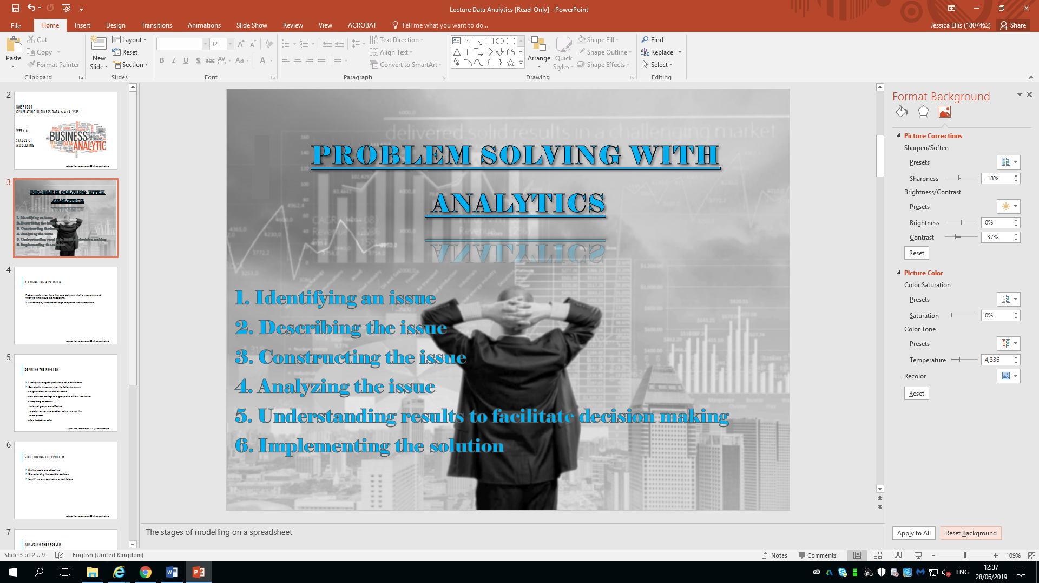

Problem Solving With Analytics
- Identifying the problem/s
Issues occur when an actual output fails to correlate with the predicted output. For example, forecasted sales of a product line are extremely North or South of what was expected. By recognizing this problem, the user can then begin to analyze factors that influenced the actual output figures. For a business, the user is going to have to iron the problem out, and take it into account for future predictions.

- Defining the problem/s
When a problem has been identified, due to multifarious possible problems such as external data and departments being affected; multiple courses of action to take; time restrictions defining the problem can be very complex.

- Structuring the problem/s
Once the objective has been agreed upon, the directions for resolving the issues can be chosen with any extra parametres being consisered.
This can be done by methods such as VLOOKUP (for the Swansea Business School File analysing ownersip of appliances); COUNTIF (to find out how many days in January that grass would grow in Weather Data File). If the objective was to see if a company was sustainable, this was exercised in the Prosumer File.
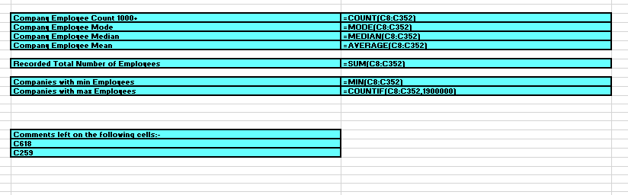
Figure 18: Excel – Prosumer File Formulas Used

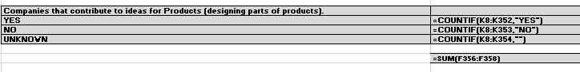
Figure 19: Excel – Prosumer File Formulas Used

By characterizing the possible decision this allows the decision maker/s to observe patterns within the recorded data in order to drive the direction of the company for better sustainability. In example, asking questions such as; ‘Should we hire more staff members?’; and identifying any constraints or restrictions, such as wheelchair access; data impacting on the outputs.

- Analyzing the problem/s
By analyzing the problem in depth, this is key to finding the problem. It would be detrimental for a business if analyzing the problem was doesn’t done properly, as the problems identified may manifest, or remain going forward, resulting in an organisation not being sustainable.
Analysis involves some sort of experimentation or solution process, such as evaluating different scenarios, analyzing risks associated with various decision alternatives, finding a solution that meets certain goals, or determining an optimal solution.

5. Deducing results and making a decision
Models are not able to display every single detail of the underlying issue, therefore it is important for decision makers within a business to appreciate that there are limitations of data models, and so this should factor into their judgement before making an executive evaluation in a case scenario. Using prescriptive analytics to simulate the likelihood of numerous outcomes and their measurements of risk, as well as worst – case scenarios, aids future planning.

6. Implementing the solution/s
Following the previous five steps, the decision maker can then translate the findings of the model back to the real world. Going forward from the results of the data mining problem solving results, preventative measures can then be implemented to help curb the possibility of previous problems happening again. They can do this by providing suitable resources, such as materials; staffing; employee morale and reassuarnce to them; revising company policies and generally restoring trust, that new practices are exercised.

Conclusion
The power of data anaylis stores inputted information and generates outputs, even with their limitations. By correctly categorizing data, it can be formulated fast and efficiently. The decision maker/s are able to see series of events (such as in HR) or statistical patterns using figures (such as in sales activity). Furthermore, it accomadates numerous departments within a company, allowing them to access the same data. For example, a sales department would have to know their sales figures for commission and if items were delivered. In this case, by having a data system, they wouldn’t always need to liaise with the courier and payroll departments. In adition, users can see influences that may have manipulated the output.
Nevertheless, data programming is not without faults. As well as the risks of human error; system failure; technology incompatibility, and appliance reliance on electricity or batteries, they are also suseptible to the orchestration of the Administrator. The administrator could be bias in any way, in example if a product in their department was successful it would benefit them. If a spreadsheet user manipulates the data to accomadate themselves, a third party or a confederate, this could have a detrimental effect on the business in terms of profit margins and morale. As well as the elaborate formula taking time and money to be educated and trained on, reports aren’t all password/ security locked. Although many PC folders are password protected, once the folder is open the files can be accessed. Therefore, once a file containing some or all of the organisation’s core information is opened, it can be printed, edited, imported, screenshot, copied, forwarded on to others and this could prove catastrophic.
Nevertheless, spreadsheet enables the ability to store and manage personal and corporate business’ central data, interpreting and visualising it.
In order for an organization to remain as sustainable as possible, data analysis needs to be exercised and executed accurately and appropriately. Spreadsheets have manifested into one of the most instrumental assets a company has, as they are integral for storing data and fuelling future forecasting

Bibliography
Bewig, P. L. (2005). How Do You Know Your Spreadsheet Is Right? Principles Techniques and Practise of Spreadsheet Style, 1 - 14.
Collier, K. (n.d.). Agile Analytics. 2001: Addison - Wesley.
Edition, K. C. (n.d.). Essentials of MIS. Pearson Global Edition.
Edwards John S, F. P. (1997). Decision Making With Computers.
Evans, J. R. (2014). Business Analytics. Pearson.
John S. Edwards, P. F. (1997). Decision Making with Computers: The Spreadsheet and Beyond.
Lucey, T. (1997). Management Information System. Hampshire: DP Publications.
Martellaro, J. (2011, Jun 17th). WWDC Developers Tell Their Stories. Retrieved from The Mac Observer: https://www.macobserver.com/tmo/article/wwdc_developers_tell_their_stories
Mather, D. (1999). A framework for building spreadsheet based decision. Journal of the Operational Research Society, 1.
Mather, D. (1999). A Framework For Building Spreadsheet Models. Journal of the Operational Research Society, 70 - 74.
Museum, C. H. (2019). Dan Bricklin. Retrieved from Computer History Museum: https://www.computerhistory.org/fellowawards/hall/dan-bricklin/
O'Beirne, P. (2008). Information and Quality Data Spreadsheets. Europian Spreadsheet Risks and Interest Group.
O'Beirne, P. (2008). Proceedings of EuSpRIG 2008 Conference "In Pursuit of Spreadsheet Excellence". Information and Data Quality in Spreadsheets .
Osborne, T. R. (2014, March 19). Chancellor George Osborne's Budget 2014 Speech . Retrieved from www.gov.uk.
Rouse, M. (2006, January). What is a spreadsheet? Retrieved from TechTarget: https://whatis.techtarget.com/definition/spreadsheet

