Performance Management, Motivation and Personal Development Plan.

Leanna Jenkins
1712164

Introduction.
For this report the Researcher studied several topics, for example: Motivation, Performance Management, Personal Development and Training. For the purpose of this report the researcher has decided to concentrate on Performance Management and Motivation. ‘Effective Performance management is essential to businesses. Through both formal and informal processes, it helps managers align their employees, resources and systems to meet their strategic objectives. It provides managers with an early warning of potential problems and lets them know when they need to make changes to keep their business on track’, (Capri, Douglas and Gascon, 2017). ‘Motivation in the workplace is defined as the willingness to exert high levels of effort towards organisational goals conditioned by the efforts ability to satisfy some individual needs’ (UNC Executive Development, 2015). The Researcher will critically evaluate and assess these development vehicles and will back up the evidence with academic references.
Task 1.
Benefits of the individual.
Performance Management.
Performance Management and Motivation are two very important development vehicles for employees and organisations. ‘An effective Performance Management process encourages managers and employees to have ongoing conversations regularly to discuss goals and expectations, accomplishments, challenges and development needs. This ensures that employees have the feedback and recognition they need to improve and succeed’ (Greenberg, 2015).
Evidence suggests that ‘Performance Management can be a waste of time’ (Patricia, 2015). Lessard (2017) states ‘Organisations that do not have a strong Performance Management System can have a negative effect on employees, but if done well it will contribute to the organisations compliance, employee success and beyond’.
Poor Performance Management can ‘lead employees to feel unappreciated, physically present but psychologically absent, miss days of work and share with other employees why they think the organisation is a poor place to work. Some of these negative effects can lead employees to quit, employees may lose self-esteem and employees becoming demotivated’ (Rotenberg, 2019).

The Researcher found that ‘an effective Performance Management enhances staff engagement and promotes staff development’ (Penn HR, 2015). Performance Management can have a positive influence on employee job satisfaction and loyalty by:
- Evaluating performance
- Recognise and reward good performance
- Provide learning and development opportunities
- Provide maximum opportunities for career growth
- Providing regular feed back
(Management Study Guide, 2019).
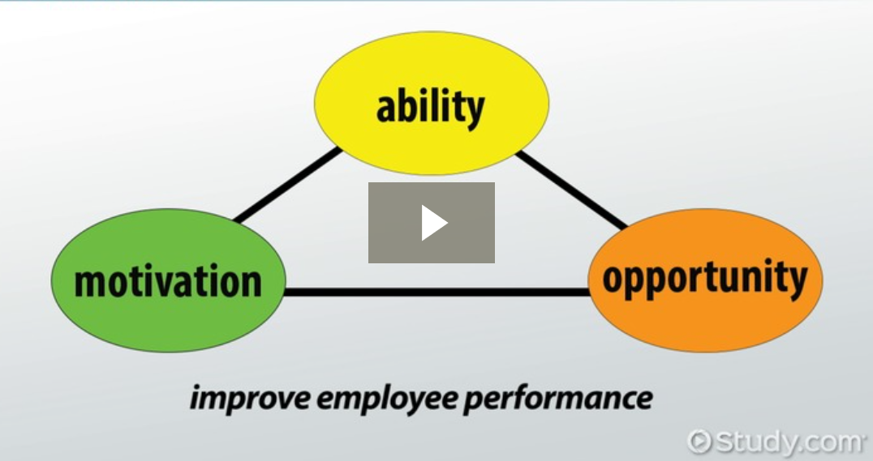
As found in Study.com (2019) ‘The AMO Theory suggests that there are three independent work system components that shape employee characteristics’. It helps employees to show their abilities through their skills and knowledge. To be motivated, whether it be by rewards and recognition or the possibility of training and developing their career. Once this is achieved employees should know their job role and responsibilities. Be able to perform these roles and be given the opportunity to give their opinions and take part in individual, team and organisational aims and objectives.
The Researcher found that using the AMO Theory for performance management helps to identify any issues the employee has and how to solve them. It also highlights all the positives the employee has achieved and shows them appreciation for their hard work. It is a chance to give the employee Performance Appraisal to show them that they are valued and trusted which will in turn make they employee feel appreciated and motivated.
The Researcher found that ‘the system should by used by managers and workers to create career plans which encompass not only training proposals but also areas of work experience, job goals and personal development. And consider career tracks which may be as much about lateral moves designed to expand learning and competence toward promotion’ (Mullins, p.511, 2010).
Motivation.
Motivation is key to employees in any organisation, but what motivates employees? Obviously the main reason is money but money can not be the sole motivator. Porter, Smith and Fagg (2006, p.87) suggest ‘Maslow described human motivation as a hierarchy of needs whereby the satisfaction of one level of needs triggers the movement to the next higher level of needs’.
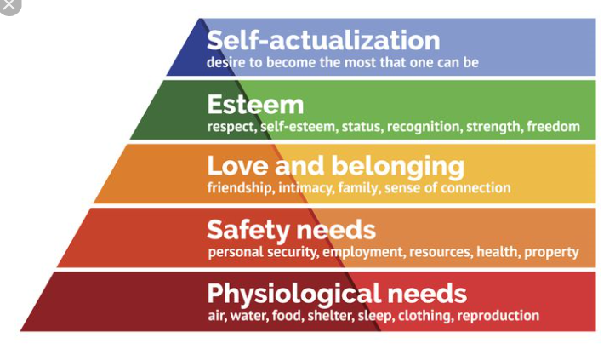

Employees in the workplace should already have the first two levels by having a job, money and other basic needs. But they need to be motivated in order to work their way up the levels. Ways to keep staff motivated are:
- Demonstration of trust
- High - quality training and development
- Feel part of the team
- Good work life balance
- Fairness in work
- Proactive and regular communication
- Regular appraisal and positive feedback
- Recognition and reward for performance
- Encouragement
(NI Business Info, 2018).
The Researcher found these to be beneficial to employees as once employees feel that they are achieving these they will work their way up the levels. Tanner (2019) states ‘Once the basic needs are satisfied an employee will want their high levels of self-esteem ad self-actualization met. Self-esteem is an employee’s image of himself and his desire for the respect and recognition of others’. And the final stage of self-actualization sees the employee fully motivated as all their needs are met. They are skilled and ready to take on any challenges where they can grow individual development. ‘Realising personal potential, self-fulfilment and seeking personal growth and peak experiences’ (McLeod, 2018).
A good organisational example for motivation for employees in a workplace is Tesco’s Regeneration Scheme. Tesco PLC (2019) states ‘Regeneration Partnership stores allocate a third of jobs to local people who have been unemployed for more than six months. These people have a wide range of skills but lack in confidence. This scheme helps them to get an interview and recruited based on the persons attitudes not qualifications. This helps to motivate the potential employee by showing faith in their ability and potential’. The Researcher feels that this is an excellent way to motivate employees as the employee will feel that they are not being judged, that they are being given a chance to prove they have potential and can be relied on, which will in turn encourage the employee to shine in the organisation and prove that the managers made the right decision in employing them.
The Researcher found that if an employee is motivated they are more likely to grow and succeed in an organisation. They will gain rewards such as, financial rewards, holiday entitlement, training, development opportunities, good working conditions, private health care, car and company pensions.
All in which will continue to help the employee stay motivated, as motivation needs to be a continuous routine. Motivated employees will reap the benefits from an organisation, and they are more likely to improve and grow and overall be happy and content with their achievements.
Task 2.
Benefits to the organisation.
Performance Management within the organisation.
A good Performance Management System can be very beneficial to organisations. In some circumstances it can be time consuming and costly, in other cases where it is performed correctly it will ensure that the organisation will run smoothly and inevitably achieve good profits. In the long run, if done correctly and efficiently it will be very beneficial to your employees and organisation in achieving their objectives and goals for future success, such as profits, productivity and quality.
‘Performance Management, done well, is a vital tool for having engaged employees. It creates an atmosphere of trust, support and encouragement. It helps develop relationships between employees and management. If an employee is aware that management cares about what they do and are dedicated to helping them do better and progress their career they are more likely to engage with the company. Engaged employees stay longer, actively involve themselves in the workplace and produce better results. (Hearn, 2018).
The Researcher found that when employees have an opportunity to gain training opportunities through the performance management system it helps them to realise what their job role and responsibilities are, what tools they have to perform their job and how to perform it. This then benefits the organisation as if employees are doing their job well, the organisation will make more profits.
Riedo (2017) states ‘Performance Management is an annual event that costs everyone in your business time and money while generating little improvements. Even though companies know that Performance Management is incredibly ineffective for evaluating performance, they are still looking for new alternatives. The alternative is called Continuous Performance Management’.
An organisational example where continuous Performance Management would be beneficial is in McDonalds. McDonalds.com (2019) states ‘Employees receive performance reviews based on competencies defined as important for their role. This occurs twice a year and is an opportunity to measure performance, set objectives and discuss the training and development needs of the employee. The sections of the review are aligned with our overall company strategy and each individual’s job description. Each section has the opportunity for the reviewer to rate an employee’s performance through both written comment and numerical rating scale 1-4. The employee has the opportunity to grade themselves and make comments on how they rate themselves within each section’. The Researcher suggests that although this is a beneficial process to the employees of McDonalds, it would be a bigger advantage to the organisation if they did the process as more of an continuous process rather than annual, as ‘continuous Performance Management is a system that emphasizes regular conversations between managers and employees. Provides ongoing feedback and check-ins about goals which make it much more likely that these goals will be met’ (Betterworks, 2018).
As suggested by Puckett (2019) the Researcher agrees that ‘companies are guilty of treating Performance Management as a yearly event. But it has been claimed that companies that practice continuous Performance Management have better business results. Companies where employees review their goals more frequently have better data quality, higher employee engagement, more efficient review process and more input from employees’. Which will ensure the organisation achieves great success.
Motivation within the organisation.
A well motivated workforce can provide several advantages to any organisation:
- Better Productivity - can lead to lower unit costs of production and enable the firm to sell its product at a lower price.
- Lower levels of absenteeism – employees are content with their working lives.
- Lower levels of staff turnover – this can lead to lower training and recruitment costs.
- Improved industrial relations – with trade unions.
- Good Reputation – workers are content and which makes it easy to recruit the best workers.
- Improve Product Quality – motivated workers are likely to improve product quality or customer service.
(Tutor2U, 2018).
A big motivator is the opportunity to gain training to progress in the organisation. Training is not just important to any company, it is vital. 20/20 Project Management (2009) states ‘Training presents a prime opportunity to expand the knowledge base of the employees. But employees attending sessions also miss out on work time which may delay the completion of tasks. But despite the draw backs, training and development provides both the individual as a whole, with benefits that make cost and time a worthwhile investment’.
The Researcher found that the potential benefits of motivation are that it can enhance your organisations image and increases financial gain. ‘It is beneficial to an organisation to develop existing employees rather than hiring new as it reduces recruitment costs, reduces absenteeism, employee turnover, engages and motivates the work force and increases productivity. The more commitment from the organisation in the investment in career development builds trust with your employees helps them to realise their professional accomplishments and your organisations success’ (Monster, 2019).
Task 3.
Personal Development Plan.
As stated by Start Up Donut (2019) ‘Personal Development Plans provide a powerful, flexible way to link employees’ professional and personal development with the development of your business’. It is a way to help employees identify any recurring issues and to set their goals and plan how they are going to achieve this. The Researcher found that it is a way for employees to improve their performance to achieve these goals, whether these are short or long term goals.
OBJECTIVES | MEASURES | PRIORITY | INTERNAL | EXTERNAL | REVIEW DATES | OTHER COMMENTS
Improve customer care. | Training course. | High. | √ |  | Weekly. | To learn to take on any feedback. Improve technical skills. To listen and to know our products and services.
Build confidence in decision making. | Practice and training course. | High. | √ | √ | Weekly. | To practice and use the support of other staff and management.
Teamwork. | Teamwork activities. | Medium. | √ |  | Monthly. | Follow Bruce Tuckman development process.
First aid. | Training course. | High. |  | √ | Yearly. | Taking a first aid course voluntary or through the organisation.
Progress to management. | Management courses. | Low. |  | √ | 2 – 3 years. | To show my skills through training. Funded through the organisation.
Widen my skills and opportunities. | Training. | Medium. | √ |  | Weekly. | To get training on other departments in my organisation.

Conclusion.
To conclude this assignment the Researcher found that it is very beneficial to any organisation and employees to use performance vehicles. Organisations rely on employees to do a good job, so the performance of employees is crucial to a organisations success. Performance vehicles help employees to understand their job roles and responsibilities, to keep employees motivated and engaged which in turn will result in employees staying with the organisation and progress to produce better results. This will increase productivity and give the organisation a good reputation. The Researcher found that the use of Personal Development Plan is very beneficial to an individual as it helps them to identify their strengths and weaknesses but also maximise their potential and improve skills. To help an individual ‘recognise their self- awareness, direction and motivation. To find their values, beliefs and goals in life and to be clear on what they want in life. Once they know the direction they want to take it can be easier to be motivated in achieving their goals’ (Ricard, D. 2017).
References.
Better works. (2018) 3 New reasons to make the move to Continuous Performance Management. Available at: http://www.blog.betterworks.com (Accessed 29 November 2019).
Capri, R. Douglas, J. and Gascon, F. (2017) Performance Management: Why keeping score is so important, and so hard. Available at: http://www.mckinsey.com (Accessed 14 November 2019).
Greenberg, G. (2015) What is Performance Management? 5 reasons why it matters. Available at: http://www.digitraining.com (Accessed 14 November 2019).
Hearn, S. (2018) Why is Performance Management important? Available at: http://www.clearview.com (Accessed 14 November 2019).
Lessard, A. (2017) Top 5 advantages and disadvantages of Performance Management. Available at: http://www.gov.loop.com (Accessed 14 November 2019).
Management Study Guide. (2019) Benefits of Performance Management System. Available at: http://www.managementstudy.com (Accessed 14 November 2019).
McDonalds.com. (2019) Your right to know. Available at: http://www.mcdonalds.com (Accessed 29 November 2019).
McLeod, S. (2018) Maslow’s Hierarchy of Needs. Available at: http://www.simplypsychology.org (Accessed 15 November 2019).
Monster.co.uk. (2019) What are the benefits of developing the skills of your existing workforce? Available at: http://www.monster.co.uk (Accessed 24 November 2019).
Mullins, L. (2010) Management and Organisational Behaviour. 9th ed. Essex: Pearson Education limited.
NI Business Info. (2018) Lead and Motivate your staff. Available at: http://www.nibusinessinfo.co.uk (Accessed 15 November 2019).
Patricia. (2015) Advantages and disadvantages of Performance Management. Available at: http://www.smartchurchmanagement.com (Accessed 14 November 2019).
Penn HR. (2017) Effective Performance Management. Available at: http://www.hr.upen.edu (Accessed 14 November 2019).
Porter, K. Smith, P. and Fagg, R. (2006) Leadership and Management for HR Professionals. 3rd ed. Oxford: Butterworth-Heinemann.
Puckett, J. (2019) The Importance of Performance Management. Available at: http://www.technologyadvice.com (Accessed 29 November 2019).
Resource Management, Inc. (2019) The Benefits of Performance Management for employees. Available at: http://www.rmi-solutions.com (Accessed 16 November 2019).
Ricardo, D. (2017) What are the benefits of Personal Development. Available at: http://www.gbtraining.org.uk (Accessed 1 December 2019).
Riedo, M. (2017) Top 10 Benefits of Continuous Performance Management. Available at: http://www.hrnews.co.uk (Accessed 16 November 2019).
Rotenberg, Z. (2019) The disadvantages of poor Performance Management. Available at: http://www.atiim.com (Accessed 14 November 2019).
Start Up Donut (2019) Personal development Plan. Available at: http://www.startupdonut.co.uk (Accessed 1 December 2019).
Study.com. (2019) The AMO Theory: Ability, Motivation and Opportunities. Available at: http://www.study.com (Accessed 15 November 2019).
Tanner, R. (2019) Motivation – Applying Maslow’s Hierarchy of Needs Theory. Available at: http://www.managementisajourney.com (Accessed 15 November 2019).
Tesco PLC. (2019) Our Tesco Exclusively for Colleagues. Available at: http://www.ourtesco.com (Accessed 29 November 2019).
Tutor2U. (2018) People Management: Introduction to Motivation. Available at: http://www.tutor2u.net (Accessed 29 November 2019).
UNC Executive Development. (2015) The role of motivation in the workplace. Executive Development Blog. 5 November. Available at: http://www.execdev.kenan-fleger.unc.edu/blog/the-role-of-motivation-in-the-workplace (Accessed 14 November 2019).
20/20 Project Management (2009) The Importance of Training and Development in the workplace. Available at: http://www.2020projectmanagement.com (Accessed 24 November 2019).

