ISAAC NTI ASAMOAH

DIGITAL SKILLS AND RESEARCH METHODS
1705783
INTRODUCTION.
According to Obama, (2008) “Technology has changed the way we live and the way we do our business”. This is really a fact. (Pearce, 2007) also made assertion that, the urgent need and importance of communication has led to scholars, scientist, experts working around the clock tirelessly to make it faster and easily accessible through the evolution of technological advancements like phones, televisions, satellites, phones, computer networking along with industrialisation and globalisation.
“Technology is ubiquitous in today’s society particularly since the advent of smartphones, and has been increasingly becoming vital component in education. (Rosen, 2013).
From what scholars like Pearce Barnett and Rosen have said and prominent public figure like Barack Obama said about the importance and fast evolution of technology, it has come to make our lives better. “In the last two decades, explosive innovation in the Information and Technology (ICT) and rapid expansion of modern communications networks with fixed mobile broadband access features are changing the way we access, store and transmit information bringing significant efficiency gain in all activities”. Nadiri and Nandi, (2015).
I very much agree with Nadiri and Nandi’s statement as it sums up the modern -day technology thus fast rising significant.

Technology For The Workplace?
(Turnage, J. 1999) defined workplace technology as being successful by aligning our vast technological resources with enlightened human resource management to become more competitive and productive. Thus it is collective and efforts.
Wallace, M. (1989) also made the assertion that it s the present and future key technological changes in the workplace. Wallace also went further to state that it is the “several key innovations in the factory and in the office”. He also went ahead to argue that “technological change sometimes makes the work easier, cleaner and safer”.
From the above scholar’s, my research, reading and experience and especially the rate at which the world is evolving, technology has really come to boost and make working life and life as whole easy and productive.
ADVANTAGES
According Wallace, M. (1989), workplace technology fosters “High flex workplace; control of work; organizational change; impact on skill; technological unemployment; educational requirements and retraining; changing occupational and class structures; occupational safety and health; the interaction of work, leisure, and family; and the quality of working life”. This idea by Wallace sums all what it stands for.
Thomas, K. (2014) also said “employees can work nearly anytime and everywhere”. This fact is really evident when people now sit in comfort on holidays, home, beds and run business on social media and online.
In education, lectures now use computers and fibre optics internet to teach. Makes it very easy and fosters understanding unlike when it was virtual teachings and assumption.
Students now have access to research and study with aid of computers and phones. Study on the go. Another example is how we submit our assignment online and ease.
In the medical field which technology is really saving live and making life easy. Now operations could be done pain free because of advancement like lasers. Barren couple could now worry no more because of the introduction IVF. Incubators and many more to save vulnerable lives.
Technology aids in online shopping, brand promotion, less expensive through free adverts and promo example facebook where I have opened a free business account and do business 24/7.
DISADVANTAGE
According to Wallace, (2014), workplace technology has given employees “unbalance life and human resource must design workplace policies”. People no more have time since they could now work twenty- four hours of on social media.
Gupta, H. (2017) note that “recent years have seen an increase use of online activities (especially pornography/gaming) at workplace. It has shown to affect productivity”.
This example happened recently in my company (lost £16000) because employee was not concentrating because of facebook and produced wrong products for the market.
Its cost unemployment because of introduction of robots (does peoples job). My company got rid of over twenty staff because we now have robot for packaging hence not needed.
From the above it is logical to accept and conclude that workplace technology has done greater good than harm.
Web conferencing (example of workplace tool)
“Web conferencing is a collaborative tool that allows for synchronous communication. This collaboration encompasses audio and visual interactions. The tool also allows for annotation on the presented material and the ability to use a chat facility amongst participants” according to Twine and Brown, (2011). From this definition and my knowledge, it combines audio, text messaging and video and example is skype.
Skype is a social media which has now become official use at the workplace. My boss recently went to business trip to china but we had emergency at work and really needed his intervention. We gathered and he spoke to us in the conference hall via skype.
ADVANTAGE
Flexible: my manager was in china but chaired emergency meeting and saved situation.
I chat my family back home and its intimate just like face to face. Before the advent of skype, u could travel and will not have that intimate visual with love ones.
Economical: instead of travelling to the meeting, saved money and had it comfort of home/hotel.
Very accessible even on mobile and anywhere there is internet.
Disadvantages
Expensive: you need computer with cam or mobile/tablet which not affordable to everyone. You also need internet connection.
Technical itches like power cuts, internet failure can stop it n midway or might not even permit.
Mobile phone
Besides, communication is so vital and important like the food we eat and air we breathe to our lives. No one or organisation could survive for long in this modern generation without it. (Trenholm, S. 2017). Evolution of mobile says it all. Just like Sarah Trenholm said we can no more live without it.
Businesses really depends on phones to communicate. At work, I take orders from customer and stays update through phone and management. Modern phones have got all communication facilities hence very vital for the workplace.
ADVANTAEG
It is portable and mobile hence communication on the go. Twenty-four hour business and updates in hand. (Thomas, K. 2014).
Security conscious thus locks and password oriented. Storage (memory) to save vital and useful documents, locks and very private.
For emergency use example call emergency and security services in time of danger.
Employers means of getting in touch when you are off work
Connect to family and friends. That is the only means to speak to my family and friends since I live in England far from them in Ghana.

DISADVANTAGE
Prone to theft. Thieves target and sometimes injuring individuals for their phones.
could lose valuable information when lost.
Expensive example latest iphone cost around £1000
Destructive and addictive at work and studies. People playing games, movies and social networking at lectures or work.
Besides the minor negatives about workplace technologies, it is entertaining, teaching informs and making lives better.

Social media
According to Kietzmann, et al (2011), defined social media “seven functional building blocks: identity, conversations, sharing, presence, relationships, reputation, and groups”.
Kaplan and Haenlein (2010) define social media as "a group of Internetbased applications that build on the ideological and technological foundations of Web and that allow the creation and exchange of user generated content."
Users range from tech-savvy young adults to baby boomers and older adults seeking ways to reconnect with family and friends (Anderson, 2009).
From the above definitions and social media trend now, I believe people of all age (legal) ready to mingle, entertain, learn, inform and make the best of opportunities.
Advantage
It is an advantageous business platform to advertise free of charge market products. I recently bought a shirt I saw the advert on face. This person took advantage and making money.
I have also opened a business account recently on facebook (Nana parlour) thus mother and making gradual grounds.
It an opportunity for studies like google, skype. It was the static library with thorn pages because of the rush to use but now we have the opportunity to study wherever.
There are degree courses online by the help of technology.
LinkedIN a site where employees find out about employers.
I got my current job through facebook. I saw the advert and applied. It is the best I have ever had. My wife also had hers through linkedIN. The human resource manager phone inbox after seeing her profile.
Former U.S president is names the “first social media president” Coren, C. (2015) because he took advantage and used it for his campaign.
Helps fights crime. Metropolitan police on several occasions have announced crimninals caught through social media.
Meeting new people. My work colleague met his wife on facebook and married with three kids.
Security conscious. You have the opportunity to decide who sees and can block people or unfriend when you feel u not ok with them.
Twitter is more like official site for most heads of states, security agencies, celebrities.
Every information about weather, transport and news are officially put there. Example London bridge attack in some few months ago was sent there by official communication office of London police warning people to avoid the area.
Disadvantage
Cyber bullying: cowards hide behind technologies to intimidate vulnerable people.
Criminals can advertise products but might end up sending fake products because it is not face to face marketing.
Stalker pick and follow addresses when you are not security conscious. They may trace you wherever it leads them. There have been instances where people have been murdered by this act.
Identity theft. Because people update profile and pictures, thieves pick to do vices. They might impose as you with your pictures and informations.
Gupta, H. (2017) noted that “recent years have seen an increase use of online activities (especially pornography/gaming) at workplace. It has shown to affect productivity”.
There have been instances at my workplace when people have been negligence an absent minded because of sites like facebook, whatsapp and online gamble and gaming. Company lost huge sum and people lost their jobs.
Though, there are little but serious disadvantages about social media, the positives far out-weighs the negatives. The negatives can be taken care of when one becomes security cautious. There are so many opportunities social has brought to the workplace, for entertainment and individuals and one need to take advantage of it. The benefit whether negative positives depends how you psyche yourself to use it.
BRIEF ADVICE ABOUT ONLINE SECURITY.
There are individuals who always wants to steal your valuables (data) hence one needs to be a thinker online.
Mobiles, computers need to be locked with strong personal password.
Cloud storage must be handled with caution and encrypt.
Always have backups to valuable data.
Strong firewall and always update software.
Technology has come to stay and will forever evolve and part of us. Example is according to report in the independent newspaper by Griffin, A. (2017) “Saudi Arabia has become the first country to give a robot citizenship”. It is therefore the signs of importance of technology to human. Technology is here to make us better hence take advantage.
I am taking advantage as shown below by creating a business on facebook (Nana Asamoah parlour) and on twitter where I follow my mentors and about inspiration daily. I often have daily offers from employers and weighing the best option.

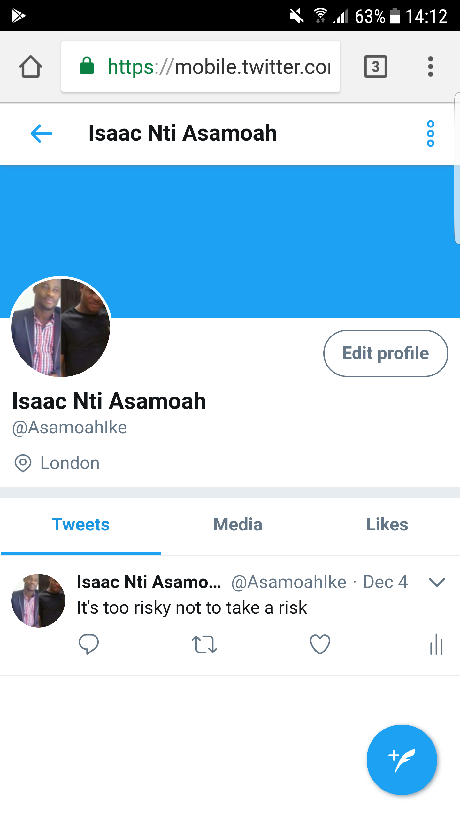

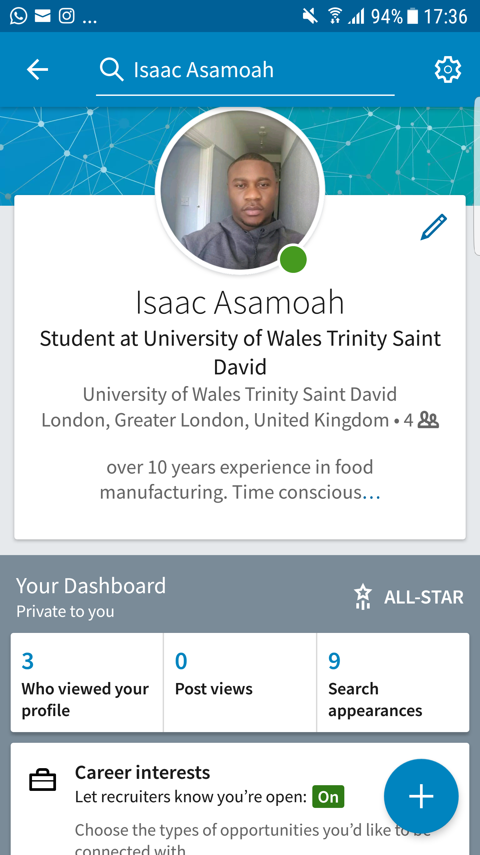

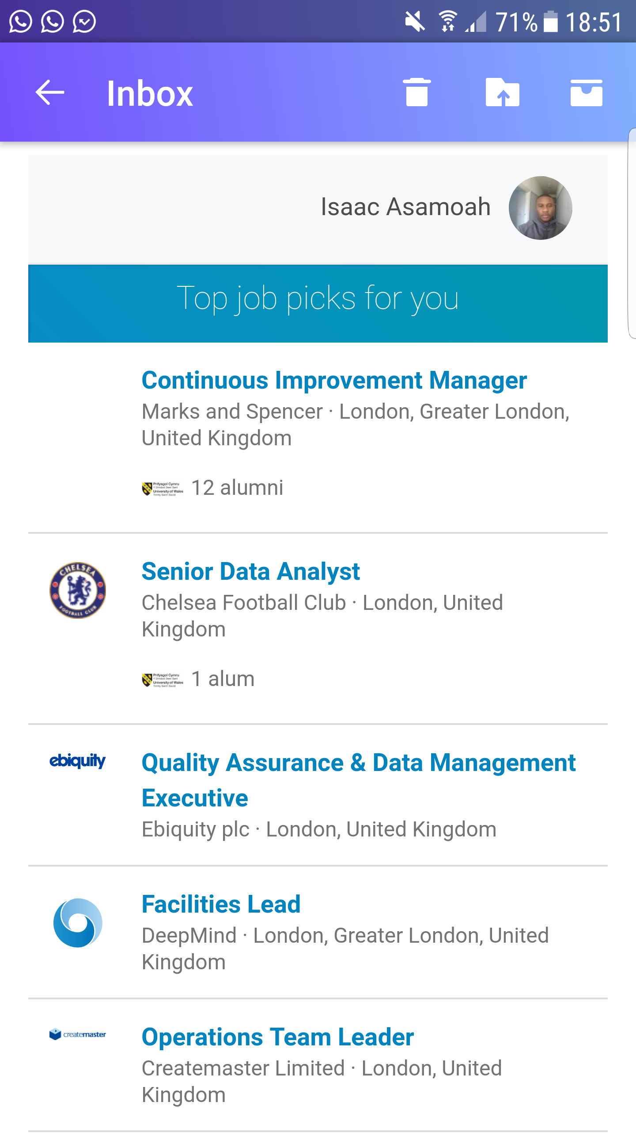



References:
Nadiri, M. Ishaq and Nandi, Banani, Modern Communication Technology and Its Economic Impact: A Survey of Research Findings (November 16, 2015). DIGIWORLD ECONOMIC JOURNAL, no. 100, 4th quarter. 2015, p. 125. Available at SSRN:https://ssrn.com/abstract=2845373
Barack Obama, (2008) speech on globalisation
Turnage, J.J. (1990). The challenge of new workplace technology. 45(2), 171-178
Michael Wallace (1989), Brave new workplace. published Nov. 1st
Kristopher J. Thomas Workplace and technology and creation of Boundaries. Pub May 5, 2014
Gupta, H. (2017). Pattern of online technology and its impact on productivity at the workplace.
April 2017 volume 41 supplement, p s460
Sarah Trenholm – Thinking through communication. 8th edition, illustrated. Publisher Routledge, 2017
Social media? Get serious! Understanding the functional building blocks of social media
Author links open overlay panelJan H.KietzmannKristopherHermkensIan P.McCarthyBruno S.Silvestre.
Courtney Coren. Washington post. Wednesday, 27 May 2015 1:41 pm
ANDREW GRIFFIN@_andrew_griffin
Thursday 26 October 2017 13:31 BS. The Independent

