A critical evaluation and the identification of next teaching and learning steps focusing on a case study of an individual learner or a group of learners, based on an observed critical incident.

Introduction
The purpose of this essay is to identify, explore and evaluate an observed critical incident. The essay will focus on a critical incident observed at School A and will refer to this incident throughout the essay. Through this critical incident this essay will explore the key literature, learning theories and pedagogy related to its theme.
A critical incident is understood to be an event, moment or action that occurs within the school environment. An important theorist in this field is Tripp who states, ‘It is the unremarkable and everyday events that make up our routine professional lives that are often the best indicators of the patterns and values that underpin our practice’ (Tripp, 1993, p 40). In Tripp’s view critical incidents are moments in professional practice that on first examination may appear to have little to no impact, but with analysis and further examination can become critical and improve or deepen the understanding of the teacher; they can be said to be of importance to developing student teacher awareness and in improving practice within the education system as a whole.

Observation
For this assignment fieldwork research was carried out to gain evidence of critical incidents in the classroom. All observation notes are listed in the Appendices (Appendix 1-4) alongside details of observed critical incidents. All notes and the main body of this essay will comply with BERA guidelines on confidentiality and anonymity (BERA 2018).
All observations took place at School A. School A is a 11-16, English medium secondary school in a small town within a rural area of Wales. According to the most recent Estyn report there are currently 534 pupils on roll at the school 15.2% of whom are eligible for free school meals, slightly less than the Welsh average of 16.4%. There are 26.6% of pupils on the ALN register which is higher than the national average of 22.5% and of these students 2.1% are statemented. Most students come from a white British background and 1% of the School A’s students are EAL. As stated above the school is English medium, however 27% of students speak Welsh fluently and 68% can speak the language to some degree. As such the school states that it is ‘English medium with significant Welsh’ spoken (Estyn 2019).

Methodology
On the 29th of September 2020 four one hour lessons were observed in School A. Due to the ongoing COVID 19 pandemic, movement in class and in the school was restricted and during the lesson observations a mask was worn as a necessity at all times to help prevent spread of the virus (Gov wales, 2020). This of course limited options for observation method and naturally placed barriers to communication. The method adopted for the observations was that of a non -participant observer(Gil and Johnson, 2010), which meant that there was no participation in the lesson or movement around the class. The observations were structured, and the notes followed a particular format. Despite the above-mentioned restrictions, it was possible to collect information and document several critical incidents. Notes were taken periodically during the lesson, observing for a few minutes and then taking time to note findings down. On observing a critical incident, a note of this immediately after it occurred. The notes followed a format adapted from Fletcher- Wood (2016) and observed the following aspects of the ‘classroom environment, Lesson details, classroom culture, objectives, access and challenge, assessment, and critical incidents’ (2016, p 125); then a critical incident was noted from each lesson in more detail.
The research undertaken is of vital importance to developing professional practice as Kumar (2014) states research can be used to ‘enhance your practice skills’ through an evaluation of observations (2014, p 2). The research undertaken took the form of a case study. Case studies are as Cohen explains in ‘Research Methods in Education’ (2013) a difficult thing to define, but can be viewed as observations of subject, individual or group holistically within their typical environment (for example, a classroom) (Cohen 2013, p 89-91). The advantages of using the case study method is that it allows the ‘researcher to intensively investigate the case in-depth, to probe, drill down and get at its complexity’ (Ashley, 2012, p102). In other words, a case study allows the researcher to immerse themselves whether as participant or observer, in their study and to place their subject within their usual context. However, when conducting this kind of research, one must be aware of ‘the Hawthorn effect’ which occurs when the subject is aware of the observer and as a result the subject alters their behaviours (Salkind, 2010, p 561). An alternative method that could have been implemented for gathering data and information about a classroom environment is the longitudinal method, which uses tools such as survey’s and questionnaires to build up a picture of the subject over time. This would mean that the researcher would avoid potential issues such as the Hawthorn effect and although the direct observation of a case study allows for the identification of a critical incident, a longitudinal study may allow for the study of the ‘cause and effect’ of a particular event through analysis of further results (Vignoles, 2012, p 114).

Four purposes and Incident details.
This essay will focus on the incident observed in a year nine, period five English lesson. The class was a higher ability set with two M.A.T. (more able and talented) learners. The students were seated in rows with students in pairs to enable peer working. The lesson was at the start of term and the class were currently reading ‘The Hunger Games’ by Suzanne Collins (2008). Due to the complexity of the critical incident and the context of the lesson, it not possible to adequately describe in full the incident here due to word count limitations, please therefore refer to Appendix 1 for full details. To summarise, the class had in the last lesson broken away from reading the book to discuss a major theme in the novel, wealth inequality. They had previously briefly explored this idea and the teacher now aimed to have them examine the ethics in more detail. The lesson objective was to learn to be the ‘devil’s advocate’ and argue for an opinion that is not necessarily your own. Teacher X put a statement regarding wealth inequality on the whiteboard for the class to discuss in pairs (see Appendix 1 for full statement). The class then broke away to discuss for one minute. As Teacher X was counting down the following critical incident occurred:
Student C: Sir this is hard. This statement.
Teacher X: Is it hard? (continues counting down and class talks. Finishes counting down, class is quiet). It is hard isn’t it?
Various students then call out saying they found the task difficult.
Teacher X: It is hard, but then it was meant to be hard. It’s hard to argue for a point you don’t agree with, especially when it challenges your own ethics. I tell you what, if so many of you found it hard we’ll try again but we’ll start off by arguing just for the first bit before the comma.
Class then restarts the task. (Appendix 1)
This is the critical incident that will be explored, evaluated, and reflected upon fully in the following sections of this essay. However, the incident is important as it links to some of the purposes of the new national curriculum for Wales ‘Successful Futures’ (Donaldson, 2015). The incident shows Teacher X to be considering the purpose of ‘Ethical, Informed Citizens’. This is evidenced in that the task is aimed at allowing students time to consider an ethical issue and challenging their own ethics and pre-conceptions by asking them to argue for an opinion that is not necessarily their own. It also feeds into the purpose of ‘Healthy, Confident Individuals’ in that the task is encouraging the students to explore their ‘Spiritual and Ethical Beliefs’. Lastly, the critical incident links to the purpose of ‘Ambitious, capable learners’ in that it is linked to the topic being studied during the school term and reinforcing, building and expanding on the students understanding if the issues presented by the book (2015, p 31). ‘Successful Futures’ also stipulates that as one of its cross-curricular obligations for all teachers is to enhance literacy. The report makes a point of stating that literacy cannot and should not be about ‘repetition’ and over relying on writing to reinforce literacy skills, but should give students the chance to talk and think about their ideas and concepts and engage in tasks that encourage them to ‘explain thinking, explore and discuss ideas’(2015, p40). Teacher X has clearly planned the above lesson to facilitate this kind of literacy development by allowing students not only to read the text studied, but to debate, explore and evaluate the key concepts contained within in an effort to develop their literacy and their ethical, moral and philosophical thinking.

Literature review
To return to Tripp a critical incident is a moment in teaching that seems at first unimportant or even irrelevant to professional practice and development, however these moments are shown to be of great value to reflection when evaluated and analysed (2011). This essay will now move on to explore the literature, key theorists and concepts that can be viewed at work in the critical incident. One of the main standards that all teachers are expected to meet through their practice is professional learning (Gov Wales, 2018, p2) and it is therefore crucial to remain up to date with current research, but also with the teaching and learning theories that are present in everyday practice.
This review will begin with the theory of Social Constructivism and how it is presents in practice of Teacher X in this critical incident. To summarise, social constructivism can be found largely in the works of the theorist Lev Vygotsky (Kozulin, 2003); Social constructivism argues that students are the shapers of their own learning but learn from their social interactions with others. Within this theory there is the idea that children learn through interactions with more knowledgeable peers, who act as a guide to the students. In Vygotsky’s theory this is the role of the teacher, to act as a guide to students in their learning (2003). This can be viewed in the practice of Teacher X in the critical incident. The lesson being a debate lesson naturally lends itself to this approach since the work is largely based on the student’s own opinions and grappling with the ethics of the concept to form their own conclusions. The role of Teacher X is to facilitate this and to guide the students in their debate.
Another concept contained within Vygotsky’s theory of social constructivism is the ‘ZPD’ or ‘Zone of Proximal Development’. This is linked to the idea of a guide in Vygotsky’s work, who in this incident is Teacher X. The ZPD is the concept that students have levels and boundaries of achievement they can attain; without help from anyone else being the lower boundary and with help from someone else (teacher/guide) being the higher end of the ZPD. This is often used in teaching in the form of the concept known as ‘scaffolding’ (2003, p 17). Scaffolding is a method of teaching that breaks down tasks into smaller, more manageable stages which then allows the student to develop a fuller understanding of the topic. Hattie describes the aims of scaffolding as supporting students in reaching the learning intentions by showing them the aim of their task, using effective questioning techniques, and remoulding a tasks and activities where appropriate (2012). In the critical incident Teacher X sets a task that is meant to deliberately challenge the students. However on receiving verbal feedback from the students that the task is too difficult, as the guide in the room Teacher X breaks down the task and allows the students extra time to discuss; using some of the key concepts of scaffolding described by Hattie, in particular when the task is rearranged to help the students achieve (2012). Scaffolding is included in ‘Successful futures’ as an aspect of ‘good’ and ‘direct’ teaching that involves the use of transparent learning objectives, demonstration of ‘success criteria’ and enabling students to lead their learning (2015, p 65).
The Critical incident also links to another key area of teaching and learning theory, that of Assessment for Learning or AFL. In particular, the critical incident displays a type of formative assessment in that Teacher X has engineered an activity that contains class discussion as a means of assessing and furthering understanding. Teacher X stated aloud that the activity was designed to be deliberately difficult and this is a form of AFL as categorised in the work of Dylan William (2011); William outlines in his book ‘Embedded Formative Assessment’ five strategies for embedded AFL. The critical incident can be found to fit into many of the subcategories of the five strategies and it would be difficult to adequately examine all now. However, one example is in terms of the learning intentions of the task, Teacher X has clearly demonstrated what they want the pupils to be able to do and also allows the students to rephrase the discussion showing evidence of learning. The task itself involves the use of peer work; another method outlined by William that allows pupils to help each other in developing their expertise (2011). It is also evident that the ideas expressed by Doug Lemov in his book ‘Teach like a Champion 2.0’ are present through the critical incident. In reframing the task and adjusting its difficulty, Teacher X shows a commitment toward building the students toward mastery of the topic. For example, Teacher X could have prioritised completion of the activity but instead chose to slow down the task and allow students more time on it, showing a commitment to objective over activity (2015, p 137-39).
This point regarding mastery of the topic moves this essay onto the final theory related to this critical incident, ‘Mastery learning’. The term Mastery learning was used by theorist Benjamin Bloom, who is also known for his system of questioning ‘Blooms Taxonomy’ (Bromely, 2019). Mastery learning is in essence the idea that all students can learn a given topic or subject and that their ability to learn is not based on the notion that some are naturally better at certain things than others. It therefore is opposed in a way to the idea of aptitude, or rather views aptitude as indicative of how long each child needs to learn, understand, or master a topic (Block, 2012). Bloom had many influences in developing this concept of teaching and learning, but as Block (2012) states Bloom was drawn to the work of John B. Caroll’s ‘Model for learning’ which made the argument that all students learnt at different rates and were all as capable of ‘mastering’ a topic as well as each other if given the appropriate amount of time to do so (2012, p 80-81).
Bloom himself stated that ‘what any person in the world can learn, almost all persons can learn if provided appropriate prior and current conditions of learning’ (Bloom, 1985, p4). Bloom does argue that their exceptions to this such as those who may have particular learning needs or those who are exceptionally gifted, but in general in Bloom’s opinion, for the vast majority of students the method of mastery learning enables students to achieve ‘85% above’ those who are taught in using a different method such as ‘Instructional’ teaching (1985, p 4).
Bromley (2019) elaborates on what Mastery learning looks like in a typical classroom. He notes that initially this approach was used for maths lessons in the UK but is perfectly adapted to any subject. He links Mastery learning to Bloom’s Taxonomy, a structure of questioning rising from knowledge-based questions at the bottom of a pyramid and more analysis/evaluation style questioning at the top. Bromley argues that in classes it is often mistaken that students who learn faster (labelled as higher performing) do not need to work on the comprehension/recall style questions and that conversely students at the other end of the scale will not be able to reach the evaluating style questions. It is Bromley’s opinion and indeed the premise of Mastery learning is that all students can achieve all levels of the Bloom’s taxonomy scale if given the right amount of time and support. Put simply, Mastery learning is when a teacher will differentiate in a manner that supports all students in the class to achieve and using methods such as feedback and assessment to continually keep track of where each student is at with their understanding and if the class as a whole is ready to move on. The teacher will decide what grade or percentage on a test demonstrates mastery (Bromley gives the example of ‘80%) and once this is achieved the student can move on (2019, p 4-5).
Teacher X demonstrates Mastery learning in the critical incident when, instead of pressing on with the task they chose instead to reassess and reconstruct for the whole class in the effort to enable the students to achieve mastery. To reinforce the links between the various aspects and theories mentioned so far, Teacher X’s use of feedback is a form of formative assessment which is used in mastery learning to continually assess understanding and progress toward mastery of the topic. Bloom laid out his theory for how this works as using two stages of formative assessment to ascertain what needs the students have to help them progress, apply ‘correctives’ (which can be seen as Teacher X rephrasing the task) and repeat this process through to mastery (the ability to ‘play devil’s advocate’ (Appendix 1) and thereby understand the nuances of the statement that formed the focus of the debate lesson) (2012, p83-84). It is worth noting that following the critical incident at the end of the lesson, Teacher X then decided to continue with the debate topic into another lesson, further demonstrating the commitment to helping all students in the class attain mastery.

Reflection, Evaluation and Next Steps
This essay will now move on to critically evaluate and reflect on the critical incident and move on to discuss next steps for the observer and Teacher X in terms of teaching practice and professional development. It is vital when reflecting to adopt an appropriate model and this essay will do this through utilisation of Brookfield’s lenses of reflection. Brookfield’s work outlines four possible narratives for reflection ‘student’s eyes’, ‘colleagues’ perceptions’, ‘theory’ and lastly ‘personal experience’ (2017, p 8). Through the above literature review, the practice of Teacher X has been evaluated and analysed through the lens of several theories, and these will come into play as this essay moves on to look at the incident through the remaining three. Through adoption of these lenses in reflective practice, Brookfield argues we can overcome the narrower conclusions that would otherwise arise if we took only our own view into account (2017, p 61).
Brookfield first asks us to consider the perspective of the student when reflecting and for Teacher X, the critical incident has been linked to several key theories that are by design, student focussed. In Mastery learning, the teacher does not move on until all students have reached the designated level of mastery through the use of assessment and ‘specific feedback’, thereby prioritising each student’s individual learning (EEF, 2018, p 3). With social constructivism, the use of scaffolding is designed to help students on their path to understanding and like mastery learning, is about placing the individual before the class (Bergin and Bergin, 2018, p 119-20). Teacher X can be seen through the critical incident to be considering each student as an individual. This can be seen when they take on board the verbal feedback of their students, which Brookfield states is of vital importance (2017, p 62), and remodels the task to suit their current level of mastery. On reflecting on next steps, Teacher X could now move on to consider how they will move forward as some students inevitably reach mastery before others. In order to ascertain this data, Teacher X could seek more thorough feedback verbally through a more in depth conversation, use a formal debate style activity to assess progress or even ask the students to write an essay format answer debating either side of the statement which would allow Teacher X to assess through their marking. Once this is done, if some have attained mastery but others not, Bloom would argue Teacher X provide a form of ‘enrichment’ or extension task for some, but return to the task for others until all have understood the objective (Block, 2012, p84). For ones own personal development, it is vital to develop a standard of teaching that as ‘Successful Futures’ states puts learners at ‘the heart of all that we do’ and ensures all children receive ‘personalised learning’ (2015, p 26) . On reflecting on this incident one can say that adoption of an approach such as mastery learning is beneficial in meeting these aims of the new curriculum and should be tested through professional practice and further learning.
Evaluation of the incident through the lens of personal experience and peer views is also of great importance. Whilst the theories discussed in the literature review can point us toward next steps for students, it is worth examining the incident against the professional standards for teachers in Wales, as well as the agenda of the new curriculum (2015), (Gov. Wales, 2018), (EWC, 2019). It is possible through examination to see how well Teacher X meets the professional standards, and it is evident to begin with how they are meeting the expectation of ‘effective pedagogy’ through the above literature review (2018, p 2); the critical incident reveals the influence of several key pedagogical concepts at work through Teacher X’s professional practice. Next steps for teacher X in complying with the professional standards could be to show effective collaboration with peers and leadership in sharing of best practice, either through training or simply sharing of resources and lesson plans. It is also possible using observation, for peers to not only learn from Teacher X, but also to provide fresh outlooks and perhaps introduce different pedagogy (O’Leary, 2014, p109- 25). For example, Teacher X could invite a colleague who perhaps adopts a different approach to teaching and learning, for example a behaviourist approach such as Skinner’s, that would perhaps teach the topic of the incident in a different manner. A behaviourist may for example choose not to teach through the medium of a debate lesson, but provide instruction on either side of the debate and therefore inform students of the different viewpoints without letting them discover it for themselves (Pound, 2011, p92-4).
Whilst this may not be what Teacher X would consider effective, there may be aspects of such an approach that they could use in their practice, for example a summary lesson that is teacher led and is used to clarify misunderstandings. On the other hand, such feedback from this peer could reinforce Teacher X’s views or even enlighten them to the theories they are implementing (perhaps unknowingly) and encourage further reading and development, another of the professional standards (2018, p 2), (2014, p109-25). It has been discussed how the critical incident links to the agenda for literacy development in the new curriculum, but taking the above steps and could also allow Teacher X to reflect on how next to involve digital literacy or numeracy in their lesson (2015, p 41).

Conclusion
To conclude, this essay has now evaluated and reflected on a critical incident and demonstrated as Tripp says, the value of examining these seemingly small aspects of teaching practice. Through a small section of a lesson this essay has been able to link the practice of Teacher X to key theories in education and has used those theories as well as modes of reflection, to expand upon practice of Teacher X and suggest next steps. It has also been possible to relate Teacher X’s practice to the four purposes of the new curriculum (2015) as well as some of its key aims for the wellbeing of young people in Wales and the development of literacy and language.
The method used for obtaining the evidence of a critical incident has also been discussed and the effectiveness of this style of fieldwork research has been evaluated. It is important to recognise that as the literature review and reflection/analysis sections demonstrate, the method used in fieldwork research has proved adequate in providing theoretical background to the practice of Teacher X and has also allowed for reflection to suggest valuable next steps. It is fair to suggest as was done so in the methodology section of the essay, that there are alternative methods available when conducting fieldwork research, and therefore it is possible to conclude that if these were employed (time frame allowing of course) that there may have been more to garner in terms of next steps and professional development for both Teacher X and the observer.
The professional standards for teachers in Wales require teachers to be aware of pedagogy and its impact on teaching and learning (2018, p2). One can now take the evaluations and the reflections of this essay and apply them in professional learning as is argued necessary in ‘Successful futures’ (2015, 65). The knowledge and insights gained through this essay and research, will be applied toward progressing toward a standard of teaching that embodies the four purposes of the new curriculum; for example, experimentation with social constructivist and mastery learning techniques to support students development and the application of feedback as a form of continuing AFL. As well as this, the evidence gathered from this essay will help to meet the professional standards in relation to implementing effective pedagogy in practice, allowing continuing professional development to deepen, expand and make room for innovation in pedagogical practice.

Reference list
- Ashley L.D. (2012) ‘Case Study Research’, in Arthur et al. (ed) Research Methods and Methodologies in Education California: SAGE
- BERA (2018) Ethical Guidelines for Educational Research, fourth edition. Available at: https://www.bera.ac.uk/publication/ethical-guidelines-for-educational-research-2018 (accessed: 30th of September 2020).
- Bergin C. and Bergin D. (2018) Child and Adolescent Development in Your Classroom, Topical Approach 2nd ed. Centage Learning
- Block J.H. (2012) ‘Sophie’s Influence’, in Guskey T.R. (ed) Benjamin S. Bloom: Portraits of an Educator Maryland: Rowan and Littlefield Education
- Bloom B. (1985) Developing Talen in Young People USA: Ballantine Books
- Bromley M. (2019) ‘Differentiation in the Classroom’ Sec-Ed, 1st April. Available at: https://www.sec-ed.co.uk/knowledge-bank/strategies-for-effective-differentiation-in-your-classroom-part-1/ (Accessed: 10th October 2020).
- Brookfield S. (2017) Becoming a Critically Reflective Teacher 2nd ed. San Francisco: John Wiley & Sons Inc.
- Cohen L., Manion L. and Morrison K. (2013) Research Methods In Education 7th edn. Oxon: Routledge
- Collins S. (2008) The Hunger Games New York: Scholastic Press
- Donaldson G. (2015) Successful Futures Gov. Wales
- Education endowment fund (2018) Mastery Learning. Available at: https://educationendowmentfoundation.org.uk/evidence-summaries/teaching-learning-toolkit/mastery-learning/?utm_source=site&utm_medium=search&utm_campaign=site_search&search_term=mastery%20learning (Accessed: 3rd October 2020)
- Education workforce council (2019) Code of Professional Conduct and Practice. Available at: https://www.ewc.wales/site/index.php/en/fitness-to-practise/code-of-professional-conduct-and-practice-pdf (Accessed: 11th October 2020)
- Estyn, https://www.estyn.gov.wales/ (Accessed: 11th October 2020) (Used for school context. More information available at request).
- Fletcher-Wood, H. (2016) Ticked off checklists for teachers, students, school leaders Crown House Publishing
- Gil and Johnson (2010) Research Methods for Managers 4th edn. London: SAGE
- Gov Wales (2018) An Introduction to the professional standards for teaching and leadership. Available at: https://hwb.gov.wales/professional-development/professional-standards/ (Accessed: 11th October 2020)
- Gov Wales (2020) Operational guidance for schools and settings from the autumn term (version 3). Available at https://gov.wales/operational-guidance-schools-and-settings-autumn-term-version-3-html (Accessed: 8th October 2020)
- Hattie J. (2012) Visible Learning for Teachers: Maximising Impact on Learning Routledge
- Kozulin A. et. al (2003) Vygotsky's Educational Theory in Cultural Context Cambridge: Cambridge University Press
- Kumar, R. (2014) Research Methodology London: SAGE.
- Lemov D. (2015) Teach Like a Champion 2.0: 62 Techniques that Put Students on the Path to College John Wiley & Sons
- O’Leary M. (2014) Classroom Observation: A guide to the effective observation of teaching and learning Oxon: Routledge
- Pound L. (2011) Influencing Early Childhood Education New York: Open University Press
- Salkind N. (2010) Encyclopaedia of Research Design California: Sage publication Inc.
- Tripp, D. (1993) Critical Incidents in teaching, developing professional judgment Oxon: Routledge
- Tripp D. (2011) Critical Incidents in Teaching (Classic Edition): Developing professional judgement Oxon: Routledge
- Vignoles A. (2012) ‘Surveys and Longitudinal Research’ in Arthur et al. Research Methods and Methodologies in Education California: SAGE

Appendices
Appendix 1
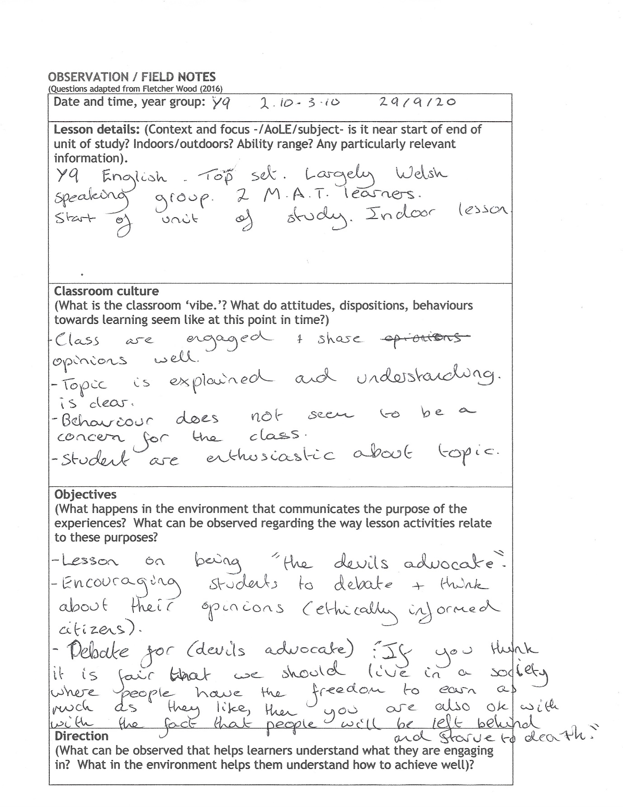
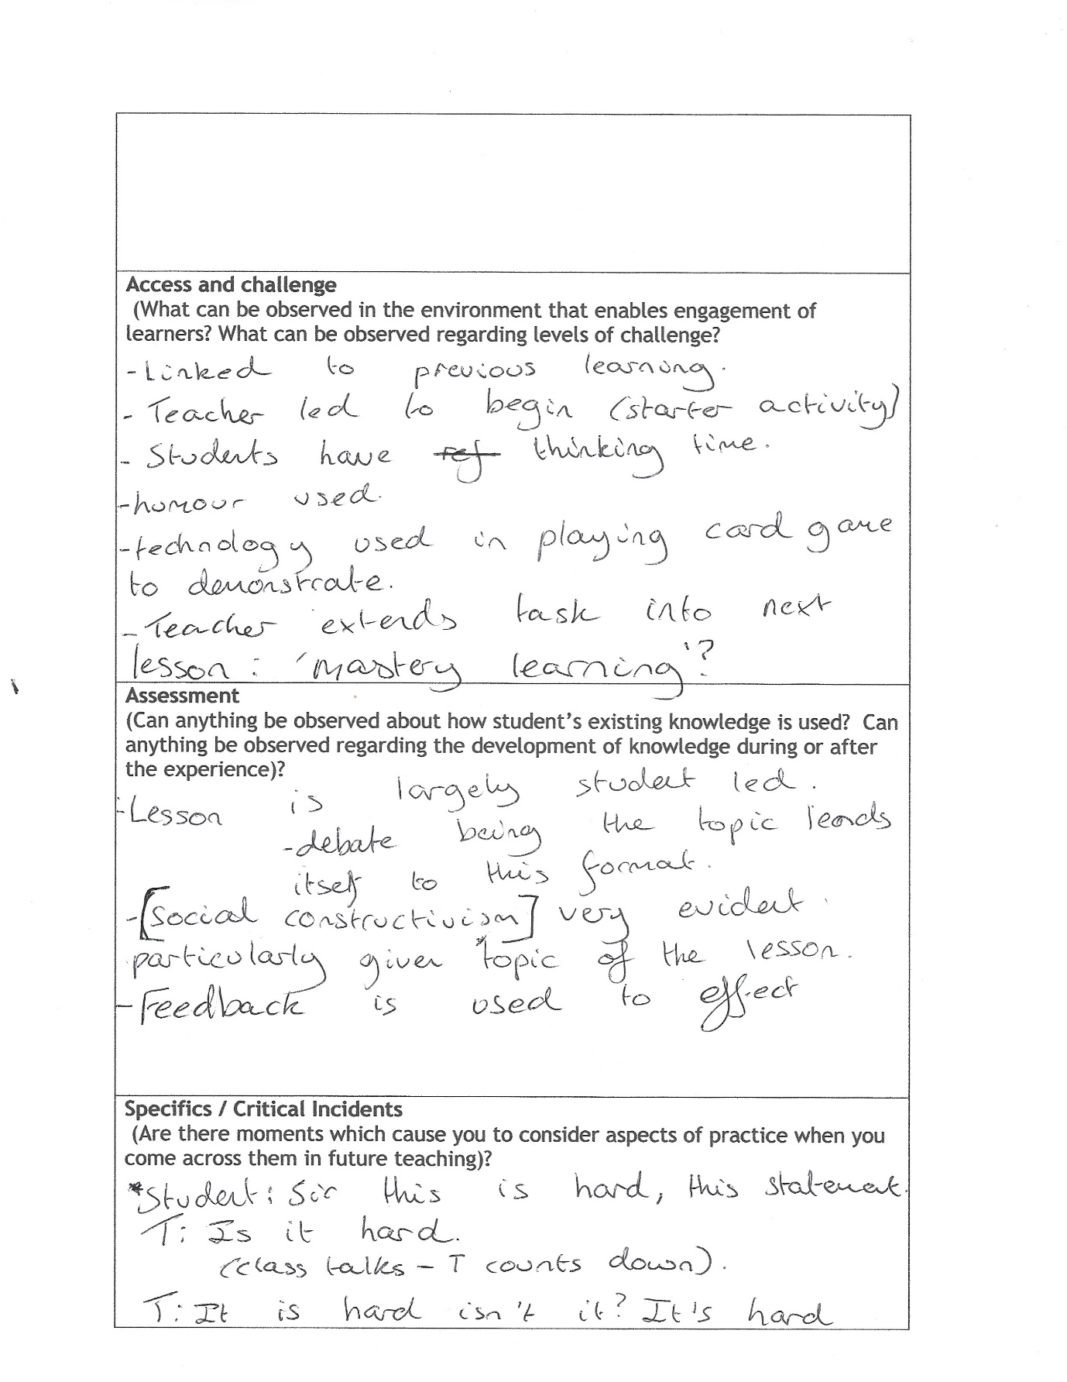
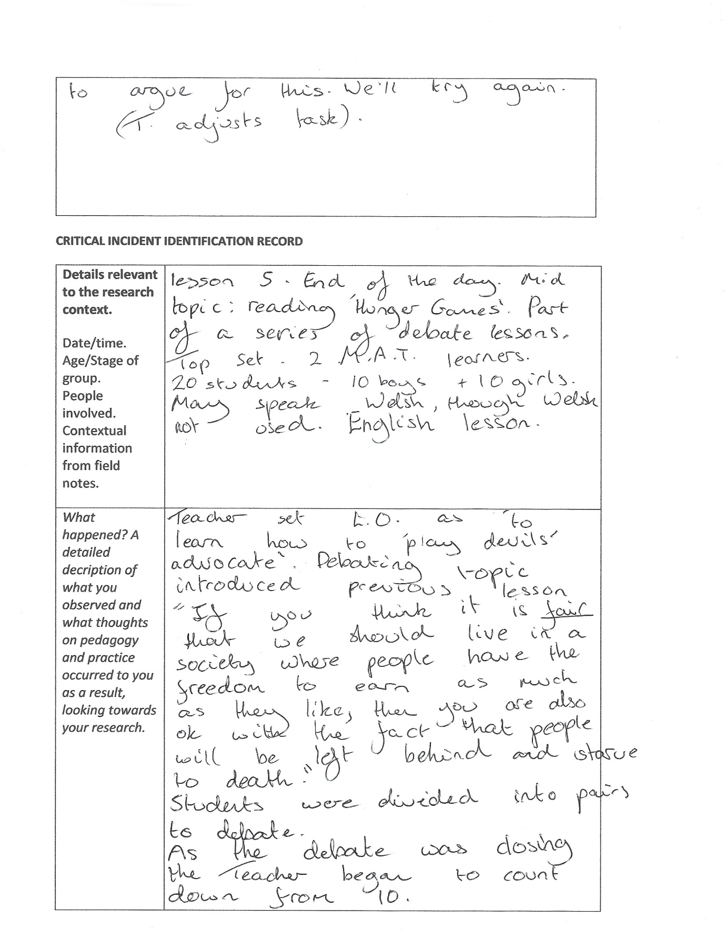
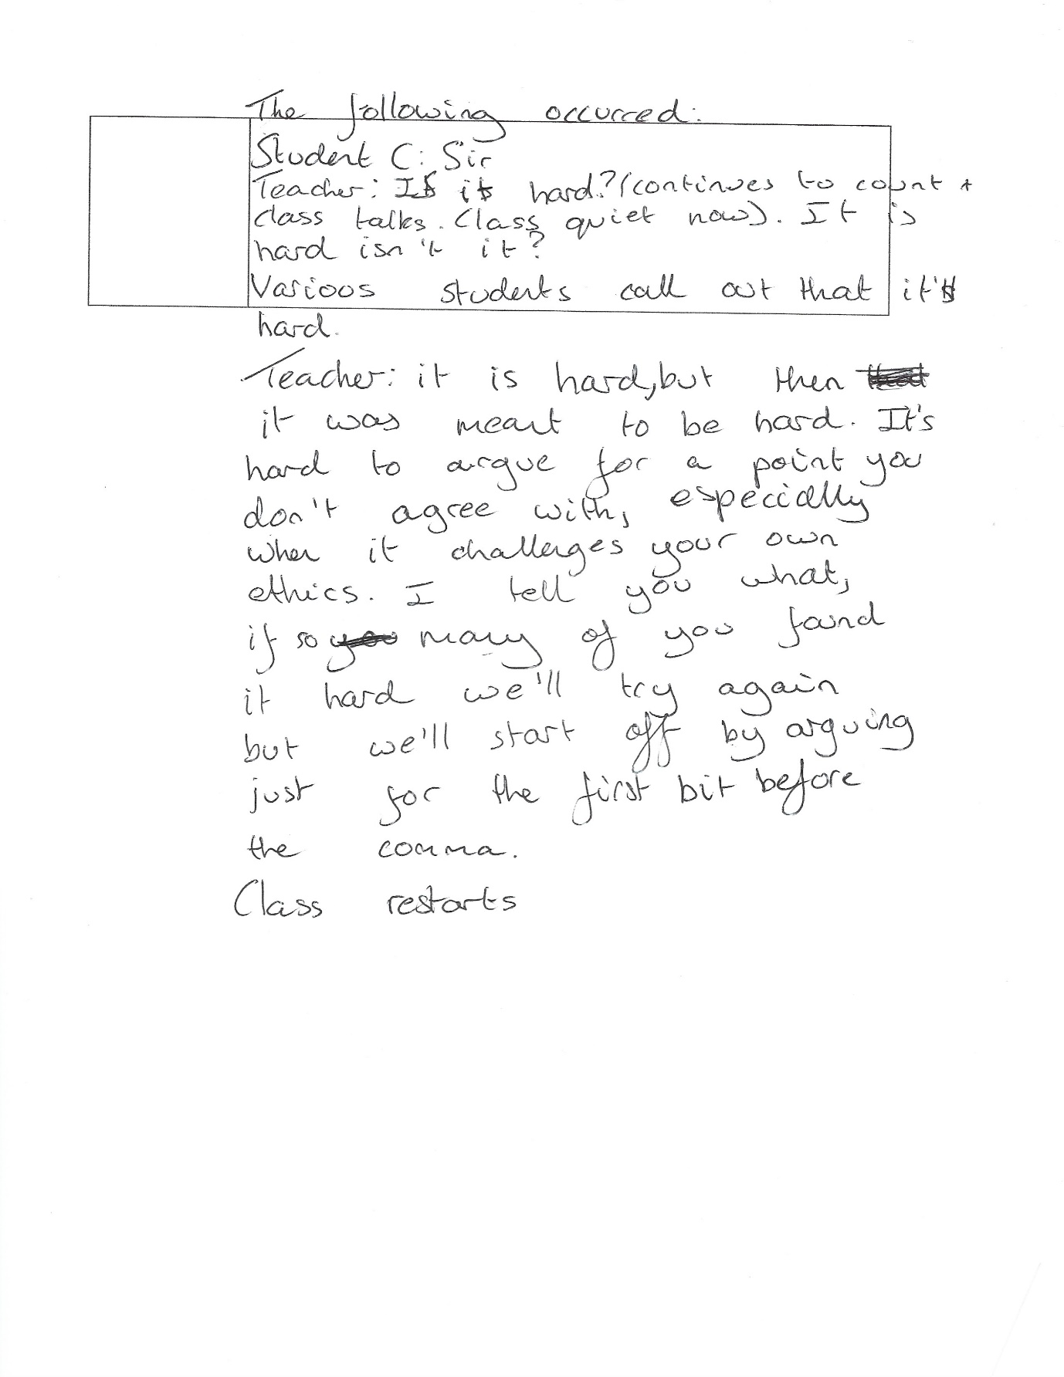

Appendix 2
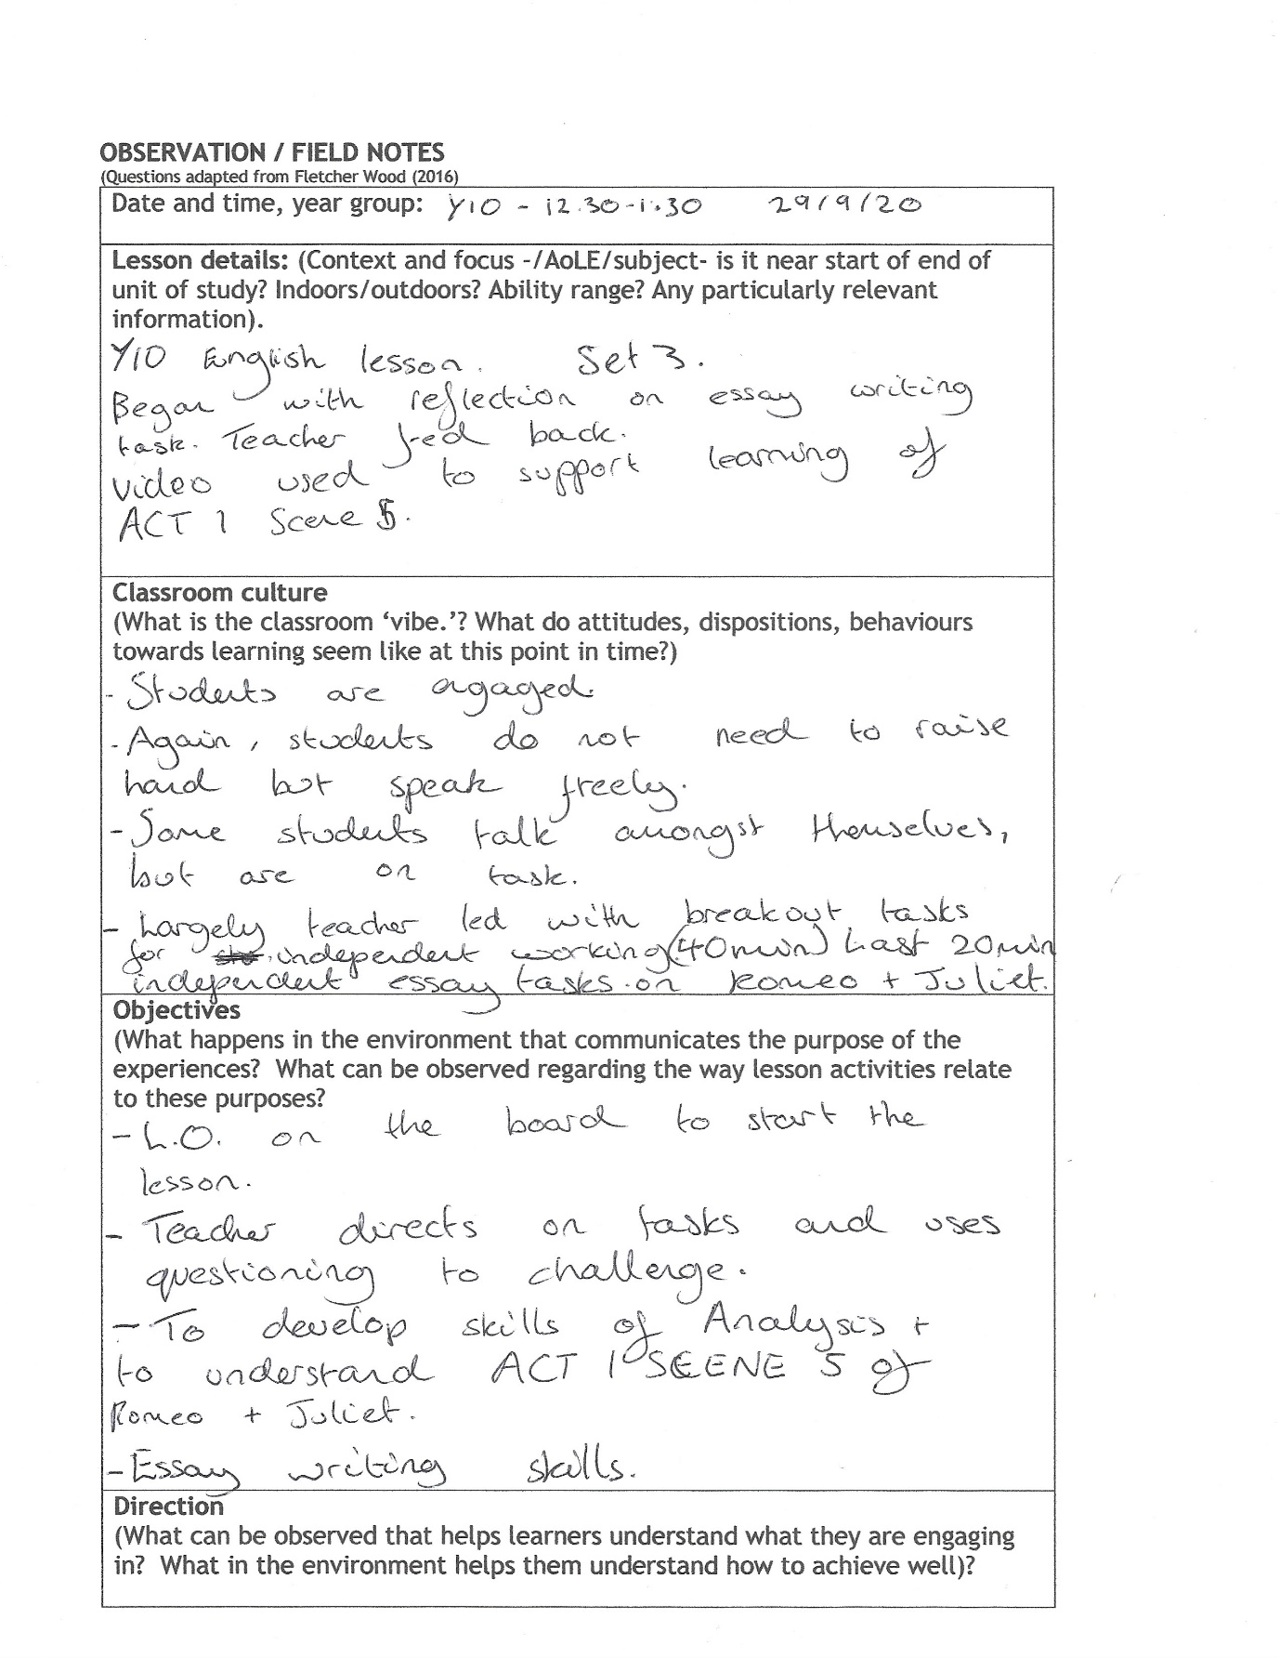
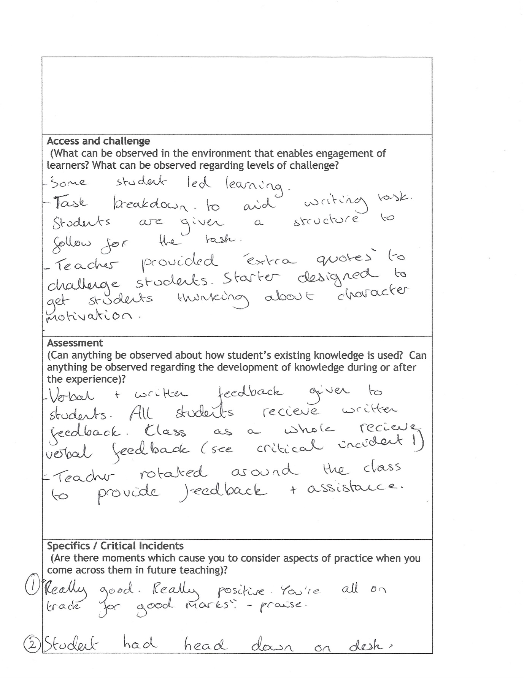
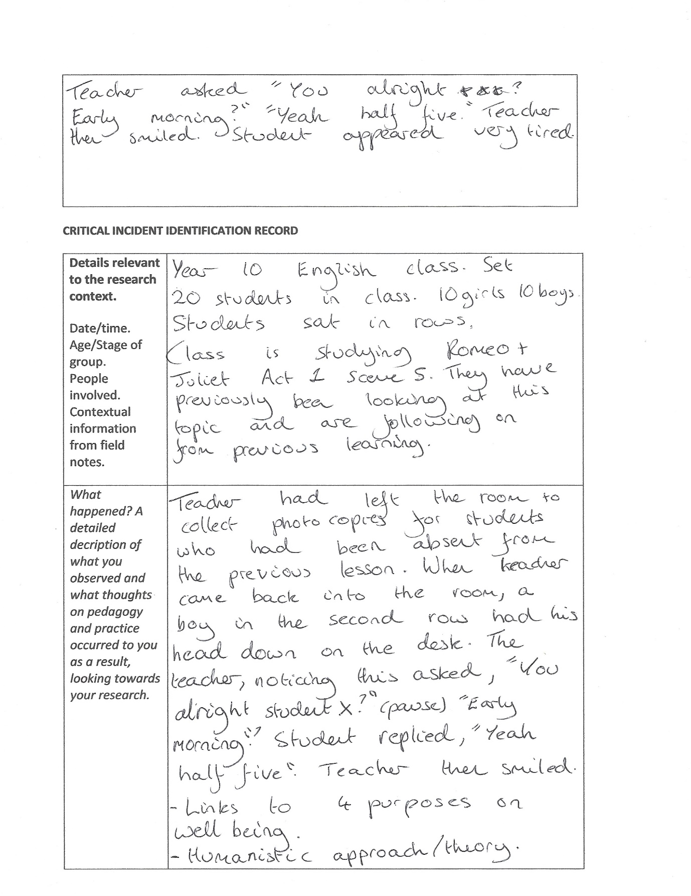
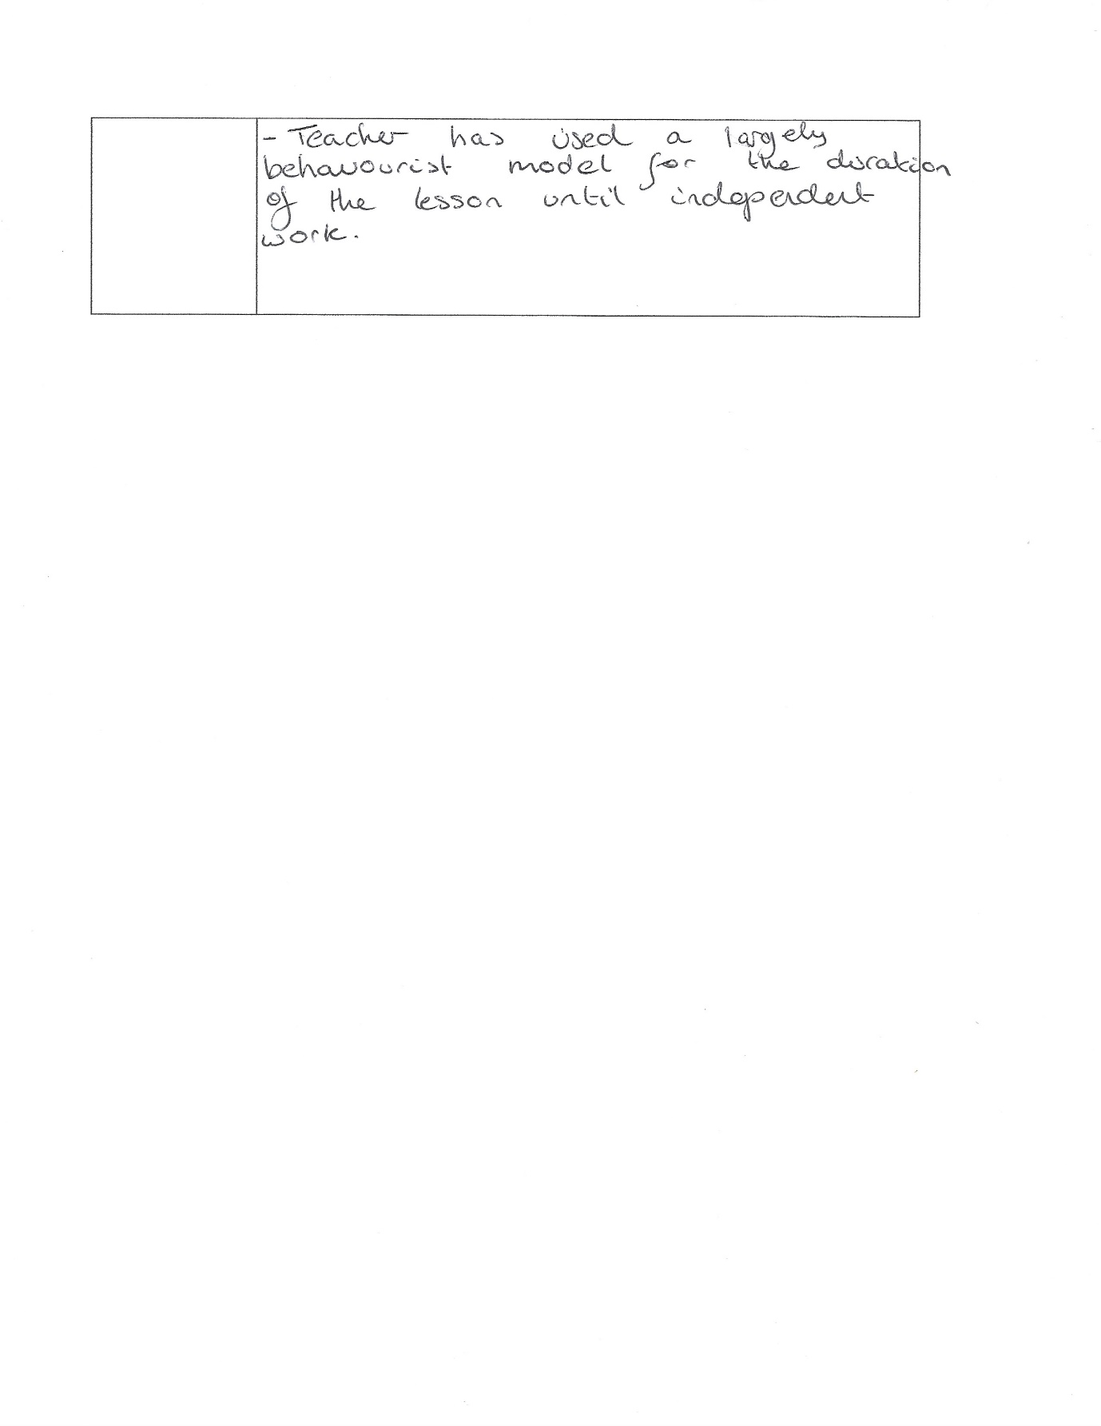

Appendix 3
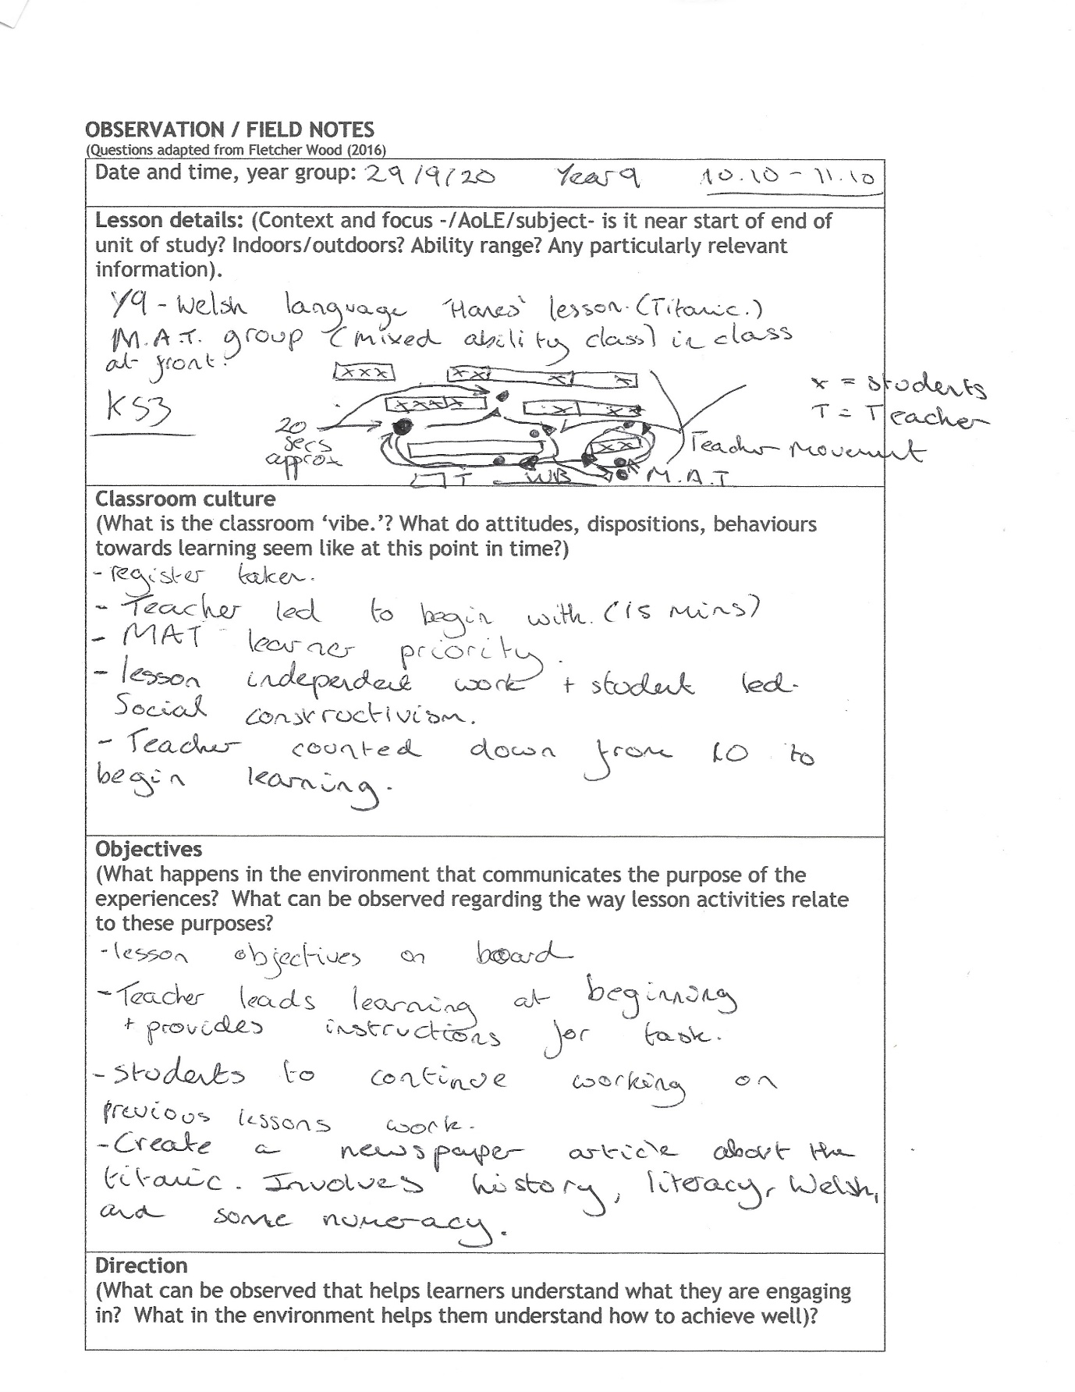
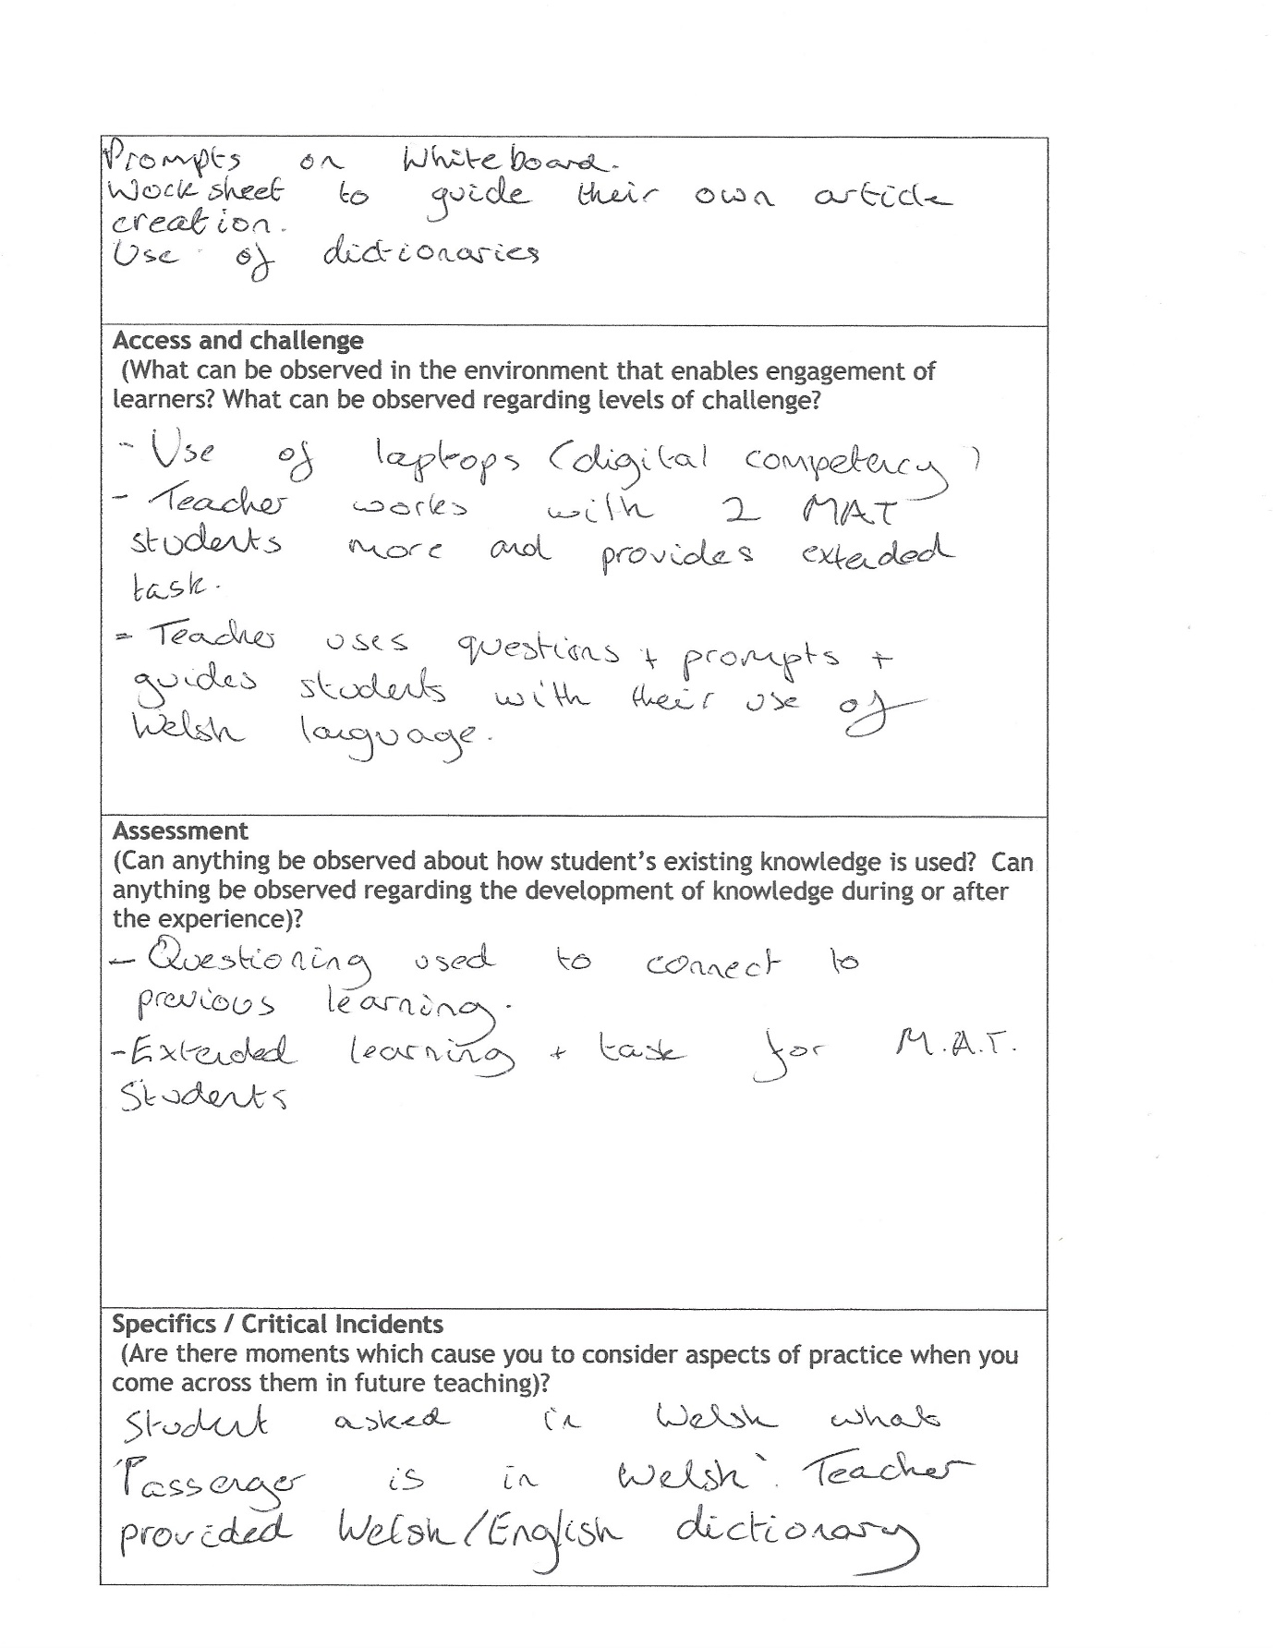

Appendix 4


