

Programme: | MSc Public Health and Social Care in Practice
Module: | Quality Assurance and Service Improvements
Module code: | LCHS7006
Assignment Title: | Component 2  Service Improvement Report
Lecturer: | Oluwadamilola Tayo
Student Name: | Bilkis Begum
Student ID: | 2432744

Table of Contents
1. Introduction 3
1.1 Background to NHS Maternity Services 3
1.2 Introducing the Recognised Issue with Quality and Safety 3
1.3 How Serious the Evidence Problem Is 3
1.4 Objectives and Goals of the Service Improvement Report 4
2. Examination of Systemic Quality and Safety Issues in Maternity Care 5
2.1 Overview of the Quality Concern in the Chosen Case Study 5
2.1.1 Governance and Safety Failure 5
2.1.2 A Review of the Key Points and Their Consequences 5
2.2 Application of Quality and Safety Theories 6
2.2.1 Pertinent Concepts of Quality Assurance and Service Enhancement 6
2.2.2 Critical Assessment of Their Appropriateness for the Case 6
2.3 Root Cause Analysis 7
2.3.1 Fishbone (Ishikawa) Diagram Analysis 7
2.3.2 5 Whys Findings 7
2.3.3 Application of the Donabedian Model (Structure, Process, Outcome) to the Maternity Case 8
2.4 Strategic Analysis 9
2.4.1 Examining the Maternity Service Context (PESTLE) 9
2.5 Overview of Principal Issues Preparation 10
2.5.1 Synthesis of Results Across All Models 10
2.5.2 Identifying Priority Areas for Enhancement 11
3. Recommendations 12
3.1 Identification of Service Improvements that are needed 12
3.2 The PDSA/PDCA Cycle for Implementation 12
3.3 Reducing Waste via the Use of Lean Principles 12
3.4 Six Sigma to Reduce Variation and Errors 13
3.5 Implementation Strategy: Actions, Responsibilities, and Oversight 13
4. Conclusion 15
4.1 Summary of Key Findings 15
4.2 Implications for Overall Quality Improvement 15
4.3 Maternity Service results anticipated impact 15
References 16

Title:
Enhancing Quality Assurance in Mid Staffordshire NHS Foundation Trust (UK)

1. Introduction

1.1 Background to NHS Maternity Services
In order to ensure that women and their families in the UK have access to safe and high-quality birthing experiences, the National Health Service (NHS) maternity services are crucial. The services' intricate healthcare system needs for strong government support, high-caliber clinical practises, and effective safety monitoring. Systematic quality control plays a crucial role in maternal health, as shown by the increasing emphasis on patient safety indicators and organised assessment systems (Labella et al., 2022). The best maternity units, according to further ethnographic research, contain critical safety features such supportive leadership cultures, strong communication, and teamwork (Liberati et al., 2021).

1.2 Introducing the Recognised Issue with Quality and Safety
There is still a lot of variation, even though national initiatives are trying to make maternity care safer and better. Several problems with NHS units have been linked to repeated failures in leadership, escalation, and following clinical standards. According to large-scale surveys, there are problems with the way improvement programs are being implemented, with monitoring being uneven, and with the dependability of reports being inconsistent (McGowan et al., 2024). Dissimilarities in safety cultures exacerbate these problems because they influence how incidents are reported, how teams work together, and how risks are managed (Noghrehchi et al., 2024). This means that maternity facilities are still seeing unnecessary injuries.

1.3 How Serious the Evidence Problem Is
These quality and safety concerns are significant because they have an effect on the outcomes for both mothers and new-borns. National studies have linked improper risk assessment, inadequate escalation, and gaps in clinical procedures to preventable death and morbidity (Young and Smith, 2022). Patient safety indicators are less effective due to weaknesses in structural conditions, such as personnel and training, according to safety monitoring systems (Labella et al., 2022). Similar findings are supported by global research demonstrating that a lack of a safety culture leads to subpar performance and an unpleasant experience for patients (Tenkorang-Twum et al., 2024).

1.4 Objectives and Goals of the Service Improvement Report
The selected maternity service is the focus of this service improvement study, which seeks to critically examine the reported underlying governance and safety problems. Organisational, cultural, and process-related factors that contribute to dangerous outcomes will be evaluated, and existing quality improvement frameworks will be used to determine the report's fundamental causes. Additionally, it seeks to provide evidence-based recommendations supported by analytical models in order to promote long-term improvement, strengthen care delivery, and increase the efficacy and safety of comprehensive maternity care.

2. Examination of Systemic Quality and Safety Issues in Maternity Care

2.1 Overview of the Quality Concern in the Chosen Case Study

2.1.1 Governance and Safety Failure
The chosen case study illustrates the presence of significant shortcomings in governance and safety in NHS maternity care, with recurring issues in clinical supervision, insufficient monitoring mechanisms, and poor organisational learning. Systemic issues with leadership competency, staff communication, escalation protocols, and adherence to evidence-based principles have been revealed time and time again in independent assessments and national inspections (Allen et al., 2020). One example is the Nottingham University Hospitals Trust, where the Care Quality Commission (CQC) found that the maternity services were dangerous. Among the many concerns raised by the CQC were the following: increasing delays, insufficient risk management procedures, and frequent foetal monitoring failures (Dyer, 2020). Management silos, uneven supervision, and a careless approach to safety are some of the governance flaws that these incidents illustrate in some English NHS maternity institutions.
Unhealthy practises have taken root due to a lack of effective governance systems. Clinical decision-making has been negatively impacted by ineffective communication among midwives, obstetricians, and neonatologists as a result of hierarchical organisational cultures. Some of the most prevalent causes of patient safety incidents, according to Adu and Zuma (2024), include blunders in communication and mistakes made by personnel. With the prevalence of obstetric crises, the ever-evolving field of maternity care is particularly vulnerable to the devastating effects of such failures. In addition, the service was unable to recognise escalating patterns of damage due to unfinished governance structures, divisions, inadequate incident reporting, and a failure to learn from previous mistakes (Darley et al., 2018). When taken as a whole, these voids show that the requirements for clinical safety and the frameworks for governance are quite different.

2.1.2 A Review of the Key Points and Their Consequences
Recurring adverse effects on mothers and new-borns, family complaints over a period of years, and warnings from regulatory bodies are the key aspects of the case study. According to Dyer (2020), the CQC inspection from 2018 to 2020 revealed a persistent issue with insufficient personnel, risk assessment work that was risky, and delays in managing issues. These incidents sparked nationwide probes and enquiries, which revealed that institutional culture contributed to the prevalence of failures rather than the exception (Bennett-Weston et al., 2025). There was a significant increase in maternal illness and preventable new-born death as a result, as well as a decline in patient satisfaction and severe damage to the Trust's credibility.
The occurrences also suggested consequences for the whole system. National objectives of safe delivery are undermined and public trust is damaged by low-quality maternity care, say Collins and Draycott (2015). Litigation, operational inefficiencies, and employee burnouts were monetary costs stemming from governance failures. Inefficiencies, adverse occurrences, and resource waste are the results of low-quality treatment, according to Chakraborty (2020), which places a financial strain on institutions. Hence, the maternity instance shows how governance problems, safety events, and organisational performance interact in complex ways.

2.2 Application of Quality and Safety Theories

2.2.1 Pertinent Concepts of Quality Assurance and Service Enhancement
Quality assurance in healthcare denotes the methodical protocols used to maintain and improve clinical standards, focusing on structure, processes, and results. Continuous quality improvement, person-centred care, and systems thinking theories emphasise the prior identification of hazards and the continual enhancement of care delivery (Crowe and Manley, 2019). The continuity of midwifery care and interdisciplinary collaboration are essential for delivering high-quality maternity services (Cbe, 2017). The service enhancement frameworks underscore the significance of measurement, feedback, and organisational learning. Contemporary quality assurance methods depend on structured instruments, such as statistical process control, root cause analysis, and audit cycles, among others (Alsahli et al., 2020).

2.2.2 Critical Assessment of Their Appropriateness for the Case
The erroneous application of the used theories reveals the disparities between the anticipated norms and the actual practices in the case study (Noghrehchi et al., 2024). The Donabedian model defines quality via structural dependability, effective processes, and good results; nevertheless, in the context of maternity care, inadequate leadership and insufficient staffing compromised care processes, resulting in adverse outcomes (Chen et al., 2024). Systems thinking highlights the need of fragmentation, with hierarchical dynamics contributing to systemic dangers rather than individual failures. Darley et al. (2018) assert that companies with limited improvement capacity often lack the cultural and structural foundations necessary for learning, aligning with the deficiencies noted in the case study. The failure to implement continuous monitoring, feedback, and evidence-based care signifies a gap between the idea of quality and practice.

2.3 Root Cause Analysis

2.3.1 Fishbone (Ishikawa) Diagram Analysis
The fishbone analysis identifies the many factors contributing to risky maternal practices.
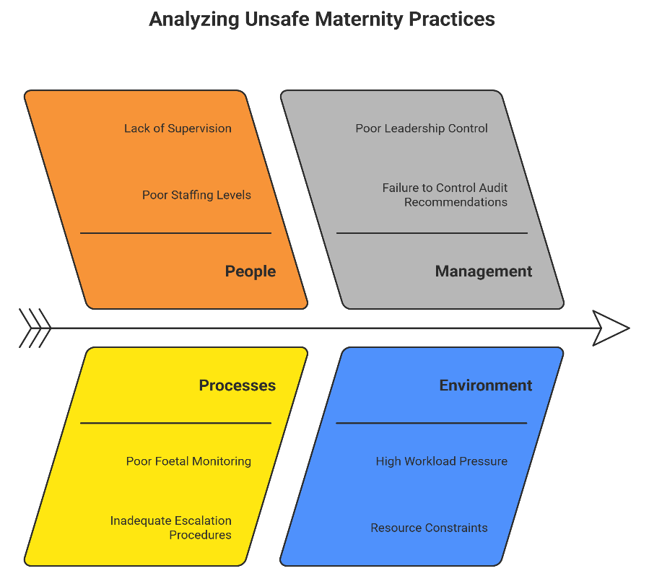
Figure 1: Fishbone (Ishikawa) Diagram Analysis (Author)
According to Adu and Zuma (2024), the personnel segment uncovered many problems, the most notable of which were insufficient staff numbers, improper management, and poor communication. Problems with procedures occurred because documentation protocols were lacking, escalation mechanisms were inefficient, and foetal monitoring was of poor quality. Inadequate leadership control and management's failure to monitor audit recommendations were also highlighted as management shortcomings. Rising demands on workers and limited resources were the environmental factors at play. The policy is undermined by clinical advice that are out of date and by deviation from NICE norms. Fishbone analysis is relevant here because, as Chang (2015) points out, it is useful for clarifying complex healthcare problems.

2.3.2 5 Whys Findings
The 5 Whys approach has been used to provide a comprehensive examination of the underlying systemic problems that contribute to hazardous maternal outcomes.
Why 1: What is the reason why unsafe outcomes take place?
Adverse events occurred because foetal distress was not adequately addressed in a timely manner during labour.

Why 2: Why did not foetal distress get escalated?
The absence of escalation occurred due to frequent misinterpretation of cardiotocography (CTG) data by personnel, resulting in delays in clinical decision-making (Adams et al., 2023).
Why 3: What was wrong with the interpretation of CTGs?
The absence of competence assessment, lack of opportunity for skill reinforcement, and inadequate and inconsistent training led to a misconception.
Why 4: What was the reason why there was insufficient training?
Insufficient training resulting from inadequate governance, ineffective management of educational programs, and a lack of allocated time for continuous professional development, which corresponds with the identified organisational weaknesses reported by maternity services (Alsahli et al., 2020).
Why 5: How come that governance structures were ineffective?
The deficiencies stemmed from the absence of acknowledgement, prioritisation, and action on performance indicators, incident patterns, and indications of inadequate safety culture growth by the leadership, which proved ineffectual.
This methodical inquiry enables the study to explore the fundamental root of the problem, beyond just individual therapeutic blunders. This indicates fundamental organisational deficiencies, including inadequate leadership, ineffective governance, and a deficient culture of learning and development. This underscores the need of institutional and cultural reforms necessary to mandate safe maternity practices.

2.3.3 Application of the Donabedian Model (Structure, Process, Outcome) to the Maternity Case
The model by Donabedian found structural concerns such as inadequate staffing ratios, insufficient training, and ineffective governance structures (Allen et al., 2020). The deficiencies in procedures included prolonged escalation times, inaccuracies in risk assessment, and inefficient multidisciplinary communication. All these structural and procedural deficiencies resulted in adverse outcomes, including more than expected infant morbidity. The research conducted by Chen et al. (2024) demonstrates that Donabedian's model remains a pertinent framework for understanding the conversion of structural deficiencies into adverse outcomes, and it is noteworthy that this model is applicable to the examination of maternal safety.

2.4 Strategic Analysis

2.4.1 Examining the Maternity Service Context (PESTLE)
Aspects of the external environment that are examined include political, economic, social, technological, environmental, and legal considerations.
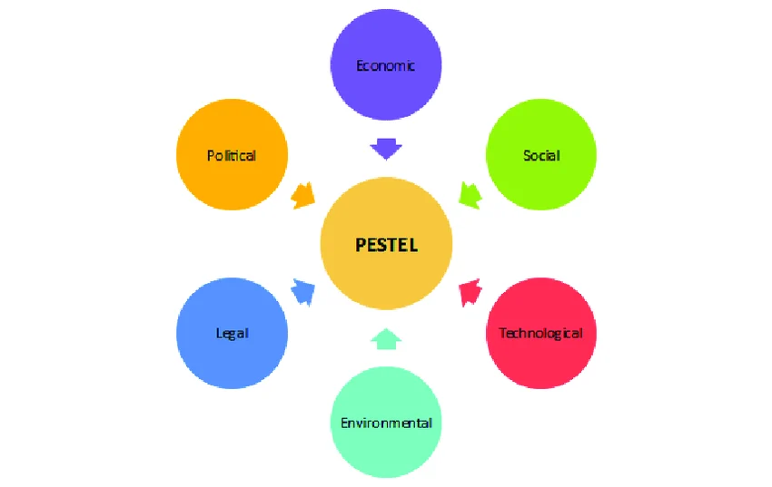
Figure 2: PESTLE Analysis (Dwyer et al., 2017)
Political
There is a lot of politics and regulation around maternity care, including inspections by the Care Quality Commission (CQC), NHS England's maternity safety standards, and policy shifts like Better Births. Failure to meet the requirements specified by such frameworks which include transparency in performance monitoring, accountability, and compliance reveals governance shortcomings (Allen et al., 2020).
Economic
Economic constraints on quality have a significant impact on maternity care. According to Saheb and Saheb (2024), limited funding makes it difficult to hire enough workers, provide enough training, and purchase the required equipment. In addition, the need of cost-effective safety measures is underscored by the fact that maternal negligence cases above 2.1 billion per annum place further financial strains on NHS budgets (Chakraborty, 2020).
Social

Changing demographics in the population, such as an ageing population and an increase in comorbidities, are adding complexity to maternity care (Sreedharan et al., 2024). The need for a system and trained staff that can accommodate patients' varied requirements is growing in response to societal demands for more individualised and considerate care (Crowe and Manley, 2019).
Technological
Technological advancements, such as telemedicine, electronic records, and digital monitoring, are revolutionising maternity care. These resources may reduce wait times for expert assistance and speed up the decision-making process. According to Fazal et al. (2020), telehealth has the potential to greatly improve access to maternal health advice and continuity of treatment.
Legal
Important legal factors include protecting individuals, meeting protection criteria, and reporting as required by law (Tenkorang-Twum et al., 2024). Organisations risk liability, regulation, and public disapproval due to noncompliance. Dwyer et al. (2017) found that dangerous practises were directly caused by failures in legal compliance.
Environmental
Chronic understaffing, an excessive amount of work, and frequent staff burnout are the root causes of the unfavourable working circumstances. Under these circumstances, teams are less able to stay coordinated and make good judgements because situational awareness is low. There is mounting evidence linking the horrendous working conditions to the regular occurrence of safety incidents in the maternity ward (Darley et al., 2018).

2.5 Overview of Principal Issues Preparation

2.5.1 Synthesis of Results Across All Models
All analytical models indicate a systemic failure in leadership, communication, workforce competence, and process reliability (Young and Smith, 2022). The Fishbone diagram and the 5 Whys technique expose deficiencies in organisational culture and governance. Donabedian elucidates how inadequate structural conditions (staffing, training, governance) result in deficient procedures and adverse consequences. The PESTLE study highlights external forces that increase operational risks, necessitating responsive governance and adaptive service design. The integration of the models reveals that safety failures are attributable not to an isolated clinician mistake, but rather to organisational dysfunction.

2.5.2 Identifying Priority Areas for Enhancement
Priorities include enhancing governance control, improving staff competency in foetal monitoring and escalation, fostering communication among multidisciplinary teams, adhering to national rules, and establishing effective feedback and audit procedures (Adams et al., 2023). Such locations adhere to the guidelines of national maternity safety, serving as a foundation for ongoing service enhancement.

3. Recommendations

3.1 Identification of Service Improvements that are needed
The findings of the root cause analysis should guide efforts to enhance services by fixing the underlying problems with systems and procedures. Some of the main treatments include making government more accountable, building a competent staff, improving acceleration mechanisms, creating standardised clinical paths, and fostering a culture of lifelong learning. Transparent leadership, increased interdisciplinary interaction, and comprehensive data monitoring are essential for a sustainable transition to take place.

3.2 The PDSA/PDCA Cycle for Implementation
An iterative and structured approach to testing and improving service modifications is the PDSA cycle. If the maternity service wants to cut in half the amount of CTG interpretation mistakes in six months, for instance, it should do it by identifying such areas of improvement at the Plan stage. It is important to collect baseline data that can guide interventions. New documentation templates, escalation protocols, or training modules must be piloted in a single maternity unit as part of the Do step (Bennett-Weston et al., 2025). During the research phase, we will measure the pilot results, look for variations, and evaluate the obstacles to deployment. Finally, during the "Act" phase, the effective interventions should be formalised and expanded in additional units. According to Alsahli et al. (2020), iterative circles increase adaptability and provide treatments with evidence.

3.3 Reducing Waste via the Use of Lean Principles
The three main goals of lean methodology are improving flow, reducing waste, and providing more value to customers. Duplicate data, pointless waiting, and postponed decision-making are some of the non-value-adding elements in the patient experience that are identified during the implementation of Lead to maternity services. Using lean process planning, we may optimise the usage of the theatres, reduce bottlenecks, and simplify the triage paths. Particularly relevant to high-pressure maternal contexts are the operational efficiency and safety culture that Lean methodologies promote (Geedey, 2015). Standardisation of procedures, use of visual management tools, and reduction of variance in care processes all contribute to increased reliability.

3.4 Six Sigma to Reduce Variation and Errors
Six Sigma aims to reduce faults and variability using the DMAIC (Define-Measure-Analyze-Improve-Control) framework (Liberati et al., 2021).
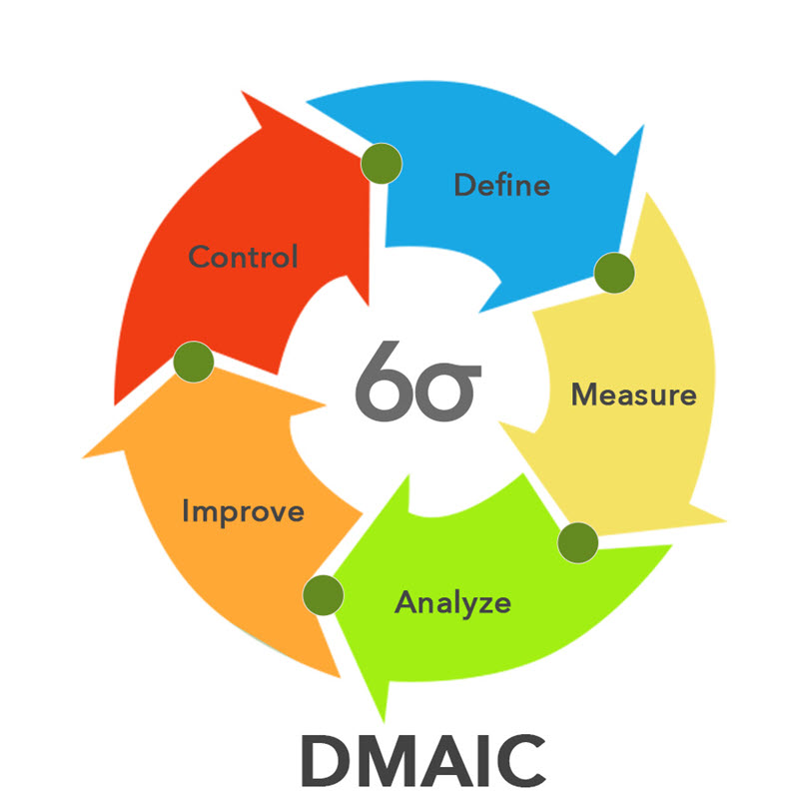
Figure 3: Six Sigma Methodology (Gullick et al., 2019)
Instances of deficiencies in maternity care include erroneous interpretation of CTG, delayed escalation of treatment, and inadequate risk assessment. The Define phase must establish measurable targets, like reducing the incidence of CTG-induced accidents by fifty percent. The Measure step entails meticulous data collection, whereas the Analyse stage identifies the fundamental reasons of variance, consistent with the findings of the Fishbone diagram. The improve phase entails the implementation of targeted interventions, such as competency-based training or decision-support systems (Demirkesen, 2021). The final Control step involves sustainability via audit cycles and performance dashboards. The data-driven methodology of Six Sigma enhances the PDSA cycles via statistical rigour.

3.5 Implementation Strategy: Actions, Responsibilities, and Oversight
According to Liu et al. (2024), a successful implementation requires well-defined leadership responsibilities, participation from several disciplines, and ongoing monitoring. Regular safety walks, risk assessments, and transparent reporting are all ways in which leadership teams may help enhance governance. Clinical educators are responsible for developing organised training programs for obstetricians and midwives, which should include mandatory competence exams. The audit teams should monitor compliance with the policy on escalation and guidelines, and create dashboards once a month to record the progress (McGowan et al., 2024). Incorporating feedback loops via incident reports, learning sessions, and time-periodic assessments against quality indicators is necessary to continue the progress. To further enhance communication and access to expert support, telehealth technologies might be used, as described in the paper by Fazal et al. (2020). An organization's long-term commitment to a culture of safety and accountability depends on its ability to maintain interventions in line with national requirements and organisational goals.

4. Conclusion

4.1 Summary of Key Findings
Our conversation has demonstrated that governance issues, inadequate staffing, ineffective escalation procedures, and uneven compliance with clinical standards are the main causes of poor maternal outcomes. Consistent with previous studies on how organisational deficiencies determine care quality, root cause analysis revealed significant structural and procedural inadequacies (Gullick et al., 2019). Concerns about patient safety and reported experiences were also highlighted in the case study (Gyapong, n.d.). These findings, taken as a whole, show that maternal failures are more often the consequence of systemic issues than of isolated cases of clinical mistake.

4.2 Implications for Overall Quality Improvement
The findings highlight the critical need for improved oversight, safe therapeutic practices, and established monitoring mechanisms. Following the recommendations made by Johnson (2017), the areas that need to be improved in terms of quality should center on the competence of the staff, the channels of communication, and the protocols for escalating situations based on evidence. In order to improve maternity safety, it is essential to have audit cycles, leadership responsibility, and continuous learning, according to national observations on maternal morbidity reviews (Knight et al., 2016). In order to address systemic flaws and promote a lasting safety culture, it is essential to implement comprehensive improvement initiatives across the whole organization.

4.3 Maternity Service results anticipated impact
It is anticipated that the proposed treatments, when put into practice correctly, would lead to a reduction in avoidable harm, an improvement in clinical decision-making, and the reinforcement of interprofessional cooperation. Systematic monitoring and data-driven improvement cycles will strengthen the system of governance, which in turn will encourage more consistent adherence to evidence-based practices. Consistent with previous studies, the aforementioned enhancements will lead to better care procedures and outcomes as structural capacity becomes stronger (Gullick et al., 2019). In conclusion, these actions will be implemented to improve the health of mothers and their newborns, boost public trust, and strengthen services throughout time.

References
Adams, M., Hartley, J., Sanford, N., Heazell, A.E., Iedema, R., Bevan, C., Booker, M., Treadwell, M. and Sandall, J. (2023). Strengthening open disclosure after incidents in maternity care: a realist synthesis of international research evidence. BMC Health Services Research, 23(1). doi: https://doi.org/10.1186/s12913-023-09033-2.
Adu, G., and Zuma, S. M. (2024). Contributory factors related to patient safety incidence: A nursing perspective. Health SA Gesondheid, 29, 2296.
Allen, T., Walshe, K., Proudlove, N., and Sutton, M. (2020). The measurement and improvement of maternity service performance through inspection and rating: an observational study of maternity services in acute hospitals in England. Health Policy, 124(11), 1233-1238.
Alsahli, S. S., Almalki, M. H. M., Alkhathami, A. M., Alharbi, A. A., Alhawit, M. E., Albalawi, K. I., ... and Binselm, K. R. A. Quality Improvement and Patient Safety: Strategies and Challenges in Healthcare System Transformation. International journal of health sciences, 4(S1), 478-497.
Bennett-Weston, A., Ward, A., Burnett, D., Hogg, J., Knight, R. and Howick, J. (2025). A Complex Intervention to Introduce a Culture of Empathy within Maternity Services: Addressing Individual, Team, and System-Level Factors. [online] doi: https://doi.org/10.2139/ssrn.5185426.
Bamford-Wade, A., Lavender, S., Massey, D., Anderson, V., Clayton, S., and Johnston, A. (2020). A case study-Implementing a registered nurse professional recognition program across a Queensland hospital and health service. Nurse education in practice, 42, 102689.
Cbe, J. S. (2017). The contribution of continuity of midwifery care to high quality maternity care. The Royal Collage of Midwive.
Chakraborty, S. (2020). Healthcare quality and hospital financial performance: A multilevel framework. Operations and Supply Chain Management: An International Journal, 13(3), 233-243.
Chang, H. (2015). Evaluation framework for telemedicine using the logical framework approach and a fishbone diagram. Healthcare informatics research, 21(4), 230-238.
Chen, C. C., Hsiao, C. T., Chang, D. S., and Lai, W. C. (2024). The delivery model of perceived medical service quality based on donabedian's framework. The Journal for Healthcare Quality (JHQ), 46(3), 150-159.
Collins, K. J., and Draycott, T. (2015). Measuring quality of maternity care. Best practice and research clinical obstetrics and gynaecology, 29(8), 1132-1138.
Crowe, C., and Manley, K. (2019). Person-centred, safe and effective care in maternity services: the need for greater change towards best practice. International Practice Development Journal, 9(1).
Demirkesen, S. (2021). From Lean Manufacturing to Lean Construction: How Principles, Tools, and Techniques Evolved. Lean Manufacturing. doi: https://doi.org/10.5772/intechopen.96191.
Darley, S., Walshe, K., Boaden, R., Proudlove, N., and Goff, M. (2018). Improvement capability and performance: a qualitative study of maternity services providers in the UK. International Journal for Quality in Health Care, 30(9), 692-700.
de Oliveira Salgado, H., Souza, J. P., Sandall, J., and Diniz, C. S. G. (2017). Patient safety in maternity care in Brazil: the maternity safety thermometer as a tool to improve the quality of care. Revista Brasileira de Ginecologia e Obstetrícia/RBGO Gynecology and Obstetrics, 39(05), 199-201.
Dwyer, T., Craswell, A., Rossi, D., and Holzberger, D. (2017). Evaluation of an aged care nurse practitioner service: quality of care within a residential aged care facility hospital avoidance service. BMC health services research, 17(1), 33.
Dyer, C. (2020). Nottingham trust must urgently improve “unsafe” maternity services, says CQC. BMJ: British Medical Journal (Online), 371, m4726.
Elmore, K. (2021). Outpatient Perioperative Care Quality and Efficiency: Factors Contributing to Day of Surgery Cancellations. Xavier University.
Fazal, N., Webb, A., Bangoura, J., and El Nasharty, M. (2020). Telehealth: improving maternity services by modern technology. BMJ open quality, 9(4), e000895.
Geedey, N. M. (2015). Lean and Six Sigma Impact on Operating Room Safety Attitudes and Efficiency. Gardner-Webb University.
Gullick, J., Lin, F., Massey, D., Wilson, L., Greenwood, M., Skylas, K., ... and Gill, F. J. (2019). Structures, processes and outcomes of specialist critical care nurse education: an integrative review. Australian Critical Care, 32(4), 331-345.
Gyapong, P. Examination of Patient Safety and Experience in Ghanaian Healthcare Facilities.
Gyapong, P. Examination of Patient Safety and Experience in Ghanaian Healthcare Facilities.
Johnson, J. (2017). Background of Quality Improvement. Quality and Safety in Nursing: A Competency Approach to Improving Outcomes, 109.
Knight, M., Acosta, C., Brocklehurst, P., Cheshire, A., Fitzpatrick, K., Hinton, L., ... and Shah, A. (2016). Beyond maternal death: improving the quality of maternal care through national studies of ‘near-miss’ maternal morbidity. Programme grants for applied research, (9).
Labella, B., De Blasi, R., Raho, V., Tozzi, Q., Caracci, G., Klazinga, N. S., and Carinci, F. (2022). Patient safety monitoring in acute care in a decentralized national health care system: Conceptual framework and initial set of actionable indicators. Journal of Patient Safety, 18(2), e480-e488.
Liberati, E. G., Tarrant, C., Willars, J., Draycott, T., Winter, C., Kuberska, K., ... and Dixon-Woods, M. (2021). Seven features of safety in maternity units: a framework based on multisite ethnography and stakeholder consultation. BMJ quality and safety, 30(6), 444-456.
Liu, M., Qingyuan, Y. U., and Liu, Y. (2024). Developing quality indicators for cancer hospitals in China: a national modified Delphi process. BMJ open, 14(4), e082930.
McGowan, J., Attal, B., Kuhn, I., Hinton, L., Draycott, T., Martin, G. P., and Dixon-Woods, M. (2024). Quality and reporting of large-scale improvement programmes: a review of maternity initiatives in the English NHS, 2010–2023. BMJ Quality and Safety, 33(11), 704-715.
Noghrehchi, P., Hefner, J. L., and Walker, D. M. (2024). The relationship between hospital patient safety culture and performance on Centers for Medicare and Medicaid Services value-based purchasing metrics. Health care management review, 49(4), 281-290.
Saheb, T., and Saheb, T. (2024). Digital health policy decoded: Mapping national strategies using Donabedian's model. Health Policy, 147, 105134.
Sreedharan, J., Subbarayalu, A. V., Kamalasanan, A., Albalawi, I., Krishna, G. G., Alahmari, A. D., ... and MacDonald, J. (2024). Key performance indicators: a framework for allied healthcare educational institutions. ClinicoEconomics and Outcomes Research, 173-185.
Tenkorang-Twum, D., Atibila, F., and Gyapong, P. (2024). Examination of Patient Safety and Experience in Ghanaian Healthcare Facilities. Ghana Journal of Nursing and Midwifery, 1(2), 21-30.
Young, M., and Smith, M. A. (2022). Standards and evaluation of healthcare quality, safety, and person centered care.

