

Client Letter

Evan Davies

Submission date: 23/01/2024

Table of Contents

Page

- Introduction 1

- Letter to Client 2 – 4

- Appended Level of Information Needs 5 – 9

3.1) Stage 0 – Strategic Definition 6

3.2) Stage 1 – Preparation and Briefing 6

3.3) Stage 2 – Concept Design 6 – 7

3.4) Stage 3 – Spatial Co-ordination 7

3.5) Stage 4 – Technical Design 7 – 8

3.6) Stage 5 – Manufacturing and Construction 8

3.7) Stage 6 – Handover 8 - 9

3.8) Stage 7 – Use 9

- Appendices

4.1) Appendix 1 - BIM maturity model 10

4.2) Appendix 2 - Level of Model Detail and Level of Model 11
Information

4.3) Appendix 3 - Specimen Product and delivery Table for CIC 12
BIM protocol, which demonstrates the use of LOD, which is
linked to APM
rather than RIBA

4.4) Appendix 4 - RIBA Plan of Work 2020 13

- References / Reading List

- Introduction

According to the UK BIM Framework (2023) Building Information Modelling (BIM) is a way to create and manage digital information about a project throughout its construction and life cycle, by

“getting benefit through better specification and delivery of just the right amount of information concerning the design, construction, operation and maintenance of buildings and infrastructures, using appropriate technologies”.

UK BIM Framework (2023)

BIM also encompasses how the building can be decommissioned and provides a complete digital model of the project for all those involved, allowing them to update and improve at key stages.

A letter will be created (Section 2), which will demonstrate the understanding of the UK BIM Framework in relation to the delivery of a ‘state of the art’ infant school in Port Talbot in collaboration with the Welsh Government, under the Sustainable Communities for Learning Programme. It will provide details on how information will be shared, co-ordinated and manged for the duration of the project and into the operational stage, making sure to make reference to international standard ISO 19650 and the use of a BIM Execution Plan (BEP). It will also address the requirement for the whole life monitoring of the asset through a Computer Aided Facility Management (CAFM) system.

An appendix to the letter (Section 3), will explain the client’s level of information required through an Level of Definition (LOD) and Level of Information (LOI) format highlighting the difference through the RIBA stages of a project.

- Letter to Client

ED Construction Ltd
Plaindealings West
Hayscastle
Haverfordwest
Pembrokeshire
SA62 5QD

12 January 2024

Gavin Traylor
New School Buildings Manager
Neath Port Talbot County Council
Civic Centre
Port Talbot
SA13 1PJ

Dear Gavin

Project Number: 5010
Complying with the UK Building Information Modelling (BIM) Framework

I write with reference to your recent communication regarding our successful appointment as the “lead appointed party for construction” in relation to the above project, namely the creation of the new cutting edge infant school, ‘Ysgol Yr Afan’, which will provide accommodation for 90 full time and 48 part time pupils. We are delighted to be working with you again and plan to cement our relationship further over the duration of this project.

Our dedicated team of highly skilled and experienced professionals have effectively implemented BIM Level 2 on numerous occasions and have successfully transitioned to the UK BIM Framework, which provides a consistent approach to information management at both a national and international level. The UK BIM Framework incorporates ISO 19650 guidance and principles, which supersedes the previous British standards and publicly available specifications and has replaced the previously known BIM Level 2 maturity (Appendix 1).

We are industry leaders who bring a wealth of qualifications and experience, which have been outlined in our pre-employment BIM Execution Plan (BEP). The pre-employment BEP also covered our capability and capacity to comply with the UK BIM Framework / ISO 19650. We pride ourselves on being informed and having the ability to make timely decisions, whilst providing information that is sufficient to satisfy the need, but not too detailed to waste resource. We work transparently and collaboratively, demonstrating mutual understanding and trust ensuring that information requirements will be met to enable project progression. Our team will strictly adhere to the requirements of the UK BIM Framework incorporating ISO 19650, allowing for the management of information through the project lifecycle. In doing so, we will ensure that the resource is managed consistently and shared seamlessly across all stakeholders.

We benefit from having worked with the Lead Appointed Parties for Architecture, Project Management and Engineering on other projects such as the Golden Grove School New Build in 2019 and the Haverfordwest High School New Build in 2022.

Our IT infra-structure supports collaborative, cross-sector working. All of the shared project resources will be held within the Bentley Systems UK Ltd Common Data Environment (CDE), which supports the information management process in ISO 19650-2. The CDE will be the central hub for storing and managing all project related data, ensuring accessibility and accountability for all stakeholders. Our in-house CDE has been tested and seamlessly connects to the Bentley CDE. Procedures for testing and developing are also in place which allow for the consistent production and sharing of information.

In line with Welsh Government requirements, the common file type used for this project will be Construction Operations Building Information Exchange (COBie) which will allow for interoperability and the ouput of compliant information to Computer Aided Facility Management (CAFM) software at the agreed information exchange stages throughout the lifecycle of the project.

In my role as the Construction Team BIM Manager, I will assume overall responsibility for co-ordinating the creation and management of the Construction Team BIM and associated information throughout the construction process. I will act as the main point of contact for BIM related issues for the construction team and for the subcontractors, design team and other stakeholders as required. I have overall responsibility for the Construction Team BIM and have established protocol software for the efficient delivery of the project. I will communicate with the Design Team BIM Manager to co-ordinate the data extraction required by construction trades and ensure that these requests are met. In addition, I will collaborate with the design team and commissioning agent to ensure completeness of COBie information. Information sharing, co-ordination and management will be paramount throughout the project’s duration. I will attend the regular BIM co-ordination meetings and risk reduction meetings where any issues can be addressed and progress can be reviewed in order keep the project on track. The company is fully committed to openness and collaboration through the use of advanced BIM tools and platforms that support real-time collaboration, reducing the risk of errors and enhancing decision making.

All construction project team members hold relevant professional qualifications in addition to being Autodesk Certified. You can be assured that our internal training programmes are robust and well attended. This combined with attendance at industry conferences allows us to ensure continuous improvement in BIM skills and knowledge. We are committed to staying abreast of technical innovations and making strides on our journey of digital transformation.

We are now a position to collaborate with yourselves and other appointed parties to agree key responsibilities and finalise the post-contractual BIM Execution Plan (BEP). The BEP includes the refined Higher Level Responsibility Matrix, which details what information is to be produced, when and by whom, in the form of specified information, data drops, level of information need, originators and model uses. It allocates responsibility for the delivery of the models and level of accuracy required.

Our master information delivery plan (MIDP) has been compiled, which encompasses the task information delivery plans (TIDPs) generated by each task team and clarifies what will and will not be delivered as part of the project scope and highlights task team members’ responsibilities for storing and maintaining project resource in a secure stable location within our organisation before making the resource available to the project team via the CDE at the agreed information exchange intervals. All staff are fully competent in use of file name conventions required in accordance with ISO 19650-2 and the BEP.

The BEP also includes the list of agreed targets for the timely delivery, exchange, reuse and final handover to yourselves. Once agreed and signed off, the relevant information will be clearly communicated to each member of our delivery team so that everyone has a firm understanding of their individual requirements.

As requested, I have appended the client level information required through an Level of Definition (LOD) and Level of Information (LOI) format, highlighting the difference through the RIBA stages of a project.

We, as a company are looking forward to working with you on another successful project.

I looking forward to hearing from you shortly.

Yours sincerely

Evan Davies
Managing Director
ED Construction Ltd

- Appended Level of Definition (LOD) and Level of Information (LOI)

There is often confusion over the acronym LOD. The American Institute of Architects refer to LOD as ‘Level of Development’ whereas in the UK, LOD is defined as ‘Level of Definition’. Level of Definition (LOD) is used to describe “the level of geometric detail and the level of information” (Welsh Government, 2022). Level of Model Detail (LOD) and Level of Model Information (LOI) can be found in Appendix 2
An example of LOD can be found in Appendix 3, Specimen Product and delivery Table for CIC BIM protocol, LOD being linked to APM rather than RIBA. This has led to the need for a clearer framework, namely the Level of Information Need framework within ISO 19650. To refrain from confusion, Level of Information Need should not be abbreviated (lBS EN ISO 19650 Guidance Part 2, Ed. 4, 2020, p. 75).

“The level of information need is a framework to define the quality, quantity and granularity of information requirements.” (lBS EN ISO 19650 Guidance Part 2, Ed. 4, 2020, p. 75). This standardised approach ensures that design information is consistently produced at an appropriate level of detail for each project stage ensuring efficiency, not too much to have waste, or too little to comprise the project.
The RIBA Plan of Work was a key reference used by architects to detail the stages of a construction project from inception to completion. In 2013, it had been adapted to incorporate BIM technologies, which aligned to the shift towards digital construction methods. (RIBA, 2013). It is now currently defined as a design and process management tool and is utilised by the UK construction industry as a whole. It comprises of 8 stages, designed to work together to inform briefing, design, construction, handover and use of a building. (RIBA, 2020). Both the RIBA Plan of Work (Appendix 4) and UK BIM Framework are interconnected elements in the context of building design and construction.
A BIM overlay on the RIBA stages ensures a collaborative and data-rich approach to design and construction and allows for the alignment of information exchanges at completion of each work stage. Find overleaf the client’s level of information needed at each RIBA stage with BIM integration.

3.1) Stage 0 – Strategic Definition
This is where “the best means of achieving the client requirements is confirmed”. (RIBA, 2020, p.40). There is more emphasis here on strategic decisions rather than design or practical details. There should also be a focus on lessons learned from previous projects. Consideration of project risks and project budgets in line with Client Requirements is required. Establishment of project goals and feasibility combined with identification of key information for strategic decision making. A digital model capturing strategic site data, early feasibility analyses and preliminary cost estimates, sustainability assessments and broad regulatory considerations in the form of clients requirements.
Level of information need: Client requirements and business case.

3.2) Stage 1 – Preparation and Briefing
This is where the client requirements are considered in more detail and will be recorded in a project brief, which is linked to clear goals and summarises the project, highlighting objectives, sustainability outcomes, quality aspirations and spatial requirements together with milestones and general scope of works, which is both realistic and allows for management of tasks and monitoring of progress. According to (Fletcher, A. 2020) “preparation …. should offer the project a sound foundation for success”. The project budget should be agreed. A responsibility matrix will need to be developed at this stage which underpins the production of information and roles and responsibilities. A Site Survey will also be required. (RIBA, 2020, p.40)
Level of information need: Project brief, feasibility study, site information, project budget, project programme, procurement strategy, responsibility matrix and information requirements.

3.3) Stage 2 – Concept Design
This is where the client and design team come together to put forward creative ideas to come up with an architectural concept proposal centred around client preferences and requirements. The proposal should ensure that the spatial requirements are being achieved. The external façade of the building must adhere to the local context and environment whilst also matching the client’s vision. In addition, design concepts must adhere to specifications within the Sustainable Communities for Learning Programme business case guidance (Welsh Government, 2022). When the architectural concept is complete and the development has been awarded, the successful supplier will submit a post-contract BIM execution plan (Cohesive BIM Wiki, 2022).
Level of information need: Project brief and information requirements updated, signed off stage report, sustainability strategy, outline specification including sustainability outcomes and cost plan.

3.4 Stage 3 – Spatial Co-ordination
Sustainability outcomes and architectural concept are tested by undertaking design studies, engineering analysis and cost exercises. This provides a spatially co-ordinated plan which will have considered classroom design. A planning application can be sought and build regulations can be reviewed against the design, in addition to an application for BREEAM excellence (Welsh Government, 2019, p.2).
Level of information need: Signed off stage report, project strategies, updated outline specification, planning application submitted, updated cost plan together with planning and BREEAM applications.

3.5 Stage 4 – Technical Design
This is where all the design information required to manufacture and construct the project is complete and meets all necessary building codes and regulations and allows for efficient and safe construction processes. An architectural and engineering technical design will be developed. It is commonplace for this stage to overlap with Stage 5 (3.6).This stage is set to evolve over the coming years, with core decision around Stage 4 shifting beyond 2D and 3D.
Level of information need: Building Regulations application, discharge pre-commencement planning conditions, prepare construction phase plan and Employer’s Requirements. Submit form F10 to HSE if applicable. Detailed Manufacturing Information, detailed construction information, final specifications, residual project strategies.

3.6 Stage 5 – Manufacturing and Construction
This is a non-design element where manufacturing, construction and commissioning are completed to meet the target sustainability outcomes. Construction can being once procurement and fabrication are complete and health and safety can be adhered to. It is imperative that progress is regularly monitored to address any issues or concerns as they arise. “Compile the Asset Information required for the effective performance and management of the building for the Building Manual.” (RIBA, 202, P. 84). The sharing of information is pivotal at this crucial stage.
Level of information need: Construction phase plan, complying with planning conditions related to construction which outcomes which building systems will be specified by the design team. The Computer Aided-Facility Management (CAFM) system makes it possible to undertake analysis in real time.

3.7 Stage 6 – Handover
This is where the building contract is concluded as the building is handed over together with the building owner’s manual, which provides a wealth of information on the building and health and safety file. The client takes sole responsibility for the site at this stage in line with the Plan for Use Strategy. Stages 6 and 7 are often concurrent. This is also a time to reflect on the project, including lessons learned. (Callister, 2024). Aftercare is initiated in the form of a light touch post occupancy evaluation.
Level of information need: Comply with planning conditions as required and ensure client has full control of building including relevant documentation. The CAFM system comes into its own again and make it possible for the client to retrieve relevant documentation in a timely manner.

3.8 Stage 7 – Use
This is where the building is used, operated and maintained efficiently. This stage last for the life of the building. This is a time in which project outcomes can be verified including sustainability outcomes. A post occupancy evaluation can be undertaken of the building’s performance whilst in use.
Level of information need: The CAFM system comes into its own again allowing the implementation of facilities management and assessment management.

Appendix 1

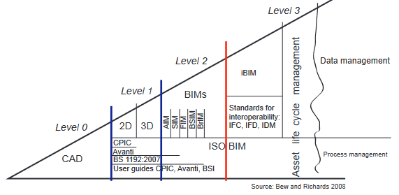
BIM Level Maturity Diagram (taken from RIBA - BIM Overlay to the RIBA Outline Plan of Work, 2012)

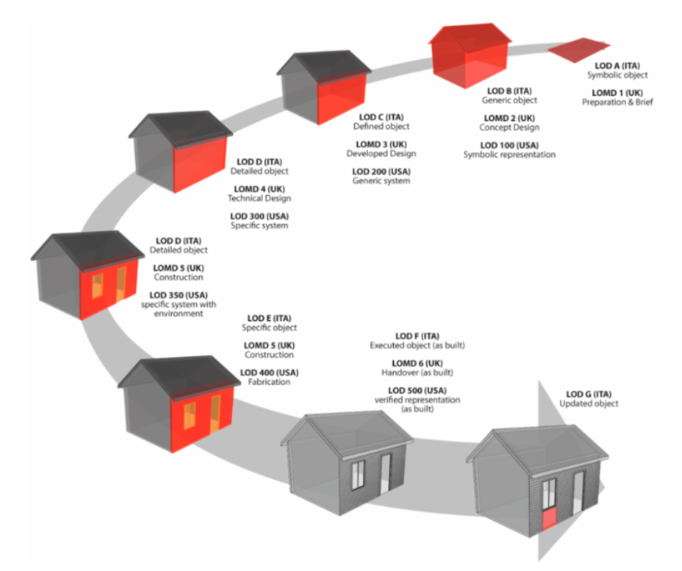
Appendix 2
Level of Model Detail (LOD) and Level of Model Information.
(taken from REBIM, 2020).
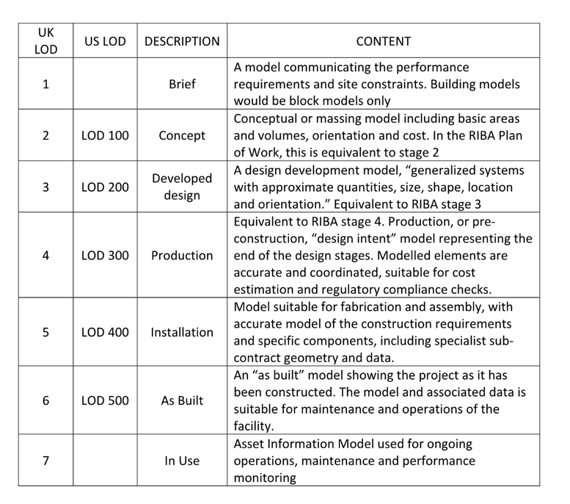

Appendix 3

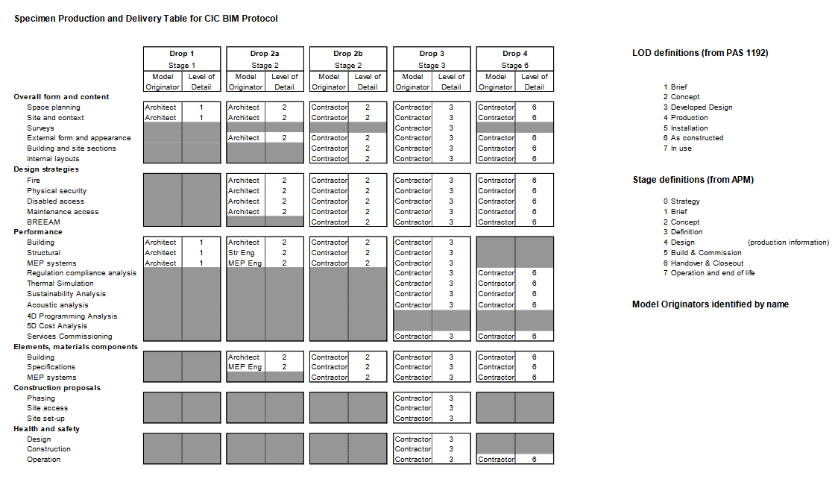
Specimen Product and delivery Table for CIC BIM protocol, which demonstrates the use of LOD, which is linked to APM rather than RIBA (taken from CLAW, 2016, p. 42).

Appendix 4
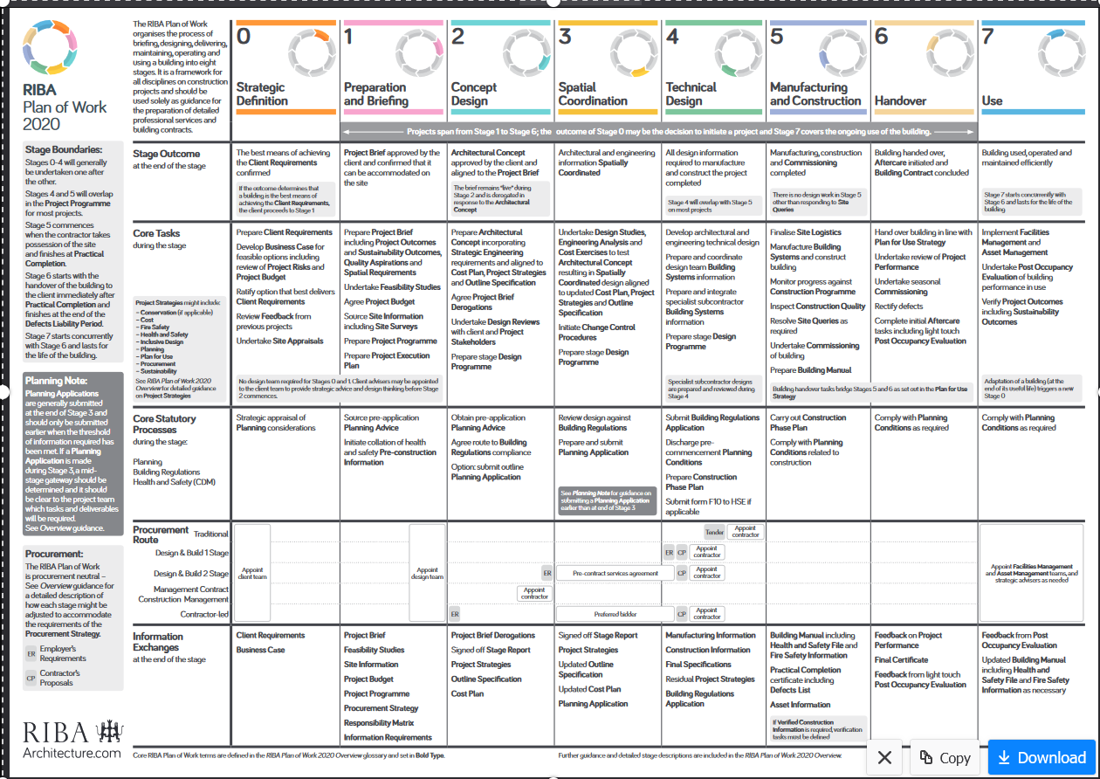
RIBA Plan of Work 2020

- References / Reading List

Austin Fletcher (2020) Key Elements from RIBA Stage 1: Preparation and Brief. Available at: https://austinfletcher.co.uk/articles/2020/02/07/key-elements-from-riba-stage-1-preparation-and-brief/ (Accessed 10 January 2024)

BIM Engineers (2023) Understand the relationship and differences between ISO 19650 and BIM Level 2. Available at https://www.linkedin.com/pulse/understand-relationship-differences-between-iso-19650/ (Accessed 6 January 2024)

Callister, R., (2024) How to use RIBA 2020 Plan of Work: RIBA design stages explained [updated]. Available at: https://urbanistarchitecture.co.uk/riba-plan-of-work-stages/ (Accessed 21 January 2024)

Cohesive Bim Wiki (2022) 2: Concept design. Available at: https://www.designingbuildings.co.uk/wiki/2:_Concept_design (Accessed 10 January 2024)

Consortium of Local Authorities in Wales – CLAW (LAW (2016) The CLAW All Wales BIM Toolkit Employers Information Requirements. Available at: http://www.cewales.org.uk/files/6414/5613/5077/4._EIR.pdf (Accessed 7 January 2024)

Designing Buildings, The Construction Wiki (2021) ISO 19650. Available at: https://www.designingbuildings.co.uk/wiki/ISO_19650 (Accessed 6 January 2024)

Ellis, M., (2020) REBIM – Level of Detail or Development: LOD in BIM. Available at: https://rebim.io/level-of-detail-or-development-lod-in-bim/ (Accessed 10 January 2024)

Erasmus, N., (2017) BIM Maturity Levels Explained. Available at: https://www.linkedin.com/pulse/bim-maturity-levels-explained-nick-erasmus/
(Accessed 6 January 2024)

Graham, S., (2023) Linked In – BIM capability and capacity. Available at: https://www.linkedin.com/pulse/bim-capability-capacity-simon-graham/ (Accessed 7 January 2024)

Kirby, M., (2022) Kimble Construction – What is a Common Data Environment and How is it Used in Construction? Available at: https://constructible.trimble.com/construction-industry/what-is-a-common-data-environment-and-how-is-it-used-in-construction (Accessed 7 January 2024)

RIBA (2012) RIBA BIM Overlay to the RIBA Outline Plan of Work. Available at
http://mono.eik.bme.hu/~zrostas/assets/files/CPM_RIBAOutlinePlanofWork_BIMOverlay.pdf (Accessed 10 January 2024)

RIBA (2020) RIBA Plan of Work 2020 Overview. Available at: https://www.architecture.com/knowledge-and-resources/resources-landing-page/riba-plan-of-work#available-resources (Accessed 10 January 2024)

RIBA (2020) RIBA Plan of Work 2020 Template. Available at:
https://www.architecture.com/knowledge-and-resources/resources-landing-page/riba-plan-of-work#available-resources (Accessed 10 January 2024)

Ruby-Lewis, V., (2023) Waldeck – What you need to know about BIM compliance in 2023. Available from: https://www.waldeckconsulting.com/latest_news/what-you-need-to-know-about-bim-compliance-in-2023/ (Accessed 9 January 2024)

Terrol, C., (2021) Global CAD – ISO 19850-2: the delivery phase of assets. Available at: https://globalcad.co.uk/iso-19650-2-the-delivery-phase-of-assets/ (Accessed 8 January 2024)

UK BIM Framework (2023) UK BIM Framework – The Overarching Approach to Implementing BIM in the UK. Available at https://www.ukbimframework.org/ (Accessed 6 January 2024)

UK BIM Framework (2020) Information management according to BS EN ISO 19650 Guidance Part 2: Processes for Project Delivery Edition 4. Available at:
https://ukbimframework.org/wp-content/uploads/2020/05/ISO19650-2Edition4.pdf (Accessed 10 January 2024)

Welsh Government (2019) Education Wales – 21st Century Schools and Education Funding Programme. Available at: https://www.gov.wales/sites/default/files/publications/2019-05/guides-to-making-your-21st-century-schools-and-educational-facilities-sustainable.pdf (Accessed 6 January 2024)

Welsh Government (2022) BIM Protocol Schedule 30 of Template MIM Education Project Agreement (WEP Strategic Partnering Delivery Model). Available at: https://www.gov.wales/sites/default/files/publications/2022-07/template-education-project-agreement-building-information-management-protocol.pdf (Accessed 7 January 2024)

Welsh Government (2018) WEP Strategic Partnering Framework, Building Information Modelling Market Engagement Paper. Available at https://www.llyw.cymru/sites/default/files/publications/2018-12/papur-modelu-gwybodaeth-adeiladu-cam-2.pdf (Accessed 7 January 2024)

Welsh Government (2022) Sustainable communities for Learning Programme business case guidance. Available at: https://www.gov.wales/sites/default/files/publications/2022-01/sustainable-communities-for-learning-business-case-guidance-2022.pdf (Accessed 10 January 2024)

