2531730
KAUSHAL PRAJAPATI
International Business Concepts (LCMB7034)
Strategic Analysis of Market Expansion: Consideration of the a2 Milk Company (a2MC) in Germany

Table of Contents
1. Organisational Classification and Global Strategy 4
1.1 Strategic Categorisation 4
1.2 Global Configuration 5
2. Macro-Environmental Appraisal and Market Attractiveness 6
2.1 Host Country Analysis 6
2.1.1 Political Environment of Germany 7
2.1.2 Economic Environment of Germany 7
2.1.3 Legal Environment of Germany 8
2.1.4 Cultural Environment of Germany 9
2.2 Market Entry Success Factors 10
2.2.1 Ownership Advantages 10
2.2.2 Location Advantages 11
2.2.3 Internalisation Advantages 12
3. Entry Mode Strategy and Strategic Synthesis 13
3.1 Historical Pattern Recognition 13
3.3 Competitive Advantage and Supportiveness 14
3.2.1 Germany Strategic Fit based on OLI 14
3.2.2 Risk, Resource commitment, Control and Flexibility 15
3.3 Conclusion and Recommendation 16
Section 2 18
4.1 Introduction 18
4.2 Description 18
4.3 Feelings 18
4.4 Evaluation 19
4.5 Analysis 19
4.7 Action Plan 20
Reference 21

1. Organisational Classification and Global Strategy
The focus of this internationalisation research and business analysis report is the a2 Milk Company (a2MC), which is a New Zealand-based dairy brand specialising in milk with the a2 protein. Available across a few market regions like China, Hong Kong, the USA and Australia, the a2 Milk Company has been serving the markets since 2000 (Thea2MilkCompany, 2026a). Since the a2 Milk Company has little to no presence in the European market, the focus of this report is to examine the market feasibility and attractiveness of Germany.

1.1 Strategic Categorisation
Since the a2 Milk Company is a multinational brand with its presence across the Asia Pacific region, applying the integration and responsiveness framework from Bartlett and Ghoshal (1989) to understand its strategic categorisation has been helpful. This has helped to understand how the firm’s transnational focus balances its core domestic operations and international business viability without sacrificing its centralised source of competitive advantage with the a2 protein-based milk (Thea2MilkCompany, 2026b).
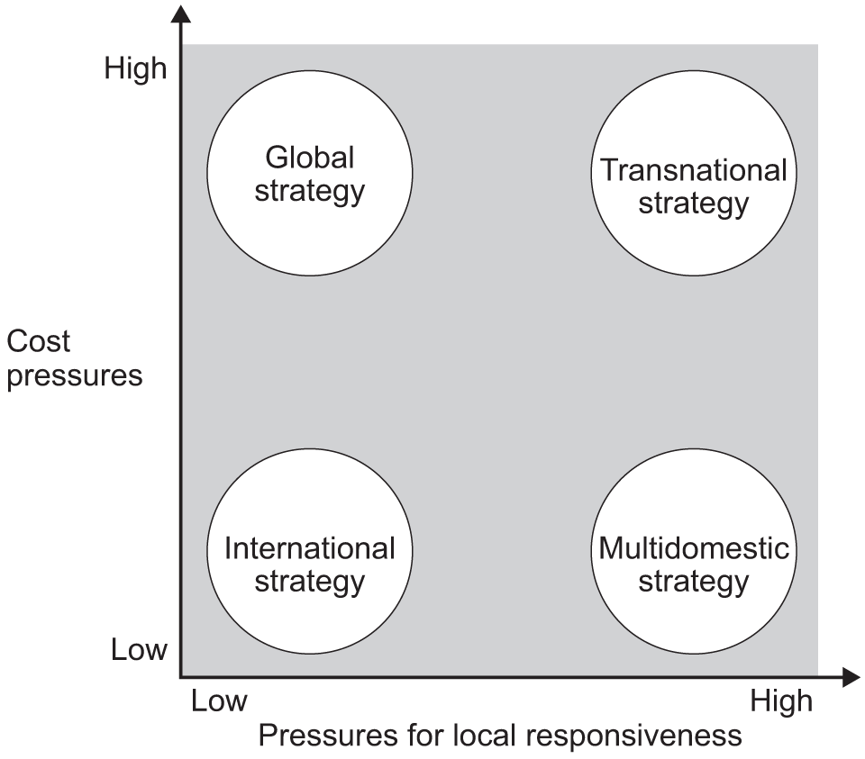
Figure 1: Integration-Responsiveness Framework
(Source: Bartlett and Ghoshal, 1989)
As indicated in Figure 1, the Integration Responsiveness Framework highlights four quadrants where cost pressure and local responsiveness intersect, leading to four subsequent strategic directions that an organisation like a2MC can follow. A key reason for the organisation's focus being in the transnational strategy is that its cost pressure informs the organisation's focus on standardising its milk sourcing and DNA-based herd testing system, which is highly controlled with its central governance system in New Zealand and acts as the proprietary competitive advantage for the brand (A2Research, 2026). However, since the brand maintains commercial operations and subsequent market-specific differentiation with Chinese and English label formulas, the brand experiences an equally high local pressure, which is facilitated either through resellers or direct cross-border e-commerce (Thea2MilkCompany, 2026b).
Although the critical focus on globalised business strategy is mostly described by Bartlett and Ghoshal (1987) to be an operation that is centralised both in strategy and execution, a2MC seems to have its operations centralised mostly through intellectual property but allows 3rd party partners in global markets to carry forward execution and subsequent strategic responsibilities (Thea2MilkCompany, 2026b). Thus, giving the brand much stronger flexibility in cash flow and profit margins but introduces more concerning competitive advantages if the partner relationship is not strengthened. Considering this asset-light model when examining a feasible German market entry is important.

1.2 Global Configuration
This flexibility with core operational decision-making has meant that its global geographic footprint is optimised for financial efficiency, such as the Chinese and other Asian markets representing around 68.6% of its total revenue of $1,899 million (Thea2MilkCompany, 2026b).
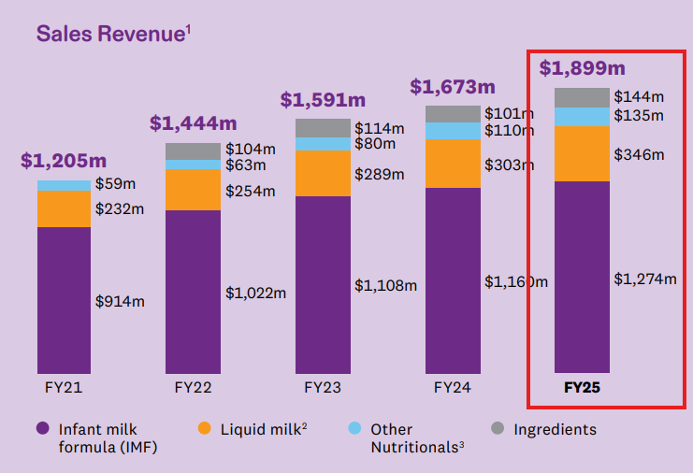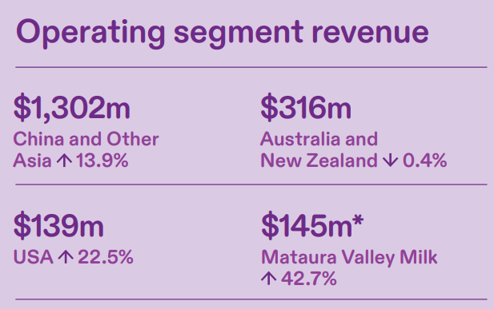
Figure 2: Total YoY Revenue (Left) and Regional Revenue Growth (Right) of a2MC
(Source: Thea2MilkCompany, 2026b)
It is, however, worth noting that despite Australia being a predominantly strong market for a two since its start up, both the Australian and New Zealand market has become secondary based total operating revenue reported from each regions, showing if 0.4% decline in the market while its US market sees 22.5% increase but a significantly smaller volume revenue compared to its Asia-Pacific volumes (See Figure 2). Especially since the brand's main value creation strategy is dependent on its scientific development, the highly nutritional and beneficial A2 milk without the presence of the A1 protein, innovation-specific differentiation failing to generate revenue in core market segments, indicates concerning domestic adoption or shrinking profit margins due to higher operational costs. Although its vertical integration for the specific purpose of building more nutritional manufacturing with a 75% stake in Mataura Valley Milk may help temporarily strengthen its security, its Asia-specific market dominance with limited global expansion may create financial limitations due to lack of volume sales (Thea2MilkCompany, 2026b).

2. Macro-Environmental Appraisal and Market Attractiveness
Conducting market attractiveness analysis of Germany, the following external analysis has highlighted both the political and legal environment, followed by the economic and cultural environment, as the most important areas that a2MC will have to consider when entering the market.

2.1 Host Country Analysis

2.1.1 Political Environment of Germany
One of the first factors within the German market that has the most effect on determining a2MC’s market entry feasibility and subsequent success is the political and trade policy aspects. As of May 1st 2024, New Zealand and the EU as a whole have established a trade agreement which has allowed tariff-free exports of New Zealand's goods, covering at least 91% of its exports, which will later on be extended to 97% in the next seven years, with milk being the only area marked as subject to tariff rates still (MFAT, 2024). With regard to the sensitivity towards milk-related products, a2MC’s key supply partner, Fonterra, noting the supply-specific constraints imposed on dairy products in the EU market, indicates that at least for Germany, a2MC will have trade policy-related hurdles to overcome before it can fully open up its local value chain into a scalable solution outputting strong volume growth (Groeneveld, 2024). This is financially restricted given that the preferential quota for identifying milk and other dairy products coming from New Zealand has a limited quota, but subsequent increases would require added verification and administrative documentation to prove its country of origin (AHDB, 2024).
This not only introduces added cost concerns for managing and documenting its production and sourcing for appropriate compliance but also introduces frequent updating of the compliance system due to the exponential increase of the quota from 6,021 to 8,333 tons (AHDB, 2024). However, the political environment is not entirely uncertain for a2MC since, being part of the eurozone, Germany is a stable economy which addresses a2MC’s core market expansion requirement more meaningfully than the uncertain and volatile regulatory structure of China (Europa, 2026; Thea2MilkCompany, 2026b). This analysis seems to indicate that, in the context of the broader European market or in the context of the German-specific focus, the market is attractive enough politically. This is because currently reported instability risks within high-volume markets like China are not reflected in a stable market like Germany, which requires more persistence, that a brand like a2MC may be able to achieve with its asset-light business focus.

2.1.2 Economic Environment of Germany
From an economic point of view, focusing specifically on the German market, its attractiveness is apparent from market evidence of the infant nutrition segment. Germany not only represents the largest share (23.5%) of infant nutrition products across all of Europe, but its underlying health care infrastructure and nutritional awareness have supported its economic viability for a2MC more prominently (Market Data Forecast, 2026). Within the German infant product market, a2MC’s closest coverage area is the organic market segment due to its close association with clean baby products that a2MC can cater to due to its highly nutritional A2 milk (Market Research, 2026). With the market growth rate of around 6.8% and expected size of around $3000 million by 2035, the economic output that Germany is expected to provide within this niche product segment alone highlights a strong capability and market attractiveness that a2MC can exploit (Market Research, 2026). However, a2MC acknowledging the global cost of living crisis and inflationary uncertainty directly affecting consumer price sensitivity is not just a global phenomenon, as Germany's current inflationary index reports a 2.9% rate that is expected to stabilise next year under the assumption of the middle eastern conflicting subsiding (KPMG, 2026).
However, the inflationary pressure is also combined with the overall cost of living that German consumers experience, making price sensitivity a much more common expectation (Martinez, 2026). Even accounting for a2MC’s existing experience in China, where the market was able to experience stronger growth outcomes after four consecutive years of investment, a completely new market entry into Germany can in fact be capital investments for the brand before the projected growth values are exploited. As the debt servicing cost increases with a subsequent rise in interest rates, the German market, even from a financial standpoint, can be unoptimized for a2MC in case the brand operates directly (Kowalcze, 2026). However, in case of 3rd party retail operations, the German market will still have similar financing risks affecting local retailers' flexibility to partner with international brands. As a result, the economic outlook in Germany appears not to be so attractive for the brand.

2.1.3 Legal Environment of Germany
As part of the legal standard in Germany, which is also influenced by the larger EU regulations such as the EU 2016/127, the required standardisation and labelling of health claims on infant formula especially requires due diligence for a2MC to be able to enter the market (Europa, 2016). It is also worth noting that the legal environment of Germany is multilayered, with an estimated review process of 18 months by the EU regulatory body, with an added national review from Germany itself (Heo et al., 2024). This affects the overall scope and flexibility that a2MC will have in effectively entering the German market with its novel health claims of A1 protein free milk. The acknowledged second layer of national regulation is tied to Germany's own safety regulation which has the standards for baby food products especially, making the initial clearance much more lengthy (Ken Research, 2025).
Additionally the viability of the previously discussed EU-New Zealand Free Trade Agreement has briefly touched upon the requirement of preferential tariff treatment adding further compliance obligations. In terms of legal verification, the preferential quota would require a2MC to not only secure proof of origin verification using both origin declaration and dedicated identifier codes in customs, but its clearance from import declaration would also have to take account their local partners in Germany have appreciated documentations and updated documents to declare the importance under the TRQ tariff rate claim (Europa, 2024). As a result, the legal environment in Germany, being multilayered in logistics and licensing, makes both the timeline required before full operational viability in the country and the regular time-to-market metric much longer.
From this analysis of the legal environment in Germany, it is clear that a2MC would not be allowed to launch its current formulations without any modification, making entry into the market significantly capital intensive.

2.1.4 Cultural Environment of Germany
From a cultural standpoint, the German market for nutritionally healthy milk products falls into the broader clean label infant nutritional product category, and existing brands like Hipp and Holle have built strong customer trust due to brand heritage (Market Research, 2026). Even setting aside the heritage brand, the German market is also captured by multinational infant formula producers like Danone, with the Aptamil brand targeting the health focused infant formula market with its Nutricia-Milupa division (Danone, 2025). Due to significantly stronger research and development pipeline that has invested in bioactive ingredients instead of differentiating on the basis of organic certification, the market culture alignment with existing competitors is much stronger in Germany than the differentiation capability of a2MC. As a result of the high health literacy and strong cultural practice of preferring nutritionally balanced and varied diet for their children's, targeting parents in German would require a2MC To build a much stronger local communication system outside of its a one protein free narrative as nutritional benefits of A2 milk may remain well established within the market, leaving differentiation difficult on the basis of scientific claims alone (Shrivastav, 2024; Innova Market Insights, 2026). The culture for consumer shopping is also highly saturated within the retail market itself, which already represents attitudinal preference for pre-existing brands due to familiarity over interest in brand consideration, especially for baby formulas and milk solutions. With prior European market expansion attempts from a2MC resulting in its weaker performance in the UK due to entrenched brand presence of alternatives, it is clear that a2MC will have to focus on building legitimacy first to appeal to the German customer’s cultural expectations (LaFrenz, 2021). The cultural factors shaping the market appeal for a 2MC in other parts of its global presence do not seem to be an ideal approach for Germany. Considering that customers are not receptive to novel concepts and formulations, a discovery approach to market adoption is also not feasible based on the consumer culture in Germany. This indicates that the market attractiveness for Germany is somewhat modest in this regard as well, where the initial target for a2MC will be to ensure appropriate legitimacy so that gradual and organic adoption can happen over time rather than risking a large investment for nationwide expansion in the hopes of quicker return on investment.

2.2 Market Entry Success Factors
Having investigated the external market factors most important to influencing the subsequent decisions and strategies of a2MC when entering the German market, it is important to understand whether or not the market entry strategy will be successful based on the unique advantages the market presents. Using the eclectic paradigm framework from Dunning (1988), the following evaluation attempts to articulate the key success factors that may arise from a2MC’s German market entry.

2.2.1 Ownership Advantages
a2MC has a distinct ownership advantage with its proprietary technologies helping to screen sources with its DNA-based herding system and a locally governed supply chain network supported by established brands like Fonterra or Howell (Thea2MilkCompany, 2026b). This advantage is very difficult to replicate by competitors when the technology itself is patented, leaving the partnership that provides limited benefit outside of scalability for alternative brands. Especially considering that clinical science has strongly supported the credibility of A1 protein-free formulation of milk, the ownership advantage of such product formulation lies in its ability to support easier validation and health claims substantiation under the previously investigated Regulation of EU 2016/127 (Duarte-Vázquez et al. 2017; Europa, 2016). It is worth admitting that even though the external market evaluation has critically commented on the legislative and cultural factors that disadvantage two MCs ' market viability in Germany, the market attractiveness can still be built around long-term orientation rather than immediate return on investment. However, predominant heritage brand awareness within the German market also means that a2MC’s own A1 protein-free milk solution will have stronger differentiation that is not easily transferable. Two alternative brands allow for ownership advantage to persist if the brand invests in the market long term.

2.2.2 Location Advantages
The external market evaluation suggests that Germany is one of Europe's largest markets for infant nutrition solutions, with around 23.5% of the market share; the location advantage for entering the German market by a2MC becomes apparent (Market Data Forecast, 2026). The previously identified opportunities for a2MC’s business growth have been the need for a reliable and scalable solution that can support volume growth (Section 1.2). With the largest market share for infant nutrition in the European Union, this market may act as a strong potential for building future capability. Combined with the location advantage support under the EU-New Zealand FTA, the cost-specific competitive advantages may alleviate the identified challenges of regulatory hurdles and other multilayered documentation and compliance-related costs (AHDB, 2024). It is, however, still worth noting that the investment turnaround for shareholders of a2MC may remain much longer than its other subsequent markets, which indicates that the location advantage for Germany is not entirely symmetrical and has some disadvantages that the brand needs to be aware of. Communication pertaining to the market entry of Germany is therefore required to be designed based on the market stability and projected growth aspects rather than immediate monetary gains as a performance criterion. With academic evidence from Jain and Jiao (2025) particularly referring to investor myopia obstructing long-term return on investment capabilities, communicating the expected initial capital-heavy business operation of a2MC will be critical to define its success within the German market.

2.2.3 Internalisation Advantages
Finally, in terms of the internalisation advantages, a2MC's current business strategy does not seem to internalise many of its operational activities outside of IP, Standard testing and research (Thea2MilkCompany, 2026b). By adopting an asset-light model, a2MC is inherently externalising its business activities such as manufacturing, distribution, and even marketing, making it a viable success in Asian markets due to strong local infrastructure and a positive cultural and regulatory environment (Thea2MilkCompany, 2026a). Yet when the same internalisation advantages were attempted to be applied to the German market, the complex regulatory environment made internalisation requirements mandatory to be able to control and report on the required licensing and distribution partnership. However, targeted partnerships with German-specific or even other EU-based manufacturers and distributors might still help build a cost-effective entry opportunity for a2MC. In fact, academic observations have commented on the potential for minorities to buy in from rival brands as an ideal opportunity creation strategy for new market development due to stronger price and profit margins (Nain and Wang, 2018). It is expected that a2MC would be able to acquire a minority stake in a German or EU-specific organic nutrition brand to help it internalise regulatory approval-related requirements while also opening up opportunities for building stronger retail partnerships locally. This would not only help to retain its original strategy of keeping asset volumes low in its international markets but also its shareholders when it comes to considering the capital-intensive nature of the market expansion due to the time-consuming nature of market viability building examined in the previous section. However, it is worth noting that a2MC has acknowledged its preference for partnership-specific internationalisation as opposed to wholly owned subsidiaries (Thea2MilkCompany, 2026b). This indicates that their core strategic vision on accelerating profitability options will not allow the brand to set up a long-term physical presence with 100% ownership (Thea2MilkCompany, 2026b).
As a result, the overall evaluation of the eclectic paradigm seems to suggest that its most important advantage is going to be its ownership and internalisation advantage, while the location advantage will be partially affected by the obvious that is unavoidable for the brand.

3. Entry Mode Strategy and Strategic Synthesis

3.1 Historical Pattern Recognition
The globalization trend of a2MC shows a choice of selective internal control with partnership-based implementation. The organisation, as it was determined in the previous section (1.2), retains control of strategically sensitive resources, especially the intellectual property in the form of A2-related, along with the herd-testing standards, brand positioning and scientific capability, but uses external manufacturers, suppliers, resellers and distribution relationships, across international markets (Thea2MilkCompany, 2026b). This is an asset-light strategy as opposed to regularly replicating a complete owned value chain in each of the host countries. In modern entry-mode studies, it is beneficial to consider these forms beyond the common decision between exporting and wholly owned subsidiaries since the international companies tend to delegate internal control to ecosystems and partner-based solutions (Brouthers et al., 2022).
Partnership however, does not exclude strategic vulnerability. Alliances at the international level rely on similar goals, administration and capacity to indicate resources among free organisations (Silva et al., 2023). This is especially true in the case of a2MC as its differentiation lies in preserving the integrity of the product but allowing it to have partners conduct market-facing operations. Moreover, the past UK withdrawal evidences that European expansion cannot be taken to imply automatically sustainable due to the presence of a differentiated product of the company. Thus, its experience over the past years justifies the maintenance of primary proprietary power and restriction of irreversible downstream commitment in an unknown European venture.

3.3 Competitive Advantage and Supportiveness

3.2.1 Germany Strategic Fit based on OLI
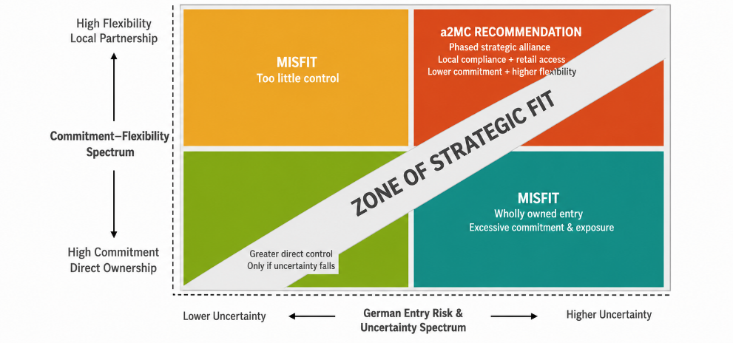
Figure 3: Strategic Fit
(Source: Self-created using MS Word)
Figure 3 demonstrate the strategic fit, considering OLI assessment shows that a partnership based entry is more strategically appropriate as compared to wholly owned subsidiary. The ownership strength is still relatively high as a2MC is in control of its A2 proposition, testing system, scientific knowledge and brand. But the benefits of ownership are not sufficient reasons to completely own a foreign market. Meta-analytic studies have recently revealed that the degree of institutional distance to which relationship to equity-based entry mode depends is not uniform, so it can be concluded that the extent of ownership cannot necessarily lead to a better result (Zhang et al., 2023). Likewise, da Silva et al. (2024) find institutional differences to affect the prices and benefits that are applied to alternative ownership arrangements.
Germany offers great location benefits in the form of political stability, market size and the trade relationship between the EU and New Zealand, but in the previous analysis, regulatory approval, product adaptation, longstanding competitors and consumer legitimacy were also found as significant location specific disadvantages. As Donnelly et al. (2024) prove, the possibility of firms to transcend institutional distance is partially rooted in resources that help them to support foreign expansion. Therefore investing a lot of resources in German plants prior to the time when there is acceptance in the locality would add an unnecessary exposure. Under internalisation aspect, a2MC can internalise its IP, quality standards and product governance to its internal, and externalise locally specific activities like distribution and market execution to a formed partner.

3.2.2 Risk, Resource commitment, Control and Flexibility
Risk:
Risk | a2MC–Germany exposure | Strategic implication
Political | EU–NZ FTA retains dairy restrictions and administrative requirements (MFAT, 2024; Groeneveld, 2024). | Partnership reduces trade-entry exposure.
Financial | Inflation and price sensitivity threaten premium-product returns (KPMG, 2026; Martinez, 2026). | Lower capital commitment limits losses.
Operational | Strict EU food regulation increases approval and compliance complexity (Europa, 2016; Heo et al., 2024). | Local expertise reduces execution risk.
Table 1: Key risks influencing a2MC’s proposed market entry into Germany
(Source: Self-developed using MS Word)
Partnership also gives a more appropriate response to the risks that we have realised in Section 2. Li and Xiong (2022) discover that environmental uncertainty influences entry-mode decision and how cooperative or conservative modes can still be suitable to certain host-market conditions. In the case of a2MC, Germany is somewhat less risky in terms of sovereign risk but significantly riskier in terms of regulation and entry uncertainty. With a German or pan-European partner having an established compliance infrastructure and retail contacts, the burden of operational learning may be transferred without a2MC having to build an entirely new downstream infrastructure.
Resource commitment: The benefit is in line with the internationalisation research literature (network-based), which is shown to enable firms to leverage relationships to overcome uncertainty and enhance access to host-market knowledge (Bai et al., 2022). However, Abdi et al. (2024) make the warning that the advantages of local alliances should be based on the kind of market knowledge that we are trying to acquire, and this may imply that partner selection itself is a strategic factor. Therefore, a2MC must choose a partner that has a specialized infant-nutrition regulatory experience and access to retailers as opposed to just having general dairy capabilities.
Control and Flexibility: The key trade-off is the one related to control. A fully owned operation would fully leverage managerial control and focus financial, regulatory and operational risk in a2MC. On the other hand, uncontrollable licensing arrangement may compromise on provisions of quality and brand positioning. It has been shown that collaboration mediates decision-making regarding foreign-entry and performance at the international level, thus illustrating the importance of unlocking the potential of the combination of the company capabilities with the external relationship (Chetty et al., 2024). So, an alliance should be accompanied by contractual regulations of the formulation, A2 test, branding and quality assurance. This is much more flexible and at the same time preserves the resources out of which the ownership advantage is derived. It has also been recently found out that international strategic alliances are also relevant ways of getting access to complementary resources when expanding abroad (Chakraborty and Singla, 2025).

3.3 Conclusion and Recommendation
In general, there is enough long-term market potential in Germany to warrant entry, whereas regulatory, cultural and financial results do not warrant a high-commitment wholly owned strategy. The entry mode suggested is thus a gradual non-equity strategic alliance with an established German or pan-European nutrition partner and incorporates licensing/co-manufacturing to the extent needed plus local distribution. a2MC should have exclusive access to its A2 intellectual property, testing protocols, product standards and brand governance and the partner contribute regulatory expertise, distribution infrastructure and retailer relationships.
The first step point of entry should be in the IMF/nutritional-powder formats deemed to be relatively aligned to the scientific positioning of a2MC. It should then be judged by performance in the form of regulatory advancement, in distribution reach, sales and consumer acceptance prior to additional capital being invested. The presence of foreign ownership can convert the firms into exposure to host-market institutional conditions (Tang, 2023); hence, a combination of a minority-equity joint venture may be regarded after the partnership has proven to be commercially viable. This orchestrated suggestion fits the opportunities of Germany into the current pattern of partner-oriented internationalisation of a2MC without compromising its ability to be flexible and preserve its core competitive advantages.

Section 2

4.1 Introduction
This reflection is based on the reflection cycle of Gibbs (1988) by applying it to my experience of conducting the research and writing up the international market-entry assessment of a2MC in Germany. The framework aids in the transition between the description of experience and interpreting learning and future improvement (Phenwan, 2024). Based on this, the reflection analyses my research method, issues, revision of assumptions and education.

4.2 Description
I started with the choice of a2MC and Germany and then went through three related steps of analysis. The framework by Bartlett and Ghoshal was initially used to learn the international strategic set-up of a2MC. The political, economic, legal and cultural evidence was next analyzed so as to evaluate the attractiveness of Germany as a market and then the OLI framework developed by Dunning was used to relate a2MC capabilities with host-market environment and entry mode options. The sources of evidence included a2MC reports, EU and governmental, industry databases and scholarly literature. This stepwise process was useful since practical learning improves when the activities are supplemented with conscious reflection on the development of knowledge (Kingkaew et al., 2023).

4.3 Feelings
My initial treaty was that Germany was a very appealing opportunity due to its economic stability and large market in infant-nutrition. This trust was eroded by the realization of regulatory requirements, compliance costs, presence of established competitors and UK experience of a2MC. There was also uncertainty due to conflicting forecasts by commercial sources. I realised that the first-glance verdict I had made was more informed by the general economic interest in Germany rather than by the practicality of entering. According to Akhmetova and Khaliullina (2023), at times reflective writing demonstrates challenges in the process of knowledge translation to meaningful understanding. In my case, it revealed the fallacious belief that a beautiful market is always a convenient or a strategy-wise, right market to venture into.

4.4 Evaluation
One of the key strengths was the integration of various types of evidences. Through company reports, the capabilities and priorities of a2MC were determined and government and EU evidence assisted in regulatory and trade analysis, market evaluation and theoretical interpretation were being informed by industry and scholarly sources. This ensured that the analysis is not a descriptive PELC exercise.
But the process of evidence-gathering was not originally so systematic. I occasionally utilized some useful statistics, without adequately evaluating where it originated, methodology and comparability. Trixa and Kaspar (2024) demonstrate that information literacy needs proper evaluation tactics, and not access to information. As a result, I got to be choosier in applying commercial forecasts. I also was aware of the danger of applying reflection as an ex-post facto justification of decisions. Tight (2024) doubts blind implementations of reflection in higher education, which supports the significance of considering weaknesses and failed assumptions.

4.5 Analysis
The greatest learning experience was that, the theories in the module were most effectively learned through their interrelationship and not individually. Bartlett and Ghoshal made me realize the reasons why a2MC could in a centralized way exercise control over its proprietary A2 capabilities and at the same time, have flexibility in terms of how it implemented in foreign markets. This strategy could not be easily replicated and moved to Germany as was initially shown in the environmental analysis.
I was also challenged as a result of the OLI analysis. In the first case, I related the high ownership benefits with increased ownership of foreign operation. Nevertheless, the legal, cultural and competitive environment of Germany has proven that a2MC will be able to maintain the ownership of IP, testing and brand standards and adopt a partner with complementary local capabilities. Sweet (2023) concludes that supported critical reflection has the potential to motivate learners to question the conventional assumptions, which is exactly what happened to my preferred entry mode shifting towards a gradual partnership, as opposed to a direct investment.
I needed to balance conflicting results as well. Germany provides volume in the market and political stability and at the same time, poses significant compliance, competitive and cultural issues. Yeh et al. (2023) relate reflective writing to superior critical thinking and re-conceptualizations. This motivated me to make up some conflicting evidence instead of choosing information that reinforced a set recommendation. Similarly, the process enhanced my understanding of my own judgement development, which was also in line with evidence that reflective writing could aid metacognition and self-regulation (Zarestky et al., 2022).
4.6 Conclusion
In general, the evaluation altered my perceptions of international entry as a one-dimensional market-selection process to a strategic choice that depends on context. I came to understand that high resource commitment and ownership may not necessarily be justified given the level of market attractiveness. I also gained a better understanding of source credibility, conflicting evidence and my personal assumptions. Harvey et al. (2025) highlight the importance of successful reflection in learning and future growth that showed up thanks to this re-evaluation of my decisions in analytical processes.

4.7 Action Plan
To develop future international-business reviews, I will develop a source-matrix prior to writing, where credibility, date of publication, methodology and purpose of analysis is documented. Triangulation of conflicting statistics will be done then they will be included. I will also compare entry modes previously on a similar basis with the use of consistent criteria of risk, resources, control and flexibility. Lastly, I will document the transformation of my initial assumptions in the process of research to create more straightforward evidence of learning. Sudirman et al. (2024) single out structured reflective writing as the one that aids self-reflection, critical thinking and problem-solving, which can be used as a resource to enhance my practice as a researcher in the future.

Reference
A2Research, (2026). Beta-Casein Testing for a2 Milk®. Available at: https://a2research.org/our-testing (Accessed: August 7, 2026).
Abdi, M., Aulakh, P.S. and Ma, Z., 2024. Exploratory search and international performance: when do local alliances matter?. Journal of International Marketing, 32(4), pp.1-20. https://doi.org/10.1177/1069031X231216409
AHDB, (2024). How might the EU-NZ trade deal impact trade? - Dairy. Available at: https://ahdb.org.uk/news/trade-and-policy/how-might-the-eu-nz-trade-deal-impact-trade-dairy (Accessed: August 7, 2026).
Akhmetova, G.Y. and Khaliullina, L.R., 2023. Reflective writing in social sciences: challenges and opportunities for medical students. Reflective Practice, 24(6), pp.693-706. https://doi.org/10.1080/14623943.2023.2237447
Bai, W., Johanson, M., Oliveira, L., Ratajczak-Mrozek, M. and Francioni, B., 2022. Where business networks and institutions meet: Internationalization decision-making under uncertainty. Journal of International Management, 28(1), p.100904. https://doi.org/10.1016/j.intman.2021.100904
Bartlett, C. A., and S. Ghoshal. 1989. Managing Across Borders: The Transnational Solution. Harvard Business School Press.
Bartlett, C. and Ghoshal, S., 1987. Managing across borders: New organizational responses.
Brouthers, K.D., Chen, L., Li, S. and Shaheer, N., 2022. Charting new courses to enter foreign markets: Conceptualization, theoretical framework, and research directions on non-traditional entry modes: Keith D. Brouthers et al. Journal of International Business Studies, 53(9), pp.2088-2115. https://doi.org/10.1057/s41267-022-00521-x
Chakraborty, S. and Singla, C., 2025. Navigating international entry via strategic alliances: Comparison of family and non-family firms. Journal of International Management, 31(3), p.101250. https://doi.org/10.1016/j.intman.2025.101250
Chetty, S., Martín, O.M. and Bai, W., 2024. Causal foreign market selection and effectual entry decision-making: The mediating role of collaboration to enhance international performance. Journal of Business Research, 172, p.114385. https://doi.org/10.1016/j.jbusres.2023.114385
da Silva, F.M., Ogasavara, M.H. and Pereira, R., 2024. Institutional distances and equity-based entry modes: a systematic literature review. Management Review Quarterly, 74(3), pp.1723-1790. https://doi.org/10.1007/s11301-023-00346-4
Danone, (2025). ANNUAL INTEGRATED REPORT. Available at: https://www.danone.com/content/dam/corp/global/danonecom/investors/en-sustainability/reports-and-data/cross-topic/danoneiar2025.pdf (Accessed: August 7, 2026).
Donnelly, R., Purkayastha, S., Manolova, T.S. and Edelman, L.F., 2024. Institutional distance, slack resources, and foreign market entry. Journal of International Business Studies, 55(2), pp.194-211. https://doi.org/10.1057/s41267-023-00647-6
Duarte-Vázquez, M.Á., García-Ugalde, C., Villegas-Gutiérrez, L.M., García-Almendárez, B.E. and Rosado, J.L., 2017. Production of cow’s milk free from beta-casein A1 and its application in the manufacturing of specialized foods for early infant nutrition. Foods, 6(7), p.50.
Dunning, J.H. 1988. The Eclectic Paradigm of International Production: A Restatement and Some Possible Extensions. Journal of International Business Studies, 19, 1-31.
Europa, (2016). Delegated regulation - 2016/127 - EN - EUR-Lex. Available at: https://eur-lex.europa.eu/eli/reg_del/2016/127/oj/eng (Accessed: August 7, 2026).
Europa, (2024). Application of EU-NZ FTA Agreement on 1 May 2024. Available at: https://trade.ec.europa.eu/access-to-markets/en/news/application-eu-nz-fta-agreement-1-may-2024 (Accessed: August 7, 2026).
Europa, (2026). Germany. Available at: https://european-union.europa.eu/principles-countries-history/eu-countries/germany_en (Accessed: August 7, 2026).
Gibbs, G., 1988. Learning by doing: A guide to teaching and learning methods. Further Education Unit.
Groeneveld, R. (2024) EU-New Zealand FTA: More possibilities for dairy but restrictions remain, Food & Agribusiness. Available at: https://www.foodagribusiness.world/dairy/eu-new-zealand-fta-more-possibilities-but-restrictions-remain (Accessed: August 7, 2026).
Harvey, M., Walkerden, G., Semple, A., McLachlan, K., Lloyd, K. and Bosanquet, A., 2025. Reflecting on reflective practice: Issues, possibilities and guidance principles. Higher Education Research & Development, 44(7), pp.1849-1857. https://doi.org/10.1080/07294360.2025.2463517
Heo, S., Lee, G., Na, H.E., Park, J.H., Kim, T., Oh, S.E. and Jeong, D.W., 2024. Current status of the novel food ingredient safety evaluation system. Food Science and Biotechnology, 33(1), pp.1-11. https://doi.org/10.1007/s10068-023-01396-w
Innova Market Insights, (2026). Food Industry in Germany: Consumer Insights and Preferences. Available at: https://www.innovamarketinsights.com/trends/food-industry-in-germany-consumer-insights-and-preferences/ (Accessed: August 7, 2026).
Jain, K. and Jiao, D., 2025. Exploiting Myopia: The Returns to Long-Term Investing. Columbia Business School Research Paper, (5464715).
Ken Research, (2025). Germany Baby Food and Infant Care Market. Available at: https://www.kenresearch.com/germany-baby-food-and-infant-care-market (Accessed: August 7, 2026).
Kingkaew, C., Theeramunkong, T., Supnithi, T., Chatpreecha, P., Morita, K., Tanaka, K. and Ikeda, M., 2023. A learning environment to promote awareness of the experiential learning processes with reflective writing support. Education Sciences, 13(1), p.64. https://doi.org/10.3390/educsci13010064
Kowalcze. K., (2026). Germany plans to boost 2027 Borrowing on Weak Tax Revenue. Available at: https://www.bloomberg.com/news/articles/2026-07-05/germany-plans-to-boost-2027-borrowing-as-tax-revenue-falls-short (Accessed: August 7, 2026).
KPMG, (2026). Economic Key Facts Germany. Available at: https://kpmg.com/de/en/insights/geopolitics/economic-key-facts-germany.html (Accessed: August 7, 2026).
LaFrenz, C. (2021) The a2 Milk Company’s fall from grace continues, Australian Financial Review. Available at: https://www.afr.com/companies/manufacturing/the-a2-milk-company-s-fall-from-grace-continues-20210517-p57sni (Accessed: August 7, 2026).
Li, K.S. and Xiong, Y.Q., 2022. Host country’s environmental uncertainty, technological capability, and foreign market entry mode: Evidence from high-end equipment manufacturing MNEs in emerging markets. International Business Review, 31(1), p.101900. https://doi.org/10.1016/j.ibusrev.2021.101900
Market Data Forecast, (2026). Europe Infant Nutrition Market. Available at: https://www.marketdataforecast.com/market-reports/europe-infant-nutrition-market (Accessed: August 7, 2026).
Market Research, (2026). Germany Organic Infant Formula Market. Available at: https://www.marketresearchfuture.com/reports/germany-organic-infant-formula-market-48006 (Accessed: August 7, 2026).
Martinez. M., (2026). Germans more pessimistic than European peers as price worries reshape spending, BCG says. Available at: https://www.reuters.com/business/germans-more-pessimistic-than-european-peers-price-worries-reshape-spending-bcg-2026-06-09/ (Accessed: August 7, 2026).
MFAT, (2024). New Zealand and European Union Free Trade Agreement Overview. Available at: https://www.mfat.govt.nz/en/trade/free-trade-agreements/free-trade-agreements-in-force/new-zealand-european-union-free-trade-agreement/nz-eu-fta-overview (Accessed: August 7, 2026).
Nain, A. and Wang, Y., 2018. The product market impact of minority stake acquisitions. Management Science, 64(2), pp.825-844.
Phenwan, T., 2024. Teaching of reflection in higher education: a narrative review. MedEdPublish, 14, p.53. https://doi.org/10.12688/mep.20389.1
Shrivastav. S., (2024). Germany Baby Food Market Overview. Available at: https://www.bonafideresearch.com/product/6209193303/germany-baby-food-market (Accessed: August 7, 2026).
Silva, S.C., Elo, M., Larimo, J., Vlačić, B. and Meneses, R., 2023. A state-of-the-art review on international strategic alliances: do we really know what we are researching?. European Journal of International Management, 21(3), pp.400-439. https://dx.doi.org/10.1504/EJIM.2021.10036503
Sudirman, A., Gemilang, A.V., Kristanto, T.M.A., Robiasih, R.H., Hikmah, I.A., Nugroho, A.D., Karjono, J.S., Lestari, T., Widyarini, T.L., Prastanti, A.D. and Susanto, M.R., 2024. Reinforcing reflective practice through reflective writing in higher education: A systematic review. International Journal of Learning, Teaching and Educational Research, 23(5), pp.454-474. https://doi.org/10.26803/ijlter.23.5.24
Sweet, S.F., 2023. Using guided critical reflection to discover deepened and transformative learning in leadership education. Journal of Research on Leadership Education, 18(4), pp.600-621. https://doi.org/10.1177/19427751221118951
Tang, R.W., 2023. Institutional unpredictability and foreign exit− reentry dynamics: The moderating role of foreign ownership. Journal of World Business, 58(2), p.101389. https://doi.org/10.1016/j.jwb.2022.101389
Thea2MilkCompany, (2026a). A dairy nutritionals company, fuelled by its purpose to pioneer the future of dairy for good. Available at: https://thea2milkcompany.com/thea2milkdifference (Accessed: August 7, 2026).
Thea2MilkCompany, (2026b). 2025 Annual Report. Available at: https://assets-au-01.kc-usercontent.com/bca3e5d5-83bd-02bf-1c27-acb036630e5b/9b9ad6ab-d7b8-4d15-8e57-6e9964f4d9d6/FY25%20Annual%20Report.pdf (Accessed: August 7, 2026).
Tight, M., 2024. Reflection: an assessment and critique of a pervasive trend in higher education. European Journal of Higher Education, 14(2), pp.324-342. https://doi.org/10.1080/21568235.2023.2193345
Trixa, J. and Kaspar, K., 2024. Information literacy in the digital age: Information sources, evaluation strategies, and perceived teaching competences of pre-service teachers. Frontiers in Psychology, 15, p.1336436. https://doi.org/10.3389/fpsyg.2024.1336436
Yeh, H.C., Yang, S.H., Fu, J.S. and Shih, Y.C., 2023. Developing college students’ critical thinking through reflective writing. Higher Education Research & Development, 42(1), pp.244-259. https://doi.org/10.1080/07294360.2022.2043247
Zarestky, J., Bigler, M., Brazile, M., Lopes, T. and Bangerth, W., 2022. Reflective writing supports metacognition and self-regulation in graduate computational science and engineering. Computers and Education Open, 3, p.100085. https://doi.org/10.1016/j.caeo.2022.100085
Zhang, W., He, X., Wang, T. and Wang, K., 2023. Institutional distance and the international market entry mode: A meta-analysis. Journal of International Management, 29(1), p.100990. https://doi.org/10.1016/j.intman.2022.100990

