UWTSD


WISA
Engineering Problem

Engineering Design
ACHA4001

Daniel Wylie Morris
(2317275)
04/04/2025

Contents
• Introduction 4
• Interpretation of Client Brief 4
• Key Legislation Considerations 5
• Specification 6
• Time Plan 7
• Relevant Research 8
• Initial Idea Sketches 10
12
• Final Design 13
• CAD Model 14
• Justification 16
• Conclusion 16

Introduction

This report is a design project for the redesign of an adonisation tank cover that is being used within an automotive Original Equipment Manufacturer factor. The current design has been highlighted as a health and safety risk as it is heavy and requires multiple workers to operate it. My objective is to create a new design that the workers will be happy with and safe for them to use with no risk of injury. My client asks that it is safe and with a simple ease of use and have chemical resistance to protect the workers while also being possible to mass produce

Interpretation of Client Brief

The brief I have been given is asking me to redesign an existing stainless-steel cover that is being used to cover anodization tanks while they are not in use. The current covers have been flagged by a health and safety officer as a major health and safety risk. The issue being that with the current design it results in the cover being very heavy and hard to lift for staff members and requiring a two-person lift. The staff has complained they find it difficult to place atop the anodization tanks. The client has also mentioned that as there are multiple tanks that require this redesigned lid, potentially an amount in that is in the low hundreds the new cover must be a cost-effective option to keep the costs from rising to high.

The redesigned cover must ensure the safety of the employees that are using it as the top priority while also ensuring that it be more ergonomically friendly to lower the chance of injury by making the cover easier to handle and allow it to be operated by a single person. A lightweight and corrosion-resistant material needs to be used in the manufacturing process so that the cover can endure temperatures of 25 degrees Celsius and possible exposure to sulphuric acid. To aid simpler use and to try and decrease the potential risk of injury hinges, lifting aids, or other similar features could be implemented into the covers design to make the placing and removal of the covert significantly more effective and safer. The new design must also be cost-effective while also guaranteeing that it can be flawlessly implemented in multiple locations while retaining adequate safety and durability.

Key Legislation Considerations

Trying to redesign a component such as the adonisation tank cover comes with a lot of obstacles. These obstacles come in the form of several legislative considerations. The new design must be in compliance with environmental, health and safety regulations to ensure the lowest possible risk to workers therefore ensuring their safety and wellbeing.

A main factor for the redesign was the fact that the existing cover design meant that the cover was very heavy requiring two people to be able to lift and position it. This is a major health and safety risk in the event of an accident involving the cover. To improve on this and ensure safety the new cover will conform the Manual Handling Operations Regulations of 1992, these regulations emphasize the importance of minimizing the chance of risk to workers when dealing with lifting heavy objects. To guarantee this regulation is met the new design will offer a reduce in weight and or the implementation of lifting mechanisms to allow for one person operation as well as generally much easier manoeuvrability. Additionally, the new cover must fit as part of a safe working environment and result in a decrease in worker risks associated with the operation of moving and placing the tank cover to ensure it complies with the 1974 Health and Safety at Work Act which enforces employers to provide a safe working environment for their employees. As this cover will be used in an industrial environment it must be adhere to the Provision and Use of Work Equipment Regulations of 1998. These regulations state that all equipment must be well maintained and suitable for its intended use to guarantee the safety and protection of those who operate them.

Although some of the main desires for the tank cover redesign is to improve the manoeuvrability of the cover and make it safer for the workers who have to move it, the cover must still be able to function effectively as protection against the sulphuric acid that it is covering. The tanks that the cover are sitting on contain 30 % sulphuric acid, when dealing with harmful substances like acid the COSHH regulations or the Control of Substances Hazardous to Health regulations of 2002 are crucially important. Following these regulations will make sure that the new cover will be effective in the prevention of exposure to hazardous fumes and contact with hazardous substances. An area where this will be most apparent is in the selection of materials that will effectively provide chemical resistance while ensure longevity and that it will not degrade as time passes. Similarly to the Provision and Use of Work Equipment Regulations the cover must comply to the Dangerous Substances and Explosive Atmosphere Regulations meaning that the cover must be not contribute to the risk of chemical leaks by ensure that the substances around the cover will at all times be contained safely.

The above-mentioned points are all legal requirements set out to guarantee the safety of those who will be in contact with the specific part. There are also an array of industry standards the need to be met to guarantee safety some of those include ISO 45001 (Occupational Health and Safety Management) as well as ISO 9001 (Quality Management Systems) and ISO 14915 (Corrosion Resistance Standards). Meeting the three of these ISO Standards will ensure the cover will be part of a safe and ergonomic working environment, the guarantee that the new cover is implemented with a high standard of reliability and durability and the materials selected with supply an effective longevity and structural integrity when in contact with harmful and acidic substances.

If the new design for the tank cover meets these above-mentioned points it will ensure the new cover will massively enhance the safety of the workers as well as the tanks effectiveness but also ensure that it can be used nationwide in all of the facilities it is required in.

Specification

Operational Requirements
. When in use the cover must ensure that the tank is fully sealed to stop any hazardous fumes and splashes while also preventing anything from accidently falling into the tank.
. The cover must be able to be operated by a single person with easy to eliminate the need of two workers.
. With the new design it must allow for easy movement of the cover and for it to be easily placed and removed.
. The cover must be able to fully move to provide access to the tank for parts to be hoisted in

Health and Safety
. Compliance with the Manual Handling Operations Regulations to ensure that the risk of injury due to heavy lifted will be a minimized as much as possible.
. To negate any risk due to the sulphuric acid inside the tank the cover will meet the Control of Substances Hazardous to Health requirements.
. Any mechanical additions must be in compliance with the Provisions and Use of Work Equipment Regulations to ensure the can operate safely.

Material Requirements
. A lightweight and cost-effective material should be used to keep the costs down while also improve manoeuvrability.
. The materials must have corrosion resistance and durability when exposed to sulphuric acid to ensure a longevity of safety.
. Any different materials must maintain a similar level of strength and resistance to ensure adequate protection against damages and harmful substances

Ergonomics and Simplicity of Use
. A system to allow the cover to be lifted by a single person easily needs to be incorporated
. Any implemented system needs to be ergonomically designed to be as comfortable for the user as possible
. A successful implementation should allow for easy and quick removal and placement of the cover

Dimension Requirements
. The new design can be any dimension that the designer wishes ensuring that it fully seal the tank when placed upon it and that it is easily moveable for a singular person.
. The cover itself as well as any added components must not interfere with hoisting of parts into the tank when the lid is removed.

Manufacturing Requirements
. As the new cover will be implemented onto multiple tanks across an array of different facilities the new design should be cost-effective and able to be produced in the low hundreds
. The design should be simple to attempt to keep the costs and production time as low as possible.
. Additional parts must be strong enough to withstand multiple times day after day and be relatively simple to maintain.

Environmental Considerations
. The use of sustainable or recycle materials should be prioritized if possible.
. Sustainable manufacturing processes should be used when possible.

Industry Standards
. Must adhere to ISO 45001 for occupational health and safety
. Must adhere to ISO 9001 for quality management in manufacturing
. Must adhere to ISO 14915 for corrosion resistance to ensure long term durability

Time Plan

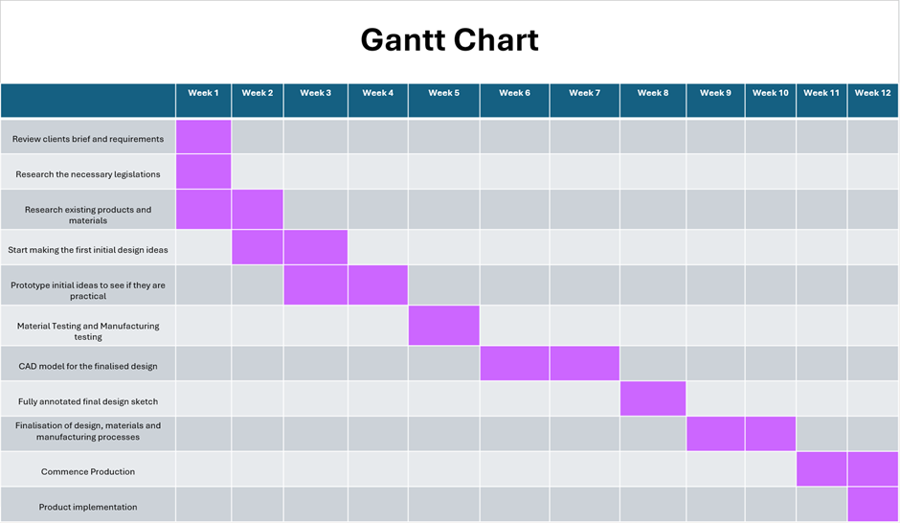

Relevant Research

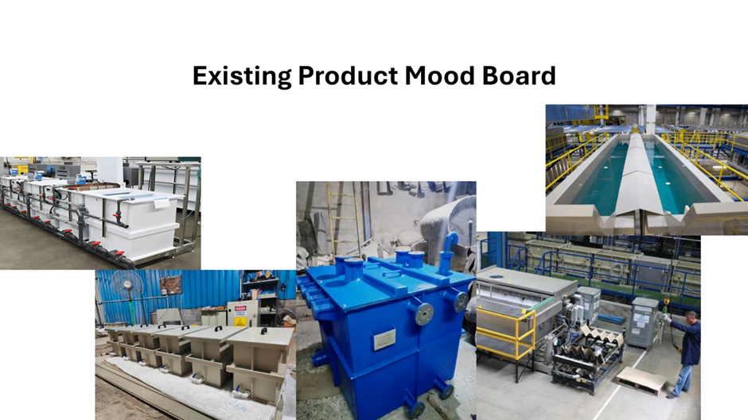

Initial Idea Sketches
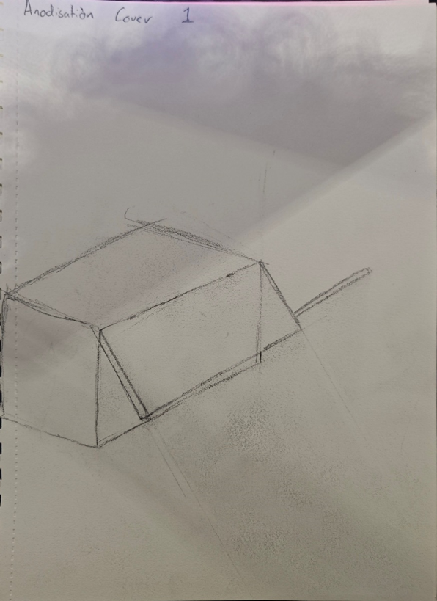

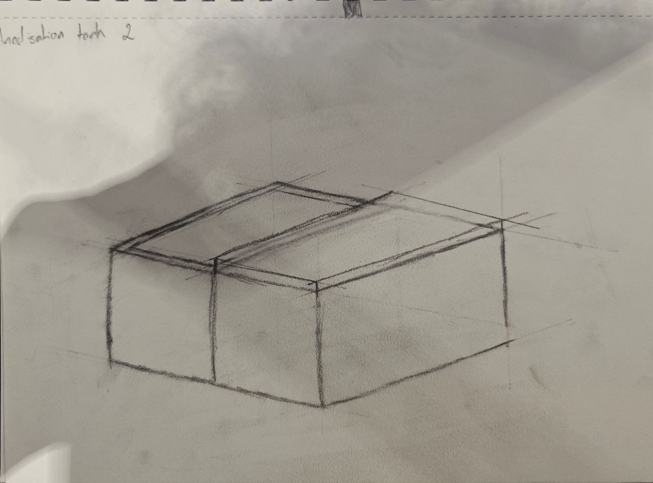

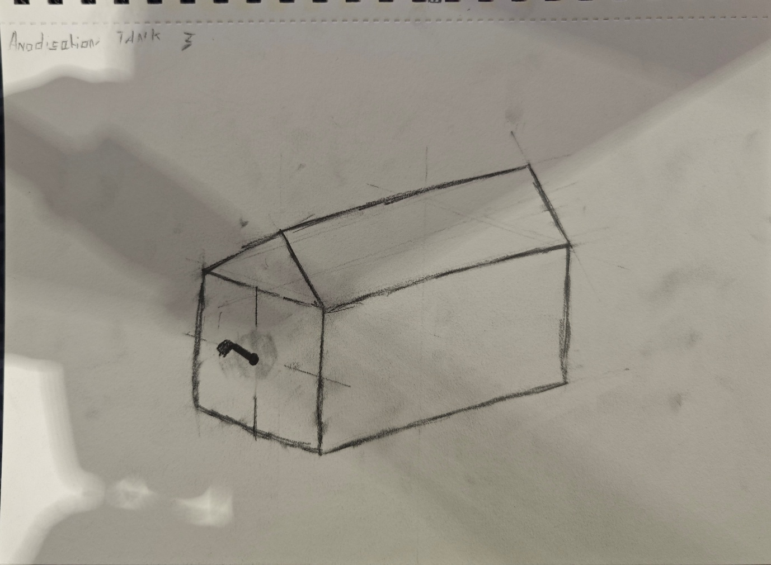

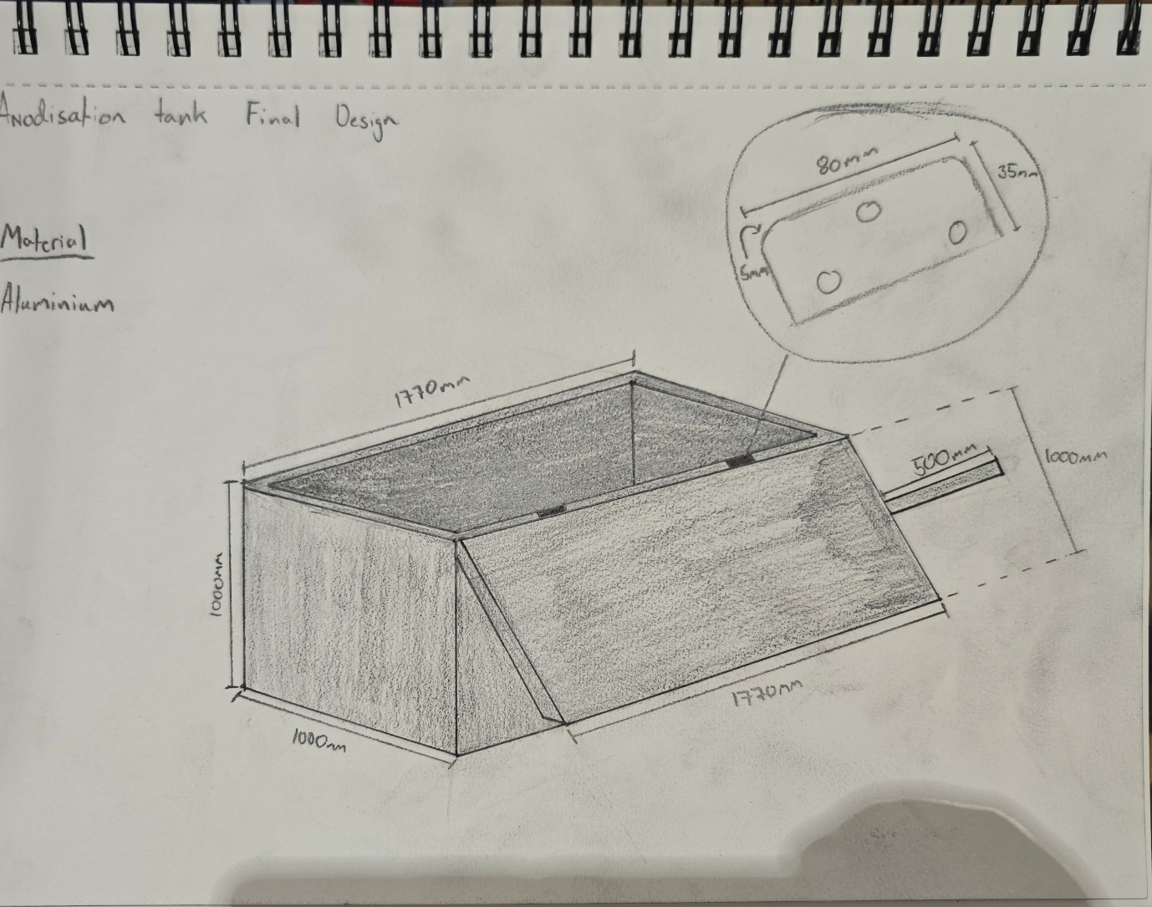
Final Design

CAD Model

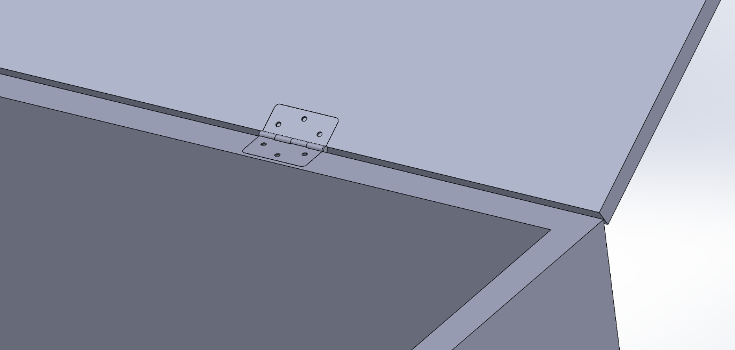

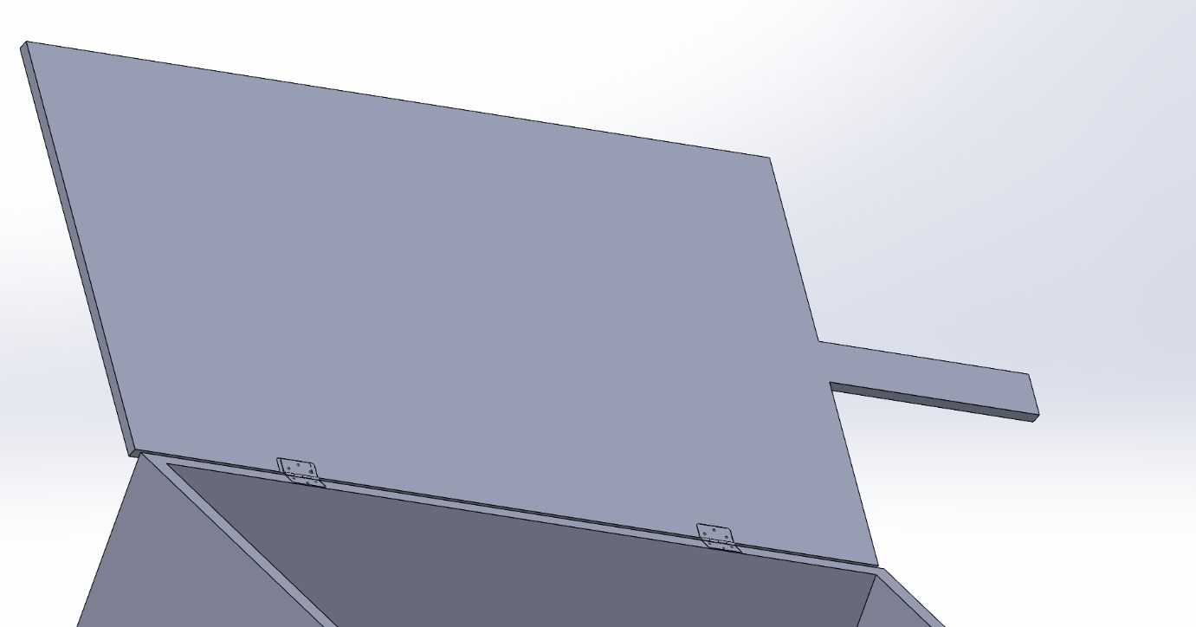

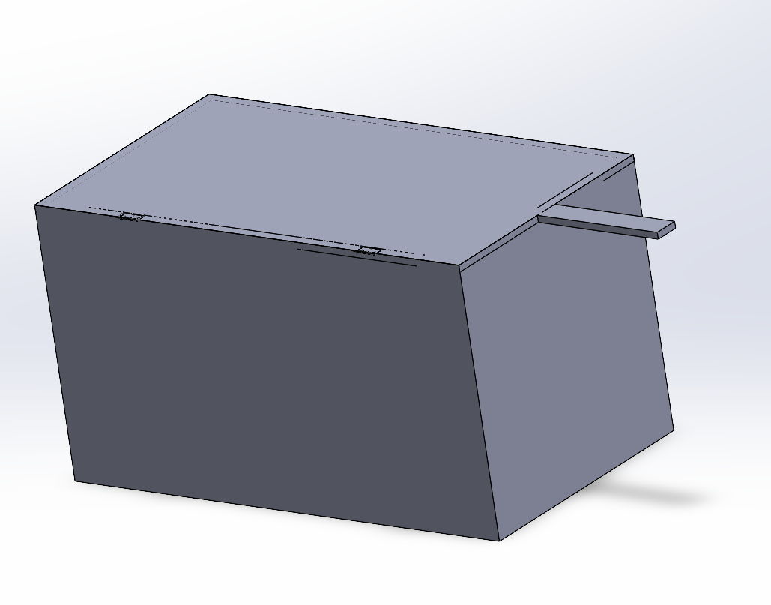
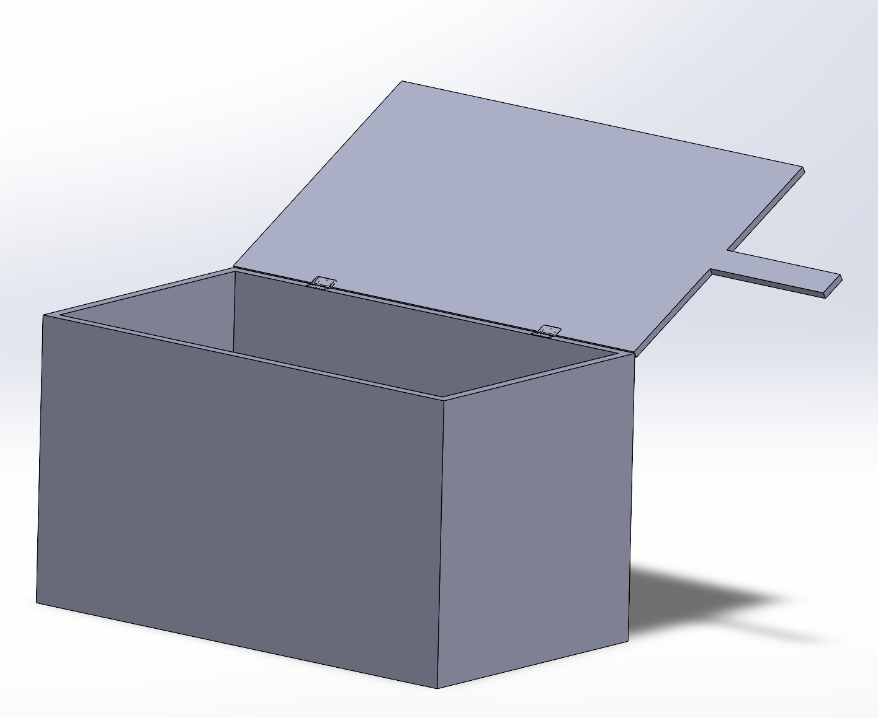

Justification

The thought process behind the new tank cover was to create a simple and easy to manufacture design that was able to be suited to the clients brief while also meeting legislative as well as industry standards. To keep the design, usability, manufacturing and cost as simple as possible the new cover has a new design that consists of two hinges that are located 345mm from the edges of the tank. These hinges are then connected to a simple rectangular shaped cover with an extruding handle that the worker operating the tank can use to open and close the tank when necessary. The long handle will give the worker the necessary leverage to be able open and close the tank cover easily without the assistance of others.

Conclusion

In conclusion the new design has met the requirements laid out in the client’s brief. The new design is simple enough to allow for a good ease of use as well as being very feasible for mass production. It also meets the requirement for it being able to be operated by a single person. It is also safe for the worker to operate and is a improvement on the previous designs health and safety.

