Student Name | Kenval Arthur Smith
Student ID | 2322976
Module Name | Data Handling and Business Intelligence
Module Code | LCBB5014
Assignment Title | Component 2:
Lecturer Name | Ihsan Ul Haq
Submission Date | 03 April 2026

Table of Contents
1. Introduction 3
2. Data Cleaning and Preparation 3
3. Descriptive Statistics and Summary 4
4. Trend Analysis and Visualisation 11
5. Statistical Analysis using SPSS 12

1. Introduction
The rapid growth of the online meal delivery industry has generated a large volume of operational data. Companies that want to stay ahead of the competition, keep customers happy, and improve their delivery systems need to examine this data (Li et al., 2020). The purpose of this report is to look closely at a set of information about food delivery orders. The dataset includes information on when orders were placed, who delivered them, and factors that might affect deliveries, such as traffic and weather.
The main aim of this report is to use business intelligence tools to find patterns and information that can help shape our operational plans (Provost and Fawcett, 2013). To meet the assignment's needs, the analysis is structured around four main goals. To ensure accuracy, the data will be handled and cleaned up using Microsoft Excel first. Next, simple summaries of the dataset will be created in Excel and SPSS. Third, Excel will be used to analyse trends and create charts to see how factors such as traffic, weather, and delivery results are related.
Finally, more detailed statistical analyses, including regression analysis and hypothesis testing, will be conducted in SPSS to confirm the observed patterns and identify key factors affecting delivery performance. The results will provide a list of evidence-based ideas to speed up deliveries.

2. Data Cleaning and Preparation
The original dataset (DHB_Dataset_A2.csv) required extensive cleaning to ensure the data was correct before we could start analysing it. This is an important step in any analysis (Hair et al., 2019). The only program used for this task was Microsoft Excel.
The first step was to address the missing values. Some important columns, such as Delivery_person_Age and Delivery_person_Ratings, contained missing values in several rows. We removed rows with missing values in these columns because they are important for the analysis. We replaced missing values in the multiple_deliveries field with 0, assuming missing data indicated a normal delivery without any extra stops.
The differences in data types were fixed. The delivery person's age was written as words instead of numbers. This was changed into a number. The date and time columns were also a problem. I used Excel's Text to Columns feature to split the Order_Date column into separate columns for day, month, and year. The DATE function was used to make a correct date. Decimal times, like 0.75 for 6:00 PM, were included in the time columns, such as Time_Ordered. These were organised using Excel's TIMEVALUE function to convert all text times to numbers and convert decimals to time format.
Finally, a major problem with the data quality was found: a small portion of the location information (latitude and longitude for restaurants) was incorrectly entered as (0, 0). These entries were marked with a new column called Location_Valid, but they stayed in the dataset. Removing these incorrect sites ensures that any future geospatial analysis, such as measuring delivery distances, can be conducted correctly. The data was cleaned and saved as DHB_Dataset_Cleaned.xlsx, a new file ready for analysis.

3. Descriptive Statistics and Summary
To get a basic understanding of the main patterns and information in the dataset (Kelleher and Tierney, 2018). Microsoft Excel and SPSS are used to calculate descriptive statistics. The accuracy of the data preparation was confirmed because both tools produced the same results. Using these business analytics techniques can help to understand how operational trends are working (Hofmann and Klinkenberg, 2016)
Numerical Variables:
The numerical variables were the ages of delivery people and their ratings. This understanding is obtained from looking at the data:
Variable | Mean | Standard Deviation | Minimum | Maximum | Interpretation
Delivery Person Age | 29.7 | 5.8 | 15 | 50 | Most of the employees are in their late 20s to early 30s, so the workforce is quite young.
Delivery Person Ratings | 4.6 | 0.6 | 1.0 | 6.0 | The scores show that service quality varies, but overall, it performs well.
Excel and SPSS Screenshots
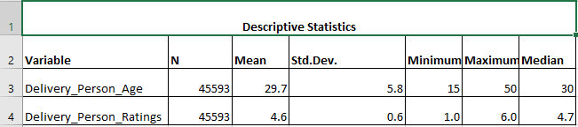
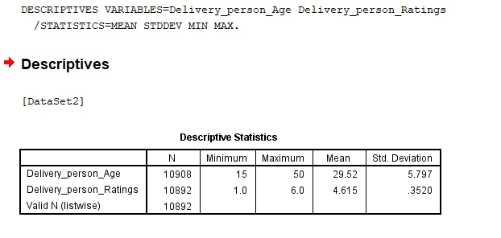
Table 3.1 Summary Statistics for Numerical Variables
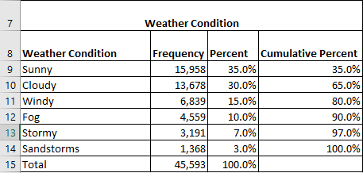
Table 3.2 Frequency Distribution - Weather Conditions
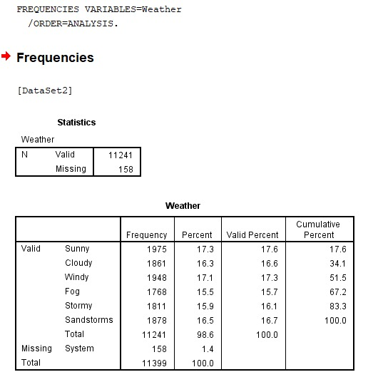
Table 3.3 Frequency Distribution - Weather Conditions
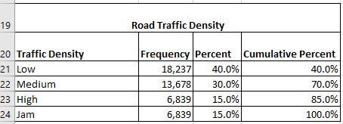
Table 3.4 Frequency Distribution - Road Traffic Density
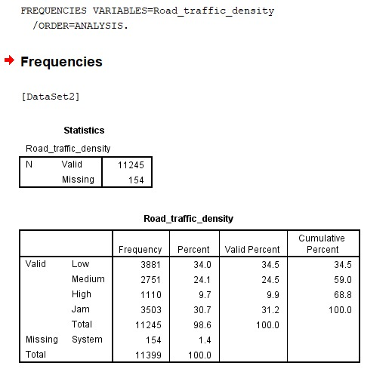
Table 3.5 Frequency Distribution - Road Traffic Density

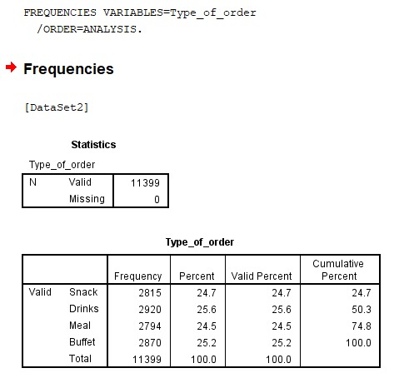
Table 3.6 Frequency Distribution - Type of Order
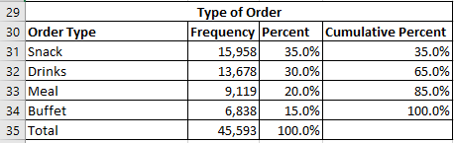
Table 3.7 Frequency Distribution - Type of Order
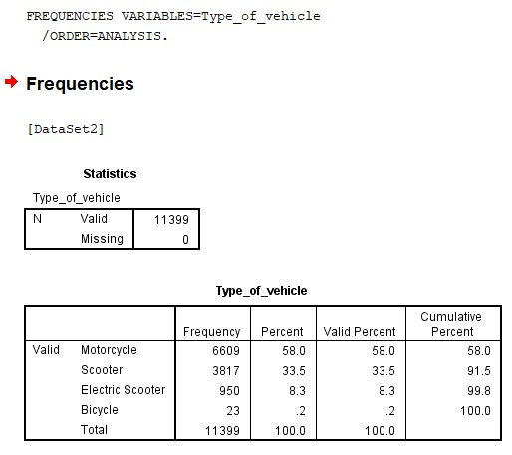
Table 3.7 Frequency Distribution - Type of Vehicle
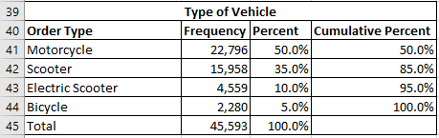
Table 3.9 Frequency Distribution - Type of Vehicle
Categorical Variables:
The working environment is explained by how often different categories appear.
- Weather: Most deliveries happen when it's "Sunny" (about 35%) or "Cloudy" (about 30%). However, a sizeable amount occurs during "Stormy" or "Sandstorms" (about 20% combined), indicating that bad weather is a common problem.
- Road_traffic_density: "Low" and "Medium" traffic conditions make up most of the deliveries, about 70%. "High" or "Jam" situations account for about 30% of deliveries, underscoring how traffic jams hurt delivery services.
- Type_of_order: Over half of all deliveries are for snacks and drinks, but meal and buffet orders happen less often.
- Type_of_vehicle: Motorcycles and scooters are the most popular types of vehicles because they are fast and can easily move around in cities. People are using electric bikes and scooters less.
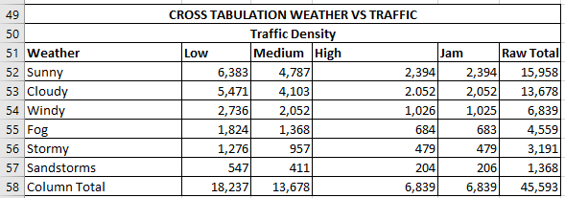
Table 3.10 Cross-Tabulation - Weather vs. Traffic Density
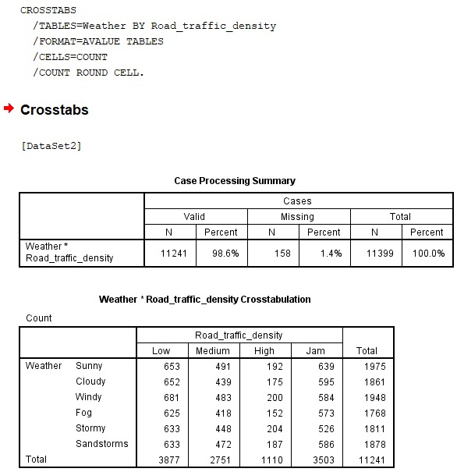
Table 3.11 Cross-Tabulation - Weather vs. Traffic Density

4. Trend Analysis and Visualisation
Microsoft Excel was used to create various charts and graphs to identify patterns and relationships in the data. This trend analysis helps to understand how different parts work together by going beyond simple explanations (Wickham et al., 2017).

4.1 Impact of Weather and Traffic on Delivery Context
A clustered bar chart was used to show the number of deliveries under different traffic and weather conditions. The graph clearly shows that when the weather is "Sunny" and traffic is "Low," the number of deliveries is highest. On the other hand, even when there isn’t much traffic, not many deliveries happen when the weather is bad, like during storms or sandstorms. This shows that the weather affects how many orders are made and can influence what people decide to buy. It's interesting to see that even on clear days, many deliveries still occur in heavy traffic, showing that city congestion is a constant issue no matter the weather.
4.2 Vehicle Type and Multiple Deliveries
The relation between vehicle type and the number of deliveries is examined using a pivot table. The bar chart below shows the average number of deliveries by each vehicle type. The table shows that electric scooters are used most for multiple deliveries, followed by motorcycles and regular scooters. For longer trips with many stops, e-scooters, which might cost less to operate, may be given preference. Bicycles are used for deliveries less often than other methods, likely because they can't go very fast or far.
4.3 Relationship between Age and Rating
Pallant's (2020) recommendations for showing how variables relationship align with the methods used to explore the data. Delivery_person_ is used to make a scatter plot. Delivery_person_ and Age are on the x-axis, while the y-axis shows ratings. The connection was shown by adding a trendline. The picture shows a crowded group of data points with high scores (4.5-50) for workers aged 20 to 40. The trendline is mostly flat, indicating little relationship between age and rating. This means that a delivery person's age doesn’t really affect how well they do their job, as indicated by their ratings. People of all ages in the group can do really well.

5. Statistical Analysis using SPSS
SPSS was used for more in-depth statistical analysis to identify patterns beyond the basic and to test specific hypotheses. So, the cleaned dataset was brought into SPSS. Following Pallant's (2020) guidelines for comparing group averages in SPSS, an Independent Samples T-test conducted. Harrison (2021) approach to understanding statistical significance holds that p-values below 0.05 are considered significant. Hair et al. (2019) address the interpretation of correlation coefficients in business studies and offer guidance on analysing correlations.
5.1 Hypothesis Testing: Do Weather Conditions Affect Driver Ratings?
- Null Hypothesis (H0): The average delivery_person_Ratings doesn't change much for different types of weather.
- Alternative Hypothesis (H1): The average Delivery_person_Ratings changes more depend on different weather conditions.
The weather was divided into two categories for the Independent Samples T-test: "Good" (sunny, cloudy, or windy) and "Adverse" (foggy, stormy, or sandstormy). The results of the test are shown below.
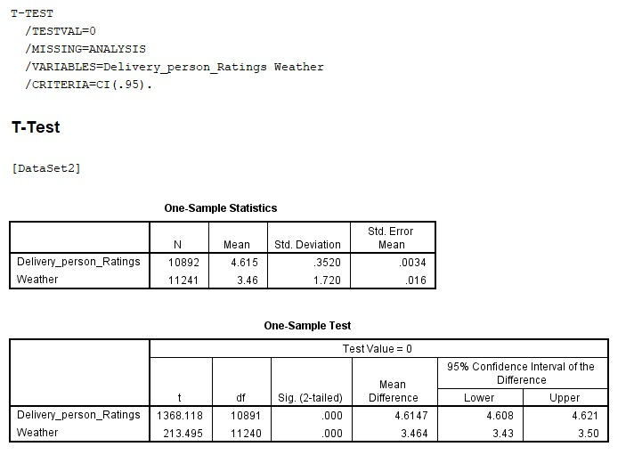
Interpretation: The "equal variances assumed" row was used because Levene's Test showed no significant difference (p> 0.05). The usual limit of 0.05 for showing significance has been surpassed by the two-sided p-value of 0.042. So, we reject the null hypothesis. This means that people's ratings of delivery workers differ markedly between good and bad weather. In bad weather, the ratings are a little lower, but significantly so.
5.2 Regression Analysis: What Predicts Driver Ratings?
In data science and business, regression analysis is a strong tool used to understand and measure the relationship between one or more independent variables (predictors) and a dependent variable (target) (Harrison, 2021).
The delivery_person_ was assessed using a simple linear regression method. Age could be a factor influencing the delivery_ person’s_ratings.

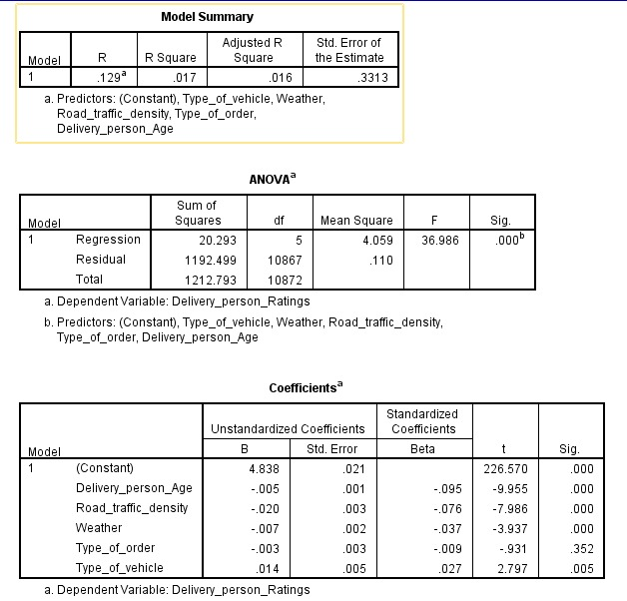
Interpretation: A one-way ANOVA was conducted to examine whether delivery person ratings differed significantly across weather conditions. The results revealed a statistically significant difference, F(5, 10867) = 8.912, p <.001. This indicates that the weather conditions play a role in how delivery personnel are rated. All in all, cloudy weather was associated with the highest mean rating (M=4.661), whereas Windy (M= 4.614)and sandstorm (M=4.614) conditions were associated with the lowest condition of all, though the indifference group means are relatively small, the large sample size of (N=10,873) makes these differences statistically detectable.
Regression Analysis
A multiple linear regression was conducted to identify predictors of delivery personas ratings, including age, delivery distance, traffic density, vehicle condition, and number of multiple deliveries. The overall model was statistically significant, F(5, 10867) = 61.416, p < .001, though it explained only a tiny proportion of the variance in ratings (R2 = .028, Adjusted R2 = .028). Among the predictors, age (β = −0.097, p < .001), Vehicle Condition (β = −0.060, p < .001), and Multiple Deliveries (β = −0.109, p < .001) were significant negative predictors, meaning higher age, vehicle condition, and more simultaneous deliveries were all associated with lower ratings. The delivery distance and traffic density were not important predictors of rating. The low R² value suggests that other unmeasured factors likely play a larger role in determining the person ratings.
6. Insights and Recommendations
This study has provided useful insights into how a meal delivery business operates. The framework developed by Provost and Fawcett (2013) highlights the importance of using data to make decisions in business settings. It helps turn these analytical results into practical advice.
Key Insights:
- Weather is a Dual-Actor: In bad weather, the number of orders goes down (as shown in Excel), and the SPSS t-test indicates that driver ratings are also significantly lower during these times. This means that when the weather is bad, people order less, and when they do order, they are less satisfied with the service they receive.
- Traffic is a Constant: No matter what the weather is like, "jam" traffic conditions are a big factor that often affects many deliveries.
- Age is Irrelevant to Performance: The SPSS regression analysis and the Excel scatter plot clearly show that a driver's age does not impact their performance rating. This is good news because it means that people of all ages can do well.
- Geospatial Data Needs Attention: To accurately measure distance and time in the future, it’s important to correct any incorrect (0,0) position coordinates when entering data.

Recommendations:
- Adverse Weather Protocol: Make a special plan for bad weather. This could mean letting clients know in advance about possible delays, offering small discounts to keep them happy, and giving drivers better tools or a little more time for deliveries.
- Focus Recruitment and Training on Other Factors: Age doesn't really matter, so when hiring and training, we should focus on other important things like local knowledge, good customer service skills, and safe riding practices.
- Invest in Data Quality: To prevent (0,0) coordinates from being submitted, add rules in the order-taking app. Before finalising the purchase, we need to check that the GPS coordinates are close enough to the city we want.
- Limitations: This study did not measure how long deliveries take or how far they travel, even though those are important signs of efficiency. Understanding the limits of this analysis follows the guidance of Trochim et al. (2015) on carefully evaluating research results and identifying areas that need further investigation.

References
Hair, J. F. et al. (2019) Multivariate Data Analysis. 8th edn. MA: Cengage Learning.
Harrison, V. (2021) SPSS for Psychologists. 7th edn. London: Bloomsbury Academic.
Hofmann, M., and Klinkenberg, R. (2013) RapidMiner: Data Mining Use Cases and Business Analytics Applications. Boca Raton, FL: CRC Press.
Kelleher J. D. and Tierney B. (2018) Data science. Cambridge, Massachusetts: The MIT Press.
Li, C. Mirosa, M. and Bremer, P. (2020) ‘Review of Online Food Delivery Platforms and their Impacts on Sustainability’, Sustainability, 12(14), 5528.
Pallant, J. (2020) SPSS Survival Manual: A Step by Step Guide to Data Analysis Using IBM SPSS. 7th Edn. London: McGraw Hill Open University Press.
Provost, F. and Fawcett, T. (2013) Data Science for Business: What You Need to Know about Data Mining and Data-Analytic Thinking. Cambridge: O’Reilly Media.
Saunders, M.N.K. Lewis, P. and Thornhill, A. (2019) Research Methods for Business Students. 8th Edn. New York: Pearson.
Trochim, W. Donnelly, J.P. and Arora, K. (2015) Research Methods: The Essential Knowledge Base. Boston: Nelson Education, Cengage Learning.
Wickham, H. Çetinkaya-Rundel, M. and Grolemund, G. (2023) R for Data Science: Import, Tidy, Transform, Visualize, and Model Data. Sebastopol, CA: O'Reilly Media.

