

Strategic Management (LCMB7003)

Strategic Analysis of Apple


Student name: Ronak Jerambhai Devani
Student Number: 2531597
Lecturer: Dr.Hoang Nguyen
Word count: 5261
Submission Date: 12th August 2026

Table of Contents
Section 1 3
1. Organisational Context and Overview 3
1.1 Summary of the organisation 3
1.2 Industry overview, competitors and market position 4
2. External and Internal Analysis 6
2.1 Evaluation of External Factors with PESTLE Analysis 6
2.1.1 Political factors 6
2.1.2 Economic factors 8
2.1.3 Social factors 10
2.1.4 Technological factors 12
2.1.5 Legal factors 14
2.1.6 Environmental factors 15
2.2 Evaluation of internal environment with VRIO Analysis 16
2.2.1 Resource 1: Apple Brand Equity, Artificial Intelligence (AI) Capability and financial strength 16
2.2.2 Resource 2: Apple’s Integrated Ecosystem and Supply Chain Capability 19
2.3 SWOT analysis 21
3. Comprehensive and holistic view of the organisation 24
3.1 Current CSR strategy by Apple 24
3.2 Evaluation through balanced scorecard 29
4. Strategic Choices and Implementation 31
4.1 Available strategic choices 31
4.2 Identification of most appropriate strategy (Ansoff) 34
4.3 Explanation of how the recommended strategy delivers optimum performance 37
4.4 Potential challenges and propose solutions 38
Section 2: Reflective account 40
1. Introduction 40
2. Gibbs’ Model 40
3. Conclusion 42
References 43

Section 1

1. Organisational Context and Overview

1.1 Summary of the organisation
Apple is one of the leading technology companies operating at the global level with exclusive products such as smartphones (iPhone) and laptops (Macbooks). Considering the values of Apple, the CEO quoted, “We believe that business, at its best, serves the public good, empowers people around the world, and binds us together as never before” (Apple, 2026). On the other hand, Apple has also committed itself in demonstrating business as a force for good. Considering the operating style of Apple, innovation has been its topmost priority which has reflected in all of its products over the years.
In this context, Apple (2025) has claimed that it has spent more than $500 billion across the United States with an aim to promote innovation for advanced high-skilled manufacturing. On the other hand, Lipton (2025) has argued that Apple has also hired 20,000 people for improving the manufacturing units, whereas the sales of iPhone jumped by 22% to $54.3 billion revenue while revenue of Mac climbed by 29%.
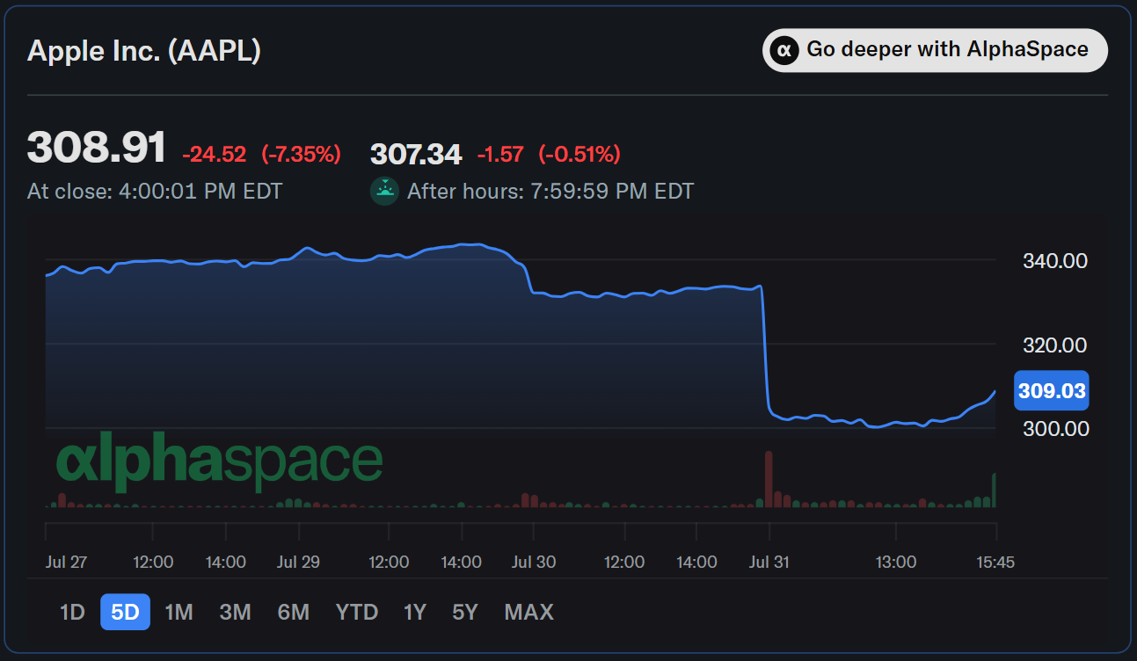
Figure 1: Revenue growth forecast of Apple
(Source: Lipton, 2025)

1.2 Industry overview, competitors and market position
Considering the Indian technology market, it can be observed that the market size was $90.2 billion in 2025 which is expected to grow at a CAGR of 12.4% to reach $102.5 billion by 2026 and $232.2 billion by 2033 (Grand View Research, 2026).
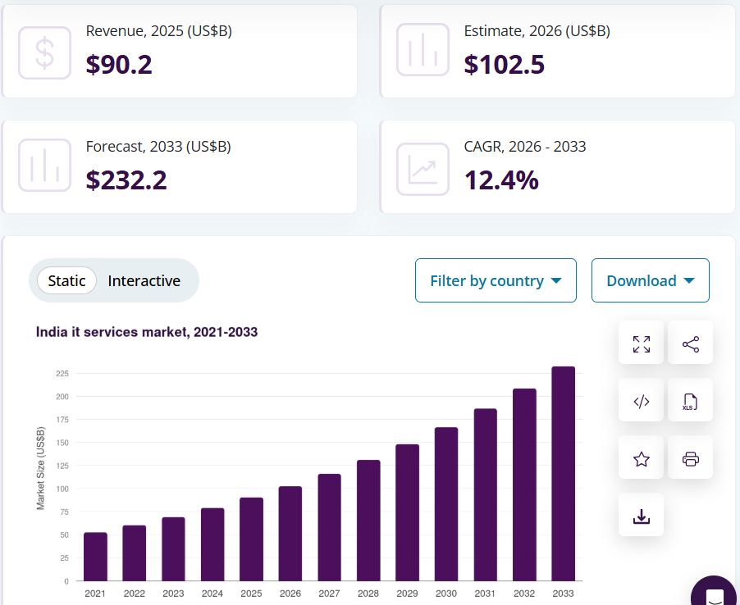
Figure 2: Market size of the Indian technology market
(Source: Grand View Research, 2026)
Apple has several key competitors in the global technology market such as NVIDIA, Alphabet (Google), Microsoft, Amazon, SpaceX and many more. Considering the market capitalization of Apple and its global competitors, Statista (2026) has reported that NVIDIA is leading the list with $4,846 billion followed by Alphabet with $4,311 billion and Apple at number three with $4,249 billion.
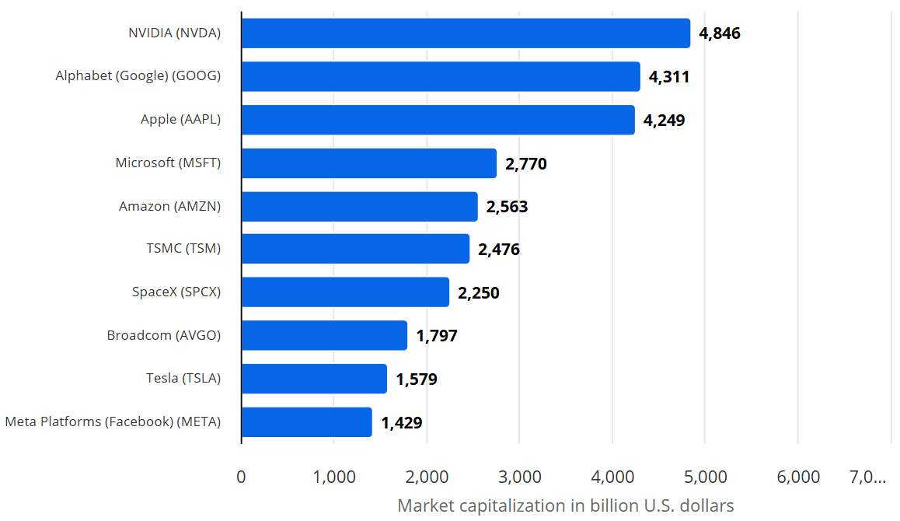
Figure 3: Market capitalisation of the global technology companies
(Source: Statista, 2026)
Taking the position and market share of Apple in the Indian market into consideration, Gusain (2025) has mentioned that Apple has been leading the market with 26% market share beating Samsung since Q1 of 2025, a rise from 20% in Q1 of 2024. The other competitors being Vivo with 16%, Oppo with 13% and Realme with 7%.
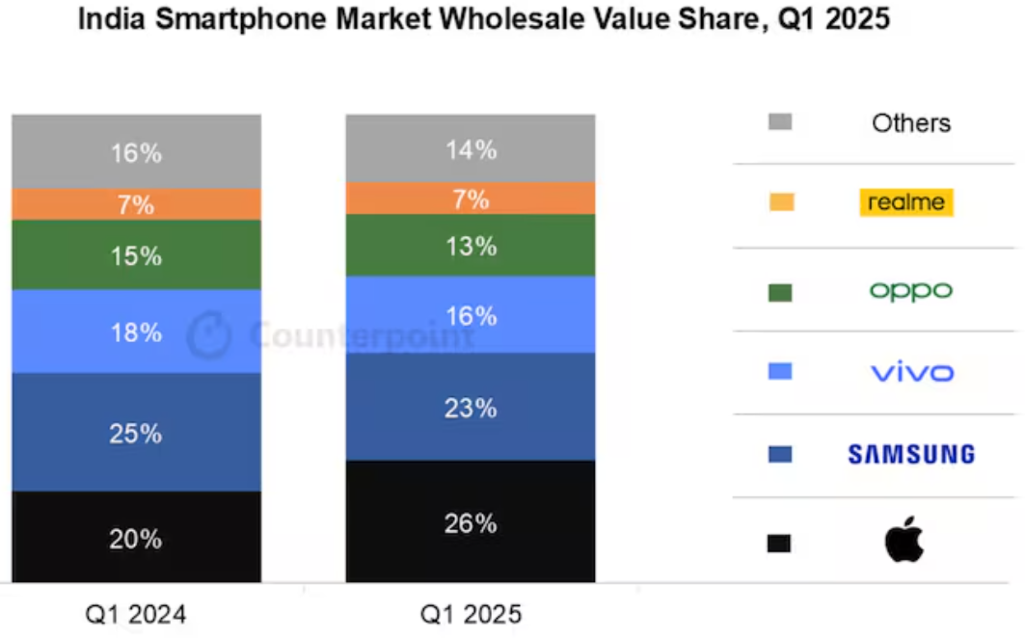
Figure 4: Market share of Apple in India compared to its core competitors
(Source: Counter Point, 2025)

2. External and Internal Analysis

2.1 Evaluation of External Factors with PESTLE Analysis
As part of the Strategic Management Module in Week 2, PESTLE Analysis is used to evaluate the macro environment by identifying the external factors to develop opportunities and threats of an organisation. The framework helps to determine the political, economic, social, legal and technological factors (Week 2).

2.1.1 Political factors
The political environment of India has become favourable for the global technology manufacturers. India has some initiatives like the "Production Linked Incentive (PLI) Scheme" and the Make in India initiatives (Times of India, 2026). These policies help with the financial incentives and reduce the dependency on imports. India has become the second-largest mobile phone manufacturer in the world with more than 300 mobile manufacturing units (IBEF, 2025). The electronic exports reached US$22.2 billion during FY2026 in India. Political factors are important as government policies such as PLI and Make in India affect the manufacturing costs of Apple, along with investment and supply chain decisions.
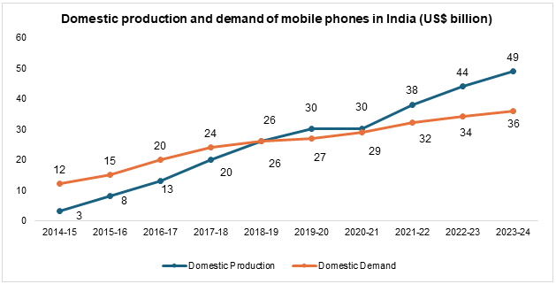
Figure 5: India’s Rise as the Second Largest Smartphone Manufacturer
(Source: IBEF, 2025)
Opportunities
- The expansion of local manufacturing under the PLI Scheme and Make in India initiatives can reduce production costs (Times of India, 2026).
- This can strengthen Apple's supply chain process and enhance its export competitiveness.
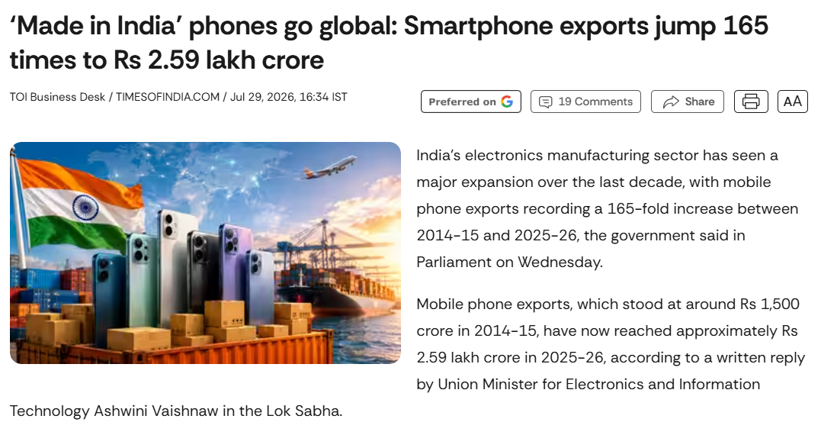
Figure 6: India’s largest mobile phone sector
(Source: Times of India, 2026)
Threats
- Changes in the localised policies, import tariffs, and geopolitical uncertainty may increase the manufacturing costs.
- This can disrupt the global supply chain of Apple.

2.1.2 Economic factors
India remains one of the fastest-growing major economies and supports higher customer spending on premium technology products. India's smartphone market grew by 8% value in 2025. However, the shipment volume increased by only 1% indicate strong premium part. The smartphone prices above ₹30,000 accounted for approximately 22% of total smartphone shipments (The Economic Times, 2026). Whereas the premium segment has recorded almost 11% of annual growth. Further, Apple achieved the highest 28% value share in the smartphone market of India (The Economic Times, 2026). Economic factors are important because income growth and demand for premium smartphones directly influence Apple’s sales and revenue.
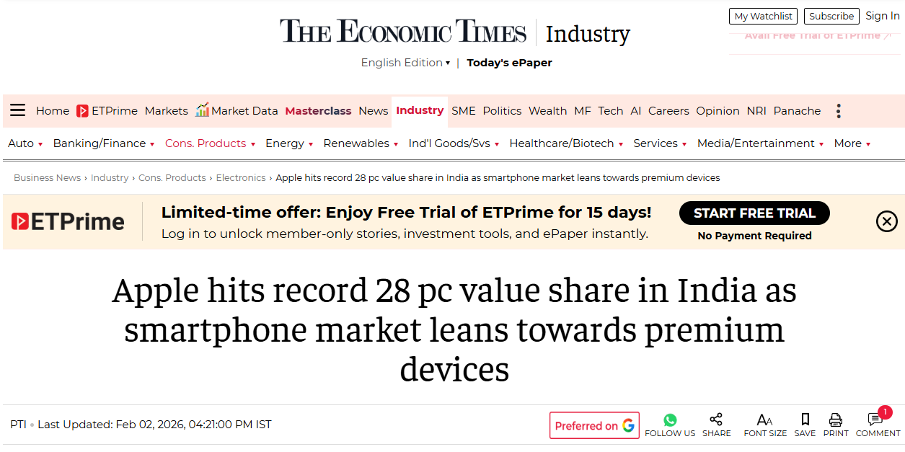
Figure 7: Apple hits record 28 pc value share in India
(Source: The Economic Times, 2026)
Opportunity
- Rising middle-class consumption drives the long-term revenue growth.
- The development of Indian premium smartphones supports the premium pricing strategy of India (Jaiswal et al., 2025).
Threats
- The price-sensitive customers continue to shift towards the lower-priced Android smartphones.
- The demand for the refurbished smartphone market of 4.9% YoY in 2025 (Counterpoint, 2025). This may reduce the sales of new iPhones.
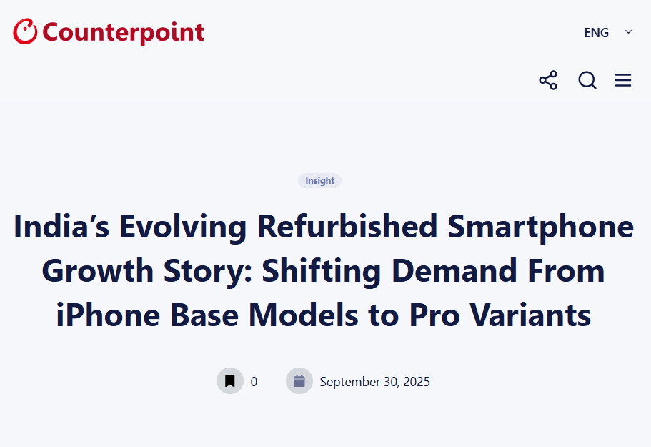
Figure 8: The demand for refurbished smartphones in India
(Source: Counterpoint, 2025)

2.1.3 Social factors
India has one of the digitally connected young populations, which creates the proper market for smartphone adaptations. As per PIB (2025), 97.6% of the urban people aged 15-29 and 96.8% if the rural people aged 15-29. They used the mobile phones during the previous three months. These development of the digitally connected with youth population enhance the demand for premium smartphones and digital ecosystems. Social factors are important because India’s large young and digitally connected population. This creates the strong demand for smartphones and Apple’s ecosystem.
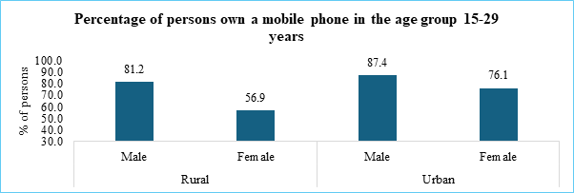
Figure 9: Use of mobile telephones in India
(Source: PIB, 2025)
Opportunities
- Growing young populations with 94.3% of internet users in India (PIB, 2025).
- The premium smartphone market grew at 20% of market share in 2025 (Counterpoint Research, 2025).
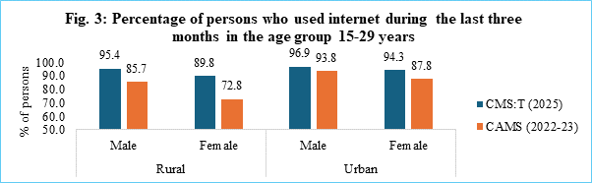
Figure 10: Use of the Internet in India
(Source: PIB, 2025)
Threats
- Strong competition from Samsung, Vivo, and OPPO limits the market expansion of Apple.
- Price Sensei customers often prefer Android over Apple.

2.1.4 Technological factors
The digital economy of India expands through 5G deployment, AI adoption and cloud-based digital services. As suggested by Farman et al. (2025), the premium smartphones increasingly depend on the AI-powered capabilities to create new opportunities for Apple. However, Apple's rollout of Apple intelligence has been slower due to limitations of languages and regional restrictions. As per Counterpoint Research (2026), the premium smartphone segment recorded almost 11% year on year growth. This has accounted for 22% of the total smartphone shipments. Technological factors are important because 5G, AI and digital services create opportunities for Apple. These offer the advance products with faster innovations.
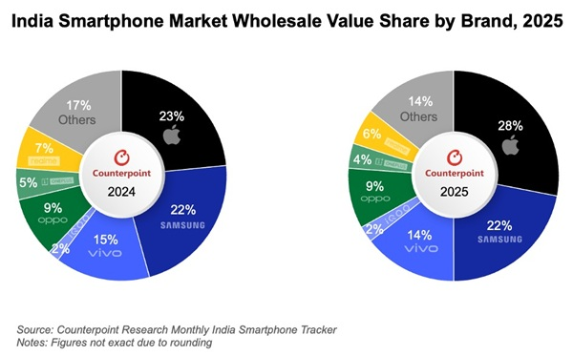
Figure 11: India smartphone market grew 1% YoY in 2025
(Source: Fonearena, 2026)

Opportunities
- Expansions of 5G infrastructure increase the demand for premium smartphones and Apple services.
- India's premium smartphone segment grew by 11% in 2025 to support the flagship of iPhones (Fonearena, 2026).
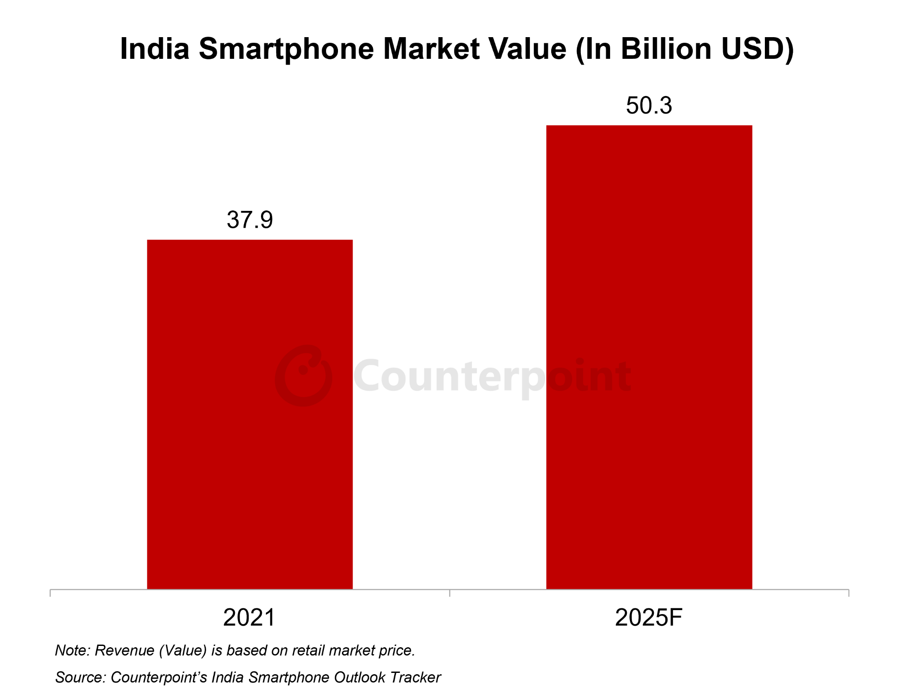
Figure 12: The Indian smartphone market
(Source: Counterpoint Research, 2025)
Threats
- Google and Samsung provide AI-powered features across a wide range of services.
- Higher technology innovations can shorten the replacement cycles of smartphones (Kaur et al., 2025).

2.1.5 Legal factors
India has developed the digital regulatory framework with the help of the Digital Personal Data Protection (DPDP) Act (PIB, 2025). This helps to maintain the strict regulations of Apple. Long-lasting privacy and security of the company align with the regulatory developments. Apple continue to face regulatory pressure related to taxation. The legal factors are important because of data protection, localisations and taxation effects.
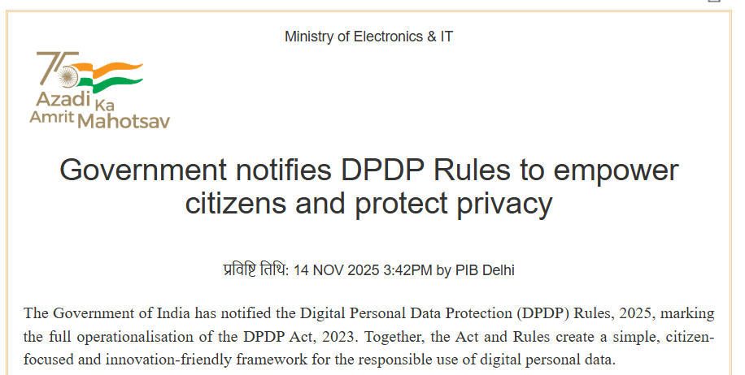
Figure 13: Legal factors of India
(Source: PIB, 2025)
Opportunities
- Strong data protection laws can maintain the competitive advantages of Apple.
- Developed intellectual property can protect the R&D capabilities.

Threats
- Increased costs related to privacy, taxation, and competitive regulations.
- Changing localisation requirements can increase the operational complexity.

2.1.6 Environmental factors
Environmental sustainability has become a main part of India's electronic industry. India is the third-largest producer of electronic waste in the world. The E-waste management market in India is expected to grow "US$ 15.29 billion by 2034 from US$ 4.40 billion in 2024" (Market.US, 2025). This factors are effective as the e-waste regulations and sustainbility can affect the recycling costs of Apple.
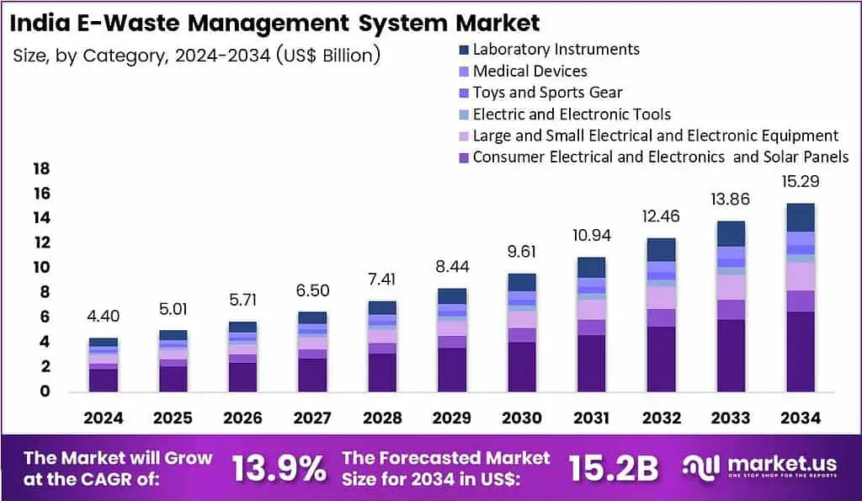
Figure 14: India E-Waste Management System Market
(Source: Market.US, 2025)
Opportunities
- Circular economy policies can help in the recovery of valuable electronic materials.
- Growing consumer awareness of sustainable products develops Apple's environmental reputation (Sharma, 2025).
Threats
- Increased e-waste regulations can increase the recycling costs.
- Failure to meet the sustainability targets could negatively affect Apple's brand reputation.

2.2 Evaluation of internal environment with VRIO Analysis
As per the Week 4 Strategic Management module, VRIO analysis evaluated the organisational resources and the capabilities. This determines the sustainable competitive advantages to position in the Indian premium smartphone market.

2.2.1 Resource 1: Apple Brand Equity, Artificial Intelligence (AI) Capability and financial strength
● Valuable: Yes
● Rare: Yes
● Imitable: Difficult to imitate
● Organised: Yes
● Competitive advantage: Sustained Competitive Advantage
Justification
Apple is one of the most valuable intangible resources in the world. As per Media Avatar (2025), Apple remained the most valuable brand in the world for the 13th consecutive year. Moreover, the brand value of Apple was US$574.5 billion in 2025 (Brand Finance, 2025). This reflects the increase of almost 10% from the previous year. This effective brand reputation helps Apple to charge premium prices and maintain higher customer loyalty. AI strengthens Apple Intelligence and improves product functionality. Apple is also organised to use the resources with consistent global marketing and integrated customer support. As suggested by Dzreke (2025), this allows the company to gain competitive advantages.
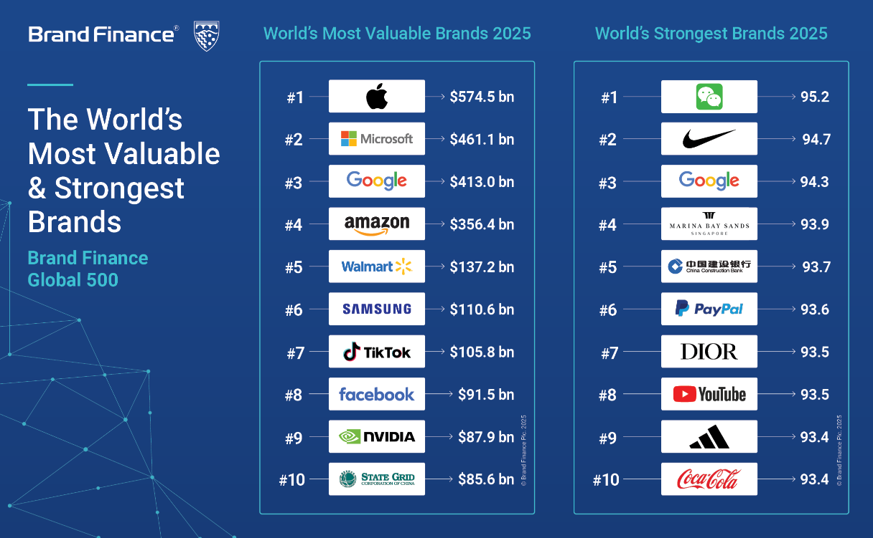
Figure 15: Apple is the 2025 most valuable brand in the world
(Source: Media Avatar, 2025)
Strengths
- The valuable technology brand in the world, such as US$574.5 billion in 2025 (Brand Finance, 2025).
- Develops customer trust and purchase intentions.
- Strong customer loyalty and the premium position of the brand.
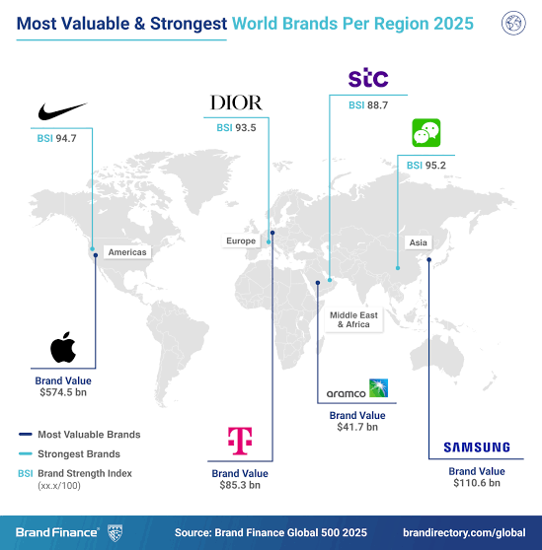
Figure 16: Apple is the 2025 most valuable brand in the world
(Source: Brand Finance, 2025)
Weaknesses
- Limited penetrations among the middle-income customers can restrict the overall market share (Akhonzada, 2025).
- Premium pricing can limit the affordability in the highly price-sensitive market in India.

2.2.2 Resource 2: Apple’s Integrated Ecosystem and Supply Chain Capability
● Valuable: Yes
● Rare: Yes
● Imitable: Difficult to imitate
● Organised: Yes
● Competitive advantage: Sustained Competitive Advantage
Justification
The integrated ecosystem of Apple combines hardware, software and digital services, including iPhone, Mac, iPad, iCloud, Apple Music, and Apple Pay. Apple also has stronger supplier network and supports large scale productions. This ecosystem of the company provides seamless business across multiple devices. As per the annual report of Apple, the service revenues of the company exceeded US$107 billion in 2025 (Apple, 2026). This shows the fastest-growing business.
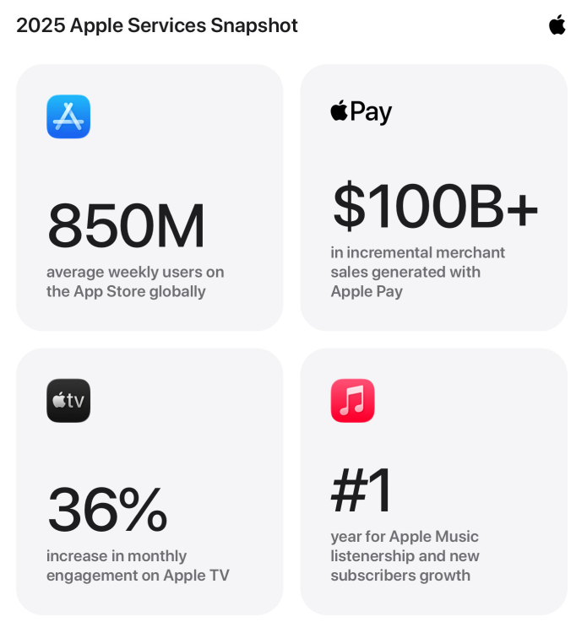
Figure 17: Apple invests every day to ensure the App Store
(Source: Apple, 2026)
Strengths
- The strong integrations between software, hardware and the digital services.
- Higher customer retention with the lock-in ecosystems (Akhonzada, 2025).
Weaknesses
- The ecosystem of Apple remains extensive for most of the Indian Customers.
- Customers using Android devices face reduced ecosystem benefits.
- Apple Pay and several ecosystem services have limited availability as compared to the developed markets (Kambhampati and Zqhair, 2025).

2.3 SWOT analysis
Strengths
- Apple is the most valuable brand, valued at US$574.5 billion in 2025 (Interbrand, 2025). This helps Apple to develop premium pricing and strong customer loyalty.
- Apple showed the highest revenue surge in India, reaching $9 billion in 2025 (The Economic Times, 2025). This reflects the strong profitability in the premium segment of the business.
- The integrated ecosystems of the company generate higher switching costs and customer retention (Apple Inc., 2025).
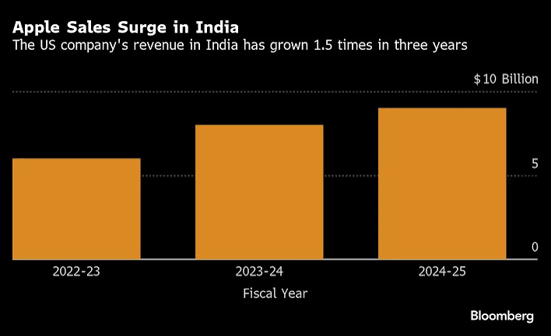
Figure 18: Apple’s Indian sales hit $9 billion
(Source: The Economic Times, 2025)
Weaknesses
- Apple's smartphone market share in India was 9% in 2025, where Vivo was in 23%, and Samsung was in 15%. This shows weak penetrations in the smartphone market segments (Tech Crunch, 2025).
- The premium price of Apple limits the affordability in the highly sensitive market in India.
- Limited Apple stores and the after-sales service centres outside the main top-tier cities can limit the market penetration of iPhone sales.
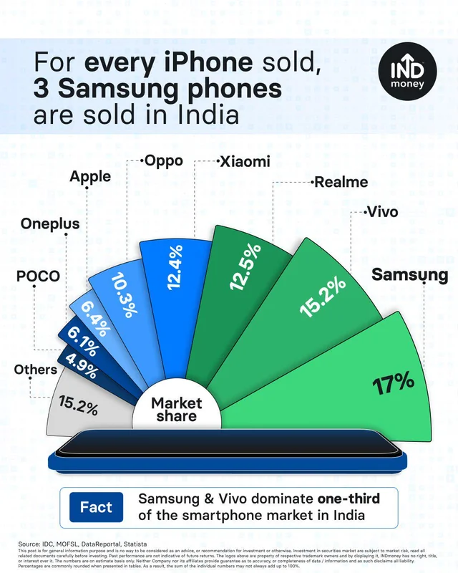
Figure 19: Indian smartphone market share
(Source: Tech Crunch, 2025)
Opportunities
- India's premium smartphone market is expected to continue to expand in 2025, with the premium segments of 25% of total smartphone shipments (Counterpoint Research, 2025).
- Growing 5G adoptions, AI integrations and the digital transformations increase the demand for premium smartphones and Apple's ecosystem of services (Ministry of Electronics and Information Technology, 2026).
- The smartphone exports market in India reached ₹2.59 lakh crore in FY2025 with 30% YoY growth (Counterpoint, 2025). This creates opportunities for Apple to expand the domestic manufacturing process.
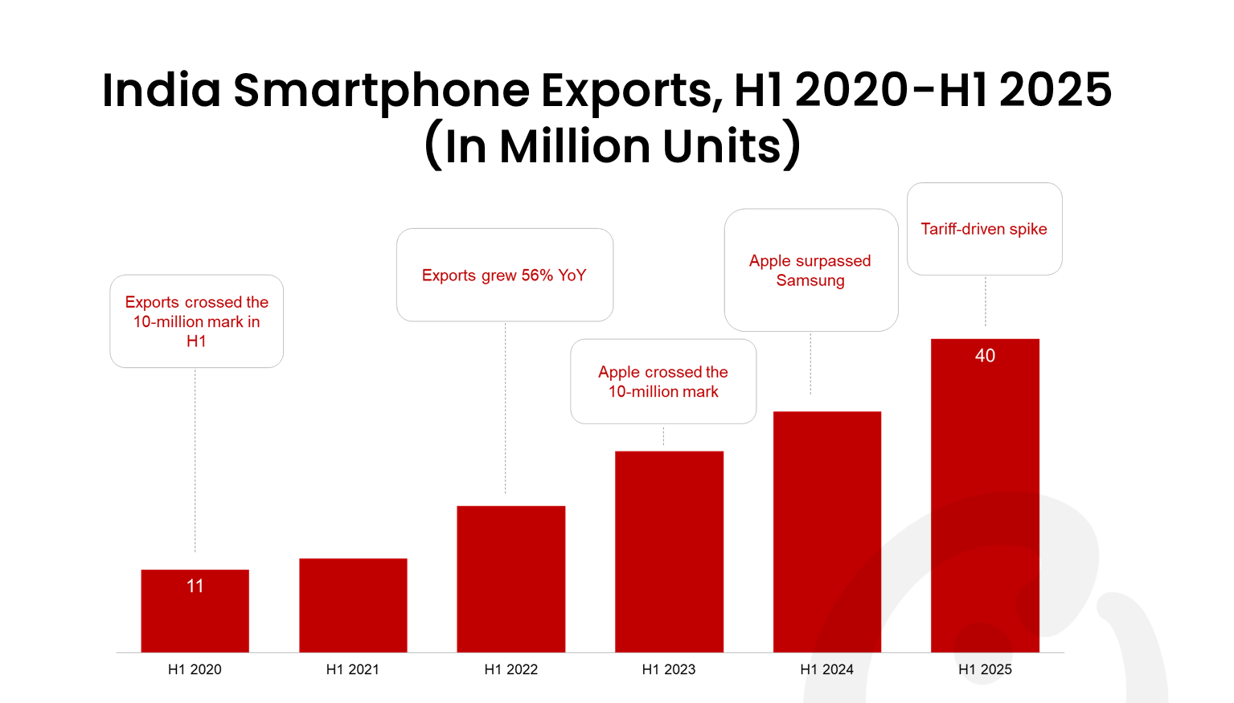
Figure 20: India’s Smartphone Exports in 2025
(Source: Counterpoint, 2025)

Threats
- India's price-sensitive consumer behaviour encourages customers to buy the feature-rich Android smartphone (Ministry of Electronics and Information Technology, 2026).
- The intense competition from Samsung, OPPO, Vivo, Google and Xiaomi offers advanced features such as batteries and AI capabilities at lower prices.
- The rapid technology innovations and the faster AI development can reduce the competitive differentiations of Apple (Farman et al., 2025).
Strategic implications of SWOT
The SWOT analysis shows Apple should use its strong brand, financial resources, integrated ecosystems and AI capabilities to maintain customer loyalty. Apple also need to address high pricing and limited market penetrations with the help of local manufacturing and wider distributions.

3. Comprehensive and holistic view of the organisation

3.1 Current CSR strategy by Apple
Apple being a global technology company, has shown some grit and commitment onwards maintaining sustainability through its business operations quite effectively. According to Apple (2026), the company has aimed to reduce greenhouse gas emissions up to 75% by the end of 2030 while using 60% recycled content in products, 50% less usage of aluminium and reducing water usage by 70%. Hence, it is evident that the sustainability strategies by Apple are not at all meeting the sustainable development goals set in the Paris Climate Agreement. On the other hand, the International Trade Administration (2026) has also mentioned that the Indian government has also enacted E-Waste Management Rules of 2016 which was amended in 2024 and Plastic Waste Management Amendment Rules, 2021 play a very crucial role in managing and regulating sustainable approaches in the technology sector.
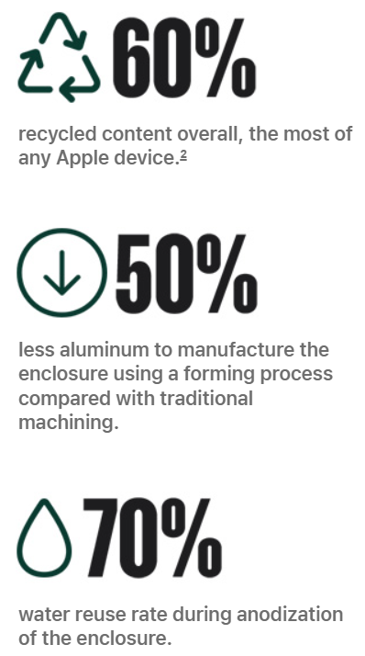
Figure 21: Sustainable initiatives by Apple
(Source: Apple, 2026 b)
In terms of maintaining diversity in the workforce, Apple has been quite active in including people from various backgrounds, origins and ethnicities across the globe. It is evident that 64% of the global employees of Apple are male while 35% of them are female and in terms of race and ethnicities, 32% are Asian, 9% are Black, 38% are White and 15% are Latinx or Hispanic (Apple, 2026 c). According to Yadav et al. (2025), maintaining diversity at the workplace can help in enhancing CSR and gaining a competitive advantage.
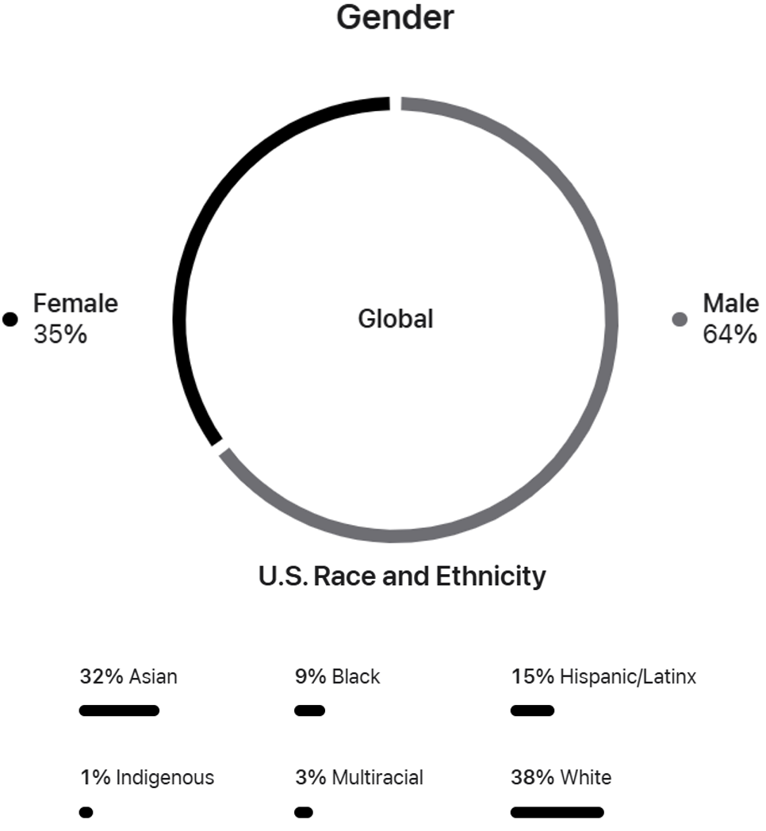
Figure 22: Diversity and Inclusion at Apple
(Source: Apple, 2026 c)
Further, considering the e-waste management by Apple, it can be observed that the company has taken some active steps. According to Apple (2026 d), Apple has partnered with local recyclers in India for recycling the used products with whom the customers can connect through WhatsApp. On the other hand, Apple has also strived forward in using 30% recycled materials in all its products while 100% recycled Cobalt in all batteries (Apple, 2026 e). In this case, Apple will be at an advantageous position in earning the trust and confidence of its stakeholders and consumers in the market, hence enhancing its competitive position. In this regard, the findings by Faibil et al. (2023) have argued that proper e-waste management can enhance CSR which ensures a competitive edge in the market.
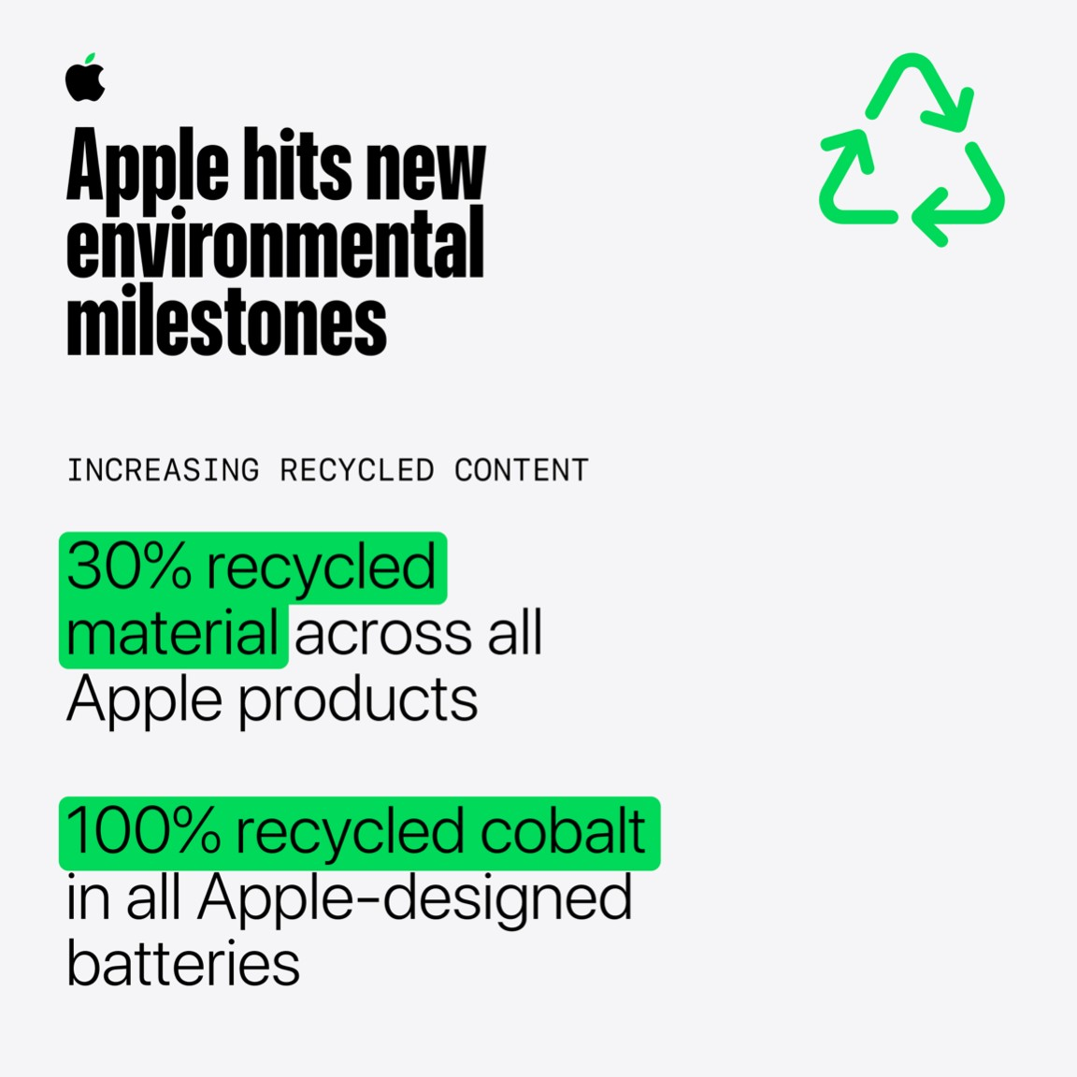
Figure 23: Environmental milestones by Apple
(Source: Apple, 2026 e)
In context to the above CSR strategies by Apple, the company will certainly get benefits in several aspects and parameters such as government regulations, influence on assets, managing costs and company reputation. Considering the green value chain of Apple, it can be observed that Apple will be able to comply with the government regulations in India which will ensure proper sustainability for the products. Further, strategies such as reduction in emission levels, improved carbon footprint and effective waste management will enhance the overall reputation of Apple in the Indian market, hence earning the trust and confidence of the consumers in the long run. In the words of Zulfikar (2024), reducing emissions levels and enhancing footprints can build company reputation and earn customer trust at the same time.
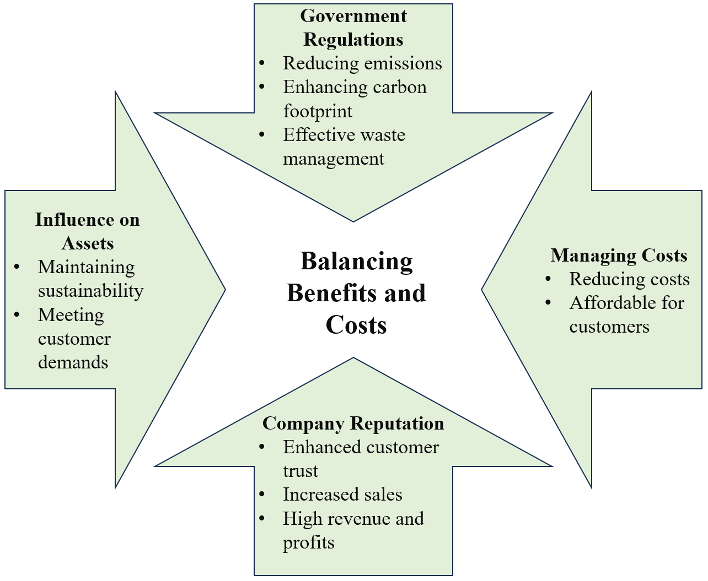
Figure 24: Green Value Chain for Apple
(Source: Inspired from Week 9; Slide 7)

3.2 Evaluation through balanced scorecard
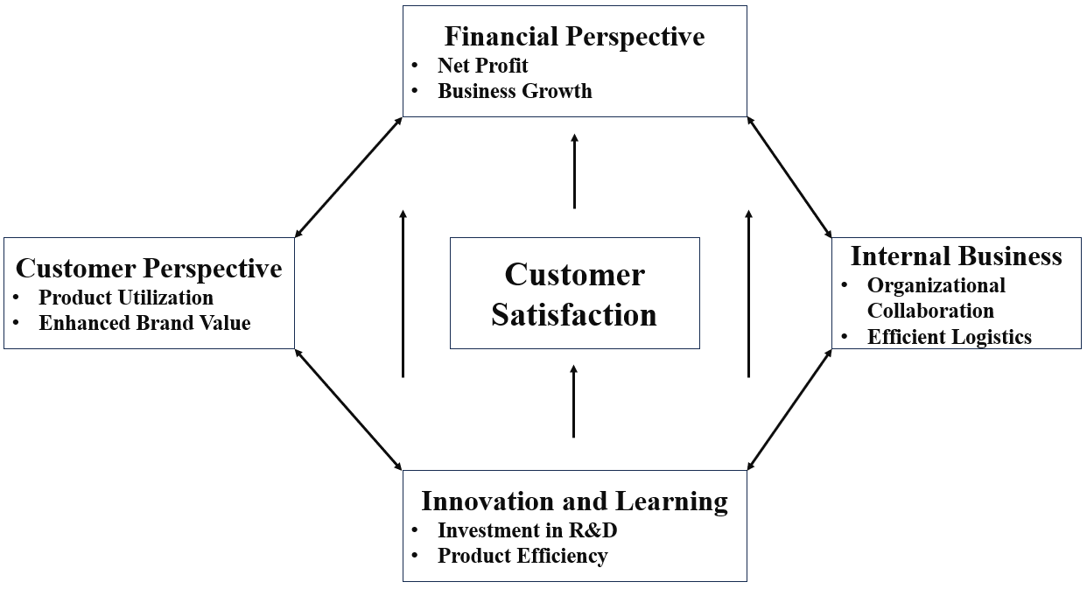
Figure 25: Balanced Scorecard
(Source: Concept taken from Week 8; Slide 20)
- Financial Perspective - In this case, the key performance indicators are net profit and business growth of Apple. Here, the focus of the company will be to enhance its net profit in the Indian market. According to Khan (2026), the revenue of Apple in the Indian market has grown to $109.4 billion, a 16% increase from the previous year. These statistics need to be improved by increasing the amount of unit sales in the Indian market compared to its competitors. As mentioned by Business Today (2024), in the financial year of 2024, Apple has shipped 4.8 million iPhones in India and generated $4.56 billion revenue whereas Samsung has shipped 9.8 million units, earning a revenue of $3.43 billion.
- Customer Perspective - In case of customer perspective, the key performance indicators are product utilization and brand value. Here, Apple needs to have a clear focus on providing quality products so that the needs and expectations of the customers can be met in the most significant way. As reported by The Hindu (2026), Samsung is leading the Indian market with an ownership share of 17.7% followed by OnePlus and Apple with 11.3% and 8.3% ownership shares respectively.
- Internal Business - In case of internal business, the key performance indicators such as organisational collaboration and efficient logistics will be considered. As found earlier, there is a significant diverse working condition in Apple workplace consisting of 32% are Asian, 9% are Black, 38% are White and 15% are Latinx or Hispanic (Apple, 2026 c). On the other hand, Nasir (2026) has argued that Apple admitted a lack of supply of iPhone 18 Pro after its launch in India. Tadayonrad and Ndiaye (2023) have argued that efficient logistics can be effective for any organisation in ensuring effective supply of products for fulfilling the market demands
- Innovation and Learning - Here, the key performance indicators are investment in R&D and product efficiency. With respect to innovation and learning, Apple will have to enhance the quality of its products by minimising the flaws such as data breaches. As per the reports by Moneycontrol (2026), the Indian government has issued a critical warning for iPhone, iPad and Mac users regarding data vulnerabilities. Hence, this issue needs to be addressed by Apple at the earliest for earning consumers trust and brand reputation at the same time.
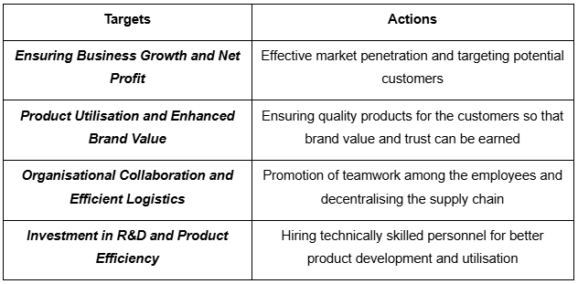
Figure 26: Targets and Actions
(Source: Self-developed)

4. Strategic Choices and Implementation

4.1 Available strategic choices
The application of Michael Porter’s generic competitive strategies such as focus, differentiation, and cost leadership can be effective in evaluating the strategic direction for the iPhone of Apple (Ștefan, Popa, and Tărăban, 2023).
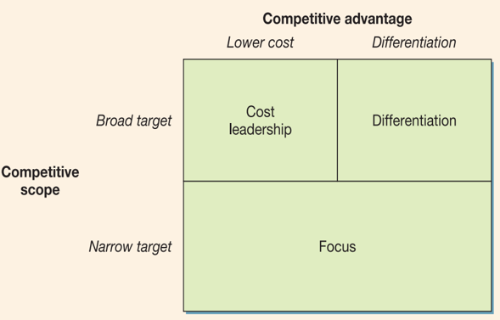
Figure 26: The Three Generic Competitive Strategies
(Source: taken from class material Week 5 slide 7)
- Cost leadership strategy: The strategy focuses on becoming the lowest-cost producer through economics of scale, process efficiency, and optimisation of input. The smartphone market in India is flat at 152 million units in 2025, and Vivo leads the market with 19.3% of market share in 2025 (BizTech Reports, 2026). On the other hand, Samsung holds 14.1%, OPPO holds 13.3%, and realme holds 9.9% of market share. In such a situation, Apple will have to cut the costs of its products so that the same can be afforded by the majority of the consumers in India, hence the sales rate will be enhanced.
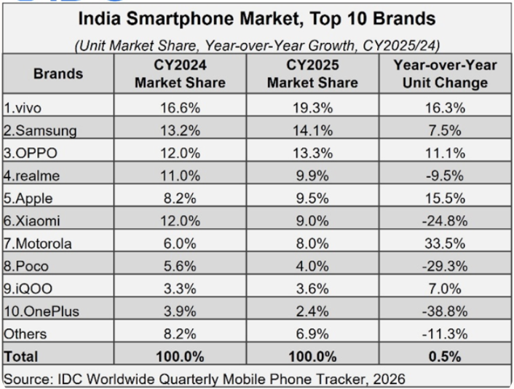
Figure 27: Market share of smartphone firms in India
(Source: BizTech Reports, 2026)
- Differentiation strategy: This strategy focuses on ecosystem lock-in, and brand prestige to justify a price premium. It is the core strength of Apple iPhone in India. Apple shipped about 14 million iPhones in India in 2025 and captured 9% of market share. The firm launched Apple Creator Studio at ₹399 that is about 66% cheaper than US pricing (Dealroom, 2026). Considering this situation, Apple needs to decentralise its supply chain and start manufacturing in India to cut freight costs.
- Focus strategy: This strategy targets a narrow and high-incomer urban segment. In this context, Apple operated in this manner for over a decade. In contrast, continued reliance of Apple on a niche results in ignoring the expanding middle class in India. The middle class of India will double to about 61% by 20246-47, making India as one of the largest markets in the world (Rajora, 2023). Similar to the cost leadership, Apple will have to reduce the costs of its products to make them affordable.
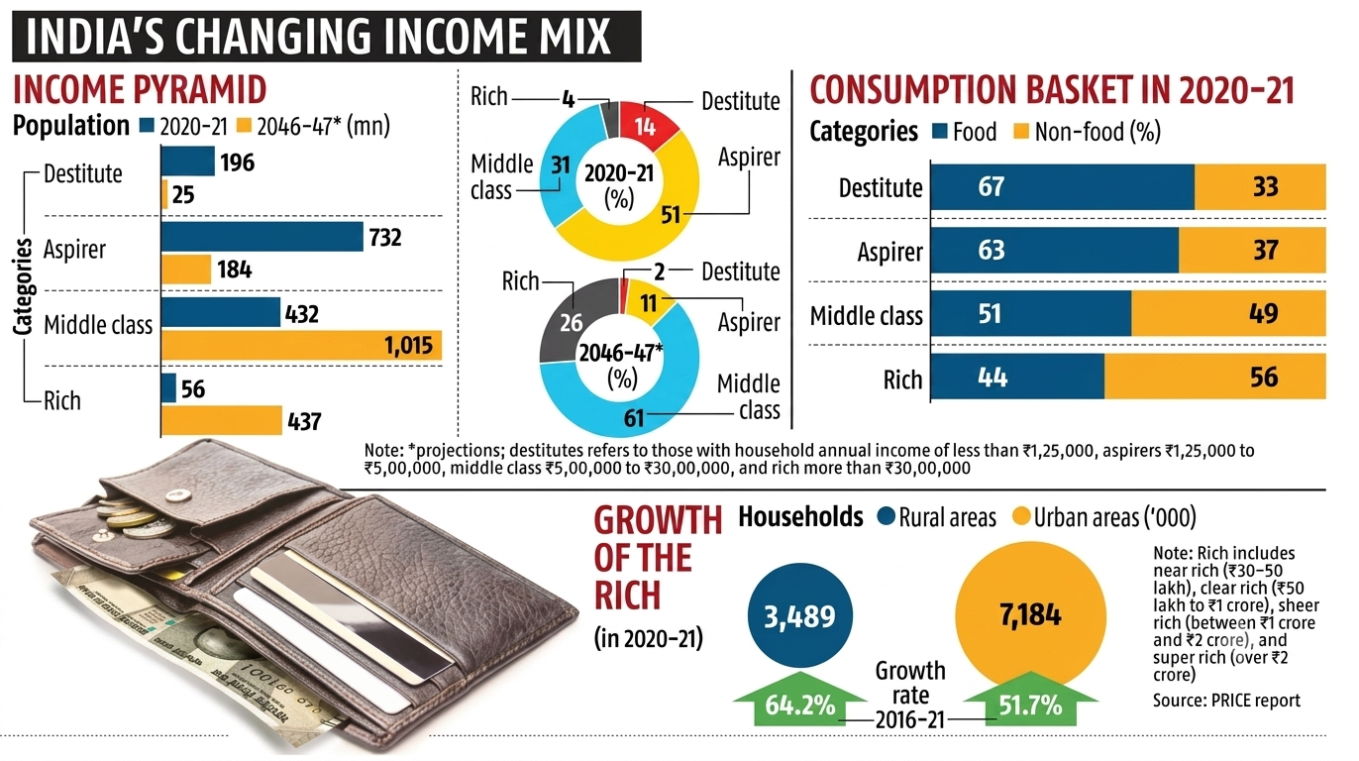
Figure 28: Middle class growth in India
(Source: Rajora, 2023)
The alignment of the SAFe framework can be effective in understanding the feasibility, suitability, and acceptability (Amadi and Dapiriteye, 2023).
- Suitability: Pure cost leadership and pure differentiation fails to match the bifurcated market of India’s price-sensitive mass buyers. These also fails to align with the fast-growing premium segment. About 25% of consumers in India delay purchases of smartphone to stay within planned budget and 29% are willing to stick to budget or consider refurbished device (Chawla, 2026). Hence, a hybrid approach fits better.
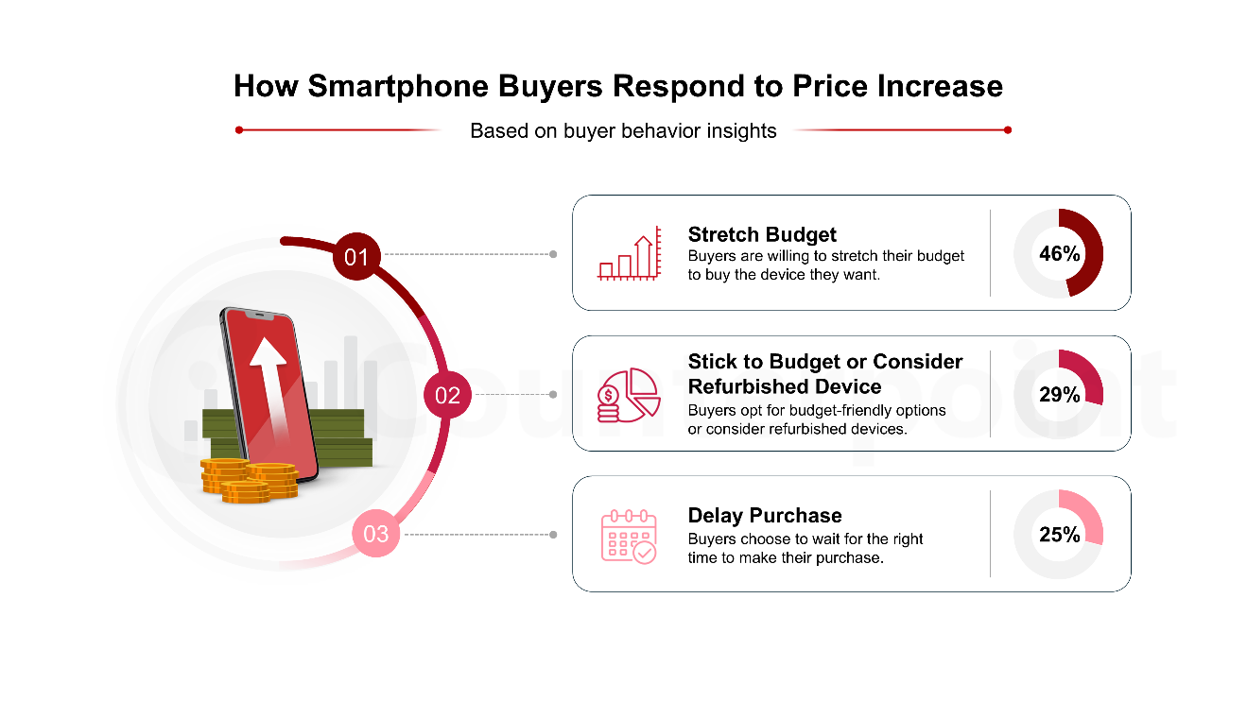
Figure 29: Price sensitivity in India for smartphone
(Source: Chawla, 2026)
- Acceptability: Investors are focused on volume growth and margin, as India is central to China diversification narrative of Apple (Milmo, 2025).
- Feasibility: Despite having capital and technical capability, the success of Apple depends on the navigation of import duties and local sourcing rules. It can be increasingly resolved through domestic assembly under the PLI (Production-linked incentive) scheme (PIB, 2025).

4.2 Identification of most appropriate strategy (Ansoff)
According to the usage of Ansoff matrix, the optimal direction for Apple consists of a combination of market development (extending existing products to broader Indian consumer segments) with market penetration (deepening share among existing premium buyers) (Ferreira and de Sá, 2024). Apple can utilise a hybrid model that is pairing premium differentiation with discipline cost efficiency. It can be attained by retaining flagship pricing on new iPhone models while utilising older-generation devices as well as localised assembly to widen accessible price points. This can be supported by the alignment of game theory (Barron, 2024). It is noted that the smartphone competition in India is an oligopoly and Chinese entrants, Samsung, and Apple continuously react to each other’s pricing and product moves in the market.
If Apple holds excessive prices with no local cost adjustment, rivals capture the expanding aspirational middle class. It this enters a price war, it can trigger a Prisoner’s dilemma that can destroy the industry-wide margins (Russell and Xu, 2024). This is reflected in the actual India trajectory of Apple, as about 40% of the final retail price of the iPhone in India is accounted for duties and taxes and has 18% of GST (Modi, 2025). As bulk of high-value components are still imported and an average assembly cost of $30 (India) is given, Apple faced challenge in cost reductions.
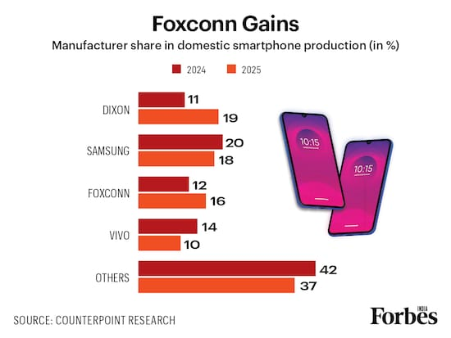
Figure 30: Smartphone product by manufacturers in India
(Source: Wani, 2026)
For executing this strategy, Apple can focus on cooperative strategy through joint ventures and contract manufacturing with Indian and multinational electronics manufacturing services partners. Tata Electronics has overtaken Foxconn regarding export value by assembling iPhones worth $26.3 billion in exports in comparison to Foxconn’s $25.6 billion (Gupta, 2026). As Apple already has manufacturing contract with Foxconn and Tata Electronics, the firm can focus on developing it into joint venture to improve growth in the Indian market.
The workforce of Tata Electronics grew from 65,647 in FY25 to 86,466 in FY26 (Techgig, 2026). Apple can also focus on entering a manufacturing contract with Dixon Technologies as it has 19% of smartphone production share in India (Wani, 2026). It became largest smartphone manufacturer in India in Q2 CY25 and is growing 196% YoY for capturing over 22% of market share and surpass Samsung (IBEF, 2026).
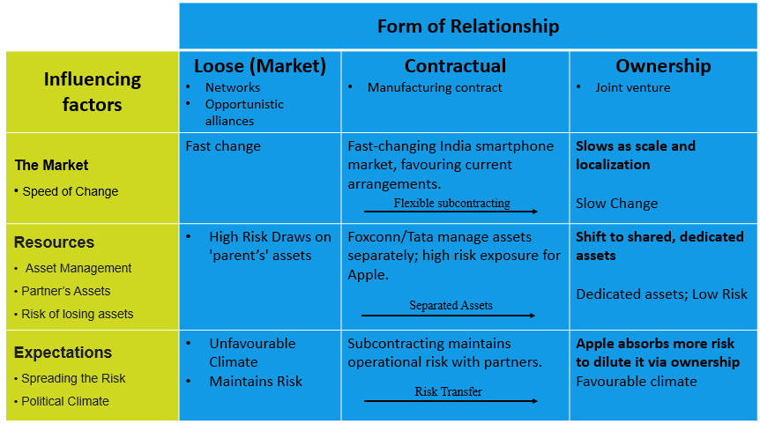
Figure 31: Forms of relationship
(Source: Inspired from class material week 5 slide 19)
Apple’s India ties map onto relationship forms, subcontracting with Foxconn and Tata sits in the contractual band, as the workforce of Tata is hiking. As risk and asset commitment grow, Apple should focus on ownership through joint ventures with Tata and add Dixon as contractual partner.

4.3 Explanation of how the recommended strategy delivers optimum performance
The combination of cooperative and hybrid models can maximise the gap between production cost and perceived customer value, indicating the essence of the mid-price and high-value positioning of strategy clock. It is visible in outcomes as India is projected to supply about 25-28% of global iPhone by 2026 as exports are expected to touch 52-55 million units in 2026 (Wani, 2026).
Across the five forces, suppliers can benefit from consolidated local sourcing leverage, and buyers can benefit from tariff-avoided pricing on locally assembled models (Loredana, 2024). This can boost adoption in the premium tier. Rivals can face combined cost-and-ecosystem threat rather than price competition alone and new entrants can deter by the scale of dual-partner manufacturing infrastructure of Apple. Substitutes can be constrained by continued iOS ecosystem lock-in. Hence, this dual capability can assist Apple from becoming stuck in the middle and capture both volume and margin growth.
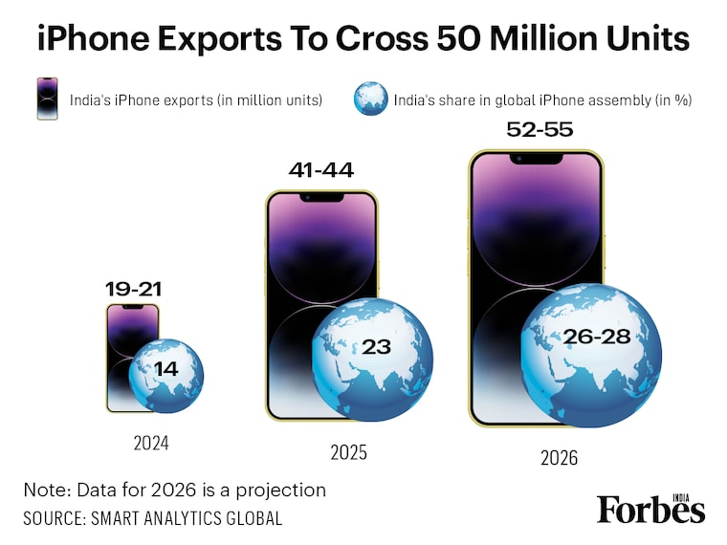
Figure 32: India’s iPhone production
(Source: Wani, 2026)

4.4 Potential challenges and propose solutions
- Regulatory and infrastructure bottlenecks: Logistics gaps, import-duty structures, and single-port dependency can create risk, as 70% of components are still imported (Sharda and Khanna, 2026). For this, deepening PLI-linked incentives, diversifying logistics corridors through PM Gati Shakti, and expand supplier-development programmes can assist.
- Brand dilution and quality control: Promoting older devices and expanding assembly can risk diluting premium perception. For this, enforcing uniform global quality assurance standards across Tata, Foxconn, and Dixon can assist in maintaining clear marketing separation between standard and pro lines.
- IP risks and partner dependency: Reliance on EMS partners can increase exposures to IP leakages and skill gaps as Foxconn replaced Chinese engineers with engineers from Taiwan, as the Chinese government aimed at limiting technology and equipment transfer to India (Fernandes, 2025). For this, keeping core technology modular, enforcing strict NDAs and continuing dual-sourcing can assist in overcoming it.

Section 2: Reflective account

1. Introduction
The reflective account shows the "Gibbs' Reflective Cycle (1988)" to determine the learning and insights gained by completing the strategic management report on Apple Inc.'s iPhone business in the Indian market. The reflection examines the applications of the strategic management theories and the analytical frameworks. This also considers the challenges faced by the organisation. The study further considered the challenges faced by the assessments, the knowledge and skills developed, and how these learning experiences will contribute to my future academic studies and the professional career in the strategic management.

2. Gibbs’ Model
- Description: This assessment focused on the researching and preparation of four sections that aimed at analysing the iPhone strategy of Apple in India. 2nd point focused on external and internal analysis that consists of using PESTLE, VRIO, and SWOT. 3rd point focused on CSR and balanced scorecard analysis. In 4th point, I utilised Porter’s generic strategies, SAFe, Ansoff matrix, as well as forms of relationship. I started the work by collecting historical and current data and the market-position of Apple, and cross-checked each recommendation’s against current industry condition.
- Feeling: Initially, I felt confident during working in 1st part as it focused on summarising the history and business model of Apple. Moving to 2nd point I felt slightly overwhelmed by amount of data that I was able to write about in PESTLE, and VRIO variables relevant to India (Opoku-Agyemang, 2025). I was worried about balancing breadth with the word limit. 3rd point felt the most unfamiliar as I had to take a deep dive into online sources to understand the ways to align green value chain of CSR and balance scorecard to Apple. In 4th point, I was assured as I already gathered market evidence and had a bit understanding regarding recommendations.
- Evaluation: I have come to learn how an effective brand reputation helps Apple to charge premium prices and maintain higher customer loyalty. This assignment has helped me to evaluate the usage of resources with consistent global marketing and integrated customer support. Maintaining consistency across various sections worked out well for me as I was able to use and align data from various sources in the work. On the other hand, I faced a bit challenge in maintaining effective word count in each sections and I had to control my initial tendency to describe the frameworks rather than effective application that I later revised.
- Analysis: I think that 4th section was one of the strongest section in the work as it consisted of information grounded in verifiable and current data and evidence-based argument is more persuasive than theoretical assertion alone. The 3rd point required the most iteration as the four perspective so balance scorecard became disconnected from actual mission of Apple unless each KPI was explicitly tied back to strategic intent. I also noted that CSR claims risked sounding generic without linking them to specific initiatives.
- Conclusion: Allocation of research time more evenly could have been beneficial for me as I think that the 3rd section received less attention in comparison to its word weightage. I also faced time pressures as I lacked effective time management and planning for this factor I also experienced mental and physical stress. As mentioned by Alhasani and Orji (2025), effective time management is one of the key drivers of stress in students. I also learned that cross-referencing sections can assist in strengthening coherence across a long assessment.
- Action plan: For any future assessments, I will aim at creating an evidence bank, plan ahead of the deadline for effective time management, and allocate research time appropriately to reduce stress and meet word count effectively. This will also assist me in apply frameworks critically and in-depth rather than just applying them to the firm’s condition.

3. Conclusion
Overall, by completing this assessment, I effectively enhanced my understanding of how the strategic management framework can be used to evaluate the organisational internal capabilities and the external environment. This assessment further developed my analytical and research skills. With the help of the module, I will continue to develop these skills by engaging with the current industry reports. The applications of the strategic models help in real-world business situations. This helps me to make more informed and effective decisions. By completing this assignment carefully, I have gained practical knowledge based on the market conditions of India. Additionally, this study examined the assessment challenges encountered, the skills and knowledge acquired, and how these insights will shape my future academic endeavors and career in strategic management.

References
Akhonzada, Z., (2025). Managing Quality in Apple’s Products and Services: A Comparative Analysis of Excellence and Ongoing Challenges. Journal Home Page, 4(2), pp.01-15. https://www.researchgate.net/profile/Zahidullah-Akhonzada/publication/400048313_Managing_Quality_in_Apple's_Products_and_Services_A_Comparative_Analysis_of_Excellence_and_Ongoing_Challenges/links/6974785a58b9985baa8a9cd8/Managing-Quality-in-Apples-Products-and-Services-A-Comparative-Analysis-of-Excellence-and-Ongoing-Challenges.pdf
Alhasani, M. and Orji, R. (2025). Promoting stress management among students in higher education: Evaluating the effectiveness of a persuasive time management mobile app. International Journal of Human–Computer Interaction, 41(1), pp.219-241. https://doi.org/10.1080/10447318.2023.2297330
Amadi, A.I. and Dapiriteye, A. (2023). Suitability-Acceptability-Feasibility Assessment and Product/Market Evaluation of Strategic Business Options for Managing Higher Education in Nigeria. NOLEGEIN Journal of Business Ethics, Ethos and CSR, 6(2), pp.11-20p. https://mbajournals.in/index.php/JoBEC/article/view/1227
Apple (2025). Apple will spend more than $500 billion in the U.S. over the next four years. [Online]. Available at: https://www.apple.com/newsroom/2025/02/apple-will-spend-more-than-500-billion-usd-in-the-us-over-the-next-four-years/ [Accessed on: 23 July 2026]
Apple (2026 b). Innovation is up. Emissions are down. [Online]. Available at: https://www.apple.com/environment/ [Accessed on: 29 July 2026]
Apple (2026 c). Inclusion and Diversity. [Online]. Available at: https://www.apple.com/diversity/ [Accessed on: 29 July 2026]
Apple (2026 d). Easy for you. Easier on the planet. [Online]. Available at: https://www.apple.com/in/reuse-recycle/ [Accessed on: 29 July 2026]
Apple (2026 e). Apple accelerates environmental progress with highest‑ever recycled material in its products. [Online]. Available at: https://www.apple.com/in/newsroom/2026/04/apple-accelerates-progress-with-highest-ever-recycled-material-in-its-products/ [Accessed on: 29 July 2026]
Apple (2026), Newsroom. Available at: https://www.apple.com/newsroom/2026/01/2025-marked-a-record-breaking-year-for-apple-services/ (Accessed on: 01/08/2026)
Apple (2026). Our Values. [Online]. Available at: https://investor.apple.com/our_values/default.aspx [Accessed on: 23 July 2026]
Apple Inc., (2026), Apple reports third quarter results. Available at: https://www.apple.com/newsroom/2026/07/apple-reports-third-quarter-results/ (Accessed on: 01/08/2026)
Barron, E.N. (2024). Game theory: an introduction. John Wiley & Sons.
BizTech Reports (2026). India Smartphone Market Flat at 152 Million Units in 2025, With 2026 Volumes Expected to Fall – IDC – March 11, 2026.. [Online]. Available at: https://www.biztechreports.com/news-archive/2026/3/10/india-smartphone-market-flat-at-152-million-units-in-2025-with-2026-volumes-expected-to-fall-idc-march-11-2026 [Accessed on: 26 July 2026]
Brand Finance (2025), Apple is the 2025 most valuable brand in the world, NVIDIA breaks into top ten. Available at: https://brandfinance.com/press-releases/apple-is-the-2025-most-valuable-brand-in-the-world-nvidia-breaks-into-top-ten (Accessed on: 01/08/2026)
Business Today (2024). Apple widens revenue lead over Samsung in India’s smartphone market: Report. [Online]. Available at: https://www.businesstoday.in/technology/news/story/apple-widens-revenue-lead-over-samsung-in-indias-smartphone-market-report-446302-2024-09-17 [Accessed on: 31 July 2026]
Chawla, A. (2026). Survey: 46% of Consumers in India Willing to Stretch Budget to Buy Preferred Smartphone as Prices Increase. [Online]. Available at: https://counterpointresearch.com/en/insights/survey-india-consumers-smartphone-price-increase [Accessed on: 26 July 2026]
Counter Research (2025), India’s Evolving Refurbished Smartphone Growth Story: Shifting Demand From iPhone Base Models to Pro Variants. Available at: https://counterpointresearch.com/en/insights/india-refurbished-smartphone-market-h1-2025 (Accessed on: 01/08/2026)
Counterpoint (2025), India’s Smartphone Exports Surge 30% YoY in H1 2025 to Reach 40 Million Units, Available at: https://counterpointresearch.com/en/insights/india-smartphone-exports-surge-30-yoy-in-h1-2025-to-reach-40-million-units (Accessed on: 30/07/2026)
Counterpoint Research (2025), India Smartphone Market’s Value Projected to Cross $50 Billion in 2025. Available at: https://counterpointresearch.com/en/insights/post-insight-research-notes-blogs-india-smartphone-markets-value-projected-to-cross-50-billion-in-2025 (Accessed on: 01/08/2026)
Dealroom (2026). Apple's iPhone hits record 9% share in India with 14M units shipped in 2025.. [Online]. Available at: https://app.dealroom.co/news/feed/apple-s-iphone-hits-record-9-share-in-india-with-14m-units-shipped-in-2025-1 [Accessed on: 26 July 2026]
Dzreke, S.S., (2025). Sovereignty arbitrage 5.3 x ROI: Apple's $900 M strategic pivot and the geopolitical resilience matrix (GRM). Engineering Science & Technology Journal, 6(8), pp.450-467. https://www.researchgate.net/profile/Simon-Dzreke/publication/395794120_Sovereignty_arbitrage_53x_ROI_Apple's_900M_strategic_pivot_and_the_geopolitical_resilience_matrix_GRM/links/68d4212dd221a404b2a24fa6/Sovereignty-arbitrage-53x-ROI-Apples-900M-strategic-pivot-and-the-geopolitical-resilience-matrix-GRM.pdf
Faibil, D., Asante, R., Agyemang, M., Addaney, M. and Baah, C. (2023). Extended producer responsibility in developing economies: Assessment of promoting factors through retail electronic firms for sustainable e-waste management. Waste Management & Research, 41(1), pp.117-142. https://journals.sagepub.com/doi/pdf/10.1177/0734242X221105433
Farman, H., Shamim, M., Mughal, M.H. and Ali, M., (2025). Machine Learning–Driven Insights into Pricing and Review Dynamics of iPhone Listings in the Indian E-Commerce Market. Journal of Computing & Biomedical Informatics. https://www.jcbi.org/index.php/Main/article/download/1118/789
Farman, H., Shamim, M., Mughal, M.H. and Ali, M., (2025). Machine Learning–Driven Insights into Pricing and Review Dynamics of iPhone Listings in the Indian E-Commerce Market. Journal of Computing & Biomedical Informatics. https://www.jcbi.org/index.php/Main/article/download/1118/789
Fernandes, J. (2025). Foxconn recalls 300 Chinese engineers from Indian plant, how much will this move impact Apple's expansion plans?.. [Online]. Available at: https://www.livemint.com/companies/news/foxconn-recalls-300-chinese-engineers-tamil-nadu-yuzhan-plant-how-much-impact-apple-iphone-expansion-plans-tech-transfer-11756032428408.html [Accessed on: 26 July 2026]
Ferreira, A.P.P.F.S. and de Sá, M.M.B.P. (2024). The importance of the Ansoff matrix for the study of the information services market. The Canadian Journal of Information and Library Science, 47(2), pp.78-84. https://doi.org/10.5206/cjils-rcsib.v47i2.17432
Fonearena (2026), India smartphone market grew 1% YoY in volume and 8% YoY in value in 2025: Counterpoint. Available at: https://www.fonearena.com/blog/474743/india-smartphone-market-2025-counterpoint.html?utm_source=chatgpt.com#google_vignette (Accessed on: 01/08/2026)
Grand View Research (2026). India It Services Market Size & Outlook, 2026-2033. [Online]. Available at: https://www.grandviewresearch.com/horizon/outlook/it-services-market/india [Accessed on: 23 July 2026]
Gupta, S.D. (2026). Tata Electronics pips Foxconn by assembling $26.3 bn iPhones for exports. [Online]. Available at: https://www.business-standard.com/technology/tech-news/tata-electronics-pips-foxconn-in-india-iphone-exports-worth-26-3-billion-126070201178_1.html [Accessed on: 26 July 2026]
Gusain, U. (2025). Apple leads Indian smartphone market in value with 26 per cent share, beats Samsung. [Online]. Available at: https://www.indiatoday.in/technology/news/story/apple-leads-indian-smartphone-market-in-value-with-26-per-cent-share-beats-samsung-2717876-2025-05-01 [Accessed on: 23 July 2026]
IBEF (2025), INDIA ADDA – Perspectives On India. Available at: https://www.ibef.org/blogs/india-s-rise-as-the-second-largest-smartphone-manufacturer (Accessed on: 01/08/2026)
IBEF (2026). Dixon Technologies India's electronic manufacturing may reach USD 500 bn by 2030. [Online]. Available at: https://www.ibef.org/industry/electronics-system-design-manufacturing-esdm/showcase/dixon [Accessed on: 26 July 2026]
International Trade Administration (2026). India Country Commercial Guide. [Online]. Available at: https://www.trade.gov/country-commercial-guides/india-environmental-technology [Accessed on: 29 July 2026]
Jaiswal, P., Verma, S., Paul, A.R., Haque, N. and Bruckard, W., (2025). Economic valuation of metal recovery from mobile phones in India. Minerals, 15(3), p.259. https://www.mdpi.com/2075-163X/15/3/259
Kambhampati, A. and Zghair, H.,(2025). Investigating the Measurable Factors Influencing Variability in Apple’s iPhone Annual Sales Performance. https://www.researchgate.net/profile/Alekhya-Kambhampati/publication/395845268_Investigating_the_Measurable_Factors_Influencing_Variability_in_Apple's_iPhone_Annual_Sales_Performance/links/68de02c502d6215259b83612/Investigating-the-Measurable-Factors-Influencing-Variability-in-Apples-iPhone-Annual-Sales-Performance.pdf
Kaur, G., Panwar, A. and Kaur, J., (2025). Voice Commerce: Current Landscape, Key Drivers and Future Prospects in the Indian Market. International Research Journal of Humanities and Interdisciplinary Studies, 6(4), pp.119-131. https://www.researchgate.net/profile/Gursimran-Kaur-31/publication/391058989_VOICE_COMMERCE_CURRENT_LANDSCAPE_KEY_DRIVERS_AND_FUTURE_PROSPECTS_IN_THE_INDIAN_MARKET/links/6809ca71bd3f1930dd63a278/VOICE-COMMERCE-CURRENT-LANDSCAPE-KEY-DRIVERS-AND-FUTURE-PROSPECTS-IN-THE-INDIAN-MARKET.pdf
Khan, D. (2026). Apple posts record June quarter revenue in India, Mac growth offsets softer iPhone shipments. [Online]. Available at: https://www.moneycontrol.com/technology/apple-posts-record-june-quarter-revenue-in-india-mac-growth-offsets-softer-iphone-shipments-article-13989682.html [Accessed on: 31 July 2026]
Lipton, J. (2025). Apple announces $500 billion US investment in bet 'on the future of American innovation'. [Online]. Available at: https://finance.yahoo.com/news/apple-announces-500-billion-us-investment-in-bet-on-the-future-of-american-innovation-110106571.html [Accessed on: 23 July 2026]
Loredana, E.M. (2024). Porter'S 5 Competitive Forces. Annals-Economy Series, 4, pp.142-146. https://www.utgjiu.ro/revista/ec/pdf/2024-04/14_Ecobici.pdf
Market.us (2025), India E-Waste Management System Market. Available at: https://market.us/report/india-e-waste-management-system-market/ (Accessed on: 01/08/2026)
Media avatar (2025), Apple is the 2025 most valuable brand in the world. Available at: https://mediaavataarme.com/the-latest/26563/apple-is-the-2025-most-valuable-brand-in-the-world/ (Accessed on: 01/08/2026)
Milmo, D. (2025). Apple ‘aims to source all US iPhones from India’, reducing reliance on China. [Online]. Available at: https://www.theguardian.com/technology/2025/apr/25/apple-source-us-iphones-india-china-trump-trade-war [Accessed on: 26 July 2026]
Ministry of Electronics and Information Technology (2026), Electronics Manufacturing and Smartphone Export Statistics Available at: https://www.meity.gov.in/ (Accessed on: 26/07/2026)
Modi, D. (2025). Why iPhones Cost More In India Despite Being Assembled Here. [Online]. Available at: https://www.news18.com/tech/why-iphones-cost-more-in-india-despite-being-assembled-here-ws-kl-9563509.html [Accessed on: 26 July 2026]
Moneycontrol (2026). Indian government issues 'critical' warning for iPhone, iPad and Mac users: How to check and fix the issue. [Online]. Available at: https://www.moneycontrol.com/technology/indian-government-issues-critical-warning-for-iphone-ipad-and-mac-users-how-to-check-and-fix-the-issue-article-13866514.html [Accessed on: 31 July 2026]
Nasir, K. (2026). Apple says iPhone demand is strong, but supply problems could worsen ahead of iPhone 18 Pro launch. [Online]. Available at: https://www.indiatoday.in/technology/news/story/apple-says-iphone-demand-is-strong-but-supply-problems-could-worsen-ahead-of-iphone-18-pro-launch-2960560-2026-07-31 [Accessed on: 31 July 2026]
Opoku-Agyemang, K. (2025). The economics of analysis paralysis: A framework for organizational decision-making. Development Economics Research Paper. https://developmenteconomicsx.com/wp-content/uploads/2025/01/PM31.pdf
PIB (2025), Government notifies DPDP Rules to empower citizens and protect privacy. Available at: https://www.pib.gov.in/PressReleasePage.aspx?PRID=2190014&reg=3&lang=2 (Accessed on: 01/08/2026)
PIB (2025). PLI Scheme: Powering India’s Industrial Renaissance A Transformational Push for Manufacturing, Employment, and Global Competitiveness. [Online]. Available at: https://www.pib.gov.in/PressNoteDetails.aspx?ModuleId=3&NoteId=155082&reg=48&lang=2 [Accessed on: 26 July 2026]
Rajora, S. (2023). Indian middle class will nearly double to 61% by 2046-47: PRICE Report. [Online]. Available at: https://www.business-standard.com/economy/news/indian-middle-class-will-nearly-double-to-61-by-2046-47-price-report-123070500864_1.html [Accessed on: 26 July 2026]
Russell, J.E. and Xu, X. (2024). The Prisoner’s Dilemma game as a tool to investigate cooperation and undergraduate education in evolution. Evolution: education and outreach, 17(1), p.12. https://doi.org/10.1186/s12052-024-00205-0
Sharda, R., and Khanna, S. (2026). From assembly to autonomy: Understanding India’s import dependency. [Online]. Available at: https://www.manufacturingtodayindia.com/indias-import-dependency [Accessed on: 26 July 2026]
Sharma, V., (2025). The Flat/Curve Dilemma: Consumer Choice for the Choice of Display in their Smartphones-An Empirical Study in Bikaner City. Available at SSRN 5368164. https://papers.ssrn.com/sol3/Delivery.cfm?abstractid=5368164
Statista (2026). Leading tech companies worldwide as of July 1, 2026, by market capitalization (in billion U.S. dollars). [Online]. Available at: https://www.statista.com/statistics/1350976/leading-tech-companies-worldwide-by-market-cap/?srsltid=AfmBOoqE6UzxTzXY1PWhLAPnB-SCh9yp-pfyhiFdCKioEyAfna9NZz-l [Accessed on: 23 July 2026]
Ștefan, S.C., Popa, I. and Tărăban, I. (2023). Strategic orientation of Romanian healthcare organizations from a contingency theory perspective based on Porter’s generic strategy model. Systems, 11(10), p.488. https://doi.org/10.3390/systems11100488
Tadayonrad, Y. and Ndiaye, A.B. (2023). A new key performance indicator model for demand forecasting in inventory management considering supply chain reliability and seasonality. Supply chain analytics, 3, p.100026. https://www.sciencedirect.com/science/article/pii/S2949863523000250
Techcrunch (2026), Apple iPhone just had its best year in India as the smartphone market stays broadly flat. Available at: https://techcrunch.com/2026/01/23/apple-iphone-just-had-its-best-year-in-india-as-the-smartphone-market-stays-broadly-flat/ (Accessed on: 01/08/2026)
Techgig (2026). Tata Group Adds 37,000+ Employees in FY26, Led by Electronics. [Online]. Available at: https://techgig.com/news/jobs-layoffs/us-bars-four-firms-from-h-1b-visa-petitions-over-violations/132675836 [Accessed on: 26 July 2026]
The Economic Times (2026), Apple hits record 28 pc value share in India as smartphone market leans towards premium devices. Available at: https://economictimes.indiatimes.com/industry/cons-products/electronics/apple-hits-record-28-pc-value-share-in-india-as-smartphone-market-leans-towards-premium-devices/articleshow/127860200.cms?from=mdr (Accessed on: 01/08/2026)
The Economic Times, (2025), Apple’s India sales hit record $9 billion after big retail push. Available at: https://economictimes.indiatimes.com/industry/cons-products/electronics/apples-india-sales-hit-record-9-billion-after-big-retail-push/articleshow/123712426.cms?from=mdr (Accessed on: 27/07/2026)
The Hindu (2026). Samsung retains pole position as most popular smartphone brand in India, says report. [Online]. Available at: https://www.thehindubusinessline.com/info-tech/samsung-retains-pole-position-as-most-popular-smartphone-brand-in-india-says-report/article70762084.ece [Accessed on: 31 July 2026]
The Times Of India (2026), Government notifies DPDP Rules to empower citizens and protect privacy. Available at: https://timesofindia.indiatimes.com/business/india-business/made-in-india-phones-go-global-smartphone-exports-jump-165-times-to-rs-2-59-lakh-crore/articleshow/132710144.cms (Accessed on: 01/08/2026)
Wani, S. (2026). In numbers: India's iPhone boom is just getting started. [Online]. Available at: https://www.forbesindia.com/photogallery/news/in-numbers-indias-iphone-boom-is-just-getting-started/2996436/1 [Accessed on: 26 July 2026]
Yadav, M.J., Gupta, M.K. and Singh, V. (2025). Cultural and Diversity Management as a Competitive Advantage in Multinational Corporations. Journal of Marketing & Social Research, 2, pp.257-263. https://jmsr-online.com/article/cultural-and-diversity-management-as-a-competitive-advantage-in-multinational-corporations-332/
Zulfikar, I. (2024). Sustainable marketing strategy: Building brand image and customer loyalty in the eco-friendly era. Jurnal Ekonomi, 13(03), pp.1737-1750. https://www.ejournal.seaninstitute.or.id/index.php/Ekonomi/article/download/5410/4294

