

Designing Learning that sticks

Katherine Lena Hobbs (1550595)
Word count: 3825

We have to rescue learning because these days almost everybody has this horrible idea that learning is somehow about stuffing information into people’s heads by any means necessary.
(Nick Shakleton-Jones)

Glossary of terms
ADDIE – Analyse, Design, Develop, Implementation & Evaluation
AGES – Attention, Generation, Emotion and Spacing
DLI - Designing Learning Interventions
DPP – Dyfed-Powys Police
HR – Human Resources
L&D – Learning and Development
LNA – Learning Needs Analysis
ONS – Office of National Statistics
PM - People Management
VUCA - Volatile, Uncertain, Complex and Ambiguous

Executive Summary

The last 12 months has seen the acceleration of agile working within Dyfed-Powys Police, and as this working ethos is embedded permanently into the workforce, a change in culture will organically raise the need for a new way of learning.

The following report identifies the need for managers to be equipped with the right people management skills to manage this transition; reducing the demand on Human Resources to allow them to act strategically rather than advising. Considerations are given to the adoption of new ways of design learning, evaluation, and online delivery.

Workforce demographics, diversity and learning and development capabilities are factors investigated and considered when making the recommendations.

Lack of motivation and engagement to the Development and Assessment Profile (DAP) has contributed to the loss of self-directed learning and continuous professional development. Creating a culture where learning and development are identifying learning needs in silo.

Creative recommendations are made on how to address this learning need and considerations are made in terms of adult learning principles within the workplace.

Contents

1.1 Introduction 6
1.1 Background 6
2. Literature Review 7
2.1 External Influences 7
2.1.1 Social Environment 8
2.1.2 Technological Environment 9
2.2 Internal Influences 10
2.3 What is a Learning Need Analysis? 10
2.4 Designing Learning Interventions 12
2.4.1 Learning Models and Theories 13
2.4.2 Content Creation 15
2.4.3 Workforce demographics 18
2.5 Delivering Learning Interventions 20
2.6 Evaluating Learning and Development 22
Conclusion 24
3. Recommendations 24
4.1 Understand 25
4.2 Build 25
4.3 Manage, Connect and Engage 26
4.4 Costings and timeframe 26
References 28
Appendix 1 – PESTLE Analysis 38
Appendix 2 – SWOT Analysis 41
Appendix 3 – Template of DPP virtual learning Hwb 42
Appendix 4 – Action Plan 43

Table of figures
Figure 1- Principles of Andragogy 14
Figure 2 - Innovative approach to learning design 17
Figure 4 - Types of learning methods 21
Figure 5 - Negative Capability 22
Figure 6 - Model for evaluation 24

Table 1 – Estimated costing of recommendations 28

1.1 Introduction
In 2019, it was identified that newly appointed managers did not have both the operational skillset and strong people management (PM) skills to become future leaders.

The Dyfed-Powys Police (DPP) reaction to this learning need was to create a five-day classroom-based course, delivered face-to-face. The pandemic caused DPP to cancel all training, therefore both time and money were lost in the development of this course. But the lack of knowledge by managers is still prevalent, causing an increased demand on Human Resources (HR) to provide advice on matters relating to people.

The pandemic has exacerbated the need to equip managers with PM skills.

Background
DPP workforce consists of police officers, police staff, and volunteers, each with varying learning needs and statutory requirements. Like most public sector organisations, DPP has a vertical chain of command and a dedicated Learning and Development (L&D) department.

Recently DPP was awarded Investors in People Gold status (Dyfed-Powys Police, 2
020a), representing only 16% of the companies assessed (Investors in People, 2019). This status illustrates that people strategies are being implemented with training being delivered to a high standard however there are areas for concern.

People issues are not being addressed causing some areas of high employee turnover. Teamed with the requirement that newly appointed police officers must achieve a degree-level qualification and a changing demographic of millennial ‘job-hoppers’; succession planning is becoming increasingly problematic.

Poor PM skills cannot be held accountable for all the issues; there is a lack of self-directed learning and continuous development. Contributing to this is a lack of engagement to the new performance and development system, DAP (Development and Assessment profile).

The easing of lockdown measures is forcing DPP to escalate the implementation of agile working measures; employees will continue to work flexibility and remotely, increasing the need to equipping managers with PM skills.

In this report, both officers and staff are referred to collectively.

The literature review considers how the external environment has affected L&D within DPP, provides analysis of the current internal landscape, and identifies relevant L&D emerging trends.

2. Literature Review

2.1 External Influences
In 2021, DPP is operating within a VUCA environment, and this is no different for the L&D function. L&D professionals need to become aligned to the needs of the business, become context savvy, versatile, adaptive, and be present throughout the organisation (CIPD, 2015).

Pradhan (2018) believes that embracing automation, building curious self-awareness mindsets, and investing time in creating meaningful, beneficial relationships will prepare individuals for the future of work.

To gain insight into which external factors affect an organisation, a PESTLE analysis should be undertaken (CIPD, 2020a). Appendix 1 shows the completion of a PESTLE analysis for DPP.

Undeniably the biggest external factor faced by most organisations in 2021 is the global pandemic.

2.1.1 Social Environment
The impact of the pandemic saw DPP offices become remote overnight. Formal learning was no longer a viable option, however individuals at DPP were unconsciously learning to work differently without any learning interventions from L&D.

This fast-changing environment created new L&D barriers due to the dispersal of learners and professional networks, causing practitioners to feel the loss of autonomy and control over the training pipeline (Pugh et al, 2021). To navigate this, practitioners need to become strategic thinkers, considering a blended approach to learning, whilst adopting a personal learning mindset.

To fully transition to a digital world, social elements are integral to the design of systems and learning (Faragher, 2018).

2.1.2 Technological Environment
Training, before the pandemic, was usually delivered within a DPP classroom environment. NCALT, an e-learning platform, is used but typically for the dissemination of statutory learning such as data protection. There is little motivation to consider alternative delivery methods; the design and delivery of learning at DPP has become stagnant.

To improve the design and delivery of learning, PWC capitalised on gamification by creating an app that motivates employees to participate in strategic initiatives; initially, the app was used for employees to win cash prizes but is now a core part of the 2020 virtual internship programme (Estrada, 2020).

To not affect the public service DPP provides, some critical training was adapted to be delivered online and, in some cases, across multiple rooms adhering to social distancing. Role-playing learning experiences were cancelled, however virtual reality (VR) could have been used.

VR can provide an immersive experience where employees build soft skills such as managing colleagues; proven to train more efficiently than in the classroom, VR can also increase wellbeing and bring employees together (HBR, 2020).

Hilton hotel employees were able to strengthen their empathy skills by undertaking VR role-playing scenarios (Oculus, 2020) but VR would not be suitable for DPP due to the cost of implementation, the large number of scenarios that would need to be created, and the geographic area of the force.

2.2 Internal Influences
Reference is made to the Cynefin model that profiles the differing contexts that exist; simple, complicated, complex, chaotic, and disorder (Snowden and Boone, 2007).

When faced with a learning need at DPP, L&D sense, categorise/analyse and respond, basing the response on habitual practice, within the domain of simple and complicated. However, in some circumstances, L&D needs to embrace the opportunities presented when operating within complexity, recognising this environment, and adapting behaviours accordingly (Snowden and Boone, 2007).

Appendix 2 identifies the strengths, weaknesses, opportunities, and threats (SWOT) that L&D is facing in DPP.

2.3 What is a Learning Need Analysis?
To identify a learning need, organisations should assess the existing knowledge, skills, and attitudes against current and future needs (CIPD, 2020b). Succession planning is routinely carried out, based on predicted leavers: little consideration is given to the VUCA environment DPP operate within.

Learning needs analysis (LNA) at DPP is data-driven, however does not follow a clear and formal process.

Barbazette (2005) suggests a three-phase approach:
- Gather information
- Analyse information
- Create a training plan
Although a simple and practical model, complexities arise when sourcing quality data.

Johnson (2017) believes that the LNA process should start with the board identifying a core organisation need. This a narrow-minded perspective as it assumes leaders have a strong understanding of the external environment and an awareness of emerging L&D trends, without consideration made to current employees' capabilities and existing learning needs.

A variety of internal methods can be used to source data; enabling the ability to gather both qualitative and quantitative data and sampling diverse groups, removing any bias in the data (Harrison and Auluck, 2014)

Current data used by L&D at DPP would be extracted from systems or collected following the delivery of training.

There is little connection between L&D and DPP employees outside of the learning environment. Focus groups should be used to obtain data directly from employees. Pappas (2014) promotes embedding focus groups into an L&D strategy rather than using surveys to capture individualist views. Focus groups are allocated time to explore learners' needs, perceptions, and views of learning; this is more cost and time effective than one-to-one interviews. However, results from focus groups may be biased, poor, and may not represent the whole target group (Ghelber, 2020).

When gathering information, organisational data such as absenteeism, turnover, complaints, and performance/productivity output should be used. Individual capability, knowledge, skillset, and behaviours is one of the most underdeveloped HR data metrics (Mayo, 2012). When using individual performance data, confidentiality must be practised.

LNA can be resource-intensive, time-consuming, and requires some degree of specialist knowledge to be conducted legitimately (Harrison and Auluck, 2014).

In the long term, DPP would benefit, as making uninformed L&D decisions will impact the training budget hindering the ability to measure the business impact (Leo Learning, no date).

2.4 Designing Learning Interventions
Workplace learning ensures that any new skills, knowledge, or behaviour is transferred to the long-term memory to enhance organisational performance (CIPD, 2020c).

To fully embed deep learning, it must be underpinned by adult learning theory (Griffiths and Inman, 2017).

2.4.1 Learning Models and Theories
Many models exist which explore the theory of adult learning. The theory coined by Malcolm Knowles – andragogy – meaning “the art and science of helping adults learn” is most widely used (Daily & Landis, 2014).

Figure 1 shows how the assumptions of andragogy can be applied to DPP, embedding an ethos of self-directed learning.
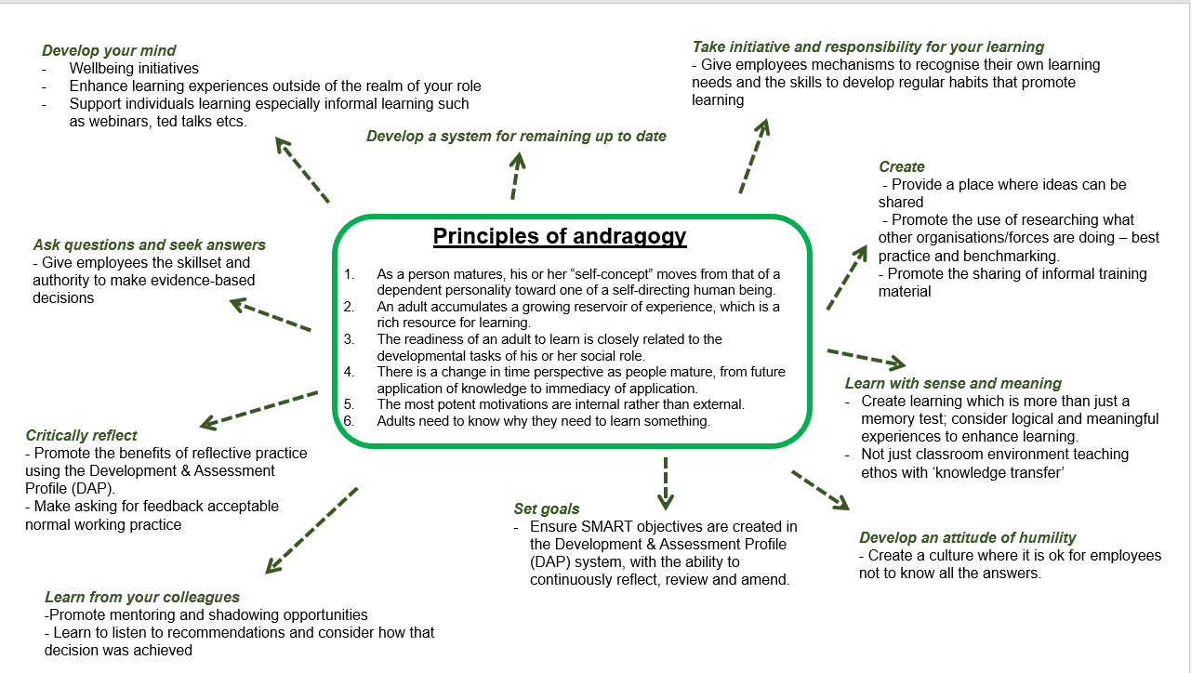
Figure 1- Principles of Andragogy (Source: Daily and Landis, 2014)

To fully embed a self-directed learning ethos, learners and learning designers must be fully aware and understand adult learning principles; with the focal point being driven towards co-creation (Griffiths and Inman, 2017).
The DAP is underpinned by adult learning principles; designed for reflection, directed learning, and goal setting. However, engagement is low, which demonstrates a lack of knowledge of these principles by employees.

Learning should no longer encompass outdated theories determining individual learning styles and should integrate evidence-informed principles instead (CIPD, 2020d).

DPP commonly uses learning style questionnaires. This methodology is outdated as the outcome derived is learner-driven and therefore formed subjectively; the process assumes the learner will be disciplined and answer without bias, therefore the outcome of the questionnaire cannot be reliable nor valid (Coffield et al, 2004).

Workplace learning relies on easy retrieval of information when needed. Neuroscientists discovered that one part of the brain plays a significant role in recalling information. New learning theories have been established based on memory creation techniques such as the AGES model (Davachi et al, 2010).

The AGES model proposes that for learning to be effective, four factors need to be part of the design and delivery (CIPD, 2020c):
- Attention
- Generation
- Emotion
- Spacing

To apply the AGES model effectively, learning must be task focussed without any distraction, linked to emotional clues, include tasks that generate own thinking, and allows suitable time gaps for learning to become consolidated (CIPD, no date).

AGES model assumes that memories formulate when learning has a personal significance or meaning (CIPD, 2020c). L&D must recognise where learning can be implemented in DPP as part of the flow of work; employees need the ability to access learning at the point of need without disruption to work activities (CIPD, 2020e).

This learning design refers to the push/pull conditions; when learners do not have an interest in the subject matter, experiences must be used to create that significance or meaning; providing resources will not be enough (Shakleton-Jones, 2019).

2.4.2 Content Creation
The ADDIE model is an instructional design model that intends efficiency, supports a lean mindset, and minimises the risk of omitting key information (Mahoney, 2018). A typical model used in DPP; Analyse, Design, Develop, Implement and Evaluate. For this model to be effective, modification is needed in terms of audience and training material; manipulation of the model exposes following a prescribed model can limit creativity with poor learning design being identified too late in the process to resolve effectively (Ferriman, 2013).

Learning resources tend to be isolated and rarely work together, unable to provide a useful account of learning activities/skill sets (Degreed, 2017). L&D activities at DPP
typically work in a silo causing duplication of learning, reducing learner confidence in L&D to deliver an efficient service.

Figure 2 explores a new approach that brings learning together, both from an organisational and individual perspective.
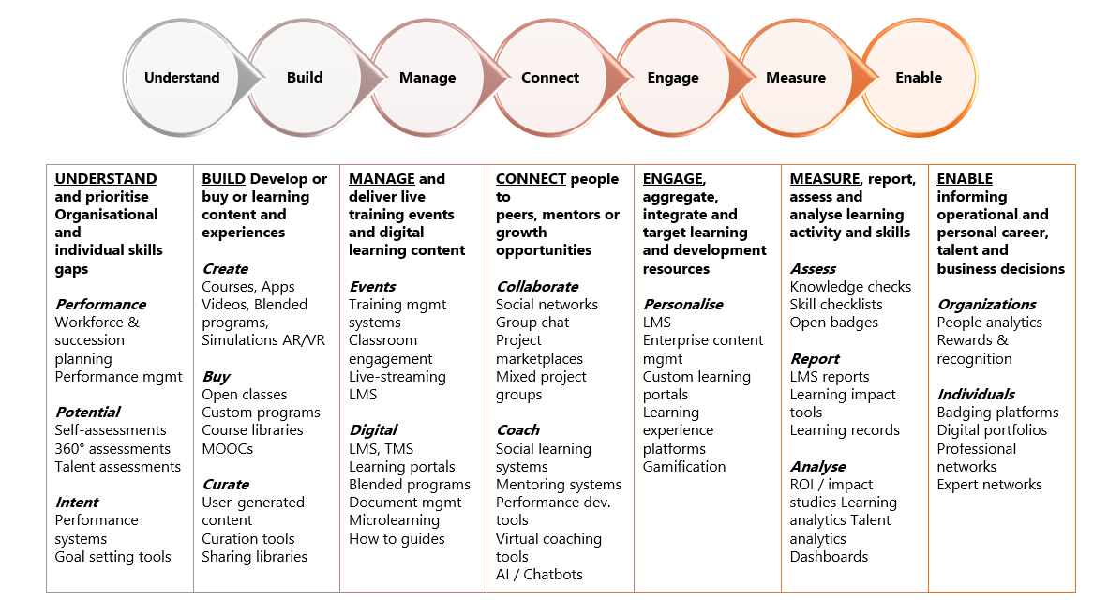
Figure 2 - Innovative approach to learning design (Source: Degreed, 2017)
Learning should be simple, diverse, useful experiences, targeted at skills gaps, and based on forward-looking analytic and insights (Degreed, 2017). DPP needs to apply this model to provide effective L&D.

As a police force, DPP is required to provide statutory training under the employment contract, but also other requirements as instructed by the Home Office; the learning schedule consists mainly of core products with little time to consider research and development.

Clever L&D resource allocation is key to innovation; resources should be allocated using the 70,20,10 framework - 70% of time spent on delivering core learning, 20% on enhancing learning, and 10% on research and development considering emerging L&D trends (Thoma, 2017). This framework creates a pipeline, supporting innovation, and experimentation into L&D.

The pandemic has caused a shift to digital learning and the focus moving to content curation; the operation of sourcing relevant learning already available and sharing this with learners, rather than creating new content (CIPD, 2021).

Massive open online courses, or MOOCs, offers learners the chance to connect with a range of diverse people however consideration needs to be given that results will differ between the population diversity (Kun, 2019).

Stakeholders buy-in from line managers and senior managers is crucial for adopting MOOCs in DPP. It would also be beneficial to review and pilot MOOCs before use and embed them into performance reviews by providing adequate support; 56% of learners completed a MOOC when supported by an employer (CIPD, 2018). Gamification improves the success rate of a MOOC (Aparicio et al, 2019).

Gamification is the use of gaming elements to enact a change in behaviours or problem solving; this approach has been labelled to increase motivation, performance, and engagement (Klemke, Eradze, and Antonaci, 2018).

Duolingo is a smartphone app that encapsulates gamification; the learner is rewarded when they achieve a daily goal. Reminder notifications are sent when there has been inactivity and the app allows friendly competition between online friends; this style of the app keeps learners interested, offering learning which is user-friendly and removes any tendencies which arise from being self-conscious (Nushi and Egbali, 2017).

2.4.3 Workforce demographics
Consideration needs to be given to a multi-generational workforce when developing a DLI. DPP has a multiple generational workforce, all with assumed differing needs. Deloitte (2018) expresses that around eight in ten millennials think that on-the-job training, employer-led formal training, and continuous professional development will ensure high performance. The use of data provides an insight into the workforce to identify trends; it is counterproductive to consider generation needs that are not present in the organisation (Fuhl, 2020).

Arguably making assumptions about the needs of people just because of what generation they are, is short-sighted. More focus should be given to providing an individualist approach to meeting people's needs (Georges, 2018).

It is crucial that L&D also consider the diversity of the workforce when designing learning. In 2019, 4.3 million disabled people were employed in the UK, an increase of 1.3 million since 2013 (ONS, 2019). In 2020, 4.1% of the paid DPP workforce self-certified themselves as having a disability (Dyfed-Powys Police, 2020b).

Learning must be inclusive to all, and this extends further than accessibility. Care should be given to ensure that learning content is not offensive to certain cultures, religion, or sex; Davis (no date) states that to ensure engagement from all learners, L&D practitioners should:
- have awareness of their presumptions or stereotypes.
- examine content to ensure there is representational of a diverse population.
- gather feedback from people with different backgrounds.
- consider technical and functional needs of the learners.

Chandrashekar (2017) insists that the goal of inclusive learning design is:

"to take advantage of human diversity in the design process to build an adaptive and adaptable one-size-fits-one learning experience that empowers each learner to be the architect of their learning. Inclusive design for learning is not just a way of doing; it is a way of thinking”.

To deliver inclusive learning at DPP, L&D practitioners must check their knowledge and identify learning gaps.

2.5 Delivering Learning Interventions
A learning method is the undertaking of an intentional activity or where a resource is provided, to assist with the learning process (CIPD, 2020e). There is a vast array of methods that could be utilised, figure 4 shows this in further detail.
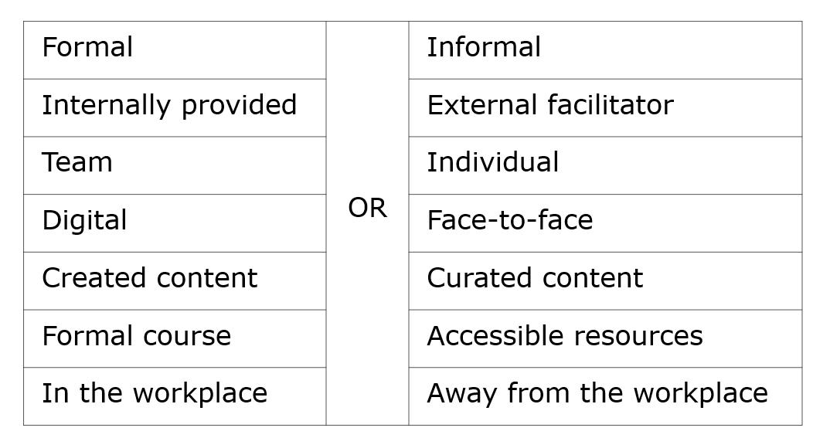
Figure 4 - Types of learning methods (Source: CIPD, 2020e)
Not only an efficient way to train a workforce there is also a clear link between employee retention and engagement when a blend of learning formats used (Pulse Learning, 2017). However, a blend of learning formats encompasses more than what is listed in figure 4.

To survive, Avon needed to deliver not only their products but also their learning differently. They invested in a platform that provided individuals with an array of information and a place to connect; the adoption success of this platform is due to content being created by users (Fuse, 2021). Social learning enables individuals to learn by sharing information on platforms where online communities can develop (CIPD, 2020f).

As this type of social learning happens organically, it is beneficial that organisations create mechanisms to capture and foster this, using the results to inform business decisions (CIPD, 2017). It is important that social learning is adopted when DLI.

With a move to agile working, social learning is occurring within DPP although limited to teams/departments; a disconnect has been created between other teams due to the loss of a formal training environment and the lack of ad-hoc social engagements.

When delivering learning, individuals must not be in the comfort zone; time should be afforded to activate a ‘negative capability'. Figure 5 demonstrates the traits which are exhibited during this.
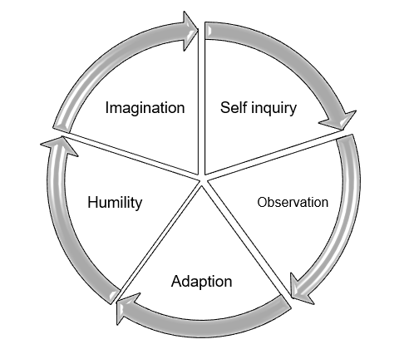
Figure 5 - Negative Capability (Source: Academi Wales, 2015)

To connect to a negative capability, mindfulness, physical movement, connecting with nature, and music practices can be adopted (Academi Wales, 2015). In practical terms, the adoption of these practices is easier to achieve when delivering physical learning rather than online delivery.

The delivery of learning should reflect the culture of the organisation. DPP is moving towards an agile workforce; only offering classroom-based learning would be detrimental to the agile working ethos. Ergo, a blended learning schedule would be the best strategic fit. Training typically refers to an instructor led, content-based intervention whilst learning is self-directed, and work based (Zhang and Kyriakidou, 2014), it is likely these definitions will continue to be used interchangeably.

2.6 Evaluating Learning and Development
Three evaluation activities can be undertaken: impact, transfer, and engagement (CIPD, 2020g)

The seminal model for evaluation, The Kirkpatrick Model can be adopted; designed to increase evaluation efforts by trainers by creating a step-by-step process (Kirkpatrick, 1979).

The model can be applied to 21st-century workplaces, but arguably there are some limitations. The model is incomplete as it does not consider external influences on the evaluation process, assumes that there is a natural link between the stages and that each level creates more evaluation information than the stage before (Bates, 2014).

The results stage of the model offers a simplistic view on the definition of value, and to fully calculate the value-added, data needs to be collected before the learning to establish a baseline (Kearns, 2007).

The establishment of learning outcomes in the design phase is integral to evaluation. Learning outcomes are a record of measurable results which are instrumental to account for what will be achieved following the learning (Sudhakar, 2017).

Figure 6 shows how this model can adapted and applied to evaluate workplace learning.
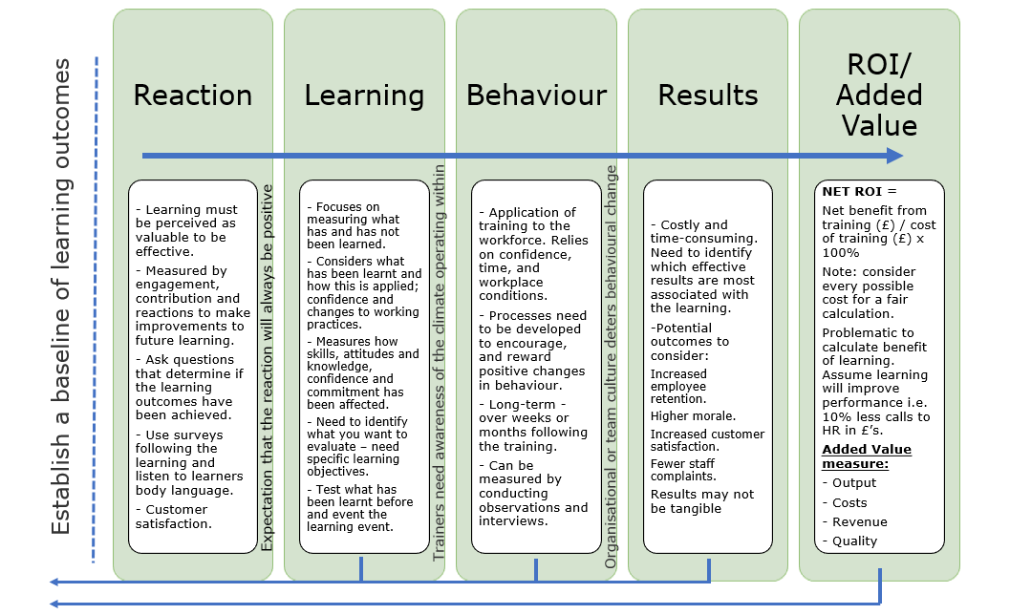
Figure 6 - Model for evaluation (Source: Kearns, (2017); Kirkpatrick and Kirkpatrick, (2006); Mindtools, (no date))
Evaluation of DPP learning lacks depth; there is a process to record reactions, but little consideration is given to the wider impact. Only a small number of practitioners use specific metrics when evaluating learning effectiveness (CIPD, 2019).

Sullivan and McFadden (2014) identity that this may be because of the perceived barriers of conducting evaluation; these include:

- L&D individuals not wanting feedback.
- Time-consuming process
- Cost

Scientists are using automation to improve processes by using machine learning to predict the future, ensuring elements of a process do not work in a silo, and investing in data management tools (Correa-Baena, Juan Pablo, et al., 2018).

Automation would diminish some of the barriers to evaluation at DPP.

Conclusion
DPP excel at designing and delivering learning through the classroom environment however are slow to adopt L&D emerging trends. This is due to the perceived constraints in cost, bureaucracy, and time.

There is little evidence that emerging theories from neuroscientists and adult learning theory principles are being embraced.

The L&D function has become stagnant, and learners expect to be told what to learn rather than direct their learning.

Radical change is needed to put learners back in control of learning.

Recommendations
Recommendations are proposed in the context of the identified new design process for learning and adult learning principles.

4.1 Understand
There is a disconnect between L&D and the learners in DPP; bridging this gap will ensure learning design is informed.

Focus groups should be held to enforce the commitment made to L&D by DPP and to re-engage the learner, promoting the move from physical learning to a blended approach with accessible resources. This data will be used to inform learning outcomes.

4.2 Build
The virtual learning space will enhance the move to an agile working ethos underpinning the adult learning theory principles. A template of the virtual Hwb is shown in Appendix 3.

Resources will be created, which will be readily accessible at the point of need, eliminating the need for managers to rely on memory when dealing with people matters. Functionality will exist to ‘rate’ the resources after use.

The system will also include an ‘ask HR’ chatbot, directing the manager to the right advice eliminating the need to contact HR with an automated feedback option.

The Hwb will also be a portal to areas for:
- Reflection
- Self-directed learning and CPD
- Wellbeing and resilience resources
- A social space for communicating with other managers and sharing knowledge.

4.3 Manage, Connect and Engage
The Development and Assessment Profile already underpins adult learning theory in terms of reflection, setting goals, and being accountable for own learning however there is a lack of engagement from users.

Suggested improvements:
- Allow individuals to earn badges and awarded points for engaging; these points will provide a total score at the end of the year, feeding into a scoreboard of colleagues whom they wish to connect with on the system.
- Promotion of external opportunities; providing relevant learning resources and dedicated space to record completion; MOOCs, webinars, TedTalks.
- Integration of opportunities that L&D offer, with the ability to request these services through the system.

Consideration should be given to review L&D and HR policies. Appendix 4 details a full action plan for implementation.

4.4 Costings and timeframe
As the technology infrastructure is already owned by DPP, costs are calculated based on employees' salaries to complete the work, including on-costs. The estimated cost of implementing the recommendations will be £66,363.00. Breakdown of this is shown in table 1.
Table 1 – Estimated costing of recommendations
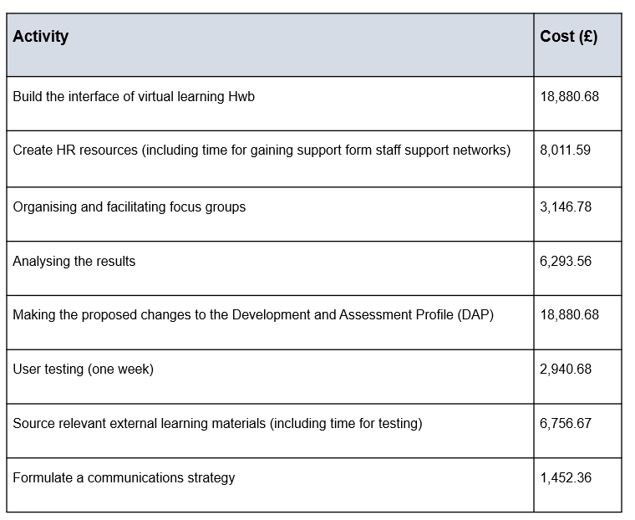
It is estimated to take around 6 months project time to build the virtual space and a further 6 months to make the proposed changes to DAP.

The costs above can be offset against the initial cost to deliver the five-day course. Facilitated by two trainers and delivered to 5 cohorts of 10-15 people in year one and then every 6 months following the promotion of officers to the next rank. The cost of delivery is estimated to £17,452.11 over the next five years; this is without the cost of abstracting the learners from a day job.

References

- Academi Wales (2015) Explore and Walk; Connecting body and mind Available at: https://academiwales.gov.wales/Repository/resource/1b52509e-082f-4350-ab59-b804a9ae792a/en (Accessed: 15 May 2021).
- Aparicia, M., Oliveira, T., Bacao, F., and Painho, M. (2019) ‘Gamification: A key determinant of massive open online course (MOOC) success’, Information & Management,56(1), pp. 39-54. Available at: https://www.sciencedirect.com/science/article/pii/S0378720616304062 (Accessed: 16 May 2021).
- Barbazette, J. (2005) Training needs assessment, methods, tools and techniques. 1st edition. Germany: Wiley.
- Bates, R. (2004) ‘A critical analysis of evaluation practice: the Kirkpatrick model and the principle of beneficence’, Evaluation and Program Planning, 27(3), pp. 341-347. DOI: 0149-7189.
- Chandrashekar, S. (2017) What is Inclusive Design for Learning? [blog]. 18 May. Available at: https://www.d2l.com/blog/inclusive-design-learning/#:~:text=%20What%20is%20inclusive%20design%3F%20%201%20Recognizing,systems%20and%20services%20to%20be%20aware...%20More%20 (Accessed: 18 April 2021).
- CIPD (2015). L&D: Evolving roles, enhancing skills. Available at: https://www.cipd.co.uk/Images/l-d-evolving-roles-enhancing-skills_2015_tcm18-9162.pdf (Accessed: 5 April 2021).
- CIPD (2017) Social collaborative learning. Available at: https://www.cipd.co.uk/podcasts/social-learning (Accessed: 16 May 2021).
- CIPD (2018) Are organisations making the most of MOOCs? In a nutshell, 74. Available at: https://www.cipd.co.uk/news-views/nutshell/issue-74/organisation-moocs (Accessed: 16 May 2021).
- CIPD (2019) Professionalising learning and development; The CIPD’s new Profession Map and key L&D development needs. Available at: https://www.cipd.co.uk/Images/professionalising-learning-development-report19_tcm18-53783.pdf (Accessed: 16 May 2021).
- CIPD (2020a) PESTLE Analysis. Available at: https://www.cipd.co.uk/knowledge/strategy/organisational-development/pestle-analysis-factsheet (Accessed: 5 April 2021).
- CIPD (2020b) Identifying learning and development needs, factsheet. Available at: https://www.cipd.co.uk/knowledge/fundamentals/people/development/learning-needs-factsheet#6601 (Accessed: 5 April 2021).
- CIPD (2020c) Learning theories for the workplace. Available at: https://www.cipd.co.uk/knowledge/strategy/development/learning-theories-factsheet (Accessed: 17 April 2021).
- CIPD (2020d) Learning and development evolving practice. Available at https://www.cipd.co.uk/knowledge/strategy/development/evolving-practice-factsheet#67228 (Accessed: 17 April 2021).
- CIPD (2020e) Learning in the flow of work. Available at: https://www.cipd.co.uk/knowledge/strategy/development/learning-factsheet#72969 (Accessed: 18 April 2021).
- CIPD (2020f) Learning methods. Available at: https://www.cipd.co.uk/knowledge/fundamentals/people/development/learning-methods-factsheet#6679 (Accessed: 18 April 2021).
- CIPD (2020g) Evaluating learning and development. Available at: https://www.cipd.co.uk/knowledge/fundamentals/people/development/evaluating-learning-factsheet#7075 (Accessed: 16 May 2021).
- CIPD (2021) Digital learning in a post-covid-19 economy. Available at: https://www.cipd.co.uk/Images/digital-learning-literature-review-report-2_tcm18-89290.pdf (Accessed: 16 May 2021).
- CIPD (no date). Learning and the brain. Available at: https://www.cipd.co.uk/Images/7558-neuroscience-infographic-FINAL_tcm18-24930.pdf (Accessed 18 April 2021).
- Coffield, F., Ecclestone, K. Moseley, and Hall, E. (2004) Learning styles and pedagogy in post-16 learning. Available at: https://www.researchgate.net/publication/232929341_Learning_styles_and_pedagogy_in_post_16_education_a_critical_and_systematic_review (Accessed: 18 April 2021).
- Correa-Baena, J. P., Hippalgaonkar, K., Van Duren, J., Jaffer, S., Chandrasekhar, V. R., Stevanovic, V., Wadia, C., Guha, S., and Buonassisi, T. (2018). ‘Accelerating Materials Development via Automation, Machine Learning, and High-Performance Computing’. Joule 2, pp. 1410-1420. Available at: https://doi.org/10.1016/j.joule.2018.05.009 (Accessed: 16 May 2021).
- Daily, A. J., and Landis, B. J. (2014) ‘The Journey to Becoming an Adult Learner: From Dependent to Self-Directed Learning’, Journal of the American College of Cardiology,64(19), pp.2066-2068. Available at: https://www.sciencedirect.com/science/article/pii/S0735109714063633 (Accessed: 12 May 2021).
- Davachi, L., Kiefer, T., Rock, D., and Rock, L. (2010) Learning that lasts through AGES. Neuro Leadership journal. Vol 3. Available at http://docplayer.net/43864-Learning-that-lasts-through-ages-dr-lila-davachi-dr-tobias-kiefer-dr-david-rock-and-lisa-rock.html (Accessed: 18 April 2021).
- Davis, J. (no date) Is Your eLearning Accidently Offensive? Here’s How to Check. Available at: https://www.jenobi.com/is-your-elearning-accidently-offensive-heres-how-to-check/ (Accessed: 18 April 2021).
- Degreed (2017) The innovator’s guide to learning technology: The future of learning is already here; It’s time to reboot your systems. Available at: https://get.degreed.com/hubfs/Degreed_InnovatorGuide.pdf (Accessed: 15 May 2021).
- Deloitte (2018). 2018 Deloitte Millennial Survey. Available at: https://www2.deloitte.com/content/dam/Deloitte/pe/Documents/human-capital/2018-Millennial-Survey-Report.pdf (Accessed: 18 April 2021).
- Dyfed-Powys Police (2020a) Dyfed-Powys Police recognised as one of the best places to work. Available at: https://www.dyfed-powys.police.uk/news/dyfed-powys/news/2020/april-2020/dyfed-powys-police-recognised-as-one-of-the-best-places-to-work/ (Accessed: 5 April 2021).
- Dyfed-Powys Police (2020b) Information about Employment Monitoring of Protected Characteristics. Available at: https://www.dyfed-powys.police.uk/SysSiteAssets/media/downloads/dyfed-powys/about-us/equality-and-diversity/public-sector-equality-duty/monitoring-of-protected-characteristics-data-2020.pdf (Assessed: 15 May 2021).
- Estrada, S. (2020) How PwC uses gamification to support learning, engagement. Available at: https://www.hrdive.com/news/how-pwc-uses-gamification-to-support-learning-engagement/582440/ (Accessed: 5 April 2021).
- Faragher, J. (2018) Why fresh approaches to L&D are presenting new problems. Available at: https://www.peoplemanagement.co.uk/long-reads/articles/new-approaches-learning-development-presenting-fresh-problems#_ga=2.77816605.848993893.1621284557-362775187.1604846779 (Accessed: 18 May 2021).
- Ferriman, J. (2013) Gaps in the ADDIE Instructional Design Model. Available at: https://www.learndash.com/gaps-in-the-addie-instructional-design-model/ (Accessed: 17 April 2021).
- Fuhl, J. (2020) 5 ways to successfully manage a multi-generational workforce. Available at: https://www.sage.com/en-gb/blog/five-ways-manage-multi-generational-workforce/ (Accessed: 11 April 2021).
- Fuse (2021) How to accelerate sales growth, AVON Fuse Case Study [video]. Available at: https://www.youtube.com/watch?v=fE45njggDXU (Accessed: 19 April 2021).
- Georges, L. (2018) How generational stereotypes hold us back at work [video]. Available at: https://www.ted.com/talks/leah_georges_how_generational_stereotypes_hold_us_back_at_work (Accessed: 12 April 2021).
- Ghelber, A. (2020) Disadvantages of Focus Groups (And How to Avoid Them); Complete guide 2020 [blog]. 29 September. Available at: https://www.revuze.it/blog/disadvantages-of-focus-groups/ (Accessed: 11 April 2021).
- Griffiths, D., and Inman, M. (2017) ‘Is it time to take learning design to task?’, Journal of Adult and Continuing Education, 23(2), pp. 226–249. DOI: 10.1177/1477971417733270.
- Harrison, T., & Auluck, R. (2014) ‘Establishing learning needs’, in Stewart, J and Cureton, P. (ed) Designing, Delivering and Evaluating L&D, Essentials for Practice. London: CIPD
- HBR (2020) How VR Training Can Help Turn Employees into Leaders. Available at: https://hbr.org/sponsored/2020/09/how-vr-training-can-help-turn-employees-into-leaders (Accessed: 16 May 2021).
- Investors in People (2019) Investors in people, we invest in people framework. Available at: https://www.investorsinpeople.com/wp-content/uploads/2019/10/We-invest-in-people-framework.pdf (Accessed: 5 April 2021).
- Johnson, B. (2017) Learning needs analyses often feature too little analysis. Available at: https://www.peoplemanagement.co.uk/voices/comment/learning-needs-analyses#_ga=2.212394772.1803792765.1618144063-1332364656.1618144063 (Accessed: 11 April 2021).
- Kearns, P. (2007) Evaluating the ROI from learning. London: CIPD
- Kirkpatrick, D., and Kirkpatrick, J. (2006) Evaluation Training Programs. 3rd edn. California: BK Publishers
- Kirkpatrick, D. L. (1979) ‘Techniques for Evaluating Training Programs’, Training & Development Journal, 33(6), p. 78. Available at: https://search-ebscohost-com.ezproxy.uwtsd.ac.uk/login.aspx?direct=true&db=eue&AN=9067458&site=ehost-live (Accessed: 16 May 2021).
- Klemka, R., Eradze, M., and Antoncaci, A. (2018). The Flipped MOOC: Using Gamification and Learning Analytics in MOOC Design-A Conceptual Approach. Education Sciences, 8(1), pp. 25. Available at: https://www-proquestcom.ezproxy.uwtsd.ac.uk/docview/2026662193?accountid=130472&pq-origsite=primo (Accessed: 16 May 2021).
- Kun, L. (2019) ‘MOOC learners’ demographics, self-regulated learning strategy, perceived learning and satisfaction: A structural equation modelling approach’. Computers & Education. 132, pp.16-30. DOI:0360-1315 Available at: https://doi.org/10.1016/j.compedu.2019.01.003. (Accessed: 16 May 2021).
- Leo Learning (no date) The growing appetite for measuring the impact of learning at work. Available at: https://cdn.sanity.io/files/nosafynr/leo-production/d57bb6ee462b1607c0567a6d8d6c87d2f90ff589.pdf (Accessed: 11 April 2021).
- Mahoney, D. (2018) Lean learning using the ADDIE model. Virgina: Association for talent development. Available at https://www.google.co.uk/books/edition/Lean_Learning_Using_the_ADDIE_Model/Xv9sDwAAQBAJ?hl=en&gbpv=1&dq=addie+model&printsec=frontcover
- Mayo, A. (2012). How to use data to get results in HR. Available at: https://www.personneltoday.com/hr/how-to-use-data-to-get-results-in-hr/ (Accessed: 11 April 2021).
- Mindtools (no date) Kirkpatrick's Four-Level Training Evaluation Model: Analyzing Learning Effectiveness. Available at: https://www.mindtools.com/pages/article/kirkpatrick.htm (Accessed: 16 May 2021).
- Nushi, M., and Eqbali, M. H. (2017) ‘Duolingo: A Mobile Application to Assist Second Language Learning’, Teaching English with Technology, 17(1), pp. 89–98. Available at: https://search-ebscohost-com.ezproxy.uwtsd.ac.uk/login.aspx?direct=true&db=eue&AN=121020893&site=ehost-live (Accessed: 16 May 2021).
- Oculus (2020) Case study: Building empathy to enhance hospitality. Available at: https://business.oculus.com/case-studies/hilton/ (Accessed: 16 May 2021).
- ONS (2019) Disability and employment, UK: 2019. Available at: https://www.ons.gov.uk/peoplepopulationandcommunity/healthandsocialcare/disability/bulletins/disabilityandemploymentuk/2019 (Accessed: 18 April 2021).
- Pappas, C. (2014) 6 Reasons to Use Focus Groups in eLearning. Available at: https://elearningindustry.com/6-reasons-use-focus-groups-in-elearning. (Accessed: 11 April 2021).
- Pradhan, A. (2018) Learning Agility: 5 Strategies for the Future of Work. Available at: https://learningsolutionsmag.com/articles/learning-agility-5-strategies-for-the-future-of-work. (Accessed: 16 May 2021).
- Pugh, C., Lewis, R., Yarker, J. and Green, M. (2021) Impact of COVID-19 on the L&D profession: perspectives from independent learning practitioners. London: Chartered Institute of Personnel and Development. Available at: https://www.cipd.co.uk/Images/impact-COVID-19-ld-profession_tcm18-92209.pdf (Accessed: 16 May 2021).
- Pulse Learning (2017). 6 Reasons Why Blended Learning Is Becoming a Trend [blog] Available at: https://www.pulselearning.com/blog/6-reasons-blended-learning becomingtrend/#:~:text=%20What%20is%20blended%20learning%3F%20%201%201.Boosts,necessary%20for%20effective%20learning.%20Blended%20learning...%20More%20 (Accessed: 18 April 2021).
- Shackleton-Jones, N. (2019) How People Learn. London: Kogan Page
- Snowden, D. J., and Boone, M. E. (2007) A leader's framework for decision making. Harvard Business Review. 85. pp. 68–76.
- Sudhakar, J. (2017) Learning objectives vs learning outcomes. Available at: https://www.linkedin.com/pulse/learning-objectives-vs-outcomes-ms-jemi-sudhakar/?trackingId=JG%2FUyMHjUhAHQ8YNC3aVXw%3D%3D (Accessed: 16 May 2021).
- Sullivan, M. and McFadden, M. (2014) ‘Evaluating Learning and Development’, in Stewart, J and Cureton, P. (ed) Designing, Delivering and Evaluating L&D, Essentials for Practice. London: CIPD.
- Thoma, S. (2017) Google's CLO, how to continuously innovate in L&D [video]. Available at: https://www.youtube.com/watch?v=GPhQpjs_-eM(Accessed: 17 April 2021)
- Zhang, C. and Kyriakidou, N. (2014) ‘Designing Learning Interventions’, in Stewart, J and Cureton, P. (ed) Designing, Delivering and Evaluating L&D, Essentials for Practice. London: CIPD.

Appendix 1 – PESTLE Analysis

 | External Factors | Effect on DPP
Political | BREXIT  Welsh devolution  Biden Administration  COVID regulations  Welsh Government Elections 2021 | UK graduates staying in the UK rather than moving away to work in the EU – retaining knowledge and skills.  Rise in protests for devolution = Rise in police resources who need to have the skills to deals with protests.  Biden has a strong agenda in terms of climate change – this will put pressure on the UK Government to act – thus having an impact on the environmental agenda for all organisations – training may need to be delivered remotely to reduce carbon footprint. Training may need to be designed to raise awareness of footprint and how to reduce.  Impact on delivery of formal classroom training.  Impact of content – need to update on changes to legislation for policing purposes.  Potential change from Labour leader – “runs health, education, local government, transport, housing, economic development, social services, culture, Welsh language policy, agriculture and other public services including some taxes” (BBC, 2021).
Economic | Recession  Home Office funding  Cost of providing training | Increased demand on recruitment for perceived ‘secure’ employment. Impact on L&D as recruitment will have a larger talent pool therefore more likely to recruit a person who has the right skills eliminating the need for some training.  Could be reduced which may impact the training budget. However, there are monetary gains from reduced overheads due to home working.  Dedicated L&D department – risk of leavers taking their knowledge and skills to other organisations.
Social | Increase in Diversity of Staff  Millennials  Gen Z  Ageing workforce  Population demographic  Agile workforce  Online learning | Adapt content to mitigate risk of discrimination.  Ensure the content of courses correctly reflects the communities and employees (sex, ethnicity, sexual orientation).  Consider individual needs for attendance at formal training – such as food available at buffet.  Consider when the training is being held – to mitigate clashes with religious festivals.  Stereotypically ‘Job hoppers’ = increased employee turnover = increased costs for training  More environmental awareness = would expect paperless training methods  More emotional and self-awareness = will wanted individualist training plans/learning interventions  Assumptions: lack of technology skills, do not want to learn anything new.  Largely a retired population therefore younger generation may leave the area unless employment opportunities arise – a rise in apprenticeships and internships to equip people with the right skills.  Increased informal training given by colleagues. Ability to share a computer screen via teams/skype/zoom etc. has reduced the need for formal training.  Content being created outside of L&D arena = cannot be evaluated and the impact is not measured.  Reduced social/human interaction.
Technological | Home/agile working  Social media  Automation  Access to resources worldwide  Online learning  Security breaches | Increased training needs for managing an agile workforce.  Increased demand for remote training rather than formal classroom-based learning.  Increases opportunities for learning.  Decreased need for some L&D roles.  Increase need for current L&D staff to re-train in specialised roles or use of technology.  Training can be delivered by anyone anywhere.  Increased use of informal training material – webinars, TedTalks, YouTube, employee created content etc.  Ensure all learners have access to devices and a strong internet connection.  Ensure that the technology is fit for purpose and does not pose a risk of data being stolen.
Legal | Coronavirus regulation 2020  Health and Safety Act 1974  Intellectual property laws  UK GDPR / DPA 2018 | Change in legislation = increase in training needs  Statutory training needed – changes due to covid.  Training on how to conduct a remote risk assessment on workspaces.  Ensuring when using content created by others, there is the right to access and share.  Continuous training to ensure employees are aware of compliance = large fines and reputation damage if data is not handled correctly.

Appendix 2 – SWOT Analysis

Strengths | Weaknesses
- A dedicated L&D function with allocated budget.  - Learning is promoted by the Chief Officers with individuals allocated training days and protected learning time when undertaking external courses.  - An online space exists where e-learning can take place.  - Learning questionnaires are adopted to align individuals to how they learn best.  - The DAP is underpinned by adult learning theory.  - Some technology to create content.  - On-the-job training can be facilitated.  - Highly trained L&D workforce  - Ability to deliver compliance training in house.  - Investment made into 360 feedback technology. | - Lack of time to consider alternative methods to delivering learning interventions due to large timetable of learning.  - The online space is clunky, outdated and primarily used for statutory training. Created nationally and therefore the interface cannot be changed.  - Learning questionnaires are deemed outdated.  - The DAP is underused and has been perceived badly. It was created by HR in silo without consultation with L&D.  - Policies on what measures a person is entitled to when undertaking learning is open for interpretation.  - L&D senior manager is not a L&D professional but a high-ranking Police Officer.  - Lack of recognition of informal learning  - Lack of recognition of professional learning such as Law, HR, IT and Accounting to maintain sound knowledge in area.  - Lack of evaluation of learning – only reactions such as happy sheets.  - Learning is designed in silo from each other causing duplication.  - Outdated people strategy therefore hard to align L&D strategy  - Poor onboarding/induction process therefore could set the scene for how DPP value learning
Opportunities | Threats
- Workforce becoming agile therefore demand to change how training is delivered to match the new culture. This will be driven by Chief Officers.  - Amend the DAP using emerging trends such as gamification and fully embed how it links to self-directed learning and CPD.  - Review L&D/HR policies to be aligned to adult learning theory and ensure fairness with allocation of protected learning time.  - L&D senior manager has an operational background and therefore could assist with bridging the gap between L&D and employees.  - All learning should be mapped to ensure duplication is removed. This will improve learner confidence.  - Remote coaching, mentoring, and shadowing.  - Improvement of skills by utilising new avenues.  - Automation of evaluation processes.  - Provide specialist training to other forces – income generating.  - Create content online – accessible by 24/7 operational team rather then the rigid structure of classroom delivery. Reduce costs of people traveling to Headquarters for training if online learning can be facilitated. | - Lack of adoption of new emerging trends such as gamification. MOOCs = increase employee turnover, lack of engagement.  - DAP could become a waste of time and money as buy in is low.  - Lack of understanding on what entitlement an individual has when undertaking learning. Risk of a rise in grievances if unfairness is perceived.  - L&D senior manager by is not an expert in the field of L&D.  - Lack of data driven; evidence-based decisions being made to design learning. DPP looking backwards rather than forwards. Learning will be created which is uninformed and outdated.  - Duplication of learning exists. Learner dropout rate will increase as they lose confidence – this could be costly.  - Diversity challenges  - Late adoption of new technologies and learning theories may increase employee turnover and loss of talent.  - Change in Chief Officer team who may have a different people vision.

Appendix 3 – Template of DPP virtual learning Hwb

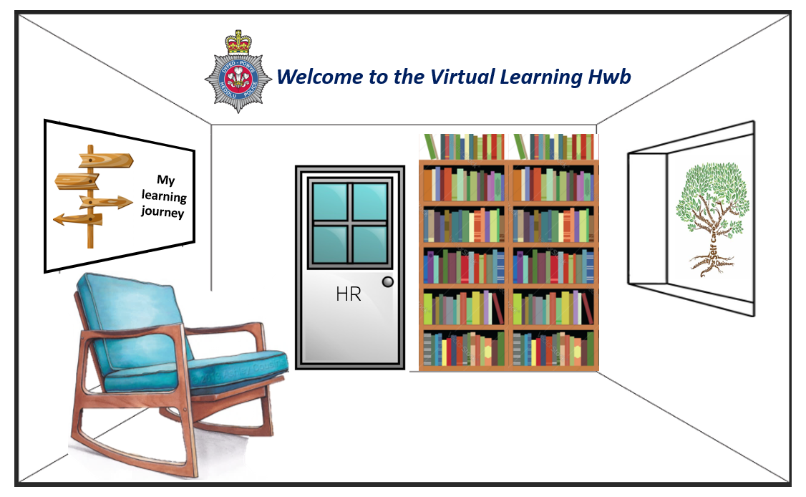

Appendix 4 – Action Plan

Action | Owner | Resources
Conduct focus groups to determine what resources are needed | L&D, HR | Agreement from Chief Officers  Support to abstract employees for attend  Skype/Teams – hold the focus groups virtually  Facilitator and note taker
Recording of the reasons line managers contact them | HR | Shared spreadsheet to be created and used  Anonymise the data – not about people about the reason for seeking advice
Review the data from the focus group and HR to establish a baseline for evaluation purposes. | Analyst | Time
Create resources specific to DPP processes | HR | Use the data provided from analyst on which resources are needed  Canva or similar platform  Policies relating to the topic to ensure compliance  Staff support networks  Translation unit – resources should be bilingual
Source external content for all employees – MOOC, TedTalks, Webinars | HR, L&D | User testing group  Map suitable course to bridge knowledge gaps
Create the interface for the virtual space | IT, HR | Stakeholder support  6 months project time  HR and IST to work together  User testing stage
Communication of the new platform for line managers | Comms, HR, L&D | Communication strategy plan  Hold events where managers can attend and view the system – facilitator and not taker  Email all managers with link to system and why to use it.
Amendments to Development and Assessment Profile (DAP) | IT, HR | Map the flow of the system – determine where badges, scores will be allocated  Chief Officer support  Staff support networks, Unison, Police Federation buy-in  User testing
Communication of changes to Development and Assessment Profile (DAP) | Comms, HR, L&D | Communication strategy plan  Hold events to demonstrate the new system – opportunity to have first-hand feedback

