Hotel Handbook

Student Name: Andreea Cretu
Student Number: 2024046
Module Title: Foreign Languages & Cultural Awareness ( BMIH5003)
Lectures Name: Rodrigo Aguilera

Summary

According to the Oxford Dictionary, culture is, the ideas, customs, and social behavior of a particular people or society.’ (languages.oup.com, 2022) Therefore, our culture includes our values, our ideologies, our belief systems, and the things we hold to be true based on our lived experiences and the experiences of others in our culture. Our culture can be seen in the way we behave, the words we speak, the food we eat, and the things we wear. Finally, culture is what differentiates people from one another.
Invisible values and ideas that determine the accepted behaviors particular to each culture or social group are real. We may be able to observe a culture's external manifestations, such as its traditions and customs that are different from our own, but we are unable to understand its internal worlds, such as its beliefs, knowledge, and concepts. Because it enables us to identify, understand, and value these invisible, intangible components of what makes our cultures distinctive, cultural intelligence is crucial. In today's worldwide society, cultural intelligence is becoming a skill that is appreciated more and more. We can comprehend the influence that culture can have on civilizations and social behavior by investing in cultural intelligence. One of the keys to success in all aspects of our lives is the ability to comprehend and embrace other cultures and their diversity. It makes social inclusion possible, which is essential for a just and prosperous society. Avoiding prejudice against members of different cultures is a key component of cultural sensitivity.
It is very important to have employees that are culturally intelligent and sensitive, especially when it comes to the hospitality industry. Hospitality employees come in contact with people of many different cultures. It is necessary to make them feel included, and welcomed, as well as to not accidentally offend them and their culture.

Cuprins
Summary 1
Introduction 3
Country A: hotel location 4
Country B: visitors’ country 4
Country analysis 6
Hotel Handbook 8
Conclusion 9
References list 10

Introduction

This report will focus on comparing two countries through their culture, respectively United Kingdom and Morocco. The first country is the location of the hotel, and the second one is the source of the hotel’s customers.
The main purpose of this paper is to create and provide hotel employees with a hotel handbook that will be of help when international customers choose the hotel’s services. In order for the report to achieve its goal, it will be taken into consideration the application of the Hofstede model on cultural differences.
An important part of understanding the influence people’s culture has on interpersonal relations is played by the studies of Geert Hofstede. According to Hofstede's research, there are local and national cultural groups that influence society and organizations' behavior and are remarkably resilient through time. Hofstede is the author of the cultural dimensions theory, the theory that will be used in this paper to analyze the differences between the cultures of both countries. The theory assumes the presence and comparison of six cultural pillars which are as follows: uncertainty avoidance, power distance, individualism versus collectivism, femininity versus masculinity, long-term orientation versus short-term orientation, and indulgence. The meeting of these six indicators shows the directionality of a culture, in relation to others, but also of the adherents of a culture, in relation to others. In order to provide a theoretical base for the comparison, I will refer to each one separately.
Therefore, hierarchical distance from power is treated by Geert Hofstede, with reference to the social treatment of inequalities, as well as to their approach, regarding the interaction of social forces. Cultural individuality influences communication style and the manner in which one expresses personal needs wants, and expectations. Collectivism relies on the coordination of all actions necessary for the collective good to triumph. The quantity of occurrences and social phenomena that are planned, intelligently, and organically, notably including more aspects belonging to one gender, to the detriment of another gender, is what is meant by the femininity vs masculinity indication. The long-term orientation versus the short-term orientation envisages the manifestation of the persistence of the regulatory element regarding social relations.

Country A: hotel location
The country in which hotel the is located is the United Kingdom and, geographically, it is found in the western part of Europe. The country has a massive culture that has various influences due to it formerly being a great empire.
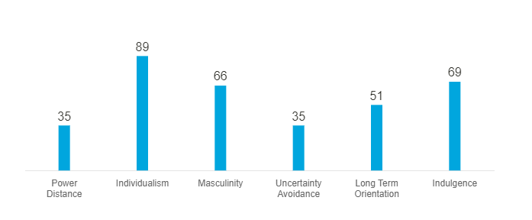
According to Hofstede Insights, the United Kingdom has reached a score of 35 on the power distance indicator. The distance to power is at a low level which can be translated into a minimum inequality in the United Kingdom’s society.
When it comes to individualism, the United Kingdom has a very high score, respectively 89. This shows that the UK is an individualist society, therefore, people take direct care only of themselves and their families.
The third pillar has a value of 66. The high male score indicates that the country has a high level of gender differentiation and discrimination.
The uncertainty avoidance indicator for the United Kingdom has a score of 35 which means that the country has a great tolerance for diversity of opinion.
United Kingdom values traditions and long-term commitments, given the 69 points the country has.
The country shows high indulgence.

Country B: visitors’ country
The international visitors that came to the hotel in the United Kingdom are from Morocco. Morocco is situated in the northwest of Africa near the Nord-Atlantic Ocean and the Mediterranean Sea. The country is very religious, over 70% of the people are Islamic. The people put a great accent on adecvate clothing.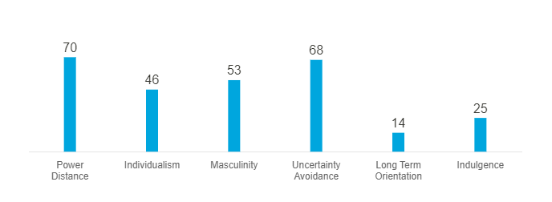
Morocco here has a very high score (70) which indicates the acceptance of a hierarchical order, in which everyone has their place, which does not require any further justification.
With a score of 46, the country is considered a collectivist society. This means that Moroccan people belong to groups where their members take care of each other in exchange for loyalty. Loyalty in a collectivist culture is paramount.
Marocco has reached a level of 53 on the third intercultural dimension, therefore, it is considered a masculine society.
The 68 points place Morocco among the countries with a great need for certainties.
Morocco has 14 points at the long-term orientation indicative, therefore, the change happens more quickly, not hindered by traditions.
With a level of 25, the country shows strict social norms.

Country analysis

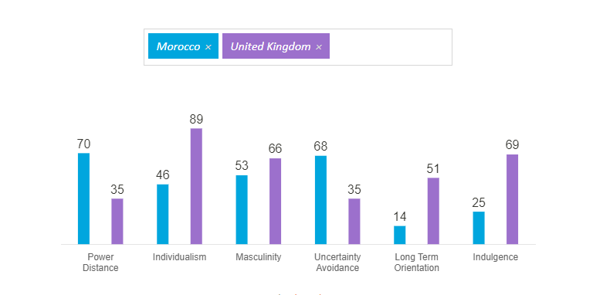
As it can be seen from the country comparison created with Hofstede Insights, the chosen countries are mainly opposites, with the exception of the third indicator, masculinity, where they show similar scores respectively 53 and 66. This means that in both countries' cultures, men must be predominant and women must assume auxiliary roles. The biggest difference between the countries is shown in the last cultural dimension which is indulgence. Another great dissimilarity can be seen when it comes to the second indicator. Unlike the United Kingdom, Morocco’s culture encourages strong relationships where everyone takes responsibility for the other members of their group and crime attracts shame and the alteration of the image.
Morocco is a very conservative country. This can be observed through the social norms that the people adopted.
In terms of alimentation, Moroccan tourists cannot drink alcohol or eat pork given their religion, therefore the kitchen should always pay attention to not using the wrong ingredients for the customers’ meals. Hotel staff should keep in mind not to serve alcohol as drinks for Moroccan visitors’ meals or as a welcoming beverage, they rather prefer mint tea.
Remaining in the food and beverage sphere, Moroccan people tend to eat their food using their hands.
Hotel employees, especially from the front office, should keep in mind not to shake hands or pass items with their left hands as they perceive this gesture to be rude.
Although Moroccan does not have a tipping culture, visitors usually leave tips to staff. However, they find asking for tips rude, therefore, employees should not ask or wait for tips when interacting with Moroccan customers.
Moroccan people are known for their negotiation skills. Although it is a very small probability, they might try to negotiate details about their stay. Therefore, hotel receptionists should expect to handle situations that involve small negotiations. However, they are very non-confrontational people, therefore, they will not insist on their negotiations so as to not escalate the situation. They also appreciate and offer punctuality.
As I mentioned before, most of Moroccans are Islamic, therefore, during the holy month of Ramadan, at sunset, they use to gather together.
Moroccans put a great accent on family, especially the elders. Hotel staff should always have that in mind.
If a situation where they need to make a decision occurs, hotel employees should know that they like to take their time. The staff is advised to be patient.
Finally, Moroccan people appreciate respect and politeness and find it very important.

Hotel Handbook
In order for the hotel employees to engage correctly and respectfully with Moroccan customers, I will create a hotel handbook.
Action | Do | Don’t
Offering drinks | Offer mint tea. | Do not offer alcohol.
Meals | Use lamb, beef, and chicken meat. | Do not use pork.
Tips | Accept tips. | Do not ask or wait for tips from Moroccan individuals.
Family | Treat their family, especially their elders, with respect. | Do not be rude and impatient.
Decision making | If they need to make a decision, wait patiently for their answer. | Do not rush them into taking a decision, they will feel disrepected.
Negociations | Kindly and respectfully manage the situation. If possible, offer them a solution that pleases them. | Do not get angry. Beware of their culture.
Religion | Respect their religion beliefs and their boundaries. Be understanding of the religious differences. | Do not disrespect their religion.
Hand-shake | Shake their hands with the right hand. | Do not use your left hand to shake the hands.

Conclusion
In conclusion, it is imperative for hospitality employees to understand how culture makes people unique and more importantly how to be respectful and solve situations that may appear due to cultural differences.
It is necessary to retain the fact that culturally intelligent employees are not experts in various cultures, but use empathy, sensitivity, observation, and intelligence to read people and understand situations.

‌
‌
‌
‌
‌

References list

- ‌ Hofstede Insights (2022). Hofstede Insights. [online] Hofstede Insights. Available at: https://www.hofstede-insights.com/.
- ‌ Lam, R. and Cheung, C. (2018). Towards an understanding of the culturally intelligent behaviour of hotel service employees. International Journal of Tourism Sciences, 18(3), pp.202–214. doi:10.1080/15980634.2018.1517955.
- Arora, D.P. (n.d.). Cultural Intelligence: Leveraging Differences to Bridge the Gap in the International Hospitality Industry. www.academia.edu. [online] Available at: https://www.academia.edu/4771781/Cultural_Intelligence_Leveraging_Differences_to_Bridge_the_Gap_in_the_International_Hospitality_Industry [Accessed 27 Oct. 2022].
- Commisceo-global.com. (2019). Morocco - Language, Culture and Doing Business. [online] Available at: https://www.commisceo-global.com/resources/country-guides/morocco-guide.
- IESE Business School (2015). Why You Need Cultural Intelligence (And How To Develop It). Forbes. [online] 24 Mar. Available at: https://www.forbes.com/sites/iese/2015/03/24/why-you-need-cultural-intelligence-and-how-to-develop-it/.
- Kotsaga, E. (2015). CROSS-CULTURAL TRAINING AS CRITICAL FACTOR OF CULTURAL INTELLIGENCE IN THE HOSPITALITY INDUSTRY. TOURISMOS: AN INTERNATIONAL MULTIDISCIPLINARY JOURNAL OF TOURISM, [online] 10(2), pp.213–222. Available at: https://edepot.wur.nl/383631.
- languages.oup.com. (2022). Oxford Languages and Google - English. [online] Available at: https://languages.oup.com/google-dictionary-en/.
- Mind Tools (2009). Cultural IntelligenceWorking Successfully With Diverse Groups. [online] Mindtools.com. Available at: https://www.mindtools.com/pages/article/cultural-intelligence.htm.
- www.roughguides.com. (n.d.). Culture and etiquette in Morocco | Local customs in Morocco | Rough Guides. [online] Available at: https://www.roughguides.com/morocco/culture-etiquette/.

