

Blogs
Task 1: Utilizing Virtual Reality for the Promotion of Mental Health Post-COVID
Task 2: Fitness Trackers and Augmented Reality: A Digital Solution for Obesity and Sedentary Lifestyles.

Student Name
Tuba Kausar Hammad Shaikh (2316288)

Module

Population Health and Digital Health Promotion (LCHS7007)

Lecturer Name
Dr. Ping Wu

Table of Content

Population Health and Digital Health Promotion (LCHS7007) 1
Task 1 2
Introduction: 2
Figure 1: VR and Mental Health 2
Utilization of Virtual Reality in Mental Health Promotion: 2
Figure 2: VR Phobia Treatment 3
Figure 3: VR Escape Room 3
Figure 4: Therapies with VR 3
Impacts: 3
Figure 4: Benefits of VR 4
Addressing Shortfalls: 4
Task 2 4
Introduction: 5
Figure 5: AR and Fitness Tracker 7
Figure 6: Wearable Devices 7
Challenges: 7
Conclusion: 8

Task 1
Title: Utilizing Virtual Reality for the Promotion of Mental Health Post-COVID

Introduction:
The COVID-19 epidemic has highlighted a worrying issue that goes beyond the physical realm: the impact on mental health. Forced solitude, anxiety, uncertainty, and economic instability have resulted in an increase in mental health illnesses worldwide. According to the World Health Organization (WHO), depression and anxiety affect approximately 260 million people globally, making it one of the top causes of disability. In this disaster's aftermath, novel approaches are required to successfully treat mental health problems. One such approach gaining popularity is the usage of Virtual Reality (VR) technology.
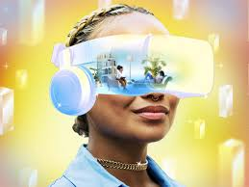

Figure 1: VR and Mental Health

Utilization of Virtual Reality in Mental Health Promotion:
Virtual Reality may be used to promote mental health by immersing users in a virtual world, allowing for interaction and experience of a different reality. VR promotes mental health in a unique way by generating immersive settings favorable to treatment and stress reduction. Therapeutic VR applications include phobia exposure treatment such as digital mental health escape rooms and mindfulness and relaxation sessions.


Figure 2: VR Phobia Treatment
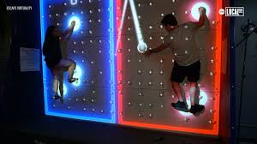
Figure 3: VR Escape Room
 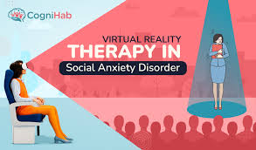

Figure 4: Therapies with VR
Numerous research studies have shown that virtual reality can promote mental wellness. For instance, a study shows that VR-based therapies dramatically decreased anxiety and depression symptoms among participants. Another study that VR exposure treatment was beneficial for treating post-traumatic stress disorder (PTSD). In addition, VR has been effectively utilized to reduce pain and promote well-being in patients undergoing medical operations.

Impacts:
The benefits of adopting VR in mental health promotion include creating regulated and immersive settings, tailoring interventions to individual requirements, and providing a safe location for exposure therapy. Furthermore, VR is accessible and can be utilized remotely, making it ideal for people who may have difficulty accessing traditional treatment. However, there are certain drawbacks to consider, such as the cost of VR equipment, the possibility of side effects including motion nausea, and the necessity for specific training for therapists.


Figure 4: Benefits of VR

Addressing Shortfalls:
To solve the limitations of VR in mental health promotion, numerous solutions may be adopted. First, efforts should be made to minimize the cost of VR equipment through subsidies or collaborations with manufacturers. Additionally, research into motion sickness prevention and user comfort should be prioritized. Therapist training programs should be increased to guarantee expertise in the use of virtual reality for mental health therapies. Furthermore, incorporating VR into current healthcare systems and insurance coverage would provide access to a larger audience.

References:
- Li, J. (2023) ‘Digital Technologies for mental health improvements in the COVID-19 pandemic: A scoping review’, BMC Public Health, 23(1). doi:10.1186/s12889-023-15302-w.

- Koh, A. et al. (2021) ‘Digital Health Promotion: Promise and peril’, Health Promotion International, 36(Supplement_1), pp. i70–i80. doi:10.1093/heapro/daab134.
- Health Survey England Additional Analyses, Ethnicity and Health, 2011-2019 Experimental statistics (2022) NHS choices. Available at: https://digital.nhs.uk/data-and-information/publications/statistical/health-survey-england-additional-analyses/ethnicity-and-health-2011-2019-experimental-statistics/physical-activity-copy#:~:text=Physical%20inactivity%20and%20ethnicity,least%20likely%20to%20be%20inactive. (Accessed: 02 April 2024).
- ( Thomas, J & Bond, Dale. (2014). Review of Innovations in Digital Health Technology to Promote Weight Control. Current diabetes reports. 14. 485. 10.1007/s11892-014-0485-1.)

Task 2
Title: Fitness Trackers and Augmented Reality: A Digital Solution for Obesity and Sedentary Lifestyles.

Introduction:
Sedentary lifestyles and obesity have arisen as major public health issues in today's technology era. Sedentary behavior, defined as prolonged periods of sitting or inactivity, including obesity, has been linked to disease , cardiovascular disease, and mental health issues. According to the World Health Organization (WHO), physical inactivity is the fourth biggest risk factor for worldwide mortality, accounting for around 3.2 million deaths per year.(WHO, 2022) These miserable findings highlight the critical need for novel ways to increase physical activity and combat inactive lifestyles.

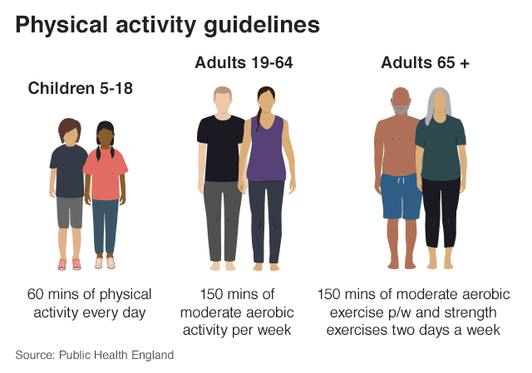 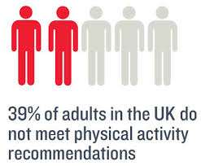
Figure 1: Guidance and Prevelance
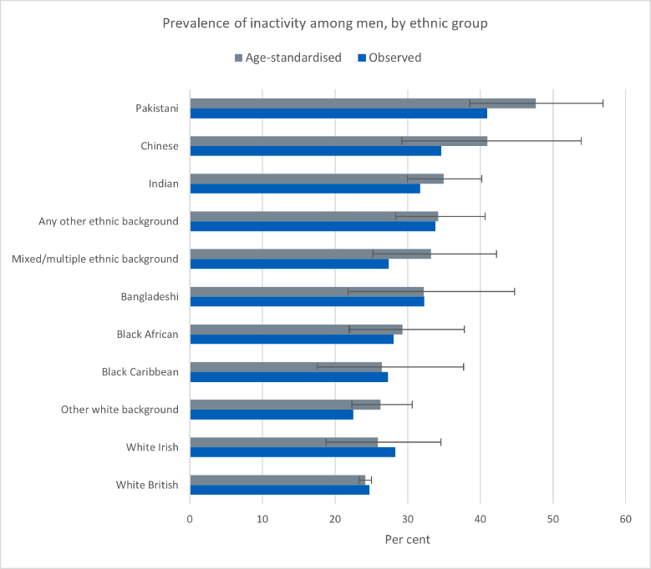 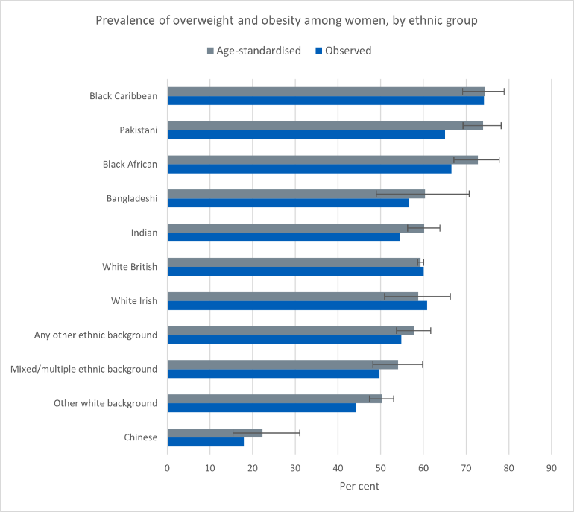
Figure 2: Statistics
One potential approach at the forefront of digital health promotion is the integration of augmented reality (AR) with fitness trackers. AR technology overlays digital material onto the actual environment, resulting in immersive and engaging experiences, whilst fitness trackers detect physical activity and offer individualized feedback. By integrating these technologies, people may participate in interesting and compelling fitness experiences that promote exercise and counteract sedentary behavior.
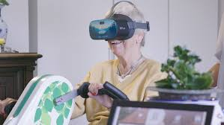 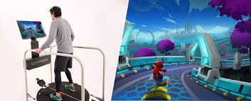
Figure 3: AR Technology
AR technology is changing the way people workout by making it more engaging and immersive. AR-enhanced applications and games allow users to participate in virtual exercises, guided tours, and fitness challenges, making exercise more pleasurable and rewarding. AR-enabled games, such as Pokémon GO, allow players to explore their surroundings and participate in physical activity while engaging with virtual animals. Gamified exercise treatments, such as those provided by AR technology, have been demonstrated in studies to boost physical activity levels and fitness program adherence. By integrating AR and fitness trackers people will be able to track their physical activity and can manage their lifestyle according to integrated technology.
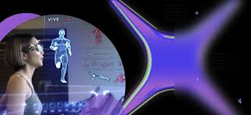 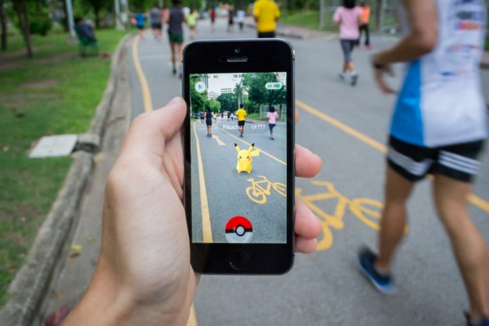
Figure 4: AR and Gamification
Fitness trackers complement augmented reality technology by giving real-time feedback and progress monitoring, allowing users to monitor their activity levels and create attainable objectives. These wearable gadgets employ sensors to record variables such as steps done, calories burnt, and heart rate, allowing users to track their progress and change their behavior as needed. According to studies, using fitness trackers leads to increased physical activity, better weight control, and better overall health results.
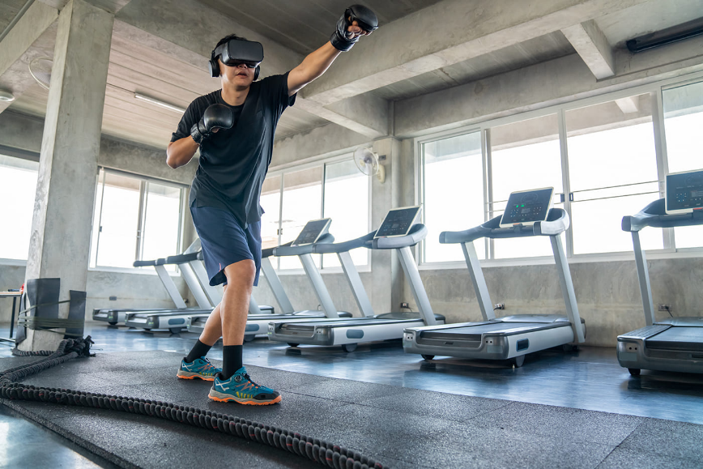

Figure 5: AR and Fitness Tracker
Wearable technology is transforming the area of tele-exercise by allowing users to continuously check their health and performance while exercising. As stated in the IoT section, gadgets such as smartwatches, fitness wristbands, and smart clothes may gather various data, including heart rate, oxygen consumption, posture, and sleep quality. This data may be examined and used to give individualized feedback and suggestions, therefore increasing workout efficacy and the user's overall health. (Moher Det al 2022)
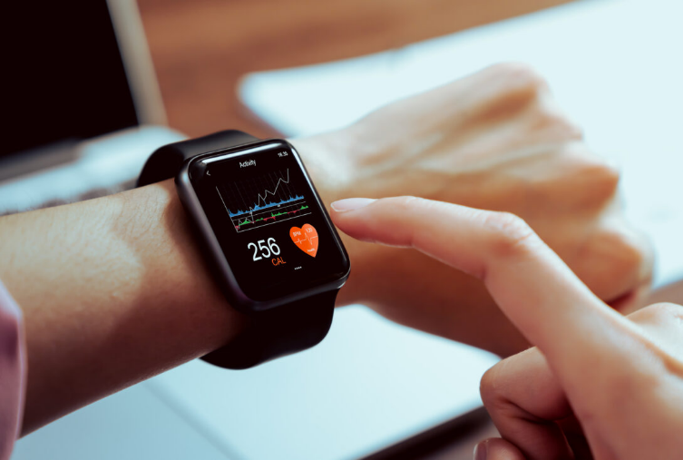

Figure 6: Wearable Devices

Challenges:
However, despite these benefits, using AR and fitness trackers in health promotion has challenges and limitations. One constraint is accessibility and affordability, as these technologies may necessitate significant hardware and software expenditures. Concerns like privacy, data security, and possible technological addiction must also be addressed to guarantee that these technologies are used ethically and responsibly.
To address these issues, politicians, healthcare practitioners, and technology companies must work together to provide equal access to AR and fitness tracker technologies. Subsidies, incentives, and public-private partnerships can help make these instruments more inexpensive and accessible to marginalized people. Furthermore, rigorous policies and standards should be implemented to protect user privacy and data security while encouraging responsible technology usage. World Economic Forum. 2020.

Conclusion:
To summarize, the combination of augmented reality with fitness trackers is a novel and inventive digital approach for encouraging physical activity while combatting sedentary lives and obesity. Individuals may participate in engaging and inspiring exercise experiences suited to their requirements by using the immersive and interactive nature of AR technology and the individualized feedback provided by fitness trackers. However, through partnerships and evidence-based solutions, we can harness the potential of technology to build a healthier and more active society for future generations.

Rferences:
Concerns for the mental health of children and adolescents during the coronavirus pandemic. European Child & Adolescent Psychiatry. 2020. https://www.escap.eu/index/coronavirus-and-mental-health/. Accessed May 3, 2020.
- Armitage R, Nellums LB. COVID‐19 and the consequences of isolating the elderly. Lancet Public Heal. 2020;2667(20):30061. 10.1016/S2468-2667(20)30061-X. Accessed May 3, 2020. [PMC free article] [PubMed] [CrossRef] [Google Scholar]
An expert explains: how to help older people through the COVID‐19 pandemic. World Economic Forum. 2020. https://www.weforum.org/agenda/2020/03/coronavirus-covid-19-elderly-older-people-health-risk/. Accessed May 3, 2020.
- Moher D., Liberati A., Tetzlaff J., Altman D.G., PRISMA Group Preferred reporting items for systematic reviews and meta-analyses: The PRISMA statement. PLoS Med. 2009;6:e1000097. doi: 10.1371/journal.pmed.1000097

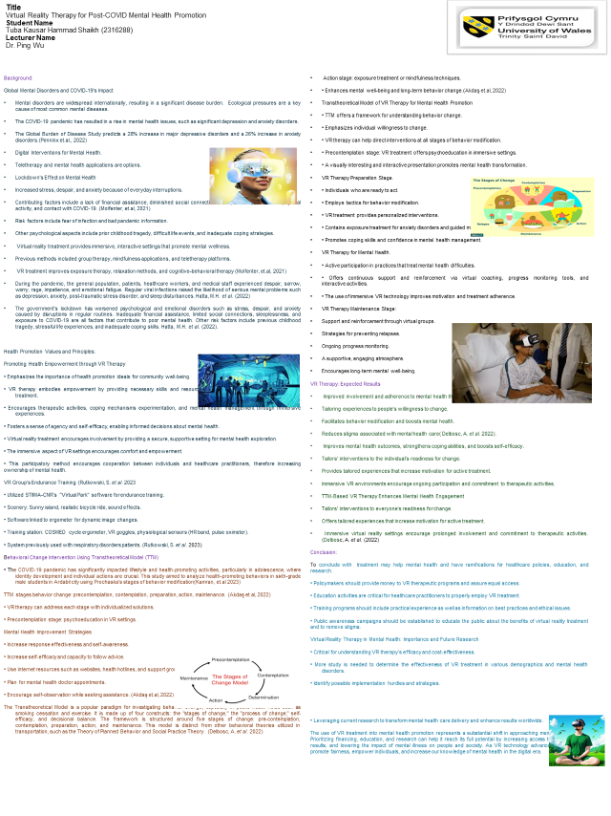

References:
- Fabbrizio, A. et al. (2023) ‘Smart Devices for Health and wellness applied to Tele-Exercise: An overview of new trends and technologies such as IOT and ai’, Healthcare, 11(12), p. 1805. doi:10.3390/healthcare11121805.
- Thomas, J & Bond, Dale. (2014). Review of Innovations in Digital Health Technology to Promote Weight Control. Current diabetes reports. 14. 485. 10.1007/s11892-014-0485-1
- Gregg, L., Tarrier, N. Virtual reality in mental health. Soc Psychiat Epidemiol 42, 343–354 (2007). https://doi.org/10.1007/s00127-007-0173-4
- Akdaş, O., Cismaru, M. Promoting mental health during the COVID-19 pandemic: the transtheoretical model of change and social marketing approach. Int Rev Public Nonprofit Mark 19, 447–474 (2022). https://doi.org/10.1007/s12208-021-00307-1
- Kamran, A., Aliakbari, P., Nasimi Doost Azgomi, R. et al. Action status and willingness to change health-promoting behaviors during the COVID-19 pandemic among elementary school children: a study based on Prochaska’s stages of behavior change theory (TTM). BMC Public Health 23, 248 (2023). https://doi.org/10.1186/s12889-023-15178-w
- Hatta, M.H. et al. (2022) ‘Virtual reality (VR) technology for treatment of mental health problems during COVID-19: A systematic review’, International Journal of Environmental Research and Public Health, 19(9), p. 5389. doi:10.3390/ijerph19095389.
- Molfenter, T., Heitkamp, T., Murphy, A.A. et al. Use of Telehealth in Mental Health (MH) Services During and After COVID-19. Community Ment Health J 57, 1244–1251 (2021). https://doi.org/10.1007/s10597-021-00861-2
- Rutkowski, S. et al. (2023) ‘Inpatient post-covid-19 rehabilitation program featuring virtual reality—preliminary results of randomized controlled trial’, Frontiers in Public Health, 11. doi:10.3389/fpubh.2023.1121554.
- Delbosc, A. et al. (2022) ‘The “re-norming” of working from home during COVID-19: A transtheoretical behaviour change model of a major unplanned disruption’, Transport Policy, 127, pp. 15–21. doi:10.1016/j.tranpol.2022.08.007.
- 1. Moukaddam N, Shah A. Psychiatrists beware! The impact of COVID‐19 and pandemics on mental health. Psychiatric Times. 2020. https://www.psychiatrictimes.com/psychiatrists-beware-impact-coronavirus-pandemics-mental-health. Accessed May 3, 2020.
- 2. Javed B, Sarwer A, Soto EB, Mashwani Z‐R. Is Pakistan's response to coronavirus (SARS‐CoV‐2) adequate to prevent an outbreak? Front Med. 2020;7:1‐4. 10.3389/fmed.2020.00158. Accessed May 3, 2020. [PMC free article] [PubMed] [CrossRef] [Google Scholar]
- 3. WHO warning on lockdown mental health. Euobserver. 2020. https://euobserver.com/coronavirus/147903. Accessed May 3, 2020.
- 4. Correia T. SARS‐CoV‐2 pandemics: the lack of critical reflection addressing short‐ and long‐term challenges. Int J Health Plann Manage. 2020;35:1‐4. 10.1002/hpm.2977. Accessed May 3, 2020. [PubMed] [CrossRef] [Google Scholar]
- 5. Mental health and coping during COVID‐19. Centers for Disease Control and Prevention. 2020. https://www.cdc.gov/coronavirus/2019-ncov/about/coping.html. Accessed May 3, 2020.
- . Yao H, Chen J‐H, Xu Y‐F. Patients with mental health disorders in the COVID‐19 epidemic. Lancet Psychiatry. 2020;7(4):e21. 10.1016/S2215-0366(20)30090-0. Accessed May 3, 2020. [PMC free article] [PubMed] [CrossRef] [Google Scholar]
- Looking after your mental health during the Coronavirus outbreak. Mental Health Foundation. 2020. https://www.mentalhealth.org.uk/publications/looking-after-your-mental-health-during-coronavirus-outbreak. Accessed May 3, 2020.
- Liu JJ, Bao Y, Huang X, Shi J, Lu L. Mental health considerations for children quarantined because of COVID‐19. Lancet Child Adolesc Heal. 2020;4(5):347‐349. 10.1016/S2352-4642(20)30096-1. Accessed May 3, 2020. [PMC free article] [PubMed] [CrossRef] [Google Scholar]
- Hatta M.H., Sidi H., Sharip S., Das S., Saini S.M. The Role of Virtual Reality as a Psychological Intervention for Mental Health Disturbances during the COVID-19 Pandemic: A Narrative Review. Int. J. Environ. Res. Public Health. 2022;19:2390.
- Alvarez-Lopez F., Maina M.F., Saigí-Rubió F. Use of a Low-Cost Portable 3D Virtual Reality Gesture-Mediated Simulator for Training and Learning Basic Psychomotor Skills in Minimally Invasive Surgery: Development and Content Validity Study. J. Med. Internet Res. 2020;22:e17491.
- Hwang N.K., Shim S.H. Use of Virtual Reality Technology to Support the Home Modification Process: A Scoping Review. Int. J. Environ. Res. Public Health. 2021;18:11096.
- Gupta A., Scott K., Dukewich M. Innovative technology using virtual reality in the treatment of pain: Does it reduce pain via distraction, or is there more to it? Pain Med. 2018;19:151–159

