

University of Wales Trinity Saint David

School of Engineering

Manufacturing Systems

Control and Automation

Development and Application of
Manufacturing Automation
ACMA5001

Joseph Lancastle
2214707
21st April 2024
Wordcount: 2553
Edited Wordcount: 2499
Contents
List of Figures 3
Introduction 4
Fixed Automation 5
History and Chronology 5
Advantages and Disadvantages 5
Control Systems and Process Variables 6
Programmable Automation 8
History and Chronology 8
Advantages and Disadvantages 8
Control Systems and Process Variables 8
Flexible Automation 11
History and Chronology 11
Control Systems and Process Variables 11
Suitability to Flat-Packed Furniture Production 13
Conclusion 14
Bibliography 15

List of Figures
Figure 1: Open-Loop Control Block Diagram (Allerman, 2015) 6
Figure 2: Closed-Loop Control Block Diagram (Allerman, 2015) 7
Figure 3: PLC Ladder Logic Rung (Chaudhari et al., 2021) 9
Figure 4: PID Controller Block Diagram (SMLease Design, 2022) 10
Figure 5: Graph Showing P, PI and PID Responses to an Error Signal (SMLease Design, 2022) 10
Figure 6: A Simplified DCS Block Diagram (InduSup.com, 2019) 12
Figure 7: A Simplified SCADA Block Diagram, (InduSup.com, 2019) 12
Figure 8: Production Volume Vs. Variety (Control Freaks, 2023) 13

Introduction
Automation used in manufacturing has been in use since the mid-20th century, the need for its emergence was efficiency of manufacture, a requisite that has increased exponentially to the present day. Now, Automation is used commonly throughout manufacturing facilities and is likely one of three primary types: Fixed, Programmable, and Flexible Automation.
Each automation type has its strengths and weaknesses, continually adapting over its lifecycle. Fixed Automation is driven by economy of scale, with highest output numbers being the primary objective. However, as its name suggests, it is fixed to the manufacture of one product, a poor trait for manufacturing industries with a large varying product portfolio. Programmable Automation sits at the opposite end of the scale, offering high versatility and line expansion potential, to the detriment to output quantity. Flexible Automation bridges the gap between the Automation types, largely suited to industries requiring swift adaption and numerous product lines and part variability, such as flat pack-furniture manufacture.

Fixed Automation

History and Chronology
Fixed Automation is a process used to automate assembly lines or production sequences. Once the process is set up, the items produced on said assembly line are dictated by its configuration. Pre-20th century, water wheels, windmills and James Watt’s steam engine were used for automating tasks. Fixed automation has been in use since the early 20th century, with the earliest examples seen on Henry Ford’s assembly line in 1913 with the production of the Ford Model-T (Weber, 2023). Fixed Automation lends itself to automotive manufacturing due to the low number of part variability in each sequential production operation, a beneficial characteristic for other industries such as: chemical, pharmaceutical, food and drink, material handling conveyor systems and machining transfer operations.

Advantages and Disadvantages
As is testament to the industries that utilise this system, Fixed Automation methods yield high throughput of repeatable product. Although the initial outlay for equipment is high, the decreased labour cost outweighs the outlay. Using Fixed Automation negates the need for a large workforce. Although, the employment that remains is highly skilled, demanding higher wages. This still yields a decreased labour income share compared to non-automated assembly lines, (Shimizu and Momoda, 2023).

Control Systems and Process Variables

In a soft drink manufacturing facility, to fill each container equally, pressurised fluid can be dosed by means of a solenoid actuated butterfly or gate valve opening and closing for a time that doses the correct volume of fluid. Open-loop control can be used to achieve this, (Figure 1). The reference input, is the valve position, set to produce a specific volume of fluid, known as the manipulated variable. The controller element monitors the time the valve is in its closed position and opens it via an electrical signal to the Actuating Input (valve). The valve will stay open until a control signal, stops the supply of power, closing the valve, by means of a motorised or spring return. This then allows the plant/process to occur, i.e., dosing the container with soft drink. This produces the controlled variable or output, a correct volume container of soft drink.
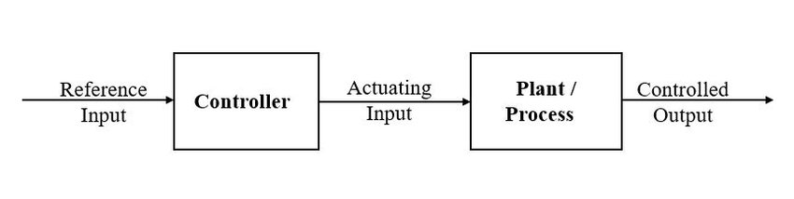
Figure 1: Open-Loop Control Block Diagram (Allerman, 2015)
Open loop control systems are vulnerable to external disturbances, such as: variance in supply pressure, temperature changes or power cuts, which could lead to the dispensing valve moving incrementally from its set position, known as slip. These extraneous effectors result in an uncontrolled output and container volume inconsistencies.
Automatic error or disturbance regulation comes in the form of a feedback loop and a comparator, creating a closed loop control system, (Figure 2) This is a more suitable approach for Fixed Automation lines (Kogan, 2009) and controlling fluid pumping systems (Naz et al., 2023). Naz et al., (2023) and Rosen (1978) suggest that closed loop control is more suitable to Programmable Automation methods whereas, MacDuffie and Pil, (1997) argue that, with the integration of technology into all automation methods, there is significant overlap of automation definitions, meaning that multiple control methods apply to many automation types.
External disturbances that affect the container fluid volume output are controlled by feedback signals from output sensors, sent to the Comparator, which compares the input value of valve time opened to produce the correct fluid volume, versus the measured volume. This produces an error signal that will adjust valve opening time to ensure correct fluid dispensation.

A closed loop control system will control system variables, minimise human interaction and decrease downtime and substandard products. Increased system components mean Closed-Loop systems break down more often and are less cost effective than open-loop derivatives, compounded by complex systems requiring multiple feedback loops to control output level, fluid pressure from pump speed measured via displacement transducers. For gravity fed fluid systems, measurement transducers such as Orifice Plates or to mitigate pressure losses, the us of Hot-Wire Anemometers (HWA) can be used to monitor pressure by analysing the passing flowrate versus the heat loss rate from its Hot Wire Element, via calculation using Bernoulli’s equation.
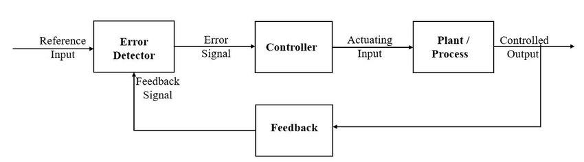
Figure 2: Closed-Loop Control Block Diagram (Allerman, 2015)

Programmable Automation

History and Chronology
Programmable Automation Systems (PAS) emerged in the 1960’s, developed by General Motors and Richard Morley, director of Bedford Associates, Rebranded Modicon, creating the Programmable Logic Controller (PLC). Morley was frustrated by the inflexibility of Fixed Automation lines where hard wired relay logic systems occupied floor space reducing the ability for product lines to expand. General Motors required a more compact, efficient and reliable systems for their automated assembly lines. Due to the large number of mechanical switching components, (Kumar.M et al., 2017), fixed systems would break down frequently and the phrase “five hours to find it, five minutes to fix it” originated from fault finding these systems (Pollard, 2022).
The utilisation of PLCs allowed for production of varying batches by reprogramming the controller, a system still utilised today. For example, a machine shop produces various items, but the number of Computer Numerically Controlled (CNC) machines is limited. Reprogramming the PLC enables the CNC machine tool to produce different parts on the same instrument. Other components in the automated production process, such as welding systems, tool changers and robots can thus be incorporated into the production system quickly with less human involvement.

Advantages and Disadvantages
PAS’s advantages come from the flexibility to accommodate changing production requirements by reprogramming the PLC, meaning less downtime than changing a Fixed Automation process, although the changeover is not completely devoid of any downtime as the PAS cannot be utilised during reprogramming (Jacobs, 2023).
The increase of product variability is detrimental to production output. Whereas Fixed Automation systems are designed for a singular purpose, Programmable Automation systems are used to accommodate several products. Allowing for this variability means the manufacturing process is not optimised for a single product, decreasing its output efficiency.
A PLC Controller “is designed to be operated by engineers with perhaps a limited knowledge of computers and computing languages” (Bolton 2015, p.14). However, with the increased load of more complex automation systems, the use of PLC’s and familiarity with their Ladder Logic Programmes is more difficult and requires comprehensive training and exposure (Foster et al., 2010; Rowe et al., 2020).

Control Systems and Process Variables
The primary method used in Programmable Automation Systems is the PLC. Its ruggedness and versatility lends itself to CNC machining centres (Jie et al., 2011). These centres contain CNC Millers and Lathes, automated welders, robotic arms and conveyors. The PLC controls discrete processes with feedback control and use of its internal, visual programming language called PLC Ladder Logic. The left rail in Figure 3 represents the power source or positive rail, the right rail represents the negative or neutral rail. Each rung of the ladder contains inputs and outputs, the combination of Normally Open and Closed contacts represents the inputs such as sensors, switches or timers. The coils represent the output functions such as motors, valves and alarms. This relationship combined with basic Logic Gates such as AND, OR, XOR (Exclusive OR) and FUB (Function Blocks) which can consolidate more complicated system functions, provides the means for control.
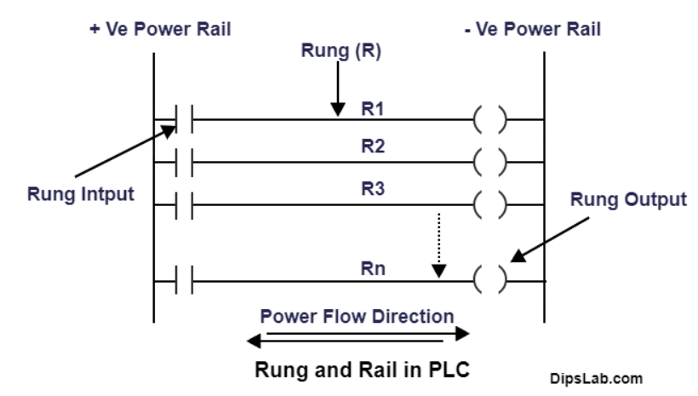
Figure 3: PLC Ladder Logic Rung (Chaudhari et al., 2021)
The sensors and feedback mechanisms will monitor output variables including temperature, pressure, vibration, and motor spindle head speed and position. Whilst machining, these output conditions will be fed back to the PLC, providing either an Adaptive or Feedback control mechanism to maintain optimal machining conditions such as cutting speeds, tool offsets, table feed rates and other input parameters to account for cutting tool wear.
Adaptive Control considers multiple variables simultaneously, using algorithmic means to control outputs that may drift over time. Including, combining reference values, with the thermal expansion of the work piece based on ambient temperature and the materials thermal coefficient, and machine degradation from resonance and Acoustic Emission (AE) sensors derived from machine learning calculations, (Stoney et al., 2013; Jaen-Cuellar et al., 2021)
The PLC using Feedback Control such as a Proportional, Integral, Derivative (PID), that emerged in the 1940’s, will identify a variable such as cutting tool wear and adjust machine offsets (Åström and Murray, 2008). PID control, will evaluate an error signal from a control system Comparator, relative to the expected signal. Such as, machine tool diameter compared to its actual diameter, measured via means of a feedback sensor such as a touch trigger probe (Figure 4).
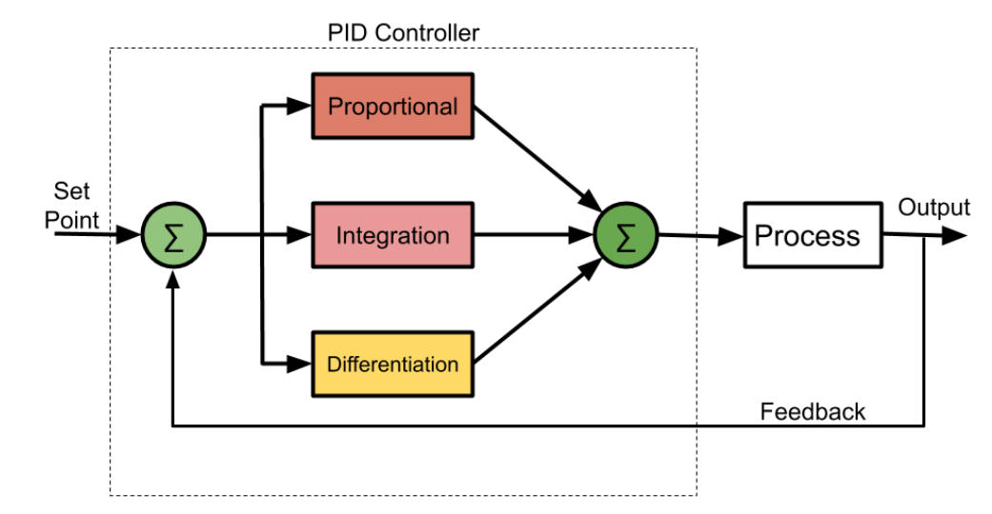
Figure 4: PID Controller Block Diagram (SMLease Design, 2022)
The Proportional component in the PID controller will adjust the required machining parameters in proportion to the magnitude of the error, the difference in diameter of the worn tool. Proportional Gain control is susceptible to Offset Errors, where the control system’s corrective action did not rectify the error and has no method of evaluating the difference, staying in a Steady State of Error (ESS). The Integral term and the Proportional term combined (PI) will control the ESS by correcting the error by considering the rate of change over time of the cutting tool and adjusting the corrective action. However, PI control can overestimate the corrective action, potentially damaging the workpiece. To mitigate large oscillations and slow settle times, the Derivative gain term will create a corrective action in accordance with the rate of change of the error signal, ensuring machining accuracy in conjunction with PI Controllers (Figure 5).
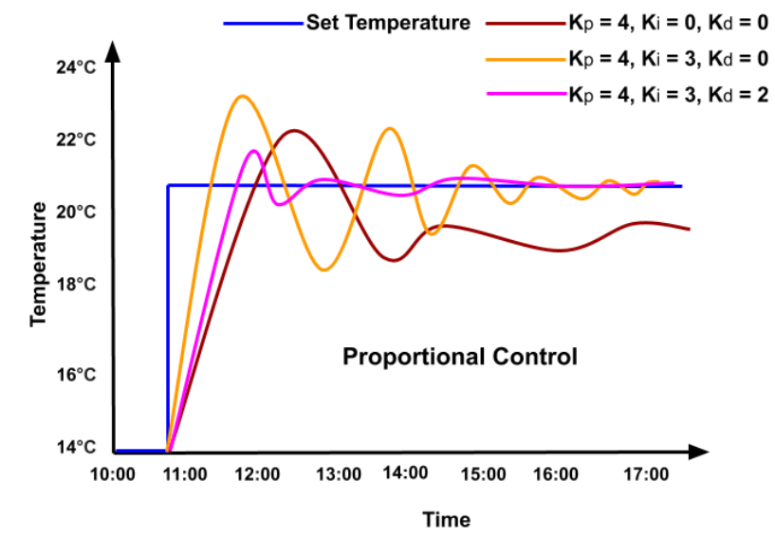
Figure 5: Graph Showing P, PI and PID Responses to an Error Signal (SMLease Design, 2022)

Flexible Automation

History and Chronology
The continuum of automation systems development resumes with Flexible Automation Systems (FAS). FAS develops PAS by reducing reprogramming time to adapt to manufacturing changes by programming the equipment off-line, (Dubey and Crowder, 2003; Groover et al., 2024). The qualities of FAS are useful in industries that require a batch manufactured, variable and customisable product, in Furniture, Automotive, Food, Medical Devices and Clothing industries.
FAS have been a part of automation processes in many guises since the late 20th century, and have developed alongside Numerical Control (NC) machines from the 1960’s. Where using punch cards to automate machine operations, developed into CNC operations which marks a significant step-change for the technology, thanks to the emergence of Integrated Circuits (ICs), its culmination was credited to IBM and Texas Instruments (Amelio et al., 2005). Evolution continued in the 1970’s and 80’s with the implementation of industrial robots and Computer-Integrated Manufacturing (CIM) which co-ordinated CNC instruments, robots, conveyors and other processes. This laid the foundations for Flexible Automation as we know it, where technologies such as robot arms and machine learning protocols are seamlessly integrated thanks to increased cost efficiencies, from to Microprocessor advancements and availability.

Control Systems and Process Variables
As with all manufacturing automation types, the process variables are similar. However, as the system becomes more complex with more processes to monitor via negative feedback, the control systems utilised are more complex. Where PLCs are useful for monitoring singular processes, Distributed Control Systems (DCS) are employed when there are several continuous processes to control. A DCS consists of multiple control units distributed throughout the FAS and connected via a central network. Each control module collects data and information from sensors, computers and controllers simultaneously. This is fed back to a dedicated central process unit with a Human-Machine Interface (HMI) enabling operators to observe and control the process (Figure 6).
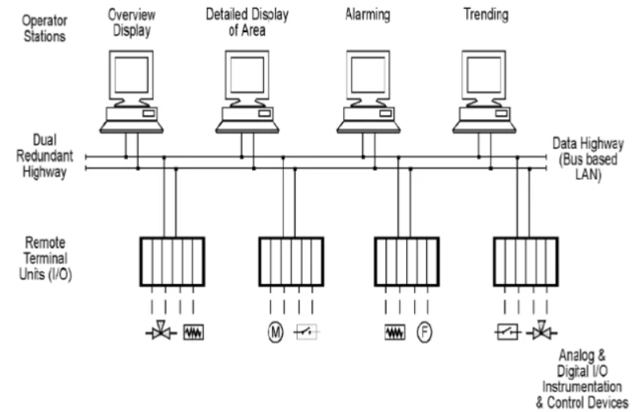
Figure 6: A Simplified DCS Block Diagram (InduSup.com, 2019)
A Supervisory Control and Data Acquisition (SCADA) system controls processes, by monitoring and providing real-time feedback of control systems such as PLC’s and DCS’s. Data is logged and fed back data to an HMI, where operators can adjust control parameters (Figure 7). Although SCADA systems can send commands to the Control Systems, its responsivity is inferior to a DCS. SCADA systems can continue production with interconnectivity breaks whereas a DCS cannot. However, a DCS may have inbuilt redundancies which means that stopping the process is less of a detriment to the overall system output.
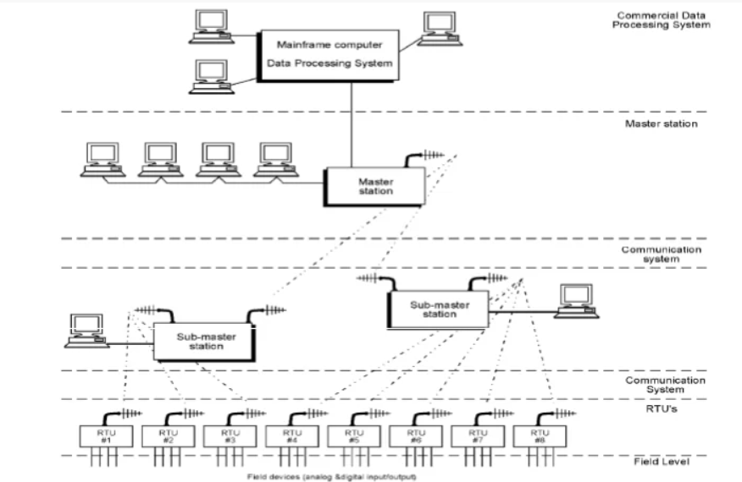
Figure 7: A Simplified SCADA Block Diagram, (InduSup.com, 2019)

Suitability to Flat-Packed Furniture Production

Although FAS is not suited to high-volume production, it can “substantially improve the productivity of mid-volume, mid-variety production” (Hutchinson and Holland, 1982, p.221) Supported by (Chen and Adam, 1991) and displayed in Figure 8. Represents the production demands of flat-packed furniture production.
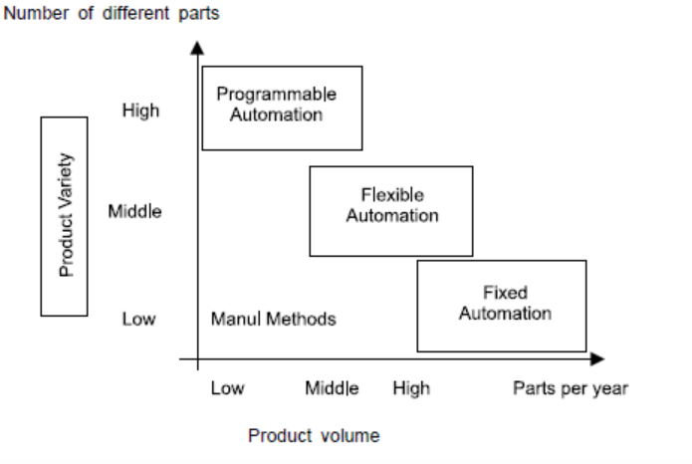
Figure 8: Production Volume Vs. Variety (Control Freaks, 2023)
The same system can produce varying furniture types using the same manufacturing line, with only programming and material changes. The system can accommodate this because the core elements of the furniture types produced are similar, with changes in size, style, colour and design features. Reprogramming FASs saves changeover downtime and financial outlay by removing any major alterations needed to the production process to accommodate product changes.
This adaptability and its ability to upscale by integrating automated process steps into the DCS ensures site viability by mitigating the initial outlay for the DCS and production machinery. To produce custom furniture and save cost, Agile manufacturing systems including technician-controlled process steps can be easily integrated (Jovane et al., 2003). However, increased process steps and complexity, demands more knowledgeable staff and higher wages increasing the cost per unit (Adler, 1988).

Conclusion
To summarise, all three types Fixed, Programmable and Flexible Automation, each offer their own set of unique capabilities catering to a myriad of manufacturing environments. The key factor when trying to decide what Automation Control type should be utilised, is fundamentally bourn from what is being produced, the scale of the operation, the extent of automation required and budgetary requirements.
As discovered in this report, Fixed Automation has high repeatable quality of output suitable for stable production requirements but lacks adaptability limiting its benefits to few industries. Programmable Automation is much more versatile with faster reconfiguration but at the expense of all out efficiency of output quantity. Flexible Automation, with the emergence and rapid development of Collaborative Robots, is a solution adopted by more manufacturing companies thanks to its versatility and adaptability to ever increasing product quantity and customisation demand. The ability to continually monitor, adapt and control multiple varying processes far outweighs the initial financial burden of the equipment.

Bibliography
Adler, P.S. (1988) ‘Managing flexible automation’, California Management Review, 30(3), pp. 34–56. doi:10.2307/41166513.

Agarwal, A. (2022) ‘Cloud internet of things based machine monitoring analysis of energy parameters using novel techniques’, Wireless Personal Communications, 124(2), pp. 1789–1814. doi:10.1007/s11277-021-09431-x.

Alleman, G. (2015) Is There an Underlying Theory of Software Project Management? (A critique of the transformational and normative views of project management), 5, p. 13.

Amelio, G. et al. (2005) ‘Fairchild Semiconductor Corporation panel discussion’, in Metal Oxide Semiconductor Integrated Circuit (MOS IC) Products. Mountain View, California: Computer History Museum, pp. 1–8.
Åström, K.J. and Murray, R.M. (2008) Feedback systems: An introduction for scientists and Engineers. Princeton, NJ: Princeton University Press.
Bolton, W. (2015) Programmable logic controllers. Amsterdam: Newnes.
A brief history of programmable logic controllers (plcs) (2020) Process Solutions, Inc. Available at: https://processsolutions.com/a-brief-history-of-programmable-logic-controllers-plcs/ (Accessed: 11 April 2024).

Chaudhari, D. et al. (2021) What is a plc rung and rail in ladder logic?, DipsLab.com. Available at: https://dipslab.com/plc-rung/#google_vignette (Accessed: 16 April 2024).

Chen, F.F. and Adam, E.E. (1991) ‘The impact of flexible manufacturing systems on productivity and Quality’, IEEE Transactions on Engineering Management, 38(1), pp. 33–45. doi:10.1109/17.65758.

Close loop vs. open loop motor control: The definitive guide (2024) Solo Motor Controllers. Available at: https://www.solomotorcontrollers.com/blog/close-loop-vs-open-loop/#:~:text=high%2Dperformance%20applications.-,Cost,them%20more%20expensive%20to%20implement. (Accessed: 10 April 2024).

Computerized Manufacturing Automation: Employment, education, and the Workplace (1984). Washington, D.C.: Congress of the U.S., Office of Technology Assessment.

Control Freaks (2023) Different Automation Types. Available at: https://www.controlfreaksltd.co.uk/different-types-of-automation/#:~:text=Fixed%20automation%20is%20a%20type,known%20as%20%E2%80%9Chard%20automation%E2%80%9D. (Accessed: 19 April 2024).

Different types of automation (2020) Control Freaks. Available at: https://www.controlfreaksltd.co.uk/different-types-of-automation/#:~:text=Fixed%20automation%20is%20a%20type,known%20as%20%E2%80%9Chard%20automation%E2%80%9D. (Accessed: 06 April 2024).

Dubey, V.N. and Crowder, R.M. (2003) ‘Designing a dexterous reconfigurable packaging system for Flexible Automation’, Volume 2: 29th Design Automation Conference, Parts A and B [Preprint]. doi:10.1115/detc2003/dac-48812.

Foster, M.R., Hammerquist, C. and Melendy, R. (2010) A review of programmable logic controllers in control systems education, Digital Commons @ George Fox University. Available at: https://digitalcommons.georgefox.edu/mece_fac/22/ (Accessed: 13 April 2024).

Groover, M.P. et al. (2024) ‘Automation’, Britannica, 19 January. Available at: https://www.britannica.com/technology/computer-aided-engineering (Accessed: 13 April 2024).

Hutchinson, G.K. and Holland, J.R. (1982) ‘The economic value of Flexible Automation’, Journal of Manufacturing Systems, 1(2), pp. 215–228. doi:10.1016/s0278-6125(82)80031-9.
InduSup.com (2019) Difference between DCS and SCADA. Available at: https://www.en.indusup.com/difference-between-dcs-and-scada/ (Accessed: 19 April 2024).

Jacobs, P. (2023) CNC programming vs PLC programming examples(ladder logic), CNC Programming vs PLC Programming Examples. Available at: https://bin95.com/articles/automation/cnc-plc-programs.htm (Accessed: 13 April 2024).

Jaen-Cuellar, A.Y. et al. (2021) ‘System for tool-wear condition monitoring in CNC machines under variations of cutting parameter based on fusion stray flux-current processing’, Sensors, 21(24), p. 8431. doi:10.3390/s21248431.

Jie, L. et al. (2011) ‘Investigation on water recording system for large user of water supply network based on PLC’, Procedia Environmental Sciences, 11, pp. 1016–1022. doi:10.1016/j.proenv.2011.12.155.

Jovane, F., Koren, Y. and Boër, C.R. (2003) ‘Present and future of Flexible Automation: Towards new paradigms’, CIRP Annals, 52(2), pp. 543–560. doi:10.1016/s0007-8506(07)60203-0.

Kingsford, P.W. (2024) James Watt - Scottish Inventor, Encyclopædia Britannica. Available at: https://www.britannica.com/biography/James-Watt (Accessed: 16 April 2024).

Kogan, K. (2009) ‘Production control under uncertainty: Closed-loop versus open-loop approach’, IIE Transactions, 41(10), pp. 905–915. doi:10.1080/07408170902973944.

Kumar.M, A. and Kumar, H.P. (2017) ‘Automatic bottle filling system using PLC’, International Journal of Trend in Scientific Research and Development, Volume-2(Issue-1), pp. 361–364. doi:10.31142/ijtsrd5953.

Lee, K. (2020) How to calculate pressure from flow rate, Sciencing. Available at: https://sciencing.com/calculate-pressure-flow-rate-5973073.html (Accessed: 13 April 2024).

MacDuffie, J.P. and Pil, F.K. (1997) ‘From fixed to flexible: Automation and Work Organization Trends from the International Assembly Plant Study’, Transforming Automobile Assembly, pp. 238–254. doi:10.1007/978-3-642-60374-7_17.

Moxley-Paquette, V. et al. (2020) ‘5-axis CNC micromilling for rapid, cheap, and background-free NMR microcoils’, Analytical Chemistry, 92(23), pp. 15454–15462. doi:10.1021/acs.analchem.0c03126.

Naz, S.A. et al. (2023) ‘Closed-loop control systems for pumps used in portable analytical systems’, Journal of Chromatography A, 1695, p. 463931. doi:10.1016/j.chroma.2023.463931.

Peng, C.-Y. et al. (2021) ‘Sound Detection Monitoring Tool in CNC milling sounds by K-means clustering algorithm’, Sensors, 21(13), p. 4288. doi:10.3390/s21134288.

Petruzella, F.D. (2005) Programmable logic controllers. Boston: McGraw-Hill Higher Education.
Pollard, J. (2022) PLC Genesis, Control Design. Available at: https://www.controldesign.com/home/article/11367569/programmable-logic-controllers-plc-genesis (Accessed: 11 April 2024).

Rosen, C.A. (1978) ‘Material-handling robots for Programmable Automation’, Information-Control Problems in Manufacturing Technology, pp. 147–152. doi:10.1016/b978-0-08-022015-4.50023-1.

Rowe, S.C., Samson, C.I. and Clough, D.E. (2020) ‘A framework to guide the instruction of industrial programmable logic controllers in undergraduate engineering education’, Education for Chemical Engineers, 31, pp. 76–84. doi:10.1016/j.ece.2020.03.001.

Rullán, A. (1997) ‘Programmable logic controllers versus personal computers for process control’, Computers &amp; Industrial Engineering, 33(1–2), pp. 421–424. doi:10.1016/s0360-8352(97)00127-7.

Shimizu, R. and Momoda, S. (2023) ‘Does Automation Technology Increase Wage?’, Journal of Macroeconomics, 77, p. 103541. doi:10.1016/j.jmacro.2023.103541.

SMLease Design (2022) What is PID controller : Proportional Integral Derivative . Available at: https://www.smlease.com/entries/automation/what-is-pid-proportional-integral-derivative-control/ (Accessed: 19 April 2024).
Stecke, K.E. and Parker, R.P. (1998) ‘Cells and Flexible Automation: A History and Synergistic Application’, in Group Technology and Cellular Manufacturing. Amsterdam: Gordon & Breach, pp. 381–400.

Stoney, R., O’Donnell, G.E. and Geraghty, D. (2013) ‘Dynamic Wireless passive strain measurement in CNC turning using surface acoustic wave sensors’, The International Journal of Advanced Manufacturing Technology, 69(5–8), pp. 1421–1430. doi:10.1007/s00170-013-5116-5.

Understanding the relationship between flow and pressure (2023) Atlas Scientific. Available at: https://atlas-scientific.com/blog/relationship-between-flow-and-pressure/ (Accessed: 13 April 2024).
Weber, A. (2023) Special section: Automation pioneers, ASSEMBLY RSS. Available at: https://www.assemblymag.com/articles/83963-special-section-automation-pioneers (Accessed: 16 April 2024).

