

Managing People-LCBB5004

Assignment 2
Written Assignment

Student name & ID:
Alina-Paula Manolache- 2114609
Table of Contents
Written Assignment Part 1 1
Introduction 2
Importance of the CIPD Code of conduct for influential HR professionals 3
Methodology Guide for Human Resource Professionals at CIPD 4
CIPD Proffessional maps application in HR at the global stage 7
Conclusion 8
References 9
Written Assignment Part 2 10
Introduction 11
Skills shortage in the UK 12
Reasons for facing skills shortages in the UK 13
Long-term Development of the Labour market in the Healthcare Sector of the UK 14
Conclusion 15
References 16

Written Assignment Part 1

Introduction

Human resource managers can benefit from an outside-in perspective by spotting industry trends in the marketplace and then brainstorming ways to implement those ideas in their organization. It's essential to keep the company's goals in mind and provide excellent customer service. Human resources should evaluate personal skills and organisational strengths and weaknesses(SMITH and MITCHELL, 2022).
About current CIPD maps, this report aims to demonstrate the importance of these behaviours for influential HR professionals in the UK and at a global scale.

Importance of the CIPD Code of conduct for influential HR professionals

The Chartered Institute of Personnel and Development (CIPD) uses a code of conduct to evaluate members' level of professionalism in the UK.
- Competence and Ethics in the Workplace
- Consistency with Principles and Honesty
- Representing the Field Generally
- Stewardship.
None of the CIPD's size, sector or speciality distinctions is relevant; all members must abide by these norms of conduct. All these factors contribute to the confidence and retention of competent HR specialists. These factors contribute to the spirit and retention of qualified UK HR specialists(Cotton, 2018).
To be successful and productive in human resources, one must acquire and hone various talents. Some of the most important ones are outlined below:

- Punctuality and reliability
- Possessing expertise in project management
- Cognitive abilities that are analytical and critical
- Competent verbal and nonverbal communication
- Relationship-building and management skills.
Instead of focusing on discrete tasks like employment and remuneration, HR departments should work toward delivering long-term, holistic solutions. HR policies and procedures of the past should be refined and updated to be more valuable and practical today. Human resources (HR) encompasses both an administrative and a strategic role, as it entails overseeing operational processes and planning for the future (TINGSAGER and SMITH, 2022).

Methodology Guide for Human Resource Professionals at CIPD

Below is the CIPD's professionalism map, which can help you understand how to portray professionalism in an HR function. The 2019 Map lays out the fundamentals of solid people management practices that underpin standard operating procedures regardless of area of expertise. One can tailor it to your specific field, amount of responsibility, and professional goals (CIPD, 2019).
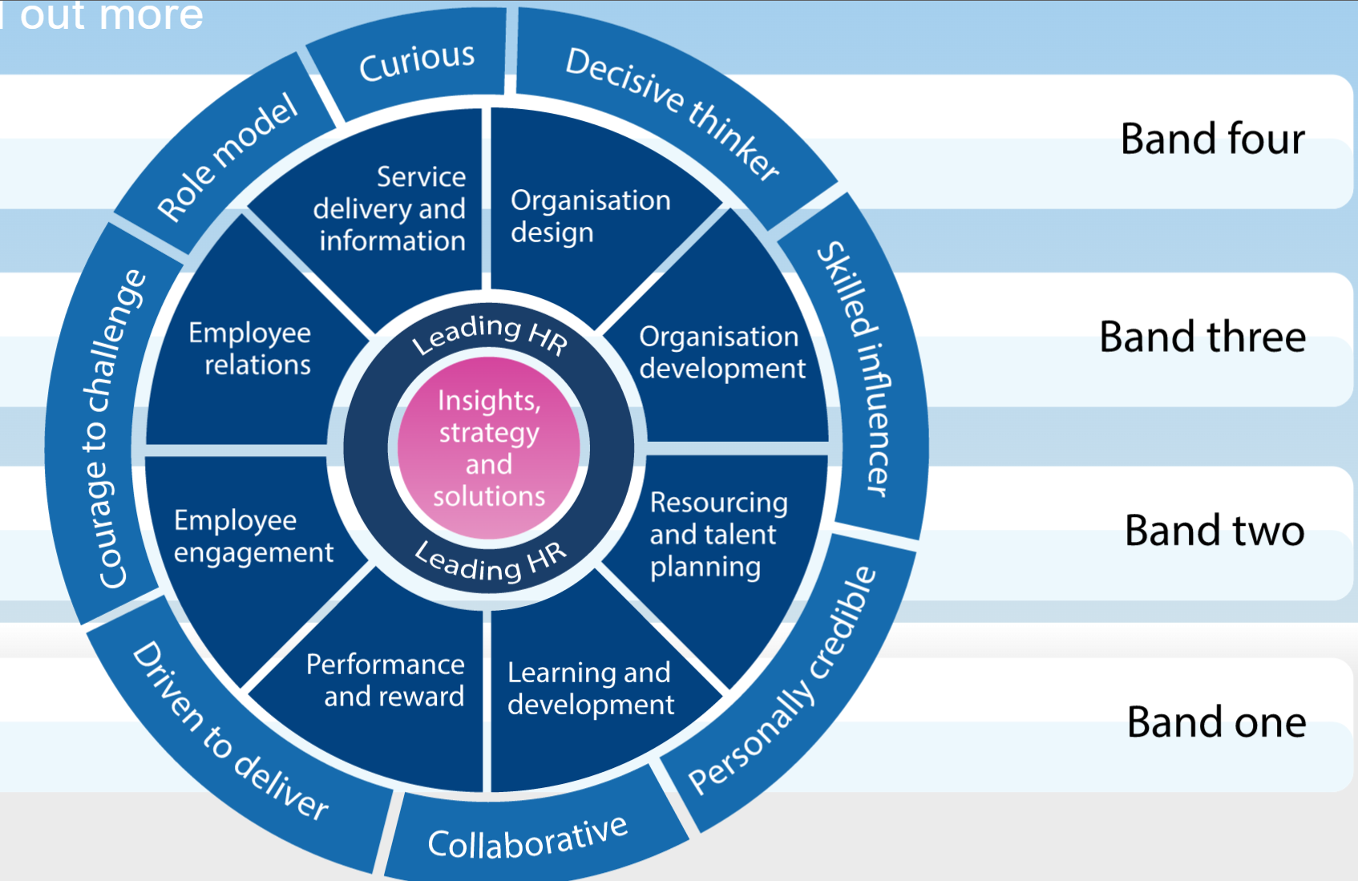
Source: (CIPD, 2019)
Insight, Strategy and Solution: This will aid in learning about the company and developing strategies and solutions most suited to achieving its immediate and long-term objectives.
To lead in HR means providing an example for other HR professionals, whether expanding your expertise in HR or the organisation as a whole or mentoring subordinates and assessing their progress.
Organisational structure — Make sure the system is set up to have the most significant possible effect on current and future aims.
Organisational growth maximises an organization's potential by bringing together its strategy, people, and procedures to achieve its goals most efficiently and effectively as possible.
Planning for resources and human capital means ensuring your company has everything it needs to succeed in the present and future, including the right people with the necessary skills.
It is developing one's skills and those of one's organization to fulfill current demands and instill a culture of learning and growth that leads to lasting capability gains.
Create and sustain a high-achieving culture by implementing programs that fairly and cost-effectively reward and recognise critical employee competencies, skills, behaviours, experience, and performance.
The term "employee engagement" refers to encouraging workers to become emotionally invested in their jobs and the people they interact with on the job, hence increasing their productivity and contributions to the company's goals.
Employee relations ensure that the company's connection with its workers is managed effectively, efficiently, and by all applicable laws, policies, and standards.
Providing data and services – Ensure all HR service delivery aspects are geared toward satisfying your customers. To provide HR services efficiently and cost-effectively and to assess how they are being used, it is necessary to put in place processes and project management (Harrison et al., 2020).

Band no. one | Band no. two | Band no. three | Band no. four
Delivering Fundamental | Adviser, issues led | Consultant, cooperative partner | Leadership, Collogue, Coach
Offers assistance to coworkers in administrative and procedural matters. Manages data and information efficiently and focuses on satisfying customers. | Guides, and handles, human resources concerns affecting an individual or group. Grasps the evaluation procedure and the options available with ease. | Manages a professional practice as a consultant or business partner, focusing on medium- to long-term solutions to the organisation's most pressing human resources issues. | Manages and directs a business unit or division. Organisational and human resources planning and execution fall within their purview.

The banding system makes it easy to assess HR’s present level of proficiency, plan for advancement to higher bands, and target specific areas of weakness.

CIPD Professional maps application in HR at the global stage

Human resource management as four concentric rings

- Taking charge of one's own life
- Collaborative leadership
- Controlling the upper echelons
- Management on a global scale

One definition of "self-management" is the ability to maintain current levels of competence in one's own set of abilities, including one's knowledge, skills, and habits. Relationships with others, whether at work or in other settings, might benefit from these abilities.
Working with other human resources experts or colleagues to address business issues or coordinate with other influential parties is an example of group or team management (Pepple and Zhang, 2021).
Third, working closely with managers and other high-ranking professionals is a requirement of being an HR professional. Without this, it will be difficult for any company to carry out its plans and strategy across the board (Boxall, 2021).
'Managing across the organization' is the focus of the fourth and final professionalism ring. HR professionals are responsible for implementing plans throughout their organizations once they have been developed.

Conclusion

Making sure that clients are satisfied is crucial to HR success. One way to do this is to respond quickly to questions, be accommodating to consumers' needs, and continue learning so that you may better meet their expectations.
A human resources professional that cares about providing excellent service to their clients will always be honest and forthright with them(Mayo, 2020). It is the responsibility of the HR department to ensure that all messages and solutions are implemented.

References

Boxall, P. (2021). Mutuality in the management of human resources: assessing the quality of alignment in employment relationships. Human Resource Management Journal, 23(1), pp.3–17. doi:10.1111/1748-8583.12015.
CIPD (2019). CIPD The Professional Body for Human Resources and People Development. [online] CIPD. Available at: https://www.cipd.co.uk/.
Cotton, C. (2018). CIPD Annual Reward Conference, London, UK, 6 February, 2018. Strategic HR Review, 7(4). doi:10.1108/shr.2008.37207dac.001.
Harrison, P., Tosey, P., Anderson, V. and Elliott, C. (2020). HRD professional education provision in the UK: past, present and future. Human Resource Development International, pp.1–19. doi:10.1080/13678868.2020.1775039.
Mayo, A. (2020). HR at the top table. Strategic HR Review, 19(6), pp.259–265. doi:10.1108/shr-08-2020-0074.
Pepple, D. and Zhang, C. (2021). Financial and managerial aspects in human resource management : a practical guide. Bingley, UK: Emerald Publishing.
SMITH, J. and MITCHELL, J. (2022). The behaviour of the people professional. Studying Human Resource Management: A Guide to the Study, Context and Practice of HR, p.141.
TINGSAGER, C. and SMITH, F. (2022). Strategy and structure. Studying Human Resource Management: A Guide to the Study, Context and Practice of HR, p.41.

Written Assignment Part 2

Introduction

In a recent survey, business owners in England and Scotland believed the current skills deficit in the UK could be a danger to business growth. The results showed that 53% of businesses presently suffer skills shortages in these regions. Complex factors contribute to the existing skill gaps in the UK, particularly in the public sector. The termination of free flow has resulted in shortages in some sectors of the UK labour market, but it is far from the leading cause. It's not just the UK having trouble filling post-pandemic positions, many other countries have seen similar trends.
This report demonstrates the skill shortage in the UK labour market and the reason behind this shortage. And the steps should be taken for sustainable labour market development in the health sector professions in the UK.

Skills shortage in the UK

Official job openings in the United Kingdom hit a new high of 1.2 million in October, according to the (ONS), indicating that businesses are having trouble finding qualified candidates.
In 2019, the Learning and Work Institute (L&W) estimated that the United Kingdom will lose £120 billion to a skills gap by 2030. There will be a need for an additional 2.5 million highly qualified professionals to make up for the shortfall of 8.1 million persons with specific specialised or soft skills (Brunello and Wruuck, 2019).
The Open University's Business Barometer found that companies were spending a hefty sum to ensure they had the right talent on staff to stay efficient and competitive, with annual costs of £6.6 billion attributable to recruitment costs, wage increases, temporary workers, and employee training hired at a lower skill level than expected. Of course, the impact of such skills shortages inside the UK will have grown in light of the pandemic, rising inflation, and new economic concerns (Tiwasing, 2021).

Reasons for facing skills shortages in the UK

The ONS reports that from October to December 2021, active job openings reached a record 1.25 million, evidencing the extreme competition for available talent. The latest edition of Hays confirms that hiring intentions have never been higher. This is just one of several signs that the economy is recovering well after the Covid-19 pandemic (Costa Dias et al., 2020). Employers, especially in the social and health care, life sciences, and technology sectors, face severe difficulties filling positions because of this and the loss of many semi-skilled workers due to Brexit (Wadsworth, 2018).
The realisation that Covid will probably spark a newfound, revitalised faith in the recruiting process. This is a striking departure from the trend toward centralisation and downsizing that prevailed in the wake of the pandemic's initial outbreak. However, there is a catch: the types of talents that businesses seek are evolving alongside this rising demand. Many people actively looking for work and students graduating from school do not have the skills companies need (Nyashanu, Pfende and Ekpenyong 2020).
This has created a very challenging environment for recruiting businesses, especially in the public sector, which has historically struggled to give competitive salaries.

Long-term Development of the Labour market in the Healthcare Sector of the UK

Multiple strategies must be implemented in response to these forces to bring about the health services industry's ideal future of employment. Mainly during structural change, governments, employees, and employers must engage in productive social conversation and consult with other key stakeholders, like patient forums (Keers et al., 2018). Before healthcare crises arise, stakeholders must take proactive measures and make long-term decisions to determine the sector's future.
Ensuring policy coherence and developing decent work in the sector require fostering inter-sectoral coordination at national, regional, and international levels. Sustainable and dignified employment will require reforms addressing the underlying causes of unhealthy market failures (Hone, Macinkoand Millett, 2018).
Achieving the SDGs would require healthcare delivery models that adapt to more prominent megatrends and forces. Health services in which individuals may put their knowledge and talents to use can be encouraged by providing workers, especially women and young people, a voice in the design and development of these services and by supporting participatory approaches to improving their workplaces (Buchan and Seccombe, 2018).
The healthcare industry places a high value on fair work schedules because of the prevalence of long hours and shifting work necessary to provide 24/7 services. Flexible work schedules, year-round schedule variations, seasonal shifts, year-round schedule compression, staggered schedules, and job-sharing are all relatively innovations (Cometto, Buchan and Dussault 2020). The benefits to both parties—extended business hours for the company and more flexibility in scheduling for the employees—make these type common.
Healthcare organisations of the future must adhere to the principles of safe staffing. Overworked employees are more likely to experience burnout, make mistakes, and expose patients and coworkers to health risks due to understaffing (Cristea et al., 2020).
The formation of industry-specific skill organisations is one approach. A recent environmental scan by Australia's Public Services and Healthcare System Skills Council revealed a growing demand for workers with specialised knowledge in areas like geriatric care.

Conclusion

Preventing freedom of travel has made it more difficult for businesses in low-wage sectors to hire new employees. However, shifting immigration policies and low-wage work visa programs contribute to the United Kingdom's labour shortage.
The future of work in the health sector must be created by all the actors engaged in a way that provides health systems to increase the contribution of health sector SDGs. The ultimate goal is to make sure that all people, wherever, have ready access to medical professionals.

References
Keers, R.N., Plácido, M., Bennett, K., Clayton, K., Brown, P. and Ashcroft, D.M. (2018). What causes medication administration errors in a mental health hospital? A qualitative study with nursing staff. PloS one, 13(10), p.e0206233.
Hone, T., Macinko, J. and Millett, C. (2018). Revisiting Alma-Ata: what is the role of primary health care in achieving the Sustainable Development Goals?. The Lancet, 392(10156), pp.1461-1472.
Cristea, M., Noja, G.G., Stefea, P. and Sala, A.L. (2020). The impact of population aging and public health support on EU labor markets. International journal of environmental research and public health, 17(4), p.1439.
Cometto, G., Buchan, J. and Dussault, G. (2020). Developing the health workforce for universal health coverage. Bulletin of the World Health Organization, 98(2), p.109.
Nyashanu, M., Pfende, F. and Ekpenyong, M. (2020). Exploring the challenges faced by frontline workers in health and social care amid the COVID-19 pandemic: experiences of frontline workers in the English Midlands region, UK. Journal of Interprofessional Care, 34(5), pp.655-661.
Costa Dias, M., Joyce, R., Postel‐Vinay, F. and Xu, X. (2020). The Challenges for Labour Market Policy during the COVID‐19 Pandemic*. Fiscal Studies, [online] 41(2), pp.371–382. doi:10.1111/1475-5890.12233.
Tiwasing, P. (2021). Brexit and skill shortages: an empirical analysis of UK SMEs. Economics and Business Letters, 10(1), pp.9–15. doi:10.17811/ebl.10.1.2021.9-15.
Wadsworth, J. (2018). Off EU Go? Brexit, the UK Labour Market and Immigration. Fiscal Studies, 39(4), pp.625–649. doi:10.1111/1475-5890.12177.
Brunello, G. and Wruuck, P. (2019). Skill shortages and skill mismatch in Europe: A review of the literature.
Buchan, J. and Seccombe, I. (2018). Nurses work: an analysis of the UK nursing labour market. Routledge.

