Name- | Cathie Davies
Student Number- | 1705973
Report Name- | A Critical Evaluation of the Role and Activities of the Marketing Department of Citizens Advice’s ‘Service Modernisation Program’
Tutor- | Dr Huw Thomas, Will Fleming
Date- | 3rd August 2018
Module- | Marketing Management
Assignment- | 2
Module Code- | SBMA7102D
Course- | MBA General Management (distance learning)

Contents

Introduction………………………………………………………… |  | 3
Design and Fit of the Marketing Function in Citizens Advice… |  | 3
Identifying the Target Market: STP……………………………… |  | 5
Segmentation……………………………………… |  | 5
Targeting…………………………………………… |  | 5
Positioning…………………………………………. |  | 6
Figure 1: Brand positioning by way of Primary Service Offerings |  | 6
The Marketing Mix………………………………………………… |  | 7
Price………………………………………………… |  | 7
Product (with consideration to process)………... |  | 7
Promotion………………………………………….. |  | 8
New Placements………………………………….. |  | 8
Measuring success……………………………………………….. |  | 9
Conclusion ………………………………………………………… |  | 10
References………………………………………………………… |  | 11
Appendixes………………………………………………………… |  | 16
A Critical Evaluation of the Role and Activities of the Marketing Department of Citizens Advice’s ‘Service Modernisation Program’

Introduction

Financial resources available to the third sector organisations such as Citizens Advice (CA) are decreasing (Young-Powell, 2012), while there has been increasing competition for these limited resources (Citizens Advice, 2014). Attempting to provide a more resilient service (Citizens Advice, 2014a) in a increasingly volatile, uncertain, complex ambiguous world (Bennett & Lemoine, 2014), CA has turned to its marketing function (Citizens Advice, 2014a) to shape business strategy, assisting CA to become more agile (Arons, et al., 2014). Marketing is no longer limited to an organisational activity but shapes the creation of value for the organisation (Parsons, et al., 2018).

Marketing department has not only had the responsibility to research, deliver, and market (Mawhood, 2012) the services the organisation provides the consumer (Citizens Advice, 2014), the CMO of CA now has a role in creating and implementing “a new structure, operating model, and capability-building program” (Arons, et al., 2014). The work that has been carried out by the department and is partnering functions has led to the creation of the “Service Modernization Programme” (Citizens Advice, 2014) which includes “One Service Strategy 2015-2020” (Appendix 1) and a rebranding of the organisation (Citizens Advice, 2015).

This essay attempts to critically evaluate the role of CA’s marketing department and function in the development of organisation, considering how their marketing function operates, identifies, designs and markets the services to its consumers. It will conclude by speculating this strategy has evidence of success three years in.

Design and Fit of the Marketing Function in Citizens Advice

Citizens Advice’s service improvement search intends to facilitate an increased quality of output (Vargo & Lusch, 2004). This is a universal shift to ‘service-centred’ intangible approach to goods and services for businesses (Baker & Saren, 2016, p. 21). What determines the effectiveness of the marketing functions to do this, is how efficiently the organisational structure expediates the implementation of strategies (Hooley, et al., 2017, p. 47).

CA does implement the traditional hierarchical bureaucratic theory of siloed department (Caramela, 2018), CA could be described though as implementing a TOFU organisational structure (Modern Marketing Partners, 2014) (Appendix 2) where the departments scale from “top of funnel” (Modern Marketing Partners, 2014). Departments and teams are divided by customer-base: access to service, customer group, market (CIPD, 2017) (Appendix 2).

For the purpose of the CA’s 'Service Modernization Programme', the organisation partnered with “marketing service agencies” (Kotler & Armstrong, 2018, p. 94), outsourcing specialised marketing functions, which not only utilizes the expertise of specialist marketing practitioners, additionally, it offers fresh eyes and ideas (Palmer, et al., 2011, p. 77). CA partnered with ‘The Good Agency’ whom specialise in marketing communications, partially in the charity sector and among other things assisted CA in benchmarking their current brand with competitors’ brands; as well as several market research agencies: ‘Moorcroft Marketing Research’ for qualitive data; ‘YouGov’ for quantitive data; and ‘Fast.map’ for BigData analysis; and finally, Supernova Insights was brought into redesign CAs marketing communications (Citizens Advice, 2014).

CA’s proposed “One Service Strategy” suggests that the marketing function is redesigned for flexibility in the organisation (CIPD, 2017), with the marketing function is intertwined with other business functions within departments: an example of this being the Marketing development team who develop the consumer services, which is placed within the Finance and Transformation Department (CIPD, 2017). This model permits the benefit of relaying important consumer information into all parts of the organisation from bottom up (Dibb, et al., 2017) with all department understanding the customer so better poised to spot opportunity and deliver value (Kotler & Armstrong, 2018). Marketing is shown to have a potential positive impact on finance of charities if only they worked as a team, as an article for the Guardian (Amar, 2013), points out, it has been found that:

“British public would give £665m more to charity each year if organisations provided more information about evidence of impact and how their money is spent” (Amar, 2013).

When a marketing function is the convergence with Human Resources it can help to develop an ‘employee brand culture’ in the organisation (Kotler & Armstrong, 2018). In doing so, it has been argued that CA can create “three-dimensional” brands that have influence with all stakeholders, inside and out the organisation (Parsons, et al., 2018). Employees and volunteers of CA become “ambassadors” who themselves become the link that defines the relationship between the consumer and the brand (de Chernatory, et al., 2013). With employees intrinsically linked to the brand though, a risk that the misdeeds of a few, such as Oxfam’s Haiti scandal (BBC News, 2018) would irretrievably damage reputation (Linssen & Bringham, 2010).

A risk of marketing’s decreased influence when it does not have a clearly defined department and is broken up into its many functions that have less and less influence down the funnel (Newman, 2015). In addition to this, with specialist marketing functions outsourced (Citizens Advice, 2014), is CA in danger of not performing what has been discussed as one of the “fundamentally most important” business activities performed (Arons, et al., 2014) and the “principles underline the marketing decisions” (Davies, 2018).

Identifying the Target Market: STP

Segmentation

CA segregates the advice sector into ten areas which cover the prospective needs of the service user including: Welfare, Work, and Consumer (Citizens Advice, 2018). This is an old fashioned approach (Hanlon, 2018), which focuses primarily on the product that the organisation has traditionally offered (Citizens Advice, 2014a) and not necessarily the customer (Hanlon, 2018). Debt and money are combined into one service area, as separately there runs the risk that the services would overlap, cannibalising the other, wasting resources (Fay & Jinhong, 2008). Market Research company Mori, used “descriptor variables” (Ipsos MediaCT, 2011), to segregates the market into demographic age ranges and socio-economic categories, and behavioural: whether they have used the service before and opinion of that experience (Citizens Advice Bureaux, 2013). The consumer is then further segmented for starting with the identifiable: clients who use the service (Ipsos MediaCT, 2011).

Targeting

The CA states that 97% service users in 2013, were satisfied with the service they have received (Citizens Advice, 2014a). In taking a closer look at the data, it was found that on service users in the 55-65 year old demographic was satisfied with the service, with younger demographics: 15-25 73% satisfied, with only around 37% extremely satisfied; 73% of the 55 to 65 year olds were extremely satisfied (Citizens Advice Bureaux, 2013). In order to increase market share, it may be useful for CA to further discover why non users who are aware of the service do not choose the organisation to for fill their needs by analysing the service users journey at each touchpoint (Edelman & Singer, 2015). To increase ROI, CA had to choose either to, increase the users in the customer segmentation whom currently view the current service as beneficial to themselves and continue the through a program of Customer Relationship Management (Dibb, et al., 2017, p. 223) or choose to increase their market share in a younger demographic whom are considered the “jilted generation”, who are markedly less well off than previous generations (Rogers, 2017). An argument for 55-65 year olds being the most attractive market segment is that with higher disposable incomes whom are more likely to give back in time or financially to the charity (Young-Powell, 2012; Rogers, 2017; Hooley, et al., 2017, p. 230). This targeted audience is the “star child” of the CA (Henderson, 1973;Baker & Saren, 2016) Please see Cathie Davies, Week 5.1 (2018) for a more detailled assessemt of CA’s service placement on the BCG matrix and critique of the matrix.

Not everyone agrees understanding the customer is the way, such as Malcom Gladwell (Gladwell, 2004) :

“Brand differentiation is the way to go and the businesses can be successful by identifying the unidentified needs by individuals and other businesses or competitors. Based on the above stated concept, Malcolm stated that people don't know what they want, and it is totally true in my opinion.” (Shakir, 2018).

Positioning

The Good Company for the “One Service Strategy” project, positioned CA the following: (Figure 1)

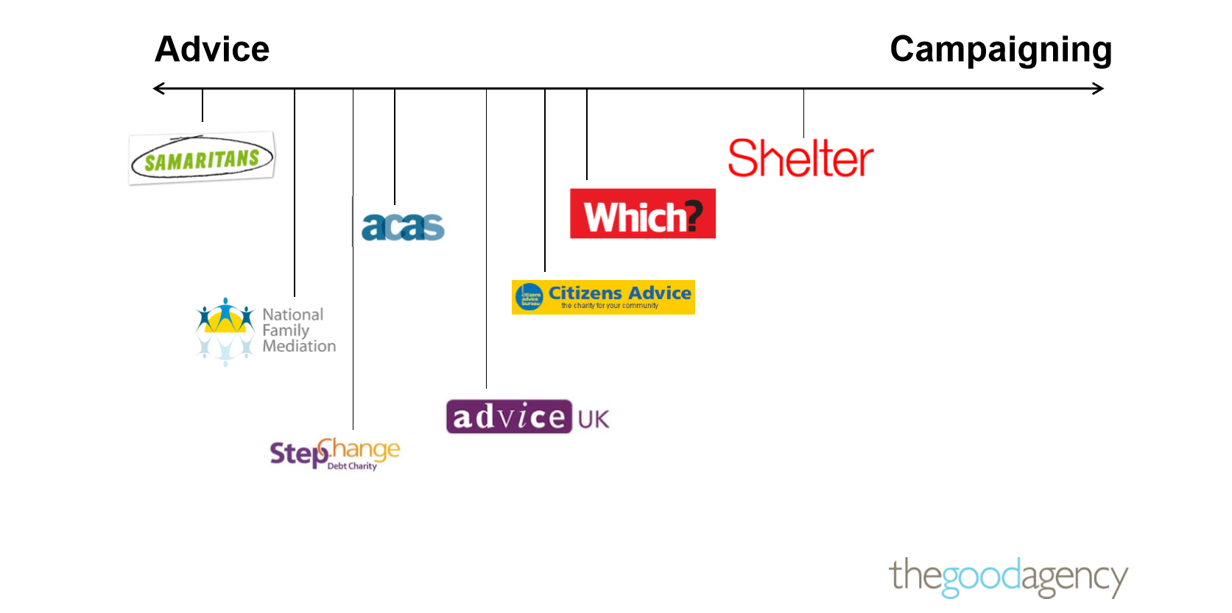

Figure 1: Brand positioning by way of Primary Service Offerings
(The Good Agency, 2014)

CA’s market position is both in the advice and campaigning sections of the market (Citizens Advice, 2015). CA’s direct competitors are along the line, each segmenting their market differently (Hooley, et al., 2017).

Many competitors offer services that CA provide as secondary services like CA to their targeted audience, becoming a disruptive force for CA, CA needs to continuously benchmark itself (Kotler & Armstrong, 2018, p. 537). For instance, Shelter, who is a charity who offer support to those who have housing need, to their clients they also offer debt and benefit advice and advocacy (Shelter , 2018) so are further near the centre of Figure 1 that the perceived position. The local offices of CA often refer clients to organisations such as Shelter, when it has been identified the client needs specialist support which is lacking in the local CAs at that geographical location so not fitting the “One Service Strategy”. CA loses service users for not only the issue that has been referred off but all other services the client may have used, so reducing the CA’s market share as per Porters five Forces (Hooley, et al., 2017, pp. 68-73).

To position themselves more effectively with their target audience, CA went about a process of rebranding their image with the targeted audience (Citizens Advice, 2014b). Three hypothesis prototype brands were constructed and tested with the target audience panels (Citizens Advice, 2014).
CA in 2014, through market research, found that although the original brand was widely recognised by the public, the brand was not understood to be a charity by most of the public (The Good Agency, 2014). A survey of 950 people, representative of the national demographic makeup was conducted by market research company Mori on behalf of CA in 2014, it was found that 35% of females and 38% of males were fully aware that CA was a charity (Citizens Advice Bureaux, 2013), down from 45% in 2009. If this was left to continue, CA would lose the opportunity to maximise its financial income through fundraising, which was one of the major aims set by the organisation in the face of governmental cuts (Citizens Advice, 2014).

Confusingly, out of the three prototype brands, CA decided on the brand image that linked to its traditional one, while removing the word Bureau from its name as it was considered “old fashioned or foreign” (Citizens Advice, 2015c).

The Marketing Mix

Price

To the user, the service is free to access (Citizens Advice, 2014a). There is a price put on to the service to the financial funders who contribute; these originations determined the perceived value of the offerings comparisons to the alternatives (Hooley, et al., 2017). Where once the main contributor to charities such ass CA was governmental originations, now it is often found to be companies in the private sector whom seek to reduce the damage they cause and increase positive perceptions by giving through CSR (Porter & Kramer, 2011).

Product (with consideration to process)

Differentiated marketing has been current best practice for organisations (Ipsos MediaCT, 2011) so to decrease marketing spend but increase effectiveness, but for a national organisation such as CA, undifferentiated targeting may widen the net to consumers unaware of the service as a free, non-governmental advice service (Kotler & Armstrong, 2018, p. 222). Each service category is divided into smaller concentrated marketing segments, who are homogeneous and can be served by the most efficient delivery methods for that service (Smith, 2005, p. 94): Face to Face, services are then segregated further defined this is further segregated by the type of adviser, general adviser, qualified caseworkers or legally trained; web chat; email; telephone; or print media (Citizens Advice, 2014a). CA’s “One Service Strategy” standardise the quality, brand message and content the user receives across the service areas, and delivery methods (Citizens Advice, 2015) to encourage usability and to encourage habit formation (Eyal, 2018).

Promotion

During the period of 2013/2014, CA amassed 11,889 reports in a range of media (Citizens Advice, 2014a), this includes being a ‘talking head’ (Mawhood, 2012) for topical, television news programs such as Newsnight, being the primary source of data and interview for a National Broadsheet and interviews for a National radio station (Citizens Advice, 2014a). For these examples and for many of the other 11,886 pieces, CA capitalised from it “brand equity”, positioning as a respected, high value offerings, and additional work in the research and campaigns strategy of the organisation (de Chernatory, et al., 2013, pp. 448-449). CA’s aim in taking this approach is to “position” themselves as “thought leaders”, positioning themselves high up the value chain than competitors. Not only does this approach have a positive impact on the brand identity of the organisation but to B2C but also with B2B (Hooley, et al., 2017). Financially, CA can benefit from from national, prime time exposure for free (Kotler & Armstrong, 2018). Though there is lack of data available to assess the value of the example of the BBC Radio 4 2013 broadcast, in 2013 the Radio station reached an averaged 10,978,000 listeners (media.info, 2018).

The partners CA chooses to associate themselves with are “neutral”, high quality in the minds of public so boosting the CA’s “credibility” (Brassington & Pettitt, 2013, p. 482). Interestingly, author Noreen Hertz (2018), and discussed in Week 3.3, suggests that “hierarchical experts” are no longer trusted by the audiences (Hertz, 2018; Davies, 2018).

Partnerships are mutely beneficial. Media outlets, too profit from the exchange, their outputs become more credible due to the inclusion of CA (Porter & Kramer, 2011). If though, CA’s image can become tarnished due to its governance or members and their involvement becomes the subject of negative stories by these media outlets, as in the case of Oxfam (BBC News, 2018). By CA is careful of negating any risk to is reputation by outside sources beyond its control, that it does not allow endorsements, paid or unpaid of partnering organisation or other through any part of the CA (Citizens Advice, 2013a). Damage to its brand would limit CA voice on important issues so limited its strategic effectiveness (Citizens Advice, 2015). Partnering organisations maybe quick to cut ties with the organisation publicly, so effecting B2B adversely. CA may soon find themselves with significantly less financial funding, as the RSPCA feared due to negative exposure they received at the start of this decade (Civil Society, 2013).

New Placements

The readiness of CA to become a ‘talking head’ for media outlets is not limited to traditional media. CA had contributed to other, often competing websites and on-line blogs. An example, of which was discussed during Week 2: Step 2.2 Marketing present (meet Mr. Splashy Pants), of the 2018 Marketing Management eMBA module (Davies, 2018a).

Popularity of online advice sites, such as Martin Lewis’s ‘MoneySavingExpert.com, which claims to be the UK’s “largest consumer advice website” (MoneySavingExpert.com, 2018), so a direct competitor to CA, proves a threat not just to CA’s online model but as competitors more to new “platform Models” (Accenture, 2016), they provide consumers easier, quicker access to services. Smaller organisations disruptive innovations such as Online Chat services, and video conferencing and potentially, AI and chatbots for has the possibility of rendering the CA sustainable innovations of face to face services obsolete through lack of demand or being uneconomical (Christensen , 2016). This disruptive innovation has been from competitors online, which include other charity/ not-for-profit organisations, governmental resources as well as for profit companies such as discussed Money Savings Expert.

During the Brand: Intelligence phase of their research (Citizens Advice, 2014b), The Good Agency found that the consumer opinion of the at the time current [2013/2014] CA websites, both corporate site and Advice guide, were over all considered poor (The Good Agency, 2014). Users found the presence of two official websites confusing, with UX low for both. As part of the ‘Service Modernisation Program’, Citizens Advice have used the opportunity of them reassess their online presence (Citizens Advice, 2014b), stream lining the Public sites into one, mobile friendly site (Citizens Advice, 2015c). Mobile friendly websites have become increasingly important over the last decade as the internet of things expands, with a large cross demographic section of the population, preferring to access the internet by smart phones and tablets as CAs own research into user access found (Citizens Advice, 2015c). Platforms should be a priority for the future of the service if it is going to remain a competitive force, CA must guard against “Marketing myopia” and develop systems which continuously evolve to meet the consumers’ needs and not the get lost focusing just developing shiny new service platforms (Kotler & Armstrong, 2018).

Measuring success

2016/2017 the CA dealt with “6.3 million issues dealt with directly, 2.7 million people helped face-to-face, by phone, by email or on webchat, 43 million visits to our digital advice” (Citizens Advice, 2017). In comparison 6.2 million advice issues dealt with directly, 2.5 million clients advised directly [face to face], 20.7 million visitors to our online advice citizensadvice.org.uk” in 2014/2015 (Citizens Advice, 2015), the year before the “One Service Strategy” launch. Where the market share of the traditional service remains relatively static, becoming the “Cash Cows”, it is maybe unsurprisingly the digital services which have increased their market share dramatically, over doubling its visits. On the 25/07/2018, the CA website averaged 1495 visitors per minute (Citizens Advice, 2018), with the most searched issue being consumer: flight compensation (Citizens Advice, 2018). This suggest that branding efforts at point of physical service maybe seen as being ineffective, where the opportunity to be innovative in their digital platforms has been missed.

An advantage of the increase of traffic to the digital service as well as reduced operating costs of the physical service (Christensen , 2016), is that CA can utilise this large amount of digital traffic by gathering data through various customer touch points. This large amount of Big Data can be analysed so to target new audiences that are not currently seen as their core user, increasing their market share (Ellis-Chadwich & Chaffey, 2016).

Conclusion

Presently, the marketing function of Citizens Advice suits the its current largest, traditional consumer group of clients and volunteers, as this group ages and decreases, CA must investigate adapting and changing to meet the need of a younger audience. CA must begin to foster a relationship with these demographics, meeting there needs and beliefs. It is this authors opinion that CA is to concern at present need of the service, with the issues it is facing, such as decreased funding, increasingly complex issues of users and increased competition. The threat of disruptive innovation is too great. While predicting and preparing for specific technological trends such as AI may prove fruitless, by not adopting technology sooner, CA may find itself out paced by its competitor. CA may still have a problem with being old fashioned, not just by perception but by practice also, going forward.

This does not have to be the way. The flexibility of CA’s marketing function with in the organisation is well suited to the adapt to the changing role, with key marketing skills through out the departments to facilitate agility. CA needs to be brave and let go of the old, dated brand, become a 21st century charity for by developing an all-new 2020 strategy.

References

ACCENTURE, (2016), TECHNOLOGY VISION 2016, Platform Economy, Ecosystems are the new bedrock of digital. [Online] Available at: https://www.accenture.com/gb-en/insight-digital-platform-economy [Accessed 20 07 2018].

AMAR, Z., (2013), Voluntary sector marketing myths. [Online] Available at: https://www.theguardian.com/voluntary-sector-network/media-network-blog/2013/apr/26/voluntary-sector-marketing-myths [Accessed 21 07 2017].

ARONS, M. S., DRIEST, F. & WEED, K., (2014), The Ultimate Marketing Machine, Harvard Business Review, July-August.

BAKER, M. J. & SAREN, M., (2016), Marketing Theory, a Student Text, 3rd ed. London: SAGE Publications Ltd.

BBC NEWS, (2018), Oxfam GB banned from Haiti after sex scandal. [Online] Available at: https://www.bbc.co.uk/news/uk-44474211 [Accessed 21 07 2018].

BENNETT, N. & LEMOINE, G. J., (2014), What a difference a word makes: Understanding threats to performance in a VUCA world. Business horizons, 57(3), pp. p.311-317.
Brassington, F. & Pettitt, S., 2013. Essentials of Marketing. 3rd ed. Harlow: Pearson Education Limited.

CARAMELA, S., (2018), While Weber's theory prioritizes efficiency, it isn't necessarily the best practice for leaders to implement. [Online] Available at: https://www.business.com/articles/management-theory-of-max-weber/ [Accessed 01 07 2018].

CHRISTENSEN, C., (2016), Disruptive Innovation Explained: Is Your Organization Prepared? Harvard Business Review, 15 June.

CIPD, (2017), Organisation design: A guide to organisation design approaches, the types of organisational structures, and the factors which influence the choice of organisation design. [Online] Available at: https://www.cipd.co.uk/knowledge/strategy/organisational-development/design-factsheet [Accessed 20 07 2018].

CITIZENS ADVICE BUREAUX, (2013), Initial results of existing and prospective client polling, London: Citizens Advice Bureaux.

CITIZENS ADVICE BUREAUX, (2013), Planning and Performance Survey 2012 Summary report, London: Citizens Advice Bureaux.

CITIZENS ADVICE, (2013a), Citizens Advice service aims and principles in practice. [Online] Available at: https://www.citizensadvice.org.uk/bmis/membership/Aims-and-principles/Citizens-Advice-service-aims-and-principles-in-practice/ [Accessed 25 07 2018].

CITIZENS ADVICE, (2014), About the service modernisation programme. [Online] Available at: https://www.citizensadvice.org.uk/cablink/the-service/Strategies-and-developments/service-modernisation/About-the-service-modernisation-programme/ [Accessed 10 07 2018].

CITIZENS ADVICE, (2014a), Citizens Advice Business Plan 2014/15, London: Citizens Advice.

CITIZENS ADVICE, (2014b), Brand: intelligence phase, [Online] Available at: https://www.citizensadvice.org.uk/cablink/the-service/Strategies-and-developments/developing-our-brand/brand-research-and-development/Brand-intelligence-phase/ [Accessed 25 07 2018].

CITIZENS ADVICE, (2014). Who we're working with. [Online]
Available at: https://www.citizensadvice.org.uk/cablink/the-service/Strategies-and-developments/developing-our-brand/brand-research-and-development/brand-who-were-working-with/
[Accessed 19 07 2018].

CITIZENS ADVICE, (2015c). A refreshed brand for a modern service, London: Citizens Advice.
Citizens Advice, 2015. Everything was falling apart – Citizens Advice helped me get back on track., London: Citizens Advice.

CITIZENS ADVICE, (2015), One Service Strategy 2015-2020, London: Citizens Advice.

CITIZENS ADVICE, (2017), National Citizens Advice organisational chart. [Online]
Available at: https://www.citizensadvice.org.uk/cablink/the-service/About-Citizens-Advice/organisationalchart/
[Accessed 15 07 2018].

CITIZENS ADVICE, (2017), The difference we make Our impact in 2016/17, London: Citizens Advice.

CITIZENS ADVICE, (2018), Citizens Advice's Home page. [Online] Available at: https://www.citizensadvice.org.uk/ [Accessed 20 07 2018].

CITIZENS ADVICE, (2018), Live traffic and searches on citizensadvice.org.uk. [Online] Available at: http://advicetracker.devops.citizensadvice.org.uk/ [Accessed 2018 07 25].

CIVIL SOCIETY, (2013), Leaked RSPCA document reveals trustee's fears for future. [Online] Available at: https://www.civilsociety.co.uk/news/leaked-rspca-document-reveals-trustee-s-fears-for-future.html [Accessed 28 07 2018].

DAVIES, C., (2018a), Week 2: Step 2.2 Marketing present (meet Mr. Splashy Pants), Carmarthenshire: eMBA

DAVIES, C., (2018), Step 1.3 The Ultimate Marketing Machine, Carmarthen: eMBA.

DAVIES, C., (2018), Step 3.3 Do you know what influences decision making? (Noreen Hertz). [Online] Available at: https://uniwales.curatr3.com/courses/emba-marketing-copy-6900/home#object/271295 [Accessed 18 07 2018].

DE CHERNATORY, L., MCDONALD, M. & WALLACE, E., (2013), Creating Powerful Brands. 4th ed. Abington: Routledge.

DIBB, S., SIMKIN, L., PRIDE, W. M. & FERRELL, O. C., (2017), Marketing Concepts and Strategies. 7th Edition ed. Andover: Cengage Learning EMEA.

EDELMAN, D. C. & SINGER, M., (2015), Competing on Customer Journeys. [Online] Available at: https://hbr.org/2015/11/competing-on-customer-journeys [Accessed 19 07 2018].

ELLIS-CHADWICH, F. & CHAFFEY, D., (2016), Digital Marketing. 6th Edition ed. Harlow: Pearson.

EYAL, N., (2018), Consumer behaviour: The Hooked model (Stanford Business School), s.l.: Stanford Business School.

FAY, S. & JINHONG, X., (2008), Probabilistic Goods: A Creative Way of Selling Products and Services. Marketing Science, 27(4), pp. 674-690.

GLADWELL, M., (2004), Choice, Happiness, and Spaghetti Sauce, Monterey: s.n. TedTalks: Chicago.

HANLON, A., (2018), The Segmentation, Targeting and Positioning model. [Online] Available at: https://www.smartinsights.com/digital-marketing-strategy/customer-segmentation-targeting/segmentation-targeting-and-positioning/ [Accessed 18 07 2018].

HENDERSON, B., (1973), The Experience Curve-Reviewed. The Boston Consulting Group.

HERTZ, N., (2018), Step 3.3 Do you know what influences decision making? (Noreen Hertz) object, [Interview] 2018.

HOOLEY, G., PIERCY, N. F., NICOULAND, B. & RUDD, J. M., (2017), Marketing Strategy & Competitive Positioning. 6th ed. Harlow: Pearson Education Limited.

IPSOS MEDIACT, (2011), A Guide to getting the best out of your Segmentation Analyses: Bite Sized White Paper 2011, s.l.: Ipsos.

KOTLER, P. & ARMSTRONG, G., (2018), Principles of Marketing. 17th ed. Harlow: Pearson Education Limited.

LINSSEN, B. & BRINGHAM, A., (2010), Your Brand Reputational Value Is Irreplaceable. Protect It!. [Online] Available at: https://www.forbes.com/2010/02/01/brand-reputation-value-leadership-managing-ethisphere.html#2788f10c3790 [Accessed 19 07 2018].

MAWHOOD, P., (2012), Marketing And Product Development, Centre for Entrepreneurship and Innovation, Said Business School, Oxford: University of Oxford,.

MEDIA.INFO, (2018), BBC Radio 4 - listening figures. [Online]
Available at: https://media.info/radio/stations/bbc-radio-4/listening-figures
[Accessed 15 07 2018].

MODERN MARKETING PARTNERS, (2014). 7 Types of Marketing Organization Structures. [Online] Available at: https://www.modernmarketingpartners.com/7-types-of-marketing-organization-structures/ [Accessed 15 07 2018].

MONEYSAVINGEXPERT.COM, (2018), About Moneysaving Expert. [Online]
Available at: https://www.moneysavingexpert.com/site/about-the-site/[Accessed 14 07 2018].
NEWMAN, D.,( 2015), This Is What Happens When Your Sales and Marketing Team Don't Mesh. Entrepreneur [Online] Available at: https://www.entrepreneur.com/article/244574
[Accessed 18 07 2018].

PALMER, R., COCKTON, J. & COOPER, G., (2011), Managing Marketing. 2nd ed. Abingdon: Routledge.

PARSONS, E., MACLARAN, P. & CHATZIDAKIS, A., (2018). Contemporary Issues in Marketing and Consumer Behaviour. 2nd ed. Abingdon: Routledge.

PORTER, M. & KRAMER, M., (2011), Creating Shared Value. Harvard Business Review, January-February.

RITSON, M., (2015), 2015 Media Forum: Mark Ritson, s.l.: YouTube.

ROGERS, C., (2017), The shrinking and emerging demographics marketers need to know. [Online] Available at: https://www.marketingweek.com/2017/03/13/shrinking-emerging-demographics/ [Accessed 27 07 2018].

SHAKIR, A., (2018). Week 5.4: Brand (Malcolm Gladwell: Choice, Happiness, and Spaghetti Sauce). [Online] Available at: https://uniwales.curatr3.com/courses/emba-marketing-copy-6900/home#object/271307 [Accessed 10 07 2018].

SHELTER, (2018). Shelter Cymru. [Online] Available at: https://sheltercymru.org.uk/ [Accessed 27 07 2018].

SMITH, B. D., (2005). Making Marketing Happen: How Great Companies Make Strategic Planning Work. First ed. Oxford: Elsevier Butterworth-Heineman.

THE GOOD AGENCY, (2014), Citizens Advice Intelligence Phase Debrief, London: Citizens Advice.

VARGO, S. L. & LUSCH, R. F., (2004). Evolving to a new dominant logic for marketing. Journal of Marketing, 68(1), pp. 1-17.

YOUNG-POWELL, A., (2012), Charity donations and donors decrease, says survey, The Guardian, [Online] Available at: https://www.theguardian.com/voluntary-sector-network/2012/nov/13/charity-donations-donors-decrease-survey [Accessed 17 08 2018].

Appendixes
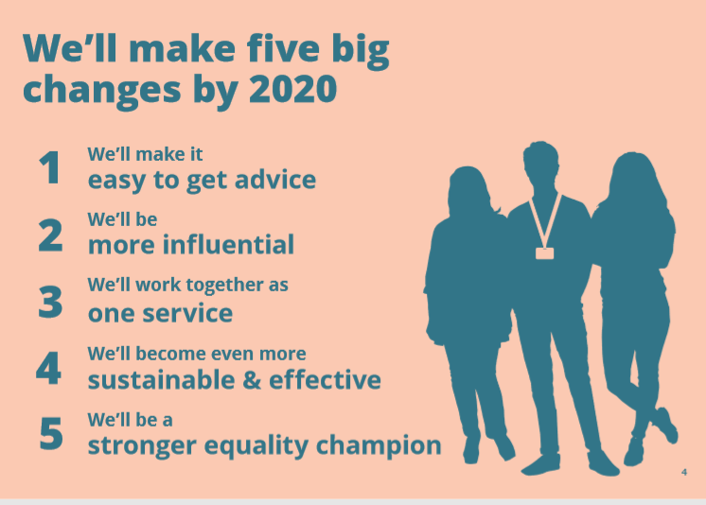
Appendix 1
(Citizens Advice, 2015)
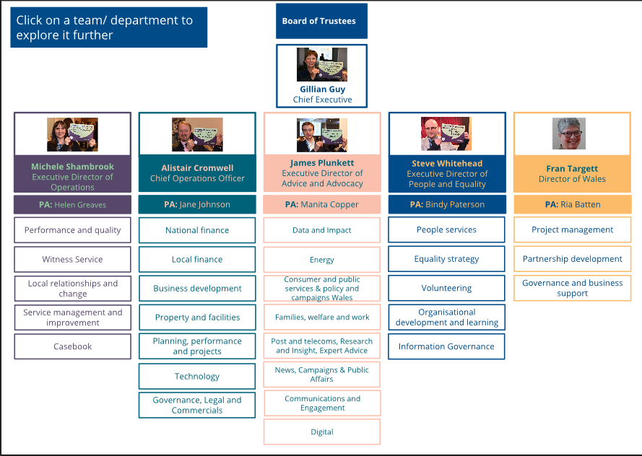
Appendix 2
(Citizens Advice, 2017)

