Module Title: | Digital Skills and Research Methods.
Module number: | BMSW4003
Student Name: | Ilona Stailse
Student number: | 1922115
Lecturer name: | Husam Helmi



Virtual Learning Environment Research

Contents

Introduction. 2
Secondary Research. 3
Aims and objectives. 4
Research method. 5
Results and discussion. 6
Conclusion. 12
Appendix 1. 13
References 14

Introduction.

A virtual learning environment (VLE) are based online courses for students that will present activities, resources, and interactions with the course structure.
This research is based around virtual learning environment (VLE) and student’s evaluation of their success in e-learning.
In my report you will be able to read about other people research in e-learning. I found an interesting ‘facts’ from another people researches that helped me to analyse how virtual learning environment (VLE) affects student’s motivation to study. And why they prefer e-learning not a face-to-face learning. Compare how successful was student’s that studied online to students that studied in the classroom. The influence of e-learning on the lecturers.
Also, in this report you will see a primary date that I collected from the University of Wales Trinity Saint David, and my analysis of this data.
You will be able to see advantages and disadvantage of studying online. After reading this report you will be able to answer questions like why students choose e-learning and how successful are students that study online.

Secondary Research.

As state students from British University in Egypt, motivation is a key element of e-learning. Students that start education online sems to be more motivated in studying.
They also suggest that possibility of people not wanting to study in classroom may be the age for example: people who have not been graduate after college may feel uncomfortable thinking that they are the oldest in the classroom. And I am absolutely agreed with this suggestion. I have so many friends that are over age 45, and they answer is that they are too old to go to classroom, but as soon as they find an online course that suit their interests, they enrol on it.
The other reason can be family issues, people who has few children basically have no time to go to the classroom, so they choose e-learning.
So, the students in their research also suggested that teachers and instructors need to restructure teaching methods from face-to- face to online teaching, this need to be done for positive outcome and students’ better performance. Because they research proved that student’s success depends on tutor’s accuracy of delivering the information. (Naglaa Seddiek, 2013)
Hurry Goldberg and Guy McKhann in they research states that students prefer VLE not a lecture classroom as they delivery format. And it is common nowadays with all the technologies and multiple choice of devices we can study without going out of the comfort zone.
They also find out in their research that higher marks have students that studied online than the students that studied in the classroom.
They suggest that e-learning benefits lecturers because students are more engaged in finding information themselves rather than ask lecturer. For example, words meaning, students will easily check the meaning online.(Harry Goldberg, 2000)
Advantages of virtual learning according to Meet Beans (2020) are
flexibility because you can allocate as much time as suits you to study.
Accessibility, because even person with the special need can attend classes. And to attend classes you do not need travel.
Affordability is mainly work for students that used to move from one country to another to go to the university they dreamed to go.
Student Management helps tutors manage the accessibility of their students and give them extra support by sending more materials. Engagement, students have chance to enjoy they studies by watching videos, answering a quiz questions or playing educational games online.
Disadvantages:
Motivation is first at risk studying online, some students have lack of concentration or self-discipline and it can cause a problem.
Limitation, you cannot learn physical experiments online and do any practical work. (MeetBeans, 2020)

Aims and objectives.

The aim of this research to understand how confident students feel about their virtual learning. What would student’s prefer e-learning or classroom learning. To investigate the virtual learning environment (VLE) and student’s knowledge in high education. To understand how often students are referring to Moodle slides and in what occasion.

Research method.

This work involves collected date from the other people researches and my own questionnaire research that you will see in appendix. In my questionnaire research participated eight students from my university.
My personal research was based around the students from University of Wales Trinity Saint David, because of the pandemic and that we are not able to see the other students my research mainly was based around my classmates. I used a questionnaire to collect data relevant to the research. All the questions are about virtual learning environment and people opinions of success in their study’s.

Results and discussion.

Figure 1. Question 1: What you use to access the Moodle (lectures)?

On the Figure 1 we can see that fifty percent (50%) of the students use computers to access the Moodle and lectures. You can see that thirty-eight percent (38%) of students using a Tablet to access the Moodle and lecture. Where only twelve percent (12%) of the students using Smartphone to access the Moodle.
We can conclude that most of the students would prefer to use computer for the VLE studies. Also, we can conclude that computer is more practical for students. But some of the students still prefer to use tablets to study. And only a small number of students would use the smartphones for studying.
Figure 2, question 2: How often a week do you access Moodle?

The Figure 2 shows that five participants of my research said that they access Moodle from three to five times a week and another two participants said that they access it from one to two times a week and only one person said that it accesses Moodle over seven times a week.
As we can see more biggest number of the students access Moodle from three to five times. And only few people access Moodle less then three times or more than five times.

Figure 3.

From this chart we can conclude that five of the participants have a good and clear understanding of what they study answering strongly agree and agree. Few of the students are not sure if they understand everything and only one participant is not clear what he studies.
Also, from this figure we can tell that over the half of the participants answered that they find it easy to access the lecture, where another three students said that they face some issues to access the lectures.
All participants are strongly agreeing or agreeing with the statement that they feel confident to ask tutor a question’s if they do not understand a task.
And as we can see from the chart all students think that lecturer gives a good example’s to students understand the subject better.

Figure 4. Statements evaluation.

This figure reflects that four students thinks that assignments are easy to do. Three are disagree that assignments are easy to do. And only one of them not sure about this statement.
Over half participants says that they often use a University library to find the information for studies. But two of the participants are not using University library as the source for information.
Only one student finds it hard to stay focused on the lecturer speech during the session, the rest are not facing any problems with focus.

Figure 5. Evaluation of the statements.

From figure 5 we can state that over half participants thinks that all subjects are connected to each other. And only two of them do not have that impression.
If students do not understand the subject six of eight will refer back to Moodle slides and go over them again and two other students will try to find another source to increase understanding of the subject.
The other statement reflected on this figure states that only one student of all eight is not reading slides in Moodle before lecture. The rest of the students prefer to prepare for the lecture before it starts.

Figure 6. Statements evaluation.

This figure shows us that seven students’ belief they are doing good with the course where only one thinks he not doing well with the course.
And six participants sure in success of them finishing the course and two students do not have as much belief in themselves.

From my questionnaire evaluation I can conclude that students feel quite confident and they have positive attitude about the virtual learning. But because my research was short term, I think students ‘long term’ opinion could change same as their self-motivation.
Virtual learning benefits students because they available to access course from anywhere just need to have their computer and access to the internet. Also helps students that they do not need to travel to access the lecture. Nowadays there is so many ways to find the information and do reading for better understanding of the subject. So, more and more students prefer to study online then face to face lectures. It helps a family’s with children for example if it is a single mum, and she wants to get a degree, virtual learning is the solution for people in the similar situation.
Even with all this benefits nothing can replace a face-to-face communication with your lecturer and classmates. Virtually it is hard to share your opinion especially if there is a lot of students in class. Also, it is hard to stay focused on lecturer speech. And of course, I would like to mention a teamwork, it is easier and much more productive to share or discuss with your team the ideas when you sit in the same room rather than online.

Conclusion.

More and more people choose online learning and the reasons are very different from family issues to just personal preferences. I think I proved in my report that e-learning have a positive impact on the students. Students believe in themself; they are self-motivated, receive the core knowledge and skills same as in face-to-face learning.
But I think students anyway miss in-class activities where you can build a discussion with you lecturer or classmates. Or just have a general conversation to your classmates.
This also improves student communication skills. And we all know that communication skills are one of the main skills that are considered by employers.

Appendix 1.
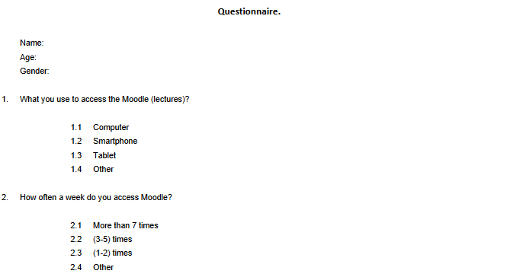
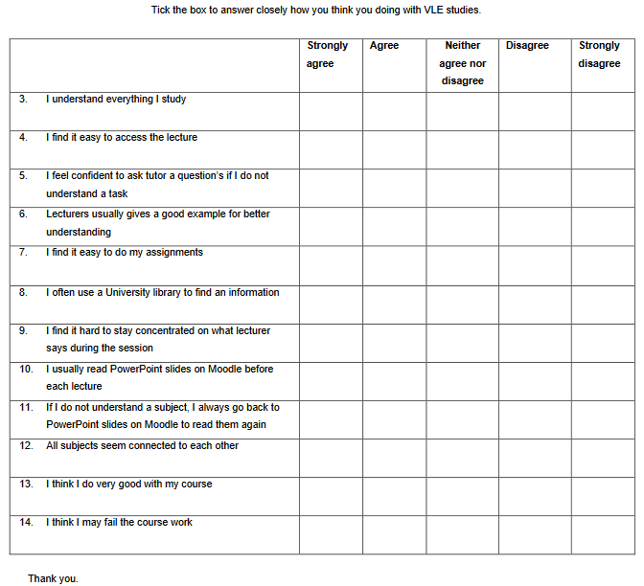

References
- Harry Goldberg, G. M., (2000). STUDENT TEST SCORES ARE IMPROVEDIN A VIRTUAL LEARNING ENVIRONMENT. [Online]
Available at: https://journals.physiology.org/doi/pdf/10.1152/advances.2000.23.1.S59
[Accessed 5 January 2020].
- MeetBeans, (2020). The Use Of Virtual Learning Environment In Education. [Online]
Available at: https://medium.com/@meetbeans/the-use-of-virtual-learning-environment-in-education-b40bb3443966
[Accessed 5 January 2021].
- Naglaa Seddiek, A. N. M. S. A. E.-S. A. T.-E. M. E.-K., (2013). E-Learning and Students’ Motivation: A Research Study on the Effect of E-Learning on Higher Education. [Online]
Available at: https://core.ac.uk/download/pdf/234940654.pdf
[Accessed 2020 December 20].

