
HRM Assisgnment1
Tesco after Covid pandemic and Brexit

Student name: Lucia Preguza
Student ID: 2111861

Module name: Human Resource Management
Module code: LCMB7000
Lecturer name: Gladius Kulothungan
Submission date: 13.01.2022

Table of Contents
Introduction…………………………………………………………….3
Company background……………………………..................................3
Tesco human resource management……………………………………4
Tesco people plan………………………………………………………5
Tesco training programme Coronavirus ……………………………….6
Tesco during the pandemic Covid – 19…………………………………7
Salary and rewards during the pandemic Covid – 19……………………8
Recruiting and selecting employees during Covid – 19………………....9
Pestle Analysis of Tesco company………………………………………10
Tesco and Brexit……………………………………………………...….11
Tesco’s employees affected by Brexit……………………………….….12
Conclusion………………………………………………………………13
Recommendations for the future for Tesco…………………………………………………………………….13
References………………………………………………………………16

Introduction
The role of the human resource function is best explained by identifying the key objectives to be achieved (Torrington, et al., 2004). By this explanation we mean that the role of the Human resource function is like description of some goals and purposes, that are fundamental basis for the success of the company. Aa a result, Human resource management is a strategy that secure all the aspects of the organisation to ensure smooth progress.
Human resource management can be defined as a strategic, integrated and coherent approach to the employment, development and well-being of the people working in organizations. (Amstrong & Taylor, 2014). In the opinion of this some of the primary functions of HRM include job analysis, hiring and selection, development, performance management and managerial relations.
Functions of Human resources management are generally planning, manage, and organizing, entire Human resource management in an organization. After all, when the employees develop their skills, the organisation will automatically have more experience advance and development for company’s objectives. We can see that all about HRM are employees that work for organizations, that is based in some strategies and trainings, and without employees the organization doesn’t exists.
This essay I will focus on Tesco company as a result of the Covid pandemic and how the Covid affected the Tesco company, which were the schemes and strategies to improve the situation. Wich kind of restrictions they implemented for safety of colleagues and customers, and how they worked. As well another impact that affected the company is Brexit, and how Tesco company afford all this changes.

Company background
The company was founded by Jack Cohen in 1919 and is headquartered in Cheshunt, the United Kingdom (Tesco, 2020). Initially was concentrate in food and drink, and later it has expanded into areas such as clothing, electronics, financial services, telecoms, retailing, etc. The business politics of Cohen was easy: buy out smaller grocery stores and sell everything cheaper than they used to be, the idea resulted in instant success (Tesco, 2017).
I think Cohen’s idea was successful because every consumer wants more quantity at a great price, and of course this idea was a huge success and with this great idea he won a good reputation in the market, as well loyal consumers that is very important in each company for a good and successful beginning.
Tesco is one of the biggest supermarket chains in United Kingdom in 2012 starts to work in fourteen countries, hiring half a million people and is having 50 million customers every week (2013). Here we can see how the Cohen’s idea has a wonderful success in the market place, because all the success is starts with a right idea.
Tesco introduced a loyalty card, branded ‘Clubcard’, in 1995 and later an Internet shopping service. As of November 2006, Tesco was the only food retailer to make online shopping profitable (Tesco, 2017). Introduction of the club card as well for the clients makes a lot of benefits and customer loyalty, I can say stronger that with Cohen’s idea and introduction of the club card makes Tesco company one on the top in the UK.
Needless we can say that the numbers can tell their own story, Tesco was in the past a medium size retailer in United Kingdom and today is the world’s third largest supermarket. Tesco has introduced to the customers the brand banner ‘’Every little Helps’’ (2011), and with this little help to the employees and customers make a strong brand name in the market place.
We can sure say that the history of the Tesco largest supermarkets from the begging to present has a great success, and all the success starts of implementation of a good idea and work hard at the work place as well respect each over.

Tesco human resource management
The basic purposes of human resource management are to hire people and to training, developing them for a company success (Foot & Hook , 2005)
Tesco has over 280,000 employees that works for serving customers and maintain the brand name (Wilton, 2011), here we can see how many people working in Tesco supermarket chain and the importance of customer satisfaction. In addition to (2011) Tesco employment set some beliefs:
- trust and support each other
- share experience
- work as a team
- say thank you
Human resource for Tesco supermarket is people and support them and this is the main task for Human Resource Management, for a better developing of the Tesco supermarket.

Tesco people plan
People are important in national resources, and incorporating into a project plan can help the company to achieve the profitability (Kaila, 2005). Cultural values are ideas and principles of all community to make a harmonious peacefully relationship at the work (Stone & Stone Romero, 2008)
People for Tesco company are the heart and basic engagement is to serving customers a little better every day (Tesco, 2021) and this related how customers are important to company because Tesco existing due to them. This can be related to the theory in human resource management, customer control has been accepted as a main method through the employees can be directed (Bach & Edwards, 2013). Getting customer care is the most important reflection and profitability for all the organizations (Leatherbarrow & Fltecher, 2019).
According to Tesco people plan how is related in figure 1.1, the main cultural values to the company are the people like employees and customers. And all this concentration of values it goes into the firm and focuses on processes that can motivate customer satisfaction.

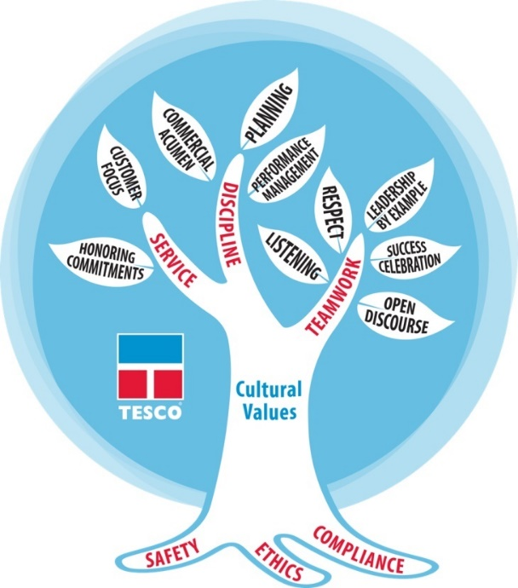
Figure 1.1 Tesco cultural values of people plan
(Tesco, 2021)
Tesco has formed a Little Helps Plan and is about the given importance and consideration to the stakeholders, colleagues, communities and the planet. The Little Helps Plan helps Tesco is about to improve, prefect and show the company performance because that the future of the organization not exist only on the actions the firm take, but also on the world around us and capacity to adapt at new challenges. (Tesco, 2021). Firms exist to get activity done for developing the business, but people are monitor for all this piece of work (Amstrong & Taylor, 2014)
Little Helps Plan focuses on four pillars how we can see in figure 1.2
- People
- Places
- Planet
- Product


Figure 1.2 Tesco Little Hels Plan
(Tesco, 2021)
Tesco training programme Coronavirus
How the pandemic (Covid – 19) started Tesco set itself the goal of:
- Food for all
- Safety for everyone
- Supporting our colleagues
- Supporting our communities
When you create a training programme you need to know what are the scheme and the goals for your programme (Foot & Hook , 2005). Tesco supported a lot their employees and colleagues, if they become ill with Covid – 19 was paid and encourage. In August 2020 Tesco created 16,000 new permanent roles to keep up online shopping, help to serve the customers in the pandemic time Tesco hired 50,000 new employees and make the services easier in the hardest time (Tesco, 2021).
To keep safe their employees and customers, Tesco supported them to wear a face mask in its supermarkets. They have capacity limitation in its supermarkets, to each station hand sanitiser and regular cleaning after speaking with colleagues or customers, so as not to spread the virus (Manchester Evening News, 2021).
All the employees who had the virus or someone in the family have it, need as well to self -isolating and follow the restrictions by NHS app (CAMSTimes, 2021), and everything is to help to maintain the safety of the colleagues and employees.


Figure 1.3 Tesco Coronavirus
(Tesco, 2020)
Tesco during the pandemic Covid – 19
Tesco’s profit increase almost £900m during the pandemic situation, online sales jump up 77%. Tesco said that Covid – 19 changed customer behaviour and after pandemic customers are buying 50% more products at each visit (Tesco, 2021). Covid – 19 is the main threat in the year 2020 so far it has seriously changed the gigantic retailers (Najah, et al., 2020).
How (2020) said the year 2020 was a big change but for Tesco was new challenge and had manifest incredible firmness during the pandemic.

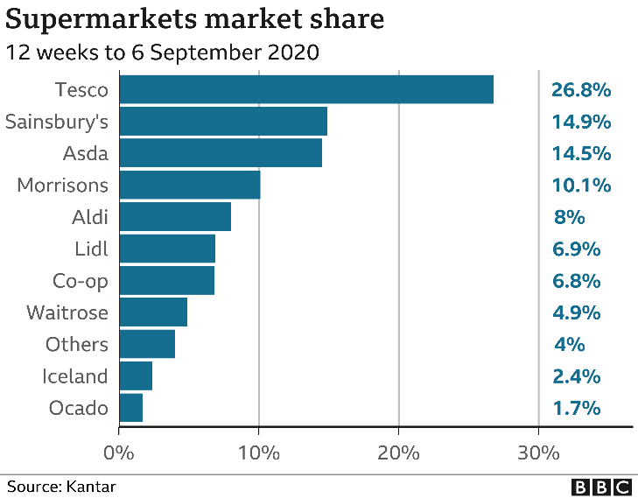
Figure 1.3 Supermarkets share during the pandemic
(BBC, 2020)
According to figure 1.3 Tesco has a good profitability compare to their competitors and this make Tesco one of the top groceries in the UK market place in the pandemic time.
Salary and rewards during the pandemic Covid – 19
Tesco contribute to help all the colleagues through Covid – 19 with a set of acts, they invested over £130 for bonus payments in pandemic time (Tesco, 2021). The reward inspires employees to support each other for a motivation and for good performance (Aquinas, 2006). Based on the ideas of (2006) if they are not paid enough they will be more passive at the work, but Tesco such as big and influent company threats very well their employees.
Since Covid – 19 started the well-being of the employees was the first engagement, all the colleagues with the high infection risk had been working from home, and receive full pay as well for those who wasn’t able to work for some health reasons (WalesOnline, 2021). Due to some error in the system someone have not received full pay but was immediately revised.
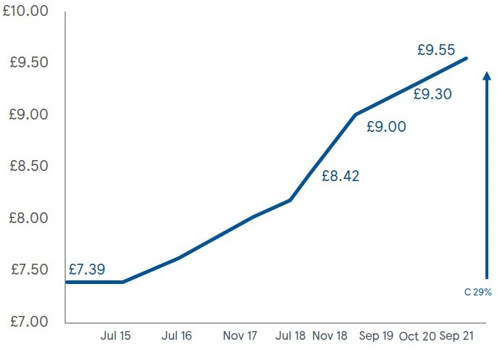
Figure 1.4 Tesco investing in our colleagues
(Tesco, 2021)
In this figure 1.4 we can see how Tesco is investing in the colleagues and in the time is increasing the investment special in pandemic time.
Recruiting and selecting employees during the pandemic Covid – 19
Is understandable that recruitment and selection is an engagement between Human Resource Management and possible employees, for developing an image of both sides in an organization (Bratton & Gold, 2012). As explained to (2012) recruiting the right employees for the right job is a main task for Human Resource Management. Tesco select their employees by some steps how we can see in figure 1.5.
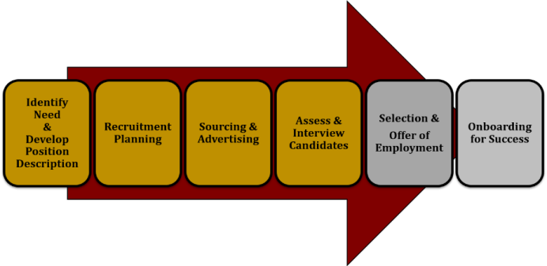
Figure 1.5 Recruiting and Selection process of Tesco
(Tesco, 2021)

Tesco external recruitment through pandemic time, enrol the employees via boards in stores and Tesco website (Tesco, 2021). Skills that Tesco is looking for are:
- Motivational
- Punctual
- Quick learner
- Communication skills

All these skills are simple and easy to apply in a work and are for all type of people because the main goal for Tesco are the colleagues and without them Tesco would not exist and progress (Tesco, 2021).
Pestle Analysis of Tesco company
With Pestle analysis we can come up with some strategies for position out the master plan in a company (Amstrong, 2006). And this model can help HR department to hire the right people for a right job, for resolving the issues that the company has analysing the Pestle factors.

Political factors affecting Tesco
Brexit has produced an environment of unpredictability for Tesco Company because Brexit can change what Britons eat said the Tesco chairman, the prices for imported food can increase up to 40% (BBC News, 2020). Political circumstances are very important for Tesco because the company is operating with many countries and political environments are different for all (Gupta & Randhawa, 2008). Britain has got a good stability in political environment and this helped Tesco company to become top retail in United Kingdom.
Economic factors affecting Tesco
The Covid -19 had a bad impact for the company, due to the restriction on social distancing, lockdown and restriction on wearing a mask but online shopping saved Tesco to become a victim of the Covid -19 and actually to increase online selling (itwNews, 2020). Brexit have caused more increase in tariff, example they need to pay more for some fresh food and Tesco has reserved some products in warehouse for long life goods.
Social factors affecting Tesco
The customer taste change from generation to generation, Tesco is careful with changing taste of customer and to their necessity. Tesco applied an understanding scheme for all employees and HR department, for understanding needs and wants of Tesco’s customers for developing the company is very important (Amstrong , 2007).
As well one of the main tasks for the Tesco is to hire young generation and support them for a prosper future, and HRM department gives opportunities for employees for training and development in their jobs for a positive thinking (Amstrong , 2007).
Technological factors affecting Tesco
Tesco has redesigned ordering food online, to help customers avoid getting infected from Covid -19 like:
- delivering products
- payment through mobile app
- barcode scanning (Tesco, 2021)
And this are some technological decisions that are positive, for Tesco company that in that harder situation like pandemic Covid -19.
Legal factors affecting Tesco
According to some restrictions by government on sales some fixed products, to avoid Britan’s obesity crisis (KentLive, 2020). These limitations help people to maintain a healthy life style, but not for shops selling variety of selling goods high in fat, salt and sugar. It is important to understand how the change of regulation and laws, can affect the market place (Tully, 2005). It has been shown that legal factors affecting Tesco with changing laws and regulations and this can have negative impact on company.
Environmental factors affecting Tesco
Tesco has implemented Terra Cycle’s program, packing can be used by customers and reused 2,5 million time a year (Recycling programe, 2021). This programme was created in 2019 to reduce waist, and it has decreased a billion piece of plastic. As well the recycling program increase the brand image of the company and popularity in the eye of the customers.
After study of Pestle analysis of Tesco, company we can say that legal and political factors are the main threats for the company, and company should be more careful on changing of these factors, but we can say that technological and environmental factors are favourable for Tesco.
Tesco and Brexit
Brexit is a retraction process of the United Kingdom from the European union including factors like emigration, sovereignty and as well including to words like Britain and Exit (Laursen, 2021). We will evaluate how Brexit impact Tesco company’s costumer and our employees.
Britain import around half of food like 30% comes from the EU, two main problems for supermarkets are the value of sterling and consumer confidence (TheGuardian, 2019), the company can increase the prices on fresh food, because of taxes on goods imported from EU (skyNews, 2020). The British grocery chain Tesco is front on to some challenges as a result related with Brexit, because any increase tariffs will add some real costs of importing groceries.

Tesco’s employees affected by Brexit
Brexit produces important unpredictability in the economy of United Kingdom, as well a negative impact on the health of the employees at the work (Weinberg, et al., 2020)
Tesco the biggest supermarket in United Kingdom, was planning to cut thousand employees because of Brexit situation (The New York Times, 2019).

A part of employees they come back to their country, the reason can be visa expiration or new Brexit regulations to live in United Kingdom. London might suffer the loss of 40,000 workers because of Brexit, and this can be unfavourable factor for company (Alalade, 2017).

Conclusion

In conclusion, it can be said that human resource management are very important in the growth of a company. Large companies that operate their business, mostly depend on their employees, that is the reason the background of the Tesco company is added here.
Also examining how Covid -19 affected the Tesco supermarket, I can diffidently say that the company had more profit than loss by applying different schemes and strategies to encourage employees. Brexit is more challenge for Tesco not a crisis because such as strong supermarket with a strong name, will be able to afford all the challenges and at the higher level.
To conclude, it can be said that without the help of human resource management, it would be very difficult for the company to sustain its business for a long time, because employees are important for Tesco supermarkets chains. And Tesco implemented strategies that helped in situations like Covid -19 and Brexit, and those schemes work very well for that unpredictable and hardest situation in a long time.
Recommendations for the future for Tesco
It can be said surely that Tesco company during the pandemic situation, did all the right restrictions that protect the wellbeing and healthiness of the employees. Like pay them benefits, support and help in the hardest situation, as well did the same for customers Tesco make them shopping easier thorough pandemic situation.
I can add here that the Tesco can give for employees some food for free, and for customers at least half price for food, because in my opinion is a supermarket that can afford that. As well they could rent some rooms for free for employees who need to isolate.
I can add some recommendations for Brexit, Tesco supermarket can extend the work visa for a long time, to help employees stay in United Kingdom, or as well to do English passport.

References
Alalade, D., 2017. 101 Amazing Facts about Brexit and the Europian Union. London: Andrews UK Limited.
Amstrong , M., 2007. Employee Reward Managment and Practise. 2nd ed. London: Kogan Page Limited.
Amstrong, M., 2006. Human Resource Managment Practise. 10nd ed. London: Kogan Page Limited.
Amstrong, M. & Taylor, S., 2014. Armstrong's handbook of humanresource managment. 3nd ed. London: Kogan Page.
Aquinas, D. P. G., 2006. Human Resourece Mnagment: Principles and Practise. New Delhi: Vikas Publishing House PVT LTD.
Bach, S. & Edwards, M. R., 2013. Managing Human Resource. 5nd ed. Chichester: Wiley.
BBC News, 2020. Tesco: Brexit impact on food prices 'very modest'. [Online]
Available at: https://www.bbc.co.uk/news/uk-55460948
[Accessed 10 December 2021].
BBC, 2020. Tesco profits surge as online orders double. [Online]
Available at: https://www.bbc.co.uk/news/business-54445399
[Accessed 6 December 2021].
Bratton, J. & Gold, J., 2012. Human Resource Mnagment Theory&Practise. London: Palgrave macmillan.
CAMSTimes, 2021. Tesco staff self-isolate after being ‘pinged’ by track and trace. [Online]
Available at: https://www.cambstimes.co.uk/news/wisbech-tesco-staff-self-isolating-8169198
[Accessed 10 December 2021].
Foot , M. & Hook , C., 2005. Introducing Human Resource Managment. 4nd ed. Harlow: Person Education Limited.
Gupta, S. & Randhawa, G., 2008. Retail Managment. Delhi: Atlantic.
itwNews, 2020. Britain's largest retailer Tesco issues warning on deliveries during coronavirus lockdown. [Online]
Available at: https://www.itv.com/news/2020-04-08/britain-s-largest-retailer-tesco-issues-warning-on-deliveries-during-coronavirus-lockdown
[Accessed 10 December 2021].
Kaila, S., 2005. Human Resource Management. Delhi: Kalpaz Pubications.
KentLive, 2020. Government announces a big change coming to Tesco, Asda, Morrisons, Sainsbury's, and Lidl. [Online]
Available at: https://www.kentlive.news/whats-on/shopping/government-announces-big-change-coming-4837413?_ga=2.135982961.1767830255.1639314957-524057880.1638988919
[Accessed 10 December 2021].
Laursen, F., 2021. Historical Dictionary of Brexit. London: Rowmam&Littlefield.
Leatherbarrow, C. & Fltecher, J., 2019. Introduction to Human Resource Managment: A guide to HR in practice. 4nd ed. Croydon: Kogan Page Limited.
Manchester Evening News, 2021. Tesco issues urgent message to all shoppers who don't want to wear face masks after July 19. [Online]
Available at: https://www.manchestereveningnews.co.uk/news/uk-news/tesco-message-face-mask-rules-21060020
[Accessed 10 December 2021].
Najah, D. S., Al Humairi, S. & Mazlan, D. N., 2020. COVID-19 PANDEMIC: Monitoring Technologies, Healthcare and Panic buying behaviour. 1nd ed. s.l.:White Falcon Publishing.
Recycling programe, 2021. Tesco Launches Loop Recycle Program in Stores. [Online]
Available at: https://www.environmentalleader.com/2021/09/tesco-launches-loop-recycle-program-in-stores/
[Accessed 10 December 2021].
Ryle, S., 2013. The Making of Tesco: A story of British Shopping. London: Random House.
Seth, A. & Randwall, G., 2011. The grocers: The rise and rise of the supermarket chain. 3nd ed. London: Kogan Page.
skyNews, 2020. Brexit. [Online]
Available at: https://news.sky.com/story/brexit-supermarkets-and-their-customers-face-a-3-1bn-bombshell-if-uk-leaves-eu-without-a-trade-deal-12157599
[Accessed 10 December 2021].
Stone, D. L. & Stone Romero, E. F., 2008. The Influence of Culture on Human Resouce Managment Process and Practise. Abingdon: Taylor& Francis Grup.
Tesco, 2014. TESCO'S CODE OF CONDUCT. [Online]
Available at: https://www.sec.gov/Archives/edgar/data/1022705/000102270514000053/exhibit141.htm
[Accessed 5 December 2021].
Tesco, 2017. Brief history, London: Tesco.
Tesco, 2020. Companies history, London: Tesco.
Tesco, 2020. The Guardian. [Online]
Available at: https://www.theguardian.com/business/2020/may/03/how-tesco-doomsday-exercise-helped-it-cope-with-the-coronavirus
[Accessed 6 December 2021].
Tesco, 2021. How does Tesco select their employees. [Online]
Available at: https://iq-faq.com/en/Q%26A/page=db6fd8812b9d9a8d10ab7f7ab60f1712
[Accessed 8 December 2021].
Tesco, 2021. Looking after colegues. [Online]
Available at: https://www.tescoplc.com/sustainability/taking-action/looking-after-colleagues/
[Accessed 5 December 2021].
Tesco, 2021. Tesco Careers. [Online]
Available at: https://www.tesco-careers.com/office/corporate-functions/people/
[Accessed 7 Dcember 2021].
Tesco, 2021. Tesco Click+Collect and home delivery. [Online]
Available at: https://www.tesco.com/groceries/en-GB/zone/tesco-delivery
[Accessed 10 December 2021].
Tesco, 2021. Tesco profits Covid - 19. [Online]
Available at: https://www.theguardian.com/business/2021/apr/14/tesco-profits-fall-as-covid-costs-offset-sales-surge
[Accessed 6 December 2021].
Tesco, 2021. Tesco Recruiting and Selection, London: Tesco.
Tesco, 2021. The Little Helps Plan framework. [Online]
Available at: https://www.tescoplc.com/sustainability/our-ambitions-and-approach/little-helps-plan/
[Accessed 6 December 2021].
Tesco, 2021. Together, we can do this. [Online]
Available at: https://www.tescoplc.com/covid-19/
[Accessed 6 December 2021].
The New York Times, 2019. Tesco Supermarket in Britain Will Cut Thousands of Jobs. [Online]
Available at: https://www.nytimes.com/2019/01/28/business/tesco-supermarket-job-cuts.html
[Accessed 10 December 2021].
TheGuardian, 2019. Tesco has it tough enough already without a no-deal Brexit. [Online]
Available at: https://www.theguardian.com/business/2019/sep/28/tesco-no-deal-brexit-supermarkets-hard-border-uk-eu
[Accessed 10 December 2021].
Torrington, D., Hall, L., Taylor, S. & Atkinson, C., 2004. Fundamentals of human resource managment. 1nd ed. Harlow: Pearson Education Limited.
Tully, S., 2005. Research Hanbook on Corporate Legal Responsability. Cheltenham: Edwar Elgar Publishing Limited.
WalesOnline, 2021. Shielding Tesco employees not paid in full for months due to 'payroll error'. [Online]
Available at: https://www.walesonline.co.uk/news/wales-news/tesco-apologised-pay-roll-error-20189367
[Accessed 7 December 2021].
Weinberg, A., Antonio, A. S. & Cooper, C. L., 2020. Brexit in the workplace: A Psihology of Survival?. 2nd ed. Cheltenham: Edwar Elgar Publishing.
Wilton, N., 2011. An Introducion of Human Resource Management. London: SAGE.

