

Emergent Leadership Skills in the Workplace
Reflective Report
Name: Mohammed Miah 2129058. Lecturer: Samuel Ofori. Date: 12th July 2024

Table of Content

Introduction | Page 3
Reflection on Emergent leadership skills | Page 3/4
Integrating synthesis and research | Page 4
Applying insight | Page 4
Applying Reflective Cycle | Page 5/6
Personal Leadership style: Transformational leadership | Page 6
Charisma or idealised influence | Page 6
Inspirational Motivation | Page 6
Intellectual Stimulation | Page 7
Tailored Approach | Page 7
Conclusion | Page 7
Reference | Page 8

Introduction
Strong leadership has a direct effect on team performance, elevates employee morale, and helps achieve strategic goals, making it a crucial element of successful organisations. Great leaders not only aim to enhance team productivity but also foster a positive work culture. In recent years, the concept of leadership has evolved significantly, with a focus on qualities such as ethical behaviour, adaptability, and transformation.
The aim of this analysis is to contemplate my insights on various leadership styles. Through integrating my research and personal learning experiences, I am keen to examine diverse leadership approaches and their real-world applications. This analysis will also encompass my favoured leadership style, illustrated with examples from my own life.
In any workplace, various leadership styles exist, each with distinct qualities and impacts on organisational structure. Understanding these styles is crucial for effective team creation and management.
Transformational leadership is a style that motivates employees by presenting an inspiring strategic vision and offering support. Leaders of this style foster a creative culture and encourage their team members to pursue personal growth in tandem with achieving strategic objectives (Khan et al, 2020).
Transactional leadership involves leaders who emphasise clearly defined roles and responsibilities. They commend their team members by offering various rewards when performance standards and objectives are met. Should these standards not be met, they implement alternative strategies to accomplish the goals (Aga, 2016).
Situational leadership is a flexible approach that adapts to the maturity and readiness level of the team members. Leaders optimise team effectiveness by shifting their style from directive to supportive, depending on the nature of the task and team dynamics. (Blake and Mouton,1964)
Ethical leadership is characterised by qualities such as honesty, fairness, and moral judgment. Ethical leaders serve as role models for their team members and foster an environment of trust and accountability (Solinger, Jansen, and Cornelissen, 2020).
Servant leadership is defined by leaders who place their team members' needs foremost, concentrating on their growth and welfare. They promote collaboration, empower team members, and facilitate both personal and professional development.
Different leadership styles offer unique benefits and drawbacks, which vary based on the organisational setting, the type of work, and the encountered challenges. Grasping these styles allows leaders to tailor their methods effectively, catering to their team's requirements and boosting satisfaction with the outcomes.
Reflection on Emergent leadership skills
I gained a thorough grasp of the many leadership traits that support efficient management and teamwork from the lectures. The module highlighted several crucial points.

Transformational leadership was a key subject discussed in the lectures. It focuses on motivating and inspiring groups through shared objectives and individualised support. This approach fosters a vibrant and dynamic organisational culture, and it nurtures employee creativity and personal development.

Transactional and situational leadership are two distinct styles that have been examined. Transactional leadership is cantered on task-oriented environments, where the leader's focus is achieving organisational objectives through clear expectations and rewards. In contrast, situational leadership involves adapting one's style to the specific task and circumstances, emphasizing flexibility and responsiveness to both employees and the work environment.
Ethical leadership plays a pivotal role in managing organisational efficiency. Training in integrity and ethical decision-making underscores the need for leaders to build honest and reliable relationships with their team members. Such relationships are essential for improving the company's reputation and promoting a positive workplace culture.
Integrating synthesis and research
Beyond my classroom education, I also engaged in independent studies to broaden my understanding of various leadership styles. For example, I learned about servant leadership, which prioritises the needs of team members and emphasises listening, empathy, and empowerment. This approach is effective in fostering an inclusive and supportive team atmosphere where each member feels welcomed, appreciated, and inspired.
Leadership during periods of change, I have also learned about leadership in times of rapid change, underscoring the importance for leaders to be resilient and adaptable. This aspect emphasises the need for continuous education and strategic flexibility to effectively manage evolving challenges and opportunities (Yang and Wei, 2018).
Applying insight
As I reflect on my personal growth, I aim to incorporate diverse leadership approaches into my development plan. Initially, my focus will be on honing my communication skills to articulate my objectives and guide my team effectively towards those goals. I anticipate that improved communication will bolster motivation, elevate productivity, and strengthen unity among team members.
Secondly, my goal is to foster ethical conduct by incorporating moral values into our decision-making framework. By dedicating myself to honesty and transparency, I am committed to cultivating a culture of trust and responsibility. Finally, I intend to polish my approach to leadership by acquiring a more profound understanding of group dynamics and the nuances of changing scenarios, which will enable me to adapt my strategies accordingly and improve my leadership skills.

Applying Reflective Cycle
The Gibbs' Reflective Cycle is utilized for personal reflection, comprising six key stages: description, feelings, evaluation, analysis, conclusion, and action plan. This model is particularly suited for methodically reflecting upon and analysing experiences to derive meaningful conclusions. The stages incorporated in the Gibbs' reflective cycle include.
The goal of the descriptive stage is to give a brief, accurate account of the events without any analysis or commentary. The feelings stage focuses on the feelings that arise from an experience, which might range from happiness to sadness. The appraisal phase looks at both the events' advantages and disadvantages, emphasising both. In order to comprehend the acts made, the analysis stage explores the incident and attempts to apply pertinent theories. The conclusion highlights the key findings from the event and makes suggestions for enhancements. In conclusion, the action plan defines specific measures to enhance individual competencies and achieve favourable outcomes (Galli and New, 2022).

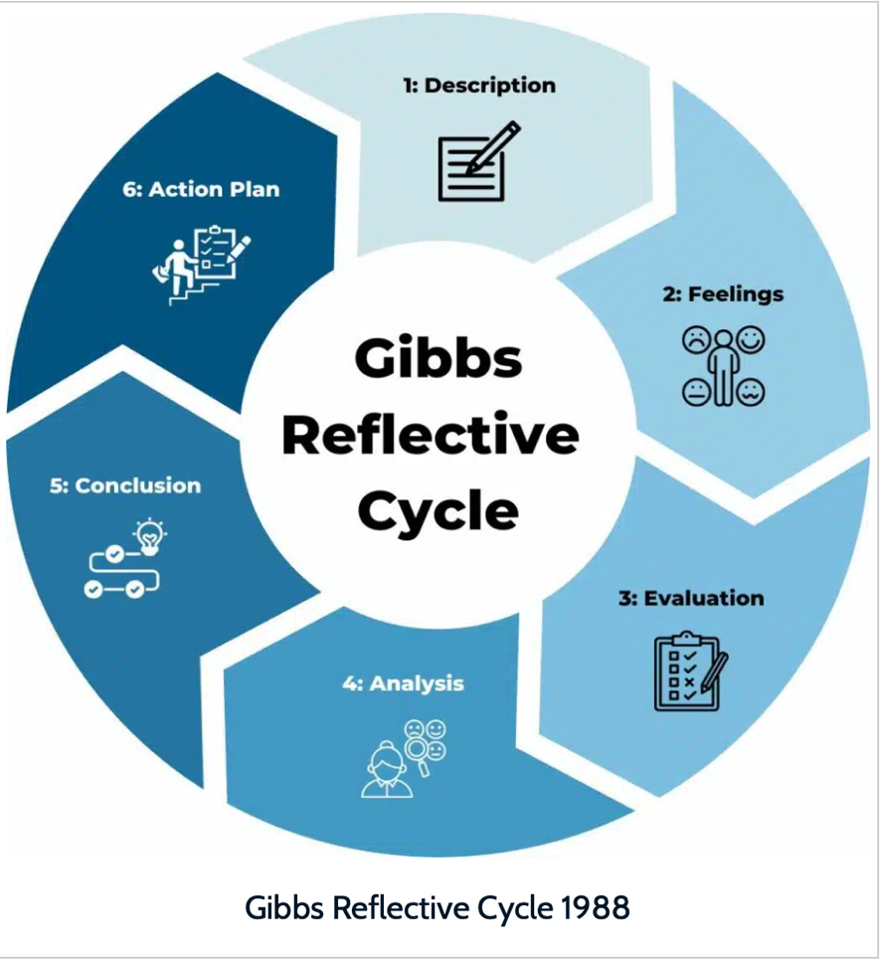
Gibbs' Reflective Cycle, which emphasises various stages of human experience and situational analysis, is well-suited for personal reflection, especially considering the stages previously mentioned. It plays a crucial role in the detailed analysis of developing leadership skills. Furthermore, this model of reflection helps in grasping the emotional aspects of leadership by focusing on the emotional elements involved in assessing an individual's leadership approach and cultivating emotional intelligence. The cycle's concluding phase involves devising an action plan, which aids in the ongoing improvement of leadership abilities.
Therefore, Gibbs' Reflective Cycle effectively connects theory with practice through its structured stages, facilitating the practical implementation of scholarly insights into real-world contexts. In essence, it promotes deep self-reflection and extensive growth in leadership at both personal and professional levels.
Personal Leadership style: Transformational leadership
Reflecting on my personal leadership approach, I find that transformational leadership resonates with me the most. This style focuses on motivating and encouraging team members, fostering a creative and collaborative work environment, and maintaining a vision for long-term goals. The four key components of transformational leadership include idealised influence or charisma, inspirational motivation, intellectual stimulation, and individualised consideration. These principles, which were discussed in lectures, are supported by the research. I plan to evaluate how these aspects manifest in my leadership approach through specific examples from my professional experience (Pastor and Mayo 2008).
Charisma or idealised influence

Leading a New Project: In my current role, I was tasked with leading a strategic initiative aimed at expanding our market presence. I highlighted the project's importance to the company's future, clearly conveying its vision and objectives to foster confidence and dedication. I witnessed a robust dedication to our corporate goals and consistently strived to meet my team's expectations. By embodying the vision and values of the project, I earned the team's trust and respect, which in turn motivated them to embrace the project's goals (Pastor and Mayo, 2008).

This is in line with the characteristics of transformational leadership, where leaders lead by example and earn their team's respect. Inspired by my dedication and efficient communication, my team felt fulfilled in achieving strategic objectives through our collective sense of purpose.

Inspirational Motivation
Supporting and encouraging employees during critical times: Faced with a challenging project that was short on time and fraught with significant risks, I maintained my motivation and moral strength to drive my team toward efficiently fulfilling the project's goals. I frequently shared updates on our progress and painted a convincing picture of success to illustrate our achievements. By blending individual and collective efforts, I fostered a sense of accomplishment and satisfaction. Furthermore, I introduced creativity and innovative problem-solving by allowing team members the freedom to work independently and contribute their valuable insights.
This demonstrates that transformational leadership is in line with inspirational motivation, where a leader presents a compelling vision that encourages employees to exceed expectations in achieving goals. Even amidst pressure, I maintained high levels of motivation to inspire my team.
Intellectual Stimulation
Encouraging innovation in product development, I encouraged employees to challenge their creativity levels and think beyond the conventional to foster innovation in product development. We held brainstorming sessions and welcomed suggestions from all team members, creating an open work environment that nurtured the development of creative ideas. While we did encounter failures, they allowed us to explore new concepts. This approach led to the introduction of several innovative features that enhanced the final product.
This illustrates how intellectual stimulation aligns with the trait of transformational leadership, fostering a learning environment that challenges assumptions and encourages employees to be more creative and innovative. I was successful in leveraging my team's ideas to foster innovation by cultivating a culture that emphasises ongoing development and creativity (Al-A’ali and Masmoudi, 2022).
Tailored Approach

Training and development of staff, as a leader, I focused on fostering both personal and professional growth of my team. I regularly held one-on-one sessions with my team to hear their ideas, track their progress, offer advice, and support their journey. For example, noticing that a team member was highly skilled yet lacked confidence, I arranged development sessions for him and provided multiple opportunities to bolster his confidence and ability. Consequently, his performance enhanced, leading to greater engagement with the team and aiding in the collective achievement of our goals (Pastor and Mayo, 2008). This demonstrates the hallmark of a transformational leader who mentors and advises their employees, helping them realise their full potential through personalised guidance and support.

Conclusion
Through effective study of leadership concepts, I've come to understand the significance of various leadership styles, particularly transformational leadership. I've embraced this style as it aims to inspire peers, foster innovation and creativity, and offer support when necessary. This approach has enabled me to motivate my team and earn their trust by leading by example and demonstrating commitment to our goals. I've noticed that heightened motivation can lead to the successful completion of even the most complex projects, driven by a shared vision and recognition of achievements. Encouraging creativity and innovation has prompted team members to engage intellectually and actively in their work, supporting and mentoring one another. In summary, my understanding of the transformational leadership concept has deepened through reflective process. Looking ahead, I aim to further develop my ability to motivate, inspire innovation, assist team growth, and consistently exhibit ethical behaviour. These future enhancements will advance my transformational leadership skills and contribute to a more productive work environment.

References
Aga, D.A., 2016. Transactional leadership and project success: the moderating role of goal clarity. Procedia Computer Science, 100, pp.517-525.
Al-A'ali, E. and Masmoudi, M. eds., 2022. Leadership and Workplace Culture in the Digital Era. IGI Global.
Blake, R. and Mouton, J., 1964. The managerial grid: The key to leadership excellence. Houston: Gulf Publishing Co, 350.
Galli, F. and New, K.J., 2022. Gibbs’ cycle review. Emotions as a part of the cycle. e-Motion: Revista de Educación, Motricidad e Investigación, (19), pp.92-101.
Khan, H., Rehmat, M., Butt, T.H., Farooqi, S. and Asim, J., 2020. Impact of transformational leadership on work performance, burnout and social loafing: a mediation model. Future Business Journal, 6(1), p.40.
Pastor, J.C. and Mayo, M., 2008. Transformational leadership among Spanish upper echelons. Leadership & Organization Development Journal, 29(4), p.340.
Solinger, O.N., Jansen, P.G. and Cornelissen, J.P., 2020. The emergence of moral leadership. Academy of Management Review, 45(3), pp.504-527.
Yang, Q.I. and Wei, H., 2018. The impact of ethical leadership on organizational citizenship behavior: The moderating role of workplace ostracism. Leadership & Organization Development Journal, 39(1), pp.100-113.

