

Marketing Fundamentals (LCBB4004)

An individual essay: Processes and stages of marketing including the role of the marketing mix in Chanel

Module Lecturer’s Name: Ze Zook

Student Name: Manuela Hristova Manoloova
Student ID: 2018271

- Definition of the marketing
This is an essay providing a critical analysis and evaluation of the processes and stages of marketing, including the role of the marketing mix connected with Chanel brand. It starts with definition of Marketing and Marketing process, explained stage by stage. This essay includes PESTEL and SWOT analysis of Chanel brand and shows its marketing mix.
The Chanel brand is a luxury fashion house, founded by Coco Chanel 112 years ago in France as House of Chanel. It produces haute couture, ready-to-wear, accessories, jewelry and perfumes. Chanel`s suit conquered the fashion world and in the middle of the 20th century determined the trends of haute couture. Perfume Chanel No. 5 was the best-selling perfume in the world. Fans of the Chanel brand are celebrities like Jennie Kim, Nicole Kidman, Kristen Stewart, G-Dragon, Cara Delevingne and Marilyn Monroe. Now there are 310 Chanel boutiques- 94 in Asia, 70 in Europe, 10 in the Middle East, 128 in North America, 1 in Central America, 2 in South America, and 6 in Oceania.

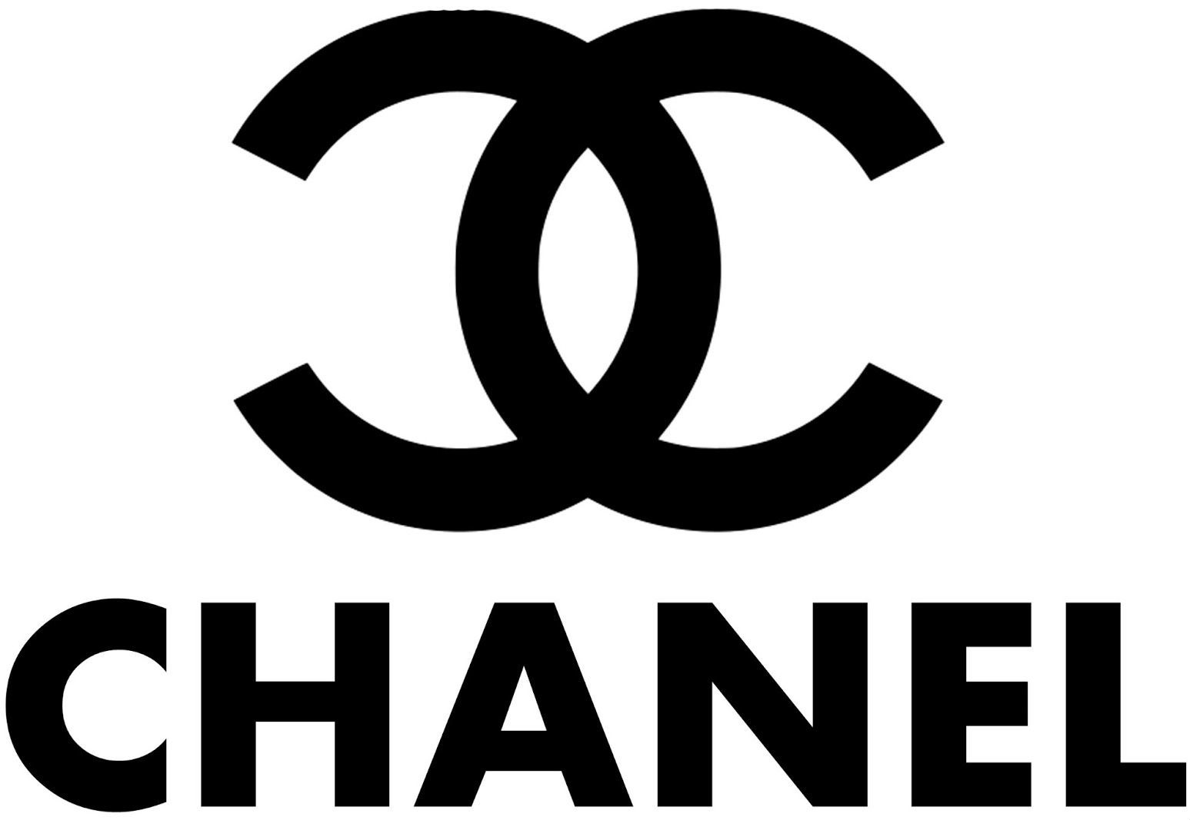

Marketing is a human activity of researching, promoting, distributing and selling services and products. The main goal of Marketing is to attract as many customers as possible, to meet their needs and thus increase sales. Marketing is related to the exchange of ideas and information, pricing and offers that meet the interests of customers.

The marketing process is a sequence of stages in the organization from consumer research to the realization of the product or service. The process of satisfying customer`s needs is include the following stages:

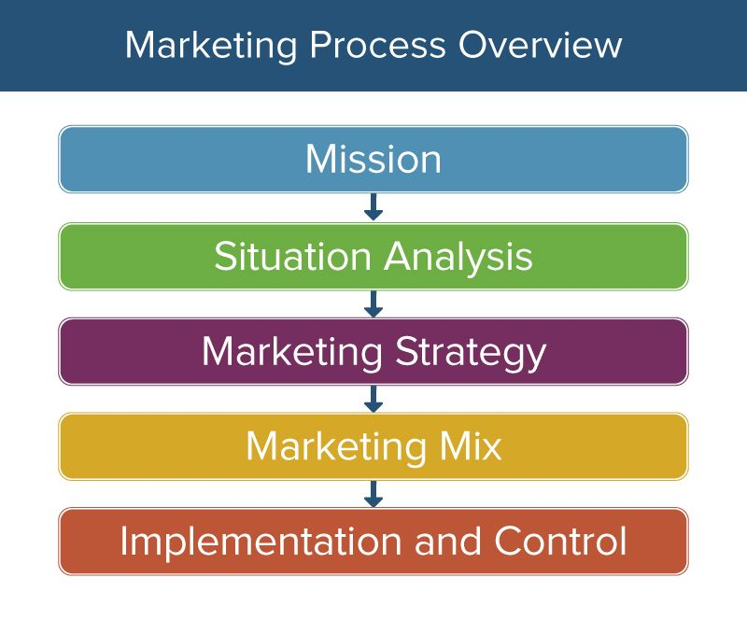

- The mission statement is the basis for building a good marketing plan. It says why is the organization exist, what are the main goals that the company wants to achieve and how to achieve it.
Chanel' s mission statement is "To be the Ultimate House of Luxury, defining style and creating desire, now and forever."

- Situational analysis is set of methods used to analyze internal and external factors that affect a company. It helps to define the problem, create better strategy, understand the opinion of the stakeholders and to give a view of the current company situation.

- Marketing objectives are linked to the actions of the company`s team that directly affect the organization`s results. Examples of marketing objectives are improve the reputation, optimize brand position and improve product quality.
- Marketing strategy is a business plan for reaching consumers and make them customers of the product and services by understanding their wants and needs.
“ The marketing strategy lays out target markets and the value proposition that will be offered based on an analysis of the best market opportunities. “ (Philip Kotler and Kevin Keller, Marketing Management, Pearson, 14th edition)

- Marketing implementation and control is about how to put marketing plan and strategy into action. It is a process that realize the achievement of the strategic objectives that the company has by managing people. The control is needed for monitoring and evaluating the marketing activities.
- PESTEL analysis of Chanel

PESTEL includes macro environment factors - Political, Economic, Social, Technological, Environmental, and Legal, that impact the business environment.



- Political factors are related to the government's influence on business. They impact the cost and long term sustainability of the company.
Chanel № 5 has been reformulated by the European Union through “Consumer Protection Laws” because of the allergens that contain,
and because of the new EU rules Chanel № 5 is threaten with ingredient bans and Labeling regulations. Politics inspires fashion brands. For one of their shows, Chanel recreates a feminist protest using signs with the inscription Ladies First.

- Economic factors- The development of the country's economy is essential for Chanel's growth. The high GDP shows the possibility for consumers to spend more on Chanel's products. Countries with high unemployment are suitable for Chanel's production, as it reduces the company's costs.
“One of the economic factors for Chanel is the increase in purchasing power in the developing world which leads to a rise in the desire for luxury goods and the disposable income to buy in countries in Africa and some of Asia. The luxury goods markets has also grown over the past 20 years with the number of customers tripled. The spending on expensive jewellery, watches, bags, shoes and clothing has risen to nearly double the rate of global GDP ” (Exclusivity for everybody,2014)

- Social factors- Chanel is an international company, so the aging population and migration are of great importance to the company. The cultural values of the consumers directly concern the company, so Chanel forms local teams and partnerships to understand public thinking and needs. This is how they implement their marketing strategies. The company is developing its marketing strategy by emphasizing the currently popular social media and online shopping, which is very relevant among young people.

- Technological factors- Technology is evolving extremely fast today. Chanel uses the 5G network to achieve high business results, increase its market share and stay ahead of the competition by emphasizing technological innovation. Chanel has nice website where is easy to find all of the products.
“Chanel is also investing in the research and development of their fragrance formulas to make them more sustainable, moving away from the synthetic chemicals they use” (Cooper, 2014)

- Environmental factors- as an international business organization, Chanel examines environmental standards and laws in different countries. Many have strict anti-pollution laws in urban areas. Chanel adopts innovative waste recycling practices. However, some countries are offering subsidies to encourage recycling, and this would be a good option for Chanel to improve its image and invest in return-to-date technologies.

- Legal factors- before entering a new market, it is mandatory to research the legal aspects. Chanel complies with the Employee Protection Laws by making an effort to protect their health and safety at work. The company does not discriminate against their employees but attract talented people. The next important law that Chanel follows is Consumer Protection Law, by protecting customer data, privacy and security.

- SWOT analysis of Chanel

SWOT analysis shows strengths, weaknesses, opportunities and threats of the company.
“SWOT Analysis is a tool used for strategic planning and strategic management in organizations. It can be used effectively to build organizational strategy and competitive strategy”. (The Journal of International Social Research, 2017)
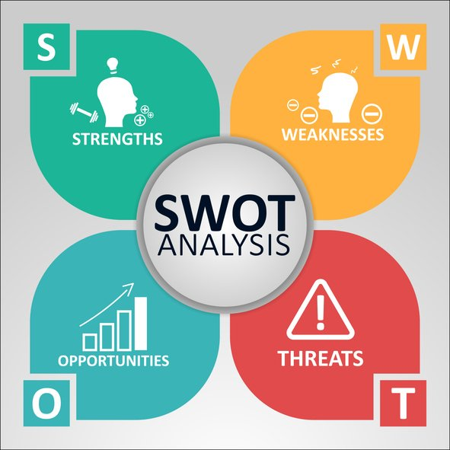

- Strengths - Chanel is a popular and luxurious company, leader in the field of its activity. That is why its strengths are many, for example:
- Very strong brand portfolio- this portfolio makes it much easier to enter new market niches.
- Reliable supplier chain
- Over 300 Chanel Boutiques in the world
- Very successful in developing a new product.
- High level of customer satisfaction and able to attract new customers younger and older
- Reliable and correct suppliers of materials
- Over 1200 talented and skilled employees- Chanel invest a lot of money for projects for motivating and training its employees.

- Weaknesses
- Chanel needs to make more efforts to improve investment in new technologies.
- It is hard for Chanel to be good at product demand forecasting that is why some opportunities are missed.
- A lot of competitors form other brands
- Need to improve financial planning.

- Opportunities
- Potential new clients from the online website of Chanel which leads to the opening of a new market and with the income to invest in new products.
- Reduction of the inflation rate which lead to more stability
- Expansions abroad
- Investment new technology

- Threats
-Very strong competition can reduce Chanel's market share
-The unstable economy and economic crises have a negative impact on production
-Copying Chanel products from lower quality and cheaper brands

- Segmentation, targeting and positioning

Chanel's market segment is focused mainly on elegant and modern women. It is characterized by class and style. Costumes and perfumes are typical for Chanel.
A huge range of products – skin care, accessories, make-up, fragrances and bags. The target of the company is to satisfy women and men of all ages. Chanel is one of the best brands in Haute Couture Line, Ready to wear line, Resort line.

- Marketing mix
Marketing mix is a set of tactics and strategies for promoting a product or brand. It is characterized by 4P- Product, Price, Place and Promotion.

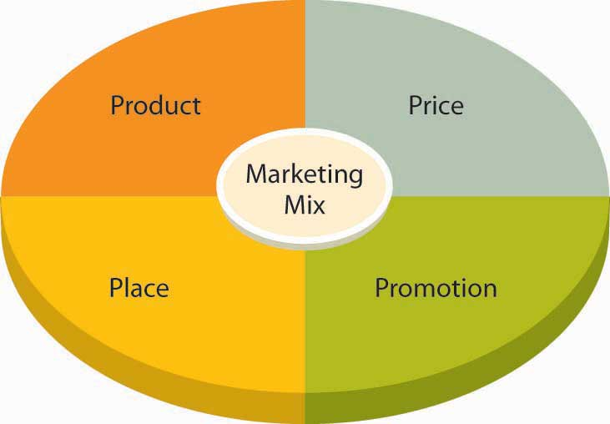

- The product strategy in Chanel is to produce luxury high quality products, used by a lot of famous people and celebrities. Very good reputation of the brand. Simple, stylish and very expensive products.
- Chanel Price Strategy- expensive materials are used for producing that is why the target segment is rich and able to pay. The Chanel Haute Couture starting from $10,000 to $60,000, with the far end going beyond $100,000.
- Chanel Place strategy- there are 310 Chanel boutiques in the cities like New York, Boston, Amsterdam, Sao Paulo, Sydney, Hamburg, Cannes, Miami, Bangkok, Geneva, Tokyo, Saint Tropez, Moscow, Los Angeles, Paris, Dubai and London- which is the biggest in the world.
- Chanel Promotion- a lot of fashion magazines, supermodels and celebrities like Marilyn Monroe, Claudia Schiffer, Vanessa Paradis, Catherine Deneuve, Winona Ryder, Nicole Kidman and Brad Pitt promoting Chanel.
The clear company strategy, good marketing mix and high quality of productions are some of the main reasons for Chanel being on the top so many years.
In conclusion marketing is one of the most important tools for every successful business. Marketing informs consumers in an interesting way about all the advantages and benefits of the product on the market. This creates relationships with customers that help the development of the business. Marketing allows even small companies to compete with large business organizations. Marketing sells.

Reference list:

- Baker, J. (2003) The Marketing Book. 5 ed. Burlington MA

- Kotler, P. Armstrong, G. (2018), Principles of Marketing. 17th ed. Pearson, 2018.

- Chanel
Available at: https://www.chanel.com/gb/fashion/handbags/c/1x1x1/
Accessed: (20th April 2021)

- (2017) “SWOT ANALYSIS: A THEORETICAL REVIEW”, Journal of International Social Research, 10(51).

- (2014) “Exclusively for everybody”, The Economist, pp. 6.

- Bishop, T. (2012) Principles of Marketing Management, World Technologies

- Sood, T. (2017) Strategic marketing management and tactics in the service industry, Pennsylvania

- Porter, M. (1980) Competitive Strategy, New York: Free Press

