Daniels Zelinskis (2104718)
Computer Networks and Cybersecurity
Changemakers: Creativity and Value Creation (ACCA5033) Assignment 1
Gareth Jones
University of Wales Trinity Saint David

Contents

1.Introduction 3
2. Links (e-portfolio and mind-map) 4
3.Appendix. 5
3.1. Screenshots of my e-portfolio: 5
3.2. Screenshots of activities. 6
3.3. Screenshots of Gantt chart. 10
3.4. Screenshots of mind map. 11
4. References: 12

1. Introduction
This work has been done to gain the necessary skills to identify opportunities, conduct research, develop ideas and critical thinking, also as value in society and for a common understanding of how creativity works.
What is innovation?
This innovation, which ensures the effective growth of processes or products, is the result of human intellectual activity, the imagination, and inventions. This is the result of investing an intelligent solution in the development and production of something new, previously unused in different spheres of life for additional value.

2. Links (e-portfolio and mind-map)

Link to my portfolio: https://danielszelinskis.wixsite.com/danielslde

Link to my mind-map: https://mm.tt/map/2486821322?t=H4frUyClem

3. Appendix.

3.1. Screenshots of my e-portfolio:

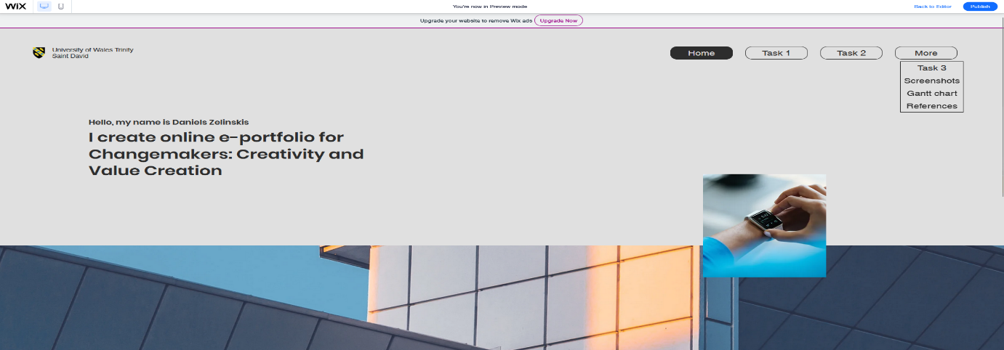



3.2. Screenshots of activities.

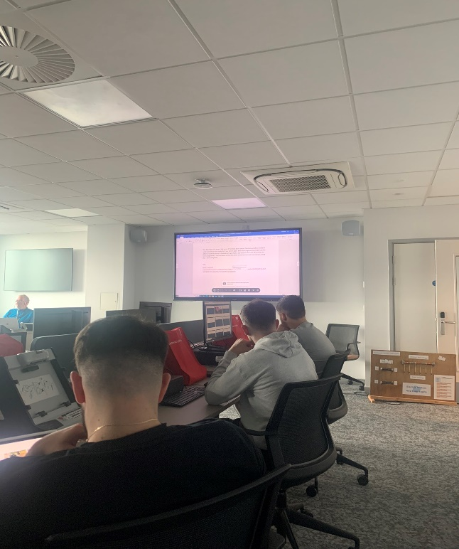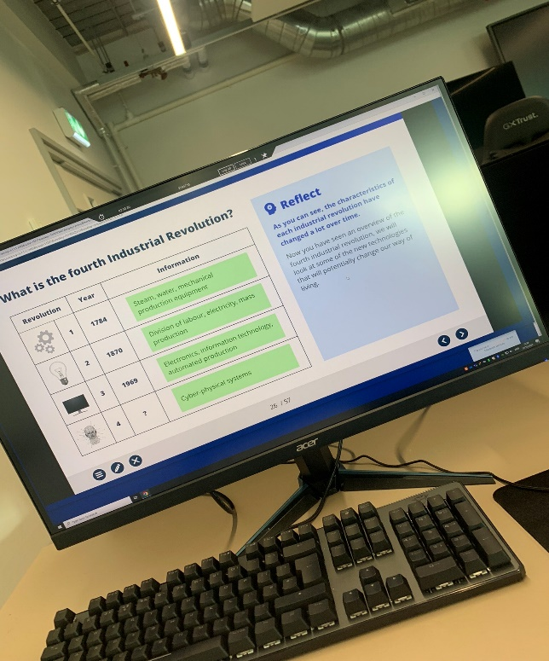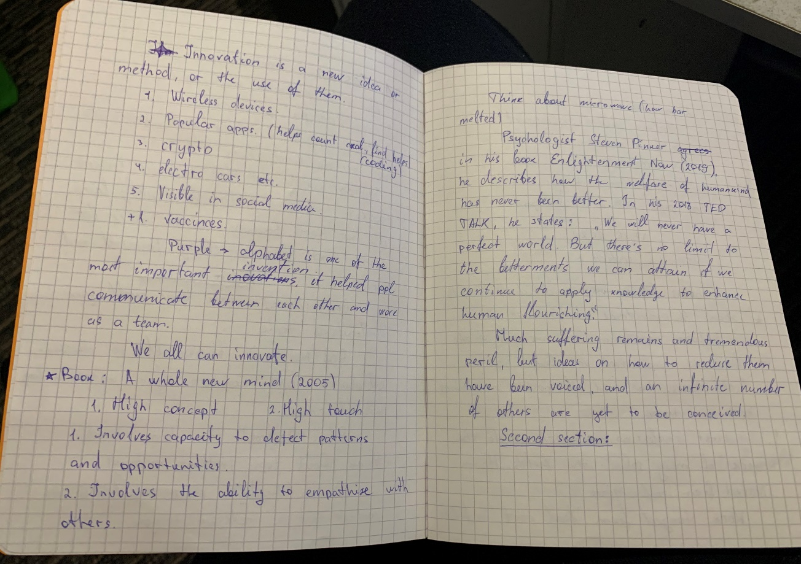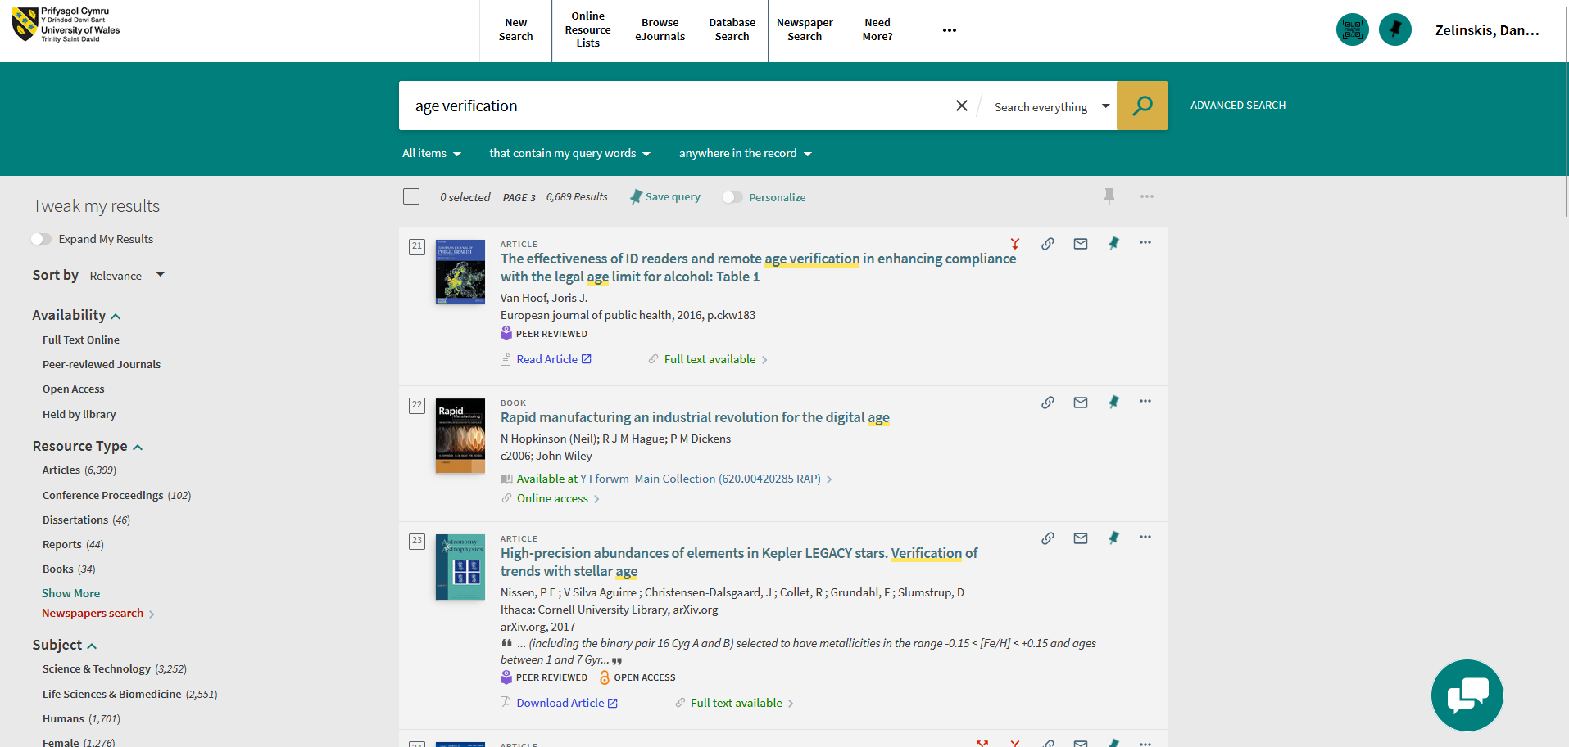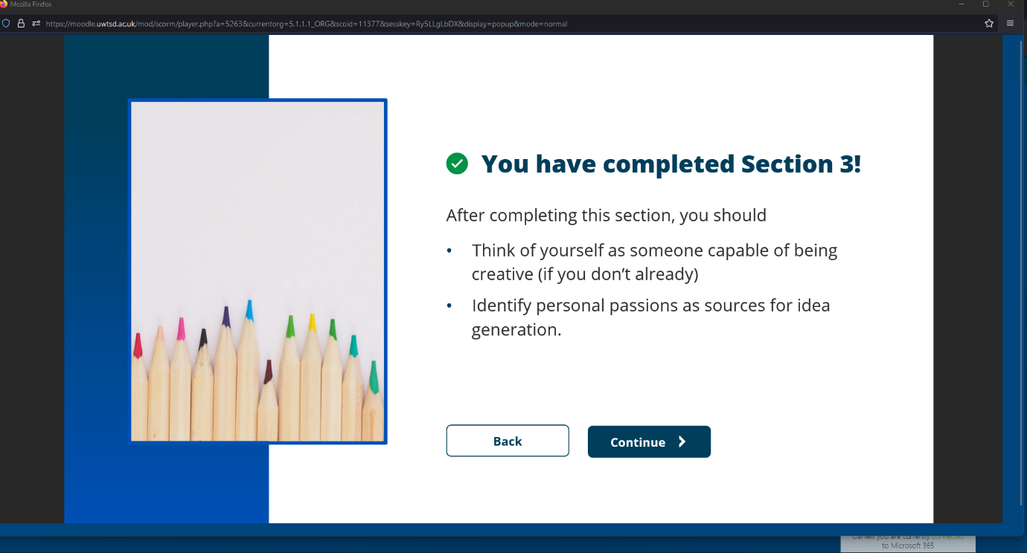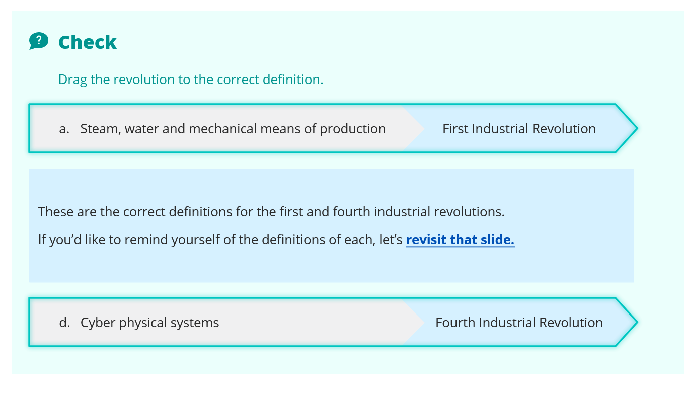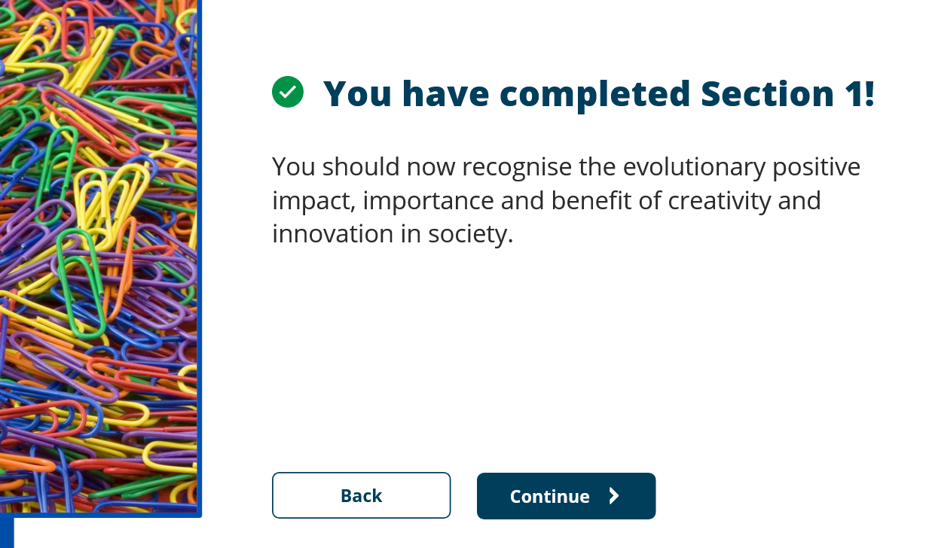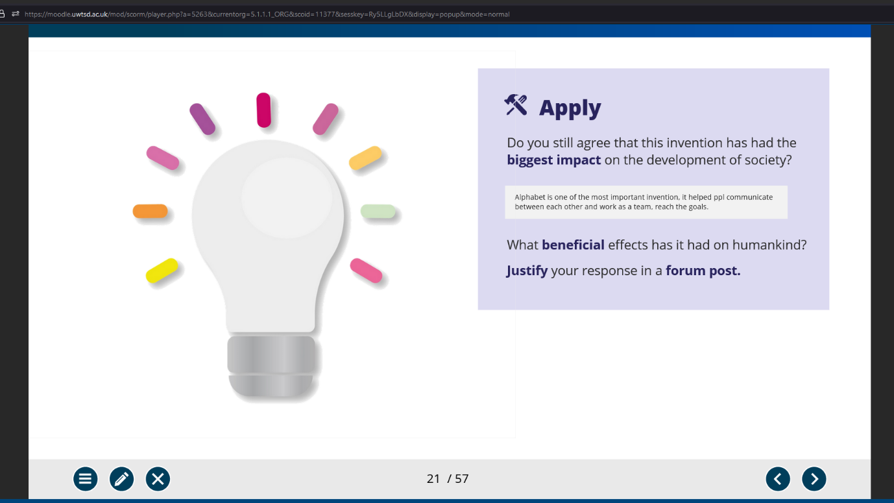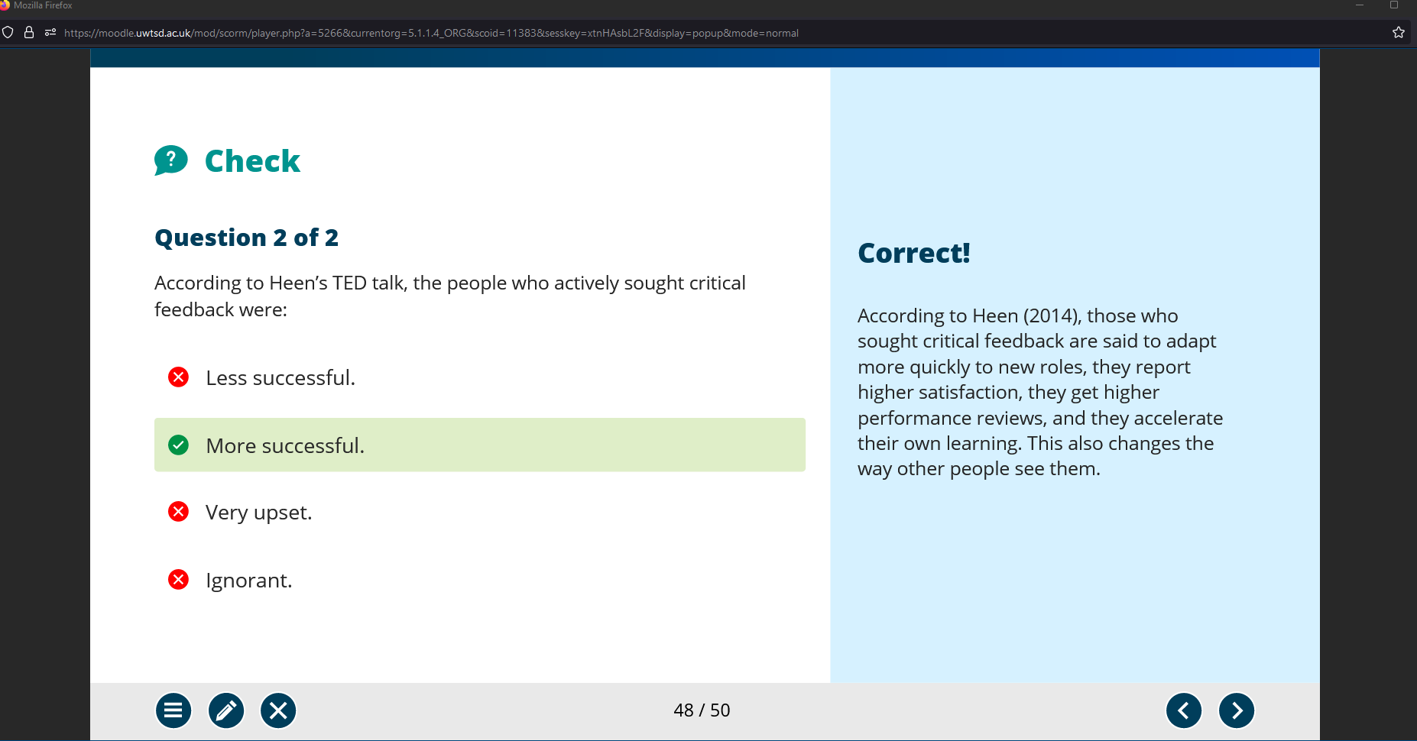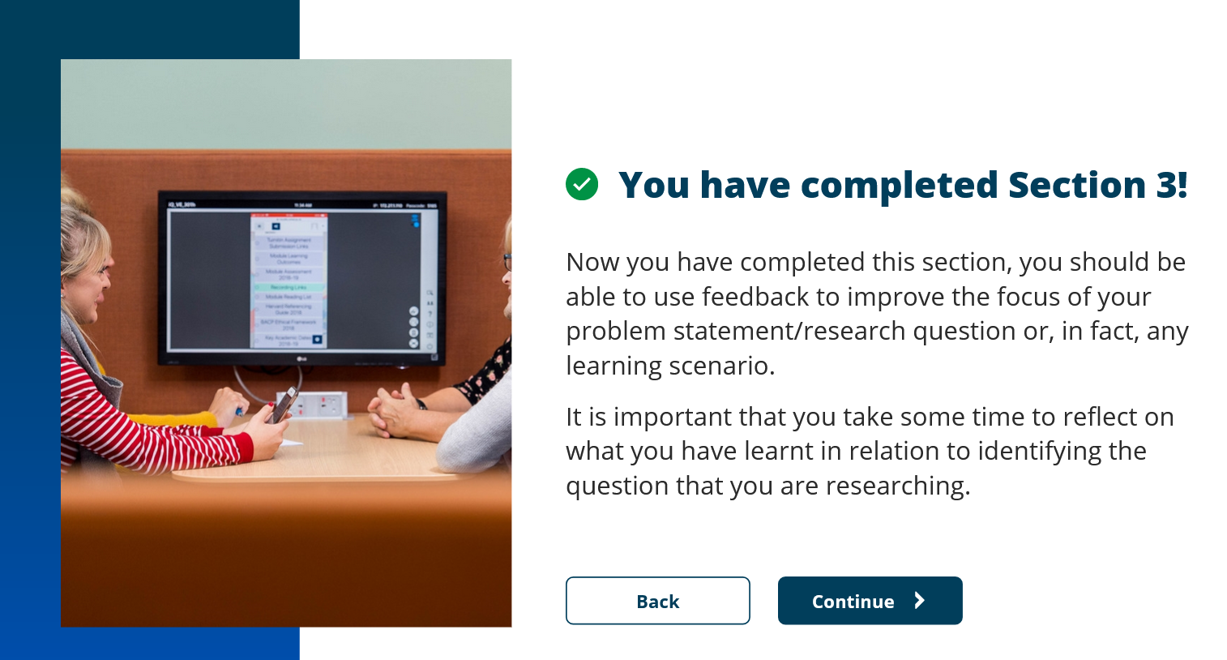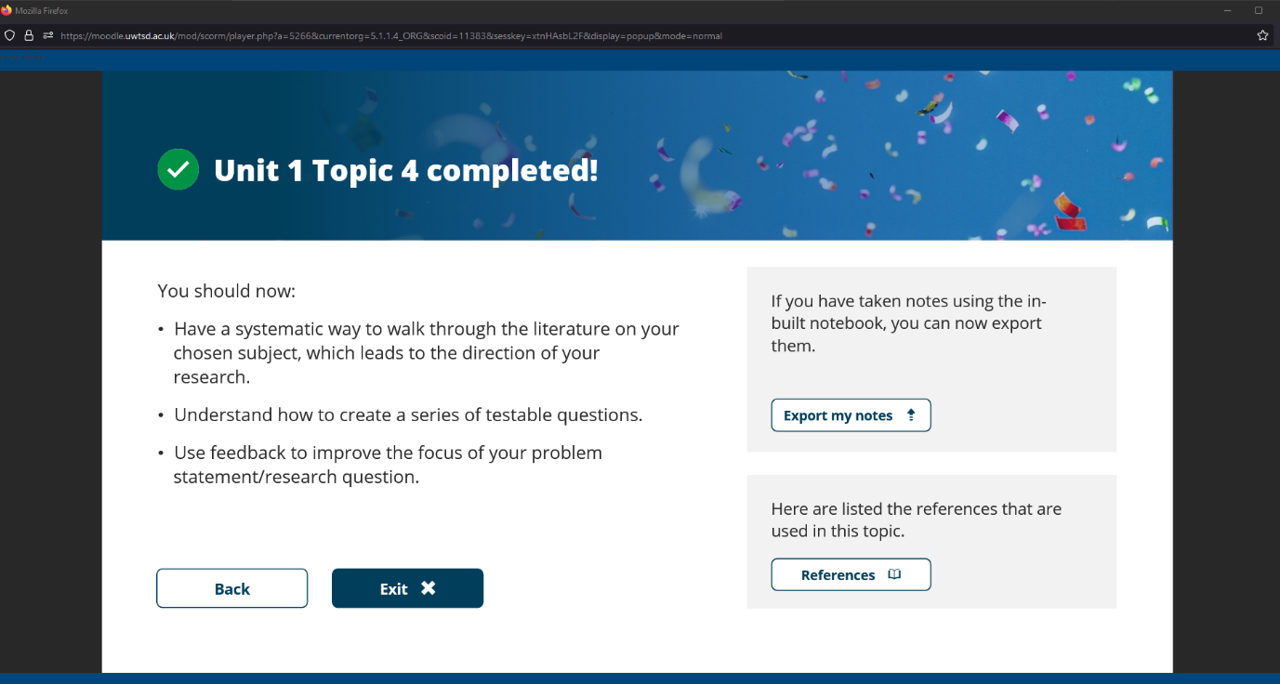

3.3. Screenshots of Gantt chart.

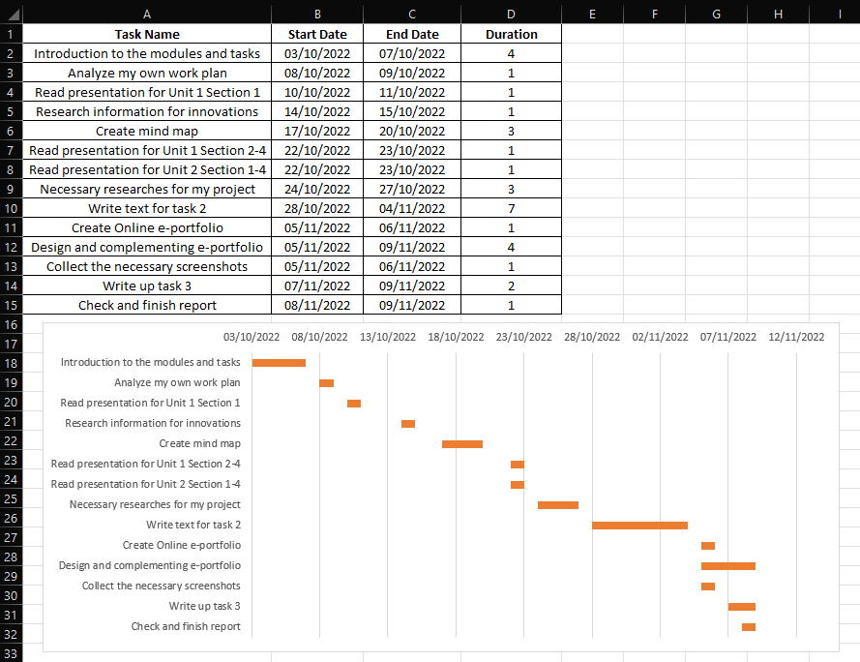

3.4. Screenshots of mind map.

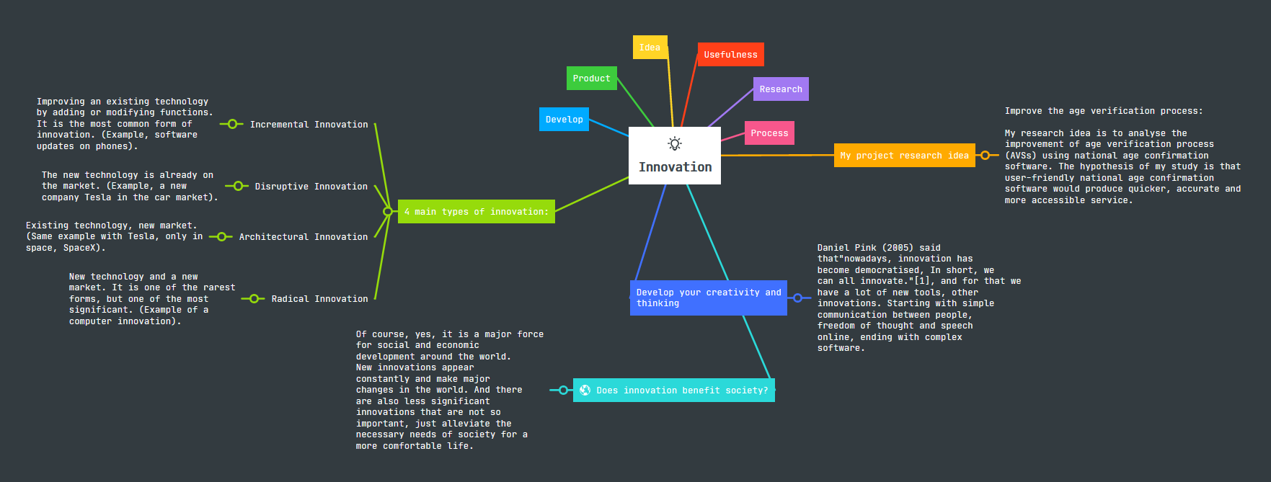

4. References:
Greenstein, D. (2021) What is boolean logic? examples of boolean logic, developer. Available at: https://www.lotame.com/what-is-boolean-logic/ (Accessed: November 8, 2022).
Kim J, Moon J. (1998).Designing towards emotional usability in customer interfaces—trustworthiness of cyber-banking system interfaces. Interacting with Computers (10), Issue 1, 1-29.
Positivism - research methodology (2022) Research. Available at: https://research-methodology.net/research-philosophy/positivism/ (Accessed: November 6, 2022).
Roodbeen, R. T., Schelleman-Offermans, K., & Lemmens, P. H. (2016). Alcohol and Tobacco Sales to Underage Buyers in Dutch Supermarkets: Can the Use of Age Verification Systems Increase Seller's Compliance?. The Journal of adolescent health : official publication of the Society for Adolescent Medicine, 58(6), 672–678.
Silja Baller, Soumitra Dutta, and Bruno Lanvin (2016) “World Economic Forum 2016,” in The Global Information Technology Report.
Thierer, Adam D., Social Networking and Age Verification: Many Hard Questions; No Easy Solutions (March 21, 2007). Progress & Freedom Foundation Progress on Point Paper No. 14.5.
Bush, V. (n.d.). Overcoming the Fuzzy Front-End With Idea Management Software. Retrieved from https://ezassi.com/overcoming-fuzzy-front-end-idea-management-software/
Cecilia Maria Patino, J. C. (2018). Internal and external validity: can you apply research study results to your patients? Retrieved from https://www.ncbi.nlm.nih.gov/pmc/articles/PMC6188693/
Helen Noble, J. S. (2015, April). Issues of validity and reliability in qualitative research. Retrieved from https://ebn.bmj.com/content/18/2/34
John Øvretveit, L. L. (2010, October 12). Increasing the generalisability of improvement research with an improvement replication programme. Retrieved from https://qualitysafety.bmj.com/content/20/Suppl_1/i87
Richards, R. (2021, September 1). 5 Main Types of Innovation: Which Is Right for Your Business? Retrieved from https://masschallenge.org/article/types-of-innovation
Talin, B. (2022, August 17). Innovation explained – Definition, Types and Meaning of Innovation. Retrieved from https://morethandigital.info/en/innovation-definition-innovation-types-and-meaning/
Bryman, A. (1984). Quantity and quality in social research. London: Unwin Hyman.
Picciano, Anthony G. (2004): Educational Research Primer. London: Continuum.

