Miss Hannah Marie Evans
BA (Hons) Youth and Community Work
2018/2019
How does UWTSD support young people with social anxiety?





Undergraduate ARP Certificate

Name of the Programme of Study: Youth and Community Work

Name of Student (Capital Letters): HANNAH MARIE EVANS

DECLARATION

I certify that the whole of this work is the result of my individual effort, and that all sources have been acknowledged.

Signed ............................................................... (Student)

Date ...............................................................

DECLARATION

I am satisfied that this work is the result of the Student’s effort.

Signed .............................................................. (Lecturer)

Date ..............................................................

Abstract
The question that has been discussed is ‘How does UWTSD support young people with social anxiety?’. the researcher wanted to gain the qualitive data that was required to explore the question fully. The results show the data that was identified when the research was conducted, and comments made by the participants who took part. The purpose of the study is to determine if UWTSD offers the right support to meet the needs of young people with social anxiety either by running a support group or offering other services like counselling. The method that has been used to gain the data is a focus group of six young people who were asked a series of questions to find out if UWTSD is offering the support that is needed and what else is available to support them. The findings of the study show that UWTSD is offering support to young people with social anxiety though a support group and other services.

Acknowledgements
I would firstly like to thank the young people who participated in this research project without whom this would not have been achievable. Without their engagement and involvement within YouToo this would not have been possible.
I would also like to thank Ken O’Grady whose help and inspiration led to the development and running of YouToo, which then leads me to thank Elis Allsopp for his dedication and time to the continued provision of the group.
The University of Wales Trinity Saint David deserves recognition for the support it has given me to set up YouToo and with my academic studies, this brings me to thank my lecturers, Angharad, Alana and Darrel who have encouraged and given me the confidence to complete my degree.

Table of Contents

Chapter 1- Introduction 5
Chapter 2 – Literature Review 7
Chapter 3 – Methodology 11
Chapter 4 - Presentation of Results 15
Health and Wellbeing 16
Access to Support 16
Self-esteem and Confidence Building 17
Chapter 5 - Discussion, Critical Reflection and Conclusions 18
Chapter 6- Recommendations 20
Reference List 22
Appendices 24
Appendix 1 - Ethics Form 24
Appendix 2- Cover letter and consent form 38
Appendix 3- Photographs of Flipcharts 41

Chapter 1- Introduction

This study that is being undertaken is to establish ‘How does UWTSD support young people with social anxiety?’ This study will show young people with social anxiety, what is available and how they can access it and what support is offered and will identify if more support can be delivered. The study is being undertaken as a need was identified by students on campus that young people are becoming isolated and lonely as they do not feel they can be part of the social aspect of university life due to not being about to cope with the social part of university life for example going out drinking.
The study has also been chosen as the researcher is a volunteer in a support group called YouToo which is already established and running on the university campus, and most of the young people who attend have some form of social anxiety although it is accessible to all young people who attend UWTSD.

The aim of the study is to look at what support is offered to young people with social anxiety at the University of Wales Trinity Saint David (UWTSD). and what implications there may be for the young people who receive any support, and if anything can be done to address any issues raised. It is hoped that the study will identify if any improvements can be made to the groups that are already running and may identify if anything else can be offered to improve young people’s experiences during their time at UWTSD.
Young people with social anxiety will benefit from this study as it will identify what support is needed, how this could be achieved and if there are any other support services that could be put in place to support young people’s time in university.
This can be achieved by the researcher collecting data by undertaking a focus group with the young people who attend YouToo. Then the data will be analysed to provide recommendations for future development of the support group and identify and areas for improvement.
The investigation will begin with literature review to identify what has been written around the subject, and to identify any gaps in the research.
The third chapter will focus upon the methodology that has been used to gain the research, so that the question is answered in an ethical way.
The fourth chapter will present the data gathered, and this will be structured under the themes that will would have emerged though the research.
The fifth chapter will discuss the data, linking it to the literature review.
The closing chapter will discuss conclusions and recommendations for further practice and research.

Chapter 2 – Literature Review

The literature review will analyse any literature that has been written around the theme identified within the Applied Research Project, which is to consider ‘How does UWTSD support young people with social anxiety?’. By undertaking the literature review it will offer an incite in to what is already written around the subject that is being explored and will help to evaluate the research findings and highlight any areas of research that are missing. This chapter will also mention youth work policy.
There has been quite a bit written around social anxiety. Some of these findings will be discussed throughout this chapter.
UWTSD (2019) offers the Mental Health Advisory Service which offers support to students with anxiety. They state that
Studying at university can be stressful and can affect your mental wellbeing. For enduring difficulties such as depression, anxiety, schizophrenia or bi-polar disorder on-going support or equipment may be required to enable students to manage their studies (UWTSD, 2019).

It is important to have a mental health advisory service as it gives the young people accessing it the support they would need during their time at university. It would also help young people who suffer from social anxiety that are thinking of applying for university to decide where to attend and what support they would be given.

The NHS (2017) states that social anxiety is ‘A common problem that usually starts during the teenage years. For some people it gets better as they get older, although for many it doesn't go away on its own’.
The fact that social anxiety usually starts in teen years means that universities should be doing all they can to help, support and encourage young people who access higher education by offering the services that could support them with any needs they may have which would help them to achieve their degree, but they must also be able to signpost young people to relevant agencies or organisations as some young people may need help from a specialised service.

Russell and Shaw (2009, p.198) state that:
Social anxiety is a debilitating condition which ranks as the third most common mental health problem after depression and alcohol abuse. Whilst it is known that adults with social anxiety do less well than peers on measures of education and career attainment little is known about its prevalence or potential impact on students studying in higher education (Russell and Shaw, 2009, p.198).

by having support services available for young people to access would identify any potential issues that they may be facing and how these can be resolved.
According to Brook and Willoughby (2015, p.125) ‘One psychosocial factor that may hinder success in university/college is social anxiety, an emotional problem that often is overlooked or hidden from the casual observer’.
The fact that social anxiety can be hidden means that some young people could be suffering from it but do not know where or who to go to seek help and advice. Having the support available and well-advertised would help these students to find out and make a decision as to if it is the right support for them.

According to Kessler (2003, cited in Topham, Moller and Davies, 2016, p. 125)
Persistent social anxiety in learning situations has an adverse impact on student engagement, retention and well-being and, if unaddressed, has an adverse impact on opportunities and quality of life after university (Kessler, 2003, p. 125).

Therefore, having support services available at UWTSD are vital in helping young people to achieve their academic qualifications and give them skills and coping mechanisms to progress with their lives after they finish their academic studies. Also, by reviewing current and past literature and research it has identified that a number of things have been written both around social anxiety in general and within higher education therefore this research project would be supporting and adding to the findings that are already present by showing how important having these support services are.
The National Youth Work Strategy for Wales (2014) states ‘All young people deserve to have a range of activities available to them which support their development needs by providing them with a safe place to relax and have fun’.
This is why offering a support group at UWTSD is important, it also shows how youth workers can play a part in helping a young person to get the support they need and to express themselves by give them the chance to be themselves and speak openly about any worries or concerns they may have and to help them build confidence in themselves.
In conclusion, from what has been identified though the findings it is clear to see how important it is to have support services at UWTSD and the impact they are having on the young people who access them.
To discuss the question in more detail, the following chapter will focus on the methodology that has been used to undertake research with young people through a focus group to explore ‘How does UWTSD support young people with social anxiety?’

Chapter 3 – Methodology

The Applied Research Project will be used to answer the question ‘How does UWTSD support young people with social anxiety?’. This chapter will be discussing the methodological approach used within the research to answer the question in an ethical way. The methodology that has been used is qualitative the reason why this was chosen is because the researcher wanted to gain thoughts and opinions from the young people participating as it was the most suitable way to get the desired outcome which focuses on what support services are available to young people and if they access them. Also, it means the researcher can gain a more in-depth insight into the research that is being obtained.
DeFranzo (2011) states that ‘Qualitative Research is … used to uncover trends in thought and opinions, and dive deeper into the problem’. There are certain research methods that can be used to undertake research, the method that will be chosen and used to gain the qualitative data within this study is a focus group. According to Creswell (2014) qualitative research ‘is an approach for exploring and understanding the meaning individuals or groups ascribe to a social or human problem’. The research was carried out during one of the YouToo sessions that are held weekly on the UWTSD campus.
According to Morgan & Kreuger (1993, cited in Gibbs 1997) focus groups provide an effective research method within the youth work field as ‘The main purpose of focus group research is to draw upon respondents’ attitudes, feelings, beliefs, experiences. Within youth work young people’s feelings and ideas are considered and used wherever possible to help them gain the confidence and self-esteem they would need to live a full and healthy life.
The National Occupational Standards (LSIS, 2012) states that the key purpose of youth work is to:
Enable young people to develop holistically, working with them to facilitate their personal, social and educational development, to enable them to develop their voice, influence and place in society and to reach their full potential.
By offering a support group at UWTSD they are helping young people to be in control of their own lives and make decisions which will benefit them later in life by giving them the confidence they may be lacking. The support group is open to all young people therefore it encompasses the key purpose of youth work.
The researcher used a focus group of six participants, who will be identified as participant A to F, they were asked to answer the five questions listed below:
• ‘What support do you think is available?’
• ‘Do you access any of these support services?’
• ‘Why do you feel they are important to have?’
• ‘What do you feel you have gained from being involved in these services?’
• ‘what else do you think should be offered?’

This was achieved by writing each question onto flipchart paper then giving each participant a marker pen and asking them to write down their thoughts and ideas, they could write whatever they wanted whether it was positive or negative. This also encouraged discussions around the topic that was being asked.
Focus groups were chosen as they are one of the most effective ways to get all the participants together to discuss the questions that were being asked. By using this method, the researcher may also gain an insight into some of the experiences these young people have had, and it may also cause the participants to discuss what is important to them whilst they are studying.
According to Kitzinger (1995) ‘Focus groups are a form of group interview that capitalises on communication between research participants in order to generate data’. Some of the disadvantages of using focus groups is that one participant may be more outspoken that the others which would not give any of them a fair chance to write down or discuss what they wanted to say. Some participants may also feel that they do not want to speak in a group of other young people. One way of overcoming this is to encourage everyone to have their say and write something down and by asking the individual what they think about the question you are asking.
A limitation to consider when undertaking research is the fact that participants can drop out at any time during the research process, which would mean that they would not take part in the focus group if this had already happened, and the researcher may not be able to use the data that participant had offered. This could change the outcome of the research by having less participants, and the researcher may not get enough information to gain a full understanding of the issue that is being discussed.
There are certain things that need to take into consideration when undertaking this research for example the time that was given to partake in the research. Due to gaining ethical approval which is needed to carry out this study, and other assignment commitments, also finding a suitable time within the groups to run the focus group session meant that the researcher may not have had the time to have an in-depth conversation with the participants on each question. Within the ethics form it was stated that semi structured interviews would be undertaken with three participants but due to time and other commitments these young people were unable to participate therefore no research could be undertaken. Also, the researcher’s skills and experience could have an impact on the outcome of the Applied Research Project as the researcher does not have much experience of collecting and analysing data.
The next chapter will focus on the presentation of the results that were obtained from undertaking research with young people about ‘How does UWTSD support young people with social anxiety?’

Chapter 4 - Presentation of Results

A focus group was undertaken were the six participants (A-F) were asked a series of questions to help identify ‘How does UWTSD support young people with social anxiety?’ by undertaking this research this is what was discovered:
Firstly, the participants were asked ‘What support do you think is available?’
• Student services
• Course reps
• Friends
• Personal tutors
• Socom
• Hall Wardens
• Societies
• SU Champions
• Welfare officers
• SJYW Students
• Support Lectures
• YouToo
• Counselling
• Student Union

The chapter will now focus on the three themes that were identified in the research from the remaining four question that were asked to the participants. The questions that were asked are; ‘Do you access any of these support services?’ to which all the participants answered yes, ‘Why do you feel they are important to have?’, ‘What do you feel you have gained from being involved in these services?’ and finally ‘what else do you think should be offered?’. The themes that have been identified are health and wellbeing, access to support, self-esteem and confidence building, and the data will now be presented under these three themes.

Health and Wellbeing

The first theme that has emerged is health and wellbeing it helped to highlight the need for young people to feel safe and secure to share any thoughts or feeling they may be having. Participant A states that ‘Better accommodation equals better quality of living’ whilst participants B mentioned that it is ‘A place to destress’. By having this space, the young people can really be themselves and not feel judged or discriminated against.

Access to Support

The second theme identified has a focus on access to support. Participant C stated that they ‘want to meet people but not necessarily in a loud environment’. All participants agreed that access to support was important to them as it help them to overcome any issues they were having at UWTSD and gave them confidence to seek help. Other things were discussed like how Participant D mentioned that ‘More awareness of roles within the university that can help out e.g. course reps, SU, student services, SU champions’, there was huge emphasis on better support and awareness for students whilst this research was undertaken. Discussion was had around students being able to share their thoughts, feelings and worries within a safe, contained environment also giving them someone to turn to. Participant E stated that is was ‘Voluntary and not forced’ they also stated that it is a ‘Shoulder to lean on’ and ‘A place to vent my emotions’ also discussed were things like how important it was to be part of a group and to make lasting friendships. Participant A stated that having a ‘safe space to chat with others who understand how I am feeling is very important to me’.

Self-esteem and Confidence Building

The final theme that has been identified though the research is self- esteem and confidence building. I discussion was had around how the participants feel confidence from accessing the support available at UWTSD. Things like the freedom to express themselves and gain confidence in their own abilities and their place within society were a few things that were mentioned. Participant F stated that things like ‘Coping mechanisms, character building’ were important and also gaining ‘confidence, self-esteem and self-worth’. One participant also stated that it gave them the ‘confidence to speak a different language’ as their first language is Welsh but it is a predominantly English speaking group.

Following on the next chapter will discuss the findings in more detail that have been identified within this chapter to explore further into ‘How does UWTSD support young people with social anxiety?’

Chapter 5 - Discussion, Critical Reflection and Conclusions

This chapter will identify key findings that have emerged from the research that was carried out with the support group on the UWTSD campus. There were three themes that have emerged these were health and wellbeing, access to support and self-esteem and confidence building. This chapter will give a more in detail discussion to examine ‘How does UWTSD support young people with social anxiety?’ this chapter will link to theory and policy and will discuss the findings within the literature review.
From the discussion with the participants it has become clear that health and wellbeing is an important theme to them. Also, this theme did not appear with the literature review therefore what has been written about health and wellbeing will be discussed within this chapter. Several things have been written about health and wellbeing especially in terms of youth work.
According to Health, Social Care and Children’s Services (no date) ‘Health and well-being is made up of four factors, physical, intellectual, emotional and social. These are the factors that help us through the day and keep us going’. Within the youth work field these stages are important as young people present with a manner of different needs that fall into these stages. However, the main one that is being focused on is social.
Another theme that was identified whilst the research was untaken was access to support again this theme was not discussed within the literature review but has become apparent since the research has been undertaken. The participants focused hugely on the support that UWTSD could offer them and how having support from other young people going through similar experiences is comforting to them. Having support groups like the group available at UWTSD is important for young people with social anxiety as it gives them a place to go and socialise and also to feel safe.

The final theme that has emerged from the research is self- esteem and confidence building. As mentioned within the other two themes self-esteem and confidence building has become apparent since the literature review so will not be mentioned there. This is a key youth work principle which is to help young people to build their self-esteem and confidence and to encourage them to find solutions to problems they may face. By having a space for the young people to go and gain these skills is vital as it will help to give them coping mechanisms for when they leave UWTSD and gain employment and also become members of society.

As stated within the literature review several things were written about social anxiety and around students with social anxiety within higher education but not much around what support is offered to young people who are already in higher education and from the research that has been undertaken its clear that the young people are accessing these services therefore more should be done to make sure young people know these services are available whilst they are deciding which university to attend.
From partaking in this research, it has shown the researcher that the participants receive all the support they need from UWTSD and are happy with what is available to them. The data that has been identified throughout the research project has been discussed and examined within this chapter and the researcher has interpreted the finding to explore ‘How does UWTSD support young people with social anxiety?’
The final chapter of the research project is recommendations for future practice and research. It will also summarise the findings within this study.

Chapter 6- Recommendations

This chapter will discuss recommendations for future practice and research and summarise findings from the research to answer the question ‘How does UWTSD support young people with social anxiety?’
The main finding from undertaking this research where that several things had been written around social anxiety within higher education but not about what support was offered or why it should be offered. This could have a huge impact on young people either within university or deciding to attend university as knowing there are services available to support their needs is vital as it shows the university as thought about its students. It also shows the young people that they can achieve their degree if they put effort and time into it as the support will be available to them should they chose to access it.
Another finding is that UWTSD offers a range of support to young people with social anxiety and that these students know where they need to go to access this support and who they can speak to if they need extra support from the university.
One thing that could be done to improve the support group is to advertise the group more as only a small number of young people attend at present, hopefully if more was done to promote the group then this would change and new members would join the group and access the support available. This could be achieved by contacting the student union as they are the main point of call for students but could also be filtered done through the course and year groups by the course reps who attend annual meetings, poster and leaflets could be put around campus and it could be advertised on the university website therefore new students would see it when applying for the university. Another way to advertise is through social media as it can be used to promote the group so that all the young people who need support know how to and are accessing it.
The recommendations from this study would be for UWTSD to keep offering the support that is available and to make sure that students and young people with social anxiety are receiving the support that is needed to help them achieve their academic qualifications. Also, to keep the support group running as it plays a big part in young people’s lives as it gives them a place to go and feel safe, so they can be themselves and socialise with others to prevent them from being isolated and alone whilst they are attending UWTSD.

Reference List
Brook, C. and Willoughby, T. (2015) The Social Ties That Bind: Social Anxiety and Academic Achievement Across the University Years. Available at: https://link.springer.com/content/pdf/10.1007%2Fs10964-015-0262-8.pdf (Accessed: 14 January 2019).
Creswell, J. (2014) The Selection of a Research Approach. Available at: https://us.sagepub.com/sites/default/files/upm-binaries/55588_Chapter_1_Sample_Creswell_Research_Design_4e.pdf (Accessed: 15 January 2019).
DeFranzo, S. (2011) What’s the difference between qualitative and quantitative research? Available at: https://www.snapsurveys.com/blog/qualitative-vs-quantitative-research/ (Accessed: 15 January 2019).
Gibbs, A. (1997) Social Research Update. Available at: http://sru.soc.surrey.ac.uk/SRU19.html (Accessed: 15 January 2019).
Health, Social Care and Children’s Services (no date) The different ways of thinking about health and wellbeing. Available at: http://resources.hwb.wales.gov.uk/VTC/2012-13/22032013/hsc/eng/unit-4/u4-rthawb49/u4-rthawb51.htm (accessed: 18 January 2019).
Kitzinger, J. (1995) Qualitative Research: Introducing focus groups. Available at: https://www.bmj.com/content/311/7000/299 (Accessed: 15 January 2019).
LSIS (2012) National occupational Standards. Available at: file:///D:/Users/Student/Downloads/1421843800_Occupational_Standards_for_Youth_Work%20(1).pdf (Accessed: 15 January 2019).
NHS (2017) Social anxiety (social phobia). Available at: https://www.nhs.uk/Conditions/social-anxiety/ (Accessed: 14 January 2019).
Russell, G. and Shaw, S. (2009) A study to investigate the prevalence of social anxiety in a sample of higher education students in the United Kingdom. Available at: https://www.tandfonline.com/doi/full/10.1080/09638230802522494?scroll=top&needAccess=true (Accessed: 14 January 2019).
Topham, P., Moller, N. & Davies, H. (2016) ‘Social anxiety in learning: stages of change in a sample of UK undergraduates’, Journal of Further and Higher Education, 40(1), pp. 125-145, DOI: 10.1080/0309877X.2014.895307
University of Wales Trinity Saint David (2019) Mental Health Advisory Service. Available at: https://www.uwtsd.ac.uk/student-services/mental-health-advisory-service/ (Accessed: 14 January 2019).
Welsh Government (2014) The National Youth Work Strategy for Wales 2014- 2018. Available at: https://dera.ioe.ac.uk/19353/1/140221-national-youth-work-strategy-en.pdf (Accessed: 14 January 2019).

Appendices

Appendix 1 - Ethics Form

APPLICATION FOR ETHICAL APPROVAL

In order for research to result in benefit and minimise risk of harm, it must be conducted ethically. A researcher may not be covered by the University’s insurance if ethical approval has not been obtained prior to commencement.

The University follows the OECD Frascati manual definition of research activity: “creative work undertaken on a systematic basis in order to increase the stock of knowledge, including knowledge of man, culture and society, and the use of this stock of knowledge to devise new applications”. As such this covers activities undertaken by members of staff, postgraduate research students, and both taught postgraduate and undergraduate students working on dissertations/projects.

The individual undertaking the research activity is known as the “principal researcher”.

Ethical approval is not required for routine audits, performance reviews, quality assurance studies, testing within normal educational requirements, and literary or artistic criticism.

Please read the notes for guidance before completing ALL sections of the form.

This form must be completed and approved prior to undertaking any research activity. Please see Checklist for details of process for different categories of application.

SECTION A: About You (Principal Researcher)

Full Name: |  |  | Hannah Evans
Tick all boxes which apply:
Member of staff: | ☐ | Student: |  | ☒ | Honorary research fellow: | ☐

Faculty/School/Centre: | Social Justice and Inclusion
Campus: | University of Wales Trinity Saint David Carmarthen Campus
E-mail address: | 1502345@student.uwtsd.ac.uk
Contact Telephone Number: | 07899621159
For students:
Student Number: | 1502345 | Undergraduate | ☒
Programme of Study: | Youth and Community work | Taught Postgraduate | ☐
Director of Studies/Supervisor: | Angharad Lewis | Research | ☐

SECTION B: Approval for Research Activity

Has the research activity received approval in principle?  (please check the Guidance Notes as to the appropriate approval process for different levels of research by different categories of individual) |  | YES | ☒ | NO | ☐
 |  |  |  | Date
If Yes, please indicate source of approval (and date where known): | Research Degrees Committee |  | ☐
 | Faculty Research Committee |  | ☐
 | Other (write in)  Angharad Lewis |  | ☒ | 29.10.18
Approval in principle must be obtained from the relevant source prior to seeking ethical approval.

SECTION C: External Ethical Guidance Materials

Please list the core ethical guidance documents that have been referred to during the completion of this form (including any discipline-specific codes of research ethics, and also any specific ethical guidance relating to the proposed methodology). Please tick to confirm that your research proposal adheres to these codes and guidelines.
BERA educational Guidelines | ☒
Community Participatory Research Ethical Guidelines | ☒
Code of Occupational Ethics for the Youth Service in Wales | ☒

SECTION D: External Collaborative Research Activity

Does the research activity involve collaborators outside of the University? |  | YES | ☐ | NO | ☒
If Yes, please provide the name of the external organisation and name and contact details for the main contact person:
Institution
Contact person name
Contact person e-mail address

Where research activity is carried out in collaboration with an external organisation
Does this organisation have its own ethics approval system? | YES | ☐ | NO | ☐
If Yes, please attach a copy of any final approval (or interim approval) from the organisation

SECTION E: Details of Research Activity

Indicative title: | How does UWTSD support Young People with social anxiety?
Proposed start date: | 12th of November 2018 | Proposed end date: | 17th January 2019
Purpose of research activity (including aims and objectives)
Outline the purpose, aims and objectives of the research activity, including key research questions. Show briefly how existing research has informed the proposed activity and explain what the research activity will add and how it addresses an area of importance. (Maximum 300 words)
The aim of my study is to explore what services are available at UWTSD to young people who suffer with social anxiety and if these services help to give them the skills they need to progress to either graduation or further education.

The questions I want to explore are:
• What support the students think is available and if they access it?
• Why they feel it’s important to have it?
• What have the students gained from being involved with the service?
• If we could offer something else what would it be?

Proposed methods
Provide a brief summary of all the methods that may be used in the research activity, making it clear what specific techniques may be used. If methods other than those listed in this section are deemed appropriate later, additional ethical approval for those methods will be needed. (Maximum 600 words)
The methodology I plan to use is qualitative and will be using focus groups of young people to answer the question I have. I will also be doing a range of semi structured interviews with young people who have graduated but have accessed the support groups previously.

Location of research activity
Identify all locations where research activity will take place.
At the university of wales trinity saint David Carmarthen campus

Research activity outside of the UK
If research activity will take place overseas, you are responsible for ensuring that local ethical considerations are complied with and that the relevant permissions are sought. Specify any local guidelines (e.g. from local professional associations/learned societies/universities) that exist and whether these involve any ethical stipulations beyond those usual in the UK (provide details of any licenses or permissions required). Also specify whether there are any specific ethical issues raised by the local context in which the research activity is taking place, for example, particular cultural sensitivities or vulnerabilities of participants.

SECTION F: Scope of Research Activity

Will the research activity include: | YES | NO
Use of a questionnaire or similar research instrument? | ☐ | ☒
Use of interviews? | ☒ | ☐
Use of diaries? | ☐ | ☒
Participant observation with their knowledge? | ☒ | ☐
Participant observation without their knowledge? | ☐ | ☒
Use of video or audio recording? | ☐ | ☒
Access to personal or confidential information without the participants’ specific consent? | ☐ | ☒
Administration of any questions, test stimuli, presentation that may be experienced as physically, mentally or emotionally harmful / offensive? | ☐ | ☒
Performance of any acts which may cause embarrassment or affect self-esteem? | ☐ | ☒
Investigation of participants involved in illegal activities? | ☐ | ☒
Use of procedures that involve deception? | ☐ | ☒
Administration of any substance, agent or placebo? | ☐ | ☒
Working with live vertebrate animals? | ☐ | ☒
Other primary data collection methods, please explain in this box  Focus Groups  Flipchart and notetaking from skype interviews | ☒ | ☐

If NO to every question, then the research activity is (ethically) low risk and may be exempt from some of the following sections (please refer to Guidance Notes).

If YES to any question, then no research activity should be undertaken until full ethical approval has been obtained.

SECTION G: Intended Participants

Who are the intended participants: | YES | NO
Students or staff at the University? | ☒ | ☐
Adults (over the age of 18 and competent to give consent)? | ☒ | ☐
Vulnerable adults? | ☐ | ☒
Children under 18? | ☐ | ☒
Prisoners? | ☐ | ☒
Young offenders? | ☐ | ☒
Those who could be considered to have a particularly dependent relationship with the investigator or a gatekeeper? | ☐ | ☒
People engaged in illegal activities? | ☐ | ☒
Others (please identify): | ☐ | ☒

Participant numbers and source
Provide an estimate of the expected number of participants. How will you identify participants and how will they be recruited?
Roughly 12 participants, 6 in each focus group and 3 young people for the interviews. I will identify participants by attending u2 and asking the young people if they wish to take part once I have explained what my research is about.
this box should expand as you type)

Information for participants: | YES | NO | N/A
Will you describe the main research procedures to participants in advance, so that they are informed about what to expect? | ☒ | ☐ | ☐
Will you tell participants that their participation is voluntary? | ☒ | ☐ | ☐
Will you obtain written consent for participation? | ☒ | ☐ | ☐
Will you explain to participants that refusal to participate in the research will not affect their treatment or education (if relevant)? | ☐ | ☐ | ☒
If the research is observational, will you ask participants for their consent to being observed? | ☒ | ☐ | ☐
Will you tell participants that they may withdraw from the research at any time and for any reason? | ☒ | ☐ | ☐
With questionnaires, will you give participants the option of omitting questions they do not want to answer? | ☐ | ☐ | ☒
Will you tell participants that their data will be treated with full confidentiality and that, if published, it will not be identifiable as theirs? | ☒ | ☐ | ☐
Will you debrief participants at the end of their participation, in a way appropriate to the type of research undertaken? | ☒ | ☐ | ☐
If NO to any of above questions, please give an explanation
(this box should expand as you type)

Information for participants: | YES | NO | N/A
Will participants be paid? | ☐ | ☒ | ☐
Is specialist electrical or other equipment to be used with participants? | ☐ | ☒ | ☐
Are there any financial or other interests to the investigator or University arising from this study? | ☐ | ☒ | ☐
Will the research activity involve deliberately misleading participants in any way, or the partial or full concealment of the specific study aims? | ☐ | ☒ | ☐
If YES to any question, please provide full details

Outline any anticipated risks that may adversely affect any of the participants, the researchers and/or the University, and the steps that will be taken to address them.

If you have completed a full risk assessment (for example as required by a laboratory, or external research collaborator) you may append that to this form.

Full risk assessment completed and appended?

Yes ☐
No ☒

Risks to participants
For example: emotional distress, financial disclosure, physical harm, transfer of personal data, sensitive organisational information
There could be a risk of emotional distress as it could bring up past experiences. May also bring up safeguarding issues which I would need to address and pass on to the safeguarding officer who will then deal with the issues that have been identified. Offering the participants support could mitigate
the risk. (this box should expand as you type)
If research activity may include sensitive, embarrassing or upsetting topics (e.g. sexual activity, drug use) or issues likely to disclose information requiring further action (e.g. criminal activity), give details of the procedures to deal with these issues, including any support/advice (e.g. helpline numbers) to be offered to participants. Note that where applicable, consent procedures should make it clear that if something potentially or actually illegal is discovered in the course of a project, it may need to be disclosed to the proper authorities
(this box should expand as you type)
Risks to investigator
For example: personal safety, physical harm, emotional distress, risk of accusation of harm/impropriety, conflict of interest
There could be a conflict of interest if I believe that things are going well but the young people tell me things are not good.
(this box should expand as you type)
University/institutional risks
For example: adverse publicity, financial loss, data protection
Risks to university could be data protection. All my research findings and young people’s personal information will be stored in a safe, secure place and in accordance with current legislation and
UWTSD policy.
(this box should expand as you type)
Adverse outcomes
List measures put in place to limit any adverse effects or outcomes of research activity where appropriate. Include any emergency protocols.
university protocols will be followed while I am engaging in the research. I will also show respect, and confidentiality, and I will follow safeguarding processes where needed. I have access to regular supervision too, which I can access if I should require additional support.
(this box should expand as you type)

SECTION H: Anticipated Risks

Disclosure and Barring Service
If the research activity involves children or vulnerable adults, a Disclosure and Barring Service (DBS) certificate must be obtained before any contact with such participants. | YES | NO | N/A
Has a DBS certificate been obtained? | ☒ | ☐ | ☐

SECTION I: Feedback, Consent and Confidentiality

Feedback
What feedback will be provided to participants, how will this be done and when?
I will inform them of how the information they gave me is used and what I found out from involving them in my research

(this box should expand as you type)
Informed consent
Describe the arrangements to inform potential participants, before providing consent, of what is involved in participating. Describe the arrangements for participants to provide full consent before data collection begins. If gaining consent in this way is inappropriate, explain how consent will be obtained and recorded.
So each young people will be given a letter detailing what my research will entail and a consent for them to sign if they wish to be involved. Young people’s personal details like name and age will not be used within the study so anonymity will be achieved also whatever information I receive will be kept between the researcher and young people involved.

(this box should expand as you type)
Confidentiality / Anonymity
Set out how anonymity of participants and confidentiality will be ensured in any outputs. If anonymity is not being offered, explain why this is the case.
Anonymity is not using young people’s personal data such as name, age, sex and confidentiality is keeping the information young people give me safe by not passing in on to anyone else but making young people aware that because I am doing focus groups confidentiality cannot be 100 percent and also I have to report safe guarding issues. (this box should expand as you type)

SECTION J: Data Protection and Storage

In completing this section refer to the University’s Research Data Management Policy and the extensive resources on the University’s Research Data Management web pages (http://uwtsd.ac.uk/library/research-data-management/).
 | YES | NO
Does the research activity involve personal data (as defined by the Data Protection Act)?  “personal data” means data which relate to a living individual who can be identified—  (a) from those data, or  (b) from those data and other information which is in the possession of, or is likely to come into the possession of, the data controller, and includes any expression of opinion about the individual and any indication of the intentions of the data controller or any other person in respect of the individual. | ☐ | ☒
If YES, provide a description of the data and explain why this data needs to be collected:
(this box should expand as you type)
Does it involve sensitive personal data (as defined by the Data Protection Act)?  “Sensitive personal data” means personal data consisting of information as to –  (a) the racial or ethnic origin of the data subject,  (b) his political opinions,  (c ) his religious beliefs or other beliefs of a similar nature,  (d) whether he is a member of a trade union (within the meaning of the Trade Union and Labour Relations (Consolidation) Act 1992),  (e) his physical or mental health or condition,  (f) his sexual life,  (g) the commission or alleged commission by him of any offence, or  (h) any proceedings for any offence committed or alleged to have been committed by him, the disposal of such proceedings or the sentence of any court in such proceedings. | ☐ | ☒
If YES, provide a description of the data and explain why this data needs to be collected:
(this box should expand as you type)

Will the research activity involve storing personal data on one of the following: | YES | NO
Manual files (i.e. in paper form)? | ☒ | ☐
University computers? | ☐ | ☒
Private company computers? | ☐ | ☒
Home or other personal computers? | ☐ | ☒
Laptop computers/ CDs/ Portable disk-drives/ memory sticks? | ☐ | ☒
“Cloud” storage or websites? | ☐ | ☒
Other – specify: | ☐ | ☒
For all stored data, explain the measures in place to ensure data confidentiality, including details of password protection, encryption and anonymisation:
All the data I use will be stored in a safe and secure place that only I have access to

(this box should expand as you type)

Will the research activity involve any of the following activities: | YES | NO
Electronic transfer of data in any form? | ☐ | ☒
Sharing of data with others at the University? | ☒ | ☐
Sharing of data with other organisations? | ☐ | ☒
Export of data outside the European Union or importing of data from outside the UK? | ☐ | ☒
Use of personal addresses, postcodes, faxes, emails or telephone numbers? | ☐ | ☒
Publication of data that might allow identification of individuals? | ☐ | ☒
Use of data management system? | ☐ | ☒
Data archiving? | ☐ | ☒
If YES to any question, please provide full details, explaining how this will be conducted in accordance with the Data Protection Act (and/or any international equivalent):
the data will be shared with my support lecturer on campus

(this box should expand as you type)

List all who will have access to the data generated by the research activity:
The data will be shared with my support lecturer Yvonne Lee

(this box should expand as you type)
List who will have control of, and act as custodian(s) for, data generated by the research activity:
Myself as the researcher

(this box should expand as you type)
Give details of data storage arrangements, including where data will be stored, how long for, and in what form. Will data be archived – if so how and if not why not.
The data that I will collect from doing my research with young people in U2 will be stored in a locked drawer, data will be stored until after the research project is complete on the 17th January 2019. Data will be destroyed in accordance with current legislation and UWTSD policy
(this box should expand as you type)

SECTION K: Declaration

The information which I have provided is correct and complete to the best of my knowledge. I have attempted to identify any risks and issues related to the research activity and acknowledge my obligations and the rights of the participants.

In submitting this application I hereby confirm that I undertake to ensure that the above named research activity will meet the University’s Research Ethics and Integrity Code of Practice
Signature of applicant: | Hmevans | Date: | 28/10/18

For students:
Director of Studies/Supervisor: | Angharad Lewis
Signature: | 
Date: | 30.11.18

For staff:
Head of School/Assistant Dean:
Signature:
Date:

Checklist: Please complete the checklist below to ensure that you have completed the form according to the guidelines and attached any required documentation:
☒ | I have read the guidance notes supplied before completing the form.
☒ | I have completed ALL RELEVANT sections of the form in full.
☐ | I confirm that the research activity has received approval in principle
☐ | I have attached a copy of final/interim approval from external organisation (where appropriate)
☐ | I have attached a full risk assessment (and have NOT completed Section H of this form) (where appropriate)
☒ | I understand that it is my responsibility to ensure that the above named research activity will meet the University’s Research Ethics and Integrity Code of Practice.
☒ | I understand that before commencing data collection all documents aimed at respondents (including information sheets, consent forms, questionnaires, interview schedules etc.) must be confirmed by the DoS/Supervisor, module tutor or Head of School.

RESEARCH STUDENTS AND STAFF ONLY
All communications relating to this application during its processing must be in writing and emailed to pgresearch@uwtsd.ac.uk , with the title ‘Ethical Approval’ followed by your name.
You will be informed of the outcome of your claim by email; therefore it is important that you check your University and personal email accounts regularly.

STUDENTS ON UNDERGRADUATE OR TAUGHT MASTERS PROGRAMMES should submit this form (and receive the outcome) via systems explained to you by the supervisor/module leader.

This form is available electronically from the Academic Office web pages: http://www.uwtsd.ac.uk/academic-office/

Application Process

All staff research projects and all research students must submit the Ethical Approval Form to the University Ethics Committee via the Academic Office (pgresearch@uwtsd.ac.uk). Staff research directly in relation to personal study for taught undergraduate or Masters programmes should be submitted via the Faculty procedures explained below.

Taught masters and taught undergraduate research Ethical Approval Forms are considered within Faculties. Faculties will provide details of the specific processes for this. Where the Ethical issues within any single ethical application are of particular concern the Faculty will refer these to the University Ethics Committee. Any student activity that involves the collection of primary data needs to undergo Ethical approval, this includes assignment work as well as dissertations.

Notes for guidance in completion of this form

Section A: About You
Please complete all relevant sections

Section B: Approval for research activity
Research proposals must be approved in principle before applying for Ethical Approval. The proposal approval only becomes final when the ethical approval is received.

The process for proposal approval varies according the individual and programme of study:
- Research students, by application on form PG1 to the Research Degrees Committee
- Taught students by review of research proposal within Faculties (Faculties provide specific details of these processes)
- Staff, by agreement by the Head of School/Assistant Dean

Section C: External Ethical Guidance materials
Many discipline areas are required to operate with the discipline specific codes of research ethics (for example health, psychology, education etc.), any such codes must be listed and you must tick to confirm that you have consulted with these.

Section D: External Collaborative Research Activity
Provide details of the external collaborative partners, where appropriate you might want to submit a copy of the external collaboration agreement with the Ethical Approval Form. If the partner requires the research to be subject to its own internal Ethical approval process then please provide details of that process and a copy of any final (or interim) approvals received from the organisation.

Section E: Details of Research Activity
Remember that the individuals reviewing this Ethical Approval Form may not have seen your research proposal, and also may not be experts in the specific area of your research. The information provided should therefore be jargon free and clearly stated.
Indicative Title: please use the same title as used on the research proposal.
Purpose: the Ethical approval process will want to ensure that the methods you propose are adequate and appropriate to address the research aims and objectives. Excessive additional data collection can be seen as unethical.
Proposed Methods: the Ethical approval process seeks to ensure that you understand the methods that are intended, and that the implementation of those methods will be appropriate and without unnecessary impact on respondents. Please be specific.
Location: this needs to mention geographical location and also local situation (for example, within Local Authority Offices in Cardiff, using a private room but close to other individuals). If you are collecting data within an organisational setting then you need to explain the permissions that you have obtained to do this.
Research Activity outside of the UK: please complete this section in detail, and note any guidance you have received. Also describe your own familiarity (or not) with the location that you will be utilising.

Section F: Scope of Research Activity
Please tick ALL of the research activities that might be undertaken. If any additional types of activity are intended then please add an extra box and describe these.
If you have answered no to all questions in F then sections G and J do not need to be completed. Section H should be considered, and may be completed. Signatures are still required in section K.

Section G: Intended Participants
Please tick all categories that might apply.
Numbers & Source: if you are using a series of different methods or research activities please list numbers for each stage/phase. Be clear about how you will find respondents. Will you use intermediaries, and if so how? How will you ensure compliance with your sampling strategy?
Information for participants: all participants should be appropriately informed about the research, what is expected of them and what will happen to the information that they provide. The Ethical review process does not ask to see this documentation, but requires this to be reviewed and approved by the Director of Studies in the case of research students, the supervisor/module tutor in relation to students on taught programmes and the Head of School/Assistant Dean in relation to staff research.

Section H: Anticipate Risks
All research carries some level of risk. The answers you provide to questions in this section will be reviewed to ensure that you have an appropriate understanding of the type of risks involved and how you can mitigate against these risks. If you have completed a full risk assessment, as required for example for laboratory work, field work, clinical tests, diving operations, or by a collaborative partner, you may append that to this form. In that case, please tick the box indicating this has been provided. You will not then be required to complete Section H.
Risk to participants Think very carefully about how your actions/questions/discussions might affect the people you are involving as participants. You might identify the risk as small but it would still be a risk. Many types of question have the potential to make respondents less content with their life / job; you need to recognise and try to ameliorate any such effects
If these are business owners, time with you may reduce profit.
In some locations physical risk is very real to both participants and yourself, please consider this.
Risk to you, the researcher Think about where you will meet people, if there are any dangers involved in the location. If you are meeting people as individuals think about using a public place. In general do not visit people in their own homes or remote locations. If you are talking to individuals about certain issues think about how their responses might affect you emotionally. What about the risk of collecting insufficient data?
Risk to the University When undertaking your research, you are acting as a member of the University (student or staff). Professionalism is important, so it is important to be well organised and well prepared. Punctuality, clarity etc. are all part of this. What will you do to ensure this? You must ensure you do not harm the good name of the University in any way and do nothing to undermine the reputation of the research it conducts and sponsors. Upholding high standards of conduct and integrity are vital in this regard. You must also conduct the research in such a way to minimise the potential for claims of negligence made against the University, its researchers and any collaborating individual or organisation. In this respect you should always comply with ethical, legal and professional frameworks, obligations and standards as required by statutory and regulatory authorities, as well as the university’s Research Integrity and Ethics Code of Practice. Research misconduct in this respect can take many forms, including:
- fabrication: making up results or other outputs (eg, artefacts) and presenting them as if they were real
- falsification: manipulating research processes or changing or omitting data without good cause
- plagiarism: using other people’s material without giving proper credit
- failure to meet ethical, legal and professional obligations: for example failure to declare competing interests; misrepresentation of involvement or authorship; misrepresentation of interests; breach of confidentiality; lack of informed consent; misuse of personal data; and abuse of research subjects or material
- improper dealing with allegations of misconduct: failing to address possible infringements such as attempts to cover up misconduct and reprisals against whistle-blowers

Adverse Outcomes. Think carefully about the possibilities, and cover here

Section I: Feedback, Consent and Confidentiality
Feedback to participants: outline your approach. Will interview transcripts be shared with respondents to check accuracy? Will summaries of questionnaire analysis be made available to respondents in some way? Will an overview report be provided? How and when?
Informed consent: Draft letter / e-mail / or heading (or footer) section of questionnaire must be approved by DoS/supervisor (if research student), supervisor/module tutor if taught student, or Head of School / Assistant Dean if a member of staff.
Confidentiality/Anonymity. Explain clearly how you will ensure confidentiality and anonymity.

Section J: Data Protection and Storage
Before completing this section it is necessary to read the University’s Research Data Management information. The questions that follow are designed to ensure compliance with the Data Protection Act as well as established research protocols.

Many research activities will involve electronic transfer of data and use of data management systems in the summarisation and analysis of data. You will need to explain these in relation to compliance with the Data Protection Act.
Think carefully about who will have access to your data, this will include supervisors and examiners. Also that a thesis will be made available via the University library and the British Library system. If you are seeking an access bar for a period of time after completion then mention it here. If you will provide a copy of your findings, or intend to give a presentation, to a facilitating/ supporting/accessing organisation then explain that in this section. But also think about the general principle of data sharing, as explained in the Research Data Management information.
In terms of storage of data please ensure security, and also mitigate against loss of data.

Section K: Declaration
Ensure the appropriate countersignatures have been provided
Look carefully at the checklist and ensure that you comply with and tick all that are relevant to your research.

Appendix 2- Cover letter and consent form


Rhif Adnabod Cyfranogwr:
Participant Identification Number:
FFURFLEN GANIATÂD CYFRANOGIAD | PARTICIPATION CONSENT FORM
Teitl Y Prosiect: / Project Title: How does UWTSD support Young People with social anxiety?
Enw'r Ymchwilydd / Name of Researcher: Hannah Evans

Rhowch Llythrennau cyntaf eich enw yn y blwch / Please initial box
1 | Cadarnhaf fy mod wedi darllen a deall y daflen wybodaeth dyddiedig Rhagfyr 2018 ar gyfer yr astudiaeth uchod. Rwyf wedi cael y cyfle i ystyried y wybodaeth, gofyn cwestiynau, ac rwyf wedi cael ateb boddhaol i’r rhain. |  | I confirm that I have read and understand the information sheet dated December 2018 for the above study. I have had the opportunity to consider the information, ask questions and have had these answered satisfactorily.
2 | Deallaf fy mod yn cymryd rhan o’m gwirfodd a bod croeso i mi dynnu’n ôl ar unrhyw adeg, heb roi rheswm. |  | I understand that my participation is voluntary and that I am free to withdraw at any time, without giving any reason.
3 | Deallaf y gellir defnyddio unrhyw wybodaeth a roddir gennyf mewn adroddiadau, erthyglau neu gyflwyniadau gan y tîm ymchwil. |  | I understand that any information given by me may be used in future reports, articles or presentations by the research team.
4 | Deallaf na fydd fy enw’n ymddangos mewn unrhyw adroddiadau, erthyglau neu gyflwyniadau. |  | I understand that my name will not appear in any reports, articles or presentations.
5 | Cytunaf i gymryd rhan yn yr astudiaeth  uchod. |  | I agree to take part in the above study.
Enw’r Cyfranogwr Name of Participant |  |  |  | Llofnodwyd  Signature
Enw’r Rhiant/Gwarcheidwad (os yn berthnasol)  Name of Parent/Guardian (if relevant) |  |  |  | Llofnodwyd  Signature
Ymchwilydd  Researcher |  |  |  | Llofnodwyd  Signature

Cewch wrthod cymryd rhan yn yr astudiaeth hon. Cewch ddod â’ch cyfranogiad yn yr astudiaeth hon i ben unrhyw bryd. Os penderfynwch barhau’n ddienw, bydd sicrhau hynny’n flaenoriaeth a chymerir pob cam ymarferol i guddio pwy ydych. Os yw’n well gennych fod yn anhysbys, ni fydd unrhyw wybodaeth yn eich enwi ar dapiau sain na thrawsgrifiadau o’r cyfweliad hwn nac o unrhyw un arall. Ni fydd neb yn clywed unrhyw dapiau sain nac yn gweld unrhyw drawsgrifiadau heb eich cydsyniad o flaen llaw. Bydd deunyddiau a grëir yn sgil y cyfweliad hwn neu unrhyw gyfweliad arall yn aros yn gyfrinachol. | You may decline to participate in this study. You may end your participation in this study at any time. If you decide to remain anonymous, maintaining your anonymity will be a priority and every practical precaution will be taken to disguise your identity. If you prefer anonymity, there will not be any identifying information on audiotapes or transcripts of this or any interview. No-one will hear any audiotapes or see any transcripts without your prior consent. All materials generated from this or any interview will remain confidential.

Ar ôl llenwi’r ffurflen, dychwelwch hi yn yr amlen a ddarperir (lle bo’n berthnasol). Rhoddir un copi i’r cyfranogwr a chedwir y gwreiddiol yn ffeil y tîm ymchwilio yn: | When completed please return in the envelope provided (if applicable). One copy will be given to the participant and the original to be kept on the file of the research team at:
ENW A CHYFEIRIAD YR YMCHWILYDD  Hannah Evans (1502345)  Youth and Community Work  University of Wales, Trinity Saint David,  Carmarthen Campus, Carmarthen SA31 3EP | NAME & ADDRESS OF RESEARCHER  Hannah Evans (1502345)  Youth and Community Work  University of Wales, Trinity Saint David,  Carmarthen Campus, Carmarthen SA31 3EP



Rhif Adnabod Cyfranogwr:
Participant Identification Number:
FFURFLEN GANIATÂD CYFRANOGIAD | SAMPLE PARTICIPANT INFORMATION SHEET
Teitl Y Prosiect: / Project Title: How does UWTSD support Young People with social anxiety?

Dear Participant:

My name is Hannah Evans and I am studying in the School of Social Justice and Inclusion

I would like to invite you to participate in my research project. This project will be researching what UWTSD provides to support young people with social anxiety and aims to find out if young people access a support group and if they feel it is helpful in supporting them with university life and completing their degree. It aims to find out if there is anything else that can be offered.

Through your participation in the focus groups, I hope to ascertain an in-depth understanding of the experiences of young people with social anxiety during their time at UWTSD.

All information collected during the focus groups will be kept strictly confidential to the researcher involved and at NO time will any responses be released to the general public. This gives you a chance to express your views on your programme a confidential and anonymous forum and still be able to make a difference. Your participation in this study is completely voluntary so you can withdraw from the focus groups at any stage.

The focus groups should take about 30 minutes, however if the group wishes to continue there is option to do this. There are also no right or wrong answers as it is your opinion. Attached to this letter is a consent form.

After careful and precise analysis of the data obtained from the focus groups, I will be happy to provide you with a copy of the findings at your request. The results of the focus groups will hopefully enhance my understanding of what support needs to be available for young people with social anxiety at UWTSD and how to develop it in the future, and will be stored in a safe and secure location. The results of the research will be fed back to university lecturers, Research project supervisor and support tutor.

I thank you in advance for your time and participation. If any questions do arise, feel free to contact me at your convenience.

ENW A CHYFEIRIAD YR YMCHWILYDD  Hannah Evans (1502345)  Youth and Community Work  University of Wales, Trinity Saint David,  Carmarthen Campus, Carmarthen SA31 3EP | NAME & ADDRESS OF RESEARCHER  Hannah Evans (1502345)  Youth and Community Work  University of Wales, Trinity Saint David,  Carmarthen Campus, Carmarthen SA31 3EP

Appendix 3- Photographs of Flipcharts

Question 1: What support do you think is available?

Question 2: Do you access any of these support services
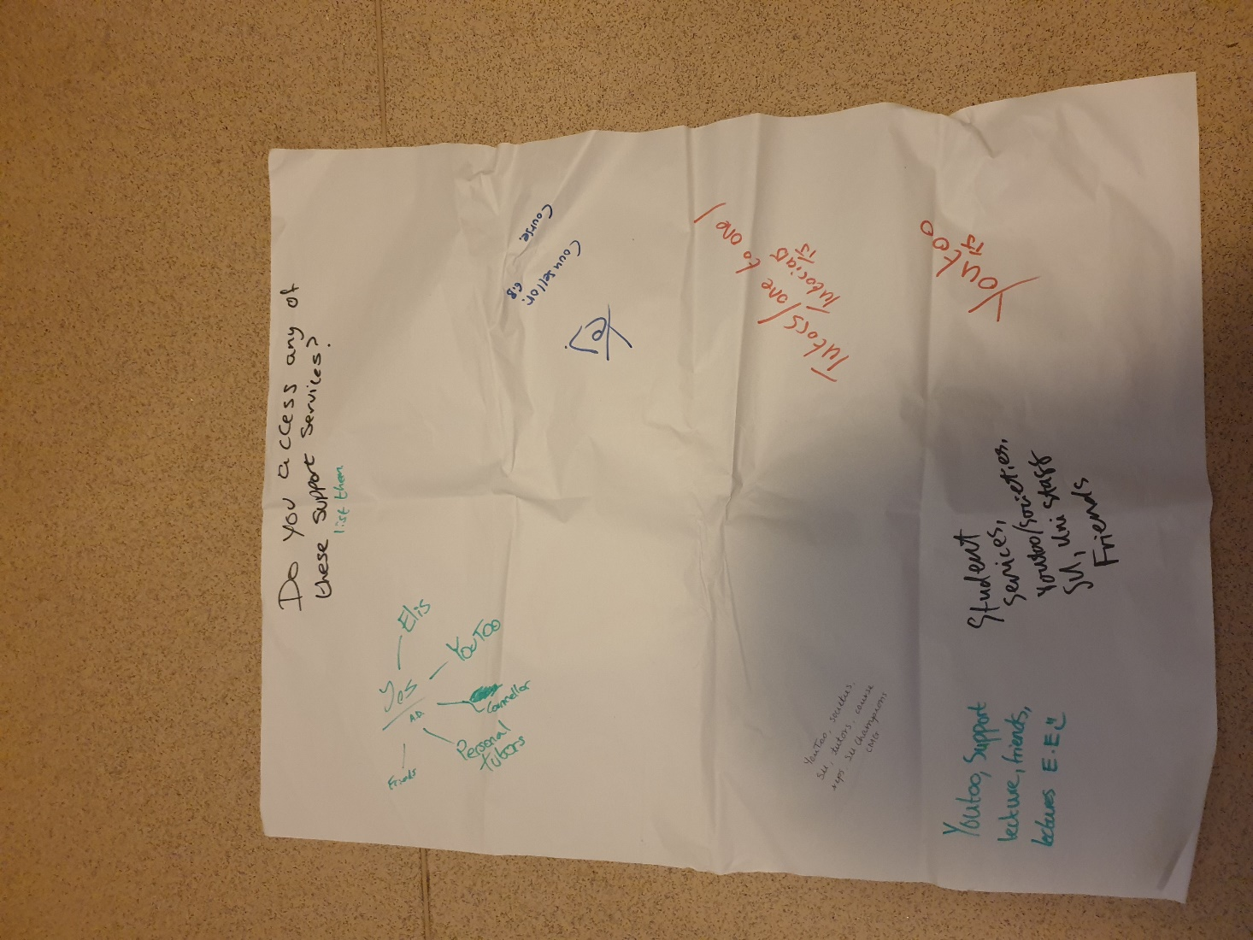
Question 3: Why do you feel they are important to have?
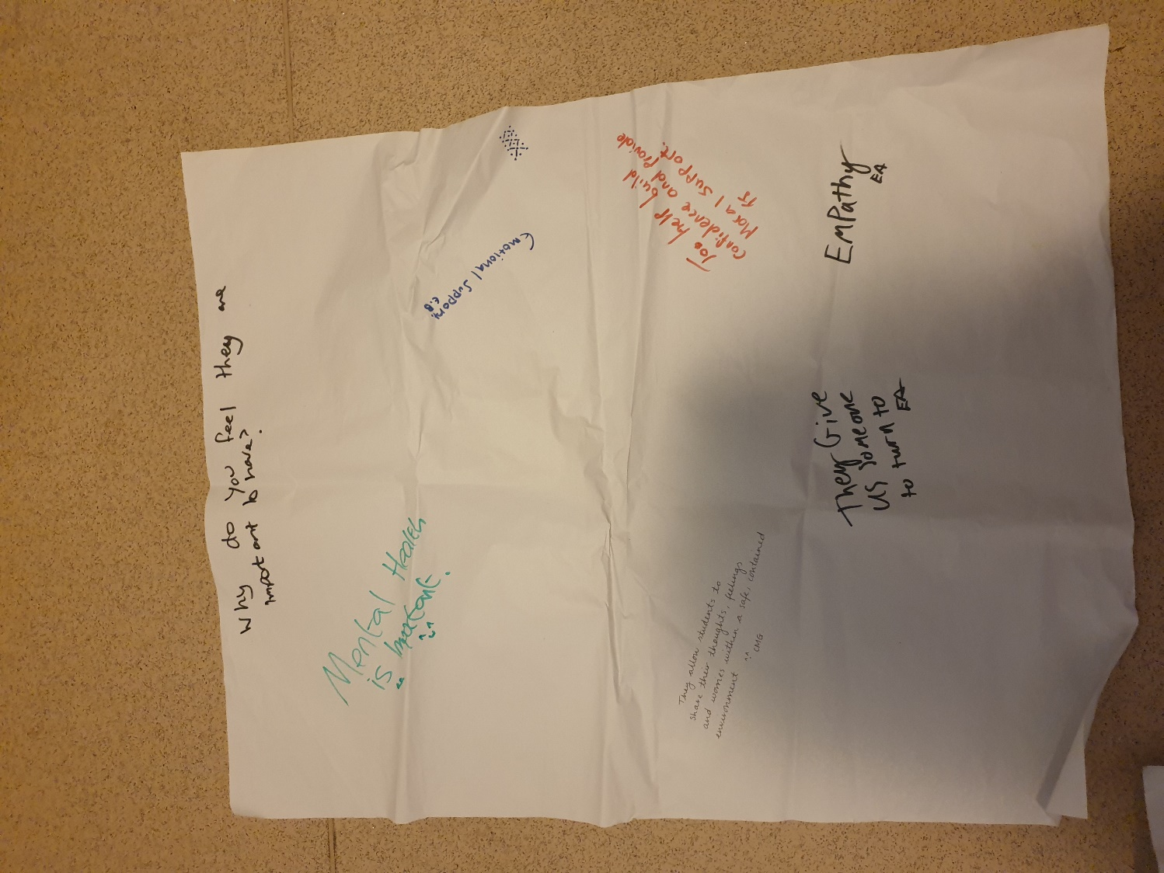
Question 4: What do you feel you have gained from being involved in these services?
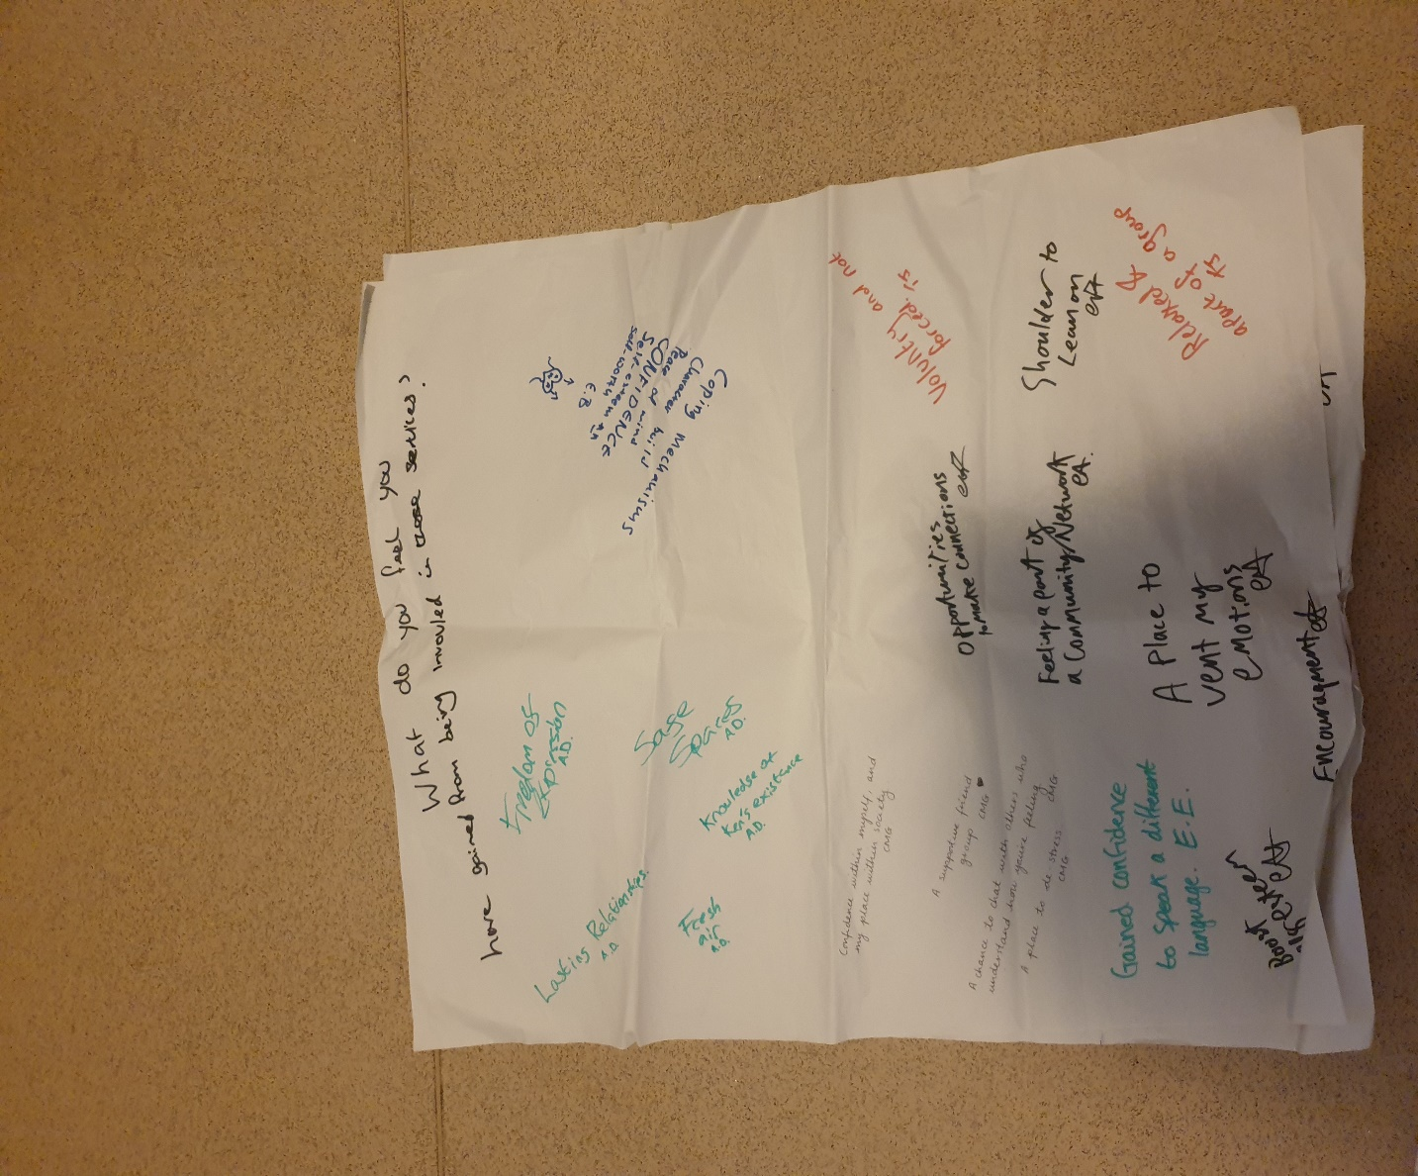
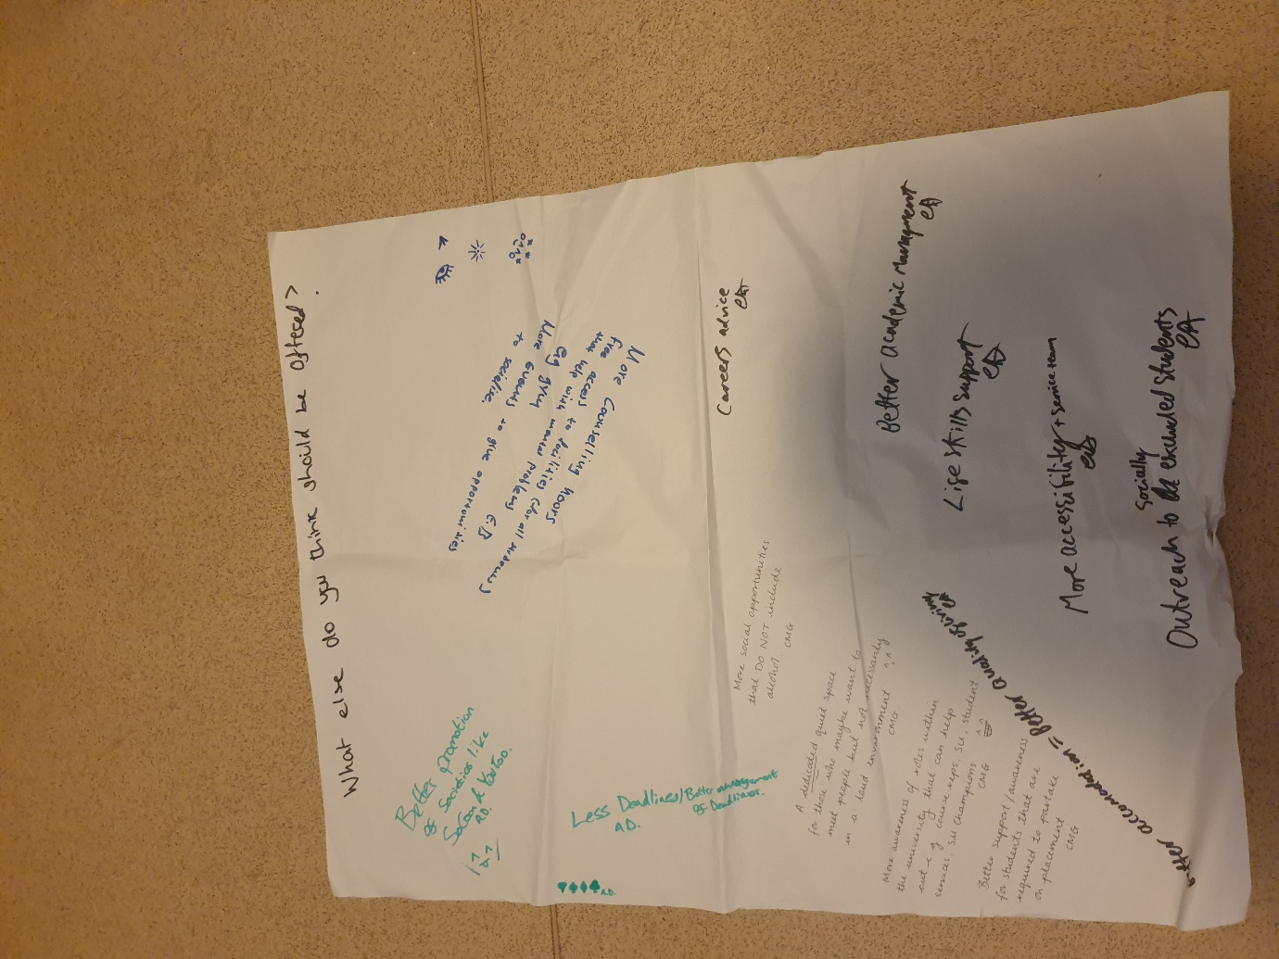
Question 5: What else do you think should be offered?

