How does randomised questioning affect children’s well-being in a Key Stage Two classroom?

Aims, Focus & Purpose of Research
Successful Futures (Donaldson, 2015) highlights the importance of well-being in children and is a key theme throughout the review of the Welsh education framework. In particular Donaldson (2015) highlights the responsibility of the school to ensure the future success and overall well-being of our learners. With the well-being of children becoming a key focus within our education system, I decided to explore this within my own professional practice. UNICEF (2007) found that the United Kingdom ranked in the bottom third internationally for well-being in children. With this in mind, I saw this as an opportunity to investigate the affect questioning has on young people’s well-being. I decided that while questioning can be a key AfL strategy throughout schools, to explore what this approach did for children’s well-being when children were selected to answer, rather than volunteering. Questioning is a valuable part of teaching but as there are so many different ways to use questioning so we wanted to find out how it would affect our learners.

Research Context
Our research was carried out in two schools in the South Wales area. School A is situated in a semi-rural area with a semi-open plan. There are approximately 235 children currently on roll with around 24% of pupils entitled to free school meals, and around 32% of the pupils are identified as having additional learning needs. (Estyn, 2012) School B is a small school situated in a semi-rural area. The school currently have 180 pupils on roll with 22% of the pupils having additional learning needs. 50% of the pupils within the school are eligible for free school meals which is well above the Welsh average. (Estyn, 2018)
In both schools, the research was carried out in a Year 6 classroom with pupils between the age of 10-11 years old. All pupils were made aware of their right to withdraw at any time and gave assent to be observed for the purpose of our research. All pupils were provided with an information sheet which outlined what the Lesson Study (LS) would entail. (see appendix B) The focus children that were selected from each class were selected at random on the day of the LS. By using random sampling for our focus group, we are echoing the views of Cohen et al (2007, p.111) that our sample should contain individuals who represent the ‘population as a whole’. Leaving the sampling up to probability or chance meant we were less likely to have an observer or non-participant bias. For the purpose of this essay all schools, pupils and data will be anonymised to protect the identities of the individuals and educators involved, in accordance with the BERA (2018) guidelines.

Literature Review

Well-Being
In 2018, the National Assembly for Wales (NAW) published a report stating the need for change in the support for children and young people’s emotional and mental health. (National Assembly for Wales, 2018) In the report, committee chair Lynne Neagle AM states that simply recognising that there has been an improvement in mental health services for children in the last two years is not enough. (National Assembly for Wales, 2018) The report found that ‘Across the UK, it is estimated that three children in an average classroom will have a mental health problem’ (National Assembly for Wales, 2018) and emphasises the importance of supporting children’s emotional well-being. These concerns are echoed in the work of Adams (2013) who highlights that due to the growing concern for children’s well-being, has been thrust onto political agendas to link these well-being issues to the education system itself. Dweck (2008) similarly brought to attention the differences between learners with a ‘fixed mindset’ and a growth mindset’. These terms are used daily throughout schools and education and have become a core subject embedded into our curriculum.
With the introduction of Donaldson (2015) and Successful Futures looking to reform the curriculum in the coming months, it is difficult to get away from the reality that as educators we now need to be taking children and young people’s well-being and mental health as seriously as their need to know their times tables. Within the reform, Donaldson (2015) has incorporated well-being into one of the four key purposes of the curriculum reform and additionally one of the six areas of learning that will be introduced to schools in the coming months. This indicates that well-being could very soon be a core subject within the curriculum throughout Wales.

Questioning
Formative Assessment (FA) has been present within education for many years. Scriven (1967) differentiated between formative and summative assessments to distinguish the difference between on-going assessment and an overall assessment. Bloom (1969) then took Scriven’s idea and applied the terms to classrooms. With FA seen as an on-going assessment tool, it is clear to see how it has become embedded into our education system today. Clarke (2008, p.7) identifies FA as a fundamental strategy improve pupils’ achievements and in fact any learners’ achievements. Arguably questioning can be seen as one of the most used and developed strands of FA. Wragg & Brown (2001) argue that giving children the opportunity to ask and respond to teachers’ questions can improve their own thinking drastically and should develop an enjoyment in children in the interaction with their teachers and peers to learn.
Still, questioning can sometimes be seen as a limitation for teachers and students within the classroom. Teachers fall into the danger of asking students closed questions which some would argue limits their learning. Clarke (2008) argues that teachers should try to avoid asking closed questions as they will not extend the pupils learning and understanding. Using open-ended questions are worthwhile and lead children down a path of knowledge and development. On the other hand, Reja et al (2003, p.172) argue in their study of open-ended questions vs close-ended questions that while using open-ended questions gives more variety to answers, they found that one fifth of the answers to the open-ended questions to their research were non-valid, meaning the answers were missing. Therefore this suggests that while open-ended questions are said to be the better method to use in classrooms, that when open-ended questions are used they still need to somehow be more specific as if they are too broad, then people are just as likely to avoid answering them as close-ended questions. Reja et al’s (2003) research hints towards a culture of people being content with a question having a right or wrong answer, and giving people choice and chance to elaborate their point is something as a culture we may not be too comfortable with.
Providing the classroom is seen by pupils as a ‘safe space’ and somewhere that failing is acceptable, then questioning can open up many paths to a learner, both between the learner and teacher, and the learner and their peers. The ‘fear of failure’ is highlighted in Black & Wiliam (1998, p.5) ‘Inside the black box’. They believe that pupils ‘become reluctant to ask questions out of fear of failure.’ What they allude to here is that if pupils are reluctant to ask questions due to a fear of being wrong, it is highly likely that children are just as reluctant to answer questions out of the same fear. However, what Black & Wiliam (1998) highlight here is contradicted by that of Austin (1949, p.102), who believed that teachers should select their questions carefully to ensure they promote success not failure. This fear of failure is stressed by Dweck (2006) as having an impact on self-esteem. She says that people with a ‘growth mindset’ found setbacks challenging and motivating. Though, people with a ‘fixed mindset’ do not tend to take control of their motivation and instead of trying to learn from their mistakes, they try to ‘repair their self-esteem.’ (Dweck, 2006, p.36) This concept of mindsets can have a detrimental impact on young people and how they continue to learn throughout their education.

Wait Time
Similarly, wait time is considered equally as important when using questioning in the classroom. Rowe (1972) was the first practitioner to coin the phrase ‘wait time’ and identified the wait time between the teacher asking the question and the pupil answering was estimated around 1.5 seconds. Rowe (1972) found from her study that by extending wait time to just three seconds, gave the children a chance to take risks and many other positive changes to students’ behaviour. Her research found that when a teacher gave just the 1.5 second wait time, pupils were less engaged and less likely to listen to each other as they fought for the teacher’s attention. When however, children were given the 3 second wait time, it was found that the response of ‘I don’t know’ or not responses were lower and overall pupils were more engaged. Hallam et al (2004, p.47) however found from their studies that prolonging the wait time can sometimes be detrimental to the higher ability learners. They found there was a difficultly with the wait time as pupils who were able to respond to the question quickly, sometimes became bored. While there are always positives and limitations with any topic or area, arguments can be made for both sides, and ultimately it is down to teachers to evaluate how they get the best results from their pupils.

Methodology

Lesson Study
The methodology used for this research was Lesson Study (LS). Dudley (2015, p.1) describes LS as an ‘approach to continuing professional development’ and believes LS can enhance learning within schools. LS is a form of action research in which a number of teachers plan and observe a sequence of lessons in a classroom environment. There are a number of steps that need to be taken in order to complete LS research effectively. (See appendix C)
We decided to use LS as our chosen research method as it is one of the fastest growing approaches to teaching and learning and is constantly developing and discovering new ways to learn from the pupils we teach. LS works well as it ‘allows the inexperienced to learn from the experienced’ and most of all the best way to learn from it, is to do it. (Dudley, 2015, p. 4) The Department for Education (2009) supports these claims and state that while LS is seen as a professional learning process, it has been used successfully throughout the UK help teachers improve techniques, and pupils improve their progress in many of the core subjects.

Data Collection
The method of data collection used are: reflection, observation (non-participant) and focus group. These methods were made clear to all participants throughout and they were aware they were being observed by a non-participant researcher. With the children’s well-being in mind we assured them that they had the right to withdraw from the observation at any time. Any observation notes taken from the lesson study were documented on a pre-planned schedule with a criterion of attributes and characteristics we were looking for. (see appendix D) In our LS, the observer was responsible for marking the case pupils against our observation schedule to rate how their well-being was affected through the use of randomised questioning. This is also known as cold calling. Dallimore et al (2006,) evidenced from their research that the average student comfort in participating in classes using cold-calling did not reduce between pre and post course analyses. This research suggests that cold-calling does not discourage pupil participation in class. Lemov (2010) describes asking students who raise their hands to answer questions as a ‘mistake’. He argues that by using the cold call strategy, it will teach students to be prepared to participate in the discussion regardless of whether they have their hand raised or not. This concept is something we considered while deciding on our questioning strategies. Taking this into consideration, we decided to use a random name picker to select a child at random to answer a question. (See appendix E) Dallimore et al (2012) state that some practitioners shy away from using cold-calling as they fear the experience will leave them feeling uncomfortable. In their study, Dallimore et al (2012, p.1) found that significantly more students ‘answer questions voluntary in classes with cold-calling’. This suggests that if a culture of cold calling was embedded into a classroom then children would be more willing to answer questions voluntarily.

At the end of the lesson, all children were presented with an exit slip to complete based on the randomised questioning technique used in the lesson. All exit slips were anonymous and used as a qualitative data method to collect the different opinions on the technique efficiently and effectively. The other factor in our lesson study was the well-being of the pupils and how the chance of them being picked to answer a question would affect them. We added in a ‘Phone a Friend’ option for the pupils to use, should they not know the answer to the question. This encouraged the children to use their peers to help them answer a question and relieve any stress or nerves experienced when selected to answer. The ‘Phone a Friend’ option is an adaptation of growth mindset routines such as ‘Brain, Buddy, Boss’ and ‘Think, Pair, Share’. Some of these growth mindset techniques are referred to in the Learning Power Approach. Claxton (2018) These approaches are developed to encourage pupils to be become independent and confident learners and thus our ‘Phone a Friend’ option is another technique to add to the long list of approaches to encourage a growth mindset.
The case pupils were chosen at random from the focus group on the day of the LS to ensure a fair and ethical representation of the class. The use of simple random sampling usually ensures that the data obtained from the sample is an ‘unbiased estimate of the population mean.’ (Ross, 2005) The first three pupils (with consent) that were selected from the randomiser were selected as the case pupils to take part in the interview after the lesson had finished. We decided to use random case pupils as initially our research project did not require a differentiation between abilities or groups.

Reflection
The reflection models we based our proforma on were Gibbs (1988) ‘Reflective Cycle’ (see appendix F) and Brookfield (2002) ‘Four Lenses’. (see appendix G) We decided to use Gibbs as we saw his ‘Reflective Cycle’ as a good starting point for putting together our first steps into our research project. We decided to use part of Gibbs’ (1988) model the ‘Four Lenses’ Brookfield’s (2002) model and combine them to create our reflection proforma. (see appendix H) We used the ‘Feelings’ and ‘Evaluation’ steps from Gibbs (1988) to include detail in our reflection and this gave us the chance to summarise the experience as a whole, rather than go into individual detail, which we felt was quite similar to Brookfield’s (2002) lenses.
Within the reflective cycle, Gibbs (1988) gives chance for analysis, evaluation and conclusion. We decided to combine these steps and use all of them within the one evaluation stage of our proforma. Brookfield (2002) four lenses are four simple steps that we felt really got the most out of the observation and research and allow the researchers to look into every aspect of the observation from different perspectives. We used ‘Self’ to help us relate to the pupils and recognise our own personal experiences in what we were observing. We used ‘Students’ in our interviews to learn and understand how the experience was for them. The use of ‘Peers’ was essential in our LS as one researcher was teaching, they were less likely to observe or notice behaviours and reactions that the non-participant observer might. Finally, the ‘Scholarship’ section gave us a focus on the literature we were looking at and helped us see that nearly everything we were observing, or researching had been done before and we could draw on this evidence, to improve our practice and LS. To conclude we decided that by combining these two approaches and reflection models that we would get the best response and feedback from our participants, ourselves and each other.

Ethical Considerations
When starting a research project, it is always essential to consider the ethical issues that may arise. There are many ethical considerations when conducting research in a classroom setting which are confidentiality, the scope of research activity and any risks to the participants or investigators. A comprehensive ethics form was submitted to the ethics committee and approved before my LS took place. (see appendix F) In lines with BERA (2018) guidelines all identities, data and observations have been anonymised to protect the identities of the individuals and schools involved. The LS took place within a typical school lesson; therefore, all pupils present on the day were required to take part in the lesson, however only the pupils with parental consent were considered for the observation and LS itself. In addition to this, any risks to participants were mitigated as mentioned on the ethics form.
One of the risks identified was the possibility of the pupils becoming distressed if selected to answer a question. In order to reduce this risk, we incorporated the ‘Phone a Friend’ option, where the child can call on a friend in the classroom to help them answer the question. As always when working with children and young people, the risk of safeguarding was at the forefront of our minds. To mitigate this risk we ensured that the door to room where the interview was taking place was open at all times. In addition there was two DBS checked adults in the room at all times and the case pupils had the option to request an additional adult to accompany them into the room if they wished. All risks and ethical considerations were carefully measured and revisited before the LS took place. Once the ethics form had been approved by the ethics committee, we were free to conduct our research and interviews in support of our project.

Lesson Study 1 results & analysis

Observation

For the purpose of the research the three case pupils will be referred to as Pupil 1A, Pupil 1B and Pupil 1C.
During the observation all three case pupils who answered the questions after being selected by the random name picker displayed different behaviour. All three case pupils answered the question they were asked in class successfully, however not all were confident in their answers. (see appendix G) We found that due to the topic being taught, all children were engaged and there were no behaviour management issues throughout the lesson. The explanation of research to pupils was received well at the beginning of the lesson and everyone felt included as questions were not just asked to the case pupils. The use of exit slips was received positively, and students liked that they were anonymous which meant we were more likely to get honest opinions from them. (see appendix H) The phone a friend option was used with a number of pupils who were asked questions which feedback from our exit slips shows was a positive option for pupils who were nervous or struggling to answer the question. One thing we found could have been clarified is the non-participant observer knowing who was who and could have benefited from a classroom seating plan. We found that this would have made it easier for the observer to locate the case pupils sooner and notice any body language or behaviour earlier.

Focus Group Interview
All three pupils contributed to the focus group interview in their own way and their feedback was specific to their own experience within the LS. (see appendix I) When asked to explain what their pictures represented, the pupils explained what they thought they were doing with their body language and reactions to being selected to answer the question. We found that what the pupils thought they were doing, was conflicting with what they were observed doing. Pupil 1C in particular stated that he felt ‘under pressure’ and that he knew the answer but with everyone looking at him he felt under pressure. However, from the observer notes it states that Pupil 1C’s response was almost instant and he was in a relaxed posture in his chair, smiling. Pupil 1A goes on to say that they liked the randomised questioning as it gave everyone a chance to be involved and the ‘Phone a Friend’ option meant they could still answer even if they did not know the right answer. Additionally, when asked whether they preferred randomised questioning or a hand’s up approach, majority of the case pupils preferred randomised questioning as it was fairer and made people try.
We found from our focus group that wait time given between asking the question and the pupil answering could have been longer or vocalised more within the lesson. In particular Pupil 1B stated that maybe next time we could say ’10 seconds and have a countdown’. Pupil 1A and 1C also expressed that they would have liked different sort of questions, maybe where this is not a right or wrong answer as this may make pupils feel less nervous. Overall within the focus group interview, we found in hindsight that we could have asked more questions to ask pupils to elaborate on what they meant. We also found some conformity within the interview, with Pupil 1B tending to conform with what her peers were saying. Finally, the case pupils were asked to rate themselves against the ‘Leuven Scale for Well-Being’.(Laevers, 1994) (see figure 6) This was the most interesting part of the focus group as all three pupils rated themselves higher or lower on the scale than what they were rated by the observer. Pupils 1A and 1B both rated themselves higher on the scale than they were, and Pupil 1C rated himself significantly lower than he was.

Reflections & Conclusions
Overall the results of the LS were specific to the individuals, however we did consistently find that all three case pupils described their body language and feelings towards the randomised questioning differently to what was observed. As a result of this, all three pupils then rated themselves incorrectly against the Leuven scale and overall contradicted what was observed during the LS.
From this initial LS we learnt that the case pupils are likely to either over rate themselves or under rate themselves during the focus group compared to what has been observed. Moving forward to our second LS observation we decided that we would change a number of aspects to improve our study. Firstly, we decided that we would use a countdown system for the wait time and be more vocal with the time left before the answer is needed, as Pupil 1B said they would have benefited from this. Secondly, we decided to use more open-ended follow up questions that we could add to our interview questions if we wanted the participants to go into further detail. On reflection we found that in LS 1, additional questions were not asked out of fear of leading the participants or asking closed questions. Finally, we decided to create a seating plan for the non-participant observer so they could identify where in the classroom the case pupils were located quickly, in order to note down as much information as possible on the observation schedule. We decided however to keep all other aspects of the LS the same as we found from the initial study that they were received well and gave us both quantitative and qualitative data. For example, the use of the exit slips was a simple and efficient method to gather a large group of data that reflected positively on our study.

Lesson Study 2 results & analysis

Observation
The findings from LS 2 are a reflection of the changes made from LS 1 and the modifications we made to our study to improve the quality of data collected. For the purpose of the research the three case pupils will be referred to as Pupil 2A, Pupil 2B and Pupil 2C.
When the LS began, the use of the seating plan that we had implemented for LS 2 was an effective tool and we found that we did locate the pupils within the classroom more efficiently, resulting in observing initial reactions and responses of the case pupils. In addition to this the use of a countdown was introduced to give the pupils prewarning of the wait time and prepared them all to answer the question asked by the teacher. We found that while some pupils were seen to be more nervous than others at answering, as a result of the countdown pupils were more prepared to answer the question and had a visual aid to tell them when they were expected to answer the question. This small addition to our LS made a significant difference in some responses of the case pupils when selected to answer.
Throughout the observation, the three case pupils demonstrated very different body language and responses to being selected. (see appendix K) Pupil 2A seemed the most anxious out of the three pupils and demonstrated nervous body language and looked to the teacher for reassurance. Contrastingly, Pupils 2B and 2C both demonstrated very relaxed postures and body language and answered the questions almost instantly. While Pupil 2B was very engaged and open, Pupil 2C was distracted with a pen and was staring at the table. All three reactions were very different, yet some showed similarities in their responses and body language.
The use of exit slips were again well received and gave use an effective and efficient way of collecting data from the entire class. The exit slip analysis (see appendix L) showed that randomised questioning was better received with 84% of the class stating that they liked it, and only 16% saying they did not. This data could suggest that the small changes made throughout LS 2 from LS 1 resulted in a positive impact in the feedback received from the pupils.

Focus Group Interview
All three case pupils contributed to the interview and gave their own opinions and experiences on the LS. (see appendix M) In contrast to the positive feedback from the first question, when pupils were asked to describe their drawings to describe what they were doing when they were selected, (see appendix O) only one of the three case pupils described accurately how they reacted. Surprisingly, the most confident of the three pupils, Pupil 2B said their ‘legs were shaking, and toes were scrunching’. However, the researcher observed Pupil 2B’s reaction and showed a relaxed posture smiling and arms open. An individual who seemed very much at ease.
We then used our probing and additional questions that we had added for LS 2, to ask Pupil 2B what they thought these actions represented. Their response was that they thought these behaviours suggested they were excited and not anything else. Pupil 2C went on to say they felt ‘relieved’ when they were selected as they really wanted to answer a question. However, their body language contradicts this. Pupil 2C was hunched over their desk, distracted and not looking at the board. Their distracted persona does not offer an accurate representation of their reflection on the experience. This may suggest that pupils may be conforming more than we had realised, however not to each other, but to what they thought we wanted to hear. Pupil 2A’s reflection on their experience was quite accurate to what had been observed of them and seemed quite content throughout the interview process.
Towards the end of the interview, the pupils were asked to rate themselves against the Leuven Scale of Well-Being. (Laevers, 1994) Similarly to LS 1, all three case pupils rated themselves differently than what the observer had rated them. In this LS, two pupils rated themselves higher than they were, and the most confident pupil, Pupil 2A, rated themselves significantly lower than they appeared when in the lesson. They said they would rate themselves level 3 because they didn’t feel like they showed any emotion when they got picked, when actually Pupil 2B was rated 5 on the Leuven scale by the observer. Pupil 2C rated themselves at level 4 because whenever they get picked, they get excited. Pupil 2C gestured that they did a fist pump under the table when they got picked. On the contrary, Pupil 2C was rated 3 on the scale due to their lack of engagement and excitement when they were selected to answer. These findings contradict those of the non-participant observer, however may suggest that the pupil’s well-being and how they rate themselves, is significantly different to how they are perceived by a spectator.

Reflections & Conclusions
In conclusion we found that some of the changes we made to LS 2 from the feedback from the case pupils in LS 1 gave us, could be seen as positive changes due to the exit slip analysis and the feedback from the focus group interview. However, the interview from LS 2 suggests that the case pupils perceive themselves in a different way to how they are seen by a non-participant observer. Their answers were varied and personal to themselves, and it could be seen their feedback and opinions are not representative of the entire class due to the inconsistences in their answers.
Similarly, to LS 1, all case pupils perceived themselves differently to the observer however there was less evidence at conformity within the interview. In LS 1 we had a few responses from some pupils of ‘same’. However, in LS 2, all three pupils expressed their opinions and gave individual answers to the questions asked. When asked what we could do to improve the lesson, Pupil 2A suggested adding another aspect of ‘Ask the Teacher’. Thus suggestion from Pupil 2A suggests more involvement from the teacher could be implemented. The continuing contradicting opinions throughout the interview lead us to believe that more research into this area is needed, in order for learners to really understand how this method effects their well-being.

Findings & Literature
Through both LS we found the responses from the focus group interviews rather specific to the individual and therefore, may not be an accurate representation of the entire class. The use of the random name picker to select our case pupils on the day meant the researchers had no control over who they were going to interview. This tactic was a positive step as it made it fair on all the children involved, however as a result overall, we had four female case pupils and two male case pupils. Arguably, this could be seen as an inaccurate representation of the whole class. Cohen et al, (2007, p.103) highlight in their work that ‘as a rough guide in a random sample, the larger the sample, the greater is its chance of being representative.’ This suggests that our research could have benefited from a bigger focus group in order to be inclusive of the class as a whole. However, Dudley (2015) would argue that the researchers should plan each lesson with three specific pupils in mind. Furthermore, they should plan the lesson around the responses the researchers are hoping to get from the case pupils. Dudley (2015, p.8) believes that these ‘predictions’ play a significant role in the research lessons themselves. As a result of our decision to use randomised questioning, it could be argued that this part of our planning was overlooked, and our observation schedules were generalised to fit the generalisation of the class.
The use of questioning as an AfL strategy was well received in both studies. This could be as a result of the pupils having previous experience with questioning throughout their education. The use of questioning in the classroom is an age-old approach to teaching, therefore children being comfortable and used to being questioned as part of their daily routine. However, the use of randomised questioning as a strategy was new to both LS classes. The effect therefore on their well-being was brought into question. When rating themselves against the Leuven scale, (Laevers, 1994) all six case pupils rated themselves either higher or lower than they were rated by the observer. Laevers (2011) argues that the Leuven scale gives an aspect of inter-rater reliability. This suggests that while the Leuven scale (Laevers, 1994) can be a useful tool, that the case pupils inter-rater reliability unfortunately was not very reliable..
However, what comes to question here is the metacognition of the case pupils themselves. If all six participants rated themselves inaccurately on the scale, then their metacognition and the way they view their own learning and progression shows their lack of awareness for their own thought processes. (Pritchard, 2009) Metacognition and well-being are very closely linked and within the reform of the curriculum, Donaldson (2015) highlights how approaches that help support learner’s well-being give opportunities to develop not only emotional intelligence, but metacognition. While randomised questioning and well-being were our research areas, the literature surrounding well-being and metacognition have subtle links that can improve practice in all three areas. Pritchard (2009) argues that teachers have the ability to develop pupil’s metacognition through their questioning approaches. He states that instead of teachers being ‘satisfied with a correct answer, a teacher can probe’ (2009, p.28) and learn about the different approaches that their pupils take to get to their answer. Wray & Lewis (1997) highlight through their work that ‘learning is a process of interaction between what is known and what it is to be learnt.’ The literature suggests that the importance of the teacher being able to relate to their pupils and what it is to learn can make all the difference when developing well-being and metacognition.
While LS is one of the more popular research methods in education, there are a number of limitations to the approach. Dudley (2015, p.5) agrees that while LS is a ‘deceptively simple sequence’ that ‘any small group of teachers can do’, there are limitations of the method. Dudley (2015, p.5) says that the danger is in the simplicity of LS and it can be too easily adapted and has been ‘encouraged to innovate for innovation’s sake.’ What Dudley (2015) alludes to here, is LS must be used for the right reasons, and in context where it makes sense. Using LS for LS sake takes away the simplicity and ease of using such an effective method to continue to explore and study children and young people in education.

Conclusion
From our research project we found that LS was the most effective method to use to gather the information and data we required in a short space of time. There are many strengths to using LS as a research method, such as the simplicity of it. LS does not require any technology or special skills. We found that even if you have no prior knowledge of LS, then it is still easy to navigate your way through and achieve the results you need. Dudley (2015) highlights that the busy-ness of our classrooms distract us from really seeing what is happening most of time. The use of LS makes us stop and take a step back and not only analyse the pupils, but teachers own practice as well. In addition to this, LS allows teachers to participate in their own progress as a professional and is a way for them to improve their own practice. (McLachlan, 2005) In my experience, I had not seen randomised questioning used in a Key Stage 2 classroom and found that as I already had developed a relationship with my class, conducting a LS was an extremely effective and simple way to see how it made them feel and their reactions to the approach. We found that due to the simplicity of LS, all pupils clearly understood the purpose of the lesson and as a result no pupils withdraw from the study. Also, we found that the use of the exit slips in our LS were very effective as they provided us with a large amount of data and feedback in a short space of time. Marzano (2012, p.80) highlights how the use of exit slips provides teachers with answers and ‘clear guidance for future instruction.’ We found the decision to use this AfL strategy was reliable and showed great validity.
Nonetheless, while we found many benefits and positives to LS, it did produce a number of limitations to our research. LS recommends a focus group of three case pupils for the interview. However, in our LS we selected our case pupils at random on the day which meant our case pupils may not have been an accurate representation of the whole class. While this can be seen as a limitation of LS due to the small sample, the use of random sampling comes under scrutiny. It is recommended when using random sampling that a large focus group is used. Though, for our LS we combined LS with random sampling, therefore our focus group only consisted of three pupils. This was a limitation of our project due to the risk of us not acquiring an accurate representation of the population.
We found from our study, that while well-being was a key focus of our research, that the well-being of the participants and the case pupils in particular was very unique and individual to themselves. We found that their well-being was linked with their metacognition, therefore the effect randomised questioning had on the pupils was exclusive to them. While Donaldson (2015) recognises that the six areas of learning he proposes in his Successful Futures report that health and well-being should stand alone as an area of learning, it is important to recognise that well-being cannot be generalised. Our findings show that children’s well-being can be affected by a number of external factors and experiences while in education, however everyone’s reactions, feelings and behaviour will be unique to them.
In conclusion, we found that LS was a suitable and valid method to use to investigate our research project due to the ease and simplicity to incorporate it into everyday school life. In addition, we found that while randomised questioning is an effective AfL tool it can have an effect on children’s well-being and feelings, both positively and negatively. While our findings shed some light on the link between AfL strategies and well-being, we did not find a unanimous result. Instead we found that well-being is exclusive to the individual and their perceptions of themselves can have an impact on the relationship between education and the child.

Recommendations
Moving forward, I would make several recommendations as a result of the research undertaken. Firstly, randomised questioning was seen as a new approach in both schools. The ‘fear of the unknown’ can often set in and I believe that if more of a range of approaches to AfL and questioning were adopted into schools, it could benefit the development and progression of the pupils. Secondly, from this research I have found that I have developed a better understanding of well-being and in particular how the well-being of children cannot be generalised. From this research I will take forward the individuality of well-being and how it is different to everyone. Additionally, in light of my research I have found that children and young people’s perceptions of themselves are not always accurate to how they are perceived by others. Many of the case pupils during the study perceived themselves differently to how the observer saw them.
If I did LS research again, I would think more carefully about the method of sampling used. While random sampling has its advantages, I found from this study that this form of sampling created unnecessary limitations to the study that could have been avoided. Moving forward I think I will follow the LS method more and plan my lessons with ‘three particular pupils in mind.’ (Dudley, 2015, p. 7) Finally, if I were to use LS again, I would conduct my research with a larger team. As there were only two researchers, it was difficult to know if we had covered and accounted for every eventuality. In each LS, one researcher was teaching, while the other was observing. I think by extending the research team slightly it would mitigate the chances of some behaviours or events being missed due to the limitation of one observer.

Appendices

Appendix A – Consent Forms
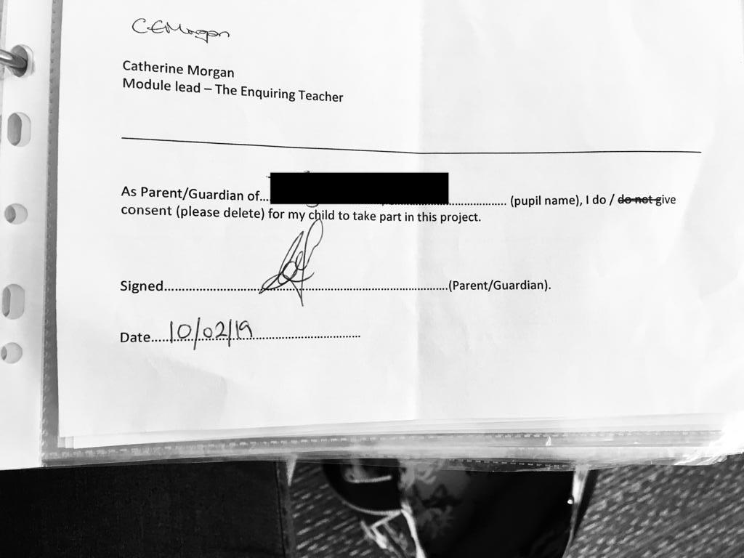

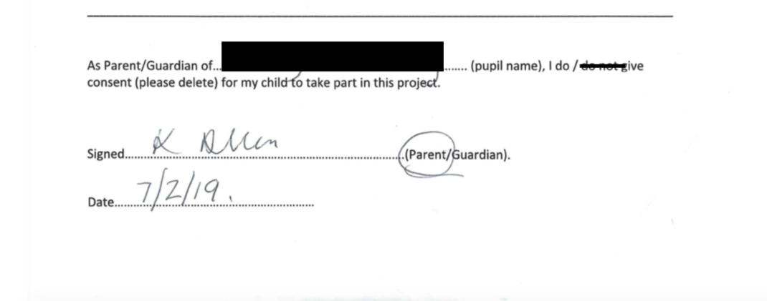
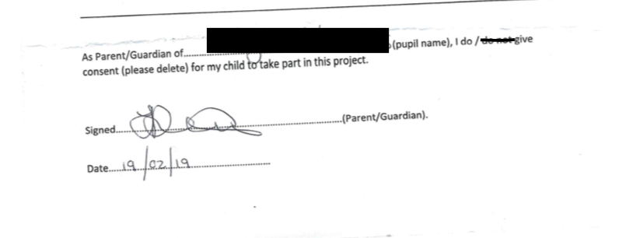
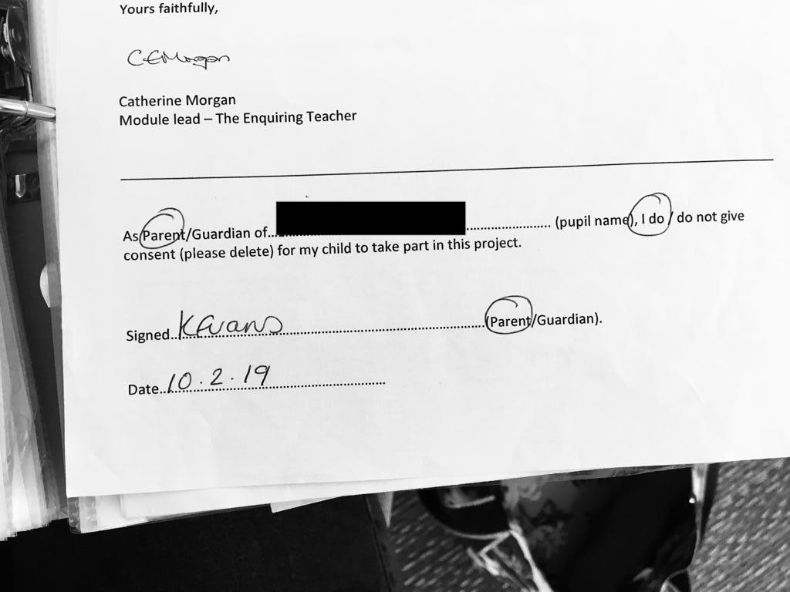
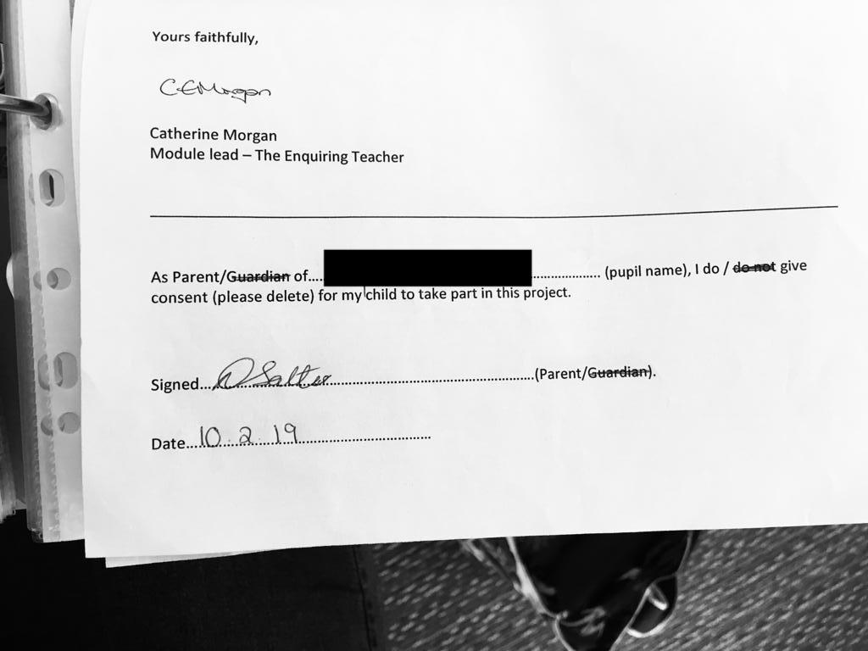
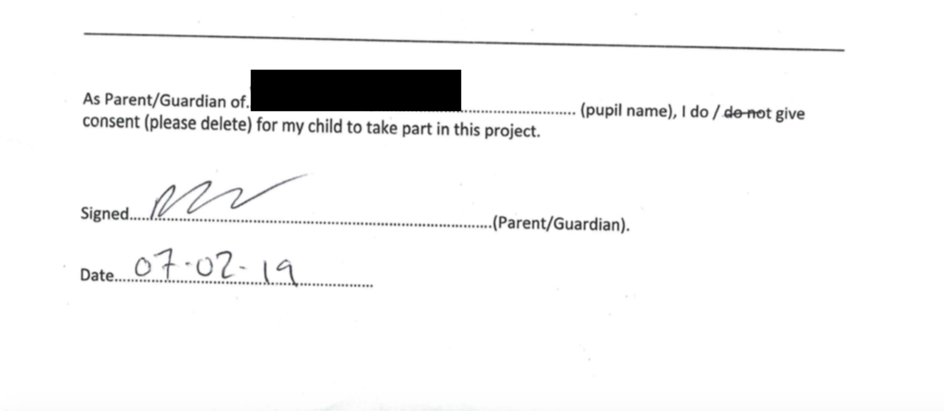

Appendix B – Information Sheet for Students
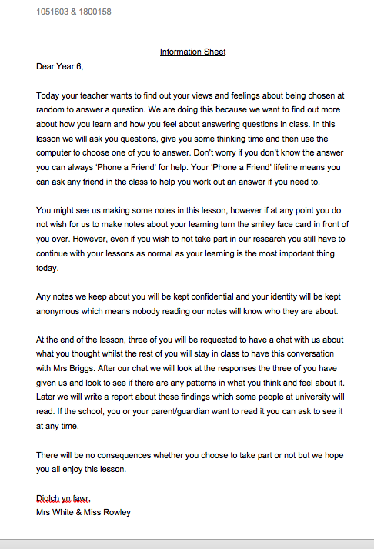

Appendix C – Observation Schedule
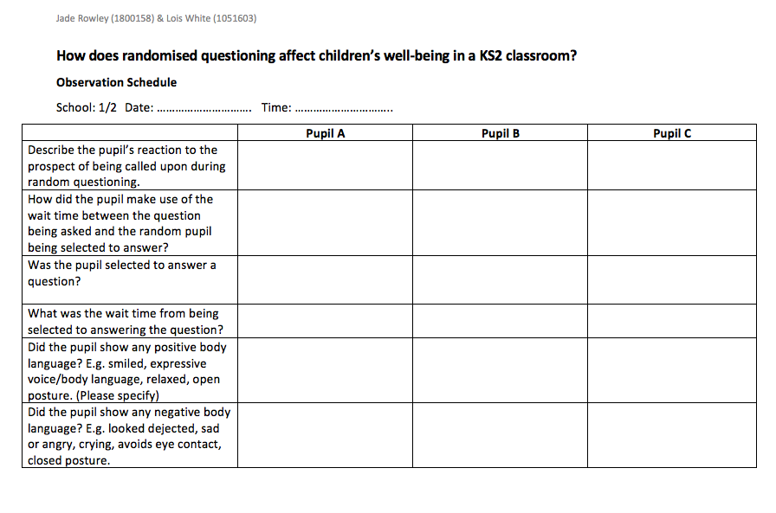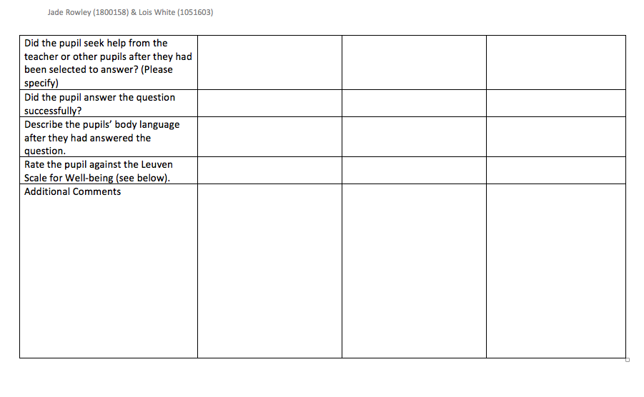

Appendix D – Lesson Study Format - TDTN (2015) - https://tdtrust.org/what-is-lesson-study
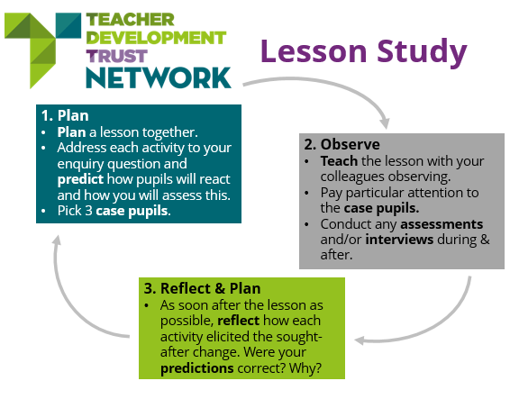

Appendix E – Random Name Picker

http://www.abcya.com/random_name_picker.htm

Appendix F - Gibbs (1988) Reflective Cycle - https://lifelonglearningwithot.wordpress.com/2016/05/02/different-models-of-reflection-using-them-to-help-me-reflect/
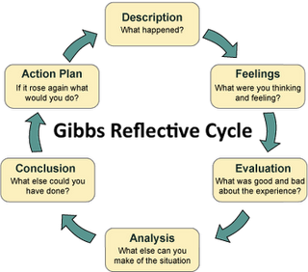

Appendix G – Brookfield (2002) Four Lenses – https://lifelonglearningwithot.wordpress.com/2016/05/02/different-models-of-reflection-using-them-to-help-me-reflect/
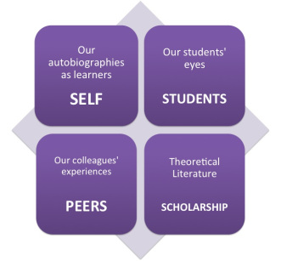

Appendix H – Reflection Pro Forma
**NEED FROM JADE

Appendix I - Ethics Form
** CHECK IF NEEDED IN APPENDICES

Appendix J – Observation Notes – School 1
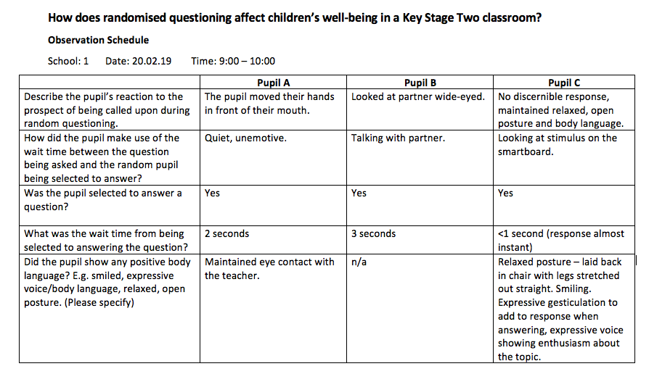
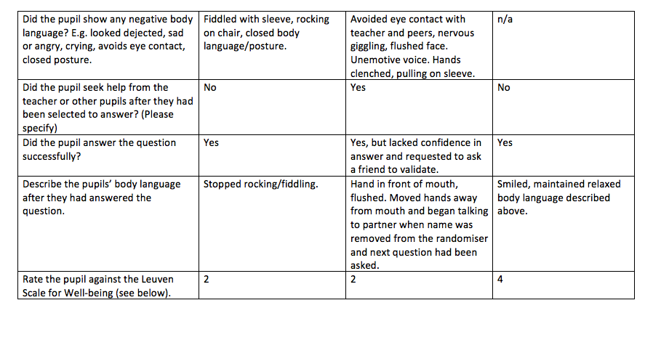
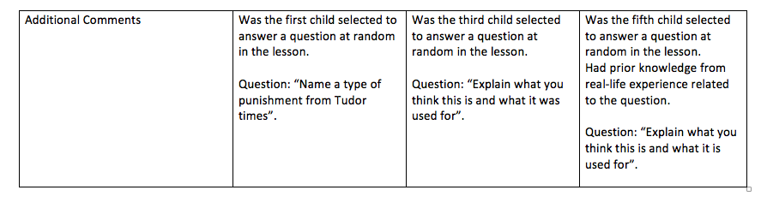

Appendix K – Exit Slip Analysis & Examples – School 1
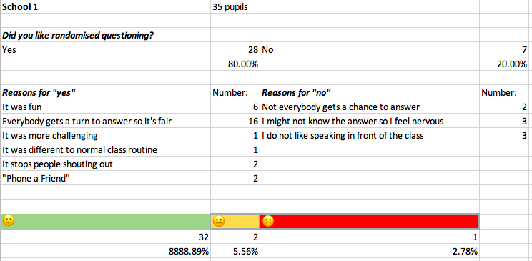
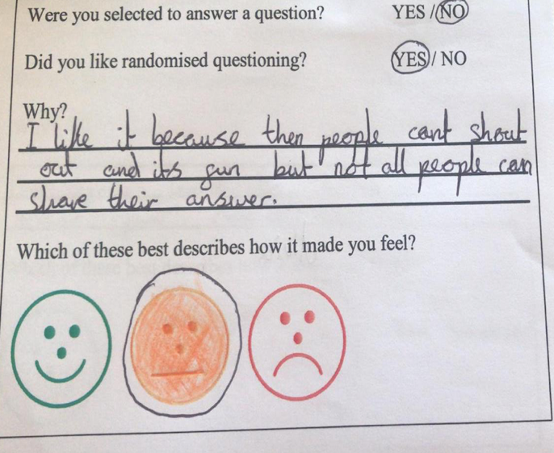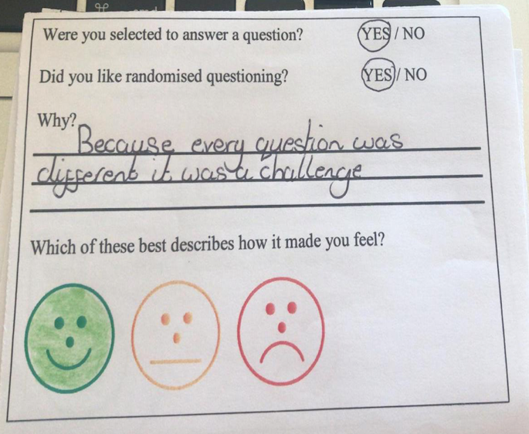
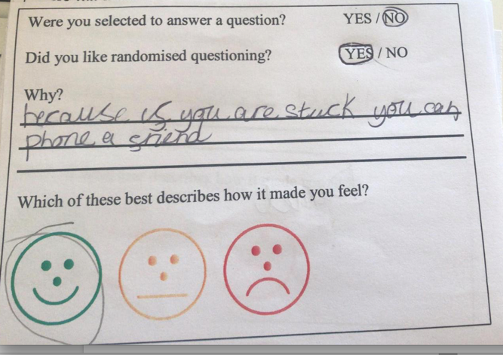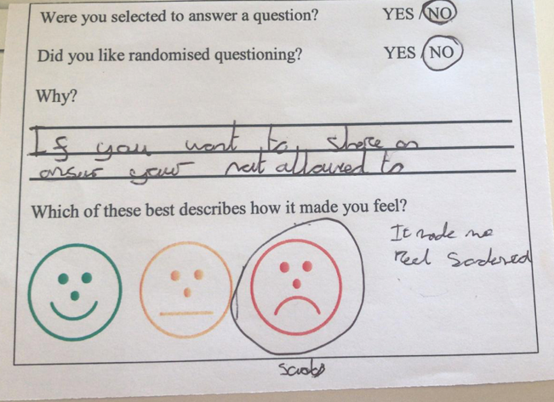

Appendix L – Interview Questions & Answers – School 1
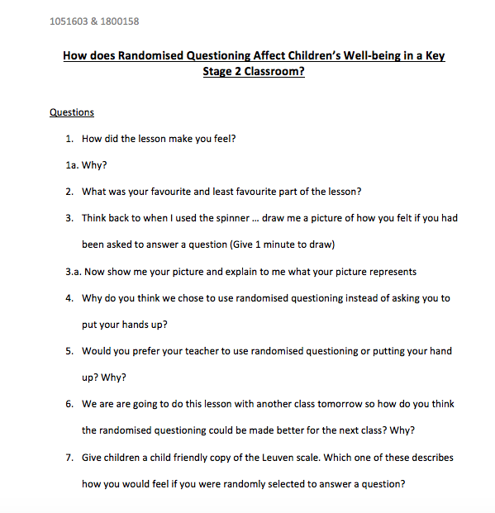
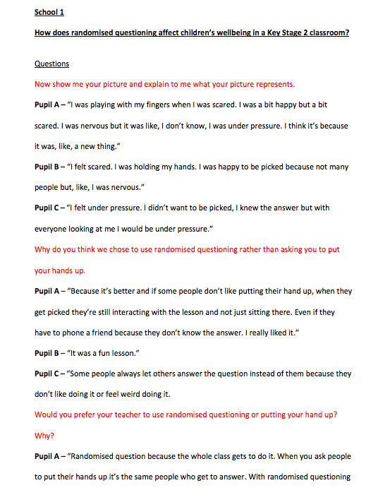
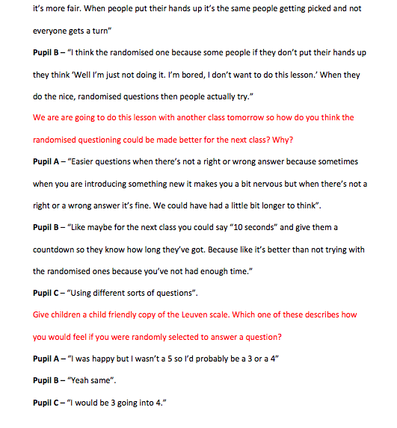

Appendix M – School 1 – Pictures of Leuven Scale
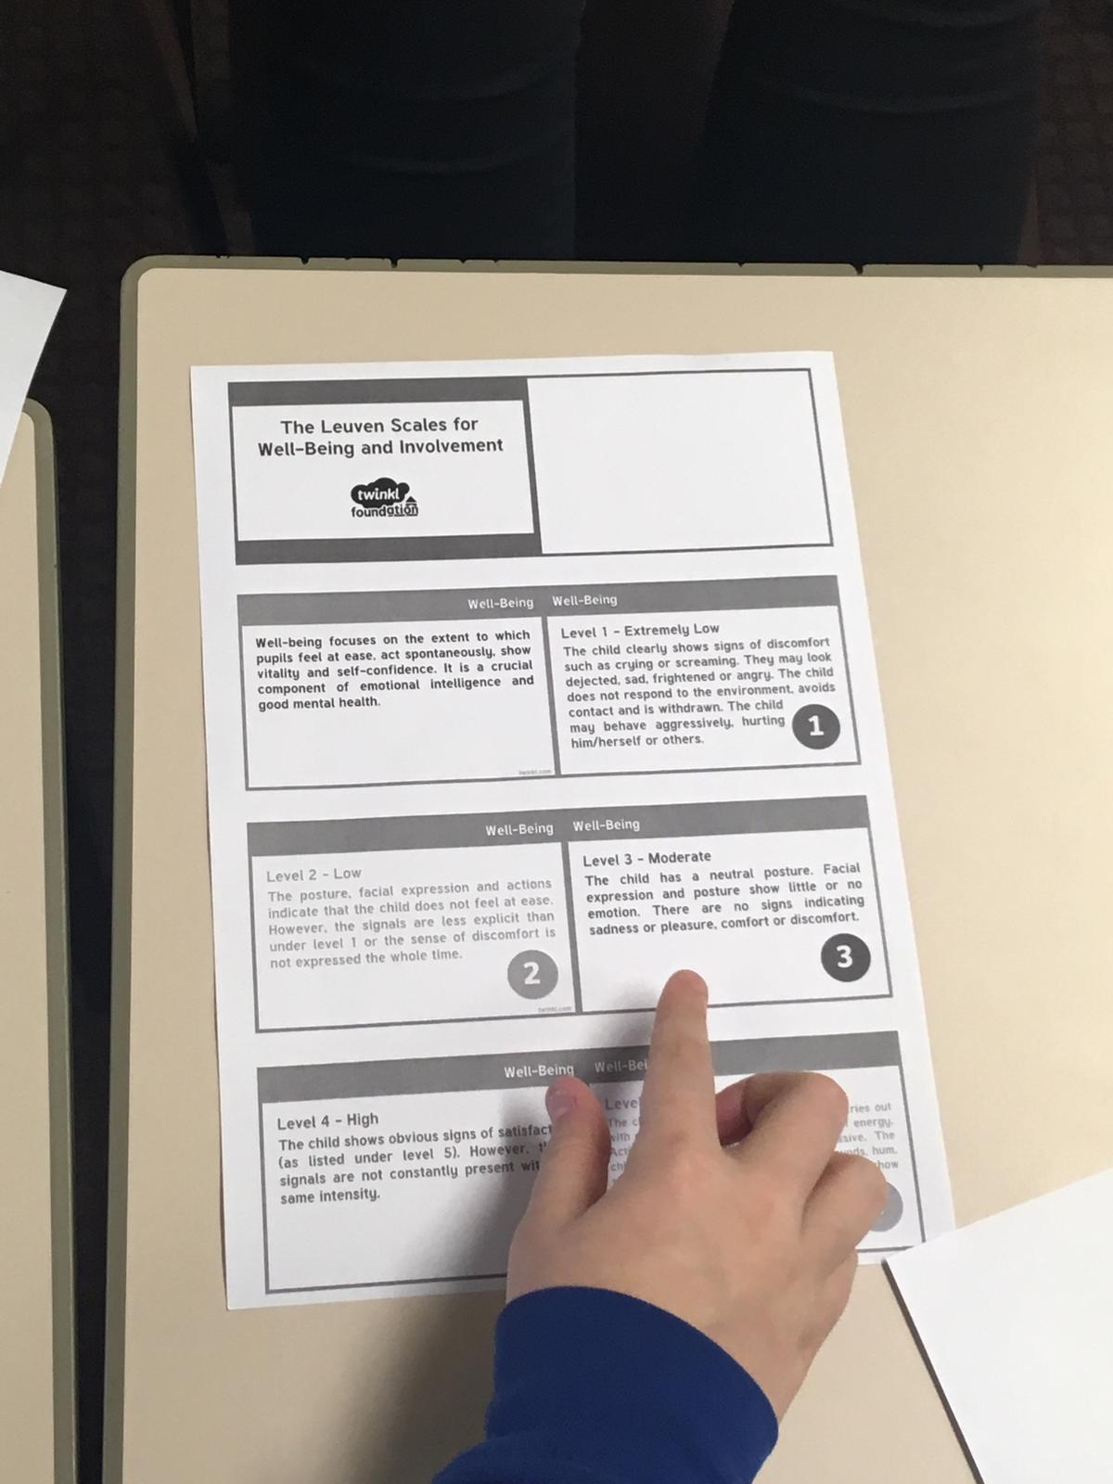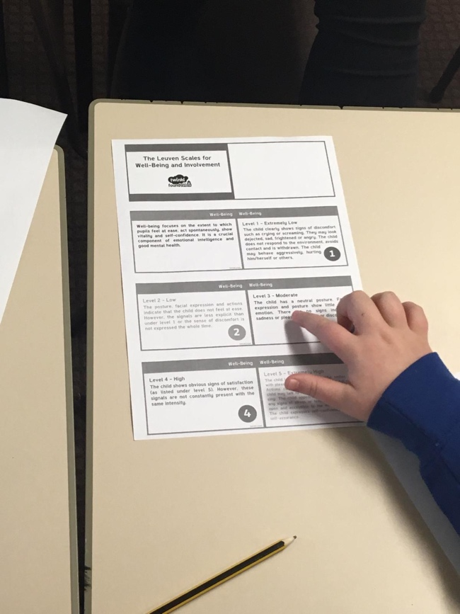
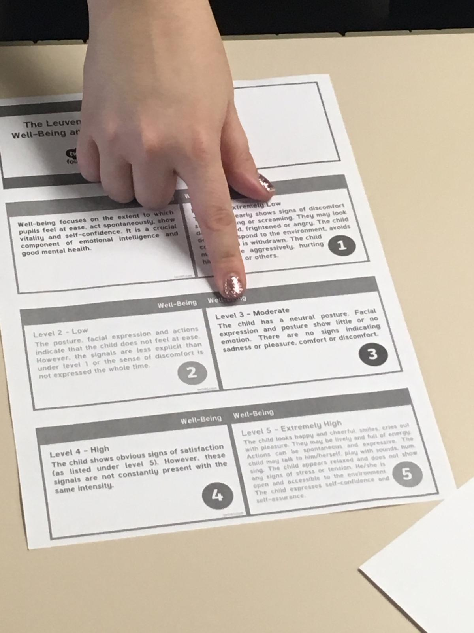

Appendix N – Observation Notes – School 2
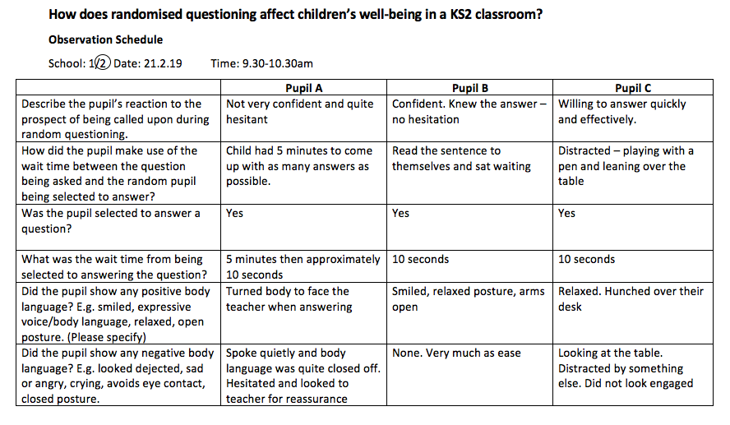
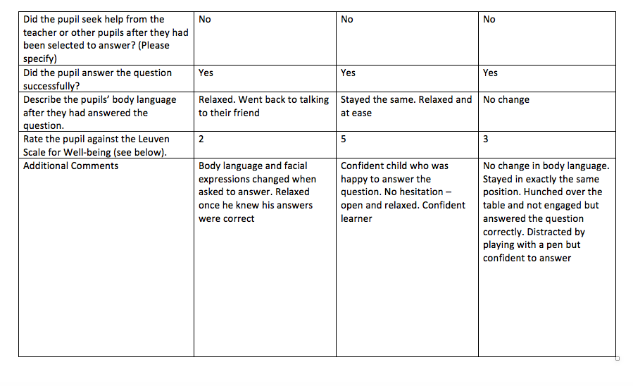

Appendix O – Exit Slip Analysis & Examples – School 2
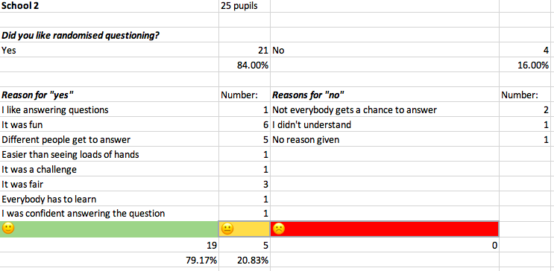
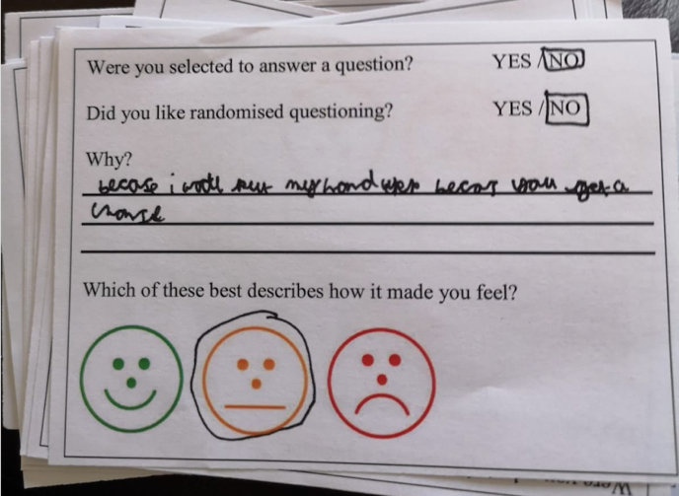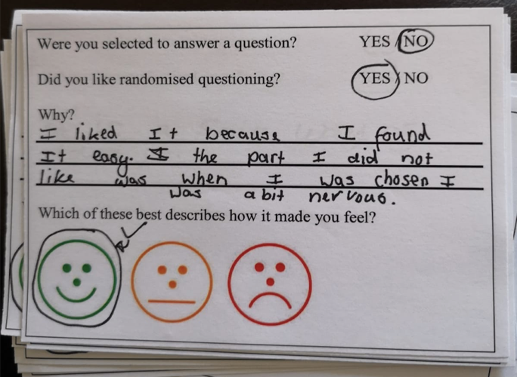
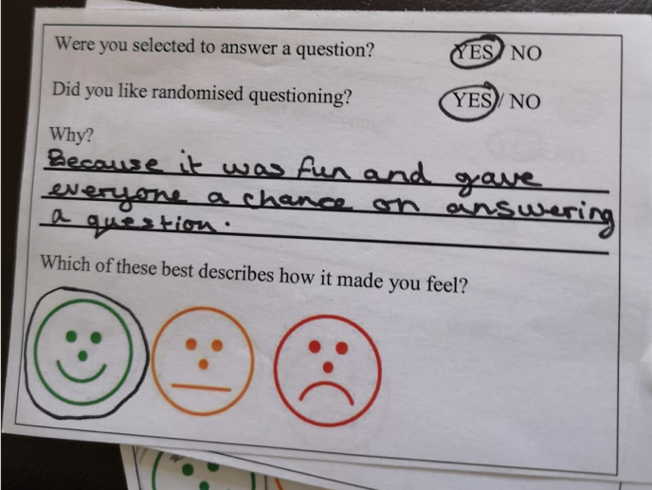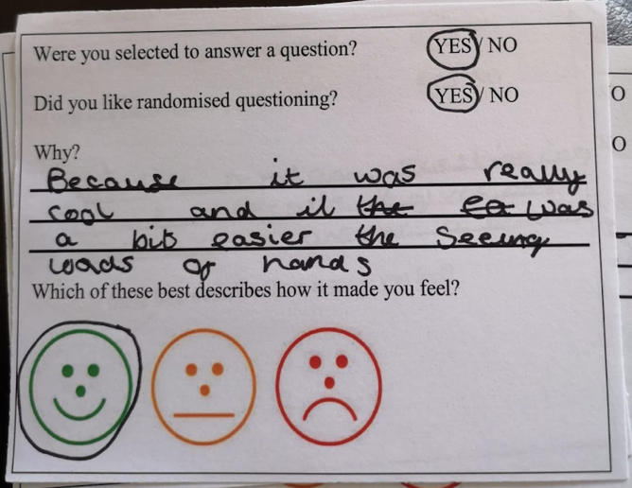

Appendix P – Interview – School 2
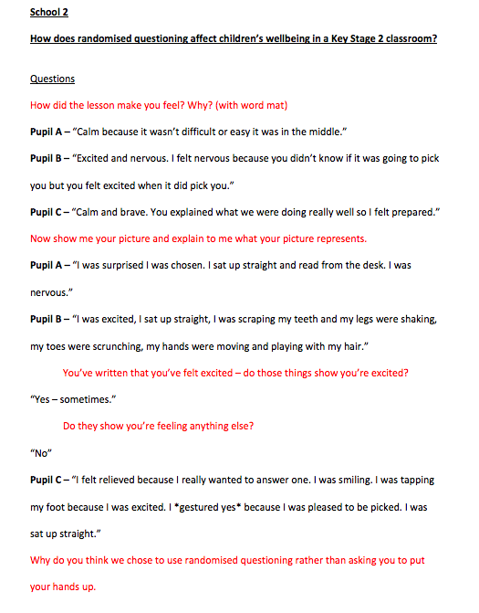
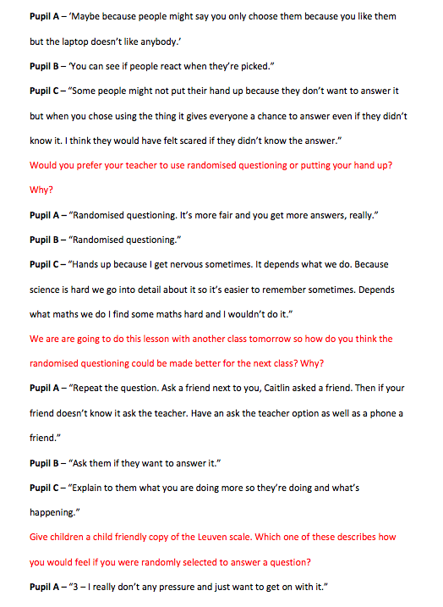
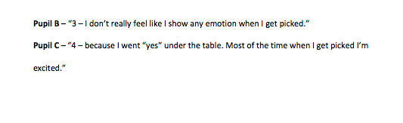

Appendix Q – School 2 – Pictures of Leuven Scale


