The impact of Mobile Health Apps on Smoking Cessation in the UK
Smoking remains a major public health issue in the UK, responsible for over 78,000 deaths annually and significant levels of chronic disease (Office for National Statistics, 2024). Digital innovations, such as mobile health (mHealth) apps, have become central to national efforts to support smoking cessation and promote equity in public health improvement (Free et al., 2013).
Introduction
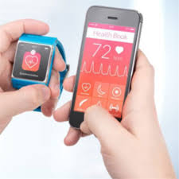

The Public Health Challenge
The adult smoking rate in England dropped from 26% in 2000 to 11.6% in 2023, yet over 6 million people still smoke, with higher rates in socio-economically deprived communities and among those with mental health problems (BMJ, 2025; Gov.uk, 2024). This places enormous pressure on NHS resources and national strategies focus both on prevention and quitting support.

Digital Technology: NHS Quit Smoking App
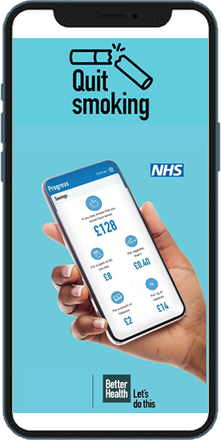
The NHS Quit Smoking app demonstrates evidence-based digital health promotion. It provides users with a four-week programme of practical support, tailored advice, motivational notifications, and cognitive-behavioural tools to facilitate quitting (NHS, 2025). Users set a personal quit date, receive daily motivational messages, track progress, and can access specialist NHS services directly through the app.

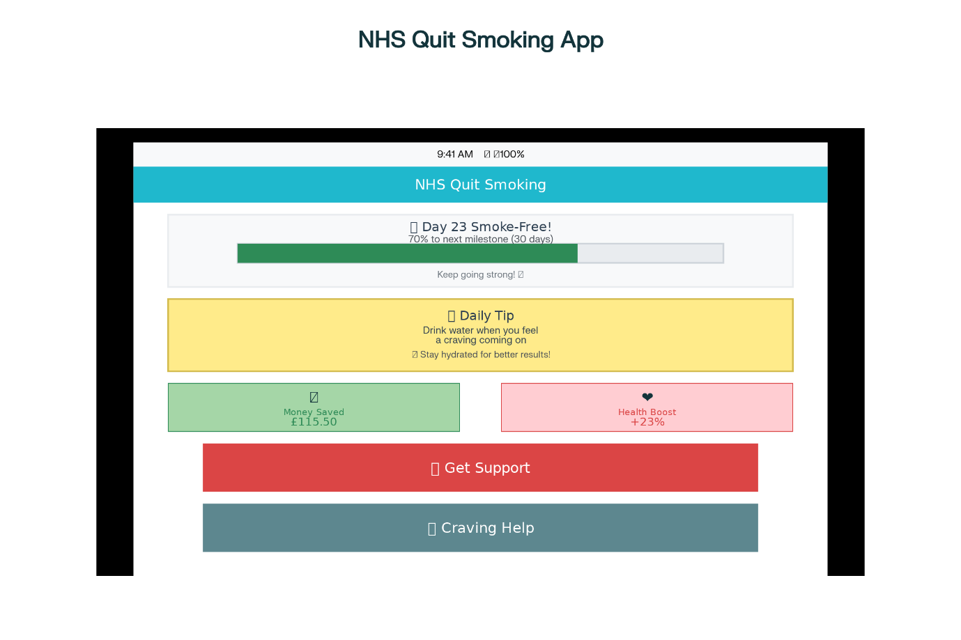
Effectiveness and Evidence

User Testimonials on Smoke Free App Effectiveness
• “This is the app if you're serious about stopping smoking. I’ve been smoke-free for 37 days and counting. Doing daily missions and seeing health improvements built my resolve. Talking to others who were going through the same journey was comforting and confidence-building… The best app I have used that actually helped me quit and stay smoke-free.” (Apple App Store, 2022)
• “I’ve tried for 41 years to quit patches, e-cigarettes, even hypnotherapy, but nothing worked. My GP told me about Smoke Free. The human advisors, group support, and 24/7 availability made it possible. After 4 days I didn’t crave a cigarette, for the first time ever!” (Apple App Store, 2022). “At the beginning, it really helped me stay motivated. The smoke-free timer is such a powerful reminder—every time I checked it, I felt proud of my progress.” (Google Play, 2025).
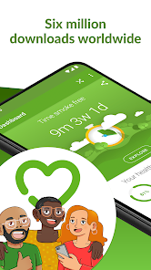
Recent studies and reviews demonstrate promising results. Users of apps like Smoke Free and the NHS Quit Smoking app are up to 1.7 times more likely to quit in the short term than those using no digital support (Rajani et al., 2019; Taylor et al., 2021; Jackson, 2024). In 2024, over 238,000 quit attempts were made with Stop Smoking Services, and 127,541 people successfully quit—indicating both increased uptake and effectiveness, especially when used alongside expert advice and NHS support (ASH, 2025). App-based support provides low-cost, scalable interventions that can reach wide audiences and complement face-to-face services.​

The user journey in the NHS Quit Smoking App is as simple as just downloading the app through the Apple App Store, Google Play and registering. Step 2: Set a quit date, step 3: Daily Motivation. Step 4: Track progress. Step 5: NHS integration and ready to go.
Advantages

•The accessibility of the Apps is available at any time and place, and can supplement in-person NHS services, making support flexible for busy users.
•Personalisation of the Digital platforms can tailor messages, reminders, and progress tracking to individual needs, increasing user engagement.
•The App is Cost-effective and reduces demand for health professionals' time and resources.
The apps update users about the dangers of smoking that can impact their health and well-being overall.
The motivation program provided through the app encourages users to have a wider view of the danger of smoking in later adult life, for their physical health and how this can affect the people around them when alerting users about how smoking can affect their unborn babies, pregnant women and men's sperm count.

Disadvantages and Limitations
Digital Exclusion among Older adults, those with learning disabilities and those in deprived groups are less likely to own smartphones and engage with digital tools, exposing widened health inequalities (NHS Digital Inclusion, 2024).
Sustained Motivation: Retention and engagement often decline over time, diminishing the app’s long-term impact (Williams et al. 2022).
Data Privacy: Confidentiality and security of user health data remain concerns.

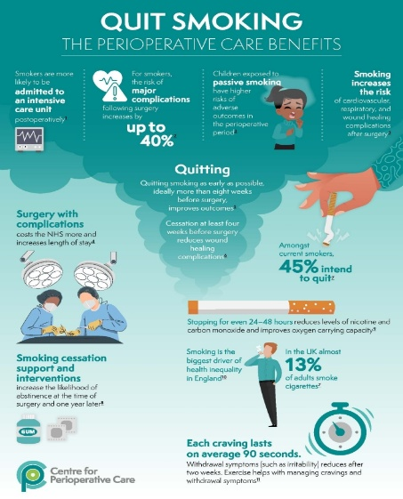
Infographic: rate and age

Diagram: NHS Quit Smoking App Effectiveness in the UK
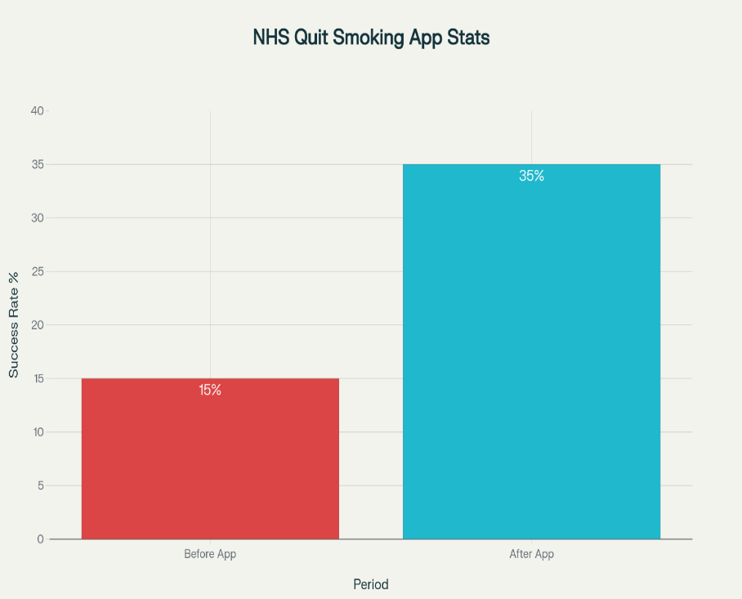



•Provide multi-platform access (SMS, desktop versions) for those without smartphones.
•Integrate social support features such as online peer groups to enhance sustained motivation.
•Collaborate with community organisations for outreach to digitally excluded groups like the elderly and people with learning disabilities.
•Strengthen privacy standards and transparent consent processes.

Recommendations for Improvement

Conclusion
Mobile apps like the NHS Quit Smoking app enhance the national public health strategy, driving higher quit attempts and supporting behaviour change. To maximise impact, future practice must address barriers to access and engagement, ensuring digital health solutions close, rather than widen, equity gaps in smoking cessation and public health outcomes.
Already, illnesses related to smoking cost the NHS 43.7 billion pounds in 2024, which includes lost productivity and health, social care costs (Action on Smoking and Health, 2025). This shows a public health concerns that need to be addressed by encouraging the health promotions of many apps, such as Mobile health apps, to reduce the impact of illnesses related to smoking habits.
Blog 1/ References
Action on Smoking and Health (2025). Economic impact of smoking. Available at: https://ash.org.uk/key-topics/the-economic-impact-of-smoking ( Accessed on 20 October 2025).
ASH (2025). Stop Smoking Services statistics. Available at: https://digital.nhs.uk/data-and-information/publications/statistical/statistics-on-nhs-stop-smoking-services-in-england (Accessed on: 26 October 2025).
BMJ (2025). Smoking rate and NHS services. https://doi.org/10.1136/bmj.r1730
Free, C., Phillips, G., Galli, L., Watson, L., Felix, L., Edwards, P., Patel, V. and Haines, A. (2013). The effectiveness of mobile-health technology-based health behaviour change or disease management interventions for health care consumers: a systematic review. PLoS medicine, 10(1), p.e1001362. https://doi.org/10.1371/journal.pmed.1001362
Jackson S et al. (2024). Effectiveness of Smoke Free app. JMIR. https://doi.org/10.2196/50963
Michie, S., Yardley, L., West, R., Patrick, K. and Greaves, F. (2017). Developing and evaluating digital interventions to promote behavior change in health and health care: recommendations resulting from an international workshop. Journal of medical Internet research, 19(6), p.e232. https://doi.org/10.2196/jmir.7126
NHS (2025). Quit Smoking App. www.nhs.uk/better-health/quit-smoking/
NHS Digital (2022). NHS Smoking Cessation Statistics. Available at: https://digital.nhs.uk/data-and-information/publications/statistical/statistics-on-nhs-stop-smoking-services-in-england/april-2022-to-september-2022 ( Accessed on: 20 October 2025).
Office for National Statistics (2023). Adult Smoking Habits in the UK. Available at: https://www.ons.gov.uk/peoplepopulationandcommunity/healthandsocialcare/healthandlifeexpectancies/bulletins/adultsmokinghabitsingreatbritain/2023 ( Accessed on: 25 October 2025).
Office for National Statistics (2024). Smoking statistics UK. Available at: https://www.gov.uk/government/statistics/adult-smoking-habits-in-the-uk-2024 (Accessed on: 26 October 2025).
Rajani NB et al. (2019). Gamification strategies in mobile cessation apps. BMJ Open. http://dx.doi.org/10.1136/bmjopen-2018-027883
Taylor, G.M.J. et al. (2021). Digital interventions for smoking cessation: meta-analysis. Addiction, 116(8): 2107-2119. https://doi.org/10.1002/14651858.CD013522.pub2
Williams, R. et al. (2022). Barriers to engagement with digital smoking cessation tools. Public Health, 205: 35-41. https://doi.org/10.1016/j.puhip.2023.100409

Designing the “Quit Link” Chatbot for Inclusive Smoking Cessation Support

Introduction

While established digital tools have broadened smoking cessation support, persistent disparities exist for older adults and those with limited technological proficiency in the UK. In response, this blog proposes that “Quit Link” is an AI-powered chatbot accessible via SMS and web—designed to make digital smoking cessation resources more inclusive (NHS, 2024)

Technology Description
“QuitLink” is an automated chatbot delivering behaviour change interventions directly via text message (SMS), eliminating smartphone dependence. Built on motivational interviewing and CBT principles, QuitLink shares daily tips, tracks quit progress and responds to queries using natural language processing. (Stop Smoking London, 2025). The partnership with NHS Digital enables seamless referrals to local cessation services.

How to use Quit Link:

Users can access QuitLink by signing up through an online registration form, texting a keyword (such as “Quit”) to a designated NHS number, or through GP/Pharmacy or local website referrals. Step 1: Visit a service website and complete a short online form with their details, quit reasons and preferred date.
Step 2- The user received a confirmation SMS and a welcome message to the chatbot which will start delivering daily motivations on quit tips and interactive chats.
An alternative to this is that you text (Quit on: 89003 or Breathe to 82998) to the public NHS SMS number registered to start receiving motivation support and tips that help your smoking cessation journey.
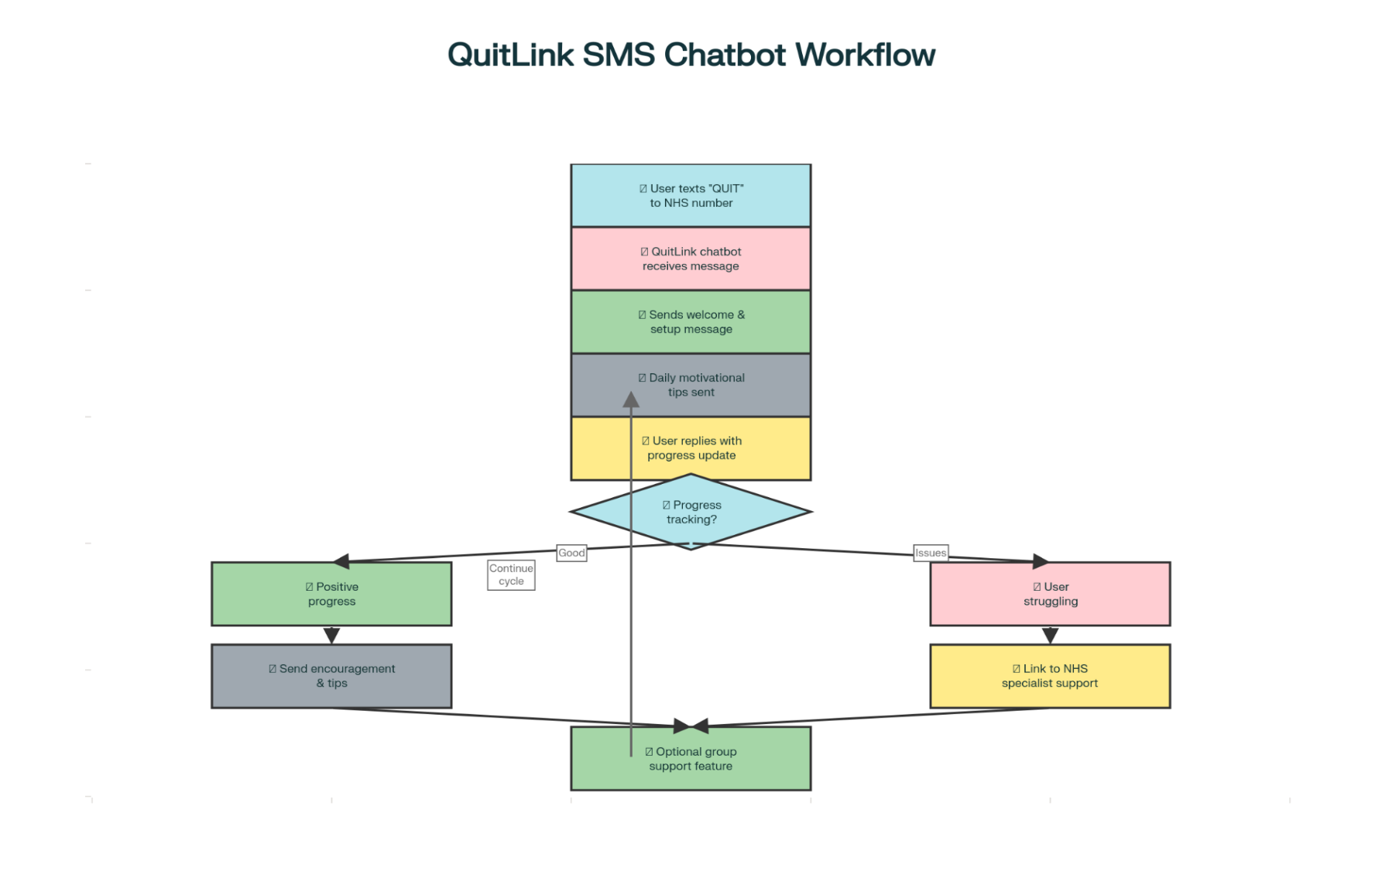

Health Promotion Approach
By leveraging SMS, QuitLink supports digital inclusivity, reaching individuals with basic mobile phones. The chatbot offers culturally competent messaging, adapts to user feedback, and integrates NHS support pathways. Features include group messaging for peer support and automatic follow-up reminders to sustain engagement. This technology breaks down the barrier of health and inequality among those in deprived socioeconomic backgrounds by allowing access to normal text messages. There is no need for the internet, as your network provider allows access to send and receive messages information needed to start your journey to quit smoking.
Infographic: Visual highlighting the accessibility features of the QuitLink chatbot, with icons for SMS, group support, and NHS integration.
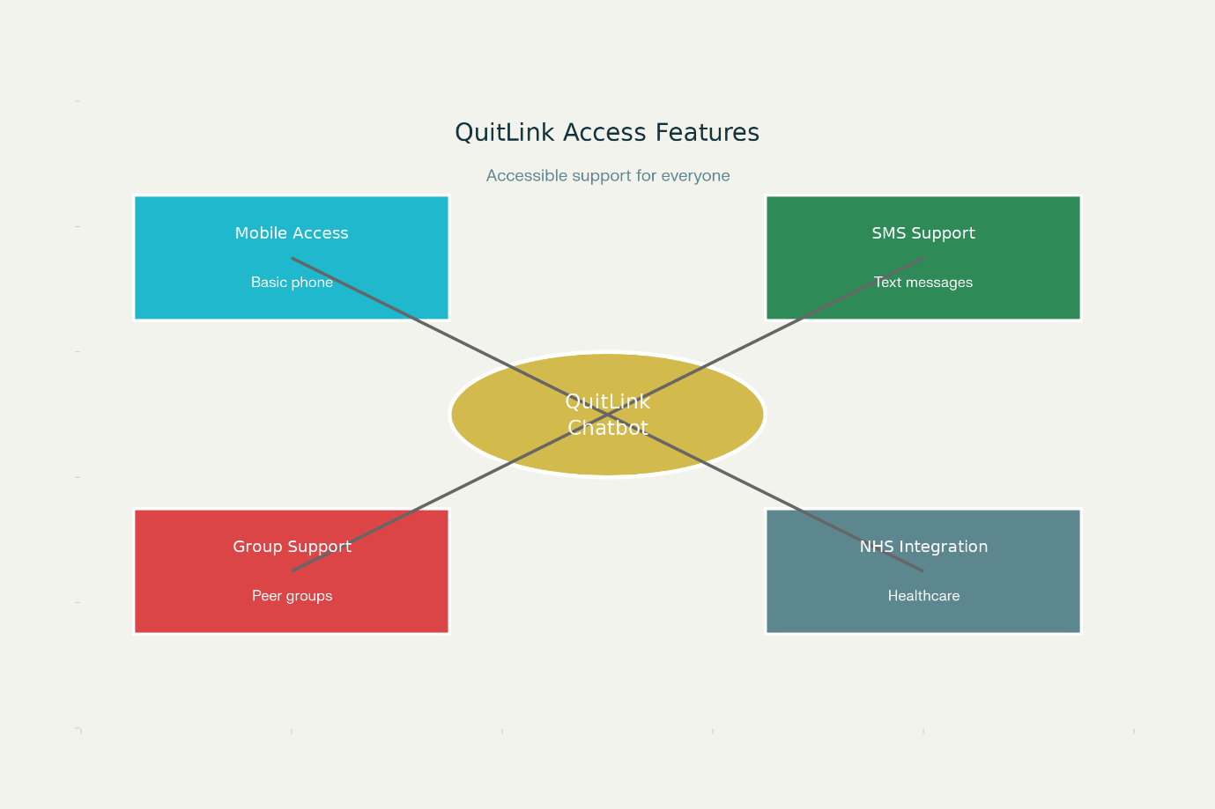
Infographic: 'QuitLink' Chatbot Accessibility Features
Critical discussion Research shows that SMS-based interventions can significantly increase quit rates. A Cochrane review found mobile text messaging doubled smoking cessation success compared to minimal support and that combining SMS with other interventions further improves outcomes (NIHR Evidence, 2024; Wang et al., 2022). Chatbots further enhance engagement with conversational prompts and real-time feedback features validated in recent UK studies (Perski et al., 2019; Wang et al., 2022).
The Public Health Problem
Over 6 million adults in the UK still smoke, with the burden disproportionately affecting deprived, older, and digitally excluded groups (Office for National Statistics, 2024). Evidence links socioeconomic status and digital access to quit rates, making inclusive digital interventions a national priority (BMJ, 2025)

Advantages

Recommendations
Addressing these shortfalls requires:
• Integrating QuitLink with additional platforms (e.g., voice assistants) for richer experiences.
• Implementing robust privacy safeguards and clear consent processes.
• Evaluating effectiveness through pilot studies and iterative redesign based on user feedback (NHS Digital, 2022).

Conclusion
The QuitLink chatbot exemplifies how digital innovation can promote health equity in smoking cessation. Ongoing evaluation and co-design with users will be vital to breaking down digital barriers in public health

- Wide reach: SMS-based delivery ensures accessibility for populations excluded from app-based interventions.
- Personalisation: Allows tailored support based on individual needs and feedback.
- Low cost: Minimal data usage and no need for advanced devices make the solution feasible for vulnerable groups.

Disadvantage Limited functionality: SMS lacks rich multimedia, potentially reducing interactivity compared to apps (Jackson et al. 2024).
- Privacy concerns: Ensuring secure data handling is essential for user trust.
- Potential Need for Human Support like some users require at least occasional human reassurance or advice, echoing the “Supportive Accountability” model (Dobson, 2023; Perski et al. 2019).

Add to the technology for improvement
By expending the QuitLink technology accessibility for the user to be able to download the app through mobile phones will widen it accessibility to those who want innovation when using smartphones. Also, including accessibility through individual email and all devices such as tablets, computers or iPads will promote a wider user experience and embrace a large community in the UK where everyone can have access to explore changes of lifestyle that support those who are willing to stop smoking. This will break the barrier of socioeconomic differences and promote equality of opportunity, reducing health and inequality among those who are deprived of access to afford smartphones and modern technology. Promoting QuitLink technology and free access link through mental health institutions, educational settings, and healthcare services will impact the lives of those willing to change their smoking habits
Blog 2/ References
Dobson, R. (2023) Effectiveness and Acceptability of Conversational Agents for Smoking Cessation. Nicotine & Tobacco Research, 25(7), pp. 1241-1254. https://doi.org/10.1093/ntr/ntac281
Free, C., Phillips, G., Galli, L., Watson, L., Felix, L., Edwards, P., Patel, V. and Haines, A. (2013). The effectiveness of mobile-health technology-based health behaviour change or disease management interventions for health care consumers: a systematic review. PLoS medicine, 10(1), p.e1001362. https://doi.org/10.1371/journal.pmed.1001362
Lim, M.S.C. (2019). A chatbot-delivered intervention for smoking cessation: Feasibility study. JMIR mHealth uHealth, 7(9): e14327. https://doi.org/10.2196/11954
Masaki, K., Tateno, R., Kameyama, N., et al. (2021) A conversational agent-based intervention for smoking cessation: Study protocol. JMIR mHealth uHealth, 9(9), e14327. https://doi.org/10.1038/s41746-020-0243-5
Michie, S., van Stralen, M.M., West, R. (2011). Behaviour change theory and public health. Health Psychol, 30(5). https://doi.org/10.1186/1748-5908-6-42
NHS Digital (2022). Digital Inclusion and Health Inequality Report. Available at: https://www.england.nhs.uk/long-read/inclusive-digital-healthcare-a-framework-for-nhs-action-on-digital-inclusion/
Stop Smoking London (2025) Text messaging support to help you quit. Available at: www.stopsmokinglondon.com/stop-smoking-text-messages-uk/(Accessed: 30 October 2025).
Thomas, G., & McLellan, J. (2023). Addressing digital health inequality: Policy recommendations for the UK. Public Health, 212: 73-78. https://doi.org/10.1016/j.healthpol.2024.105122
Wang, Y., Zheng, Y., Li, X., et al. (2022) Effect of SMS-based interventions on smoking cessation: A meta-analysis. Addiction, 117(4), pp. 857-870. https://doi.org/10.1186/s12889-023-16441-w

