THE GLOBAL BUSINESS ENVIRONMENT

Contents
Introduction 3
Major forces shaping the car-manufacturing industry 3
PESTEL Analysis 3
Porter five forces for the car manufacturing industry 6
Opportunities and threat of car manufacturing industry 7
Competitive advantages of the Automotive Industry 8
Conclusion 9
References 10

Introduction
The car manufacturing industry has faced different types of major factors in developing and securing their industry. According to this assignment, PESTEL analysis will be discussed for demonstrating environmental factors as well as evaluating the changing global business environment. Michael Porter’s five forces factors will also discuss for identifying industrial changing reasons in a few years. Both opportunities and challenges will be discussed and identified for securing this industry. Finally, evaluating competitive advantages, the industry will secure the best position in the global business environment.

Major forces shaping the car-manufacturing industry

PESTEL Analysis
PESTEL analysis consists of political, economic, sociocultural, technological, environmental, and legal factors that highly affect the car manufacturing industry.
Political factors
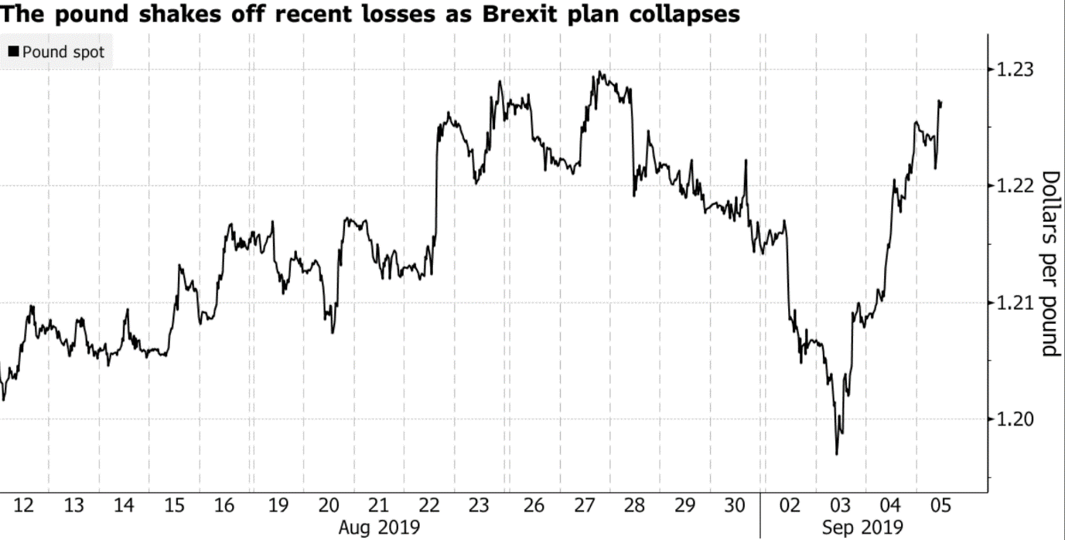
Figure 1: Currency Fluctuation rates in UK
Source: (Camilleri, 2020)
Political factors have a direct impact on the profitability that helps in shaping the car-manufacturing industry. Governments are focusing on producing low emission vehicles. Luxury vehicles and fuel guzzlers have faced higher tax growth rates and the EU, as well as the UK, are focusing on government subsidy for producing low emission vehicles. Environmental vehicles have faced higher market demand all over the world and receiving higher governmental support for their environmentally friendly steps (Camilleri, 2020). Moreover, government rules and regulations are affecting the brand of the top vehicle were environmentally friendly car manufacturing company (low on emission and fuel-efficient) easily fulfil the government criteria. Different types of political factors such as import rules, tax rates, and so on highly affect the car manufacturing industry. They also face changing government regimes, political regulations can vary for favourable and unfavourable fluctuations. As a result of automotive industry transfer, their manufacturing plants developing countries where they enjoy low wage related regulations. China is the top favourable country for many organizations because of low labour costs. The export and import rules and regulations also have an impact on the car manufacturing industry and politicians have a higher interest in maintaining environmental consequences of the car industry.
Economic factors
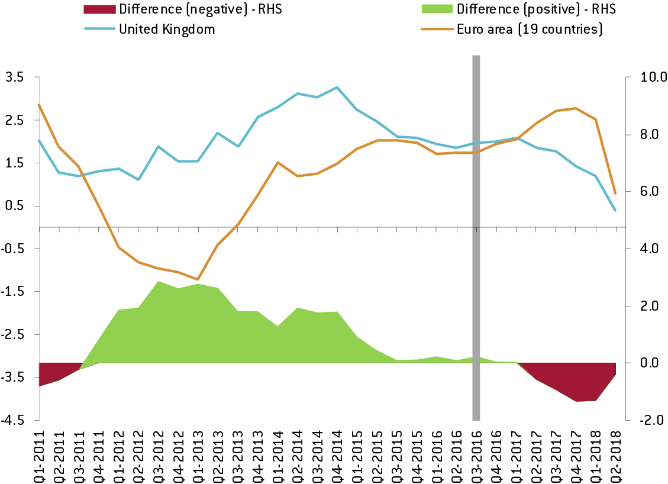
Figure 2: Brexit Issues in UK
Source: (Pangestu and Setyorini, 2020)
The economic factors have the greatest impact on the automotive industry where the recent economic crisis was hit hard for this industry. Covid-19, Brexit issues are the main context that adversely affects economic conditions all over the world, and sales of vehicles have fallen. It also negatively affects the demand for luxury or high priced vehicles for poor economic conditions. Tax rates, household disposable incomes act as the main reason for increasing or decreasing sales of vehicles. When individuals enjoy more earning and more money, they spend more on purchasing luxurious items. The developed market has experienced higher sales for the higher purchasing power of customers, on the other hand, the low priced variants are demand in underdeveloped or developing markets. Besides, the size of the economy and economic situations has a greater impact on ensuring profitability in the car manufacturing industry.

Social factors
The car manufacturing industry is also influenced by the changing socio-cultural factors or people’s perceptions. The car manufacturing industry must adopt these changing socio-cultural trends to bringing new models. Specific styles vary from culture to culture where SUVs would be enjoyed higher market demand. Demographic segmentation has an impact on targeting consumers. Apart from these cultural variations, people's age, styles and preferences also vary from country to country, and changing cultural trends sometimes obsolete the older model.
Technological culture
The technological culture shifts impact into the automotive industry and ensuring the advance of self-driving technology. For example, Bentley Motors try to offer completely new motor vehicles that meet up the changing customers’ demands. Therefore, it also focuses on safety and security that decreases uncertain accidents.
Legal factors
The legal factors consist of consumer rights, government rules, and regulations, employment rights that have high impacts on the automotive industry (Shu and Lewin, 2017). Copyright issues include copyright, patent, trademark laws that create automotive space and protect different brands.
Environmental factors
It is one of the challenging issues that developing a threat to the world. Therefore, the car-manufacturing industry should pay intense attention as well as transferring technology as alternative sources of energy. Today customers are more conscious about environmental factors so they focus on reducing emissions for ensuring a better environment.

Porter five forces for the car manufacturing industry
The car manufacturing industry is a multi-billion dollar industry all over the world that faces extreme competition with many higher players to obtain majority as well as market share. The industrial environmental factors have a significant impact where automobile manufacturers cannot depend on reliability and safety.

The threat of new entrants
Impacts: to face high entry barriers in this industry and the threat of new entrants are very low.
Effects: in this manufacturing industry, the new entrepreneurs or new players are less capable of entering into this industry because it needs higher capital requirements for developing manufacturing plants or distribution networks (Kalaitzi et al., 2020). It is very difficult for new players to offer a highly competitive price to gain a competitive position in the market. For example, Bentley Motors enjoys safety, reliability, and durability to build a reputation to be competitive.
Threat from substitute products
Impacts: The threats of substitute products are high.
Effects: The higher fuel prices decrease the demand for automobiles and the public is stubborn to use public transport. If this industry faces these trends continuously, car manufacturers are not able to develop a cost-effective solution. As a result, the threat will increase. For Example, Bentley Motors has gave an effort to reduce the pressure of substitutes and customers will be able to get benefits from purchasing fuel-efficient cars.
Bargaining power of supplier
Impacts: Switching costs are very high for developing a design for parts and need fair initial investment.
Effects: the existing potential suppliers reduce the power of suppliers where car manufacturers need labour, raw materials, parts to increase profitability. Bentley Motors Company was depending on different suppliers to collect materials and parts and somewhat expensive (Beer, 2018). In recent times, the company followed the Japanese lead to obtain organic parts makers for outsourcing their parts for producing cars.
Bargaining power of buyers
Impacts: the bargaining power of buyers is high and individuals can negotiate prices.
Effects: Individuals, governments and commercial companies are preliminary buyers of the car manufacturing industry. In this industry, buyers have enjoyed the power to talk, purchase from the same manufacturer, other manufacturers, or the same platform. Customers can switch from one company to another company for purchasing cars.
Rivalry among competitors
Impacts: Rivalry among competitors has more intense in this car manufacturing industry.
Effects: The car manufacturing industry has faced serious competition in the early 1990s for bringing new vehicles, concepts, and designs. Companies are trying to offer various incentives to attract customers to sell their vehicles. For example, Bentley Motors has gained success from this marketplace and created a place as the biggest player in this industry.

Opportunities and threat of car manufacturing industry
The Strengths and weaknesses are the internal factors where opportunities and threats are external factors. It helps to explore uncover opportunities as well as understanding the industrial weakness and eliminate threats.
Opportunities | Challenges
Bringing fuel efficient vehicles:  The cost-effective programs and fuel driven combustion engines are the essential opportunities for the car manufacturing industry (Sanny et al., 2018). With the help of this, introducing fuel-efficient vehicles can adopt with the newly emerged demands and fulfil the need of reducing hour.  To change the customers lifestyles:  There are three powerful forces helps to fulfil the needs of automotive industry. It helps to shift consumer demands as well as fulfil the requirements of safety and fuel economy. However, it also ensures the data availability and demands of two-wheelers cars.  Strategic alliances:  The car manufacturing industry has also enjoyed the strategic alliances opportunities for the expansion of international business. This smart strategy has ensured specialized capabilities and allowed to partnership with other companies. They can also differentiate the industrial offerings. | To stand out from the rest:  It is one of the challenges that automotive manufacturing sector has faced. They should try to ensure better design to stand out from the gather and attract more individuals from this crowd. The todays’ customers are more value sensitive and try to gain unique products from this industry. The industry has consciously tried to re-invent themselves and offer varied products to their customers. Therefore, it helps industry to cope with automotive manufacturers to re-invent healthy design.  Intense competition:  The number of players in the automotive industry has faced intense competition and every company has loosed their shares for new players.  High fixed and investment cost in R&D:  It is another important challenge for this car manufacturing industry where matured market has already faced intense crowd in this industry. They has tried to shifting themselves for developing facilities but ROI decisions has already capitalized.

Competitive advantages of the Automotive Industry
The global car manufacturing industry has enjoyed remarkable changed and gained an intense growth rate into the last century, it also created billions of jobs all over the world. In Europe, more than 12 million jobs as well as the US around 8 million and Japan enjoyed 5 million job sectors globally. This industry has enjoyed significant competitive advantages from technological innovation and made driving safer to ensure smooth driving.
Technology
With the help of technological innovation, the car manufacturing industry has gained the biggest competitive advantages. Now, the industry has enjoyed higher customers’ expectations and technological innovation acted as an important part (Pangestu and Setyorini, 2020). Environmental concerns are also crucial for the automobile industry where brands secure their sustainability into this market. The digital demand is also increased that fulfil the demand of brands investment. For example, Bentley Motors is environmentally friendly vehicles than the other brands also making other electric brands. Technological innovation is also important to maintain proper supply chain and distribution channels. Now, the car manufacturing industry focuses on developing safer vehicles to produce a higher level of connectivity ( such as gas stations, shopping malls, and restaurants) to connect customers. Technology acts as key determinants for ensuring industry popularity and highly affects sales directly.
Band Equity
The automotive industry has also gained competitive advantages by developing its brand image. It not only a source of gaining competitive advantages but also changing the market conditions (Pangestu and Setyorini, 2020). Still, this creates a great role in surviving fast changing situations. From the luxury to low-cost brands, the customers have selected the best one to create their values, on the other hand, sporty and stylish brands create premium images into this industry.

Conclusion
This report has demonstrated and evaluated the major factors of the car manufacturing industry. The PESTEL analysis consists of different factors such as political, economic, socio-cultural, legal, technological, and environmental that allows the industry to change their situations as well as secure its place in the global marketplace. Porter’s five factors have also affected the shaping business environment of the automotive manufacturing industry. SWOT analysis is important for every industry for evaluating their strengths, weakness, opportunities, and threats. The assignment has portrayed opportunities and challenges in this industry. Finally, the report has evaluated industrial competitive advantages for securing its best position in this industry.

References
Beer, A., (2018). The closure of the Australian car manufacturing industry: redundancy, policy and community impacts. Australian geographer, 49(3), pp.419-438.
Camilleri, M.A., (2020). European environment policy for the circular economy: Implications for business and industry stakeholders. Sustainable Development, 28(6), pp.1804-1812.
Kalaitzi, D., Matopoulos, A., Fornasiero, R., Sardesai, S., Barros, A.C., Balech, S. and Muerza, V., (2020). Megatrends and trends shaping supply chain innovation. In Next Generation Supply Chains (pp. 3-34). Springer, Cham.
Pangestu, G.A. and Setyorini, R., (2020), July. Value Chain Analysis At Bank SampahBersinar In Bandung Regency As A Competitive Advantage Strategy. In Proceeding of International Conference on Management, Education and Social Science (Vol. 1, No. 1, pp. 8-21).
Pehrsson, A., (2016). Firm’s strategic orientation, market context, and performance. European Business Review, 28(4), pp.378-404.
Sanny, L., Simamora, B.H., Polla, J.R. and Atipa, J.L.,( 2018). Business Strategy Selection Using SWOT Analysis with ANP and Fuzzy TOPSIS for Improving Competitive Advantage. Pertanika Journal of Social Sciences & Humanities, 26(2).
Shu, E. and Lewin, A.Y., (2017). A resource dependence perspective on low-power actors shaping their regulatory environment: The case of Honda. Organization Studies, 38(8), pp.1039-1058.

