KAZI SADIA AHMED
STUDENT NUMBER: 1806239
PROFESSIONAL CAREER DEVELOPMENT
ASSESSMENT 1
BMSK4005.

Contents:
Introductions
Findings-
Three methods.
SWOT
GO M.A.D
Barriers
Options and Interventions
Personal development plan
Conclusions.

INTRODUCTIONS

Personal and professional development is a very important aspect in one’s life. We always want to improve ourselves with the existing skills and knowledge as well as we want to attain new skills and knowledge to prosper in our career.
Personal and professional development is a continuous process which not only helps the individual but also the organisation (Throop & Castellucci, 2010). It involves processes of self-discover and self-examination wherein one analyses their own skills and potentials and plan improvements in order to attain desired future goals and career achievements (Carducci, 2009). Once the learning needs are identified they define their learning goals, recognise input resources and evaluate the learning outcomes on a regular basis (Friedman, 2013). We always want to see ourselves successful in career. Therefore we should set out a career development plan to achieve success in our professional life. I have always been passionate to achieve a bachelor degree in UK and then get some work experience in administration related work. So at the moment my plan is to achieve a bachelor degree and to get IT skills to make myself job applicable. So for my professional career development, first of all I would finish my studies and enhance my IT skills and would gather some work experience. Work experience will help me to learn how to do a presentation in a work place and how to lead a team work. Through work experience I will learn how to work in various situations, like working under pressure or multi-tasking and many other administrational skills. So these are the few areas I would like to develop myself by taking self-initiative to evaluate my own learning needs.

FINDINGS

Self-managed learning also referred to as self-directed learning involves individuals taking self-initiative to analyse their own learning needs with or without the support of others (Aspin, 2008).
Every individual has their own learning style and the self-motivation greatly influence what they learn (West & Turner, 2010).
Learning styles refer to set of theories that evaluate the differences in one’s habitual and natural pattern of processing and absorbing knowledge in particular learning environment (Graves & Norman, 2013).

QUESTIONS METHODS

So I have carried out a test on questionnaire that is designed to find out one’s preferred learning style. This an internationally proven tool designed by Peter Honey and Alan Mumford. There are mainly four types of learners in Honey and Mumford’s learning style. Such as: Activist, Reflector, Theorist and Pragmatist.
Activist learners learn from experiences. They learn by doing. They like to involve themselves and have an open-minded approach to learning.
Reflectors learn by observing and by reflecting over what happened. They like to stand back and prefer to observe from different perspective. They first gather all the ideas or data and then works towards an appropriate conclusion.
Theorist likes to know the cause of an action. They prefer to analyse their learning.
Pragmatist wants to see the effectiveness of the learning in reality.
The Honey and Mumford learning style defines four types of learners as shown in the figure below:

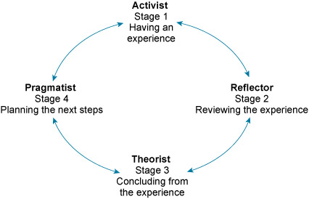

Figure 1, Source: Honey and Mumford’s styles (Honey and Mumford, 2006).

So what I have learned about myself is that I am reflector as I like to stand back to reflect on my learnings and see them from different point of view. I always prefer to gather all the knowledge before I need to do any work or to give any feedback of what I have learned. I always prefer to self-evaluate of what I learned and what I know about it. I am more cautious in taking any actions. I step back and let the others take over, so that I can reflect on the outcome. I like to keep a low profile of myself. I prefer to be thoroughly aware of what I do.
The second test that I took on myself is Myers Briggs personality profiling test where the result came out as me being an introvert person. I am a shy person and often prefer not to speak in front of a big audience. I can speak once I am familiar with the environment. I keep things to myself and over think too much of the consequences. Sometimes I think my nature can bother my abilities as I hold back myself most of the time. I should overcome from this situation and should take initiatives with any assigned task.

In the VARK questionnaire where V is for Visual, A is for Aural, R is for Read/write and K is for Kinaesthetic. After doing the test for myself the result came out to be as R which means read/write study strategies. I learn better with reading books and writing as well when required. I work better with clear instructions. I don’t have a good understanding of abstract article.

SWOT

I carried out a SWOT analysis to self-evaluate myself. The SWOT analysis is a way to self –evaluate one’s self. It’s a great approach to increase the encouragement to learn and gain the knowledge for both personal and professional life. By self-evaluation I can analyse or evaluate the strength that I hold, the weakness which are becoming the challenges for me to achieve my goals, the opportunities help to achieve my targets, and the risk obstruct the ways to the goal achievement. In the following chart I am presenting the SWOT analysis:-

Strengths:-  1) I always like to learn new skills that can enhance my knowledge.  2) I am enthusiastic and friendly.  3) I like to help others.  4) I like to work with numbers like Maths and Accounting.  5) I am punctual. | Weakness:-  1) I am not confident enough which stops me for taking challenges.  2) I am not very creative.  3) I feel nervous to speak in front of a crowd or an audience.  4) I am not very skilled in IT.  5) I feel nervous to face interviews.
Opportunities:-  1) I have the opportunity to gain more confidence after finishing this course as I am going to do some group and individual presentation in the class, which will be a good practice for me to get the skill of presentation.  2) I am going learn some digital skill in this course which will enhance my skill in IT.  3) I am going to learn about organisational skills in this course< which is going to be very beneficial for me.  4) I will learn about creating an effective CV.  5) I will learn how to represent myself to an interview. | Threats:-  1) Financial crisis.  2) Travelling long distance from home to University.  3) Managing work and studies.  4) Looking after family.

According to SWOT analysis I can develop my personal learning plan by applying self-reflective learning and by continuing professional development. I should be able to find out my own weakness and should be able to take measures to overcome that gap. Thus it will help me to learn new things and develop my personal skills by taking challenges.

GO M.A.D

I have formed a GO M.A.D frame work for my future plans. The GO M.A.D is a framework of one’s planning for development in one’s own life. Since I am a student and a future applicant in the job market, I have got my own preferences for the planning. I shall use the GO M.A.D framework to represent my points of planning. I am putting the GO M.A.D framework figure and on the basis of the stages explained in the diagram, I shall write about my future planning for developing myself and mention all my goals and priorities in my planning.

The GO M.A.D framework’s diagram:-

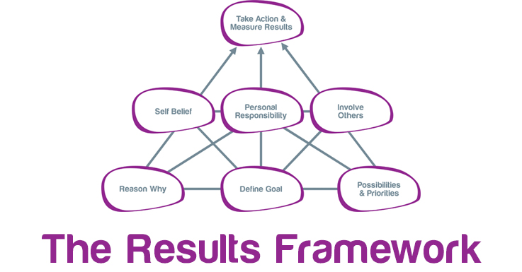
LEVEL 3

LEVEL 2

LEVEL 1

I am going to write about every point in each level of the GO M.A.D framework. In level 1 there are three things. They are:-
Reason why, Define goal and Possibilities and Priorities.
In level 2 there are three things to mention. They are:-
Self-Belief, Personal Responsibility and Involve others.
In the last level:-
Take Action and Measure Result.
As a personal reflection of the GO M.A.D framework, I am writing my plans and priorities in the following:-
Level 1
Reason why: - I want to achieve a Bachelor Degree in UK and apply for jobs.
Define Goal: - My goal is to achieve a Bachelor degree.
Possibilities and Priorities: - After I finish this course it will create a possibility for my higher studies in future. At the moment my aim is to achieve a good result in this course. So that I can get into the degree.
Level 2
Self-Belief: - Once I start any learning I try to get to the end. So I think I will get into higher studies.
Personal Responsible: - I have to be persistent with this course, no matter how hard I find it.
Involve others: - Getting support of family to get into studies again. The teachers are supportive and helpful. Get help from classmates as well.
Level 3
Take action and measure result: - Started this course this year and after finishing next I will start my bachelor degree.
In the above discussion I mentioned my plans and priorities though the GO M.A.D framework.

BARRIERS

Barriers to my learning and development are lack of IT skills, fear of presentations, need of rich vocabulary and getting all that time for myself from work and family.
At the moment I am struggling to work efficiently due to the lack of IT skills. I think it is acting as a barrier to my learning and development.
I get very nervous and conscious when I am asked to do presentations in front of my class. I need to get out of this fear and practice to do presentation in front of my friends so that eventually I can do presentations confidently. I will give full effort to get over this barrier.
I sometimes struggle to find a richer vocabulary when I am preparing my assignment. I need to read more reports, journal, and articles to adapt the skills of writing.
It is hard for a mother to get back into studies again, children are always my priorities so after fulfilling their needs I get very little time for myself. I should learn to manage time appropriately. So that I can develop myself with those skills that I lack now.

Options and Interventions

In this course we are going to learn about Digital Skills and that’s how I will get the opportunity to learn IT. Presentation skill are practised in this course, so I am already learning the presentation skills. Since as learner I am a Reflector as in Honey and Mumford questionnaire and R according to VARK, where R means reading and writing. I learn best by reflecting on my experiences and by reading and writing. In this course I will be learning through class lectures and by taking part in presentations, which is going to enhance my skills for presentations. There are many options and interventions available in this course.
Support that I can access are like the community training centres for Digital Skills. I did few courses with them. The tutors for this course are very helpful and try to help us as much as they can. I get the support from my family to do this course. My employer is very considerate about time flexibility. Their support gives me the strength to pursue my dream.

PERSONAL DEVELOPMENT PLAN
Success of personal development plans depends on how dedication level of the learner and how religiously they follow the designated time frames (Schon, 2008). The personal development plan can be done in four steps. Such as: Identify, Plan, Action and Reflect. First step of PDP cycle involves identifying personal learning needs (Armstrong, 2011). Second step is planning which involves goal setting, planning activities to be undertaken and defining definite time frame (Deb, 2006). Third step involves identifying resources that can help in achievement of desired learning goals (Carroll, 2013). Last stage of PDP cycle involves reflecting on actions performed and gathering feedback for evaluating achievements and progress (Denicolo & Reeves, 2013).
A PDP should be SMART where S is specific, M is measureable, A is achievable, R is realistic and T is time.
.
WHAT | HOW | WHY | WHEN
Enhancement of Digital or IT skills. | Through the community learning centre. | To help me in my studies and to apply for jobs. | After I finish this course next September.
Building Presentation skills. | Through practice in this course. | Because when I get into further higher studies I will need this skill. | By the end of this course.

When I finish this course next year. I should be more confident in presentation and Digital skills as both are practices in this course.

CONCLUSION
Professional Career Development can be successful if we can I identify our needs accurately and set out a plan to fulfil those needs. We need to self-evaluate ourselves through reflecting on our experiences. I identified my learning needs through self-evaluation and created a PDP to achieve those goals. (2199 WORDS).

REFERENCES
Armstrong, M., (2011) Armstrong's Handbook of Strategic Human Resource Management. London: Kogan Page Publishers.
Aspin, D. N., (2008) Philosophical Perspectives on Lifelong Learning. Hamburg: Springer Science & Business Media.
Carducci, B. J., (2009) The Psychology of Personality: Viewpoints, Research, and Applications. New Jersey: John Wiley & Sons
Carroll, D., (2013) Skills for Academic and Career Success. Melbourne: Pearson Higher Education AU.
Deb, T., (2006) Strategic Approach to Human Resource Management. New Delhi: Atlantic Publishers & Dist.
Denicolo, P. & Reeves, J., (2013) Developing Transferable Skills: Enhancing Your Research and Employment Potential. London: SAGE.
Friedman, A. L., (2013) Continuing Professional Development: Lifelong Learning of Millions. New Jersey: Routledge.
Graves & Norman, (2013) Learner Managed Learning: Practice, Theory and Policy. New Jersey: Routledge.
Schon, D., (2008) The Reflective Practitioner: how professionals think in action. London: Temple Smith.
Throop, R. K. & Castellucci, M., (2010) Reaching Your Potential: Personal and Professional Development. New York: Cengage Learning.
West, R. & Turner, L., (2010) Understanding Interpersonal Communication: Making Choices in Changing Times, Enhanced Edition. New York: Cengage Learning.

