Goodrum, Joseph (J)

Hotel proposal appraisal
ACBA5019 part 2
Contents
Introduction 2
The proposal specification 2
Environmental impact 2
Peak runoff calculation 7
Greenfield runoff rate (Qbar) 8
Storage volume 9
Swale sizing 9
Proposal Buildability 11
Conclusion 12
Appendices 13
References 17

Introduction
This report will build on the previous proposed design for the multi-storey commercial hotel development located in the SA2 area of Swansea. The report will discuss the proposed building design and buildability at the location and assess potential sustainable design elements for the building.

The proposal specification
The building report consists of an above-ground multi-storey design proposal, with material and construction choices suggested based upon the site conditions, structural requirements, and sustainability objectives.
The substructure proposal is in response to the local ground conditions, which comprise sand, clay, and gravel deposits. The proposal recommends the use of deep piled foundations, specifically recycled displacement piles, to provide adequate load-bearing capacity, minimise the risk of settlement, and remain environmentally conscious.
For the superstructure, a skeleton frame system combining cross-laminated timber (CLT) with reinforced precast concrete at ground level and elements, such as the stairwells, is proposed to achieve structural strength, fire resistance, construction efficiency, and reduced embodied carbon.
The external envelope is intended to incorporate a combination of non-load-bearing cladding and glazed curtain walling, enabling improved thermal performance, natural daylighting, and an enhanced architectural appearance.
Overall, the proposal utilises construction techniques that meet the demands of a high use building and is environmentally responsible and aligned with the vernacular aesthetic demands of the local environment.

Environmental impact
The proposed development has tried to minimise the impact on the environment by using recycled materials, such as recycled displacement piles, and by opting to use virgin materials like cross-laminated timber (CLT) for large portions of the superstructure in lieu of traditional concrete. The proposed building envelope features glazed curtain walling and timber cladding, with the purpose of maximising light into the building by having the largest glazed elements on the south- and westerly-facing sides of the building. This method of orientation also has an added benefit, given the coastal location, with the sea view being on the same aspect as the glazing. Figure 1 below shows a representation of the proposed building.

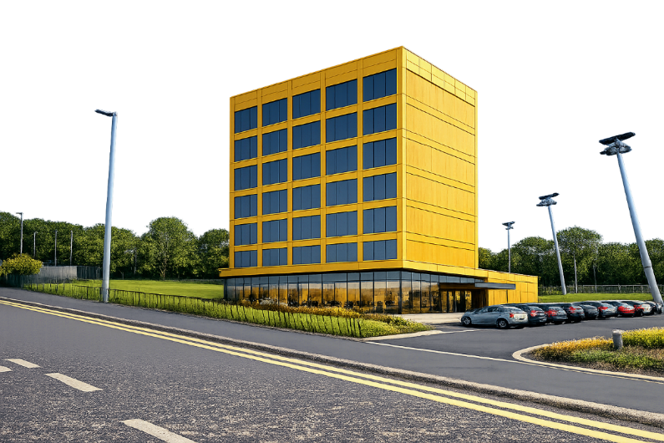
Figure 1. Proposed development orientation and elements (Goodrum, 2026a).

Figure 1 above shows that the design of the building is not complex in terms of building form, being cuboid in appearance. Although this is less visually appealing than a complex structure, the resulting design has less surface area and is a better-performing building that is also simple to construct, resulting in a shorter construction phase and less embodied carbon (Passivhaus Trust, 2020). The appearance of the building is not out of keeping with the locality, with the nearest buildings of significance being Singleton Hospital and Swansea University, comprising a mix of mainly modern and brutalist architecture (Swansea Bay University Health Board, no date).
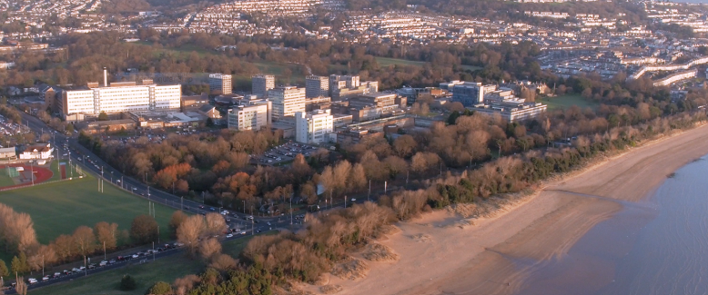
Figure 2. Proposal location and local architecture (Swansea Bay University Health Board, no date).
This simple building form with a framed structure will also allow greater flexibility of occupancy and use, with a simple design using framed structures and sectioned spaces being easier to convert than complex, highly individualised forms (Lüley, 2023). The hotel proposal could easily be converted into residential or commercial spaces. This adaptability approach can reduce the proposal’s environmental impact by extending the building’s operational life, reducing demolition waste, and lowering the amount of new construction required, in turn reducing the amount of carbon in construction. However, this adaptability may require greater upfront design and material input than traditional construction (ISO, 2020).
Using the building orientation to maximise the amount of daylight let into the building through the curtain walling and cladding elements, the building can reduce the amount of power consumed in the operational phase of the building’s lifecycle. British Standards Institution (2022) recommends that daylight is a critical design consideration for buildings.
The proposed design also looks to utilise the orientation and glazing to reduce the heating demand of the building by using solar gains as a passive design strategy, although using glazing on the building needs careful design consideration to prevent overheating and cooling of the building interior. Figures 2 and 3 below show how using sunshades above the glazing can help mitigate against thermal overheating in the summer and not prevent solar gains in the winter by not obscuring the low sun. Combining this with designing the glazing to be orientated horizontally, which gives better performance in terms of heat loss and gains compared to vertical glazing, means the performance of the proposed building will be further enhanced.
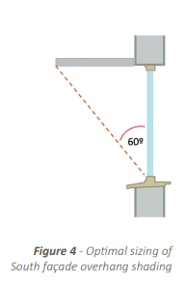
Figure 3. Solar shading of glazing (Passivhaus Trust, 2021a).
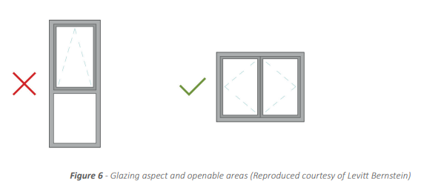
Figure 3. Glazing orientation for heat loss and gain performance (Passivhaus Trust, 2021b).
Although these proposed elements and design strategies will help reduce the building’s environmental impact and operational costs throughout its lifecycle, additional materials such as sunshades, and the resources required to install them, will increase the embodied carbon of the project. The use of virgin materials such as timber for the frame can offset some of these impacts by sequestering carbon within the structure, while also providing a large proportion of material that is readily recyclable and reducing the amount sent to landfill. A whole-life carbon assessment could therefore be undertaken for the development to assess the environmental impact of the various design elements at the design phase.
Adopting a lifecycle carbon assessment (LCA) will analyse the impact of the building during construction, operation, and demolition, from cradle to grave, and can enable informed decisions on the proposed design choices (RICS, 2017).
Another option, although not utilised in the proposal, to improve the building’s sustainability would be the addition of an internal or external green façade, also known as a living wall. An example of a living wall is shown in Figure 4 below, which shows how the Eden multi-storey commercial building in Manchester, UK, has created Europe’s largest living wall to enhance the sustainability and aesthetics of the project whilst creating a sustainable drainage system (SuDS) and promoting better outdoor connection with the users of the building in a built-up urban environment. The case study shows that, in order to integrate a green façade system into a building, there needs to be more input into the design phase to ensure the successful integration of the systems to install and keep the façade healthy, whilst also increasing the M&E works during the construction and operational phases of the building to install and maintain the equipment, in turn increasing the facilities management time, resource, and cost to keep the systems operational and the plants maintained (Swansea Council, 2026; CIBSE Journal, 2024).
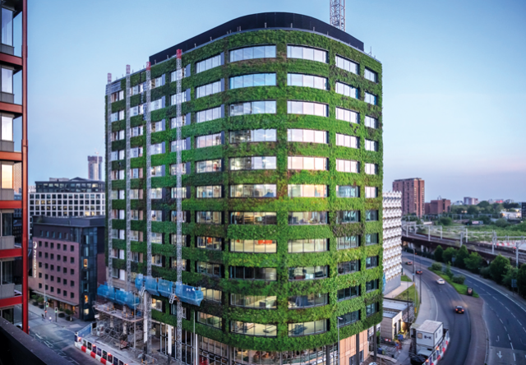
Figure 4. Screenshot of Case study: Manchester’s Eden.
The proposed building has not employed the use of a green façade and has instead focused on the other sustainability features mentioned for several reasons. The additional costs previously mentioned during the design, construction, and operational phases would reduce the return on investment and add to the already high facilities management costs associated with a high-use commercial building such as a hotel. The coastal location of the building can also dramatically affect plants due to the exposed, harsh conditions, and the installation of non-coastal species would make it difficult to maintain a healthy living wall. The other sustainable design features of the building can offset the omission of a green façade system.
There is a legal requirement within Wales, under Schedule 3 of the Flood and Water Management Act 2010, for commercial developments and any development greater than 100 m² to utilise a SuDS system to manage rainwater runoff from the development, reduce the risk of flooding, and protect the environment. The design of this system must comply with the Welsh Government statutory standards for SuDS (UK Government, 2010; Welsh Government, 2018a).
The use of a green façade in the development could have formed all or part of the SuDS system. Due to the omission of the green façade, other acceptable SuDS design strategies will need to be utilised, with calculations used to determine whether the proposed measures are suitable enough to comply with the technical guidance set out in CIRIA C753, The SuDS Manual, which is regarded as best practice for designing SuDS systems (Woods Ballard et al., 2015a).
Acceptable SuDS designs include permeable paving, swales, rain gardens, infiltration features, green roofs, and underground attenuation systems. Compliance with the previously listed documents and legislation should enable approval before construction of the system with the SuDS Approving Body (SAB) (Welsh Government, 2018b; Woods Ballard et al., 2015b).
The proposal intends to use a combination of strategies to first minimise the runoff created by the development and reduce the amount of storage required, and second to comply with the regulations by storing and slowly releasing the runoff generated by the development.
The use of permeable asphalt and paving on external hardstanding areas allows rainwater to infiltrate through the surface, reducing runoff rates and making use of the parking areas required for hotel guests.
Shallow grassed swales provide a means of storing and slowing runoff across the site, while leaving areas of grassland undeveloped to promote biodiversity. The development is mainly flat, with a slight fall from north to south, with the lowest point being on the south side. Given this information and the elevated adjacent properties, the swales have been located on the south side on the basis that this is the lowest point and the natural collection point for runoff to flow towards, while also providing access to local drainage infrastructure if required.
Figure 5 below shows a cross-section of a swale that can be utilised in the SuDS system for the proposal, consisting of a purpose-made depression in the landscape designed to hold rainwater runoff and slowly release the water to alleviate flood risk (United Utilities, 2022a).
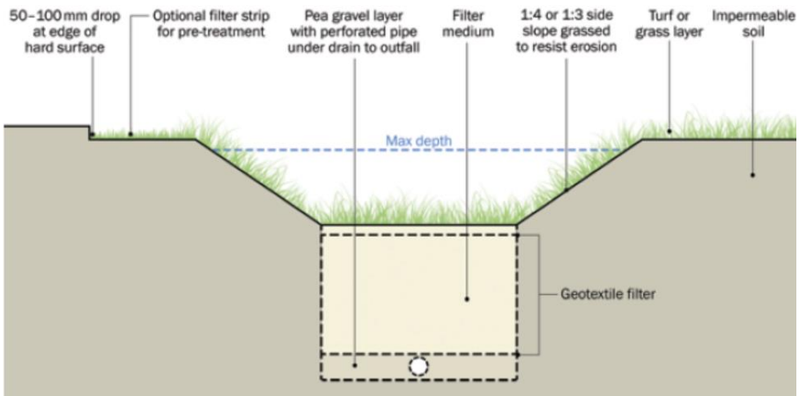
Figure 5. SuDS swale cross section.
Appendix A shows a plan view of the site and the approximate locations of the SuDS components of the development listed above.
The calculation below determines the swale size required for the SuDS proposal to store the runoff generated by the development. The site area is shown in Appendix B, with the permeable and impermeable surface areas shown in Appendices C to F. The soil type is shown in Appendix G and, for the purpose of this calculation, has been taken as clay loam.

Peak runoff calculation
Swansea m5-60 = 17mm (HCE Ltd, 2022)
Development area
Q = 2.78 × C × i × A
Q = Peak runoff rate (l/s)
C = Runoff coefficient (depends on land use)
i = Rainfall intensity (mm/h)
A = Catchment area in hectares

A coefficient of 0.2 for the permeable asphalt and paving has been used rather than the 0.9 used for impermeable asphalt and paving in line with guidance from the CIRIA manual.

Permeable asphalt area

Q = 2.78 × 0.2 × 17 × 1.03 (Woods Ballard et al., 2015c)
Q = 9.73 l/s

Building

Q = 2.78 × 0.9 × 17 × 0.49
Q = 20.84 l/s

Permeable Paving

Q = 2.78 × 0.2 × 17 × 0.30
Q = 2.84 l/s

Grassland

Q = 2.78 × 0.3 × 17 × 0.64
Q = 9.08 l/s

Total development peak runoff = 42.49 l/s

Greenfield runoff rate (Qbar)

Qbar = 0.00108 × Area^{0.89} × SAAR^{1.17} × SOIL^{2.17}

Qbar = Mean annual flood (m³/s)
Area = Catchment area (km²)
SAAR = Standard average annual rainfall for 1941–1970 (mm)
SOIL = Soil index

Qbar = 0.00108 × 0.5^{0.89} × 1136^{1.17} × 0.45^{2.17} (UK Centre for Ecology & Hydrology, no date; Marshall and Bayliss, 1994)
Qbar = 0.189 m³/s (for 50 ha site)
Qbar = 189 ÷ 50 = 3.78 l/s/ha
Qbar = 3.78 × 2.7 = 10.21 l/s

Total Greenfield runoff rate = 10.21 l/s

Storage volume
Storage volume = (Inflow rate − Outflow rate) × Duration
Inflow rate = Peak runoff (Q) (l/s)
Outflow rate = Greenfield runoff rate (Qbar) (l/s)
Duration = Storm duration (s)

V = (42.49 – 10.21) × (60 × 60)
V = 32.28 × 3600
V = 116,208 L
V = 116,208 ÷ 1000
V = 116.21 m³

Total water storage volume = 116.21 m³

Swale sizing

Figure 6. below shows the swale sizes used in the calculation to determine the size of the swale required to hold the volume of water for the SuDS calculation.

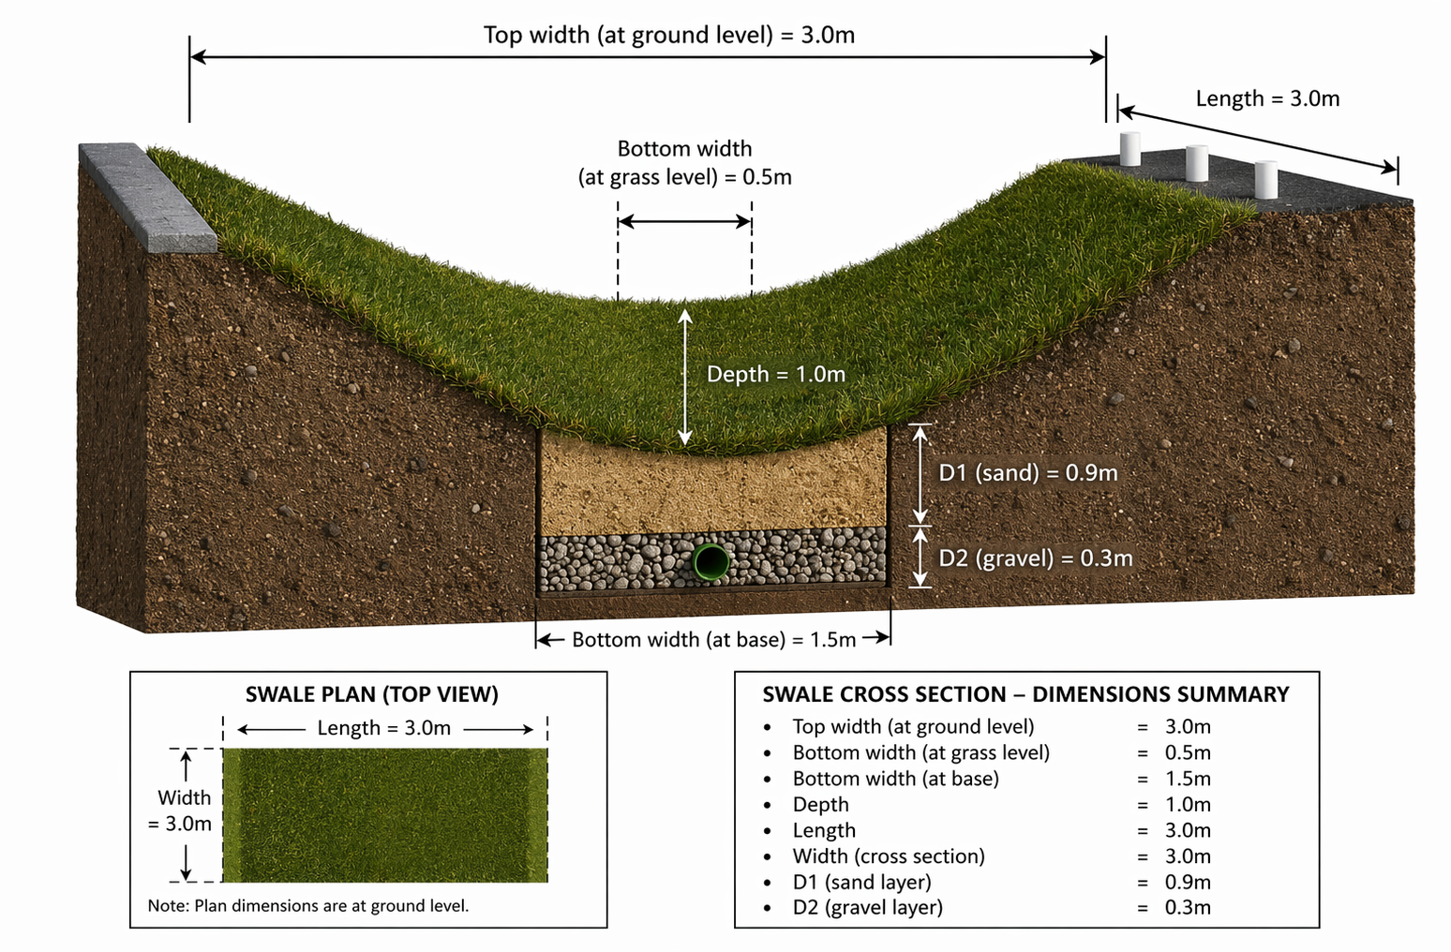
Figure 6. Swale cross section and dimensions (Goodrum, 2026c).

Calculating sand storage volume

Sand SVP = 0.30
Sand VFC = 0.25
Sand SVP (1 − VFC) = 0.225

V = L × W × D1
V = 3.0 × 1.5 × 0.9
V = 4.05 m³

Vs = V × SVP (1 − VFC)
Vs = 4.05 × 0.225
Vs = 0.911 m³ per 3 m swale

Calculating gravel storage volume

Gravel SVP = 0.30
Gravel VFC = 0.15
Gravel SVP (1 − VFC) = 0.255

V = L × W × D2
V = 3.0 × 1.5 × 0.3
V = 1.35 m³

Vg = V × SVP (1 − VFC)
Vg = 1.35 × 0.255
Vg = 0.34 m³ per 3 m swale

Calculating surface storage volume

V = 0.5 × D × (W1 + W2) × L
V = 0.5 × 1.0 × (3.0 + 0.5) × 3.0
V = 5.25 m³ per 3 m swale

Calculating total swale volume

Vt = V sand + V gravel + V surface
Vt = 0.911 + 0.34 + 5.25
Vt = 6.50 m³ per 3 m swale

Total swale volume per 3 m length = 6.50 m³

Total swale length calculation

Required swale length = 116.21 m³ ÷ 6.50 m³ × 3 m = 53.64 m

Total swale length needed = 53.64 m

Proposal Buildability
The proposed development lies within a plot of 2.7 ha, with a comparatively small building footprint relative to the overall size of the plot and good adjoining road infrastructure to facilitate the movement of resources and materials. These factors allow for efficient site set-up and demobilisation, together with material and plant storage for the construction of the development (Transport for London and CLOCS, 2021).
The simple form of the design and the use of modern methods of construction, with off-site prefabricated elements such as CLT and precast concrete sections, will create an efficient construction phase with minimal resources and less on-site construction required compared with traditional construction techniques. Appendix G shows the construction storyboard for the hotel development, showing the key activities and sequence of events during the construction phase and highlighting these modern methods of construction. The use of off-site manufactured components can eliminate complexities around site construction and material lead times, ensuring that there are no shortages during construction activities, reducing material and resource risks, and in turn reducing delays to the project (UK Government, 2022a).
The elimination of basement construction eliminates the need for excavations and the room associated with these activities for the storage and disposal of spoil, materials, and plant, decreasing the size of the supply chain, reducing the number of interfaces, simplifying the sequence of works, and reducing the logistics required around the development (Transport for London and CLOCS, 2021; HSE, 2015a).
Despite the positives mentioned above, the use of innovative MMC such as a CLT frame can lead to potential risks due to a lack of knowledge of this form of construction. The pool of available companies to fabricate and construct this material will likely be smaller than for traditional methods such as concrete frames. The availability of these companies may not align with the project programme, and any delays can have severe consequences due to resource unavailability. A lack of knowledge of these materials and the key quality aspects associated with them during construction could lead to defects going unnoticed, which could in turn lead to building failure during operation (RICS, 2024; UK Government, 2022b).
The design supports sustainability, safety, and efficiency using MMC and virgin materials, as previously mentioned. The design reduces on-site resource hours to complete with off-site construction, which in turn reduces the likelihood of accidents during construction. The lack of on-site construction also reduces the number of activities required to install the components, further reducing this risk. Although the construction of the building will require careful design considerations to eliminate risks, the simple design and lack of site constraints result in a project that is both achievable and efficient (HSE, 2015b).

Conclusion
The hotel development is both sustainable and buildable, it looks to incorporate cutting edge methods of construction to address sustainability in construction issues and reducing any impact the development has on the surrounding environment. The proposal also takes a whole life approach looking at tomorrows building requirements and how buildings can be repurposed beyond what they were initially required to do and at end of life scenarios how to minimise the impact on the environment.

Appendices

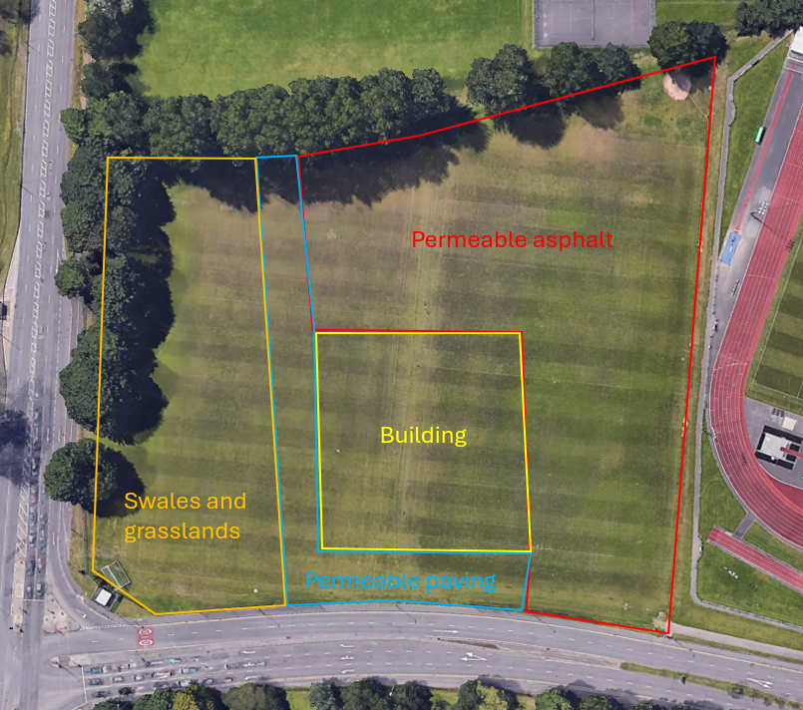
Appendix A. Proposed SuDS component locations (Google Earth, no date a).

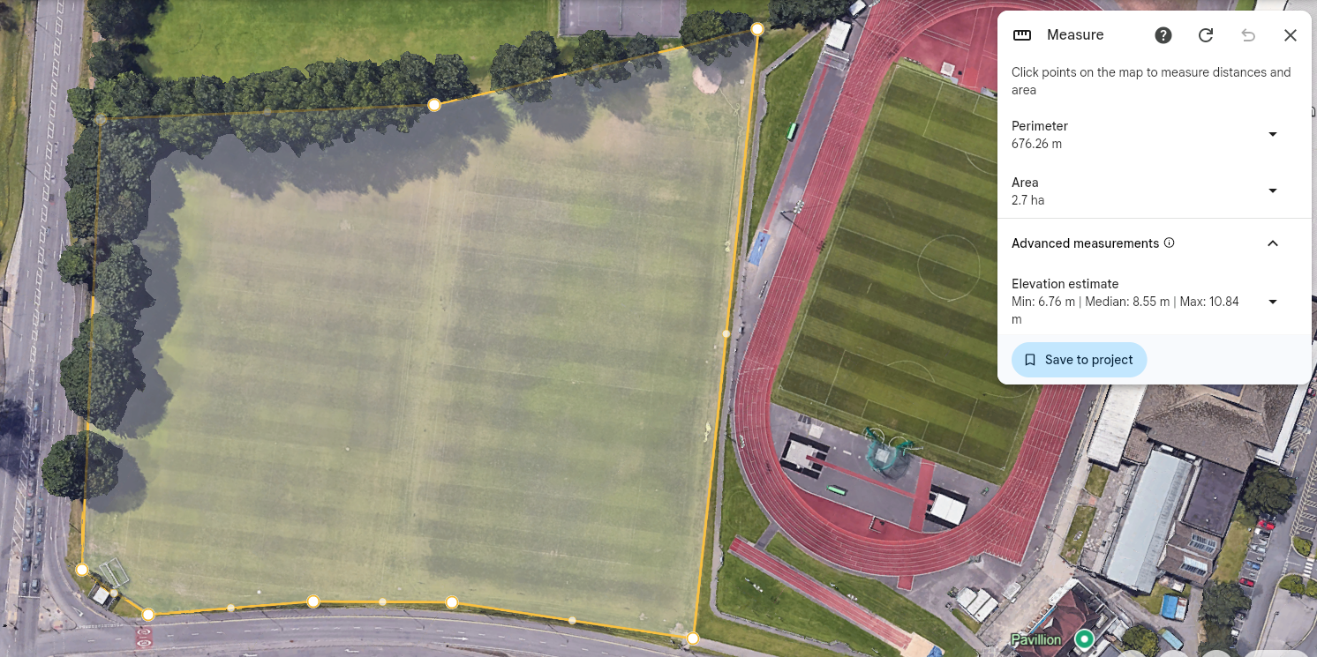
Appendix B. Total site area (Google Earth, no date b).
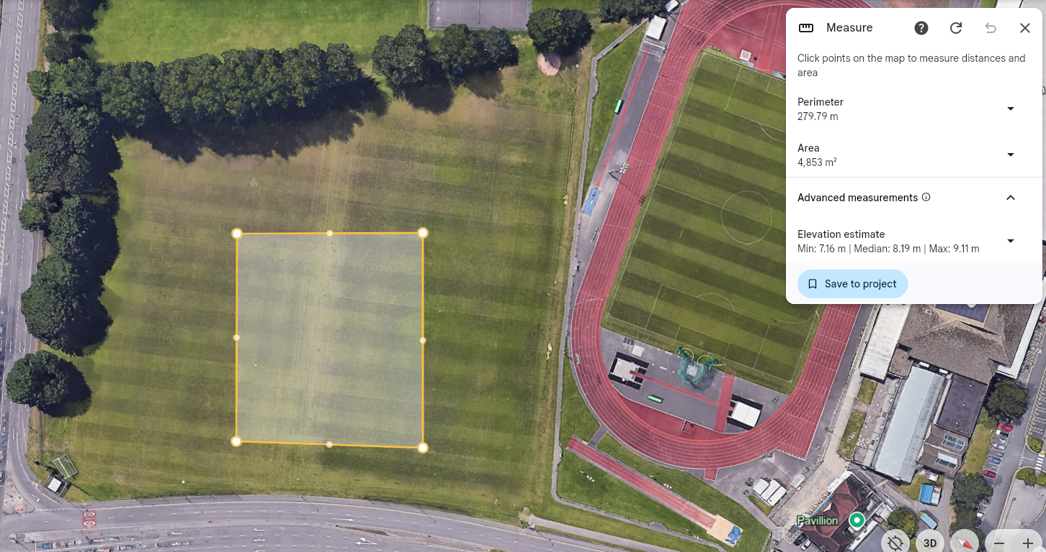
Appendix C. Area of building (Google Earth, no date c).

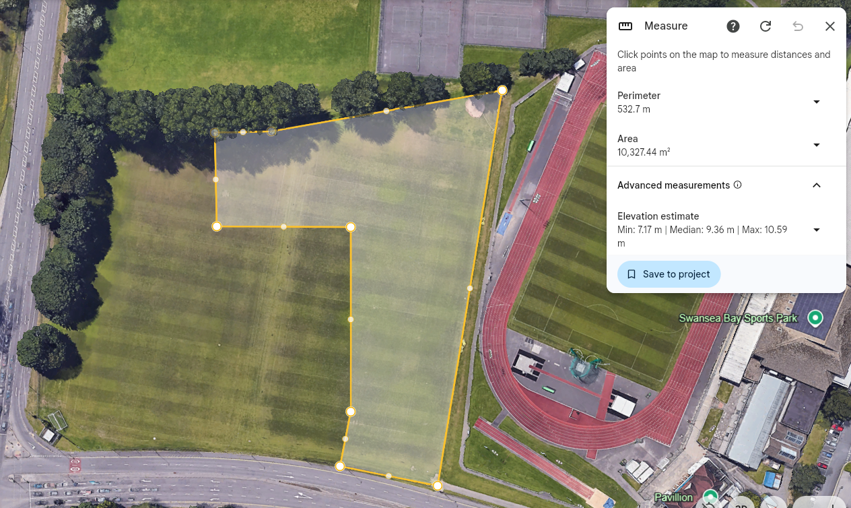
Appendix D. Area of asphalt (Google Earth, no date d).

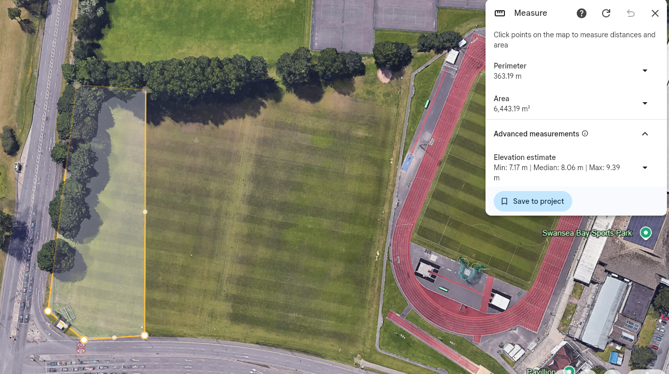
Appendix E. Area of grassland (Google Earth, no date e).

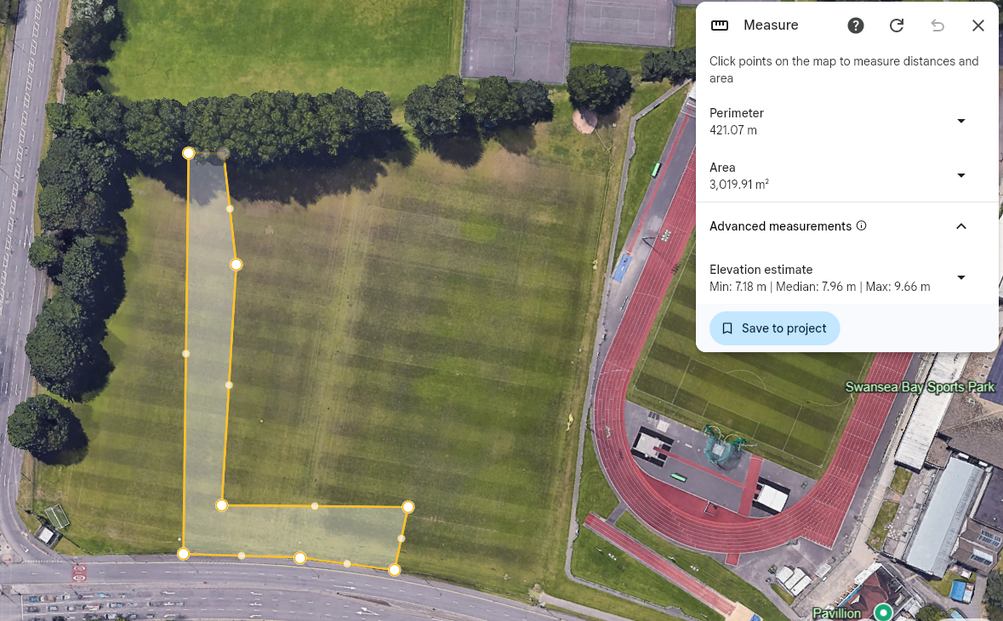
Appendix F. Area of paving (Google Earth, no date f).
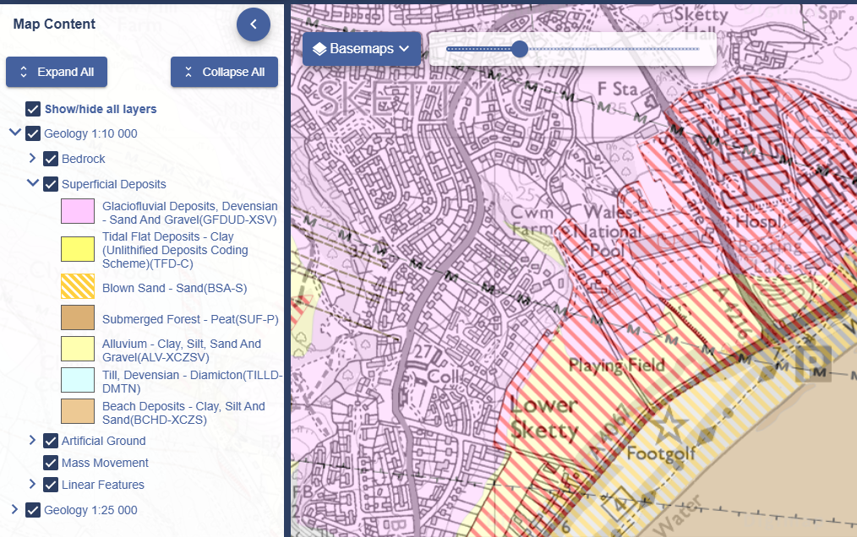
Appendix G. Development soil type (EDINA Digimap, no date).

References

British Standards Institution (2022) BS EN 17037:2018+A1:2021, Daylight in buildings. London: BSI
CIBSE Journal (2024) Case study: Manchester’s garden of Eden. Screenshot from webpage. Available at: https://www.cibsejournal.com/case-studies/case-study-manchesters-garden-of-eden/ (Accessed: 5 June 2026).
EDINA Digimap (no date) Geology Roam map. Screenshot from online map. Available at: https://digimap.edina.ac.uk/roam/map/geology (Accessed: 7 June 2026).
Goodrum, J (2026a) AI-generated visualisation of a multi-storey commercial CLT building with glazed ground floor and adjacent car park, based on site photograph. Created using Microsoft Copilot (OpenAI), 16 May.
Goodrum, J. (2026b) Construction storyboard for multi-storey hotel development (CLT frame and concrete core). AI-generated image. Created using Microsoft Copilot (GPT-5), June 2026. Unpublished.
Goodrum, J (2026c) Swale cross-section showing grassed surface, sand and gravel layers with dimensions (L = 3 m, W = 1.5 m, D1 = 0.9 m, D2 = 0.3 m). AI-generated image. Created using Copilot (GPT-5). Unpublished.
Google Earth (no date a) Location view at 51.60604905, -3.98626288. Screenshot from online map. Available at: https://earth.google.com/web/@51.60604905,-3.98626288,8.9589521a,364.59974636d,35y,235.38929876h,0t,0r/data=CgRCAggBQgIIAEoNCP___________wEQAA?hl=en-GB (Accessed: 9 June 2026).
Google Earth (no date b) Location view at 51.60604905, -3.98626288. Screenshot from online map. Available at: https://earth.google.com/web/@51.60604905,-3.98626288,8.9589521a,364.59974636d,35y,235.38929876h,0t,0r/data=CgRCAggBQgIIAEoNCP___________wEQAA?hl=en-GB (Accessed: 9 June 2026).
Google Earth (no date c) Location view at 51.60604905, -3.98626288. Screenshot from online map. Available at: https://earth.google.com/web/@51.60604905,-3.98626288,8.9589521a,364.59974636d,35y,235.38929876h,0t,0r/data=CgRCAggBQgIIAEoNCP___________wEQAA?hl=en-GB (Accessed: 9 June 2026).
Google Earth (no date d) Location view at 51.60604905, -3.98626288. Screenshot from online map. Available at: https://earth.google.com/web/@51.60604905,-3.98626288,8.9589521a,364.59974636d,35y,235.38929876h,0t,0r/data=CgRCAggBQgIIAEoNCP___________wEQAA?hl=en-GB (Accessed: 9 June 2026).
Google Earth (no date e) Location view at 51.60604905, -3.98626288. Screenshot from online map. Available at: https://earth.google.com/web/@51.60604905,-3.98626288,8.9589521a,364.59974636d,35y,235.38929876h,0t,0r/data=CgRCAggBQgIIAEoNCP___________wEQAA?hl=en-GB (Accessed: 9 June 2026).
Google Earth (no date f) Location view at 51.60604905, -3.98626288. Screenshot from online map. Available at: https://earth.google.com/web/@51.60604905,-3.98626288,8.9589521a,364.59974636d,35y,235.38929876h,0t,0r/data=CgRCAggBQgIIAEoNCP___________wEQAA?hl=en-GB (Accessed: 9 June 2026).

HCE Ltd (2022) Storm Water Drainage Calculations for New Production Facility at TIMET UK, Waunarlwydd, Swansea. Document no. HCE-1546-CVD-CAL-001, Rev. R03, February 2022. Available at: https://www.evansbanks.com/wp-content/uploads/2022/02/HCE-1546-CVD-CAL-001-SW-Drainage-Calculations.pdf (Accessed: 7 June 2026).
Health and Safety Executive (HSE) (2015a) Managing health and safety in construction: Construction (Design and Management) Regulations 2015. Guidance on Regulations. L153. Available at: https://books.hse.gov.uk/gempdf/L153.pdf (Accessed: 9 June 2026).
Health and Safety Executive (HSE) (2015b) Managing health and safety in construction: Construction (Design and Management) Regulations 2015. Guidance on Regulations. L153. Available at: https://books.hse.gov.uk/gempdf/L153.pdf (Accessed: 9 June 2026).
International Organization for Standardization (ISO) (2020) ISO 20887:2020 Sustainability in buildings and civil engineering works — Design for disassembly and adaptability — Principles, requirements and guidance. Geneva: ISO. Available at: https://www.iso.org/standard/69370.html (Accessed: 27 May 2026)
Lüley, M. (2023) ‘Ephemeral occupancies: Non-linear approach to adaptable architecture’, ALFA, 28(2). Available at: https://www.usablebuildings.co.uk/UsableBuildings/Unprotected/EphemeralOccupancies.pdf (Accessed: 27 May 2026).
Marshall, D.C.W. and Bayliss, A.C. (1994) Flood estimation for small catchments. Wallingford: Institute of Hydrology. (IH Report No. 124). Available at: https://nora.nerc.ac.uk/id/eprint/7367/1/IH_124.pdf (Accessed: 7 June 2026).
Passivhaus Trust (2020) What is Passivhaus? Easi Guide. [PDF] London: Passivhaus Trust. Available at: https://www.passivhaustrust.org.uk/UserFiles/File/research%20papers/easi%20guide%20PH%20design/Passivhaus%20easi-guide_screen_portrait.pdf (Accessed: 27 May 2026).
Passivhaus Trust (2021) Avoiding summer overheating: guidelines for summer comfort in Passivhaus buildings and the PHT Summer overheating tool. [PDF] London: Passivhaus Trust. Available at: https://passivhaus.uk/wp-content/uploads/2024/10/Avoiding-summer-overheating.pdf (Accessed: 20 May 2026).
Royal Institution of Chartered Surveyors (RICS) (2017) Whole life carbon assessment for the built environment. 1st edn. London: RICS. Available at: https://www.rics.org/content/dam/ricsglobal/documents/standards/whole_life_carbon_assessment_for_the_built_environment_1st_edition_rics.pdf (Accessed: 27 May 2026).
Royal Institution of Chartered Surveyors (RICS) (2024) Developing a construction procurement strategy and selecting an appropriate route. 2nd edn. Available at: https://www.rics.org/content/dam/ricsglobal/documents/standards/Developing-a-construction-procurement-strategy.pdf (Accessed: 9 June 2026).
Swansea Bay University Health Board (no date) Singleton Hospital. Screenshot. Available at: https://sbuhb.nhs.wales/hospitals/our-hospitals/singleton-hospital/ (Accessed: 2 June 2026).
Swansea Council (2026) Green wall information. Available at: https://www.swansea.gov.uk/greenwallinfo?lang=en (Accessed: 5 June 2026).
Transport for London and CLOCS (2021) Construction Logistics Planning Guidance. Version 1.2. Available at: https://www.tfl.gov.uk/cdn/static/cms/documents/clp-guidance-clocs.pdf (Accessed: 9 June 2026).
UK Centre for Ecology & Hydrology (no date) FEH Web Service. Available at: https://fehweb.ceh.ac.uk/ (Accessed: 7 June 2026).
UK Government (2010) Flood and Water Management Act 2010, Schedule 3: Sustainable drainage. Available at: https://www.legislation.gov.uk/ukpga/2010/29/schedule/3 (Accessed: 5 June 2026)
UK Government (2022a) Modern Methods of Construction Guidance Note. Available at: https://assets.publishing.service.gov.uk/media/631222468fa8f5423fb0c7c0/20220901-MMC-Guidance-Note.pdf (Accessed: 9 June 2026).
UK Government (2022b) Modern Methods of Construction Guidance Note. Available at: https://assets.publishing.service.gov.uk/media/631222468fa8f5423fb0c7c0/20220901-MMC-Guidance-Note.pdf (Accessed: 9 June 2026).
United Utilities (2022a) S104 SuDS Guidance Document: Swales. Version 3, October 2022. Available at: https://www.unitedutilities.com/globalassets/documents/builders--developers-docs/s104-suds-guidance-document-swale.v3.pdf (Accessed: 7 June 2026)
United Utilities (2022b) S104 SuDS Guidance Document: Swales. Version 3, October 2022. Available at: https://www.unitedutilities.com/globalassets/documents/builders--developers-docs/s104-suds-guidance-document-swale.v3.pdf (Accessed: 7 June 2026).
Welsh Government (2018a) Statutory national standards for sustainable drainage systems. Available at: https://www.gov.wales/sites/default/files/publications/2019-06/statutory-national-standards-for-sustainable-drainage-systems.pdf (Accessed: 5 June 2026).
Welsh Government (2018b) Statutory national standards for sustainable drainage systems. Available at: https://www.gov.wales/sites/default/files/publications/2019-06/statutory-national-standards-for-sustainable-drainage-systems.pdf (Accessed: 5 June 2026).
Woods Ballard, B., Wilson, S., Udale-Clarke, H., Illman, S., Scott, T., Ashley, R. and Kellagher, R. (2015a) The SuDS Manual. CIRIA C753. London: CIRIA. Available at: https://www.ciria.org/CIRIA/Books/Free_publications/C753F.aspx (Accessed: 5 June 2026)
Woods Ballard, B., Wilson, S., Udale-Clarke, H., Illman, S., Scott, T., Ashley, R. and Kellagher, R. (2015b) The SuDS Manual. CIRIA C753. London: CIRIA. Available at: https://www.ciria.org/CIRIA/Books/Free_publications/C753F.aspx (Accessed: 5 June 2026)
Woods Ballard, B., Wilson, S., Udale-Clarke, H., Illman, S., Scott, T., Ashley, R. and Kellagher, R. (2015c) The SuDS Manual. CIRIA C753. London: CIRIA. Available at: https://www.ciria.org/CIRIA/Books/Free_publications/C753F.aspx (Accessed: 7 June 2026).

