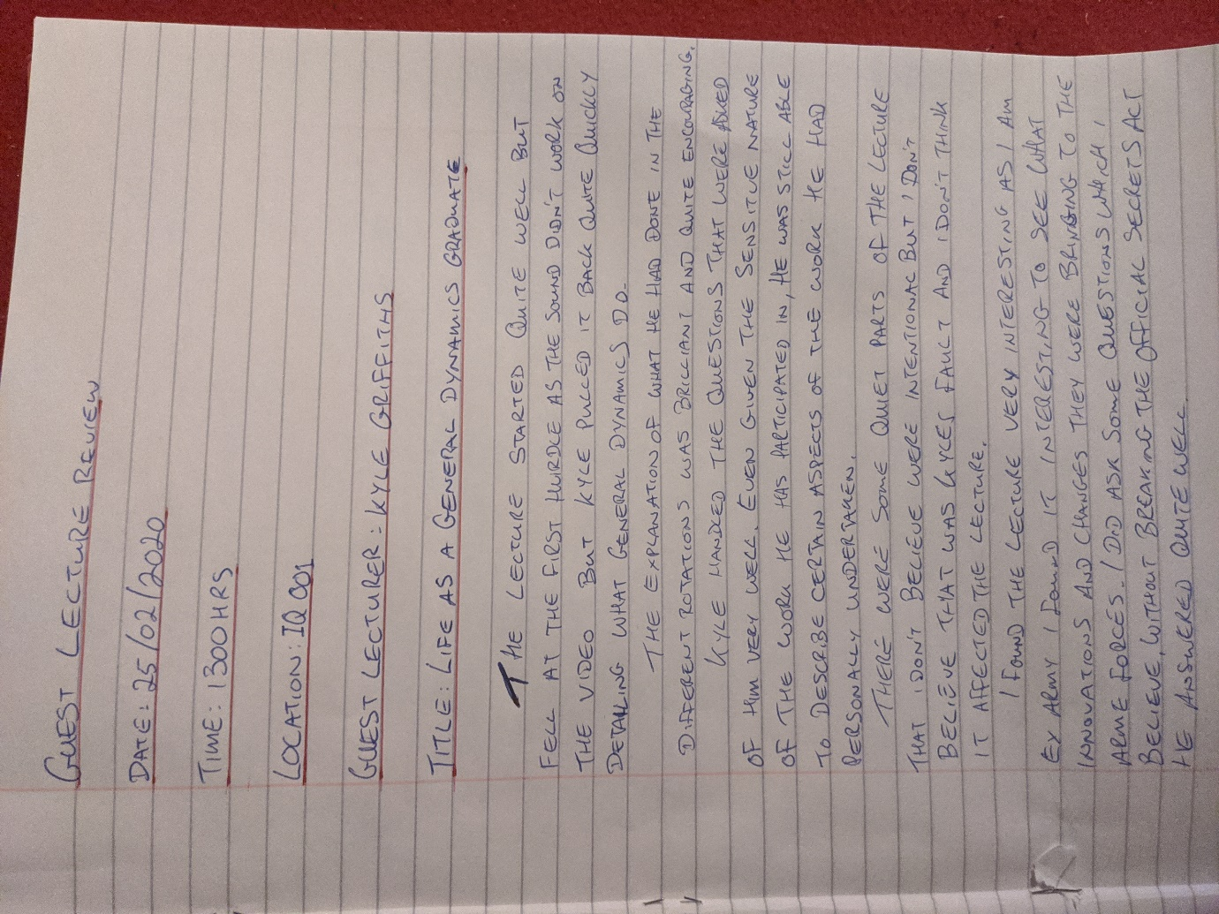

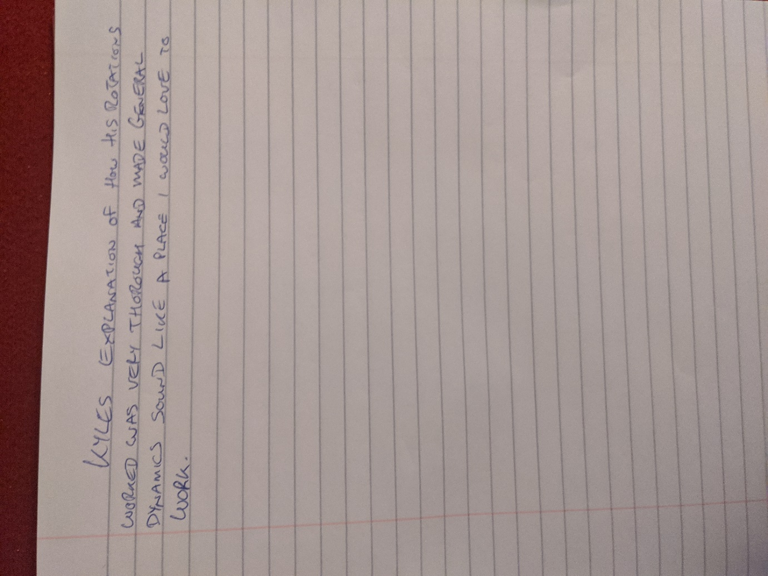

J j j j j j j j j j j j j j j j j j j j j j j j j j j j j j j j j j j j j j j j j j j j j j j j j j j j j j j j j jj j j j j j j j j j j j j

