(2119559) Marian Postolache
Doreen Nyaa Amundam
Academic and Employability Skills
BMSW4001_BIRM
Task 2
Reflective report

Abstract
The report is based on the implementation of technology that is helpful to add a competitive advantage on an overall purpose. In the following task, the report focused on several of the questions which were being asked to the participants to gather considerable amounts of knowledge. Here, the methods that have been taken are the quantitative survey approach which is helpful to a certain degree. Moreover, the fact is that in the entire task, the focus has been made on the aspects of the technology and the advantages that have been probed by it in the future.
Besides, this report also highlighted some of the other aspects that are crucial in the following task. The entire basis of the study is focused on the innovative strategies that are helpful in due course of action. On another ground, it can be defined that most of the questions which are being asked are based on creative notions that are competitive.
Table of Contents
Introduction 4
Research Design 4
Research Questions 4
Methods 5
Ethical Considerations 5
Results 6
Discussion 7
Conclusion 8
References 10
Appendix 11

Introduction
In the present form of the competitive world, most people are implementing technologies to attain a competitive position. These have some of the variations by which benefit is being achieved (Attarzadeh et al., 2022). The paper will therefore discuss how technology has been able to pose a unique position in the life of the people through the acquisition of different forms of innovative techniques. A detailed account will be provided based on the topic and the relevant discussion based on the participants' answers on the following case for debate. Also, the report will discuss the results that have been achieved by the participants and further what could be done in response to the topic. Henceforth the overall discussion will be made on the topic that is relatively related to technology and the strategies that are essential for the following course of action. It can again be stated that in the mere phase of the future, this will help them to achieve a sustainable notion in the long run. Again the confirmation is based on the fact that it is the utilisation of technology that has helped to enhance the growth and development aspects in the long term basis over some time.

Research Design

Research Questions
The research questions are:
Q1 What are the present forms of technology that have helped the people?
Q2 Are any innovative approaches available for the development of technology?
Q3 Do you approve with the argument that creativity can produce a beneficial aspect in the future?
Q4 What are the different traits of technology which can make it better?
Q5 What type of advantages are provided by the technology?

Methods
In the following research work, the methods which are followed are quantitative data analysis techniques. This has been made by the process of a survey questionnaire (Dwivedi, 2022). The implementation of the survey procedure has helped to gather relevant knowledge regarding the topic of discussion. Insistently, it can be marked that with the help of the survey procedure, enough of the information is taken into account, which is competitive. Again the key element is that the quantitative process of the data collection includes several procedures which are competitive.
The questions which are asked are:
Q1 What is your gender?
Q2 What digital tool is used for the process of the collaboration?
Q3 Does technology improve the form of the school work?
Q4 Is collaboration on an online procedure improving the school work?
Q5 Are MS teams helpful to perform school work?
Q6 Which type of technology is comfortable for you?
The questions which were asked were from eminent personalities who were college students. These were the people who mostly employed technology as one of the forms that help. Moreover, it can be stated that these people made use of the form of technology to gather competitive advantage in the future (Gnanadurai et al., 2022). Besides this, other individuals use technology to get accumulated to the different forms of technology, and thus a profitable aspect is earned on an overall purpose. Also, online conduction was made by which the participants were conducted such that they were connected on a long-term basis. It is such that the recipients were contacted via social media also. It can again be said that

Ethical Considerations
In the following research report, ethical considerations have been followed. The data which has been gathered will not be used for any commercial purposes. And such is that the process which has been employed will also not be employed for any purpose in the future (Khlaif and Salha, 2022).
Moreover, it can be explained that ethics has been maintained in the following research work, and thus there is no kind of transparency in work. It is such that whatever the information is gathered, each of the information is collectively not used for any reason in the long run respectively. Moreover, it can be confirmed that honesty is maintained in the report. It can be formed so that no kind of dishonesty is followed.

Results
From the following charts and the graphs, it can be seen that most of the participants are agreeable to the proposition (Mukherjee and Mitra, 2022). It can be formed that in each of the questions, the participants are variable. Again the critical fact is that most of them make use of the MS teams frequently. Also, it can be stated that the people use or implement the two software at a given period. From the following graphs, it can be seen that MS word is one of the software which been being used by individuals over some time.
Again, it can be stated that with the help of collaboration, the teams can work confidently and such is that each of them makes use of the software in many ways (Shaheen, 2022). It can be formulated that the answers which are being gathered from the following respondents accumulate to the fact that they have positive implications over some time.
The implication which can be given in this case is that each of the student's responses is a positive one and such that they have a belief that the utilisation of the MS teams is helpful to some extent or the other. It is so that, on a certain basis, the fact is that in the online mode, the process of collaboration is helpful to some extent or the other in a long term process in the long run, respectively. From the given analysis, it can be formed that the entire answer which had been received is based on the fact which assimilates the key proposition that technology plays one of the major roles in the growth of education. On a further basis, it can be formed that it is the utilisation of strategies of technology that is helpful over some time. Even the online mode of the strategy is helpful to some extent. In other words, the analysis portion has shown how technology throws a positive type of impact on the minds of people.

Discussion
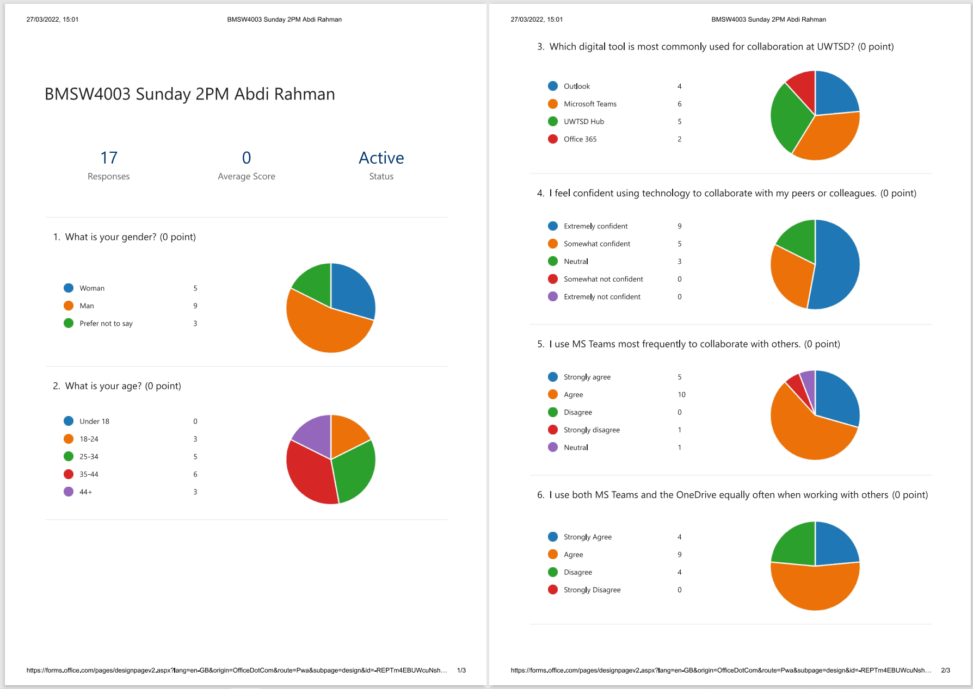
In the following analysis, the section can be formed that technology plays one of the dominant roles in shaping the organisational Structure. The fact of the essence is that in the comprehensive report, the results which have been obtained imply the fact that simultaneously two technologies can be used that are competitive.
These appear to show that all the participant's answer was more or less similar at some point of action. It can again be stated that each of the answers which are provided in some of the other cases regulates the fact that matches the research questions that are being asked in the long run.
The implication is that in each of the questions, the answer that came up in some of the other ways had a positive notion of an overall purpose (Potashnik, 2022). The fascinating fact is that in each of the questions that were asked to the participants, some of the objectives that were being asked were true to some extent or the other. It is such that the overall analysis that was made contained some of the points that are important for discussion.
It can be marked that the following analysis which was made contained some points that are important (Syvyi et al., 2022).
The following discussion that was being made focused on the fact that each of the questions was thoroughly being asked in the concept of technology, and such is that technology has some positive implications on an overall basis. The statement which can be nurtured in this case is that today's learning is impossible without the means of the implementation of strategies of technology on a long-term basis. The fact of the essence is this adds to a productive account.

In consideration of the following statement, it can be made that technology plays a significant role to uphold a positive implication to the life of the students. Besides this, it can be determined that the use of the different strategies of technology is helpful to a certain degree of competency. Again the fact is that the utilisation of the following strategies is useful in the future. Moreover, the purpose is that each of the technologies which will be used perhaps will have some benefit in the long run.
According to the research questions which are being asked, it can be marked that technology can be taken as one of the perspectives that is helpful to produce a beneficial aspect in the mere future. The concluding fact is that the graphs which are being shown are entitled to the fact that most people are of the proposition that either of the two options any software can be employed across a given period. Besides this, it can be formed that by the process of following trends of technology, beneficial aspects are earned in the long run.
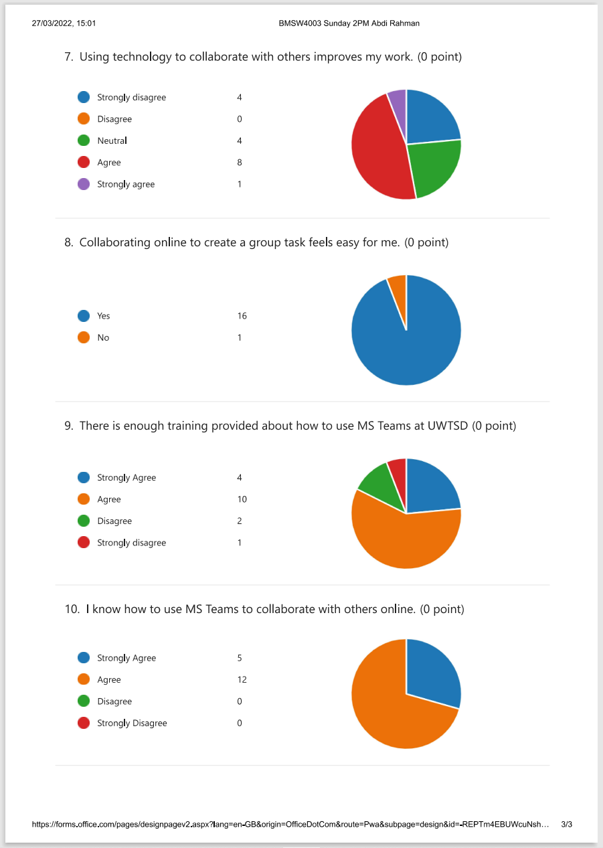
Therefore, the implication which can be put in this case is that technological insights can produce effective regulation on a long-term basis. The fact or the statement that can be put in this case is that this will help to achieve a productive gain in the future. The principle is such that through the use of the following technology, the people will be able to adopt a huge amount of knowledgeable facts through the process of the following notions of the resources. It can be formed so that by the process of the following types of technologies, a useful aspect is being achieved in a long-term process.
Therefore, it can be stated that from the following analysis, the results have shown wider importance of the use of technology that adds a competitive background. It can again be held that each of the following resp[ondents have explored differently.
It can so be formed that technology has helped to a greater extent in the future. In other terms, it can be confirmed that the analysis which has been made in the previous portion alludes to the fact which is the function that is being played by technology.
It is the implementation of technological insights that have added a greater competitive advantage in the present times. Furthermore, this will help to establish a proper connection to the helpful perspectives. The underlying fact is that the utilisation of efficient technology is helpful to a certain degree of competence. Perhaps, a proper benefit is achieved on an overall purpose which enhances the value in the long run.

Conclusion
Based on the overall report is based on the methodology which is being used to ask questions based on the topic of discussion. In the entire report, it can be determined that the overall report is based on the strategies that are useful in the long run. Moreover, in the entire task, the implication is that each of the technologies used is elaborately described, which is helpful for the future. It can so be impacted that in the competitive world, as everything is becoming advanced, it is the fact that each of the advancements is very much beneficial to attaining a productive notion in the future.
Here the key area is that in the overall report, the fact is that the survey method has been enunciated, which is believed to be beneficial in an overall procedure. Therefore, it is justifiable to remark that in each of the following questions which are being asked, there is a kind of important notion in the future.
The implication is that technology plays one of the critical roles in each of the instances, which is regarded as one of the compelling propositions within a period. On a fundamental basis, this is described in the entire report.

References
Attarzadeh, F., Gurkan, D. and Benhaddou, D., 2022, March. Innovative improvements to engineering technology laboratory education to engage, retain and challenge students of the 21st century. In 2006 GSW.
Dwivedi, P., 2022. Technology of Education and Instruction. KK Publications.
Gnanadurai, J.B., Thirumurugan, S. and Vinothina, V., 2022. Exploring Immersive Technology in Education for Smart Cities. In Immersive Technology in Smart Cities (pp. 1-25). Springer, Cham.
Khlaif, Z.N. and Salha, S., 2022. Exploring the factors influencing mobile technology integration in higher education. Technology, Pedagogy and Education, pp.1-16.
Mukherjee, D. and Mitra Thakur, G.S., 2022. Generic Course Outcomes For Internationally Evolving Futuristic Outcome-Based Technology Education And A Model Of Their Implementation. Available at SSRN 4023579.
Shaheen, N.L., 2022. Accessibility4Equity: Cripping technology‐mediated compulsory education through sociotechnical praxis. British Journal of Educational Technology, 53(1), pp.77-92.
Potashnik, M., 2022. Cost analysis of information technology projects in education: experiences from developing countries.
Syvyi, M., Mazbayev, O., Varakuta, O., Panteleeva, N. and Bondarenko, O., 2022. Distance learning as innovation technology of school geographical education. arXiv preprint arXiv:2202.08697.

Appendix


