

Student’s Name: Cristina Mutu
Student’s ID: 2012841
Module title: Foreign languages and cultural awareness
Lecturer’s Name: Rodrigo Fernandes Aguilera


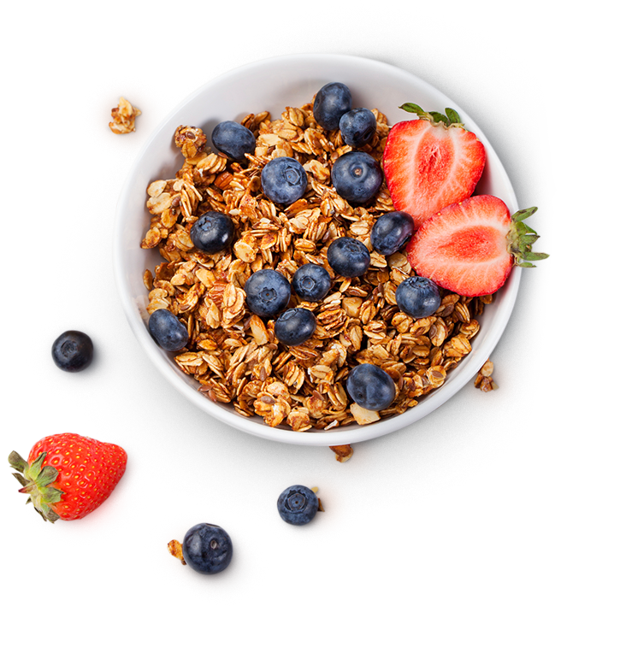


08:00 AM – 11:00 AM
Croissants Franceses
&
Espresso
£5.00
French Croissants
&
Espresso
£5.00
BREAKFAST MENU/ TABLERO DE DESAYUNO
Quesadilla de Desayuno
&
Cafe con leche
£8.00
Huevos Escalfados y Aguacate
Capuchino
£7.00
Huevos, Salchichas, Pan
&
Cafe con leche
£8.00
Avena, Plátano, Miel
&
Café Macchiato
£7.50
Breakfast Quesadilla
&
Caffe Latte
£8.00
Poached Eggs & Avocado
&
Capucinno
£7.00
Oatmeal, Banana, Honey
&
Café Macchiato
£7.50
Eggs, Sausages, Bread
&
Caffe Latte
£8.00
Honey Waffles
&
Espresso
£6.00
Waffles con miel
&
Café exprés
£6.00

