
Placement Research Project
The impact of technology on staff shortages at the reception: A case study of Hotel Belvilla Crewe City Centre



The impact of technology on staff shortages at the reception: A case study of Hotel Belvilla Crewe City Centre

Student Name: Marina Georgiana Hogea
Student ID: 2131351
Module: Hotel Placement Research Project
Module Code: BMIH6008
Lecturer: Ben Chong

I confirm that I have not presented any AI generated text as my own work. I confirm I have copies of my drafts, notes, and other resources I used before, and after the use of AI tools which I may be asked to provide in evidence.
Abstract
The subsequent research has thoroughly given an understanding of technology which results in staff shortages in the reception designation at Hotel Belvilla Crewe City Centre. The first section has provided an overview of the research background included with research objectives. Furthermore, the literature evaluation has given more understanding of the technological influence on staff shortages throughout hotel industries. This has been done with the help of secondary books, journals and publications. Moreover, the methodology section has covered all the steps undertaken by the researcher to perform the investigation. Additionally, the case study hotel overview has uncovered many knowledge about the hotel such as its background, location, turnover, branches along with its internal and external environment.

Table of Contents
Chapter One: Introduction 5
1.1 Introduction 5
1.2 Aim and Objectives 5
1.3 Research Questions 5
1.4 Research Background 6
1.5 Project Scope and Structure 6
Chapter Two: Literature Review 8
2.1 Introduction 8
2.2 Examining the extent to which technology, including self-service applications, can reduce the necessity for reception personnel while simultaneously ensuring operational efficiency 8
2.3 Assessing the benefits and drawbacks of implementing automated solutions in reception services 10
2.4 Suggesting a balanced approach to the integration of technology and human interaction that ensures inclusivity for visitors who prefer non-digital options or cash payments 12
2.5 Literature Gap 14
2.6 Summary 15
Chapter Three: Research Methods 16
3.1 Introduction 16
3.3 Research Philosophy 16
3.4 Research Approach 17
3.5 Research Strategy 17
3.6 Research Methods 18
3.7 Data Collection Tools 18
3.8 Data analysis 18
3.9 Time Horizon 19
3.10 Ethical consideration 19
3.11 Summary 19
Chapter Four: Case Study Hotel Overview and Findings 20
Chapter Five: Exploration of Themes and Discussion 31
5.1 Thematic Analysis 31
5.2 Discussion 42
Chapter Six: Conclusion 45
Chapter Seven: Recommendations 47
References 50

Chapter One: Introduction

1.1 Introduction
The following section will briefly provide knowledge on the effect of technology on staff shortages in the reception of Hotel Belvilla Crewe City Centre. Here, a thorough overview of the research goals will be shown. Depending on these factors, the background based on which the research is being performed will be included followed by a scope and structure.

1.2 Aim and Objectives
Aim
To understand the impact of technology on staff shortages at the reception: A case study of Hotel Belvilla Crewe City Centre.
Objectives
1. To examine the extent to which technology, including self-service applications, can reduce the necessity for reception personnel while simultaneously ensuring operational efficiency.
2. To assess the benefits (e.g., cost savings, efficiency) and drawbacks (e.g., loss of human interaction, resistance to technology) of implementing automated solutions in reception services.
3. To suggest a balanced approach to the integration of technology and human interaction that ensures inclusivity for visitors who prefer non-digital options or cash payments.

1.3 Research Questions
1. How can technology, including self-service applications, be leveraged to address staffing shortages at the reception while balancing operational efficiency, guest inclusivity, and exceptional service delivery, and what are the advantages and disadvantages of such an approach?

1.4 Research Background
Over time, the hospitality sector has been facing a consistent problem of staff shortages, mainly in reception areas that has directly impacted customer service quality and operational success. It is known that technology has turned out to be a vital solution to overcome many problems (Steinhardt, 2024). This way, hotels have started to use automated check-in systems along with light or heat which are activated by motion detection sensors as per the season. During this time, the hotel acts as a suitable case study in exploring how technological developments have influenced staffing problems in the reception area (rightrevenue, 2024). After examining the incorporation of self-service kiosks and automated communication tools, the research would investigate the efficiency of technology. Such efficiency is based on reducing dependence on human reception employees while keeping service qualities and guest satisfaction. Thus, the research will be able to offer knowledge into the productivity and sustainability of technology-based solutions for hospitality staffing (Jiwnani, 2024).

1.5 Project Scope and Structure
The current hospitality sector is surrounded with major employee shortages that have risen in reception areas, and it impacted guest experiences. While overcoming the problems, many hotels have started to use technological solutions. Deploying AI systems like automated check-in kiosks or virtual concierges holds potential in streamlining operations and decreasing the dependence on human employees (Lacalle, 2024). For example, AI chatbots are useful to handle guest inquiries or booking properly to overcome the workload that is put on reception personnel. Therefore, the study emphasises on the Hotel Belvilla Crewe City Centre to examine how technological integration has influenced the reception staffing.

Chapter Two: Literature Review

2.1 Introduction
The summarised document of many scholarly sources about the research topic is considered a literature review. This refers a comprehensive analysis which has collected data from books, past research and journals. This context will discuss the impact of technology on the reception activities. Alongside this, the necessity of self-service applications to minimise the reception staff will be assessed here. The automated solutions in the reception activities creates many drawbacks and advantages which will be evaluated in this literary analysis. A balanced strategy will be delivered in this analysis which assist companies for proper technological integration.

2.2 Examining the extent to which technology, including self-service applications, can reduce the necessity for reception personnel while simultaneously ensuring operational efficiency
Enhancing Efficiency through Self-service Applications
Park et al. (2021) mentioned that hotel businesses maintain self-service technology assist them to manage the reception staff. They maintained technological advancements through activating mobile applications, automatic checking process and Kiosks. Businesses this way permit customers to automate their tasks like bookings and payment procedures. Conversely, as claimed by Papakonstantinidis et al. (2021), companies freed up reception individuals by automatic their routine activities and involved them to focus more complex enquiries. Following these activities, they performed smoother operations and enhanced effectiveness in their performance.

Cost Reduction and Resource Allocation
As mentioned by Casey (2022), businesses reduce their labour costing by following self-service applications. They also reduce the count of reception staff and enhance operational effectiveness by activating automated services for their repeated work. As argued by Monson et al. (2022), the reduction of human tasks helps businesses to allocate resources more properly and invest funds in areas of requirement. This way they directly improve their customer experience as well as maintain business growth in the ever-changing market. This kind of shift in the organisation helps them to lead more streamlined processes, advance customer satisfaction and cut down the wait times of audiences.
Maintaining Operational Efficiency
According to Challoumis (2024), self-service applications require adequate support and maintenance to maintain their performance properly. Businesses incorporate self-service applications for minimising the necessity of reception staff but face many complexities related to their maintenance. Conversely, as claimed by Turner et al. (2021), the hotel organisations for maintaining operational efficiency required to provide technical support to these applications as well as deliver backup personnel during complexity. Maintaining such balance makes sure that the businesses get technology complements, maintain human interactions and control their seamless service delivery.

2.3 Assessing the benefits and drawbacks of implementing automated solutions in reception services
Advantages
Cost-Savings
As opined by Tien et al. (2021), businesses by incorporating automated solutions in their reception services minimise their operational expenses and invest those amounts in important activities. Hotel businesses through implementing self-service processes minimise their reception personnel which helps them to save costs greatly. As argued by Nwosu (2024), these organisations allocate resources more properly by incorporating this modern technology into their operations. In this way, they reduce the requirement of staff for performing routine tasks like customer enquiry, check-in and information dissemination to minimise human errors. This way hotel corporations minimise their labour cost as well as expenses related to maintaining and training reception personnel.
Increased Efficiency
As stated by Siderska (2021), integrating automation businesses improves their operational efficiency and speeds up their processes which ultimately enhances their business reputation. They automate booking and check-in activities which minimise the wait times of audiences and reduce human errors. Conversely, as claimed by Trabucco and De Giovanni (2021), mobile applications and self-service processes help customers to perform they are activities independently. Following this, they freed up the time of their employees and directed them to focus on value-added and more complex services which enhance overall productivity.

Disadvantages
Loss of Human Interaction
According to Basile et al. (2023), hotel corporations by incorporating technological modifications may face many challenges in their operations. Due to automated solutions, companies reduce face-to-face interactions with people. Alongside this, the brands lose many of their personnel who are experienced and expert in different activities. As argued by Toromade and Chiekezie (2024), some customers prefer human connections for questions, guidance and problem-solving which creates dissatisfaction among others. Hence, sometimes following automated services businesses may face many issues in their personal attention and customer service process.
Resistance to Technology
As stated by Roberts (2022), many individuals cannot accept technology modifications, and they start ignoring the processes. Mostly the older generation is less tech-savvy than modern people and these older individuals mainly create resistance to adopt automated services. As stated by Broccardo et al. (2023), to overcome this complexity, businesses need to deliver assistance and training related to technological activities to them. This process helps customers to become comfortable with technology and allows organisations to maintain their effective customer services properly.

2.4 Suggesting a balanced approach to the integration of technology and human interaction that ensures inclusivity for visitors who prefer non-digital options or cash payments
Offering Multiple Payment Method
According to De Andrade and Tumelero (2022), businesses are required to deliver a range of payment options to ensure inclusivity in their operations. Companies necessary incorporate both non-digital and digital ways of payment in their receptions. Conversely, as claimed by Ouedraogo and Tiemtore (2021), many visitors prefer using credit cards and mobile applications whereas some people interested in paying the cost of amenities in cash. Companies may accommodate a vast range of customer preferences by maintaining their cash register along with digital payment processes. This way they ensure that no one feels excluded from this modern process.
Combining Digital and Human Support
As stated by Oriol et al. (2021), hotel organisations are required to follow human assistance as well as technology in their operations. Maintaining the balance between these components’ businesses can enhance their customer experience. Usually through mobile applications, and self-service kiosks, organisations handle their routine activities such as payment processes, check-ins and many more. As argued by Bagrationi et al. (2021), this way they can freed up with reception staff for many crucial activities and make them available to assist people who require support and prefer face-to-face interaction. This way hotel companies can easily attend to their visitors mainly those who are unfamiliar with technology modification and prefer human connection.

Clear Communication and Assistance
According to Veile et al. (2022), communication is essential for every mode of service delivery, and it helps to increase operation efficiency in companies. Following effective communication channels businesses share instructions regarding their available options. Hotel businesses provide clear guidelines for their customers regarding available options in both online and offline processes. These help visitors to select their required things at their convenience. Apart from this, as argued by van Hoek and Dobrzykowski (2021), hotel staff need to be available for visitors who prefer non-digital methods along face difficulties related to technology. This creates an environment where all people feel supported and welcome properly.
Technology Acceptance Model
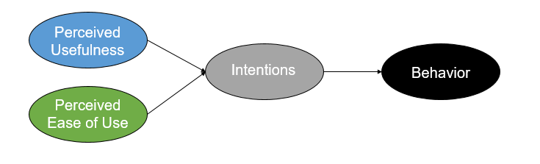
Figure: Technology Acceptance Model
Source: (Veile et al., 2022)
As stated by Kraus et al. (2021), businesses may adopt a technology acceptance model for smoothening their activities and advance automation processes by reducing reception staff. This model suggests perceived usefulness and perceived ease of use. These are critical factors which regulate the adoption of new technology. This framework is necessary to balance both technology and human interaction in the same place. Conversely, as claimed by Elia et al. (2021), integrating technology with human interaction is required to follow the postulates of this model. Many visitors are interested in utilising digital systems as these are convenient, but some other people specifically prefer cash payment and non-digital transactions. Due to this, business is required to maintain the seamless digital experience of people while they need to manage traditional human-centred services such as cash payment, in-person assistance and more. Following these strategies, hotel organisations broaden their acceptance and make visitors feel valued.

2.5 Literature Gap
The aforementioned section has discussed the effect of technological modification on staff shortage in reception services. The study has discussed general information related to subjective matter by collecting data from past researchers, books and journals. There is vast information available which sometimes misguided the main aim of the study. The way self-service applications assist organisations to reduce the necessity of reception personnel has delivered here but lacks the relevant data support from real-time incidents. Some advantages as well as drawbacks have been mentioned based on some past research which requires some relevant evidence that the study lacks. Based on this information the context has also delivered some balanced approaches which may not be appropriate for the current scenario of the market. Hence, the study has created a clear gap which needs to be mitigated properly. Due to this, some additional research following theme-based analysis is required to be performed to conclude the context.

2.6 Summary
The aforementioned section has analysed the effect of technology on staff shortage issues in the reception activities of businesses. The study has analysed the importance and effect of technological modifications and assessed self-service applications. The way technology reduces the necessity of reception personnel along with maintaining operational effectiveness has been mentioned in this section. Implementation of technology in the reception activities of any hotel corporation has generated many benefits and drawbacks which have been discussed in this literature. Some strategies for maintaining a balance between human interaction and technological integration have been provided here which maintain inclusivity for visitors.

Chapter Three: Research Methods

3.1 Introduction
Each research work generally implements particular methods for gathering required data and analysing those insights according to the study is considered as a research methodology. This section will use the research onion framework by including its different layers. Additionally, a significant justification will also be presented in terms of choosing the suitable research 3.2 Research Onion 3.2 Research Onion
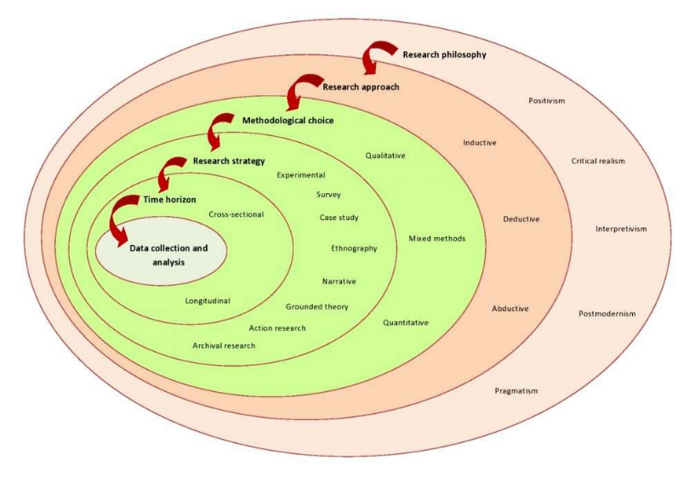
Figure: Research Onion
Source: (Saunders et al., 2012)
Research onion is a conceptual framework that presents different layers to a researcher during the time of designing a particular study. This framework supports the researcher in organising their thoughts and making the outcome more credible (Saunders et al., 2012).

3.3 Research Philosophy
The researcher follows some ethics or beliefs in terms of creating some effective assumptions regarding the subjective matter depending on the research topic. This is classified into three like positivism, interpretivism, and pragmatism. In terms of conducting this research, interpretivism has been followed in terms of understanding the situation from relevant and proven secondary data (Veal, 2006).

3.4 Research Approach
The research approach is an aspect that enables the researcher to make an effective plan for gathering and analysing those insights. This is divided into three like indicative, deductive and abductive. The particular research has followed an inductive approach as this allowed the researcher to explore new ideas and create new theories based on the overall data findings (Bryman, 2008). Additionally, inductive approach has supported the researcher to build concrete theories from observed data. This led to build novel insights as well as concepts, especially while there is little known about the research topic.

3.5 Research Strategy
Research strategy is a solid context that effectively outlines the overall methods as well as procedures that are utilised for addressing the research objectives and questions. This is classified as a survey, case study, interview and others. Case studies strategy have been used here for applying theoretical approaches to real-world situations (Grbich, 2006). Utilising case studies for gathering data has helped the researcher to understand the complicated issues especially in real-world scenarios. In terms of gaining a concrete, conceptual and in-depth understanding of the real-world subject has also supported the researcher to make the outcome more credible. Leveraging case study and analysing relevant website articles has made the findings concise and meaningful. On the other hand, the use of PESTLE analysis has also provided with a significant understanding regarding the wider business environment. In this way, this tool has encouraged the development of strategic and external thinking.

3.6 Research Methods
Research methods are a process that is utilised for analysing and collecting data in terms of gaining a better understanding and gathering knowledge. This is classified into three like mono, multi and mixed methods. Here, the mono method has been chosen in terms of improving both time and cost for the researcher (Marshall, 2015).

3.7 Data Collection Tools
Data collection is a process in terms of gathering, measuring as well as analysing accurate data. There are different kinds of data collection tools, including surveys, focused groups, and others. For this context, the researcher has selected the thematic and qualitative analysis rather than interviews, surveys and others (Robson, 2016). Systematic thematic and qualitative research has allowed the researcher to explore the complicated phenomenon, while uncovering nuanced perspectives and meaning at the same time.

3.8 Data analysis
The process of collecting and analysing the information related to the research topic to conduct the study is called data analysis. There are two kinds of data like qualitative and quantitative data, while qualitative data analysis has been implemented. This has provided the researcher a depth and rich insights with respect to the chosen research topic (Silverman, 2011).

3.9 Time Horizon
Dividing the entire research into smaller tasks or sections including a specific timeline enables the researcher to complete the project within a particular time. This is classified into two like cross-sectional and longitudinal, while cross-sectional has been implemented (Yin, 2003). Cross-sectional has made the research time-sensitive and made the outcome more effective in-spite of having limited budgets.

3.10 Ethical consideration
The researcher has significantly maintained the data authenticity for completing this work, while also respecting all ethical aspects like data protection and others. Additionally, the researcher has also managed confidentiality, while avoiding any kind of misinterpretation.

3.11 Summary
The aforementioned research methods have effectively discussed different layers of research onion. Here, this research has followed interpretivism philosophy and inductive approach while gathering the qualitative data for gaining the outcomes effectively.

Chapter Four: Case Study Hotel Overview and Findings
Overview of Hotel Belvilla Crewe City Centre
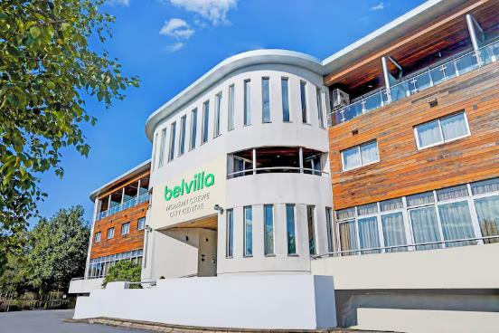
Figure: Hotel Belvilla Crewe City Centre
Source: (cvent, 2025)
Analysis
Belvilla Crewe City Centre Hotel – Lifestyle represents a 3.5-star business-friendly hotel which is located in Crewe, United Kingdom. Here, the hotel provides many amenities which include daily housekeeping, bar, lounge, business centre, meeting rooms and 24-hour front desk. Over time, guests have also praised the hotel for its great room, friendly staff and convenient location. Moreover, the hotel offers free Wi-Fi, business centre and luggage storage. Along with that, it provides free parking as well as electric vehicle charging stations. Thus, the proximity of the with respect to Crewe Railway Station makes it a suitable choice for all travellers.
Location
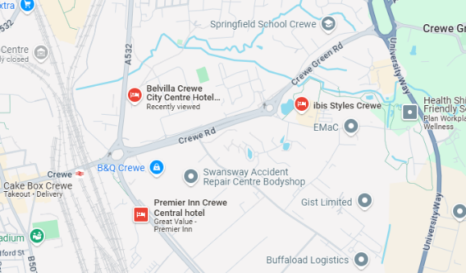
Figure: Hotel Belvilla Crewe City Centre
Source: (google, 2025)
Analysis
Hotel Belvilla Crewe City Centre is located on Macon Way in Crewe, United Kingdom. The central location can easily place guests in a 5-minute drive of local attractions that consist of the Alexandra Stadium aside from the Lyceum Theatre. The hotel is right near to the Crewe Railway Station which is approximately 1350 feet away that directly offers smooth access for travellers. Moreover, Manchester Airport is also situated about 28 miles from the hotel that makes it accessible for international guests. Therefore, the surrounding regions consist of many dining and entertainment options which directly enhances the complete guest experience.
Staffing
The hotel brand is famous for its friendly as well as helpful employees which hugely contributes to bringing positive guest experiences. Many reviews from different websites have shown that professionalism and attentiveness of the team is maintained as guests have always praised the warm hospitality. Furthermore, the 24-hour front desk has ensured that every help is available at any time, directly improving guest satisfaction. Moreover, the daily housekeeping services helped in maintaining cleanliness and comfort across the hotel. Therefore, the staff’s dedication for service excellence has played a vital role to make the hotel an optimum choice for travellers visiting to Crewe (ebookers, 2025).
Branches
Belvilla was first established in 1980 and since then it has grown into being a prominent provider of holiday homes in Europe. The portfolio of this brand has exceeded more than 40,000 properties in 20 nations. In this way, Belvilla provides a broad range of accommodations, ranging from countryside cottages to city apartments. The brand serves approximately 550,000 guests every year. They range from many nations such as the Netherlands, Belgium, Germany, France, Italy, Spain and the UK. During 2019, Belvilla became a part of OYO Vacation Homes that further expanded the reach across the vacation rental market (belvilla, 2025).
Turnover
Belvilla has managed to gain an estimated annual revenue of $40.6 million approximately where the calculated revenue per worker is $278,300. Here, the business has employed around 146 people even when it has gone through an 18% reduction of its entire workforce in recent times. Moreover, the financial stability is also seen with the help of its revenue range that comes within $50 million and $100 million. All of these figures have shown the strong presence of Belvilla throughout the vacation rental market. Also, it has displayed the capacity of generating major income using its broad portfolio of properties throughout Europe (growjo, 2024).
SWOT Analysis
Strengths | Weaknesses
The primary strength of the hotel is located in Crewe City Centre which is closer to important transportation links like Crewe Railway Station that has made it easier for travellers. There are modern amenities present through many facilities like free Wi-Fi, a business centre, EV charging stations and bar/lounge that serve the diverse guest needs (oyorooms, 2024). This has helped to garner a good reputation for its service through positive reviews due to its friendly and professional workers to ensure enhanced guest satisfaction. Also, the price rates are very affordable with respect to its competitors present in the same area, attracting budget-conscious travellers. The hotel has also incorporated many digital solutions like online booking, automated systems and self-service check-ins which has helped in improving operations. | The weaknesses of this company are shortage of staff present in the reception, delaying services and negatively affecting the guest experience. Even when technology has improved efficiency, continuous dependence on automated services might have decreased personal interactions which are preferred by guests. Further, there were occasional complaints about maintenance issues which include cleanliness or outdated furnishings which can impact the hotel’s complete reputation (expedia, 2024). Additionally, unlike the high-end hotels, Belvilla Crewe City Centre does not offer premium facilities like spa, gym and fine-dining restaurant, directly limiting its appeal to leverage guest experience. Hence, the lack of full-service restaurants has brought inconvenience to those people who want to dine in hotel premises.
Opportunities | Threats
There lie some opportunities to improve mobile check-ins aside from AI concierge services and chatbots which can improve efficiency and guest experience. Similarly, partnering with the local restaurants, attractions and transport providers can bring developments to guest offerings and yield revenue. Further, making investments in sustainable practices like energy-efficient systems or waste reduction programs can attract potential environmentally conscious travellers (Shebanina et al., 2023). Building partnerships with businesses for corporate stays could possibly increase occupancy rates to secure a constant revenue stream. Lastly, making changes in room aesthetics by upgrading facilities can boost guest satisfaction and gain better online reviews. | The presence of many more budget hotels such as Airbnb and luxury accommodations across Crewe could reduce the market share held by Hotel Belvilla Crewe City Centre. Other economic fluctuations as well as less travel spending can impact occupancy rates (Ozdemir et al., 2022). Moreover, the constant demand for technological updates and possible system failures can affect overall hotel operations. Challenges in hiring and retaining workers can disrupt service qualities since the hotel will not be able to get skilled personnel. Finally, unexpected crisis like pandemics can result in fewer guest arrivals and higher operational hurdles.

PEST Analysis
Factors | Analysis
Political | The hotel has to follow UK hospitality regulations like health and safety standards followed by employment laws and taxation protocols which affect operations. Any changes in immigration laws and visa regulations after Brexit have impacted the availability of skilled hospitality employees that directly led to staff shortages. Conversely, government initiatives directly promote domestic and international tourism within the UK that boosts hotel occupancy rates. Still, any restrictions on foreign travel, like the ones seen during the Covid-19 pandemic, adversely impacts the companies (Spanaki et al., 2021).
Economic | The costs of utilities have gone very high along with wages and supplies which directly affect the profitability of the hotel. Inflation also results in higher room rates and affects guest affordability. The minimum wage laws in the UK brings an influence on staffing expenses and makes it vital for the hotel in maintaining balance for payroll expenses with operational efficiency (Grigoli and Pugacheva, 2024). When an economic downturn takes place, visitors start to stop spending on hotel stays and look for budget accommodations and alternative options like Airbnb. Hence, when the economy recovers, then it results in higher travel spending. The need for travel accommodations also fluctuates depending on the economic situation. In this time, the hotel can get benefits from partnerships with corporate clients when strong economic growth takes place.
Social | Guests always look for personalised experiences that have digital convenience and eco-friendly accommodations which influences hotel service offerings. On the other hand, younger travellers prefer budget-friendly offers which are given by tech-based hotels. Whereas older guests value other in-person services, and these demands have to be balanced by the hotel. Alternatively, online ratings and reviews play another role for guest choices. When there is high negative feedback regarding service delays and maintenance problems, then it can deter bookings (Mathews et al., 2022). A decreasing labour pool throughout the hotel sector impacts the availability of correct staff that compels the hotel to make more investment in employee retention solutions.
Technological | Hotel Belvilla Crewe City Centre has used self-service check-ins which are surrounded by online booking systems and AI-based customer service tools which enhanced productivity and resolved employee shortages. Due to high online transactions and guest data shortage, the hotel has to follow the GDPR and cybersecurity regulations to safeguard personal information (Florido-Benítez, 2024). Integration of features such as mobile key access, smart temperature control or voice-based help can improve guest experiences to stand out from competitors (trip, 2024). Lastly, the growth of online travel agencies such as Booking.com and Expedia has shown that the hotel needs to optimise its digital presence constantly to attract higher bookings.

Competitor Analysis
Hotel Belvilla Crewe City Centre | The Waverley Hotel | ibis Styles Crewe
Hotel Belvilla Crewe City Centre provides rooms at an average rate of $76 per night (agoda, 2025). Here, the guests have acknowledged its friendly staff, cleanliness and easy location near the railway station. Other amenities are also given which include free Wi-Fi, EV charging stations and secure parking. Still, there had been reviews about occasional maintenance problems and less dining options. | The hotel is present 0.29 km from Crewe Railway Station, and it is a family-run establishment which includes 21 en-suite rooms. Visitors have appreciated its proximity for being near the station and personalised service characteristics seen like that of smaller hotels. The average rate of each room is around £75 per night, making it a budget-friendly option (waverleyhotelcrewe, 2025). Even then, few feedback stated that the facilities are quite basic and lacks modern amenities that are present in big hotels. | Located in Crewe Business Park, ibis Styles Crewe is present 1.9 miles from Crewe Railway Station. It offers contemporary rooms consisting of modern amenities that includes complimentary breakfast and Wi-Fi. The average room rate is mostly £59 per night (booking, 2025). The stylish design aesthetics have often been praised by the visitors which represented value for money. Still, its location in the business park is less easy for leisure travellers who seek for hotels that are near city centre attractions.

Netnography
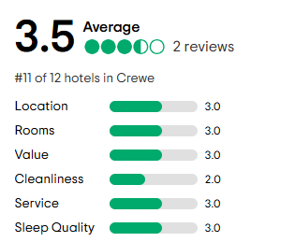
Figure: Hotel Belvilla Crewe City Centre rating
Source: (tripadvisor, 2024)
As seen from the majority ratings given by the visitors, the hotel has an average rating of 3.5. This rating mainly comes from the ones who have experienced either good or poor services. Depending on the recent reviews from November 2024, the food quality is reviewed very bad. Here, the eve meal was very disappointing, and it has not changed from the frozen mixed veg instant mash potato and pie. Still the rooms have been acknowledged as being spacious by including a decent bathroom and shower. On the other hand, another review was very positive where the check-ins were quite easy with plenty of parking and a good-sized clean room. Still, the pressure of the big shower was poor while the bed was comfortable with big fluffy pillows as the breakfast was decent with a low price point. Thus, the hotel is suggested to work on its shortcomings so that guests will remain satisfied and acquire a memorable experience.

Reflective account
Based on the professional experience acquired in the hospitality sector, Hotel Belvilla Crewe City Centre consists of a mixture of strengths and other areas which need developments. While the central location and affordability has attracted guests, shortage of premium services and service delays can affect in retaining long-term guests (Raković et al., 2022). I have seen that keeping a fair balance between automation and personal interaction is vital to maintain guest satisfaction. Similarly, investing in employee training and proactive maintenance can leverage the complete experience. Overall, resolving such gaps in a strategic manner can enhance ratings but also improve the competitive standing of the hotel in the Crewe market (Harris, 2023).

Chapter Five: Exploration of Themes and Discussion

5.1 Thematic Analysis
Theme 1: Examine the extent to which technology, including self-service applications, can reduce the necessity for reception personnel while simultaneously ensuring operational efficiency
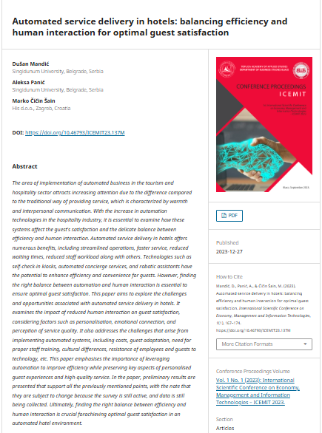
Figure: Automated service delivery within hotels: maintaining proficiency and human interaction regarding optimal guest satisfaction
Source: (Mandić et al., 2023)

Analysis
The area of implementing automation within the current business process, especially in the tourism and hospitality industry. This generally attracts attention for making a huge difference between modern and traditional ways of offering services. This service is proficiently featured through interpersonal as well as warm communication. Apart from that, the effective increment of automation technology is currently playing the most crucial role in terms of enhancing the satisfaction level of the guests. This system is also accountable for making a delicate balance between human interaction and efficiency. Regarding this, different technologies like automated concierge services, self-check-in and others (Mandić et al., 2023).
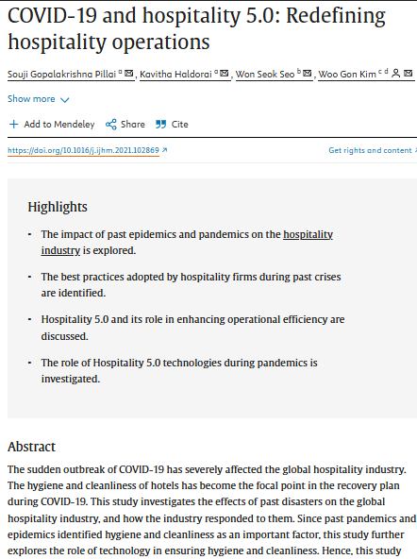
Figure: Covid-19 and Hospitality: Redefining hospitality operations
Source: (Pillai et al., 2021)
Analysis
Especially after the sudden outbreak of COVID-19 has effectively influenced the international tourism industry. In terms of maintaining cleanliness and hygiene within hotels has become the prime point of recovery during this pandemic situation. The above article has critically discussed the overall effects of past disasters especially in the hospitality industry worldwide. With this regard, the hospitality industry further explores the overall role of digital technologies in determining cleanliness and hygiene. In this way, this sector has reshaped its designed principles considering this hospitality perspective. Implementing those technologies, the sector generally focuses on offering touchless services to ensure cleanliness and hygiene at the same time (Pillai et al., 2021).
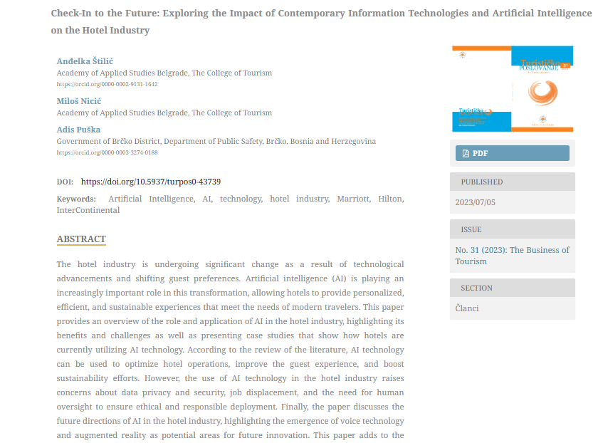
Figure: Check-in to the future: Exploiting the influence of Contemporary information technologies and AI within the Hotel industry
Source: (Štilić et al., 2023)
Analysis
Currently, the hotel sector is undergoing a severe change due to the emergence of technical advancements as well as shifting the preferences of the guests. In this context, AI is playing the most vital role in making proficient transitions, while allowing hotels to offer customised, sustainable as well as sustainable experiences. This would enable organisations to meet the specific needs of the modern guests. This article has offered a critical overview regarding the application and the role of AI especially within the hotel industry (Štilić et al., 2023). Those tools proactively support the businesses to enhance the organisational operations and boost guest satisfaction levels, while also supporting them to drive sustainability efforts. However, there are some critical challenges in terms of implementing AI like data and privacy, the requirement of human oversight as well as job displacement (Arapou and Kapiki, 2023).

Theme 2: The benefits (e.g., cost savings, efficiency) and drawbacks (e.g., loss of human interaction, resistance to technology) of implementing automated solutions in reception services
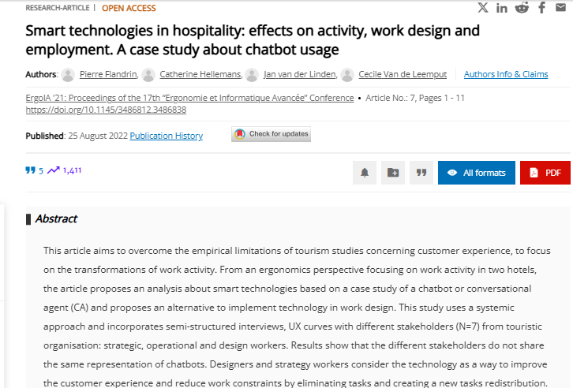
Figure: Smart technologies within the hospitality: Influences on the work design, activity and employment
Source: (Flandrin et al., 2021)
Analysis
Different kinds of smart technologies in the hotel industry like IoT or Internet of things, mobile tools and AI are playing the most effective role in the current digital era. Implementing those tools into regular business enables organisations to automate their repetitive tasks, while also minimising human errors at the same time. This article has discussed voice control, which enables businesses to leverage voice commands in terms of controlling all of the amenities. On the other hand, the robots may support businesses to automate their business tasks like self-check-in, as well as room service. AI chatbots also offer significant facilities to offer instant responses with respect to the inquiries of consumers. Implementing and leveraging smart technologies within the current business enables them to offer their consumers personalised services while improving the guest experiences at the same time (Flandrin et al., 2021).
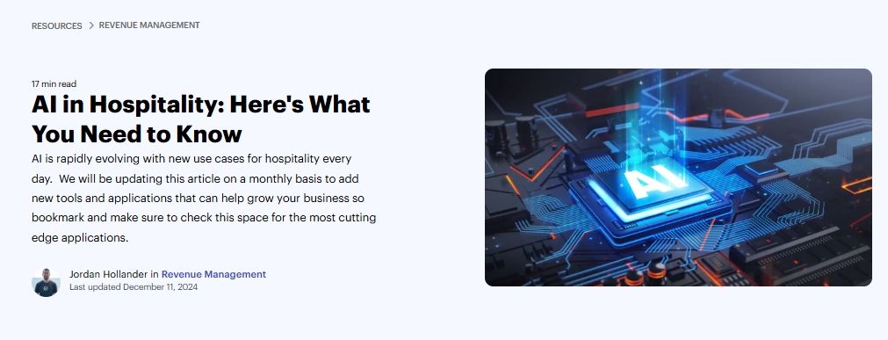
Figure: AI in hospitality
Source: (Hollander, 2024)
Analysis
Artificial intelligence is constantly evolving within the hospitality industry for a regular manner. The tourism industry effectively stands on the cusp regarding the revolutionary transformation that is proactively spurred by the emergence of artificial intelligence. The above article has effectively exposed the challenges as well as opportunities related to AI implementation. The overall illumination regarding the potentiality for AI in redefining the factors of this hospitality sector. This influences the hospitality experience from reshaping the service quality to augmenting the consumer interactions, while also deriving the overall economic growth. This article critically examined the effective potentiality of AI in terms of infusing the entire hospitality industry with an unparalleled level of proficiency as well as customised services. This section has also identified several challenges or complications that organisations face in terms of driving digital evaluation. There are diverse kinds of technical constraints like significant investment, resistance to change and others (Hollander, 2024).
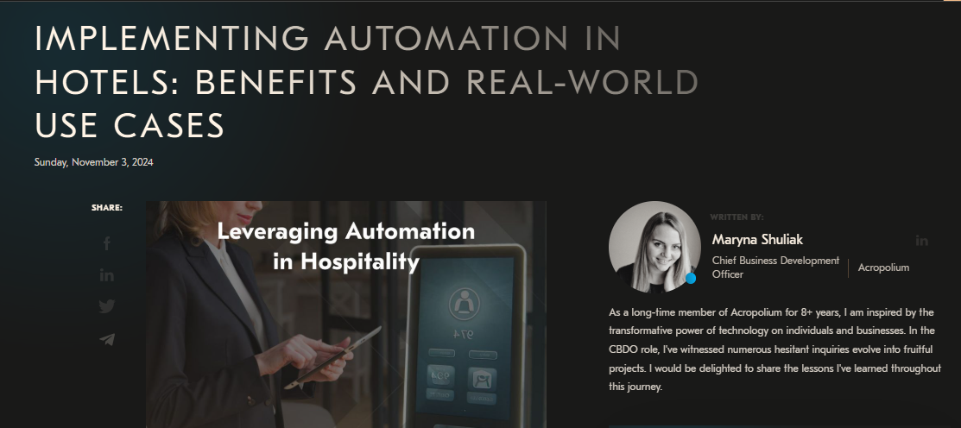
Figure: Implementation of automation in the hotels: Benefits and real-world use cases
Source: (Shuliak, 2024)
Analysis
Hotels nowadays regularly implement automation by minimising the manual input through AI-powered systems. This enables organisations to streamline both hospitality workflows as well as guest experiences at the same time. Through the way of embracing the technologies within the hospitality industry like AI-driven guest services automated housekeeping as well as offering smart rooms play the most effective role in terms of optimising operational excellence. In relation to this, approximately 93% of the hoteliers report respective enhancement regarding proficiency following the overall adaptation of technologies. Almost 58% of guests are effectively like the self-check-in and booking system. Regarding this, there are many giant films like Hard Rock, Hilton and others that are experiencing significant revenue growth through the way of automating their repetitive tasks, while also aligning the IoT-based and AI-based solutions. This industry has gained effective popularity in terms of its time-intensive tasks and recurring. They offer immersive services from guest check-ins as well as reservation entries for their room assignments and rated adjustments (Shuliak, 2024).
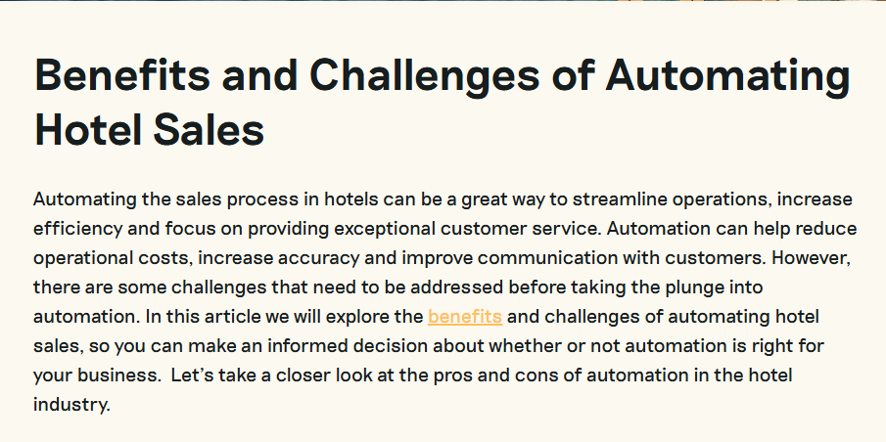
Figure: Benefits and challenges of automating hotel sales
Source: (Prenohq, 2024)
Analysis
Automating the overall sales process in the hospitality industry is considered a great way to streamline business operations. This is capable for enhancing the proficiencies in terms of offering exceptional consumer service. In relation to this, implementing an automation system may help the business to minimise operational expenses, while also driving thei8r accuracy and developing their interaction with the consumers. However, this particular article has also mentioned there are some issues that is needed to be addressed effectively during taking the plunge into the automation system. In terms of exploring several benefits and challenges of implementing AI solutions into the hotel industry, helps different organisations to make informed decisions. They can understand whether the automation is right for their business or not (Prenohq, 2024).
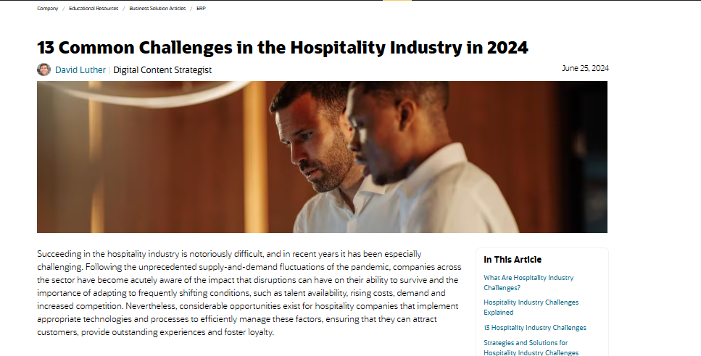
Figure: Common challenges in the hospitality industry
Source: (Luther, 2024)
Analysis
Getting significant success within the hospitality industry has become respectively difficult, and in the current days, this has become effectively challenging. Economic fluctuation and unprecedented supply and demand generally create effective distractions for organisations in terms of continuing regular business operations. There are also other difficulties that the hotel sector faces like data privacy concerns, issues in adopting technologies among staff, improper balancing of technologies with human interaction, improper data quality, costing concerns and others (Luther, 2024). Those potential influences cause significant disruption for the businesses in maintaining smooth business operations. As the AI system balances the sensitive guest information, this raises effective concerns regarding data breaches as well as the requirement for dynamic security measures for maintaining the reliability of guests. Apart from that, implementing artificial intelligence with existing hotel management systems often becomes difficult as this needs technical expertise (Milton, 2024).
Theme 3: Suggest a balanced approach to the integration of technology and human interaction that ensures inclusivity for visitors who prefer non-digital options or cash payments
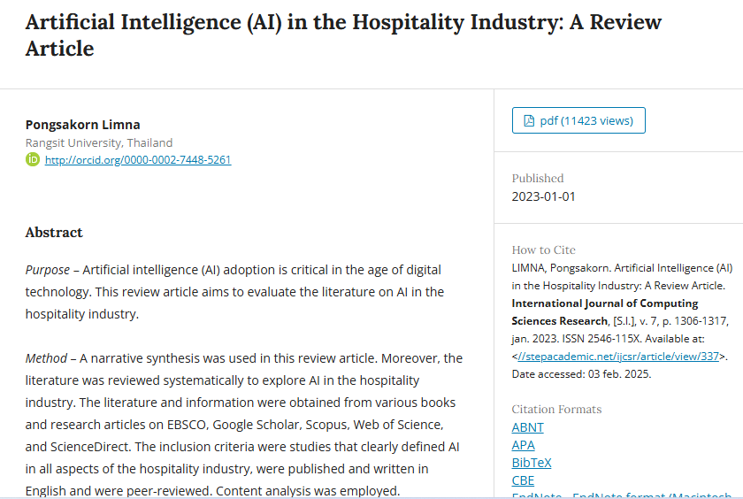
Figure: Artificial Intelligence within the hospitality industry
Source: (Limna, 2023)
Analysis
Artificial intelligence plays the most crucial role, especially in the current age of digital technology. The automation is leveraged for streamlining the business operations and customising the client experiences, while also boosting the pricing strategy alongside enhancing the consumer service. The significant incorporation of automated check-ins, virtual concierges, and data analytics is playing a significant role in terms of understanding the current market demand (Limna, 2023). This enables them to forecast the current market trends and improve the smart room system that can be adjustable based on the preferences of the guests. Deploying virtual assistance within the organisation’s official websites supports them in answering the questions of the consumers, by providing accurate information. They can also manage their requests through natural language interaction with the customers (Cobanoglu et al., 2021).
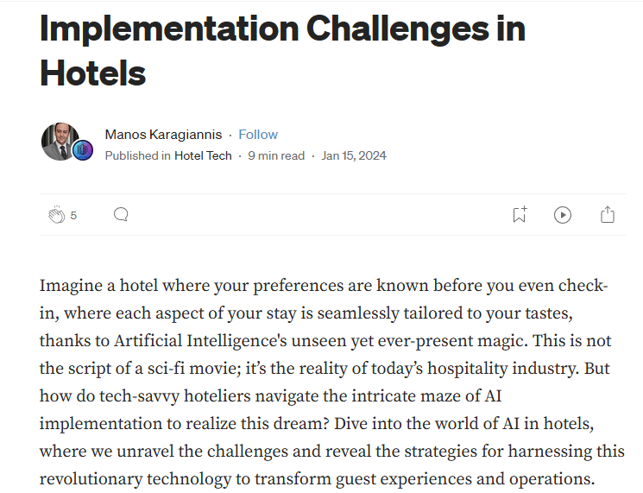
Figure: Overcoming common challenges while implementing AI within Hotels
Source: (Karagiannis, 2025)
Analysis
Living within an era where technology plays the most crucial role in terms of shaping every aspiration, especially within the hospitality industry. Artificial intelligence is a futuristic concept that enables different organisations to reshape their business operations while improving their interactions with their guest from personalised room settings to offering virtual concierges (Karagiannis, 2025). Focusing on offering high-standard data, the business should conduct effective training programs for their employees. In addition to this, the hotel industry should also take major steps in terms of managing the overall data privacy of all employees and consumers. In this way, they can address the common challenges related to AI implementation (Castelli et al., 2022). Applying the TAM or Technology of Acceptance model to current business practices is one of the significant solutions to optimise the consumer experience within the hotel industry. TAM supports explaining the way through which users accept and leverage tech solutions based on two key aspects including perceived ease of use or PEOU and perceived usefulness.

5.2 Discussion
The overall incorporation of technology within the hotel industry especially in the consumer and reception service has affected the operational proficiency. This context has highlighted the crucial aspect of automation, and smart tools in terms of transforming overall hotel operations. Implementing artificial intelligence supports organisations to boost their operational proficiency. In addition to this, possible benefits and challenges of incorporating automation alongside the significance of balancing technology with human interaction has also been explored through this sectional. Advancements in technologies like self-check-in options and AI-powered services are accountable to revolutionise the overall guest experience. Those innovations not only help businesses to minimise human errors but also make the business process smoother. In addition to this, the AI-powered chatbots as well as the voice control system support the business to provide 24/7 consumer support. This also supports them in addressing all of the inquiries without the requirement of human interactions. This proficient shipment is playing the most beneficial role in terms of managing operational issues, especially during the time of high-demanding period. Apart from all of that discussion, the utilisation of digital technology including AI has started to accelerate during g the time of COVID-19 pandemic. In terms of maintaining touchless payment and cleanliness as well as hygiene, most hotel businesses started to implement AI-powered solutions into their regular business operations. Those organisations started to employ systems like digital keys and mobile check-in processes as well as automated housekeeping. Those effective services support the firm to improve safety while also enhancing the overall perception of the guests at the same time. However, those technologies often present significant advantages like cost savings, improved accuracy and driving guest experiences. The way of replacing manual and reparative tasks with AI-driven solutions supports the business to minimise unnecessary complications and decrease staff costs. Despite those advantages, AI also represents significant challenges like the loss of human interactions, the inability to maintain consumer privacy and security, increased primary costs and others. There are many guests who prefers human interactions within the hotel workforce, especially within boutique and luxurious hotels. Apart from that, the significant resistance to technology adaptation also presents effective challenges among employees after implementing the emergence of AI. In terms of achieving an optimal balance between human interactions and technology, hotels should adopt an inclusive approach that can enable them to appeal to both traditional guests and tech-savvy consumers. This section has also highlighted the significance of offering different non-digital substitutes like in-person check-ins and cash payment options and others. While those effective solutions are accountable for improving operational excellence, hotels should effectively ensure that the human workforce also remains accessible in terms of addressing customised requests and managing other problems. In relation to this, implementing effective training programs are also another essential aspect for proactively adopting new technologies while balancing the warmth within this hospitality sector. In terms of increasing operational effectiveness and customer happiness, hotels are rapidly implementing self-service kiosks, digital check-ins, and AI-powered chatbots. Guests who see these technologies as simple and useful are more likely to use them, lowering dependency on conventional reception services. Mobile apps that provide digital access keys and cashless transactions, for example, meet modern consumer demands while increasing convenience. Hotels deploy machine learning and AI in their welcome lobbies to provide personalised suggestions, voice-controlled room control systems, and robotic responses to visitor enquiries. A well-executed TAM strategy guarantees that clients trust and are comfortable using such advances, resulting in higher levels of fulfilment and loyalty.

Chapter Six: Conclusion
Businesses in recent times have incorporated digital technology in their operations to advance their service delivery. Hotel Belvilla Crewe City Centre also incorporate self-service systems to manage the staff shortage in reception activities and following this advanced technology, they deliver effective customer service to their audiences. The study has evaluated the background of the research and assessed the importance of it. In recent times, hotel corporations have adopted many advanced technologies which shapes their operations. The study objectives have been analysed in the literary section by gathering some general data. Businesses generally incorporate self-service applications for reducing operational costs, advancing efficiency and allocating resources properly which ultimately reduces their necessity of reception staff. On the other side, following these processes, corporations experienced some challenges including resistance to technology and loss of human interaction. Lack of human touch in operations affects the organisation greatly and to manage this they follow a balanced approach where they combine human support and digital solutions. Hotel corporations have been required to incorporate clear communication as well as multiple payment methods online and offline. These processes enhance customer satisfaction, ensure inclusivity and delivered seamless operational efficiency in hotel and service industries. The literature has completely provided some general information which has created some confusion and has not helped the study to conclude the matter. Later, the study performed a secondary analysis of Hotel Belvilla Crewe City Centre. Through performing SWOT and PEST analysis, and understanding their staffing, financial performance and background, the study has gained some important insights. Apart from this, the guest feedback and competitors' insight about the hotel have also been reviewed in this section. This context has to provide some in-depth knowledge about the mentioned hotel and solve the issue related to reception staff which has been resolved by performing a thematic analysis. This assessment has highlighted that the automation in hotel reception increases their operation efficiency but creates many challenges. To solve these complexities Hotel Belvilla Crewe City Centre has been required to maintain a balanced approach by assuring inclusivity for traditional and tech-savvy guests.

Chapter Seven: Recommendations
Hybrid Approach with Human Assistance
Hotel Belvilla Crewe City Centre is required to maintain human interaction to attend to their visitor requirement. This way they can make sure to deliver a personalised experience to their guest while automation may minimise staff workload (Erxleben, 2024). In managing this situation, the mentioned hotel needs to adopt a hybrid approach where they deliver human support along with digital solutions to their audiences. The brand also needs to deliver necessary assistance to guests by maintaining some reception staff. These employees are mainly involved in non-digital tasks and guide the people who are not comfortable with technology (Marr, 2024). The said hotel may generate an inclusive and supportive environment by offering human-assisted services and digital payment methods that improve their guest preferences. This way the said corporation can deliver high-quality service as well as gain benefit from automation.
Upskilling and Training Staff
Businesses performing change management train their workforce to develop the skillset they have to manage modern technologies. Hotel Belvilla Crewe City Centre is required to train and upskill its staff during the incorporation of technology in its operations. They are needed to advance the knowledge of their reception staff regarding modern technology and how this modification can automate their repeated task completely. Following these activities, the brand may manage technological modifications properly and assist guests who may require assistance to navigate the digital platform (Friedman, 2024). Gaining the technical knowledge the employees can easily manage and troubleshoot issues and improve the operation of the mentioned brand. Through upskilling employees, the hotel may guide them to concentrate on different activities such as maintaining cancellation and concierge service. The knowledge of modern technology gained by organisations like Hotel Belvilla Crewe City Centre and the skills they gain can provide many opportunities for career growth. This development process ultimately enhances job satisfaction and morale.
Cash Payment and Non-digital Options
There are many people are present who are not interested in following digital method for cash payment and communications. Hotel Belvilla Crewe City Centre need to maintain inclusivity in their services by which they can satisfy guests through meeting their preferences. The brand needs to maintain traditional payment methods as well as incorporate digital payment processes (Wewege, 2021). Performing these activities, they can deliver convenience to their guest and allow those who do not wish to use their cards and mobile payment applications. This way persons who are not interested in a digital mode of payment get an accessible and easy option to settle their bills. They can maintain a cash register as well as a manual payment system which helps visitors complete their transactions without availing of any kind of digital solution and mobile application. Along said this, the brand is required to explain the available options of payment to their customers and provide clear signage by which guests can feel comfortable in choosing payment methods as per their convenience.
Personalisation of Digital Services
Hotel Belvilla Crewe City Centre is required to incorporate personalised digital processes to help guests. This makes them feel valued and respected as their preferences are maintained in this hotel. Self-service applications as well as digital kiosks may assist the hotel in meeting their guest preferences as well as allow the brand to deliver a customised check-in experience (Murphy, 2023). The hotel is required to allow their visitors to choose their preferred room, features, location and necessary amenities that they required. Belvilla Hotel may deliver language preferences on their system which delivers audiences a level of personalisation. They may follow automatic processes, and this kind of approach may improve visitors' satisfaction as well as reduce the negative impact of minimising face-to-face interaction.
Regular Feedback and Continuous Improvements
Belvilla Hotel is required to collect feedback from guest about their experience with the digital solutions that they provide to them. Following this way the hotel can understand the effect of technology that they implement on their operational efficiency and guest satisfaction (Andrews, 2024). Due to this, they organised online review options service and in-person conversations which helped them to gather valuable inside regarding the way guest feel about their processes. They suggested incorporating digital technology by maintaining human interaction and how these affect guests. Due to this, they organised feedback sessions and based on these insights the hotel can improve operations and systems and generate adjustments to meet audience requirements (Folsom, 2023). This assures that technological modification not only leads the band to maintain guest satisfaction but also helps them to become responsive regarding changing customer expectations.

References
agoda, (2025). Belvilla Crewe City Centre Hotel Lifestyle. [Online]Available at: https://www.agoda.com/en-in/holiday-inn-express-crewe_5/hotel/crewe-gb.html?ds=HbECMae5EnTX%2Futn [Accessed 24 January 2025].
Andrews, M., (2024). The Power Of Feedback: A Catalyst For Growth In Leadership And Employee Development. [Online] Available at: https://www.forbes.com/councils/forbesbusinesscouncil/2024/07/18/the-power-of-feedback-a-catalyst-for-growth-in-leadership-and-employee-development/ [Accessed 30 January 2025].
Arapou, D. and Kapiki, S., (2023). Enhancing the Guest Experience in Hospitality Through Technology: An Outlook of the Future. Proceedings http://ceur-ws. org ISSN, 1613, p.0073.
Bagrationi, K., Thurner, T.W. and Gordienko, O., (2021), September. Resistance to digital transformation and the destruction of social capital. In Proceedings of the European Conference on Innovation and Entrepreneurship, ECIE (pp. 47-53).
Basile, L.J., Carbonara, N., Pellegrino, R. and Panniello, U., (2023). Business intelligence in the healthcare industry: The utilization of a data-driven approach to support clinical decision making. Technovation, 120, p.102482.
belvilla, (2025). 'About Belvilla'. [Online]Available at: https://www.belvilla.com/service/about-belvilla/ [Accessed 22 January 2025].
booking, (2025). ibis Styles Crewe. [Online]Available at: https://www.booking.com/searchresults.en-gb.html?aid=356980&label=gog235jc-1DCAsoUEITcmFtYWRhLWVuY29yZS1jcmV3ZUgJWANobIgBAZgBCbgBF8gBDNgBA-gBAfgBAogCAagCA7gC1_WCvQbAAgHSAiQxZTI0MDBjMi1mNDdmLTQ2NjgtYTg2Ni01ZWFlNWJlMjIxYTHYAgTgAgE&highlighted_hotels=37556&r [Accessed 24 January 2025].
Broccardo, L., Zicari, A., Jabeen, F. and Bhatti, Z.A., (2023). How digitalization supports a sustainable business model: A literature review. Technological Forecasting and Social Change, 187, p.122146.
Bryman A., (2008), Social Research Methods, 2nd Ed, Oxford University Press.
Casey, S.J., (2022). Towards digital dole parole: A review of digital self‐service initiatives in Australian employment services. Australian Journal of Social Issues, 57(1), pp.111-124.
Castelli, M., Pinto, D.C., Shuqair, S., Montali, D. and Vanneschi, L., (2022). The benefits of automated machine learning in hospitality: A step-by-step guide and AutoML tool. Emerging Science Journal, 6(6), pp.1237-1254.
Challoumis, C., (2024), October. Building a sustainable economy-how ai can optimize resource allocation. In XVI International Scientific Conference (pp. 190-224).
Cobanoglu, C., Dogan, S., Berezina, K., Collins, G., Nanu, L., Shahtakhtinskaya, K., Kaya, G. and Parvez, O., (2021). Hospitality and tourism information technology. University of South Florida M3 Center Publishing, 17(9781732127593), p.2.
cvent, (2025). Belvilla Crewe City Centre Hotel - Lifestyle. [Online]Available at: https://www.cvent.com/venues/crewe/hotel/belvilla-crewe-city-centre-hotel-lifestyle/venue-524a7b3f-ec1a-4244-8d14-144618c33041 [Accessed 22 January 2025].
De Andrade, I.M. and Tumelero, C., (2022). Increasing customer service efficiency through artificial intelligence chatbot. Revista de Gestão, 29(3), pp.238-251.
ebookers, (2025). Belvilla Crewe City Centre Hotel - Lifestyle. [Online]Available at: https://www.ebookers.ie/Crewe-Hotels-Crewe-City-Centre-Hotel-Lifestyle.h1520095.Hotel-Information [Accessed 22 January 2025].
Elia, S., Giuffrida, M., Mariani, M.M. and Bresciani, S., (2021). Resources and digital export: An RBV perspective on the role of digital technologies and capabilities in cross-border e-commerce. Journal of Business Research, 132, pp.158-169.
Erxleben, U., (2024). Managing The Human/Machine Transition To A Hybrid Workforce. [Online] Available at: https://www.forbes.com/councils/forbesfinancecouncil/2024/10/29/managing-the-humanmachine-transition-to-a-hybrid-workforce/ [Accessed 30 January 2025].
expedia, (2024). Belvilla Crewe City Centre Hotel - Lifestyle. [Online]Available at: https://www.expedia.co.in/Crewe-Hotels-Crewe-City-Centre-Hotel-Lifestyle.h1520095.Hotel-Information [Accessed 23 January 2025].
Flandrin, P., Hellemans, C., Van der Linden, J. and Van de Leemput, C., (2021), October. Smart technologies in hospitality: effects on activity, work design and employment. A case study about chatbot usage. In Proceedings of the 17th “Ergonomie et Informatique Avancée” Conference (pp. 1-11).
Florido-Benítez, L., (2024). The cybersecurity applied by online travel agencies and hotels to protect users’ private data in smart cities. Smart Cities, 7(1), pp.475-495.
Folsom, J., (2023). How To Build A Culture Of Continuous Feedback. [Online] Available at: https://www.forbes.com/sites/jenniferfolsom/2023/05/26/how-to-build-a-culture-of-continuous-feedback/ [Accessed 30 January 2025].
Friedman, E., (2024). The Upskilling Revolution: Invest In Your Team For Boosted Success. [Online] Available at: https://www.forbes.com/councils/forbeshumanresourcescouncil/2024/07/22/the-upskilling-revolution-invest-in-your-team-for-boosted-success/ [Accessed 30 January 2025].
google, (2025). belvilla crewe city centre hotel about us. [Online]Available at: https://www.google.com/maps/search/belvilla+crewe+city+centre+hotel+about+us/@53.0926651,-2.4333322,15z/data=!3m1!4b1?entry=ttu&g_ep=EgoyMDI1MDEyOS4xIKXMDSoASAFQAw%3D%3D [Accessed 22 January 2025].
Grbich C. (2006), Qualitative Data Analysis, Sage Publications Ltd.
Grigoli, F. and Pugacheva, E., (2024). COVID-19 inflation weights in the UK and Germany. Journal of Macroeconomics, 79, p.103543.
growjo, (2024). Belvilla Revenue and Competitors. [Online]Available at: https://growjo.com/company/Belvilla#google_vignette [Accessed 22 January 2025].
Harris, S.G.K.R., (2023). The role and development of self-regulation in the writing process. In Self-regulation of learning and performance (pp. 203-228). Routledge.
Hollander, J., (2024). AI in Hospitality: Here's What You Need to Know. [Online] Available at: https://hoteltechreport.com/news/ai-in-hospitality [Accessed 30 January 2025].
Jiwnani, L., (2024). AI's transformative role in the hospitality industry. [Online]Available at: https://www.deloitte.com/uk/en/Industries/consumer/blogs/embracing-the-future-ais-transformative-role-in-hospitality.html [Accessed 20 January 2025].
Karagiannis, M., (2025). Overcoming Common AI Implementation Challenges in Hotels. [Online] Available at: https://medium.com/hotel-tech/overcoming-common-ai-implementation-challenges-in-hotels-15881b1d530f [Accessed 31 January 2025].
Kraus, S., Jones, P., Kailer, N., Weinmann, A., Chaparro-Banegas, N. and Roig-Tierno, N., (2021). Digital transformation: An overview of the current state of the art of research. Sage Open, 11(3), p.21582440211047576.
Lacalle, E., (2024). A complete guide to self-check-in kiosks for hotels in 2024. [Online]Available at: https://www.mews.com/en/blog/hotel-self-check-in-kiosk [Accessed 21 January 2025].
Limna, P., (2023). Artificial Intelligence (AI) in the hospitality industry: A review article. International Journal of Computing Sciences Research, 7, pp.1306-1317.
Luther, D., (2024). 13 Common Challenges in the Hospitality Industry in 2024. [Online] Available at: https://www.netsuite.com/portal/resource/articles/erp/hospitality-industry-challenges.shtml [Accessed 31 January 2025].
Mandić, D., Panić, A. and Šain, M.Č., (2023), December. Automated service delivery in hotels: balancing efficiency and human interaction for optimal guest satisfaction. In International Scientific Conference on Economy, Management and Information Technologies (Vol. 1, No. 1, pp. 167-174).
Marr, B., (2024). Why Hybrid AI Is The Next Big Thing In Tech. [Online] Available at: https://www.forbes.com/sites/bernardmarr/2024/10/02/why-hybrid-ai-is-the-next-big-thing-in-tech/ [Accessed 30 January 2025].
Marshall, C. (2015), Designing Qualitative Research, 6th Ed, Sage, London.
Mathews, S., Prentice, C., Tsou, A., Weeks, C., Tam, L. and Luck, E., (2022). Managing eWOM for hotel performance. Journal of Global Scholars of Marketing Science, 32(3), pp.331-350.
Milton, T., (2024). Exploring the Synergy of Artificial Intelligence and Financial Management in the Hotel Industry: A Critical Review of Innovations, Challenges, and Strategic Implications for Enhancing Operational Efficiency and Competitive Advantage. International Journal for Multidimensional Research Perspectives, 2(2), pp.79-95.
Monson, R.K., Trowbridge, A.M., Lindroth, R.L. and Lerdau, M.T., (2022). Coordinated resource allocation to plant growth–defense tradeoffs. New Phytologist, 233(3), pp.1051-1066.
Murphy, B., (2023). Are Brands Built Differently In The Age Of Digital Personalization?. [Online] Available at: https://www.forbes.com/councils/forbesbusinesscouncil/2023/09/12/are-brands-built-differently-in-the-age-of-digital-personalization/ [Accessed 30 January 2025].
Nwosu, N.T., (2024). Reducing operational costs in healthcare through advanced BI tools and data integration. World Journal of Advanced Research and Reviews, 22(3), pp.1144-1156.
Oriol, E., Brauer, M., Matheus, A.A. and Macedo, J.C.S., (2021). Resistance to Blended Learning in Business and Public Administration Higher Education. In Academy of Management Proceedings (Vol. 2021, No. 1, p. 11558). Briarcliff Manor, NY 10510: Academy of Management.
Ouedraogo, A. and Tiemtore, N.C., (2021). Technological innovation, organizational change, and employee's resistance in developing countries. Management Review: An International Journal, 16(1), pp.23-43.
oyorooms, (2024). Belvilla Crewe City Centre Hotel - Lifestyle. [Online]Available at: https://www.oyorooms.com/gb/247634/ [Accessed 23 January 2025].
Ozdemir, O., Han, W. and Dalbor, M., (2022). Economic policy uncertainty and hotel occupancy: the mediating effect of consumer sentiment. Journal of Hospitality and Tourism Insights, 5(2), pp.253-273.
Papakonstantinidis, S., Kwiatek, P. and Baltezarevic, R., (2021). He impact of relationship quality and self-service technology on company performance. Polish Journal of Management Studies, 23.
Park, S., Lehto, X. and Lehto, M., (2021). Self-service technology kiosk design for restaurants: An QFD application. International Journal of Hospitality Management, 92, p.102757.
Pillai, S.G., Haldorai, K., Seo, W.S. and Kim, W.G., (2021). COVID-19 and hospitality 5.0: Redefining hospitality operations. International Journal of Hospitality Management, 94, p.102869.
Prenohq, (2024). Benefits and Challenges of Automating Hotel Sales. [Online] Available at: https://prenohq.com/blog/benefits-and-challenges-of-automating-hotel-sales/ [Accessed 30 January 2025].
Raković, M., Bernacki, M.L., Greene, J.A., Plumley, R.D., Hogan, K.A., Gates, K.M. and Panter, A.T., (2022). Examining the critical role of evaluation and adaptation in self-regulated learning. Contemporary Educational Psychology, 68, p.102027.
rightrevenue, (2024). With staffing our major issue right now, can technology help?. [Online]Available at: https://www.rightrevenue.co.uk/blog/with-staffing-our-major-issue-right-now-can-technology-help [Accessed 20 January 2025].
Roberts, R., (2022). Generative AI is here: How tools could change your business. Quantum Black AI by McKinsey, 20.
Robson, C. (2016), Real World Research, 2nd Ed, Blackwell: Oxford.
Saunders, M., Lewis, P. and Thornhill, A. (2012) Research Methods for Business Students, FT/Prentice Hall: Harlow.
Shebanina, E., Burkovskaia, A. and Poltorak, A., (2023). Management of the Informational Potential of Eco-Hotels in the Conditions of Sustainable Development of Hospitality and Tourist Destinations Based on Agricultural Enterprises in Ukraine.
Shuliak, M., (2024). Implementing Automation in Hotels: Benefits and Real-World Use Cases. [Online] Available at: https://acropolium.com/blog/implementing-automation-in-hotels-benefits-and-real-world-use-cases/ [Accessed 30 January 2025].
Siderska, J., (2021). The adoption of robotic process automation technology to ensure business processes during the COVID-19 pandemic. Sustainability, 13(14), p.8020.
Silverman, D. (2011), Qualitative Research Methods, 2nd Ed, Sage: London.
Spanaki, M.Z., Papatheodorou, A. and Pappas, N., (2021). Tourism in the post COVID-19 era: evidence from hotels in the North East of England. Worldwide Hospitality and Tourism Themes, 13(3), pp.357-368.
Steinhardt, D., (2024). Staff shortages in the hotel industry: how AI can address new challenges. [Online]Available at: https://www.hijiffy.com/resources/articles/staff-shortages-in-hotel-industry#:~:text=This%20shortfall%20impacts%20hotel%20staff,waiting%20times%20reduce%20service%20quality. [Accessed 20 January 2025].
Štilić, A., Nicić, M. and Puška, A., (2023). Check-in to the future: Exploring the impact of contemporary information technologies and artificial intelligence on the hotel industry. Turističko poslovanje, (31).
Tien, N.H., Ngoc, N.M. and Anh, D.B.H., (2021). Current situation of high-quality human resources in FDI enterprises in Vietnam-solutions to attract and maintain. International Journal of Multidisciplinary Research and Growth Evaluation, 2(1), pp.31-38.
Toromade, A.S. and Chiekezie, N.R., (2024). Driving sustainable business practices in SMEs: Innovative approaches for environmental and economic synergy. Int. J. Manag. Entrep. Res, 6, pp.2637-2647.
Trabucco, M. and De Giovanni, P., (2021). Achieving resilience and business sustainability during COVID-19: The role of lean supply chain practices and digitalization. Sustainability, 13(22), p.12369.
trip, (2024). Belvilla Crewe City Centre Hotel - Lifestyle. [Online]Available at: https://in.trip.com/hotels/crewe-hotel-detail-2381379/belvilla-crewe-city-centre-hotel-lifestyle/ [Accessed 24 January 2025].
tripadvisor, (2024). Belvilla Crewe City Centre Hotel - Lifestyle. [Online]Available at: https://www.tripadvisor.com/Hotel_Review-g499507-d28816273-Reviews-Belvilla_Crewe_City_Centre_Hotel_Lifestyle-Crewe_Cheshire_England.html [Accessed 25 January 2025].
Turner, H.C., Archer, R.A., Downey, L.E., Isaranuwatchai, W., Chalkidou, K., Jit, M. and Teerawattananon, Y., (2021). An introduction to the main types of economic evaluations used for informing priority setting and resource allocation in healthcare: key features, uses, and limitations. Frontiers in public health, 9, p.722927.
van Hoek, R. and Dobrzykowski, D., (2021). Towards more balanced sourcing strategies–are supply chain risks caused by the COVID-19 pandemic driving reshoring considerations?. Supply Chain Management: An International Journal, 26(6), pp.689-701.
Veal, A J (2006), Research Methods for Leisure and Tourism, 3rd Ed, Financial Times/ Prentice Hall.
Veile, J.W., Schmidt, M.C. and Voigt, K.I., (2022). Toward a new era of cooperation: How industrial digital platforms transform business models in Industry 4.0. Journal of Business Research, 143, pp.387-405.
waverleyhotelcrewe, (2025). The Waverley Hotel. [Online]Available at: http://www.waverleyhotelcrewe.co.uk/rooms.php#:~:text=Welcome%20to%20the%20Waverley%20Hotel,to%20availability%20in%20the%20restaurant. [Accessed 24 January 2025].
Wewege, L., (2021). The Rise And Future Of Contactless And Cashless Payment Options. [Online] Available at: https://www.forbes.com/councils/forbesfinancecouncil/2021/10/20/the-rise-and-future-of-contactless-and-cashless-payment-options/ [Accessed 30 January 2025].
Yin, R. K. (2003), Case Study Research, 4th Ed, Sage: London.

