

Student name: Ramsey Nakazibwe
Student ID: 2315008

Module name: Independent Project
Module code: BMHP6020_LON
Supervisor’s name: Jolly Nwankwo

 |  | Project title: The impact of person-centred care on dementia patients in residential care home United Kingdom.  Project aim: To investigate the impact of person-centred care on the quality-of-life individuals living with dementia and examine how person-centred approaches can improve wellbeing, independence, dignity and overall care outcomes.  Project objectives:  To explore the concept and principles of person care in dementia care.  To examine how person-centred care influences the physical, emotional and social wellbeing of people living with dementia.  To identify the benefits of person-centred care for people living with dementia.  To provide recommendations for improving person-centred dementia care in residential settings. |  | 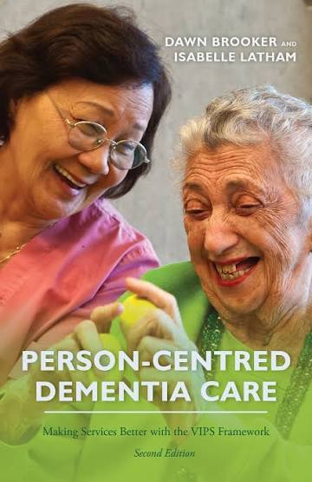
Figure 1 |  |  |  | Figure 2
The impact of person-centered care on dementia patients in residential care home United Kingdom.  Methodology  This study will use a qualitative approach based on secondary research to explore the impact of person-centered care on people living with dementia in UK residential care homes. Research will be gathered from academic databases such as CINAHL, PubMed, Google Scholar and university library databases. Key search terms will include person-centered care, dementia, residential care, quality of life, dignity and wellbeing.  The study will use peer-reviewed journal articles, academic books and reliable health and social care reports. NICE (2018) recommends that dementia care should reflect an individual’s needs, preferences and circumstances. The selected literature will be analysed using thematic analysis to identify key themes such as dignity, independence, communication, wellbeing and quality of life (Braun and Clarke, 2021).  Ethical principles will be maintained by accurately representing previous research, referencing all sources and avoiding plagiarism. |  |  |  | Data Analysis Method  The data collected from existing academic literature will be analysed using thematic analysis to identify common themes and patterns related to the impact of person-centred care on people living with dementia in UK residential care homes.  The findings will be compared and organised into key themes, including quality of life, emotional well-being and individual needs. Braun and Clarke (2006) explain that thematic analysis is a useful method for identifying and interpreting patterns within qualitative data. This approach will help me understand how person-centred care influences the well-being of people living with dementia.  Ethical considerations  Ethical considerations are important in ensuring that research is conducted responsibly and respects the rights and dignity of individuals. As this research will use secondary data, information will be collected from existing academic journals, books and reliable sources. All sources will be acknowledged through appropriate referencing to avoid plagiarism. The research will also ensure that information is presented honestly and accurately without misrepresenting the original findings. Care will be taken when discussing people living with dementia to maintain respect for their dignity, privacy and confidentiality. According to the British Educational Research Association (2018), researchers should follow ethical principles throughout the research process to protect participants and maintain academic integrity.

Data collection method
This project will use secondary data collection by reviewing existing research, journal articles, books and reliable online sources related to person-centred care and dementia. Information will be collected from academic databases such as Google Scholar to understand how person-centered care affects the wellbeing and quality of life of people living with dementia.
According to Johnston (2014), secondary data analysis allows researchers to use existing information to explore research questions.
Inclusion criteria: english language UK-focused publications from 2016-2018 examining dementia patients.

References
Braun, V. and Clarke, V. (2006). Using thematic analysis in psychology. Qualitative Research in Psychology, 3(2), pp.77–101. doi:10.1191/1478088706qp063oa (Accessed on 20th October 2026).
Manu, E. (2021). Secondary research methods in the built environment (Accessed on 10th October 2026).
Nowak, S.A. (2025). V. Braun, V. Clarke, thematic analysis. A practical guide Londyn: SAGE Publications Ltd, 2022, 376 s. Neofilolog, [online] (64/2), pp.470–474. doi:10.14746/n.2024.64.2.15 (Accessed on 9th October 2026).
Pink, J., O’Brien, J., Robinson, L. and Longson, D. (2018). Dementia: Assessment, management and support: Summary of updated NICE guidance. BMJ, [online] p.k2438. doi:10.1136/bmj. k2438. (Accessed on 10th October 2026).
Practitioner day conference Saturday 8th September 2007 at the British Educational Research Association (BERA) Annual Conference Institute of Education, University of London, Bedford Way. (2007). British Educational Research Journal, 33(2), pp.285–285. doi:10.1080/01411920701243917 (Accessed on 5th October 2026).
Savundranayagam, M.Y., Schumann, A., Norris, G., Campos, J.L. and Orange, J.B. (2026). Implementing virtual reality training for person-centered communication in dementia care: A longitudinal qualitative study. Innovation in Aging, 10(5). doi:10.1093/geroni/igag021. (Accessed on 12th October 2026).

