


Security Penetration Testing in virtualised wirEless Network Environment
By
Aaron Cowdry
Supervisor: Carlene E-A Campbell

Project submitted as part of the requirements for the award of BSc (Hons) Computer Networks

April 2017

Declaration of Originality

I, Aaron Cowdry declare that I am the sole author of this Project; that all references cited have been consulted; that I have conducted all work of which this is a record, and that the finished work lies within the prescribed word limits.

This work has not previously been accepted as part of any other degree submission.

Signed : .............................................

Date : ...............................................

FORM OF CONSENT

I Aaron Cowdry hereby consent that my Project, submitted in candidature for the B.Sc.(Hons) Computer Networks degree, if successful, may be made available for inter-library loan or photocopying (subject to the law of copyright), and that the title and abstract may be made available to outside organisations.

Signed : .............................................

Date : ...............................................

Copyright Acknowledgement

I acknowledge that the copyright of this project report, and any product developed as part of the project, belong to University of Wales Trinity Saint David, Swansea.

Table of Content
Table of Content
List of Figures
List of Tables
Acknowledgements

Copyright Acknowledgement iii
Chapter 1
1.1 Introduction 7
1.2 Aim 7
1.3 Objectives 8
1.4 Structure Of The Project Error! Bookmark not defined.
Chapter 2 - RESEARCH & REVIEW OF LITERATURE 9
1. Introduction 9
2. Man in the middle attack 9
3. DENIAL OF SERVICE (DOS) ATTACK 11
4. PENETRATION TESTING METHODS & Tools 13
5. WIRELESS SECURITY 14
2.1 Introduction 17
2.2 Research Overview 17
2.2.1 Research Philosophy 18
2.2.2 Research Approaches 19
2.2.3 Research Strategies 19
2.2.4 Data Collection
2.3 Conclusion
Chapter 4 - DESIGN & IMPLEMENTATION 21
4.1 Introduction 21
4.2 problem formulation 21
4.3 Implementation 23
4.3.1 Windows Server 2012 23
4.3.2 Windows 10 Client 28
4.3.3 Kali Linux Client 29
4.4 Conclusion
Chapter 5 – Testing and Evaluation 32
Introduction
Denail of service attack 32
Reconnaissance Attack 34
Chapter 6 - CONCLUSIONS AND RECOMMENDATIONS 40
6.1 Summary
6.2 Conclusion 40
6.3 Recoomendations for Further Research 40
Chapter 7 – Reflections 41
chapter 8 - REFERENCES 43

Chapter 1

Introduction
According to Cisco [1], Network Security is the protection of services and data that exist on the network. Network attacks come in many variations and the most common include; Viruses, Hacker attacks, Denial of Service (DOS) attacks and Data interception attacks.

These types of security breaches can cause major disruption to organisation operations and in some cases their reputations may be damaged. The Internet service provider, TalkTalk Telecom Group PLC is an example of this: the company suffered from a suspected Distributed Denial of Service attack; millions of customers’ payment details were also stolen by the hackers and posted online [2]. .The company has recently placed a £35 million figure on the security breach and is predicting a major loss in the revenue [3].

A virtualised network has been created, where penetration testing can test the security features of the network. Wi-Fi has been used as the local area network solution. The virtualisation software chosen is Oracle VM VirtualBox. Virtual Box is a type two hypervisor and runs in conjunction with a current host operating system. The virtualised network consists of a Windows Server (2008 R2) with three Windows clients connected wirelessly. In addition, to the Windows clients a Kali Linux client will be introduced into the network. Kali Linux is a security penetration testing software that offers a range of security tools that will allow the testing of the virtualised wireless network. The same test will be repeated to the evaluation effectiveness of security features added to the network. Security features such as firewalls, intrusion detection and logging events on the network could be added to prevent unauthorised access.

Aim
The main aim of the project was to investigate penetration testing, by carrying out an experiment to evaluate the effectiveness of security in a wireless networks.
The experimental aspect of this research used a number of attacks to carry out an evaluation of the security of the virtualised network.

Objectives
The objective for this project are:

• To review the current literature within the field of security and penetration testing which ensured that the research is valid and appropriate.

• To implement a virtual wireless network to test for security vulnerabilities.

• Compare the results of the wireless penetration techniques; with and without the configuration of security features on the virtualised network.

Chapter 2 - RESEARCH & REVIEW OF LITERATURE

Introduction
This chapter will review the current literature in the field of wireless security and penetration testing. The review will also investigate common current attacks against wireless networks.

Wireless Networks operate in an ad-hoc fashion over an unreliable transmission medium, this allows the network to become vulnerable to adversaries and attacks. There are number of security threats and attacks that can maliciously affect these wireless networks such as:
- Man in The Middle Attack
- Denial of Service (DOS) attacks
- Reconnaissance
These three attacks will be the key attacks research in this review.

Man in the middleattack
Yuan et al [4], defines a Man in the Middle (MITM) attack as an interception of traffic between two computers. Usually in a wireless environment the attacker uses a Rogue Access Point (AP) that is not part of the usual network.

An Access point is a wireless network device that is responsible for sending and receiving data across a wireless network. This device allows for user to connect to a wired network or just a solely wireless ad-hoc network. The purpose of a wireless AP is allow host devices to communicate with other network devices and other hosts connected to the Wireless Local Area Network (WLAN). A WLAN may include multiple AP’s to allow for full wireless connectivity on a particular network.

A rogue AP is usually set up to mimic a genuine WLAN AP to get host to connect to the unauthorised network device, for example using a similar Service Set Identifier (SSID) or offering a free service. A Rogue AP captures packets and potentially modifies them or analyse the packet depending upon the type of encryption. The paper states that a critical part of a MITM attack is the reliance on the host to associate with the Rouge AP. Once the association between the host and the AP is complete, the host believes the AP is a legitimate AP and part of the network.

Conti et al [5], describe in depth the type of MITM attacks and how they can be prevented this type of attack using a number of software and hardware solutions. The paper describes a MITM attack which is when a third party secretly captures information from the wireless communication channel between two (or more) end points in the WLAN. This type of attack targets the data flowing between the two end points or nodes within the network. The purpose of this type of attack is to intercept, change or replace the data being communicated between the two end points. They divide the types of MIMT attacks into four categories, spoofing-based MITM, SSL/TSL MITM, BGP MITM and False Base Station based (FSB-based) MITM. Table 1 illustrates the layers of an OSI model where different types of attacks are carried out at various layers.

 |  | MITM Attacks
OSI Layer | Application | BGP MITM, DHCP Spoofing-based MITM, DNS Spoofing-Based MITM.
OSI Layer | Presentation | SSL/TSL MITM
OSI Layer | Transport | IP spoofing-based MITM
OSI Layer | Network | IP spoofing-based MITM
OSI Layer | Data Link | ARP Spoofing-based MITM

Table 1 – MITM Attack on Different Layers of OSI Model and Types of Cellular Networks, taken from [2].

The paper [5], further describes in-depth Spoofing-based MITM, SSL/TSL MITM, BGP MITM and False Base Station based (FSB-based) MITM. Furthermore, Timm and Perez [6], identify that a MITM attack is a versatile attack and can be carried out a number of types of communication mediums such as a Long-Term Evolution (LTE), Bluetooth, Near Field Communications (NFC) and more traditional networks such as a wired Ethernet and WLAN.

Conti et al [5], defines a spoofing attack as an impersonation of a host or end device by an unauthorised user within the WLAN to gain access to sensitive data. Hosts are not aware of this and the attack controls the data being sent between the two or more hosts in the network. A spoofing attack is generally used to gain access to a WLAN and to start a larger MITM Attack or a DOS Attack. There are a number of different protocols that can be utilised to spoof a WLAN; these include ARP Spoofing, DNS Spoofing, DHCP Spoofing and IP Spoofing. All these protocols have a weakness with authentication at the source and destination nodes within the network. They identify that ARP and DNS Spoofing should be used in a LAN (Local Area Network) environment. ARP uses Media Access Control (MAC) addresses to locate devices on a LAN; this is vital to communication between devices within a LAN. ARP uses the destination device’s MAC addresses to forward packets to the correct host within the network. ARP does not use any countermeasures to stop unauthorised activity with packet frames. Attackers commonly tamper with ARP cache table to direct packet that are intended for a legitimate host to the IP address of an attacker. Two type of ARP spoofing is identified, ‘cheating the gateway or cheating the host of the internal network’. In explanation of the prevention approaches for ARP spoofing, they conclude that strong authentication, a secure key channel and using cryptography must be used to prevent Man in the middle attacks.

They [5] outline the approaches for various ARP spoofing prevention.
A logical table shows details according to the category of the type of prevention
However, two-thirds of the approaches they discuss in the article are not considered current because they are over ten years old. Upon further analysis, some approaches are incomplete. The table also does not identify any positives approaches mentioned. Also, some areas of the article are unclear and do not describe the solution in full.

DENIAL OF SERVICE (DOS) ATTACK

According to SANS Institute [7], a DOS attack can be targeted against both a wireless and wired network. DOS attacks are normally achieved by sending amount of packets to request a service, application or device being utilised on the network. The aim of such attack would be to exhaust a server, router or access point capability of handling such traffic. In addition, the types of DOS attacks that are targeted at particular network layers. Application layer attacks are the most common DOS attack used; attacks at the application layer involve the targeting of networking applications such as Hyper Text Transfer Protocol services (HTTP). An example attack would be a HTTP flood attack using the SYN and SYN ACK packet types. DOS application layer attacks can be highly effective when targeted at wireless networks, resulting in complete network loss or degraded performance. Moreover SAN Institute describes attacks at the network layer: it identifies that wireless AP’s with no security access configured are more likely to be exposed to this type of attack. Internet Control Message Protocol (ICMP) flooding is an example of an attack at this layer.
Compton [7] describes this attack as “The ICMP flood attack works by an attacker sending so many ICMP echo request packets to the target wireless system that it cannot respond fast enough to ease the amount of traffic.” Furthermore, Compton [7] states that attackers may spoof the source IP address; this would allow the attacker to use all the network’s services.

The network will be obligatory to use all of its resources to process packets that are being sent from the attacker’s IP address. This would potentially cause quality of service to be degraded and potentially stop the wireless network from operating completely. This is caused by the attacker consuming the available network bandwidth. Compton [8] further describes the DOS attacks at the MAC layer; this type of attack used a spoof MAC address of a wireless AP. The client receiving the spoofed packets cannot differentiate from the legitimate and illegitimate packets and requests being made.

Huang et al [8], explain that the MAC layer of IEEE 802.11-based WLAN is at high risk of attacks. They also identify that MAC address spoofing would allow an attack to initialise many types of attacks including DOS attack and a MITM attack. Furthermore, they point out that wireless security protocol such as WEP, WPA and WPA 2 only offer protection upon transmission of the data from the source.

Huang et al [8], go on to introduce the protection protocols such as the Microsoft PANS protocol and Lancaster protocol.

The effectiveness of these protocols to prevent attacks targeted at the MAC address layer and in particular the protection against MAC address spoofing attacks.

PENETRATION TESTING METHODS & Tools

Johns [9] describes various techniques and tools required to carry out penetration testing in a wireless environment. These techniques and applications are directly related to penetration testing that were carried out in the experimental part of this project. He explains and evaluated the use of wireless penetration testing tools such as: NetStumbler, WEP Crack, Aircrack and Metasploit. The publication does not directly discuss the use of Kali Linux or of these techniques in a virtualised environment but he does offer an in-depth investigation on wireless penetration testing techniques that are used in industry which could be applied in the implementation stage of the project.

Mehta et al [10] investigate the use of mobile devices using an android operating system installed with Kali Linux and an application called Connector that analyses information related to username and passwords. They go on to describe how they used Kali Linux to set up a rogue Wi-Fi AP also known as an Evil Twin. Wireshark is also used to capture packets transfer between the host and the Evil Twin. This research is similar to the proposed project but the project applies some of the similar tools and attack types available.

Also, Buchanan [11] in addition to Mehta et al’s investigation describes the use of similar penetration techniques in a Microsoft/Linux network environment. He describes in-depth the process of creating a venerable machine in the windows environment. He states that in order to create vulnerabilities on a network, services on the network must be made vulnerable such as a Domain Name System (DNS) server being placed in position that could be compromised on a wireless network.

Buchanan [11] describes the methodology for cracking WEP using a penetration tool available in the Kali Linux application called Airbase. In addition Python and iptables are used to create the environment to effectively crack WEP. He [11] describes in detail the process of cracking WEP and setting up the network infrastructure on the Kali Linux side of the wireless network. In addition, he [11] investigates the process of cracking Wi-Fi Protected Access 2 (WPA-2). This is done by capturing the WPA-2 handshakes using the application Airbase, that could potentially reveal sensitive information about that network and its configurations.

This type of attack is created using the Airbase –NG application within Kali Linux. This also include using a MAC filter tool, this allows for specific devices to target by an attack rather than attacking every device within the access points range. He [8] describes how to DNS spoof a wireless device using a specific command within airplay called airplay-ng. These types of techniques and methodologies are similar to what this project aimed to achieve within the virtualised network. The techniques are not specific to the Windows wireless network environment but are related to tools within Kali Linux. A drawback of Buchanan’s [11] research is that he does not provide any examples for implementing these types of attacks using Oracle VM VirtualBox or any other virtualisation software.

However, Allen et al [12], state that wireless penetration testing techniques can be carried out in a virtual machine environment. It recommends the use of Oracle VM VirtualBox and Kali Linux to evaluate the security of a Network. Yet they do not discuss the use of Kali Linux or the use of Oracle VM VirtualBox in a wireless penetration testing situation.

WIRELESS SECURITY

Lashkari et al, [13] investigate the effectiveness of the most common wireless security protocols that are actively used in wireless networks today, such as WEP (Wired Equivalent Privacy), WPA (Wi-Fi Protected Access) and WPA2/802.11i (Wi-Fi Protection Access, Version 2). In addition, the paper identifies the main security weakness with the various security protocols. The paper identifies WEP as being the most redundant and least secure protocol. They identify the protocol as having a faulty RC-4 algorithm, allowing brute-force attacks to be possible due to a poor and weak encryption key.
They highlight the simple procedure to imitate and replay encrypted packets to gain access to the protected data and the simple process to modify encrypted data and to forge authentication packets.
Lashkari et al [13], further identifies characteristic and faults of WPA and WPA2.

Vanhoef and Piessens [14], investigate the vulnerabilities that are common with WPA2 (WPA-TKIP). They look at the use of TKIP in wireless networks and highlight the problems with TKIP as a wireless security protocol. They describe TKIP as an improved version of WEP but which uses faulty the MIC algorithm. In addition, TKIP uses the same faulty RC-4 algorithm that is present in WEP.

They’re [14], research finds TKIP is still used in a high number of networks despite the well documented faults. The paper included an investigation of commercial areas in Belgium and states that 71% of networks surveyed use or supported TKIP, with 19% of the networks solely using TKIP in their wireless networks. It is also noted that 14% of the wireless networks use WEP as their choice security protocol. They concludes that TKIP is still in operation today which could attributed to the fact that routers and access points which are configured by default to use a mixed security mode. This would allow the use of both TKIP and the more secure CCMP.

Dobrilovic et al [15], research into the wireless security options available, such as WEP, 802.1x Extensible Authentication Protocol (EAP), WPA, WPA2 and WPS. They involves carrying out a survey of wireless networks in a number of geographical locations. The purpose of this was to evaluate and survey the type of security that wireless networks were using. They [6], used Wardriving techniques and software to gather the information and classify the data. They also investigated the number of wireless networks using WPS. Dobrilovic et al. [11] study evaluated the security of nearly 3000 networks in Serbia in a period of almost a year. The investigation concluded that the majority of networks were using a mixed mode of WPA and WPA2. Also it identified that 4.88% of networks within this geographical location were using only WEP, which is obsolete and is no longer recommended for use. In addition, they [6], identify that only 24% of networks were using CCMP and identify these as highly protected networks; the majority of the other remaining networks were being protected by the much less secure TKIP. Dobrilovic et al. [16], identify that 35% of the APs assessed have WPS enabled; they state this is percentage is too high and unacceptable because of the well-known security faults with the protocol.

Both Vanhoef and Piessens [14] and Dobrilovic’s [15] research reach similar conclusions and both identify that the proportion of networks are still using legacy security protocols. They identify that obsolete security protocols such as WEP and WPA are using the authentication method T-KIP is too commonly found which heighten the potential security risk to wireless networks.

Chapter 3 - RESEARCH METHODOLOGY

Introduction
This chapter will explain and introduce the research philosophies, approach and strategies used in this project. Furthermore the chapter explains how data was collected and analysed and the processes put in place to ensure that that the data collected was reliable and valid.

Research Overview
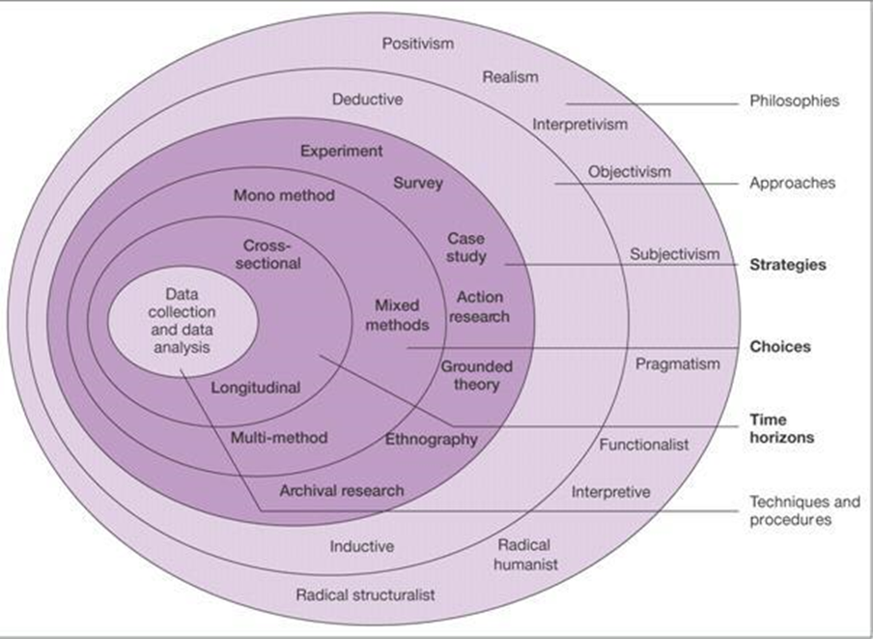
Figure 1 – Taken from [16]

The research onion has multiple layers that offer the different philosophies, approaches, strategies, research methods and time horizon. Layer one describes the suggested research philosophies; the most common are Interpretivist and Positivism. A research philosophy is a process that used to gather information and data, analyse the data and the how the data is further used.

Research Philosophy
Several of the most common philosophies have been explored which justify the use of a philosophy or give reasons for a common philosophy that would not be suitable for this project type.

Ontology
Ontology is the research philosophy that examines the ‘way the world operates’. It is identified as producing valid research in many subject areas. Ontology is split into two aspects of the philosophy, Objectivism and Subjectivism. According to [16] Objectivism ‘portrays the position that social entities exist in reality external to social actors concerned with their existence.’ Taking a subjective approach implies that social theories are created by actions of social influences. This type of approach does not suit this project theme as social factors and influences would not be a factor in the outcomes of this project. [16]

Positivism
Positivism is the research philosophy that generally uses a classical scientific approach to research, gathering data by observation and creating an end result that it is credible. Positivism relies on the formation of hypotheses to test the current theories and ideas that are present within the field. The hypotheses will be the key research questions and tests or experiments will be carried out to prove the statement. [16]

Positivism also relies on the data being collected not being altered, adapted or interpreted in other than its raw form. Generally, the research is independent of the data collected and has little or no input into final results in the form of opinion or views. Positivism uses a highly structured approach and is focused on the collection of quantifiable observations which will lead to an analysis of the data collected. [16]

For this project a positivism research philosophy was used. This approach has been chosen because the project relies on observations of the network’s performance. These observations were undertaken when a particular type of attack was carried out on the virtualised network. Data was collected and analysed to formulate a result based on testing the findings against current theories (the project hypotheses) to determine a final outcome. The project is based on an experiment of comparing scenarios applied to a wireless network; this would indicate that a research philosophy using a positivism approach would be best suited in order to produce accurate findings.

Research Approaches

The two type of research approaches are deductive and inductive approaches.

A deductive research approach is most associated with the positivism research philosophy; it is consider as the most traditional research approach. A deductive approach is a testing theory rather than developing or making a new one. A deductive approach would involve developing a research hypothesis and then developing strategies to test the hypothesis stated.

The alternative research approach to deductive approach would be an inductive approach. Taking an inductive approach is more commonly associated with forming theories, from using data such as interviews. This approach is more aimed at social science themed research, where people’s opinion is main source of data. Data collection in this approach would be more aimed qualitative form.

The research approach best suited to the project would be deductive. A deductive approach is best suited with a positivism research philosophy and is more of a traditional research strategy.

The hypothesis for this for the project was agreed as:
When the network was penetrated using a Kali Linux virtual machine, the network prevented more intrusion and data manipulation with the security facilities turned on and firewalls were configured.

Research Strategies
The project used the following research strategies:
• Experimental
• Document Review

Experimental Strategy
The project will use an experimental strategy to evaluate the relationship between using security facilities on a wireless local area network (WLAN) and unsecure WLAN. The both secure and unsecure LANs will test to evaluate the secureness of the network using Kali Linux.
The attacks to be carried out are:
• Man in the Middle
• Denial of Service (DOS) attacks
• Reconnaissance

Document Review
A document review will identify the key concepts and theories of penetration testing and wireless security. The document reviews will highlight relevant research in the whole field of wireless penetration testing and security. The review will also justify the project’s practicality, along with identifying the facts involved and give a guide to be able to compare the results of the proposed research.

Action Research
Action research is addressing a problem to find the most efficient solution to a problem. This type of strategy allows the researcher to be part of the solution. Generally, action research does not use clear objectives to identify the problem but uses actions to identify and solve the problem [17].

In addition, action research is the use the knowledge of experts or practitioners of a particular field(s) - in this project’s case network security, penetration testing or general computer networking to develop knowledge and findings [16]

Chapter 4 - DESIGN & IMPLEMENTATION

Introduction
This chapter will look at design and implementation that will be involved in this project. The chapter provides a detailed implementation and design for the virtual network.

problem formulation
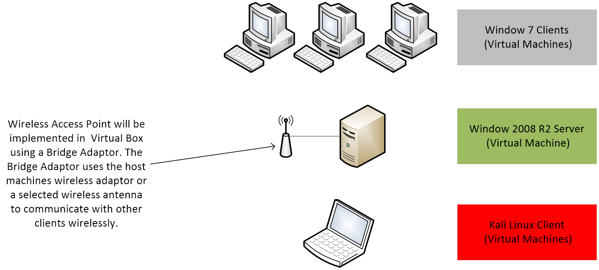
Figure 2 – Initial Basic Network Design

The original solution as described in figure one was to use the host machines wireless card to emulate a Wireless LAN connection to communicate with other host on the network. This solution was unable to implement in VM Ware using the Bridge Adaptor. Upon further research it was found that this option could only be used for bridging to a physical access point for an Internet connection for use on the virtual machine. It was not an option to connect to other wireless networks using this feature.

The option of using a Virtual AP was explored using a solution such as Open WRT image and installing it in to a Linux based machine was explored within VM Ware. Open WRT provides frame ware for APs and could have been potentially used to act as a Virtual AP in the virtualised network. Upon testing this solution the Access Point frame ware were not combatable with the versions of Linux offered in Virtual Box. This option would have been possible if the project was carrying out penetration methods in a wired network.

A solution of using a Software based access installed on a PC within the network was also investigated and tested this option. Although the AP appeared to be broadcasting it SSID, it would not allow the virtual machines or other test devices such as the host PC to connect to the AP. This solution was discarded because of the connection issues.

The chose connection solution was to use a physical AP to allow the virtual machines to communicate over a wireless network. This solution was the most viable option to ensure that a reliable and flexible communication method.

Furthermore, upon on carrying out some initial testing it was found that the using just the hosts wireless network adapter would not all multiple host to connect to a the test AP. To allow all the Virtual Machines to connect to the test AP an individual Wireless network card was required for each Virtual Machine on the network. This creates a more

Implementation

Windows Server 2012
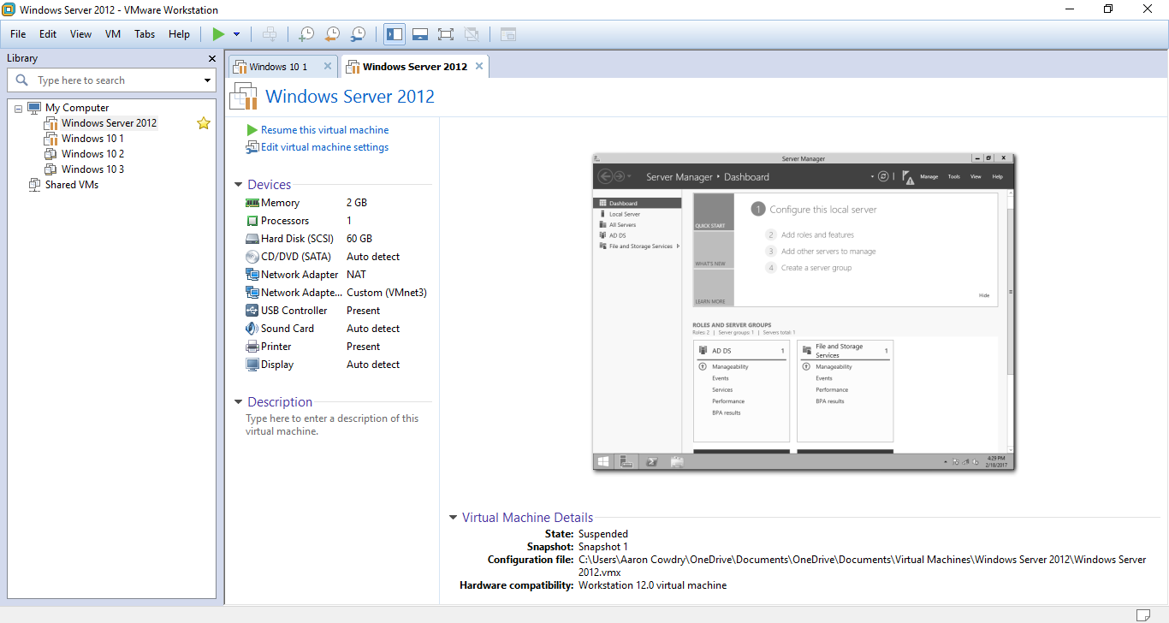
Figure 3 – Server Configuration in VM Ware Workstation

Figure 3, shows the virtual machine configurations chosen for the Window 2012 R2 server implemented in the virtual network. The hardware has been kept to the recommend settings by VM Ware for the particular operating system. A basic 2 GB of Memory and 1 Processor was implemented, this would minimise the performance demand on the host machine.

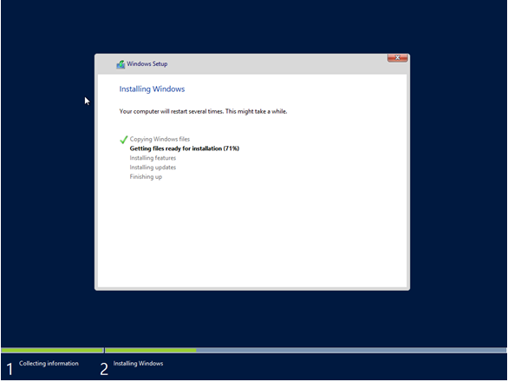
Figure 4 – Windows 2012 R2 Installation Process

Figure 4, shows the installation process of the server in VM Ware Workstation.
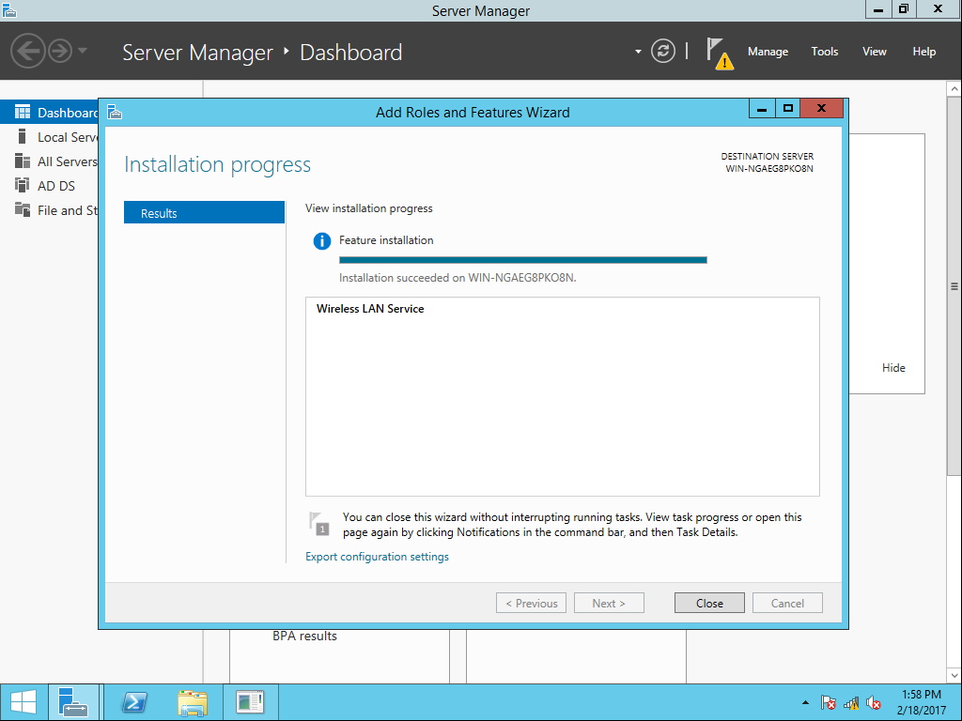
Figure 5 - Installation of Wireless LAN Services

Figure 5, shows the installation of Wireless LAN Services role on the server. This allows the server to connect to Wireless Networks by enabling WLAN Auto Config service. This feature automatically configures the wireless service and allows the server to use wireless adapters connected [18]. In addition, Active Directory services were installed on the networks sever.
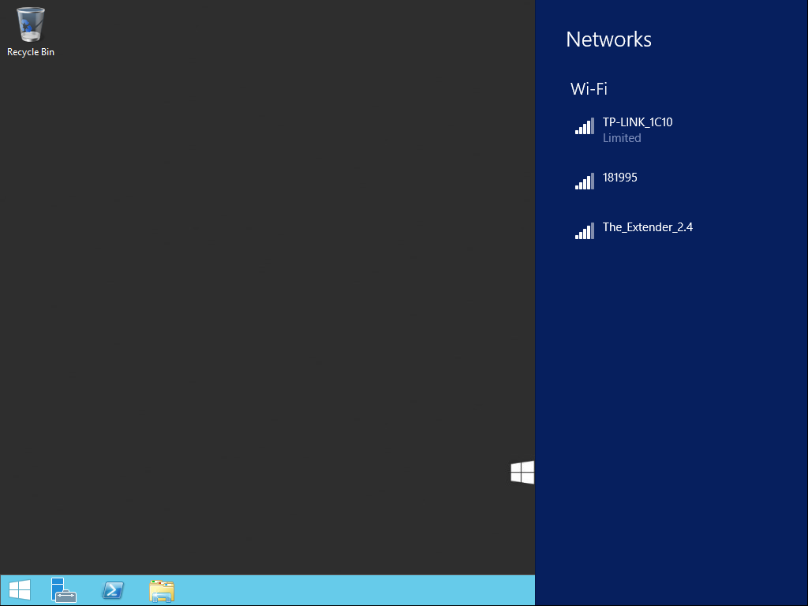
Figure 6- Connection to Access Point
Figure 6, shows the server fully connected to the WIFI network using its Wireless Network adapter to connect to the physical access point.

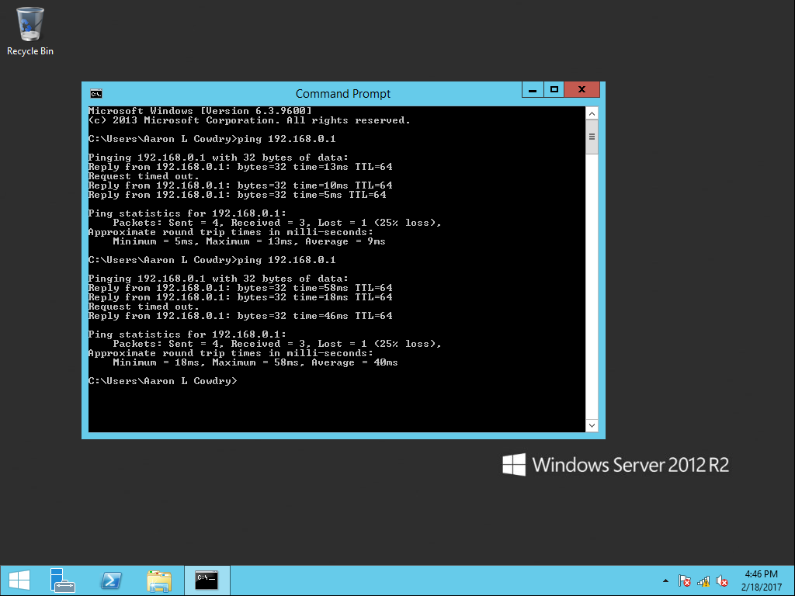
Figure 7 - Connection test with other host and AP
Figure 7, shows the testing of the wireless network connection. The screenshot shows the connection between 192.168.0.1 (the routers IP address) is fully connected and data can be transferred between them. The figure also indicates that there is a successful connection between 192.168.0.100 on the network. This is the one of Windows 10 clients also on the wireless network.

Windows 10 Client
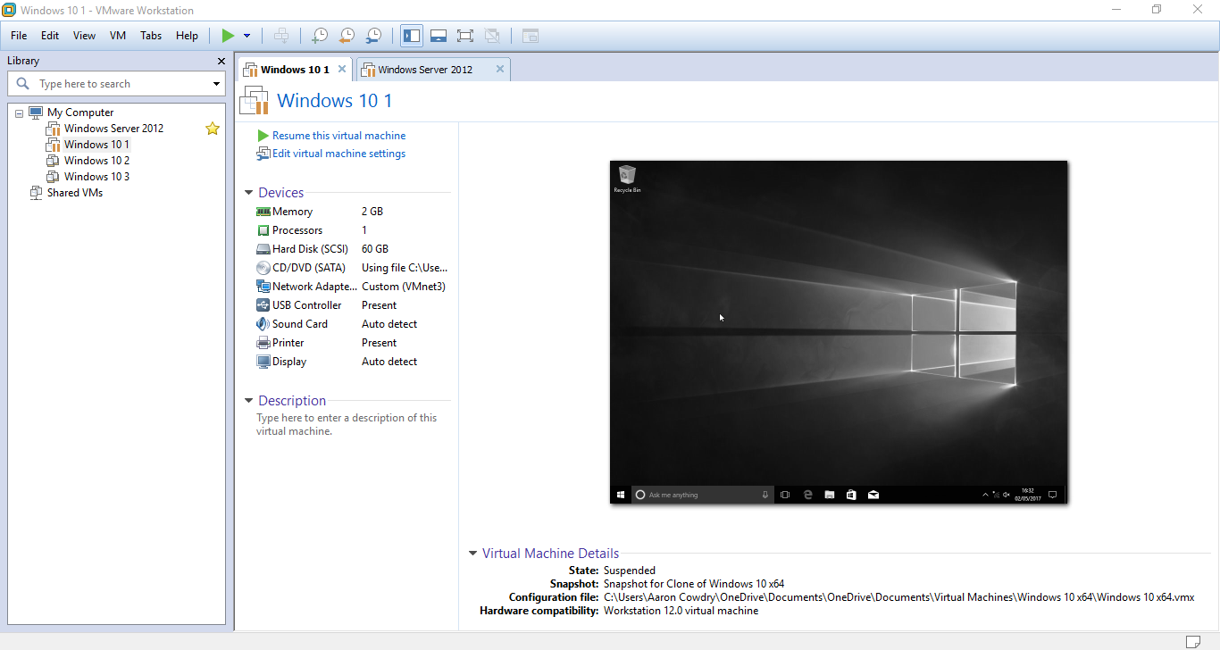
Figure 8 – Installation of Windows 10 Client in VMware

Figure 8, describes the hardware chosen and implemented for the client based on the virtual network. As with all other Virtual machines the virtual network adapter is not utilised. This is due to the use of an external USB network adapter being used to connect the physical AP. The virtual network adapter being show has no bridged or NAT adapters connected.

Kali Linux Client
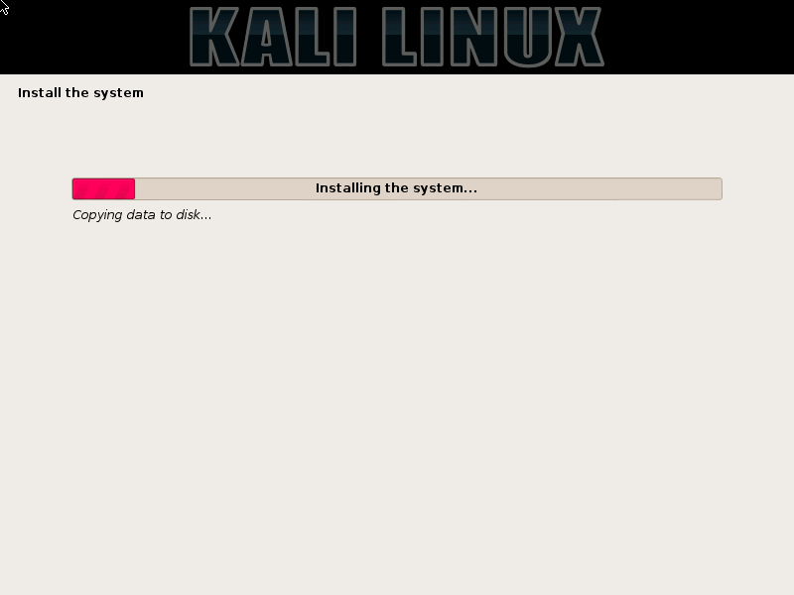
Figure 9 – Installation of Kali Linux within VMware
Figure 9, shows part of the installation process in Kali Linux. A 64 bit version was used and installed using a Debain 7 in VMware.
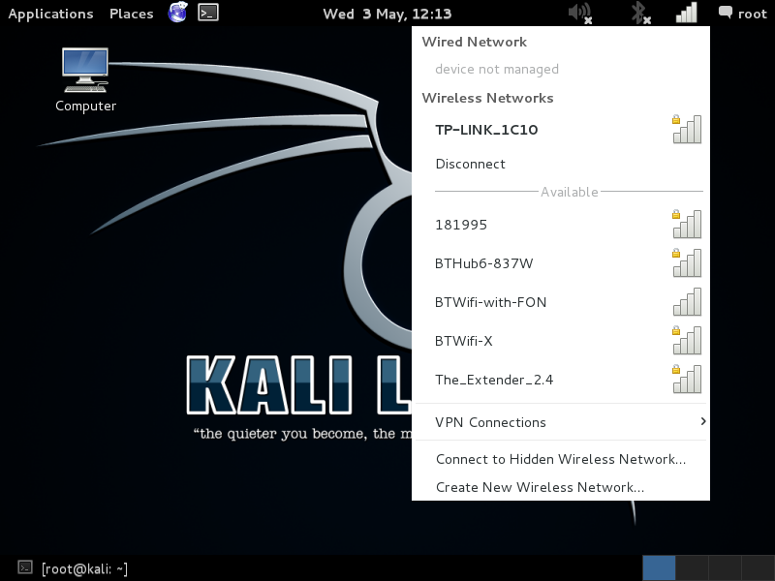
Figure 10 - The Kali Linux machine connected to WiFi Network.

Figure 10, Kali Linux machine is shown connected to the physical AP. The machine successfully connected to the router using a USB wireless adapter.

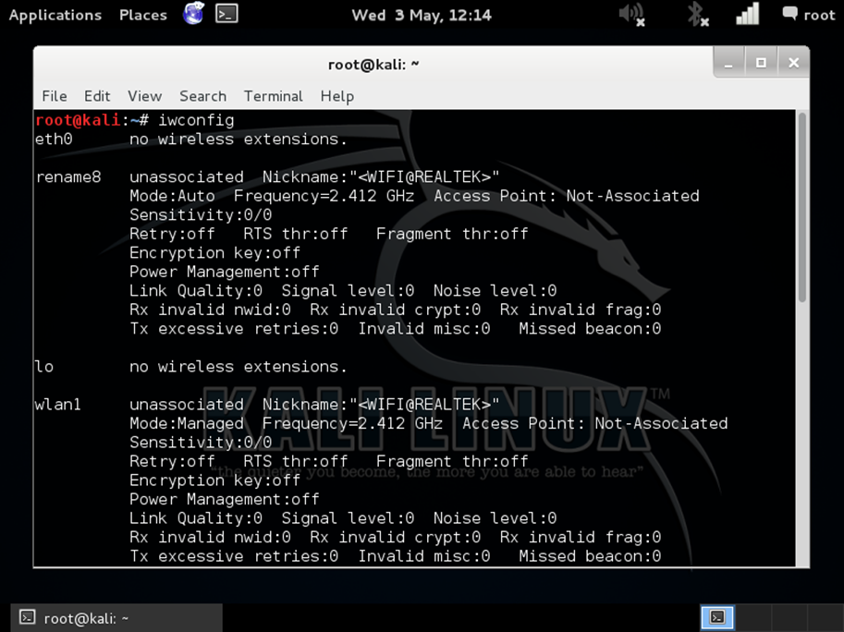
Figure 11 – Network Connections to the Kali Linux machine.
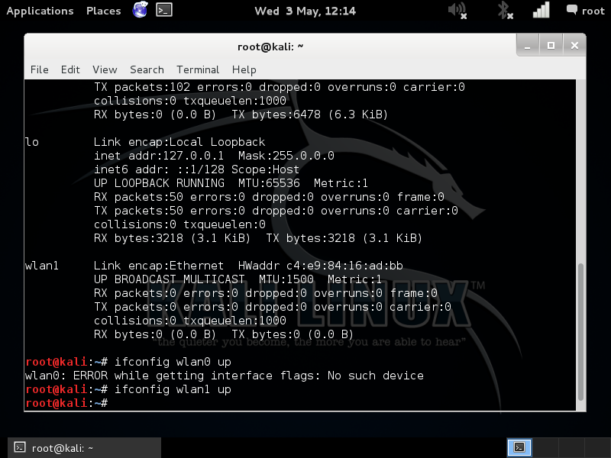
Figure 12 – Configuring the wireless interface in Kali Linux

Figure 11 shows the connection to the Kali Linux machine. WLAN 1 is wireless adapter that will be used for penetration testing aspect. Figure 12 details the process of configuring the wireless interface to allow it to connect to networks. In addition, a monitoring virtual adapter was created. This allows the network adapter to monitor other networks that are within range of the wireless adapter.

Chapter 5 – Testing and Evaluation

Denail of Service Attack
Without Security Features Enabled on the WIFI network:
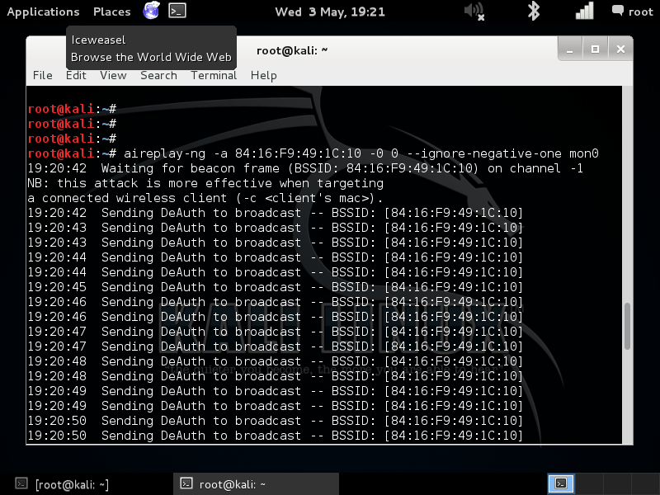
Figure 13 – DOS 1 attack within Kali Linux
Figure 13, illiterates the process of attacking the access point using Kali Linux. This is done using the aireply-ng that specially targets the mac address of the physical access point in the wireless network. The attack uses broadcast packet in an attempt to de-associate all clients connected to the wireless network and cause the connection to be lost.

A set time of 5 minutes was put in place to allow the Kali Linux machine to target the wireless AP. This would ensure that when the test was repeated, the same number of packets would attack the network every time the test was conducted.

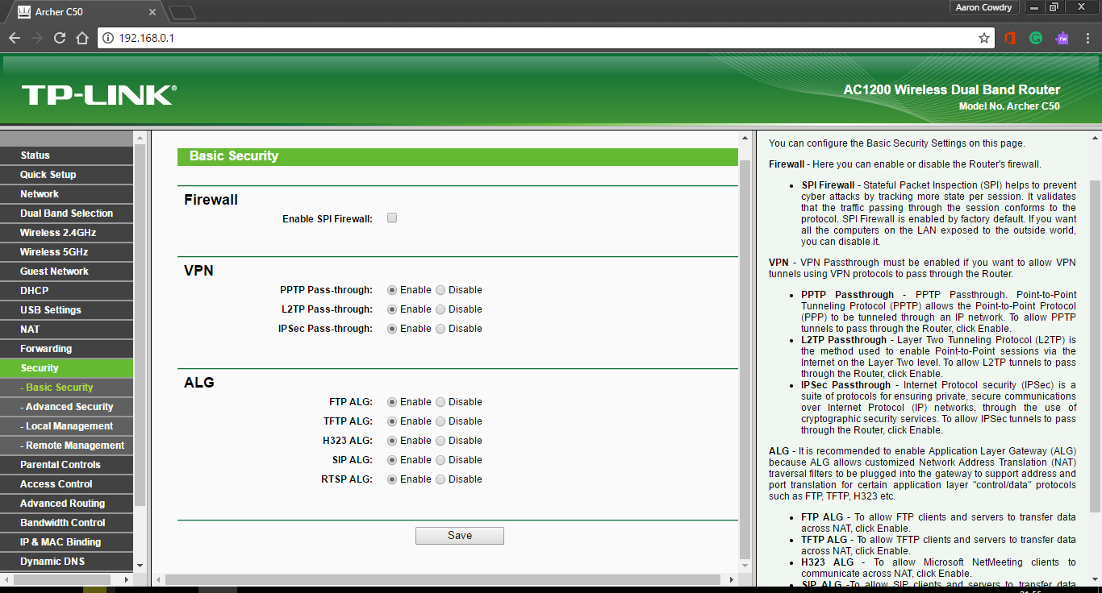
Figure 14 – Firewall Disabled on Physical Router
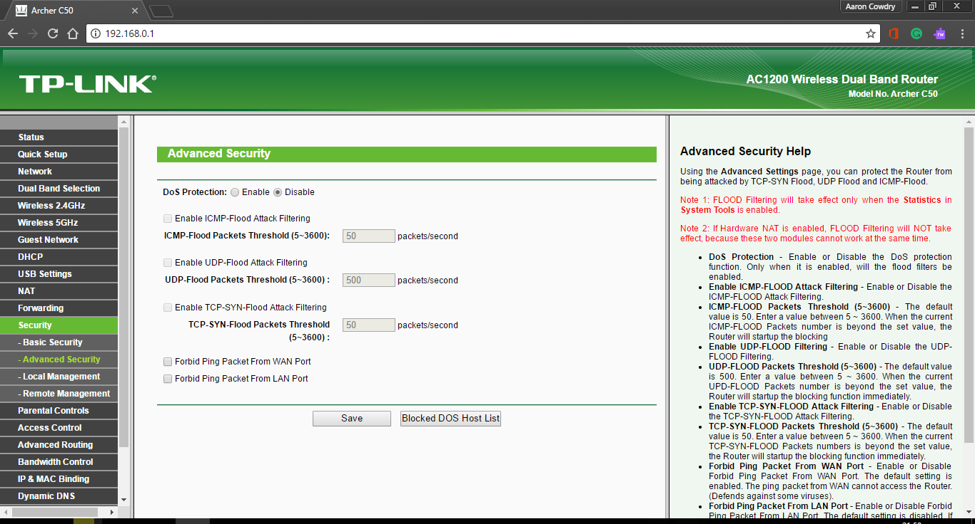
Figure 15 - DOS Protection Disabled on Physical Router

Figures 14 and 15 show that all security features on the physical wireless access point were disabled at the time of the attack. This would in theory all the network to be completely attacked with no countermeasures in place to stop a DOS attack. For the DOS attack to be consider complete, of all the devices on the network must de-associate with the AP.

Data Collection and Results:
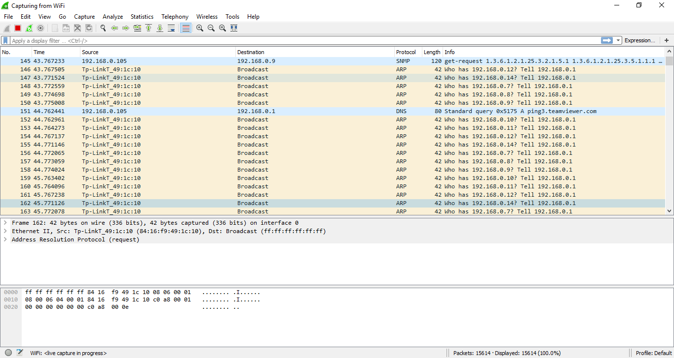
Figure 16 – Screen Capture of Wireshark during DOS 1 attack
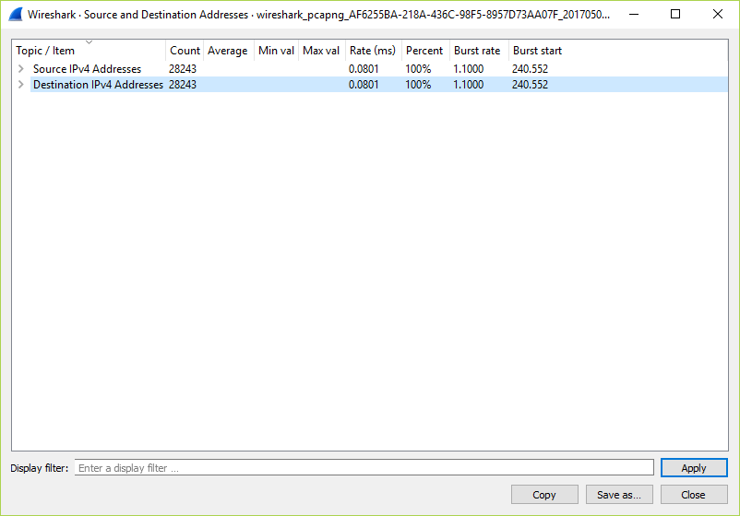
Figure 17 – Analysis of Packets being sent over Wireless Network during DOS 1 attack

Figure 17 shows the number of packets sent over the duration of the attack, to IP address on the network. This shows that 28,248 packets were sent over the network in the DOS attack

During the observation of the attacks it was found despite the large number of packets being sent over the network the host did not de-associate with the AP. The test was completed 21 times to attempt to get the AP to de-associate with the AP.

With Security Features Enabled on the WIFI network:
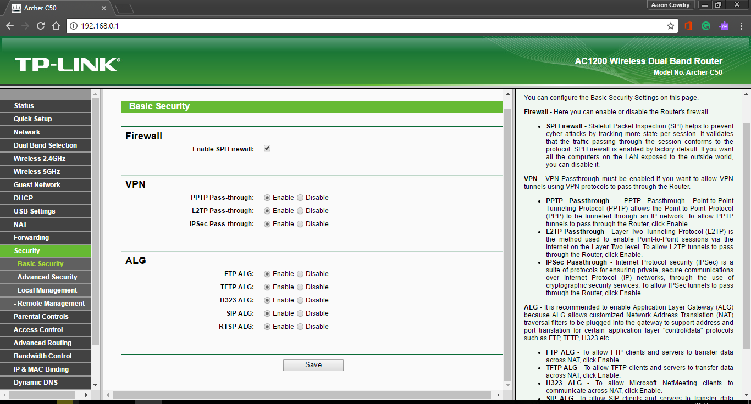
Figure 19 - Firewall Enabled on Physical Router
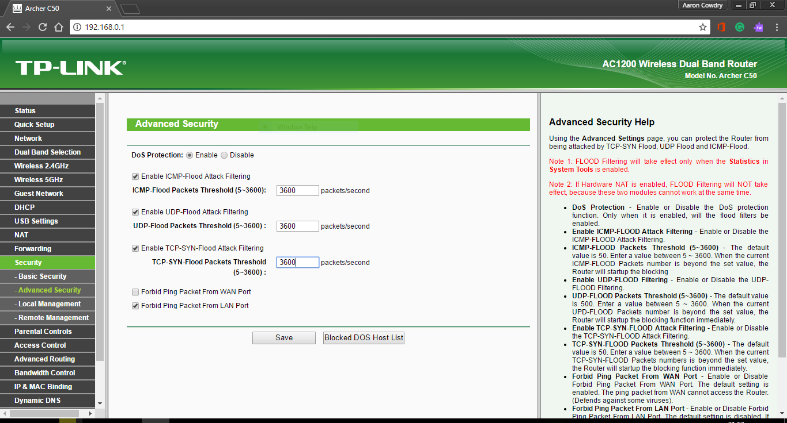
Figure 20 - DOS Protection Enabled on Physical Router

Figure 19 and 20 show that the Firewall and DOS protection have been enabled for this part of the attack. The DOS protection was set 3600 packet for parameters and ping was filtered on the WLAN.

Data Collection and Results:
Figure 21 – Screen Capture of Wireshark during DOS 2 attack
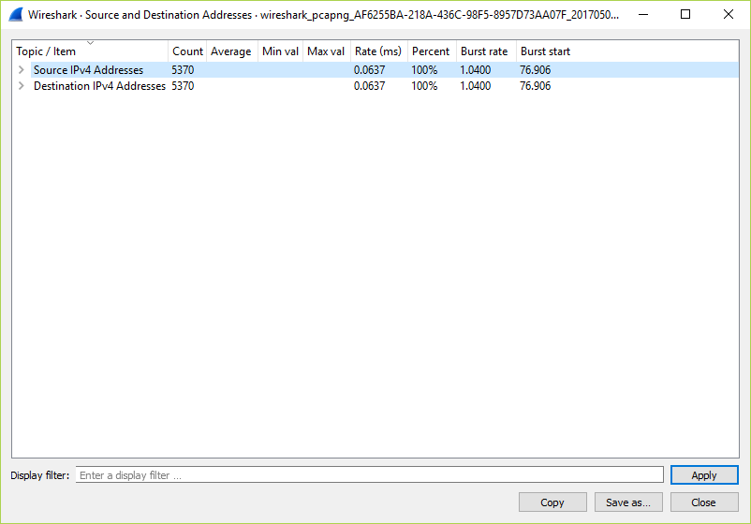
Figure 22 - Analysis of Packets being sent over Wireless Network during DOS 1 attack

Figures 21 and 22 show the data collected with security features enables on the wireless network. Figure 21 show the broadcast packets attacking the wireless network.
Figure 22 indicates there is significantly lower amount of packets that have reached the host on the network. The total number of packets sent to host on the network was 5,370 witch is lower than the 28,248 packet reaching the host on the network without any security features enabled.

Although, like in the scenario where no DOS protection and no other security features were enabled the wireless devices did not de-associate as expected.

Reconnaissance Attack
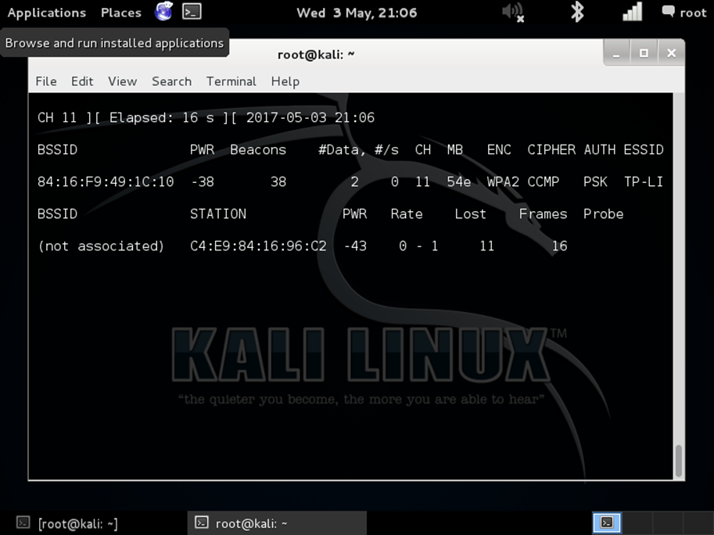
Figure 23 – Example 1 of Monitoring Other Wireless networks
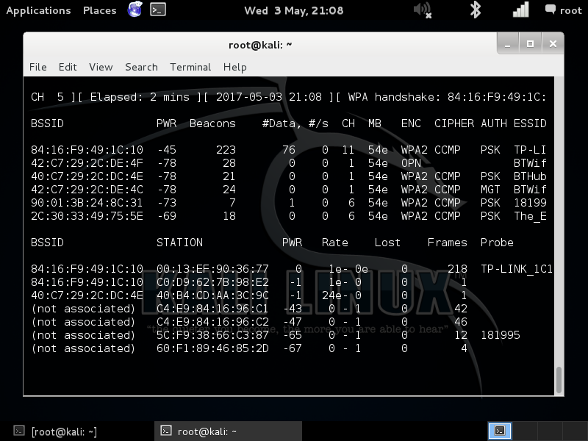
Figure 24 – Example 2 of Monitoring Other Wireless networks
Figure 23 and 24, show the how wireless networks can be monitored in Kali Linux. This example shows mac address of the access point, the wireless channel it is operating at, the encryption type, the cypher type and the authentication is discovered. This is critical information to start any type of attack on a wireless network.

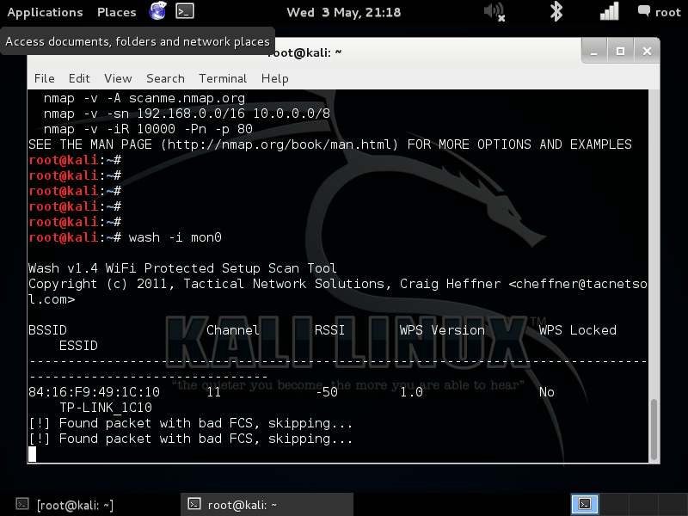
Figure 25 – Identifying networks with WPS enabled

Figure 25, shows the use of ‘Wash’ feature in Kali Linux. This allow the attacker to identify networks that have WPS enabled. WPS is a weakness of wireless networks as it particularly easy to gain the key and therefore access to the network [15].

Chapter 6 - CONCLUSIONS AND RECOMMENDATIONS

Conclusion

The project has identified the key literature currently in the security field related to Penetration testing in a type two hypervisor. The review identified that there is little related literature offered in the area of Wireless Penetration Testing using virtual machines to carry out the practice.

A detailed methodology has been constructed to ensure that data is captured and results are recorded accurately to produce accurate findings.

The project has designed and implemented a virtual wireless network to allow attacks to be successfully carried out.

The project has carried out a number of wireless network attacks, these include a Denial of Service attack and two type’s reconnaissance attack to gather information on the network. The project has proven that with security features enabled on the wireless access point it prevented a Denial of service attack potentially causing disruption on the network.

Recoomendations for Further Research

- To carry out the same attacks with the same hypothesis in place using a type one hypervisor. This will minimise the problems incurred during this project as the host operating system has stopped attacks from working and possibility created false positives.
- To implement a virtual wireless access point to have a complete virtual network infrastructure.

Chapter 7 – Reflections

On reflection, overall I feel that the project has met the aim and objectives. I feel that the design and implementation chapter of the report was well documented and described. Clearly, my investigation has proven that the network prevented more attacks with security features enabled on the virtualised network than without any switched on. This supports my hypothesis that, when the network was penetrated using a Kali Linux virtual machine, the network prevented more intrusion and data manipulation with the security facilities turned on and firewalls were configured.

In measuring the success of the aims and objectives, I have determined that the current literature in the field of security needs exploration, in particular the use of virtual machines in penetration testing in a wireless environment. I have compared the results of my experimental aspect of the project by evaluating the security technologies that are available for wireless networks to prevent network attacks.

Overcoming the initial problem of VMware not allowing the implementation of a software or virtual type Wireless Access Point was a positive part of the project for me. In addition, I feel that the Methodology chapter is extremely thorough; this has supported me in the making changes to the initial plan of using a software based router. I feel that the only section of the Methodology that could have been stronger was the Data Collection section because initially there was a lack of understanding in how the data would be collected once the attacks had been completed.

I feel that the Testing and Evaluation chapter of this project is the weakest due not being able to implement a Man in the Middle attack to due to a problem within Kali Linux. However, I feel that the rest the attacks are well documented. I had some further difficulties implementing some of reconnaissance attack, I was unable to run port scanning to an error with Kali Linux virtual machine becoming corrupt once the scan had been completed.

I feel that the Literature Review chapter is a particular weakness as I do not feel I reviewed enough of the topic area. However, my research indicated that there was not enough research carried out into the area of Wireless Penetration Testing in a virtual environment. I feel that key research I concentrated on had some weaknesses because they were dated and that they do not specifically mention the use within a virtual environment such as VMware. Yet, this justifies the need for this particular study.

chapter 8 – REFERENCES

[1] Cisco, “What Is Network Security?,” Cisco. [Online]. Available: http://www.cisco.com/cisco/web/solutions/small_business/resource_center/articles/secure_my_business/what_is_network_security/index.html. [Accessed: 16-Nov-2015].
[2] S. Armstrong, “What are the costs associated with the TalkTalk breach? - SC Magazine UK,” SC Magazine UK, 2015. [Online]. Available: http://www.scmagazineuk.com/what-are-the-costs-associated-with-the-talktalk-breach/article/452744/. [Accessed: 16-Nov-2015].
[3] BBC, “TalkTalk hack to cost up to £35m - BBC News,” BBC News, 2015. [Online]. Available: http://www.bbc.co.uk/news/uk-34784980. [Accessed: 16-Nov-2015].
[4] X. Yuan, R. L. Archer, J. Xu, and H. Yu, “A visualization tool for wireless network attacks,” 2nd International Multi-Conference on Society, Cybernetics and Informatics, IMSCI 2008, 2008. [Online]. Available: http://www.scopus.com/inward/record.url?eid=2-s2.0-79953275343&partnerID=40&md5=8e157b21b050885309eeb428a9a47e2d. [Accessed: 16-Oct-2015].
[5] M. Conti, N. Dragoni, and V. Lesyk, “A Survey of Man in the Middle Attacks,” IEEE Communications Surveys and Tutorials. 2016.
[6] C. Timm and R. Perez, Seven Deadliest Social Network Attacks. 2010.
[7] S. Compton, “802.11 Denial of Service Attacks and Mitigation,” SANS Institute InfoSec Reading Room, 2007. [Online]. Available: https://www.sans.org/reading-room/whitepapers/wireless/80211-denial-service-attacks-mitigation-2108. [Accessed: 23-Nov-2015].
[8] I.-H. Huang, K.-C. Chang, Y.-C. Lu, and C.-Z. Yang, “Countermeasures against MAC address spoofing in public wireless networks using lightweight agents,” 2010.
[9] A. Johns, Mastering Wireless Penetration Testing for Highly Secured Environments. Packt Publishing Ltd, 2015.
[10] Mehta, Gourav, Faruki, and Parvez, “WiFi AP Info. Exploitation and Packet Capturing on Android Devices using CONNECTOR & KALI LINUX.,” Res. Gate, 2014.
[11] C. Buchanan, Blueprints, Kali Linux CTF Title. Packt Publishing Ltd, 2014.
[12] T. Heriyanto, L. Allen, and A. Shakeel, Kali Linux - Assuring Security by Penetration Testing. Packt Publishing Ltd, 2014.
[13] A. H. Lashkari, M. I. R. Mohammad, S. Danesh, and B. Samadi, “A Survey on Wireless Security protocols ( WEP , WPA and WPA2 / 802 . 11i ),” Comput. Sci. Inf. Technol. 2009. ICCSIT 2009. 2nd IEEE Int. Conf., no. Iv, pp. 48–52, 2009.
[14] M. Vanhoef and F. Piessens, “Practical verification of WPA-TKIP vulnerabilities,” Proc. 8th ACM SIGSAC …, pp. 427–435, 2013.
[15] D. Dobrilovic, B. Odadzic, Z. Stojanov, and Z. Covic, “Approach in IEEE 802 . 11 security analytics and its integration in university curricula,” pp. 2011–2014, 2014.
[16] M. Saunders, P. Lewis, and A. Thornhill, Research methods for Business Students (Fifth Edition). 2009.
[17] University of Derby, “The Research Onion,” 2014.
[18] Microsoft -TechNet, “Wireless LAN Service Overview.” [Online]. Available: https://technet.microsoft.com/en-us/library/hh994698(v=ws.11).aspx. [Accessed: 02-Feb-2017].

