Sustainable Cinema

Rachel Vetter
1708006

Business Management
Business Inquiry and Research
Dr Alex Bell
May 2019

Contents

1. Introduction…………….……………………………………………………………...…... 3
2. Methodology approach…...……………………………………………………………….. 4
3. Planned data Analysis and Presentation……...…………………………………………… 6
4. Research Planning and Ethics…………………………………………………………..… 7
5. Time planner…………………………………………………………………………….... 8
6. References……….………………………………………………………………………. 10

- Introduction
Cinema has undergone many changes during its 114-year history, from its small town beginning in Pittsburgh, Pennsylvania, to the multi-million-pound industry of today. The cinema industry worldwide has been faced with many barriers, from the outbreak of World War Two, the invention of the television, video cassette players and its current battle against streaming services.
Silver and McDonnell (2007) stated that cinema is “built upon two foundations.” The first, is that it represents the “first-release retail market,” the second, is that it is the primary source for consumers viewing new films on the big screen. Back in 2007 when this article was written, technology was going through many changes and the home cinema systems were beginning to grow in popularity. At this time cinema was in a slump suffering low viewing figures (Silver & McDonnell, 2007). Attendance figures have improved since then, but what has changed?
Parlow and Wagner (2018) state that results from their study into cinema attendance found that on average customers only made two to three trips per year. They continue that although it is not possible to truly replicate the full cinema experience in the home; factors like these low individual attendance figures and new original films being produced by Netflix can allow for streaming services to become creditable competitors for the cinema industry (Parlow & Wagner, 2018).
This dissertation will consider the sustainability of cinemas, it will endeavour to study the changes that have occurred within cinema and the home entertainment industries. This will be completed through an examination of the cinema’s humble introduction in 1906 to the impressive IMAX screens in multiplexes across the world today. Analysis will be made into the introduction of new technologies in the home, such as the giant 4k Ultra High Definition TV’s and streaming companies like Netflix, Amazon Prime and upcoming sites from Apple and Disney. Findings will state how these technologies have affected the cinema industry.
Primary research will be completed to discover the answer to a number of questions including, but not limited to.
Why certain people favour watching a new movie on the big screen, whilst others would rather watch the same movie in the comfort of their own home?
What barriers are there that prevent patrons from going to the cinema?
How has the cinema experience altered over the years from a customer prospective?
How has the cinema experience altered over the years from an employee prospective?
What are the cinemas doing to fight back against streaming services?
What do the customers feel that cinemas could do in order to encourage their custom?
Along with secondary research this dissertation aims to look at the future of cinema by studying these subjects, as well as academic papers to find answers to the question, does cinema have a sustainable future?

- Methodological Approach
In order to correctly distinguish what form of primary research strategy will be undertaken, it is necessary to Identify the information required from its participants. Financial and attendance figures along with graphs can shed some light on the direction cinemas are going and where they have been. This quantitative method would offer a scientific answer to the sustainability of cinema as a business, it does not however, allow for the expression of feelings, emotions, experiences and stories that would be gained through conducting a Qualitative research method. These insights and stories would embody the spirit of Cinema, its journey and future as considered by long term employees and movie goers. I believe that the qualitative method offers the depth required to fully answer the question of the sustainability of cinema.
Face to face Interviews will be arranged and conducted offering an open-ended approach to questioning, with two sets of questions being given, one set will be for long term employees who have a knowledge of how things have changed over the years and ask what the cinemas are doing to combat any issues. The second set of questions will be offered to a small selection of movie patrons, these will look at the changes in experiences.
It should be decided when composing the questions whether a structured or non-structured approach would be more valuable. A structured approach offers set questions with no variants, this could restrict the answers received, but insures only the information required is sourced. A non-structured approach offers minimal questions, however, offers the subject a chance to express their thoughts and feelings. A disadvantage of a non-structured approach could be the participant going off on a tangent and moving the interview in an unwanted direction (Key, 1997).
The interview methodology can be a time-consuming form of research collection. Interviewees will need to be chosen, contacted and convenient times to complete the interviews arranged. The predicted length of each interview must be given consideration followed by time to transcribe and analyse the data. Completing interviews instead of producing surveys does however offer a much higher response rate and allows incomplete answers to be followed up or extended. Interviews also offer a more personal response (Hartland-Fox, 2003).
Each interview conducted will be recorded, this will be only with the agreement of the participants and these recordings will be stored on a phone, which requires a password for access. The recordings will then be transferred to a computer ready for transcribing, this again will be accessible only by passcode. All participants will be made aware of how the data will be used and stored and asked to read and sign an ethics form to agree to the process.
During the study secondary data will also be sourced, this will be collected from journals, books, and industry websites and other online sources. Initial research has found a very limited number of academic papers on the subject, those sourced to date were written either before Netflix was introduced or when it first started. Therefore, further detailed research will be required to build the basis of secondary data.
Once the secondary data has been sourced it will be analysed along with the primary research carried out and comparisons and variances will be identified and acknowledged within the paper.
- Planned Data Analysis and Presentation
Once the interviews have been transcribed, Thematic Analysis with be used to analyse the data obtained. Thematic Analysis is the process of identifying and reporting patterns known as themes within the information sourced, this form of evaluation offers the transcriber a more flexible approach to analysis. Themes are acquired through the discovery of material that highlights something significant within the transcript in relation to the research question (Braun & Clarke, 2006). Thematic analysis works well with a wide range of research subjects and perspective including people’s personal experiences and insights, within focus groups as well as interviews. If applied correctly it aids the production of data-driven or theory-driven analyses (Braun & Clarke , 2013). A criticism of this approach stems from the personal interpretation and identification of the themes, this process is reliant on the responsibility of the researcher to act in a creditable manner during the analysis (Starks & Trinidad, 2007).
Once the findings have been identified, it is essential that they associate with the conceptual framework of the piece. Findings from collected data are required to provide an appropriate level of evidence in order to fully support conclusions made (Keller, 2015). Quotations drawn from interviews can be used as a source of evidence along with extracts from documents and observations viewed. Keller (2015) states that ethically, it is important that you are confident of your findings and an account must be made for any contradictory evidence to your primary findings.

- Research Planning and Ethics
For the purpose of obtaining all pertinent data available, two different sets of questions will be produced and asked to the selected participants. Consideration is needed to decide how many interviews will take place; this is to ensure that the data obtained forms a full and concise response to the proposal question of sustainable cinema. The first set of questions will therefore be posed to two long-term cinema managers, both interviewees have successfully come up through the ranks to achieve manager status. During their employment history it is my belief that they have both witnessed a number changes within all areas of the business. This will allow them to offer a meaningful insight into the cinema industry past and present, as well as offering an insight into what cinema is doing to move forward. Both of these participants live in Portsmouth so interviews will need to be organised to coincide with my visit to the city later in the year. It is important to note that Skype interviews maybe required if face to face interviews cannot be organised.
The second set of questions will be posed to between four and six randomly chosen members of the public. This will ensure that there is no chance of bias, whether the interviewee is a regular cinema goer or not. These interviews will be organised to take place locally during prearranged dates and times. By completing a maximum of six interviews, the information sourced will deliver the highest degree of information without reaching saturation, meaning no more data would be revealed (Seale , 1999).
Due to the primary research method being obtained through interviews there are various ethical considerations that must be made. All personal data received, and documentation collected in relation to the interviewees must be stored securely, and anonymity given to all participants. Background information will be supplied to all participants in order for them to understand the research goal and an ethics form will be completed and signed by both the interviewer and interviewees.
All participants will be over the age of 18, care will be taken to insure no contributors are vulnerable and some recognition and anticipation of any potential risks. At no time will any participant be put in any situation that they find uncomfortable and should be aware that they are able to stop the interview at any point. All participants must be made aware that the interviews will be recorded and that these will be used to extract information to form the base of the research. It is important that the interviewees are informed in advance of the recordings as well as reiterating these details on the day. The interviews can only continue if the participants are happy to do so and all ethics forms are completed.

- Time plan
Below is a timetable drawn up to efficiently complete this project. The timetable comprises of the steps from choosing a dissertation topic during lectures through the necessary steps needed to fully complete and submit the dissertation in May 2020. This table includes start and finish dates for each stage as well as stating the time in weeks.

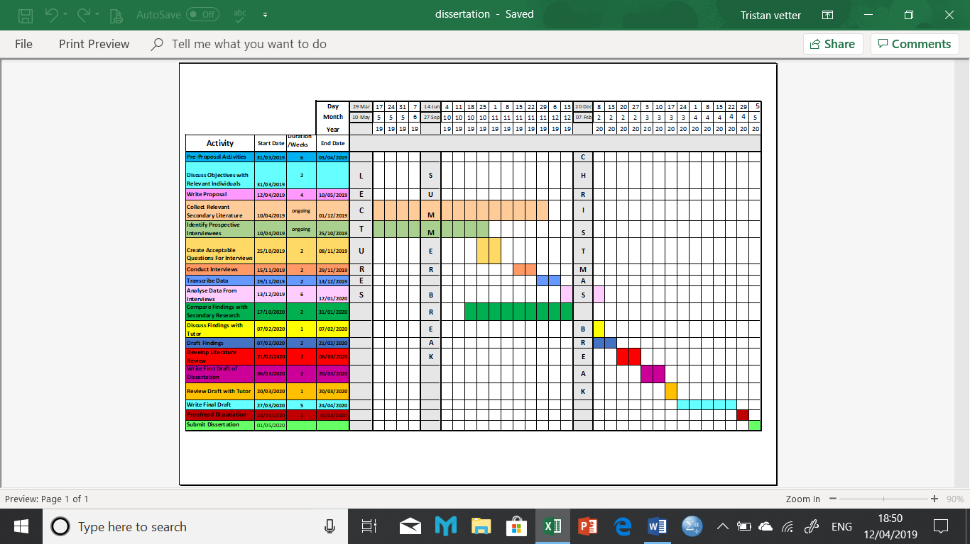

- References

References
Braun, V., & Clarke , V. (2013, Febuary). Teaching Thematic Analysis:Overcoming challenges and developing strategies for effective learning. The Psychologist, 26(2), 128-129. Retrieved from eprints.uwe.ac.uk/21155/3/Teaching%20thematic%20analysis%20Research%20Repository%20version.pdf
Braun, V., & Clarke, V. (2006, January). Using Thematic Analysis in Psychology. Qualitative Research in Psychology, 3(2), 77-101. Retrieved from eprints.uwe.ac.uk/11735/2/thematic_analysis_revised_-_final.pdf
Hartland-Fox, R. M. (2003). The online toolkit: scope and rationale. . University of Central England Birmingham . Birmingham: eVALUEd. Retrieved from www.evalued.bcu.ac.uk
Keller, M. (2015). Navigating the Dissertation: Presenting Findings (Qualitative). Retrieved April 10, 2019, from USC Rossier School of Education: dissertationedd.usc.edu/presenting-findings-qualitative.html#
Key, J. P. (1997). Questionaires and Interviews as Data Gathering Tools. Oklahoma State University . Stillwater, OK: Oklahoma State University. Retrieved from Oklahoma State University: okstate.edu.research
Parlow, A., & Wagner, S. (2018). Netﬂix and the Demand for Cinema Tickets - An Analysis for 19 European Countries. University of Rostock. Munich: MPRA. Retrieved from https://mpra.ub.uni-muenchen.de/89750/1/MPRA_paper_89750.pdf
Seale , C. (1999, December 1). Quality in Qualitative Research. Sage Publications, 5(4), 465-478. doi:https://doi.org/10.1177%2F107780049900500402
Silver, J., & McDonnell, J. (2007). Are movie theaters doomed? Do exhibitors see the big picture as theaters lose their competitive advantage? Science Direct, 50, 491-501. Retrieved from http://isiarticles.com/bundles/Article/pre/pdf/512.pdf
Starks, H., & Trinidad, S. B. (2007). Choose your Method:A Comparison of Phenomenology, Discourse Analysis and Ground Theory. Qualitative Health Research, 17, 1372-1380. doi:10.1177/1049732307307031

