

LOCATION: Swansea | LLEOLIAD: abertawe
LEVEL 6 | LEFEL 6
EXAMINATION PERIOD | CYFNOD ARHOLIADAU
July 2024 | Gorffennaf 2024
MODULE CODE: ACBA6014
Geotechnical and Environmental Engineering
TIME: 2 HOURS

answer four quESTIONs out of five

Equipment or materials required.

Cyfrifiannell/Calculator

Llyfr Agored/Open Book

Arall/Other Nodwch/Please Note ……………………….

ANSWER FOUR OUT OF FIVE QUESTIONS

  - Discuss at least 2 factors that influence the stability of a slope. [12 Marks]

  - A long natural slope in a fissured overconsolidated clay is inclined at 12° to the horizontal. The water table is at the surface and seepage is roughly parallel to the slope. A slip has developed on a plane parallel to the surface at a depth (z) of 5m. The saturated unit weight (γ_{sat}) of clay the clay is 20kN/m³. The peak strength parameters are c’=10kN/m² and Ø’r=26°. Determine the Factor of Safety (FoS) along the slip plain. [12 Marks]

  - Is the slope currently stable or unstable? [1 Mark]

  - Explain the term Water Table [2 Marks]

  - What is the primary influence on soil permeability. [2 Marks]

  - A pollution incident has occurred at a factory, resulting in chemicals entering the groundwater. A borehole used to supply irrigation for crops is located 10km downstream.
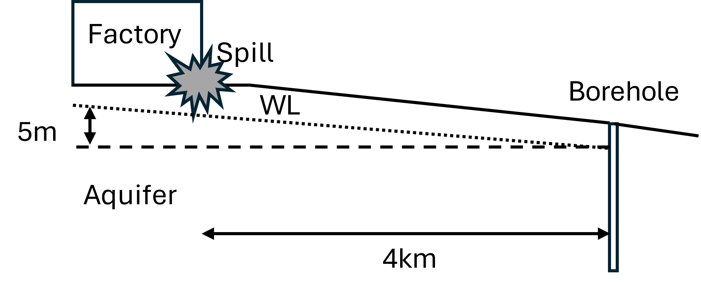
Given the following information:
Hydraulic Conductivity of Soil (k) = 20m/day
Kinematic Porosity of Soil (n) = 18%
Use Darcy’s Law to determine the time it will take for the pollutants to reach the borehole. [7 Marks]

  - Suppose the aquifer in the above question is actually made up of a large number of horizontal fissures. This decreases the kinematic porosity (n) to 0.3%. How long does it take the pollutants to reach the bore hole now? [5 Marks]

  - If the pollution poses a threat to the borehole either way, explain the significance of it reaching quicker or slower. [4 Marks]

  - Briefly explain Source Protection Zones (SPZs) [5 Marks]

  - Label the following diagram of the hydrological cycle [3 Marks]
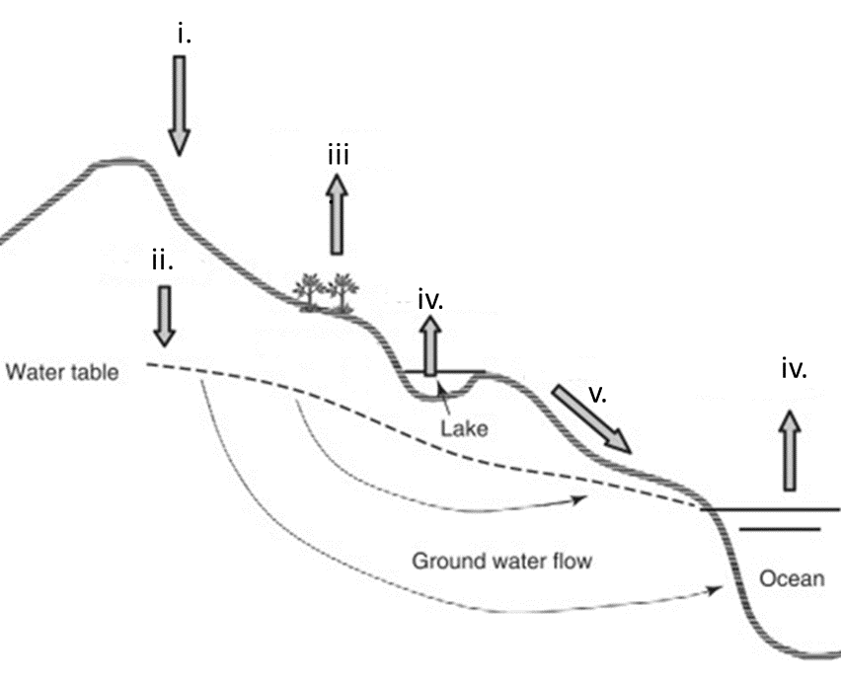
  - A reservoir has a surface area of 70.8 hectares. For the month of April, the inflow was 1.5m³/s. A dam regulated the outflow to be 1.25m³/s. If the precipitation record for the month was 7.62cm and the storage volume increase by 650000m³, calculate the estimated evaporation in m³ and cm. Assume no water infiltrates out of the bottom of the reservoir. [14 Marks]

  - Explain 2 impacts that increased urbanisation has on water infiltration. [8 Marks]

  - Briefly explain the concept of Carbon Capture [4 Marks]

  - Explain the process of Carbon Capture and Storage with particular reference to the key mechanisms for trapping CO₂ [12 Marks]

  - Describe the three different types of geological storage sites [9 Marks]

  - Name the three main types of coastal structure. [3 Marks]

  - Choose one type of coastal structure and describe in detail including function, advantages and limitations. Use diagrams where appropriate. [8 Marks]

  - Briefly explain wave overtopping. [2 Marks]

  - For a 1:2 rock armoured (r=0.55) sloping seawall with a toe at 0mCD, still water level at 3.0mCD and a crest level of 4.2mCD. Estimate the overtopping when H_{s}=5m and T_{m}=8.8s using Owen’s Method. [12 Marks]

Diwedd/End

