TUI Package Travel - Strategic Management to HR
Caitlin Morgan

Introduction -

This report will conclude with a clear understanding of what TUI the package travel company has in place when researching strategic frameworks. Then introduce different methods of framework and see which one TUI would benefit from using. The report will conclude with key findings of the report and then introduce strategic recommendations for the future.

In this report the research methods that will be used are secondary data. The report will only have secondary data as all the data will be collected from the internet and library sources. (Ajayi, V.O., (2017). Quantitative data research methods will be used in this report to gain an understanding of the HR practice at TUI. The quantitative research method that will be used is Indeed's website, collecting the reviews from past and current employees how the company could upskill its training policy and program, and how it can keep its employees for the future. Myers, M.D. (2019). The report will also compare the mission statements of the two companies in the same field in the travel industry. As Radtke, J.M. (1998). states a mission statement is the values and beliefs of the company. This is how the organisation would entice the employees to stay and to make the customers believe in the products and services they offer, to make them loyal customers. The organisation is largely governed by corporate thinking. Corporate thinking is when the company values that make customers buy the product and services regardless that being short or long-term. This would be due to the decision-making of the employee and what the business would have to consider for the future. (Kuratko, D.F., Goldsby, M.G. and Hornsby, J.S. (2018). This shows that TUI has no individuality as all of the corporate thinking is made by management and then sent down to the employees to put in place, this would be an example of how higherary of management works.

The frameworks that will be used in this report to analysis the development of the approach on TUI. (Saunders, M., Lewis, P. and Thornhill, A. (2023). The research methods are SWOT, pattern of development and the Harvard framework model 4Cs. These frameworks have been chosen to develop an understanding of the HR practices within TUI.
This report will focus on the human resources of the travel company TUI. The areas that will be looked into are training, careers, and progress. These areas will be analysed due to the lack of values and support from TUI employees from senior management as the Indeed website. (2023). States. This is where the report gives TUI opportunities for improvements in the HR department. This report will compare another travel component with TUI to analysis how the strategies in place with Emirates, have an impact on the employees. If the strategies work for the opponent then TUI could implement them in their career paths.

Mainbody -

The package travel company has all their staff start from the bottom to the top. A new employee could not go from a management role straight into a new management role. That manager would have a payment cut for six months and then be able to find a management role in the organisation. If that person's values and culture were strong enough, that person would have a great opportunity to step in and learn.
TUI Travel company's mission statement has three sections, which are “Our promise - Discover your smile (for the customers), our values - trusted, unique, and inspiring (for the employees) and Our vision - think travel, think TUI”. (TUI Values. (2023). This mission statement is basic and not much thought has gone into how to engage with the employees. Compared to Emirates the vision is to make sure that safeguarding staff and customers is the main priority throughout reviews, training, and education. Implemented safety and security to the company to ensure that the industry standards and practices are environmental in the business's growth. (Emirates website. (2023). Both of the organisations have different training requirements for different job roles but their mission statement is what the whole organisation will follow as they are the values and the beliefs of the company. Alongside that, Emirates’ mission statement is slightly different from TUIs. Emirates is targeting the staff members and how they look after them as a company. As indeed reveals that Emirates is rated at 4.2 stars and TUI is at 3.7 and that is from previous staff members and staff members that are still in the job roles. (Indeed website. (2023).

Training programs for all the training practices are for individual job roles. The values of TUI will be the same throughout the organisation. That is to ensure that all customers have a safe and pleasant experience, achieving their dream. Hussinki, H., Kianto, A., Vanhala, M. and Ritala, P. (2018). Says theory is correct without happy employees how does the company expect the staff to give excellent service and products? Keeping the employees happy is a vital part of managing an organistaion due to there being so many opportunities in different businesses. The strategy approach that will be able to upskill the management team in the training department will be SWOT. (Kotler, N.G., Kotler, P. and Kotler, W.I. (2008). The alternative method that was going to be used was Porter's five forces. Porter's five forces are big in TUI with the different products and services they have to offer. Due to the five elements being overwhelming to the business, they conclude that Porter's five forces are too broad. (Grundy, T. (2006).

SWOT analysis -

Strengths | Weakness
- That newly employed people will become managers.  - Spent enough time in the organistion have embodied the values.  - All managers could say that they were at the bottom and worked their way up. | - Due to people being in the same job role for such a long time, they are stuck in their ways and are not looking for improvements.  - Old staff members will not appreciate new members of the team telling them how to do their job.
Opportunities | Threats
- Open the scope to a larger group of people to attract talent.  - Within the organisation to do weeks of training and then be ready to be put in the of work at a senior level.  - Interest from the staff that the company already has.  - Word of mouth.  - Show the employees the management has been listing.  - Massive impact on the company. | - Employees felt let down due to someone being able to come in and start straight into a manager's role when other staff members have been waiting years for this opportunity.  - Angry staff.  - Black last from the press.

How to make employees enjoy their careers and make them lifelong staff members? For a staff member to stay in the business and to be able to enjoy the working experience to stay there for the rest of their lives. As Elliott, G. and Corey, D. (2018) days great management, incentives, and motivation to make the employees go to work without stress.

The pattern of development - venn diagram.

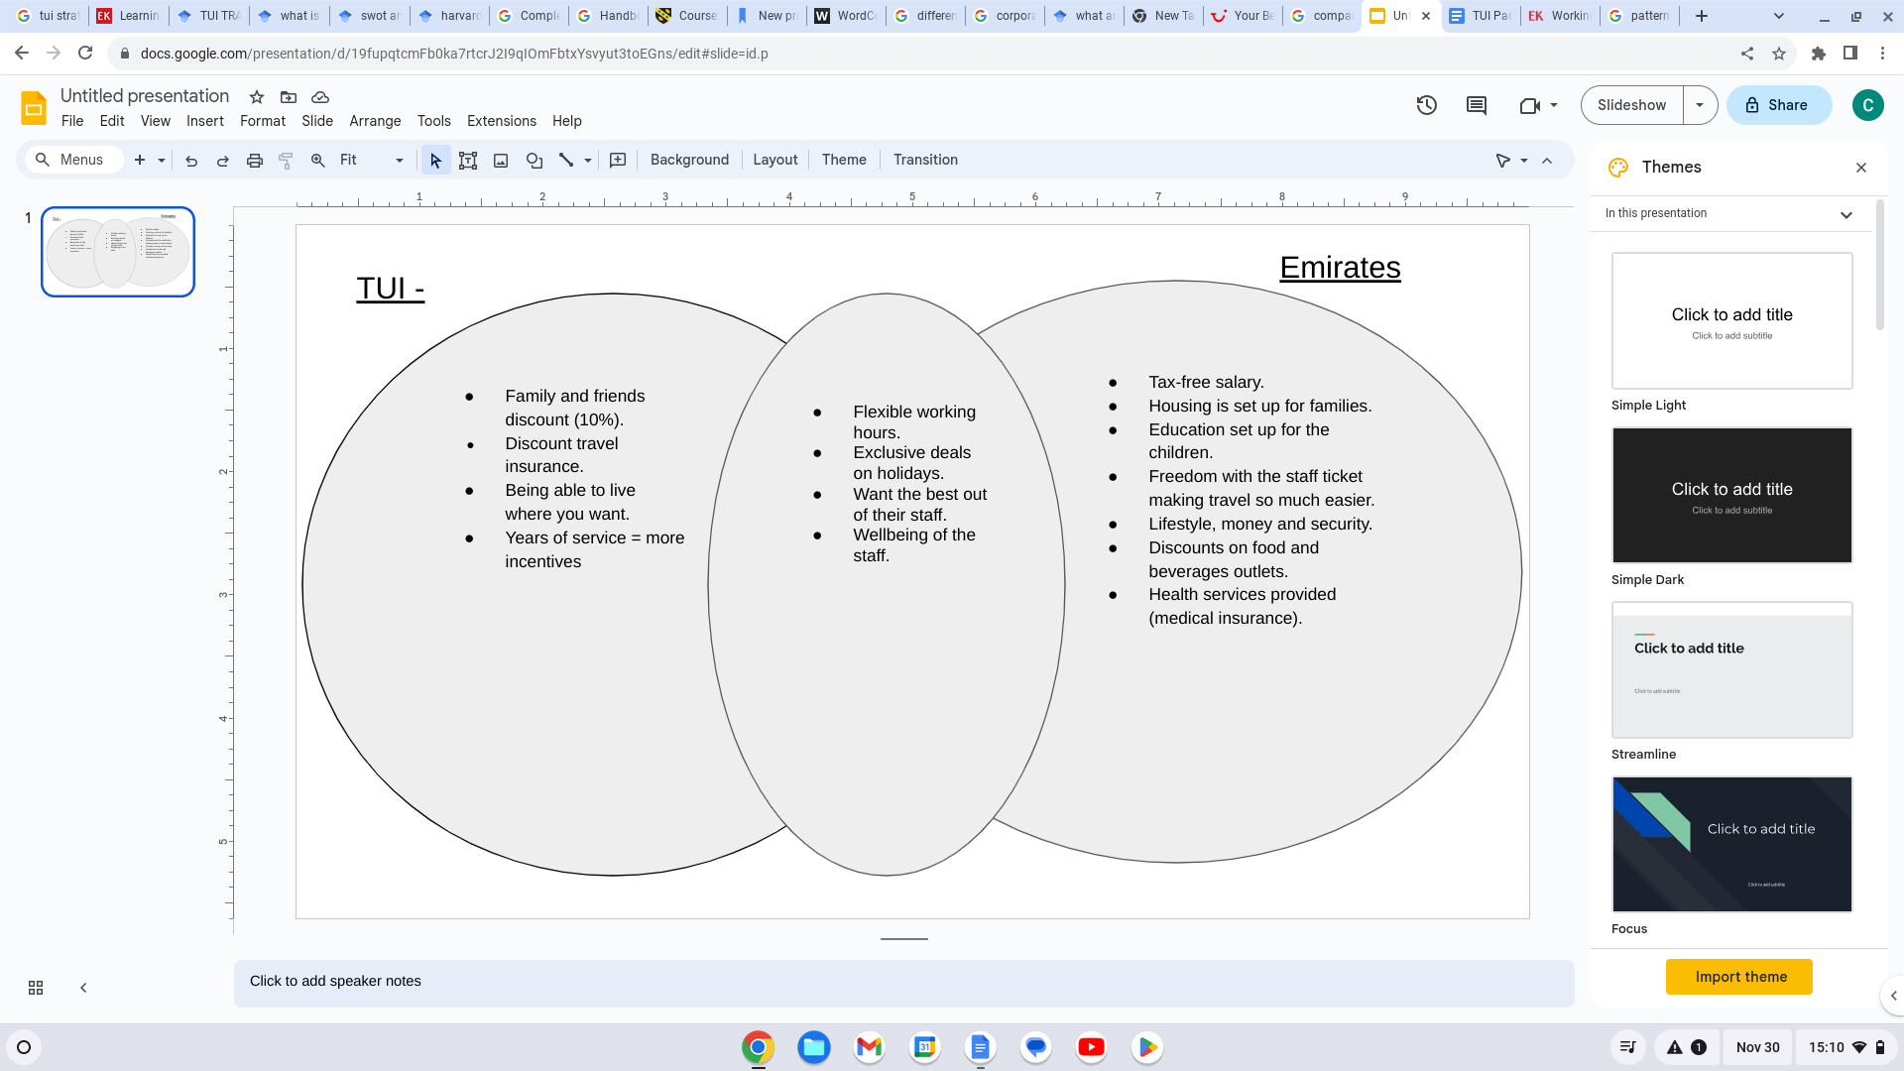

As Saunders, M., Lewis, P. and Thornhill, A. (2023). States that all methods that are being used have to make sure that they are collecting the correct data and what data they want to achieve from the method being used. Venn diagram shows the differences and the similarities between two businesses as Hruby, P. (2006) states. This Venn diagram shows the comparison of the careers of the companies. Emirates can fund all their staff with the products and services shown above. On the other hand, TUI staff are UK and Germany-based therefore tax-free salaries could not work. Also housing for 10,463 staff members in the UK is not feasible. (Statista website. (2022). Healthcare services are available to UK residents at no fee. What TUI would benefit from attracting new employees would be to invest in a staff travel ticket as one of the Emirates employees said that getting on a flight with the ticket is as “easy as getting on the bus in the street”- Emirates group and careers. (2023).

The 4Cs of the harvard HRM framework
To assess the progress that is being made and to ensure that the process would be effective. Investigating with the 4Cs of the Harvard HRM frameworks outcome. The 4Cs stands for commitment, congruence, competence, and cost-effectiveness. (Marchington, M. and Wilkinson, A. (2005).

Commitment -
This is a promise and an understanding of what the organsitions will have to follow to ensure the progress keeps growing. TUI would then have an increase in productivity, meeting the target, value addition, and being ‘fun’ to work. (QuestionPro (2018). Commenting to letting the employees grow and have a future within TUI without going through all the training/applying again which they have to do currently.

Congruence -
Congruence is things that fit well together such as having a relationship with the management to be able to talk to them and the employee would know the manager would listen to the causes and concerns. Ensure that the employees are in the correct job role for them as an individual. This will enable the business to get the best out of the employee. (Enders, A. (2012).

Competence -
From the employee perspective the skills are important for a successful business and the employee relationship can help achieve the same goals. (Mulder, M. (2016). The new skills would mean that the employees would have a clear understanding of how to deal with different people coming into the job role.

Cost-effective -
TUI would not be at a loss with money, by improving the skills of their current employees. They would not have to recruit new people and the people not having an understanding of how the organisation works, this could be a loss. TUI should offer recruitment of the job to anyone in the business regardless of how long that member of staff has worked with them. (Lawler, E.J., Thye, S.R. and Yoon, J. (2009).

Conclusion -
These strategies and methods that have been used to improve the company have given a clear understanding of what TUI as a company has to achieve. Clear conclusion of the key findings in the main body of the report are;
- The mission statement showed that Emirates put their staff first whereas TUI put them second.
- The difference between the company's values and beliefs.
- Depending on the job role there are different levels of training at Emirates.
- All thoughts and concerns by employees are listed to by management.
- The SWOT worked well - a clear understanding of how changing the system could affect the company.
- Venn diagram compared the differences and similarities between the both companies.
- The 4Cs - did not work as well as the other models. (not enough information).

Strategic recommendations -
- TUI needs to understand that putting the employees first will benefit them in the future as people will feel comfortable with their work environment.
- Two completely different cultures in the same industry, with different ways and strategies towards each one.
- Offer the opportunity to learn and develop the skills of new or existing employees.
- Widen the scope of opportunities that are given to the staff members by investing in the staff ticket to be able to travel the world freely.

References -

Ajayi, V.O., (2017). Primary sources of data and secondary sources of data. Benue State University, 1(1), pp.1-6.

Elliott, G. and Corey, D. (2018). Build It: The Rebel Playbook for World-Class Employee Engagement. P.p 91-98.

Emirates Group and careers. (2023). Working with us. Avilbe from:https://www.emiratesgroupcareers.com/working-with-us/#:~:text=You'll%20receive%20a%20tax,with%20the%20Emirates%20Platinum%20Card. [accessed on November 27th, 2023]

Emirates website. (2023). Our vision. Available from; Our Vision, Mission and Values | Emirates Group Security. [accessed on November 27th, 2023]

Enders, A. (2012). Management Competence: Resource-Based Management and Plant Performance. Pp 116.

Grundy, T. (2006). Rethinking and Reinventing Michael Porter’s Five Forces Model. Strategic Change, 15(5), pp.213–229.

Hruby, P. (2006). Model-Driven Design Using Business Patterns. [online] Google Books. Springer Science & Business Media.
Hussinki, H., Kianto, A., Vanhala, M. and Ritala, P. (2018). Happy Employees Make Happy Customers: The Role of Intellectual Capital in Supporting Sustainable Value Creation in Organizations. Intellectual Capital Management as a Driver of Sustainability. Pp.101–117.

Indeed website. (2023). Tui Group and Emirates reviews. Available from; TUI Group Employee Reviews - Indeed
The Emirates Group Employee Reviews - Indeed [accessed on November 27th, 2023]

Kotler, N.G., Kotler, P. and Kotler, W.I. (2008). Museum Marketing and Strategy: Designing Missions, Building Audiences, Generating Revenue and Resources.
Kuratko, D.F., Goldsby, M.G. and Hornsby, J.S. (2018). Corporate Innovation: Disruptive Thinking in Organizations. [online] Google Books. Pp. 89-94
Lawler, E.J., Thye, S.R. and Yoon, J. (2009). Social Commitments in a Depersonalized World. Pp 103-106

Marchington, M. and Wilkinson, A. (2005). Human Resource Management at Work: People
Mulder, M. (2016). Competence-based Vocational and Professional Education: Bridging the Worlds of Work and Education. P.p 756.
Marchington, M. and Wilkinson, A. (2005). Human Resource Management at Work: People Management and Development. Pp.5-10.

Myers, M.D. (2019). Qualitative Research in Business and Management. [online] Google Books. SAGE Publications. Available at: Qualitative Research in Business and Management - Michael D Myers [Accessed 29 Nov. 2023].
Radtke, J.M. (1998). How to Write a Mission Statement. Pp 1-3.
Saunders, M., Lewis, P. and Thornhill, A. (2023). Research Methods for Business Students. 9th ed. Harlow: Pearson.
Statista website. (2022). A number of TUI AG employees. Available from;https://www.statista.com/statistics/266690/tui-ag-employees-by-region/ [accessed on November 27th, 2023]
TUI Values. (2023). Vision and values. Available from; TUI Values - TUI Careers. https://careers.tuigroup.com/uk/life-balance/ [accessed on November 27th, 2023]
QuestionPro (2018). Commitment to work: Definition and tips to improve work commitment | questionpro. [online] QuestionPro. Available at: https://www.questionpro.com/blog/commitment-to-work/.[accessed on November 27th, 2023]

