1.Introduction

A realm hidden from the view of the living countries, up above the clouds, where many islands float in the skies, each one with a unique culture, magic, and classes. They hold firm to the ideals friendship and peace and work together to balance their dream world.
The Empty Quarter consists of five primary 'lands': the Island Centre, the Island of Nature, the Empty Quarter City, the Castle in the Sky, and the Borderlands. The middle of the island is ancient magic, the people living here are proud of themselves as magicians, and have strong magic power, guarding the peace and prosperity of the island; the people of the island of nature is simple and hardworking, and prefer planting, mostly rely on self-grown crops to make a living; the city of airspace is the largest area of the airspace and has the largest population, people in the city engage in all kinds of work, business is prosperous; the castle in the air is the political centre of the airspace, and is the most important place of the airspace. The Air Castle is the political center of the Hollow Realm, the residence of Hollow Realm leaders and administrators who reign over everything in this area; The Borderlands is the most dangerous area of Hollow Realm, home to debris and black holes that make you lose your balance and fall into an abyss that will never end, but also have endless treasurable to explore.
The unique thing is that the Empty Domain is a city without ground, and the people who live here will grow wings base on certain circumstances, 80% of them will, and the rest can be by buying artificial wings.

Inspiration: Barbie's Fairy Secrets in the Fairy World—Shining Los Angeles (Gloss Angeles) City in the Sky
Inspiration: regions in The Lord of the Rings, Game of Thrones.
Main Characters

2.1 Aria - Wing Designer
Appearance: Short blonde hair, small face, big eyes, usually wear jeans, a nice pair of self-designed wings.
Personality: Courageous, hopeful, tough yet gentle.
Backstory: Aria was born in a regular family in the Hollow Realm, but her family was unfortunate because of a genetic issue that they had for generations where their natural wings would never grow, luck also has it that Aria opened up a wing shop in the Hollow Realm, selling her very own handmade wings, but, the materials needed for the wings gained were on the other side of the Hollow Realm where Aria was born, Aria would need to journey to the other end of the Hollow Realm to be able to access the appropriate material needed.
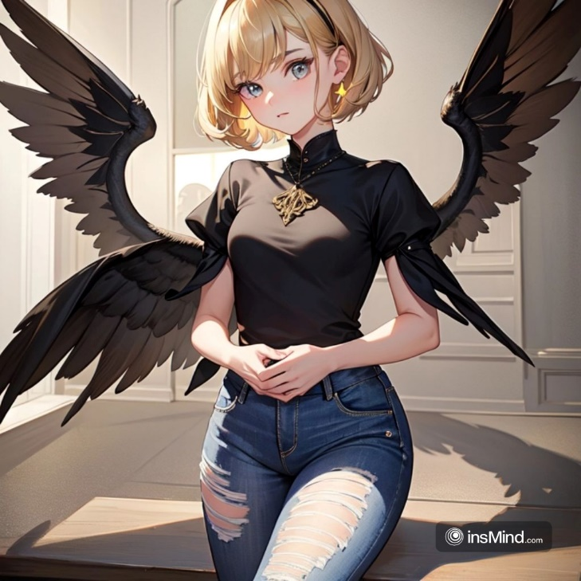
2.2 Verne - Mage
Physical description: slim build, short dark hair. He frequently has on ornate robes and carries a wand, but the wand’s origins are unclear.
Vine (22-23): She’s smart, cool under pressure, and excels at using magic to fix just about anything. It was a boyhood passion and an obsessive quest for the magical world. He is reclusive, distant and asocial.
Backstory: Wei En hails from a family of magic users in the heart of the islands in the Empty Realm, and had displayed prodigious magical talent as a child. With the family’s guidance, he learned a wide range of strong magical abilities, and he eventually became known as an esteemed magician. He is thirsty to uncover the secrets of magic, and also wishes to use his power to bring peace and prosperity to the Empty Realm.
2.3 Lilian - Guardian Elf
Looks: Lillian’s body is light as a feather, with gossamer wings and feather-soft hair that ruffles at the breeze. She usually wears long dresses and bears a faint scent of new perfume.
Traits: Lillian is sociable, warm-hearted and enjoys the outdoors. She values freedom, is courageous and daring, and is always there to rescue her friends in dire moments. Aria has a good friend in her, who listens and helps her understand her feelings.
Backstory: Lillian is the Empty Realms guardian spirit She grew up with the wind and learned to tame it, manipulate it and speak to it.
2.4 Zack - The Air Castle Knight
Physical Appearance:Zach is a big, buff man with short, dense light brown hair. He typically wears massive plate armour and carries a long, deadly sword.
Interview Background:Can you tell us more about yourself (your basic background information, personality traits, and interests)?
Backstory: Zach is an orphan who was taken in by the Castle of the Air as a child and has been trained relentlessly. He wants to earn the right to be a true warrior by standing watch in the Air Castle.
3 Narrative design elements
3.1 Climate of the airborne island
The suspended height of any island has a direct influence on the incidence of solar external radiation and the weather. Because of their heights, the islands are subjected to high solar radiation, atmospheric and wind zones.
The biggest islands, Airspace City, formed its own climate system: precepitation when there is a lot of cloudy build-up, though mostly sunny days. The other islands are subject to the air currents under the islands and are patchy in climate but are more often hotter.
3.2 Air Castles
Castle of the AirPolitical centre of the AirlandsThe most important and oldest building in the Airlands.
Appearance and Structure
The Air Castle is located on the highest point of the islands in the Hollow Realm, the main body of which is composed of semi-transparent crystal stone, so that the entire building appears elegant, noble and prosperous. Pillars upon pillars, the towers of the magnificent castle protrude higher than the clouds, and etched with numerous totems and runes into the walls are blessed with ancient power by the wizards from the Air Domain Centre to protect the harmony of the tower.
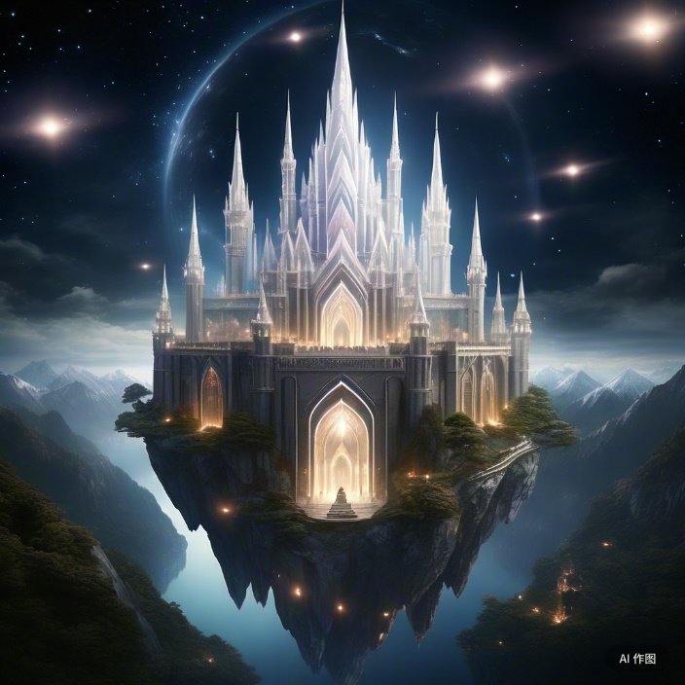
3.3 ‘The Shadowed Edge’
Far away in the airspace, there is a dangerous area called the Shadow Frontier, which is located in the periphery of the Air Castle, and is a nightmare for many people in the airspace. This borderland — a sort of lost wilderness — brims with risk and uncertainty, and is a crucible of courage and wisdom.
The sky of the Phantom Shadow Border Region always had a layer of faint black fog, which seemed to swallow all the light, so that the whole region looked particularly dark and depression. Every now and then the fog lit up with echoes of bizarre light, like during the eyes of some unknown animal, watching all who dared to step into the dark. At night, these rays of light became even more dazzling, wandering through the night sky like ghosts, sending chills down the spine.
A strange wave of power filled the air of the borderlands, causing it to become unstable and active. If there were outsiders who were not familiar with this area, as soon as they stepped into this area, they would be hit by a sudden energy shock, and the weaker ones would be injured, while the more serious ones would die. Even veteran explorers need to exercise immense caution when flying the borderlands — as even the most unusual trigger can activate hidden traps or summon unknown foes.
Also lurking in this perilous borderland: many unknown creatures. Some are fierce or cunning, some are fierce or cunning, some are powerful at attack, while others are good at hiding and camouflage. In the Phantom Shadow Borderland, the presence of these beings turned the terrain into an arena of life and death. Explorers, therefore, not only have to survive the perilousness of nature. they also have to be wary of danger from these animals.
Yet this perilous and formidable frontier is also a land of infinite promise and riches. Deep in the borderlands were vast resources and this particular material was called Light Feather, which was perfect to create artificial wings. Thus, even if the Phantom Shadow Frontier Region was perilous with unknown dangers, this did not devastate numerous wild dreams that people dreamed about here again, going mad except for searching for boys and girls.
3.4 Empty Realm Wings Design
Design ka tay kya: Customer ki marzi se design ka tasverata bananano, zyaddatar khudayi ke parntay aur node.
Choice of materials: Choose materials for the skeleton that are as light as possible but also strong, the best of which is the magical vines that have grown in the Island of Nature.
Now, create a skeleton: You need to make the skeleton structure of those wings with whatever material you ever decided to choose, and as per your design.
Fixing the Fabric Material: Cut and fix the fabric material on the skeleton to ensure proper distribution and aesthetics, the one that fits best is the light feathers from the Borderlands.
Testing and refining: Test the wing's performance in a controlled environment and refine as necessary
The young magician Vine had long been the centre of everyone's admiration in the vast, cloudy heart of the Empty Realm, with his extraordinary talent and his handsome appearance. However, in the face of fate's love for playing pranks on people, it was an accidental magician training accident that dragged this proud son of heaven out of the clouds.
Vion was trying flying magic, it was a very difficult flying magic, but Vion was not paying off, and today was a windy and sunny afternoon. But as soon as that magic ran wild, like a handshaking horse, it tossed him too far, quintuple the impact, and directly ripped him apart. Just then, Vine's whole world collapsed, and as if one whose wings have been broken, he fell into the depths unable to close the chute, where his heart was filled with fear and despair never seen before.
His parents (who had high hopes for him yet were extremely strict) were the first thing that came to mind in the wake of this disaster. Wei En has always been pride of the family and they were very proud of Wei En. But should they hear that he had flown through the world with only damaged wings, they imagined that he would be subject to unending admonition and disappointment. So, Vion's parents were told a different story from what just happened, and to escape he decided to make his way to the Empty Quarter City alone to find Aria, ‘the strongest wing designer’ for hope for a new life.
But inside Wei En's heart, he did not respect Aria that much. In the Empty Realm, the class system of magicians was the top and most popular existence, so he naturally thought that an ordinary person like Zy with no magical talent, no matter how excellent, was not comparable to his existence.
Air Domain City, bustling, vibrant, familiar, unfamiliar in that current instance. His heart racing with hope and fear, he moved through the throngs. He eventually made his way to Aria’s studio after asking a few questions. It blared of creative flavour in every direction, displaying a plethora of wing designs along the walls, each one as beautiful as an exquisite piece of art that one couldn't help but walk past and stand before in awe. But as soon as Wei En set his eyes on Aria, a trace of disappointment surged in his heart. Aria was extremely simplicity and low-profile, not to mention the slightest bit of the mystery and majesty of a magician, which was completely different from what he had envisioned in his heart.
Long story short whenhe found out Aria liked him back he went to see her, and out of the irritation inhis heart he still told her he intended to be with her Aria's furrowed brow only deepened as she listened, and a thorough examination of Vien's wings soon made it clear that the damage was much worse than at first thought. The magical energy that Vayne utilized while flying was too tremendous for the ordinary materials to withstand, making repairs incredibly challenging to accomplish. But Aria wasn’t discouraged as she said to Wei En that in the distant border, there was a rare item there known as ‘Star Glow’, which contained rich magical energy and toughness, and was the most suitable material to repair the wings. But this border area is the most dangerous place in the Empty Realm, full of variables and dangers. But for Verne’s wings, she was willing to gamble.
Hearing this, there were mixed feelings in Wei En’s heart. On the one hand, he was grateful for Aria’s bravery and selflessness, but on the other, he was worried about her safety. Under Aria’s insistence, Verne finally agreed to go to the Borderlands with her to find the legendary starburst. In the Borderlands, many unprecedented challenges have come to them. Debris, black holes, and wild beasts … There is no safety at every step, but Aria continued to use her wisdom and bravery to make Vine turn danger into safety again and again. Finally, in a barren pile of rubble, they find the Starburst Stone, which glows slightly dim. For a moment, it seemed to them that they could see the dawn and hope. After returning to Airspace City with Starglow Stone, Aria immediately opened the restoration work of the wings. She incorporated the Starglow Stone into the wing down again and again, striving to ensure that the wings could adapt to the power of Vayne perfectly. After several days of hard work, the wings on Vayne’s body reappeared. These wings not only restored the functions in the past, but also have strong magical attack power and defense capabilities. When Wei En’s wings opened again and he soared freely into the sky, he laughed aloud. He knew that it was impossible to use any force without Aria’s help. To show his gratitude, Vien personally creates a magical badge for her with sparkling gems and sows magic powers, and gives it to Aria.
Aria opened the gift and had a huge smile. She told Verne that his renewed courage and self-confidence were the real gift, along with the deep friendship that had grown up between them. She advises Verne to keep chasing his magical dreams, while also remembering to respect and understand people from different backgrounds and with different abilities. Listening to this, Vern felt very guilt-ridden and grateful, and also he knew how small-minded and prejudged he had been.
From that day on, Vien treasured them with all his heart and put in even more effort with his magic cultivation. He was committed to making use of this ability in upcoming quests and hurdles, aiding the unity and equilibrium of the Empty Realm. Simultaneously, he also learned the importance of maintaining an open and tolerant mind when observing both people and things in his surroundings. And Aria's name was etched in his heart forever, he wasn't so jealous anymore that she no longer saw him as her favorite memory. Not only did this experience mend the wings of Vine, but it also lifted his heart.
Their hearts however drew a little closer together, sharing adventures and challenges in the Borderlands and a deep love grew silently. But it was not a union approved by both parents, and found itself facing challenges never seen before.
As a famous family of magicians in the Empty Realm, Vion's parents had long hoped that their son could inherit the glory of the family and become a great magician. They knew in advance that while Aria was talented, she didn't have an ounce of magic talent, and it would surely be a roadblock on the road of Vien's future. Thus, they were strongly opposed and dissatisfied when they learned of the news of their romance.
As for Aria’s parents, while they were proud of their daughter’s career path, they too were not wild about the romance. They figured, hey, Vine might be young and talented, but as a magician, he was in a completely different world than Aria. They were genuinely concerned that such an alliance would bring never-ending anxiety and trouble to their daughter, and would even impact her career development.
Both parents adamantly opposed this union, and they left Verne and Aria deeply confused and wounded. They could realize that it requires a lot of effort and sacrifice for the relationship to be recognised. But that is when they become even less willing to give up on each other, unwilling to let this hard-won romance slip away so easily.
So the two turned to trying to convince both parents in various ways. Verne shared with his parents his profound and unconditional love for Aria and the significantly positive influence she was having on his magical practice. Love, he told his parents, was not about talent or status, but rather about hearts that fit, and about supporting each other. Aria, on the other hand, has proven with her own actions that even if she is a magician, she can still rely on her wisdom and talent to break through and not be behind in the empty realm, and she is the most solid support for Wei En.
But that was a bumpy road. Both parents were set in their ways, even arguing about it at times. Verne and Aria needed to tread more lightly with the relationship — it wouldn't do either of their families any good to be tormented further.
At that moment, a sudden disaster struck the Empty Realm. And so an evil force quietly grew up and threatened the peace and tranquility of the entire Hollow Realm. Mr. Verne & Aria knew this evil force well. In this battle, they showed unprecedented tacit understanding and courage, carried out the defense against the enemy, and even won the respect and praise of the residents of the empty domain.
It was their romance’s turning-point crisis. When they witnessed them fighting alongside each other for the peaceful nature of the Empty Realm, both parents were finally impressed by their hardiness and courage. They started looking at the relationship again and realised that love is genuinely far more than that. With time and the efforts of the couple, their parents eventually set aside preconceptions and consented to their marriage.
And from there, Verne and Aria's love story got its happy ending. They relied on each Other as the most important people in Eachother life, and set out to bring balance and stability in The empty Realm together. In the process, they realize how much they care for each other and they grow to believe even more strongly that love is the answer and can overcome all troubles and challenges.
The Wonders Of The Empty Quarter | LTD1988: 4th Exhibition: 2nd Project | Film And Television Camera Design
Opening shot:
[The camera pans closer, from the skyline, to a mysterious world floating beyond the cloud line - the Domain of Air.]
[The overhead visual of the Empty Realm, where countless floating islands are arranged in a staggered pattern, each island giving off its own light, shining in the night sky like stars.]
The centre of the islands:
[Camera pans to the mysterious ancient magic tower and solemn magic academy in the centre of the island, where students are learning magic, mixed with a mysterious aura of magic.]
(Talan takes out several pieces of paper, frees his fingers, a bright light cuts through the sky, at this moment Talan's magical stamp just shows his powerful magic power.)
The Island of Nature:
[The camera abruptly cuts to the Island of Nature, the busy inhabitants tilling the soil, the verdant fields flourishing with produce]
[The camera zooms in on a farmer harvesting his crops, a huge smile on his face as he loads his crops into a basket, ready to take to Hollow City to sell to the public.]]
Airspace City:
The camera cuts to Airspace City, showcasing an extravagant commercial level covered with intricate properties with people walking between them going about their lives.
[ONTAR OTA ENSKAN or The Taking Of Control] [The camera pans to a merchant bartering with a customer, the wares in his hands glimmering with a tantalizing sheen, catching everyone nearby's eye.]
The castle in the air:
[The camera rises slowly, until it slowly follows up to the Castle in the sky, the castle architecture magnificent — height towers straight into the sky, solid castle walls — the castle master of the empty domain responds dignified!
[The lens shows a leader standing on the castle observation deck, staring at the empty realm of the whole land, looking wise, full of strength, pondering how to better protect this place.]
Borderlands:
[Kill Bill style cut to the Borderlands; a barren land full of debris and blackhole; where taking one wrong step results in you losing your footing into an endless void.]
[The camera zooms in on some bold adventurers travelling the Borderlands, picking their way past the black holes in hunt of buried treasure.]
Special Footage:
The camera PULLS AWAY to get a full shot of the Empty Realm and its inhabitants, who are so filled with Life, so full of purpose and their own desires that they will soar up into the air — completely free — with the Infinite expanse of the Empty Realm behind them, their wings glimmering in the Sunlight.]
[Camera pans on a young fat resident, as he learns to Fly, baby wings sprouted out of his back and he still doesn't master the wings yet, but encouraged by his friends, he tries to spread his wings and flies.]
[The camera finally focuses on the skyline of the Empty Realm, crowned with gentle music that suggests the quiet beauty and balance of this world of the mind.]
Narrator:
‘In this mysterious realm suspended above the clouds, the “Empty Realm,” every island has its culture and its magic, its residents keep the belief of friendship and peace between the inhabitants and together ensure the completion of the dream world to maintain its peace and stability. There’s a place for you here, whether you’re a magician, a farmer, a merchant or an explorer.”
Rebirth of the Verne and Aria: The Film and Video Camera Design
MS shot 1: The center of the Empty Domain, the cost of Viens training accident with untwisting magic.
ANGLE: A bright island in the air, sunlight dappling down. On the edge of the island, Verne stands in elegant magician's robes, wand in hand, on the verge of casting flight magic.
CAMERA: Zooms in on Verne’s concentrated face, pulling away to a wide shot of the magic starting to swirl around him in the darkness.
OOMPH — the sound of spirits rushing toward a furious void and slamming into it, the hum of gathering magic suddenly jumbled, deep-flooded, and then — deafening roar.
SCENE: The magic goes haywire and Venn gets tossed aside by the tremendously powerful force, his wings getting torn away as he slips down helplessly.
CAMERA: Venn's POV as he plummets, terrified and hopeless.
(of which he is leaving) Shot 2: [Venn being something like mountain determined or sad and lingers or fierce and lingers.
CLOSE-UP of Venn, lying on his back, wings bandaged, eyes fierce.
– A close-up on Venn’s intense stare, cut to him stuffing his bag and rushing, prepared to leave the Land of Airspace.
AUDIO: Quieter background music, fading well into excitement.
-. LOCATION: Verne on the streets of a busy Hollow City, asking about Aria.
SCENE 3 aria’s workshop & first look
– SCENE: Aria’s studio, wing designs line the walls, rich with artistic flavour.
Verne finds his way to the studio, the camera tight on his expectations and intrigue.
SHOT: Aria’s studio, CU: his anticipation and curiosity (The shot: Aria’s studio, a close up of his eagerness and curiosity.)
CAMERA: Venn looking disappointed, then transitioning to be frank about his intentions with Arelia.
Shot 4: Borderlands and Trials
A glimpse: Verne and Aria line walking the Borderlands, beheld rubble, black holes, ferocious monsters.
Camera Rapidly switches scenes, revealing their bravery and wisdom, repeatedly turning danger into danger.
– Sound: Music that builds tension, exciting, with battle and escape sound effects.
Shot: They see the Star Glow Stone that gently radiates in the middle of the empty pile of Things.
Shot 5: Surgical repair and supernatural wings rebirth
– CAMERA: Arielia is in the workshop, carefully embedding the Starglow Stone into Verne’s wing.
Shot: close-up of Aria’s attentiveness and precision, then pulling away to a panoramic view to reveal the slow evolution of the wings.
SHOW: Tension-building sound.
Cut to: Vern flaps his wings once more and flies and, for the first time in his life, screams happy in the air.
Camera 6: Observers of Appreciation and Companionship
CLOSE UP: Venn Thanking her (Cross tribute) CUT TO: (PASS) Venn hands Aria the Frontline badge.
Shot: Arielia smiling with joy when she sees the gift, and she encourages Vayne and gives her a blessing.
Warm and touching background music plays.
Shot 7: The ambitions and drive of Vine
SCENE — Verne at the brink of the island, gazing into the distance once again, this time with a bit more resolve and acceptance.
CUT TO VERN on one of his ramshackle wooden vessels, imagining VERN's face with determination and confidence, then we pan out to a wide shot of VERN readying himself for things to come.
— AUDIO: A stirring and uplifting score.
SCREEN: Fade to black with subtitles reading ‘Henceforth, the names of Vayne and Aria are forever etched in the history of the Empty Realm.’
Ending narration:
‘The Empty Realm is a vast and boundless land, where everyone is chasing their dreams and hopes. The saga of Verne and Aria is not only a tale of rebirth and adventure, it is also a hymn of courage, friendship and growth. Makes sense that way, as well. Let’s start anew and write our own legend on this mystical and gorgeous world.’

