Analysis of the Best Practices of
Community Engagement in
Barnet Community Primary Care Group

Prepared for:
Dr. Olusoyi Ashaye
University of Wales Trinity Saint David

Prepared by:
Student Name- Maria Hagiu
Student ID- 2024157

May 06, 2021

Table of Contents
Introduction 3
An overview of “Barnet Primary Care Group” 4
Part A- Analysis of the Best Practices of Community Engagement in Barnet Primary Care Group, Barnet, London 5
Introduction of Social program and business and the expected benefits from it to the society 5
The benefits of social program to the society 6
What sort of relationship with the stakeholders and how they engaged with them 7
The way to engage stakeholders 8
The different eras of the organisation and highlight how their community engagement has evolved 9
The nine principles of community engagement 10
How they are using social media platforms to develop the community 11
Explain the training and development required to make the employees productive to deal with the socio-cultural issues 12
Why the organisations need to adopt a forward-looking approach in training their employees on multi-culturist & the external factors in building a sustainable relationship 14
How “Barnet Primary Care Group” makes their community engagement better to get the competitive advantage 16
Conclusion 18
References 19

Introduction
The report is all about Analysis of the Best Practices of Community Engagement in a Community Barnet Primary Care Group, Barnet and London. The key discussions include the Introduction of the Social program, relationship with the stakeholders, community engagement, social media platforms to develop the community. Moreover, it also includes the training and development required to make the employee’s productive, sustainable relationship and community engagement better to get a competitive advantage (Shah, 2021).

An overview of “Barnet Primary Care Group”
“Barnet Primary Care Group” was recognised on 1 April 2001 which key aims are to develop the health of the occupant population within London. “Barnet Primary Care Group” was provided by Barnet, Haringey Mental Health NHS Trust, and Enfield. “Barnet Primary Care Group” was accountable for handling the local health system, improving services, and making monetary investments. “Barnet Primary Care Group” aims to inspire inhabitants and organisations to come together and support our communities & to ensure the advance of quality health and social care facilities in their Area (Mekpor et al, 2020).
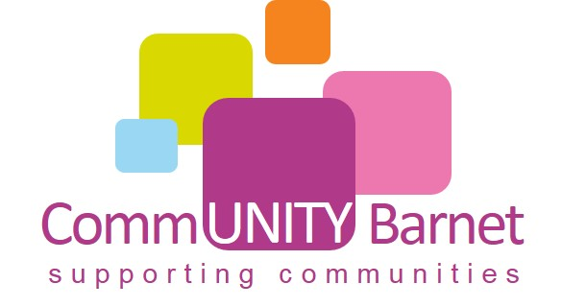
Figure: “Barnet Primary Care Group” (Silviyani et al, 2021).

Part A- Analysis of the Best Practices of Community Engagement in Barnet Primary Care Group, Barnet, London

Introduction of Social program and business and the expected benefits from it to the society
Understanding the concept of social program
Fundamentally, social programs ensure that the basic needs of the people are met that include cash assistance, food assistance, health insurance, housing subsidies, utility subsidies, childcare assistance, and education. The social program is so important for redistribution, solidarity, and social cohesion. Besides, the social program also supports promoting social justice and economic efficiency properly. For example, “Barnet Primary Care Group” was accountable for handling the local health system, and for improving services effectively (Changdeo et al, 2020).
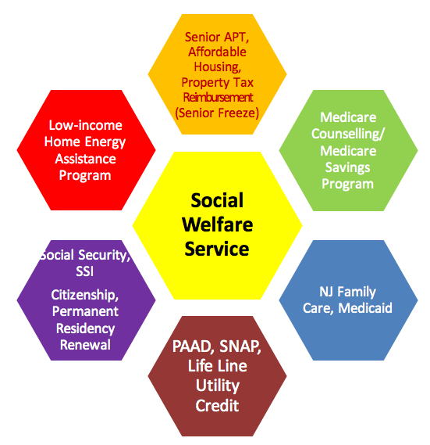
Figure: Social welfare services (Merga et al, 2021).

The benefits of social program to the society
Help to promote social justices
The social program plays a great role to promote social justice by supporting a local organisation, adopting a politician and embracing diversity, etc. For example, “Barnet Primary Care Group” needs to take some effective steps to promote social justice properly such as reach out to legislators, donate and volunteer, etc. (Facchin et al, 2021).
Help to develop economic efficiency and productivity
Social programs also help to improve economic efficiency and productivity by planning, decision-making, and understanding the right field. For example, as a community, “Barnet Primary Care Group” needs to create many job opportunity for the social people and also provide a loan so that the people can be self-contained (Merga et al, 2021).
Increasing people satisfaction
Finally, as a community, it is the responsibility of “Barnet Primary Care Group” to manage people by providing effective services, proper care, proper treatment, effective legislation, and manage the cost which will increase people's satisfaction (Changdeo et al, 2020).

What sort of relationship with the stakeholders and how they engaged with them
As a community, “Barnet Primary Care Group” has some key stakeholders such as residents, government workers, community groups, business owners, neighbour leaders, and developers. Besides, “Barnet Primary Care Group” needs to take some vital steps for engaging the stakeholders properly. Also, “Barnet Primary Care Group” needs to try its best to make a positive and effective relationship with the stakeholders because without stakeholders they cannot reach the destination (Merga et al, 2021).
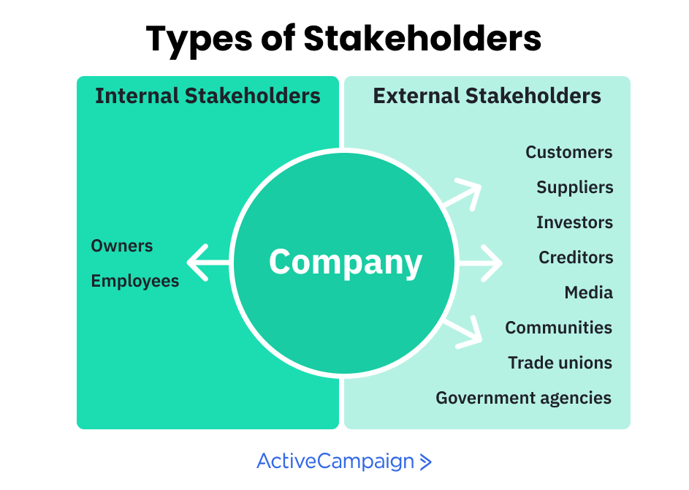
Figure: Types of stakeholders (Mekpor et al, 2020).
The relationship with a community group
“Barnet Primary Care Group” needs to keep communication with community group so that they can make effective decisions and solves matters easily (Facchin et al, 2021).
The relationship with government workers
“Barnet Primary Care Group” needs to properly respect the opinion of government workers and also follow the legislation properly (Purohit et al, 2021).
The relationship with the developer
“Barnet Primary Care Group” also needs to make an effective relationship with the developer by communicating, team working and understanding each other (Silviyani et al, 2021).

The way to engage stakeholders
Keep communication
If “Barnet Primary Care Group” can able to make an authentic and effective communication with the stakeholders, they will engage their stakeholders properly (Mekpor et al, 2020).
Maintain conflict
If “Barnet Primary Care Group” can also able to maintain conflict between stakeholders then it will also so beneficial for engaging them properly (Merga et al, 2021).
Manage expectation
“Barnet Primary Care Group” also needs to manage stakeholder’s expectations and requirements as it is very essential to engage the stakeholders successfully (Facchin et al, 2021).

The different eras of the organisation and highlight how their community engagement has evolved
According to the history of the organisation, the organisation has passed lots of eras, and “Barnet Primary Care Group” has evolved with the organisations directly. For example, according to the organisation era based on policies, there have lots of rules and regulations and the community needs to maintain all the rules and regulations properly otherwise it will too difficult to continue the community perfectly (Shah, 2021).
In the past, “Barnet Primary Care Group” faces lots of difficulties to serve the people properly because of lack of advanced technology and lack of social media. But by improving social media helps “Barnet Primary Care Group” to change their leadership and management styles properly (Merga et al, 2021).
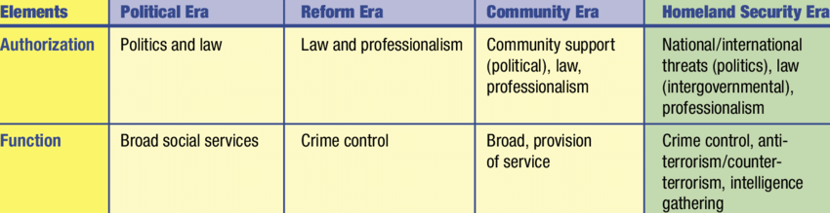
Figure: Organisations era based on policies (Bhola et al, 2020).
For example, in the past, “Barnet Primary Care Group” needs to collect people's information by taking notes but now they collect and gather information by the database. Besides, in the past, “Barnet Primary Care Group” needs to advertise their services into the traditional media but now they advertise their services into digital media e.g. Facebook, YouTube, etc. which are very effective than the traditional media. That’s why; it can be said that the “Barnet Primary Care Group” is evolved by the different eras of organisations (Silviyani et al, 2021).

The nine principles of community engagement
First of all, the first principle is careful preparation and planning and second is demographic and inclusion diversity and the third is collaboration and shared purpose. The fourth is openness and learning and fifth is transparency and trust and the sixth is impact and action. The seventh is sustained engagement and participating culture. The eighth is to empower human rights and the final is self-determination and collective actions (Bhola et al, 2020).
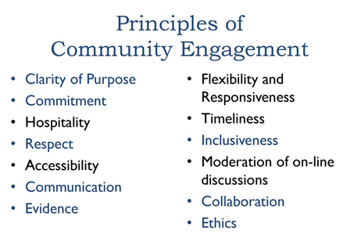
Figure: The nine principles of community engagement (Merga et al, 2021).
The methodology used to engage the community
Here, “Barnet Primary Care Group” needs to take survey research techniques during engaging the community. Besides, they also need to apply the quantitative and qualitative data analysis methods during engaging the community properly. Also, they need to follow the data analysis and data collection research methodology for engaging the community (Silviyani et al, 2021).

How they are using social media platforms to develop the community
“Barnet Primary Care Group” needs to consider using the best digital and traditional media as the media helps to develop the community properly. According to the digital media, “Barnet Primary Care Group” needs to use the digital image, digital video, websites, social media, database, digital audio and electronic books, etc.
According to the social media, “Barnet Primary Care Group” needs to use Facebook, YouTube, LinkedIn, Twitter, Instagram, Snapchat, etc. If they use these types of social media, then “Barnet Primary Care Group” can able to improve community efficiency, productivity and performance properly (Shah, 2021).

Figure: Different social media (Nguyen Viet et al, 2021).
For example, by using Facebook, “Barnet Primary Care Group” can advertise their services and inform people about their care system. Besides, by using YouTube, they can make many important videos to inform people about many diseases and their symptoms, and how to recover from the disease, etc. Also, by using Twitter, they can send some important messages to the people that will increase business productivity and performance effectively (Huang et al, 2021).
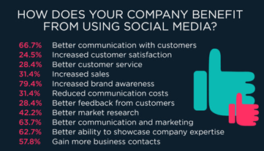
Figure: The benefits of using social media (Huang et al, 2021).

Explain the training and development required to make the employees productive to deal with the socio-cultural issues
“Barnet Primary Care Group” needs to consider providing some effective training and development to make employees productive such as Time Management Training, Leadership Training, Personal Development Program, Employee Ethics Training, etc. (Huang et al, 2021).

Figure: Training and Development to make employees productive (Facchin et al, 2021).
Time Management Training
Time management training is very effective for the employees to make them productive. Time management training helps to manage time and do extra particular tasks. For example, if “Barnet Primary Care Group” provides time management training, employees will respond at works and do more effective tasks (Purohit et al, 2021).
Leadership Training
Leadership training is also very essential for guiding, motivating, regulating, and directing others properly. For example, “Barnet Primary Care Group” needs to provide leadership training and also provides leadership styles so that employees can provide effective motivation to the people and also can regulate them perfectly (Mekpor et al, 2020).

Personal Development Program
A personal development plan supports an individual to improve his strength and reduce all the weaknesses properly. For example, if “Barnet Primary Care Group” provides personal development plan training to the employees, it will increase employee productivity and efficiency properly (Changdeo et al, 2020).
Employee Ethics Training
Finally, “Barnet Primary Care Group” also needs to provide employee ethics training such as effective communication, obey the community rules, taking responsibility, professionalism, accountability, etc. so that they can do their particular tasks effectively and accomplish their objectives properly (Shah, 2021).

Why the organisations need to adopt a forward-looking approach in training their employees on multi-culturist & the external factors in building a sustainable relationship
Fundamentally, forward-looking is a business term used to classify forecasts that publicly traded businesses make about future business circumstances, reforms, earnings approximations, and other important business information. Here, “Barnet Primary Care Group” needs to provide proper training to the employees as training is mostly required to achieve the business objectives properly. Besides, “Barnet Primary Care Group” needs to provide basic skills and technology training as it will increase their productivity and also develop their performance accordingly (Nguyen Viet et al, 2021).
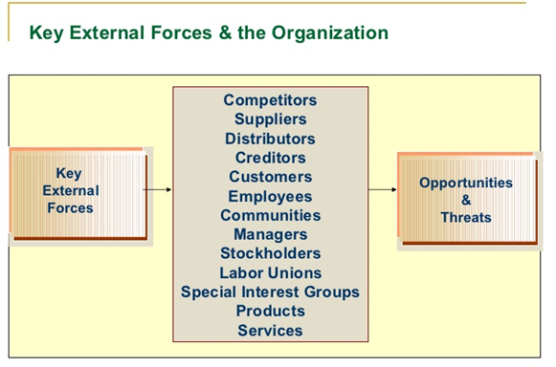
Figure: Key external factors (Marcial et al, 2021).
Also, “Barnet Primary Care Group” needs to provide effective training about the external factors as it will support building a sustainable relationship. According to the external factors, “Barnet Primary Care Group” needs to train employees how to behave with people and how to make effective communication with them (Shah, 2021).
When employees can able to understand effective communication it will support building a sustainable relationship. Also, “Barnet Primary Care Group” needs to follow some key ways to build sustainable relationships such as pay attention to the people, communicate effectively, challenge each other to do better, ask questions and actively engage, etc. (Purohit et al, 2021).

To build a sustainable relationship “Barnet Primary Care Group” needs to follow some key steps such as (Shah, 2021).
Assess (Planning)
“Barnet Primary Care Group” needs to plan for the key training to the employees such as time management, leadership development, personal development and works ethics training for building a sustainable relationship (Bhola et al, 2020).
Design (Implementation)
During implementation, “Barnet Primary Care Group” needs to follow the steps of implementation strategy such as describe strategy framework, build a plan, define KPIs, establish strategy rhythm, implement strategy reporting, and relation performance to strategy.
Monitoring
“Barnet Primary Care Group” also needs to monitor employee’s performance as it is mostly required for developing employee’s productivity and getting a sustainable relationship (Lim et al, 2021).
Evaluation
“Barnet Primary Care Group” also needs to evaluate employee’s daily activities so that they can get the best performer. For example, when employees can able to understand effective communication it will support building a sustainable relationship (Changdeo et al, 2020).
Reflection
“Barnet Primary Care Group” needs to reflect on their experiences so that they can get their strength and weakness. After getting weakness, they need to take action and implement it properly for getting a sustainable relationship (Merga et al, 2021).
Sustainability
Finally, “Barnet Primary Care Group” needs to focus on some key ways to make sustainable relationships such as pay care to the people, interconnect effectively, test each other to do better, ask questions and aggressively engage, etc. (Silviyani et al, 2021).

How “Barnet Primary Care Group” makes their community engagement better to get the competitive advantage
If “Barnet Primary Care Group” wants to get better engagement, they will need to build a competitive advantage. Besides, they need to follow some core ways to get a competitive advantage which are given below (Lim et al, 2021).
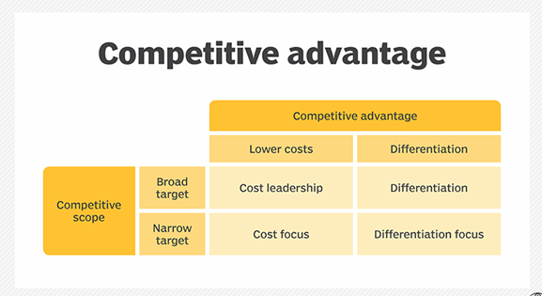
Figure: Competitive advantage (Merga et al, 2021).
Clarify the Strengths- “Barnet Primary Care Group” needs to clarify its key strength so that the people can understand their importance and want to get service from there. As a community, “Barnet Primary Care Group” key strength is providing effective services, effective communication, effective management styles, and effective leadership ability (Mekpor et al, 2020).
Establish a Unique Value Proposition- “Barnet Primary Care Group” also needs to understand their services and also take feedback from the people so that they can able to provide the expected services. For example, if it is required to change or innovate its services, “Barnet Primary Care Group” needs to make innovative services for satisfying the people (Facchin et al, 2021).
Become an Online Influencer
“Barnet Primary Care Group” needs to follow some core steps for becoming a social media influencer such as select the niche, understand the audience, be regular and consistent, engage with an audience, select the right channel, etc. which will support building a competitive advantage properly (Changdeo et al, 2020).
Superior people service
Finally, “Barnet Primary Care Group” needs to ensure that they provide superior services and their mission is to work together to sustain a tough general practice that’s why it will very effective for them to build a competitive advantage successfully (Bhola et al, 2020).
Effective communication
“Barnet Primary Care Group” needs to make a positive communication as it is the more appreciate steps for building competitive advantage. For example, if “Barnet Primary Care Group” can able to make an authentic and effective communication with the stakeholders, they will engage their stakeholders properly (Silviyani et al, 2021).
Stakeholder engagement
“Barnet Primary Care Group” needs to take some vital steps for engaging the stakeholders properly. For example, “Barnet Primary Care Group” needs to properly respect the opinion of government workers and also follow the legislation properly and also needs to make an effective relationship with the developer by communicating, team working and understanding each other (Purohit et al, 2021).
Logic model and strategic plan
The key benefits of logic models are helping members describe a general understanding, recognising indicators of success, supporting future efforts. Besides, “Barnet Primary Care Group” needs to follow a strategic planning process for getting a competitive advantage e.g. determine a strategic position, improve a strategic plan and review and revise the plan (Facchin et al, 2021).
Implementation strategy
“Barnet Primary Care Group” needs to follow the steps of implementation strategy such as describe strategy framework, build a plan, define KPIs, establish strategy rhythm, implement strategy reporting, and relation performance to strategy (Merga et al, 2021).

Conclusion
Thus, it can be concluded that “Barnet Primary Care Group” needs to take some effective steps to promote social justice properly such as reach out to legislators, donate and volunteer, etc. “Barnet Primary Care Group” needs to keep communication with community group so that they can make effective decisions and solves matters easily. Finally, “Barnet Primary Care Group” needs to consider using the best digital and traditional media as the media helps to develop the community properly (Facchin et al, 2021).

References
Bhola, A., Halder, K., Prasad, A. and Kan, M.Y., 2020, December. Retrieving Skills from Job Descriptions: A Language Model Based Extreme Multi-label Classification Framework. In Proceedings of the 28th International Conference on Computational Linguistics (pp. 5832-5842).
Changdeo, S.R., 2020. Job Description and Job Satisfaction of Library Professionals Working in CPE Colleges in Maharashtra State.
Facchin, M., 2021. Structural Representations do not meet the job description challenge. Synthese, pp.1-30.
Huang, H.C., Xu, J. and Lim, A., 2021. Marketing Mix Optimization with Practical Constraints. arXiv preprint arXiv:2101.03663.
Lim, X.J., Cheah, J.H., Ng, S.I., Basha, N.K. and Soutar, G., 2021. Will you stay or will you go? The effects anthropomorphism presence and the marketing mix have on retail app continuance use intention. Technological Forecasting and Social Change, 168, p.120763.
Marcial, V.F., 2021. Marketing mix de servicios de información: valor e importancia de la P de producto. Bibliotecas. Anales de investigación, 11(4), pp.64-78. MURAD
Mekpor, B. and Dartey-Baah, K., 2020. Beyond the job description. Journal of Management Development.
Merga, M.K., and Ferguson, C., 2021. School librarians supporting students’ reading for pleasure: A job description analysis. Australian Journal of Education, p.0004944121991275.
Nguyen Viet, B. and Nguyen Anh, T., 2021. The role of selected marketing mix elements in consumer-based brand equity creation: milk industry in Vietnam. Journal of Food Products Marketing, pp.1-17.

Purohit, S., Paul, J. and Mishra, R., 2021. Rethinking the bottom of the pyramid: Towards a new marketing mix. Journal of Retailing and Consumer Services, 58, p.102275.
Shah, M.B.H., 2021. The Impact of Green Marketing Mix on Purchase Intention of Customers in Karachi, Pakistan. RJ Journal of Business Management & Social Sciences, 1(1).
Silviyani, S., Azizah, N., Zakiah, L. and Iqbal, M., 2021. Analisis Marketing Mix Dalam Islam (Studi Kasus: Bisnis Online Shop Wardah). Al-Sharf: Jurnal Ekonomi Islam, 1(3).

