Managing Leisure 12, 74–88 (January 2007) 
Physical activity programmes for secondary schools in Wales:
Implications from a pilot scheme
Nicola Bolton, Scott Fleming and Maria Galdes
Cardiff School of Sport, University of Wales Institute, Cardiff, UK
In 2004 a pilot scheme was launched in Wales to address the physical activity participation patterns of young people. A large survey (n5 1834) was conducted at six schools to investigate the participation patterns of 12 2 14-year-olds. The data gathered informed the design and delivery of programmes of extra-curricular activities introduced at each of the schools in 2005. The implementation of these was based on a partnership between physical education professionals and sports development practitioners. A review of the programmes (from seven interviews with gatekeepers plus 11 focus groups involving 43 young people) revealed that they were perceived to be successful around three central themes: the activities provided, and by whom; those engaging with the programme, and why; and the role of the key agents (the School Sports Organizers).

INTRODUCTION
In 2004 the Sports Council for Wales made a commitment to implement a small-scale scheme designed to increase the number and range of sporting and physical activity opportunities for children of secondary school age. Called the Secondary School Sport Pilot (SSSP), the vision was:
To create schools where a broad range of sports and physical activity is offered in extra-curricular time, particularly weeknights and weekends to all children regardless of their ability. Non-specialist staff, parents, older pupils, students, leisure managers and development officers, local clubs and coaches will work together to organize and provide this activity. (Sports Council for Wales, 2003c, p. 1)
The design of the SSSP was informed in part by a large-scale survey of over 1800 young people aged between 11 and 14 which was undertaken in January 2005. The SSSP was then introduced and reviewed in July 2005 through a series of interviews with enablers and providers, and focus groups with some of the young people who participated in the earlier survey. In this paper we present some preliminary baseline participation data from the survey which helped to shape the SSSP and address operational themes and issues that emerged from the review.
Managing Leisure ISSN 1360-6719 print/ISSN 1466-450X online # 2007 Taylor & Francis http://www.tandf.co.uk/journals
DOI: 10.1080/13606710601071579
The discussion is structured around five main sections. In section two, a UK policy context is outlined which considers the relation of physical education to physical activity, and various government initiatives. In section three, there is a brief account of the data collection techniques employed. In section four, an overview of participation survey data is presented emphasizing the gendered nature of patterns of activity. In section five, there is a review of the operation of the SSSP based on the interview and focus group data. Finally, based on this evidence, policy implications for the wider implementation of the scheme are identified.
BACKGROUND AND POLICY CONTEXT
There has been wide recognition for some years of the importance of physical activity
(PA) for young people as they move through their adolescent years and into early adulthood (Penney and Evans, 1999; Kirk, 2003). Evidence from participation surveys undertaken by the Sports Councils in England and Wales (Sport England, 2003; Sports Council for Wales, 2003a, b) reveals, as Green et al. (2005, p. 30) note that ‘... more young people in England and Wales are doing more sport and physical activity than ever before’. They preface this conclusion with an important caveat: ‘... just as with adults, there is a significant minority of young people doing relatively little or absolutely nothing’. Other commentators have noted a general decline in participation amongst young people with increasing age, and on the greater propensity for this amongst girls than amongst boys (Collins with Kay, 2003). There has also been considerable debate over the extent to which PE curricula have facilitated lifelong participation in PA (see, for example, Kirk, 2003, and Green et al., 2005).
The Education Reform Act (ERA) in 1988 changed the content and structure of the whole education system in England and Wales (Talbot, 1995; Penney and Evans, 1999; Kirk, 2003). One of the key features of the ERA was the identification of core subjects and foundation subjects and within the latter a clear schedule for the development of the National Curriculum. Alongside other subjects including art and music, PE was relegated in importance. This position has remained unchanged as the present Labour government has retained its commitment to basic literacy and numeracy, and to the division between core and foundation subjects. These issues have been exacerbated as the teaching profession has grappled with ‘government initiative overload’ and other professional issues including recruitment and training of teachers, classroom assistants and others (Bailey, 2005). The cumulative impact on PE in schools has been a clear reduction in the number and variety of teacher-led extra-curricular activities (Robson, 2001), and there is little prospect of changing the priority of physical education vis-a`-vis other subjects, or indeed of providing additional hours for PE within the curriculum.
It was during John Major’s Conservative government, in particular, that school sport became a high and visible strategic priority. Raising the Game (Department of National Heritage, 1995) identified the need to address the decline of school sport and this policy initiative had his personal seal of approval (Houlihan and White, 2002). When the Labour administration took over in 1997, there were mounting concerns about young people’s engagement in PA, and there was a view that many secondary school age young people were not taking enough PA to confer health benefits (Health Education Authority, 1998; Sports Council for Wales, 2006c). As part of the Labour Party’s modernization agenda, A Sporting Future for All was published (Department of Culture, Media and Sport (DCMS), 2000) focusing on three interconnected themes: sport in the community, sport in schools, and sport and national governing bodies. The strength of this policy document lay in its focus on improving sport in schools; and by comparison, the level of detail given to sport in the community and local authorities was much less (Houlihan and White, 2002). Subsequently, a further policy document, Game Plan, was published (DCMS and Strategy Unit, 2002). It addressed improvement in international performance, support for major events, and increasing participation in sport and PA – with an explicit link to the health agenda.
Following consultation in 2003, the Welsh Assembly Government (2005) produced a national sports strategy, Climbing Higher which was published in January 2005. Three of the targets referred to objectives for young people of secondary school age to achieve by 2023:
Target 3 has two parts:
. At least 90% of boys and girls of secondary school age will participate in sport and physical activity for 60 minutes, five times a week.
. All secondary schools will provide a minimum of 2 hours of curricular based and 1 hour of extra-curricular sport and physical activity per week (p. 9).
Target 7 states:
. 80% of children will be junior members of sports clubs or centres (p. 9).
Target 9 states:
. All children in Wales will have experienced an outdoor adventure activity before the age of 12 and a further experience before the age of 16 (p. 11).
There was general agreement over the need to increase participation in PA among young people in England, Scotland and Wales, but distinctive programmes of intervention have been developed in each country. In England, education was the critical driving force and a total of over £1 billion was invested to transform PE and school sport (Department for Education and Skills and DCMS, 2004). The national strategy for PE, School Sport and Club Links (PESSCL) has been delivered through school sport partnerships: families of schools that enhance sports opportunities by improving coordination, links between primary and secondary schools and out-of-hours opportunities, and coaching, leadership and community sport. In secondary schools the School Sport Coordinators were fully qualified teachers and were released for 2 days a week to take on this function.
In Scotland, an emphasis was placed on the health agenda. The School Sport Coordinator Programme was initially a 4-year National Lottery funded initiative, and by 2003/4 positions were created for 330 parttime secondary and 53 full-time primary school coordinators. A key difference was in the full-time status of the primary school teachers and the part-time nature of the secondary coordinators. As with England, these positions have typically been allocated to secondary school teachers released from teaching duties (Coalter and Thorburn,
2003).
In Wales there was an existing initiative called Dragon Sport which was concerned with the promotion of extra-curricular activity among primary school age children. Launched in 1999 and funded through the National Lottery, it was based on each local authority employing a coordinator who built links and delivered programmes with primary schools in her/his area. Dragon Sport now has 93% (1298) of eligible schools taking part incorporating some 3475 school clubs. A joint PE and School Sport initiative was launched in 2003 by the Welsh Assembly Government and the Sports Council for Wales to address some of the wider issues regarding the delivery of PE in schools.
The SSSP was introduced in 2004 through the appointment of School Sport Organizers (SSOs) whose aim was to raise levels of participation in extra-curricular school sport (Sports Council for Wales, 2003c). Following an invitation from the Sports Council for Wales to all 22 local authorities, six schools were selected for the pilot. The sponsoring agency was keen to ensure some broad representativeness of the diversity of schools in Wales within the sample, as well as differentiated extra-curricular provision (ranging from those that had an established programme of extra-curricular activity to others which, at best, would have been considered under-developed). With the exception of one ‘all girls’ school, the participating schools were mixed comprehensives with school rolls ranging from 660–1502 with four out of the six schools totalling over 1000 pupils. Five of the participating schools were based in unitary local authorities found in South Wales with one school located in North Wales. With the exception of one school which catered for young people until GCSE, all schools had a sixth form. The schools had socio-economically diverse catchment areas: two served wards characterized by widespread social deprivation; two were situated within former industrial areas and the other two were in relatively affluent, suburban areas.
Before addressing the findings of the research some conceptual ‘ground-clearing’ is needed about PE, sport and sports development. Consensus over definitions of PE has been elusive, partly because PE itself has changed emphases (Kirk, 2003). For operational clarity, however, PE is taken to be concerned with the holistic development of young people (continuing into and throughout adulthood) through engagement in various PAs. It is also used more prosaically by participants in the research to refer to specific curriculum areas and associated educational outcomes (Bailey, 2005). The growing body of literature linking young people to PA, lifelong participation, PE and school sport is significant (Collins, 2004; Penney and Jess, 2004; Bailey, 2005; Green et al., 2005). Paradoxically, as PE has been marginalized in recent years (Kirk, 2003), other government departments, including health and sport, have played an increasingly important role in formulating and implementing policy regarding PA.
The term ‘sport’ is ambiguous. The most commonly used definition (see for example, Coalter, 2001; Sport England, 2004; Torkildsen, 2004), is the Council of Europe’s European Sports Charter (1993) which states:
‘Sport’ means all forms of physical activity which, through casual or organized participation, aim at expressing or improving physical fitness and mental wellbeing, forming social relationships or obtaining results in competition at all levels. (p. 1)
This definition is inclusive and serves to legitimize organizations engaging in a whole range of activities which go beyond a more limited definition of ‘competitive’ sport. It also situates an examination of sport within the context of social change and intervention (Jarvie, 2006).
‘Sports development’ is also a contested concept, but for the purpose of this discussion we accept the account provided by Bramham et al. (2001, p. 2) that ‘those engaging in sports development must be in the business of devising better and more effective ways of promoting interest, participation or performance sport’. The focus here is on developing the right community infrastructure which will create pathways of opportunities.

METHODOLOGICAL NOTE
The research was conducted in two distinct phases. In phase one a detailed survey of all young people in Year 7 (aged 11 to 12 years) and Year 9 (aged 13 to 14 years) attending the six pilot schools was conducted. It sought broad contextualizing data about the young people themselves, their existing levels of participation, their aspirations for further participation (especially amongst those who described themselves as ‘non-participants’), and some of the perceived barriers that prevented or constrained participation. The inclusion of all young people in each year was important to ensure that the data were relevant for the SSOs at an individual school level as they would inform the extra-curricular programme and reflect local diversity. The self-completion questionnaire, based on previous participation surveys undertaken by the Sports Council for Wales (2003a, b), was administered between mid-January and mid-February, 2005. Inevitably this makes the ‘snapshot’ of a particular moment in time subject to the seasonality of the datacollection period.
Following a briefing and training session, the SSOs arranged for the questionnaires to be completed in their own school at a year group assembly. The SSO and the form teachers for the year group were present to ensure assistance was given to any respondent where required. A total of 1834 responses were received from a potential total of 2273 pupils, providing an overall response rate of 81%.
The second phase of the research was concerned with reviewing the operation of the SSSP. Seven semi-structured interviews were conducted with gatekeepers including three SSOs, a Headteacher, the Heads of two PE departments, and the Sports Council for Wales’ manager of the project. Additionally, 11 focus groups were held involving 43 of the young people who completed the survey. The raw data, some of which are included in section five as illustrative examples, were subjected to content analysis which yielded three over-arching themes of direct applied relevance to practitioners.

PARTICIPATION SURVEY DATA
A central function of the survey was to establish the level of participants’ engagement with extra-curricular and community club provision – it was, after all, possible to infer with some confidence what young people were doing within the PE curriculum. All schools were following the National Curriculum in PE. Overall, 63% of participants had taken part in some form of extra-curricular activity during the school year 2004/5, with the range being 55% to 75% in the different schools. Additionally, though, there was consistency with national data as participation in extra-curricular sport was less amongst Year 9 respondents (57%) than amongst Year 7 respondents (68%) 2 see Sports
Council for Wales (2003a).
For the activities themselves, Figure 1 shows the participation patterns of boys and girls that were reported for the PE curriculum, in extra-curricular activities and in community-based sport and PA. Predictably, the ‘top 20’ activities reveal engagement in the major team games (football, hockey, netball and rugby), though as Figures 2, 3 and 4 demonstrate, there is clear differentiation amongst many activities by sex. Furthermore, with the exception of gymnastics, all of the most widely practised activities within the PE curriculum are also those that are popular in extra-curricular teams and clubs or through community-based provision. There is also evidence of a breadth of experience of participation that includes dance and various forms of health-related PA (aerobics, circuit training, ‘keep-fit’, weight training).
The gendered nature of participation is clear in Figures 2, 3 and 4. Participation in aerobics, badminton, dance, gymnastics, hockey, netball and rounders was shown to be considerably more widespread amongst girls (even within the PE curriculum) than amongst boys. Whilst for basketball, cricket football and rugby the opposite was true.
A further aim of the survey was to identify the perceived needs/demands for developing extra-curricular activities amongst the young people. The question was deliberately left open-ended in order to provide the opportunity to identify PAs that did not necessarily conform to traditional conceptualizations of competitive ‘sport’. In total, 131 individual and diverse activities were identified, for example, 19 different forms of dance were listed (e.g., hip hop, street, pop). There were two important findings.

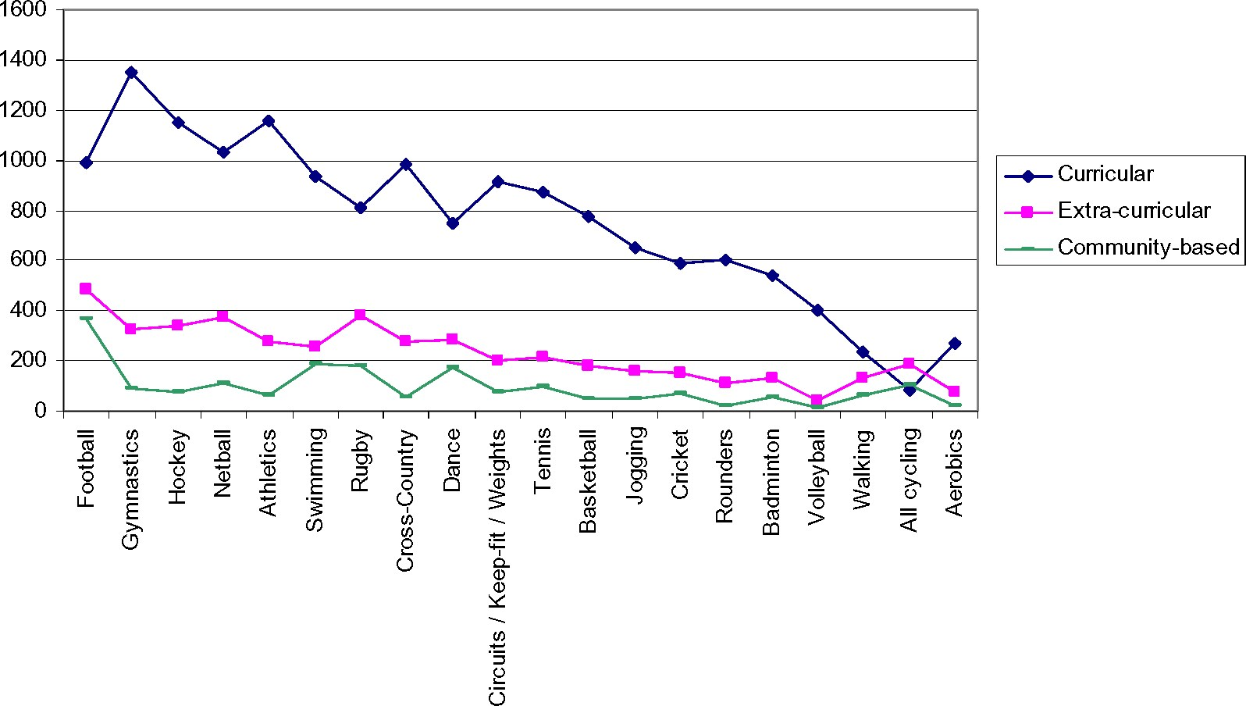
Fig. 1. Participation in curricular, extra-curricular and community-based sport and physical activity (n ¼ 1834).
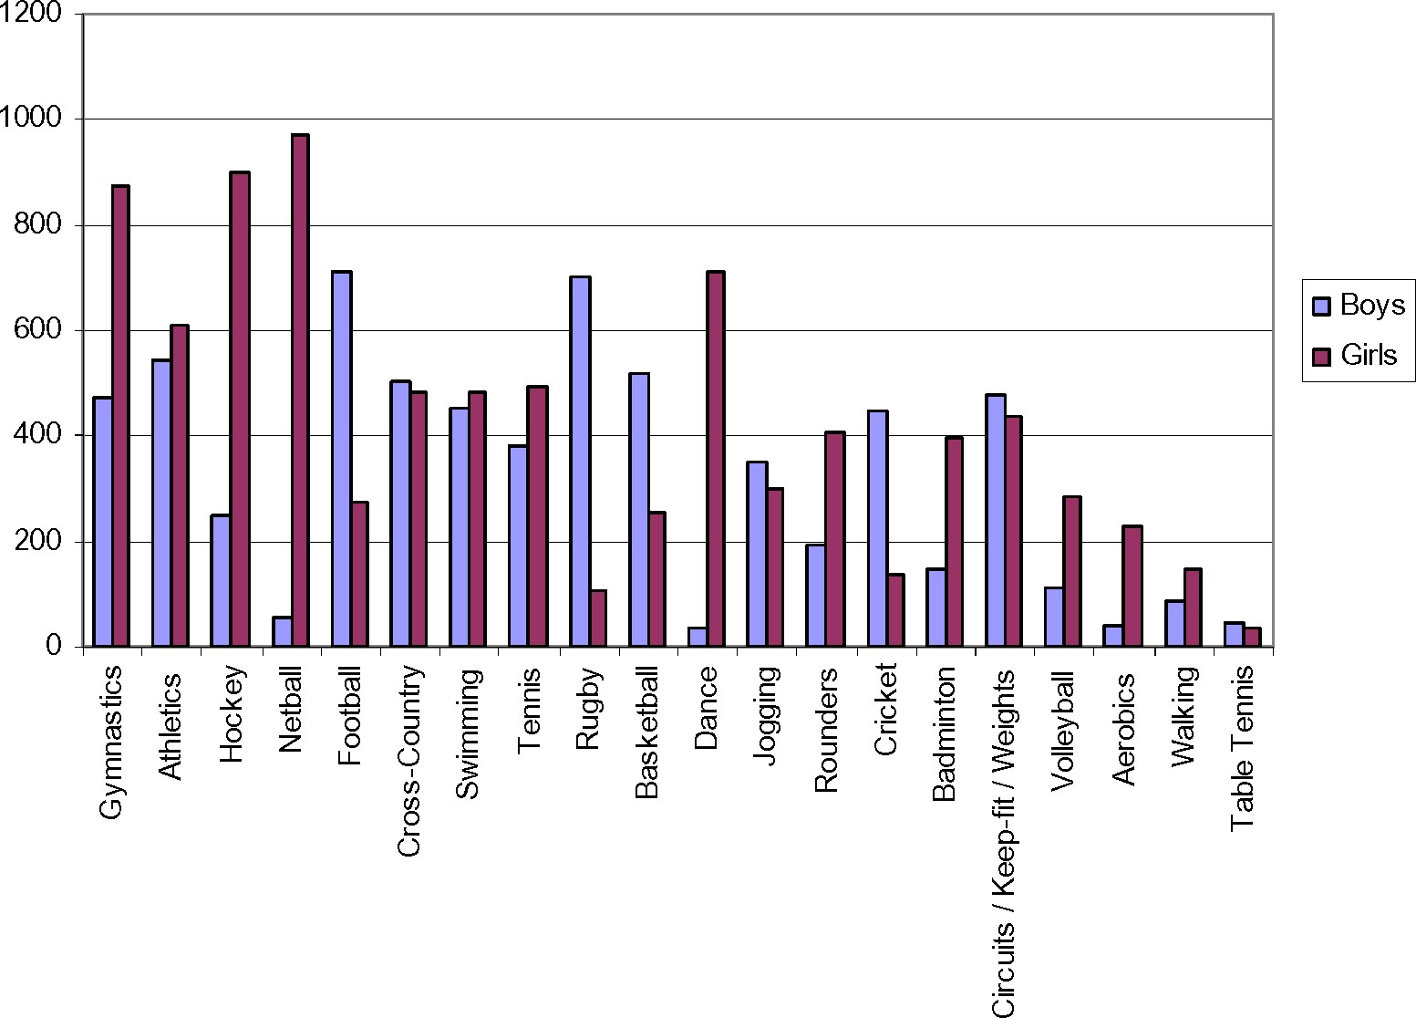
Fig. 2. Participation in curricular sport and physical activity by sex (n ¼ 759 boys; n ¼ 1028 girls).
Fig. 3. Participation in extra-curricular sport and physical activity by sex (n ¼ 501 boys; n ¼ 638 girls).
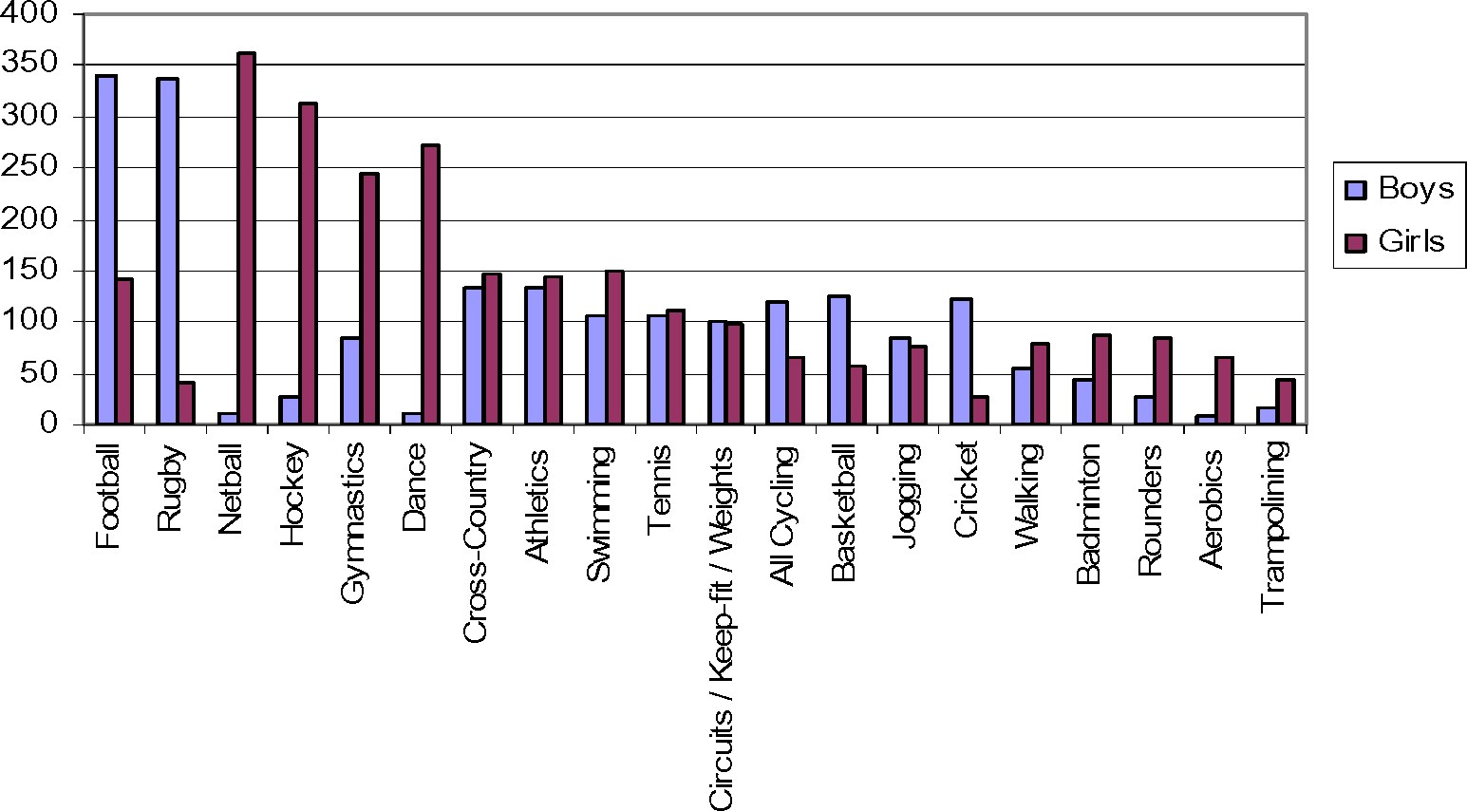
First, there existed further demand for activi- major team games). That is to say, there ties which form part of the PE curriculum was an expressed demand for more opportuand/or were provided as part of the extra- nities to participate in a way that is both reccurricular programmes (i.e., some of the reational and competitive. Second, there was
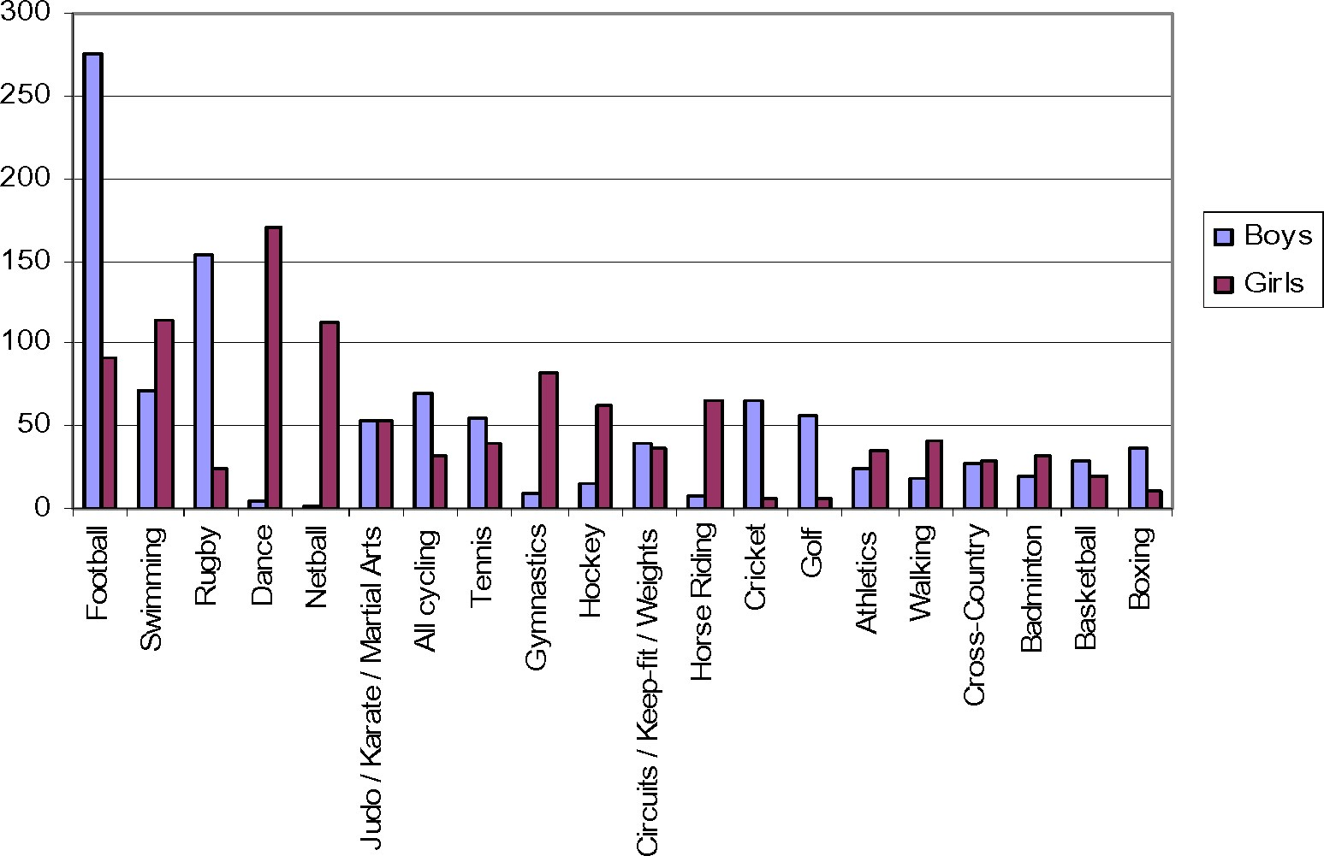
Fig. 4. Participation in community-based sport and physical activity by sex (n ¼ 501 boys; n ¼ 475 girls).
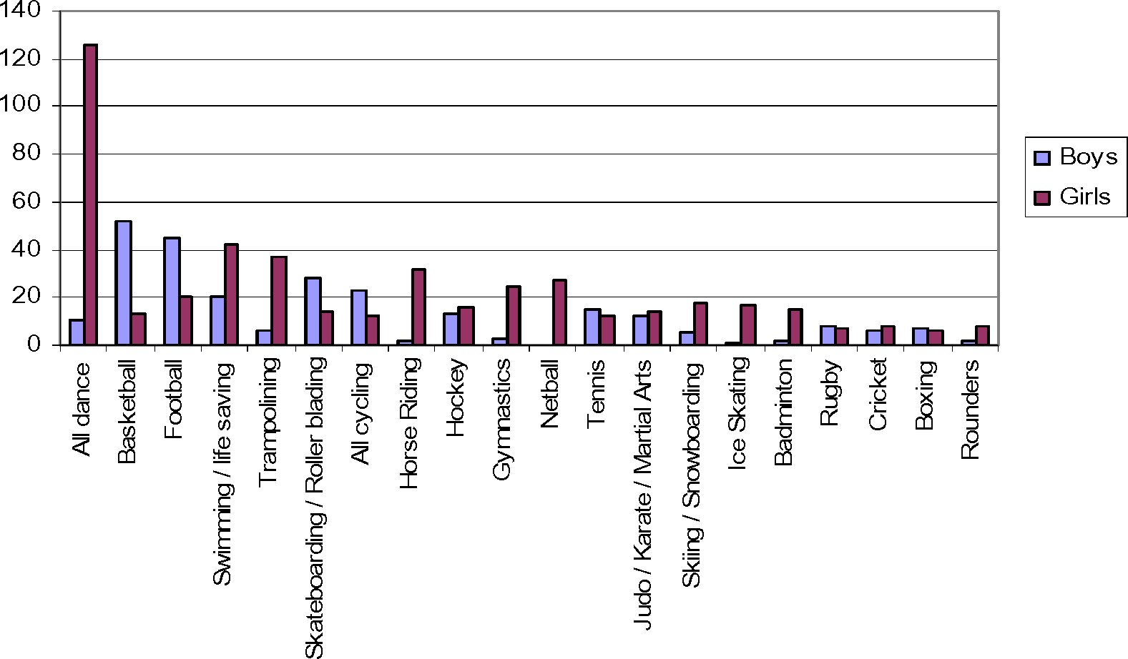
Fig. 5. Expressed preferences amongst non-participants for extra-curricular sport and physical activity by

sex (n ¼ 227 boys; n ¼ 354 girls).
also an expressed demand for activities that lie outside existing school-based provision (e.g., boxing, horse riding, skiing) as well as a number of newer activities (e.g., BMX freestyle cycling, skateboarding, snowboarding). Almost one-third of all respondents (32%) reported not participating in school-based extra-curricular sport and PA during the previous year. Figure 5 displays the expressed needs/demands of this constituency, and it is these young people that pose a considerable challenge to policy makers and practitioners. The expressions of greatest demand reflect a mixture of the activities for which there is already some extracurricular and community-based provision (e.g., basketball, football, netball), activities for which there is provision within the PE curriculum (e.g., dance, trampolining, gymnastics), and activities that do not feature prominently in either (e.g., cycling, horse riding, skateboarding).
Finally, these ‘non-participants’ reported barriers that prevented or constrained their participation in sport and PA included ‘availability and adequacy of local facilities’ (35%), ‘no-one to go with’ (22%), ‘perceptions of incompetence’ (16%), ‘lack of transport’ (13%) and ‘expense’ (8%). These perceptions may be either real barriers or merely imagined, but whether they are real or imagined they become real in their consequences for the non-participants.

REVIEW OF THE SSSP
The interview and focus group data shed light on the operation of the SSSP. The three emerging themes were: the activities provided and by whom; those engaging with the programme and why; and the role of the SSOs.
The activities provided, and by whom
There were approximately 10 activities per school per term (each activity running for the duration of a half-term), and these were usually wide ranging – one 12-year-old girl listed her own participation at the time of being interviewed as: ‘cardio-kicks, circuit training, volleyball, table tennis and “funclub”’. Across the six SSSP schools, the organizers offered thirty-three different activities in 492 sessions. They represented a mix of traditional team games (e.g., football, rugby, netball and hockey), those identified as ‘in demand’ but for which there was no provision (e.g., dance, BMX biking, martial arts and skateboarding), and those that were entirely new (e.g., ‘walking club’, climbing, surfing and golf). The inclusion of traditional team sports was important and reflected the expressed demand from the young people themselves. It also supported other research suggesting that many young people were seeking additional opportunities to play traditional games (Sports Council for Wales, 2003a; Green et al., 2005). The inclusion of outdoor adventurous activities also resonated with the wider national policy initiatives in Wales (Welsh Assembly Government, 2005). The ‘new’ activities which were not expressly demanded by the young people reflected the Sports Council for Wales’ desire to be innovative in providing a wide choice of activities.
Significantly, one of the PE teachers interviewed recognized the increasing number of activities available in the school and in the community (see also Green et al., 2005). He commented,
There are so many different sports out there. If they are doing GCSE now, they have a choice of 100 sports to choose from. It’s essential to have a go, a taster of these sports ... We cover about 10 sports over 2 years and then specialize in four in their final year. But they could specialize in offsite activities such as horse-riding or judo.
The SSOs were both the providers and facilitators of the extra-curricular programme. Often they were running activities, though in other instances external coaches were employed on or off the school site. Offschool activities were most frequently associated with outdoor adventurous activities. The PE staff within the school did assist the organizers with some activities, but as Coalter and Thorburn (2003) found in their evaluation of the Scottish School Sport Coordinator Programme, it was seldom that other members of teaching staff provided support.
In the vision set out by the Sports Council for Wales (see the introduction above), there was an explicit aim to attract a wide range of persons to deliver or assist in support of the programme. The employment of community coaches who worked in the area was viewed positively by the SSOs, the schools and the young people. For those organizers who knew their local authority sports development unit, they were able to draw on additional support to attract specialists into the school. By comparison, those organizers with less established links to the sports development unit noted the difficulties in networking and identifying the appropriate persons. Early evidence also suggests that it has proved difficult to enlist the support of volunteers from within the school (i.e., other teachers) and externally (i.e., parents). One SSO illustrated the nature of the difficulty:
SSO: PE staff have been quite helpful with the [Inter-] House Cup. Pupils have helped out but mainly coaches have come in.
Interviewer: Other staff from school?
SSO: No.
Interviewer: Parents?
SSO: No.
Interviewer: Local clubs? SSO: No.
Additional support to the SSOs was, however, provided by older students (studying for A levels and BTEC). In dong so, the latter gained some volunteer recognition/ certification, but the overall effectiveness of their involvement (as evaluated by the targeted groups of young people) was variable. Although the initiative has potential in involving these young adults, there were some challenges in gaining an appropriate level of commitment. One SSO explained how difficult and frustrating it had been:
Volunteers, this is a hard one, as I have got older students helping me 2 but they are not helping me, if that makes sense. To start with they were great, got them on board, but then after two to three weeks they wouldn’t turn up – only one student has continued ... For Dragon Sport they need to complete ten hours for their award and having completed their training they need to decide whether to do one activity or lots of activities in the week. But they are not turning up. In terms of other volunteers, there are probably other clubs in the area, but when I need the sessions, most of them, the club volunteers, are working. So, the coaches I am using at the moment, are linked to the sports development unit.
Those engaging with the programme, and why
This Welsh initiative aimed to attract ‘new participants’ not just ‘the sporty types’ or ‘team players’. A personal and targeted approach was adopted as a means of attracting particular kinds of young people. The activities were often running in parallel to team practices thereby, de facto, precluding ‘the sporty types’. The SSOs commented themselves about the time they spent ‘walking and talking’ in the playground during the break before a scheduled activity was due to take place in order to encourage participation. One SSO in a socially disadvantaged area explained about the young people taking part in a half-term climbing and trampolining programme at the local Further Education college:
A group came and there were a few kids on it with disability problems. Some of them are not allowed to do games for some unknown reason and I don’t know but have to go and sit in the unit. They came out for this day and they loved it and just to see that they can do it, and given that opportunity, yeah, it was awesome to be honest. They got picked up outside their house 2 literally pick-ups, they wouldn’t have come otherwise. Yeah, you could see those kids have never been given the opportunity to do anything like that before.
Her apparent sense of pride in attracting different kinds of young people to these activities was extremely important, and was not uncommon. Another described how one activity had become both an interest in itself as well as a distraction from misbehaviour:
Just recently started gymnastics specifically for boys because there is a group of boys in Year 7 and 8 who are naughty pupils and they are really interested in gymnastics, and this is a way of expending energy at lunchtime. They need to be kept active at all times. We’re going to have a trip to the local gymnastics centre now at the end of next week.
The SSOs seem to have engaged both young people who were interested in sport and others who might not, typically, have been attracted to such programmes.
The survey indicated the key reasons for young people participating in extracurricular activities were for fun and enjoyment. Whilst this was the primary focus, the young people themselves commented on the desire to improve their skills and suggested that without opportunities to play in some structured games/matches, the activity could become monotonous. The following part of a conversation between three boys who did not play for a school team illustrated a genuine desire for some to take these activities seriously:
I know that I am competitive with whatever I do ... I want to get better, but I think a lot of boys come in for a laugh. It is alright to a certain point and then it just goes over the top.
I really wanted to learn to surf so it just happened to be that all my friends were going – it was the way it was done to be honest – we could have a laugh but also learnt at the same time.
Going along with your mates and improving a lot.
In two of the schools, very successful interhouse competitions provided some competitive opportunities. At another school there were plans to provide some competition with another neighbouring school, with the focus on fun rather than winning. This SSO commented:
The boys were excited about playing against some other boys, and I said well yes, it’s only some fun, (as we both have our own small leagues) ... and then we play each other so we get something out of the end of it. Otherwise they come every Thursday and, you know, after a while, what for?
There are, of course, many reasons why competitive sport may be important. Davis (2004) lists 13 of them. They include opportunities to develop a sense of achievement and confidence, extending skills in a competitive setting, and developing the ability to cope with winning and losing. The unsophisticated competitive – cooperative dichotomy (see Robson, 2001) about certain PAs does not accommodate properly the experiences of some of these young people who were both keen to enjoy their experience through having fun, and at the same time wanted a sense of purpose through development and/or competition. This willingness to embrace competition is entirely compatible with a broad and inclusive approach to the delivery of sport and PA programmes – especially as in many cases the beneficiaries are likely to be those not experiencing competitive extra-curricular sport.
The role of the SSOs
The SSOs had two sets of primary functions: first, within the school as an enabler and deliverer; second, as the interface between schools and the wider communities of which they were a part. In every case the SSOs were new to the school and were not qualified teachers. In five out of six schools they were recent graduates securing their first posts in the sports development sector. Inevitably, as one Head of a PE department noted, there was some delay for them in becoming fully established:
It took a while to get going. The organizer did not know the pupils or the infrastructure of the school and how to get things sorted. It was slow to get going, but as soon as it was up and running the feedback from the pupils at different lessons is very good. What it has provided them are lots of different opportunities and different sports to pursue.
Notwithstanding the delays, however, the SSOs’ work was valued widely by the PE teachers and by the young people themselves. The Headteacher differentiated the role of the SSO from the school’s academic staff explicitly:
Their role is different isn’t it, in a sense. The goals and tasks of the PE teacher are not necessarily the same, are they? Don’t get me wrong, I’m not saying a qualified teacher couldn’t do that role, but it is a different role 2 and it is the idea of the distinction of the role which is the important aspect of it. You need someone with enough ‘nous’ to understand that, and character and personality and cajoling within them ... and also when the going gets tough to keep on at it and want to succeed.
The young people also noted this distinction, and there was a view that the SSOs had built a different type of professional relationship and rapport with them when compared to the teaching staff. One SSO had noted that the young people with whom she worked were those who did not ‘usually participate in school PE lessons’. Another mentioned the desire to be ‘more like a friend to the young people’. Two boys also revealed their perception of the close connection between the PE teachers and the organization of school teams:
The PE teachers want to win and so they pick the best all the time.
They know who they like in the first PE lesson in Year 7. They know if you are going to be in the school football team or rugby team and then unless they are injured or sick or anything, you’ll always be out no matter how much you are playing or what you attitude is like.
The PE teacher does not like me that much as I am not the biggest sports person in the world. Like, if you think there is a baseball team, I don’t mind baseball, but you don’t feel very welcome to go like, you want to go but you like, are not very welcome.
Yeah ... these activities are better as they get people in from outside the school. They don’t know you, but can judge from that training session whether you are good enough or whether your attitude is good enough.
The programme of extra-curricular activities provided additional and alternative opportunities facilitated by different kinds of people with different emphases.
There also appeared to be a mismatch between the expressed interests of the young people surveyed and the capacity and/or capability of the PE profession to meet that demand. As one 15-year-old girl remarked:
I know loads of girls who wanted a girls’ rugby team as well – loads of Year 6 coming up to Year 7 have been asking us and, umm, there are Year 9 wanting a rugby team but none of the teachers were really available to coach us.
A skills gap amongst PE teachers was also highlighted in a survey by Gadd (2004). In it, she noted a shortage of expertise in dance (especially amongst male PE staff). Significantly, in the present survey, 19 forms of dance were identified as areas of interest by the young people. And while neither the PE curriculum nor the set of extra-curricular activities provided in schools can be completely ‘market-led’, there is a key point here about levels of engagement in PA amongst those not currently active. In this example at least, others outside the PE profession might have been well placed and perhaps better equipped to enhance the portfolio of activities at these schools. The opportunity to recruit external coaches is a key positive feature identified by teachers in the Girls First initiative (Sports Council for Wales, 2006a).
The outward-looking function of the SSOs was concerned with developing strong partnerships between the school and the local authority sports development unit. It appeared that synergies were possible where an effective partnership had been forged between the PE professionals and sports development practitioners rather than relying on their separate and distinct contributions. One Head of PE explained:
There is a limit to the range of sport we can do and the time to give. So the biggest thing has been an extra body available after school to put on various activities to suit the pupils’ interests. We’ve been very lucky that [name] has got good connections with other development officers and expertise; you know what I mean, in pulling people in to run practices or to help her with sessions. We’ve been very lucky as she has contacts, and I could see that could have been a problem.
The review of the SSSP indicates that these partnerships were achieved only in part. Where there were strong links to sports development units, schools made connections with some or all of the following: local clubs; leisure centres/swimming pools; private entrepreneurs; and local further education colleges.

POLICY IMPLICATIONS
There are three sets of policy implications that emerge from the SSSP:
. the need to engage with young people in order to inform locally context-sensitive programmes of sport and PA;
. the need to establish who is best placed to implement the programmes and how; and
. the extent to which the programmes are sustainable.
If programmes are going to attract all children to participate in sport and PA, they need to be varied, imaginative and sensitive to the local situation. In order to establish the precise nature of the programmes it is necessary to canvass the opinion of the young people themselves because they are stake-holders whose opinions have previously been neglected. In this way the young people become empowered to contribute with others to the decision-making about the provision for them. This approach contrasts with the Scottish programme wherein most of their co-ordinators (existing teachers) determined the programme from existing staff expertise, personal judgement and consultation with other staff (Coalter and Thorburn, 2003).
Notwithstanding the high quality opportunities for extra-curricular sport and PA that exist in some schools, the involvement of external SSOs add value to the provision in two important ways. First, they are often able to build new and different relationships with the young people. They are seen as empathetic and largely removed from the ‘school hierarchy’, and therefore able to create a programme seen as distinct from the experience of school sport and PA. Second, through their links with the local sport development unit they are able to act as an interface between the community and the school, thereby building local capacity for successful partnerships and networks between many different stakeholders (for example, leisure centre managers, voluntary clubs, independent coaches and so on). Sports development is a relatively young and emerging profession, yet its role and contribution towards the PA agenda and the distinctive skill set these officers bring (Nesti, 2001) is increasingly valued and respected (DCMS, 2000, 2001).
Projects of this kind raise issues concerning medium- and long-term sustainability. The current experience in Wales (as well as England and Scotland) relies upon funding from central government. If historical precedent is repeated, however, it is unlikely that central government funding will remain for an indefinite period. The challenge is, therefore, to do one or more of three things: first, to establish new precedent for long-term funding from central government; second, to secure alternative funding arrangements through public-private partnerships; and third, to maximize the contribution of volunteers to support the programmes. The first two of these are beyond the scope of the SSSP, but nonethelessrepresentkeyadvocacyissuesfororganizations such as the Sports Council for Wales in its strategic leadership role as principal advisory agency to government. In terms of the third, the review of the SSSP draws attention to the operational challenges of increasing and sustaining the volunteer base.
Postscript
The Welsh Assembly Government’s original strategy document (2005) was followed by an action plan (2006). The key action identified in order to achieve increased levels of participation among young people was the development of a secondary school sport initiative. It is intended to include 30 schools funded at a cost of £0.6 million in year one (2006/7), 120 schools at a cost of £3 million in year two (2007/8), and 190 schools at a cost of £4 million in year three (2008/9). The Sports Council for Wales’ (2006b) preferred model for implementation adopts key principles from the SSSP. These include: targeting non-participants; consulting with young people; sensitivity to local context; and recruitment of individuals (akin to SSOs) to be working in schools but managed through sports development units.
Acknowledgement
We are grateful to the Sports Council for Wales who commissioned and funded this research, and to Huw Jones, Fiona Jordan and the two anonymous reviewers for constructive comments on earlier drafts.

REFERENCES
Bailey, R. (2005) Evaluating the relationship between physical education, sport and social inclusion, Educational Review, 57, 71–90.
Bramham, P., Hylton, K., Jackson, D. and Nesti, M. (2001) Introduction, in K. Hylton, P. Bramham, D. Jackson and M. Nesti (eds) Sports Development: Policy, Process and Practice, London, Routledge, pp. 1–6.
Coalter, F. (2001) Realizing the Potential for Cultural Services: The Case for Sport, London, Local Government Association.
Coalter, F. & Thorburn, M. (2003) An Evaluation of the School Sport Co-ordinator Programme in Scotland, Research Report 87, Edinburgh, sportscotland.
Collins, M. (2004) Sport, physical activity and social exclusion, Journal of Sports Sciences, 22, 727–740.
Collins, M. with Kay, T. (2003) Sport and Social Exclusion, London, Routledge.
Council of Europe (1993) European Sports Charter, London, The Sports Council.
Davis, R. (2004) High quality competitive school sport – opening the debate, The British
Journal of Teaching Physical Education, 35(3), 6–10.
Department for Education and Skills and Department for Culture, Media and Sport (2004) Learning through PE and sport: national strategy for PE, school sport and club links strategy, London, DfES and DCMS.
Department of Culture, Media and Sport (2000) A Sporting Future for All, London, DCMS.
Department of Culture, Media and Sport (2001) A sporting future for all: the Government’s plan for sport, London, DCMS.
Department of Culture, Media and Sport and Strategy Unit (2002) Game plan: a strategy for delivering the Government’s sport and physical activity objectives, London, DCMS.
Department of National Heritage (1995) Sport – Raising the Game, London, DNH.
Gadd, J. (2004) PE and school sport project in Wales: continuous professional development survey, The British Journal of Teaching Physical Education, 35, 23–26.
Green, K. Smith, A. and Roberts, K. (2005) Young people and lifelong participation in sport and physical activity: a sociological perspective on contemporary physical education programmes in England and Wales, Leisure
Studies, 24, 27–42.
Health Education Authority (1998) Young and Active? Young People and Health–Enhancing Physical Activity Evidence and Implications, London, HEA.
Houlihan, B. and White, A. (2002) The Politics of Sports Development: Development of Sport or Development through Sport,London,Routledge.
Jarvie, G. (2006) Sport, Culture and Society: An Introduction, London, Routledge.
Kirk, D. (2003) Sport, physical education and schools, in B. Houlihan (ed.) Sport and Society, London, Sage, pp. 143–162.
Nesti, M. (2001) Working in sports development, in K.Hylton,P.Bramham, D. JacksonandM.Nesti (eds) Sports Development: Policy, Process and Practice, London, Routledge, pp. 195–213.
Penney, D. and Evans, J. (1999) Politics, Policy and Practice in Physical Education, London, E & FN Spon.
Penney, D. and Jess, M. (2004) Physical education and physically active lives: a lifelong approach to curriculum development, Sport, Education and Society, 9, 269–287.
Robson, S. (2001) Sport and health, in K. Hylton,
P. Bramham, D. Jackson and M. Nesti (eds) Sports Development: Policy, Process and Practice, London, Routledge, pp. 126–148.
Sport England (2003) Young People and Sport in England, Trends in Participation 1994–2002, London, Sport England.
Sport England (2004) Framework for Sport in England–Making England an Active and Successful Sporting Nation: A Vision for 2020, London, Sport England.
Sports Council for Wales (2003a) Secondary School Aged Children’s Participation in Sport, 2001, Sports Update 51, Cardiff, Sports Council for Wales.
Sports Council for Wales (2003b) Primary School Aged Children’s Participation in Sport, Sports Update 53, Cardiff, Sports Council for Wales.
Sports Council for Wales (2003c) Secondary School Sport – Discussion Paper. Council Paper [SCW 03, 67], Cardiff, Sports Council for Wales.
Sports Council for Wales (2006a) Girls First: Year 2 Evaluation, Cardiff, Sports Council for Wales.
Sports Council for Wales (2006b) Secondary School Programme 5 X 60 First: Council Paper [PPA (06)05 item 6], Cardiff, Sports Council for Wales.
Sports Council for Wales (2006c) Active Young People in Wales. Sports. Sports Update 58, Cardiff, Sports Council for Wales.
Talbot, M. (1995) Physical education and the National Curriculum: some political issues, in A. Tomlinson and G. McFee (eds) Education, Sport and Leisure, Aachen, Meyer & Meyer, pp. 34–64.
Torkildsen, G. (2004) Leisure and Recreation Management, fifth edition, London,
Routledge.
Welsh Assembly Government (2005) Climbing Higher: The Welsh Assembly Government, strategy for sport and physical activity, Cardiff, Welsh Assembly Government.
Welsh Assembly Government (2006) Climbing Higher – Next Steps, Cardiff, Welsh Assembly Government.



