The Global Challenges of: Preservation, Presentation, Promotion and Profit of –
The Statue of Liberty

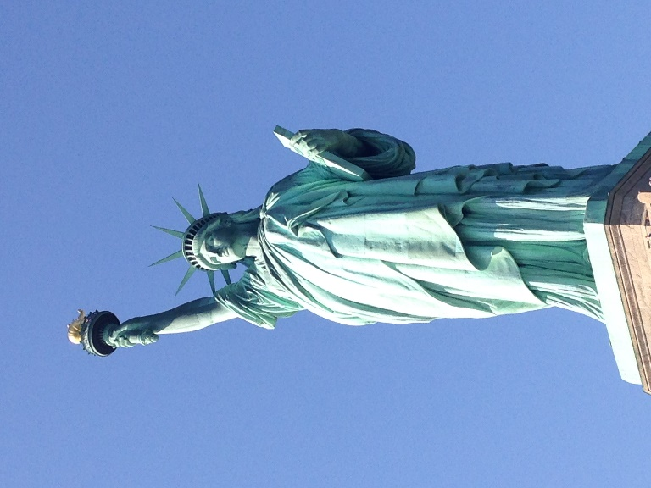

Background
The Statue of Liberty is a hollow colossus made of thinly pounded copper sheets over the steel framework and was made in Paris by the French Sculptor Bartholdi, in collaboration with Gustave Eiffel. The landmark was a gift from France on the centenary of American Independence – standing on an island at the entrance to the New York Harbour – and has welcomed millions of immigrants to the United States ever since its launch in 1886. (Unesco World Heritage Centre, 2019).
The Statue of Liberty was granted the Unesco World heritage Site status in 1984, and falls into criterion (i): as a “masterpiece of human spirit”, and criterion (vi): where “It was presented by France with the intention of affirming the historical alliance between the two nations” (Unesco World Heritage Centre, 2019), revealing the importance of its symbolic value, with a strong representation of the ‘American Dream’ and the aspirations that many immigrants brought with them upon arriving to New York City.
Preservation
The French American Committee for the Restoration of the Statue of Liberty was formed in May 1981, where in June, the committee was incorporated as a non-profit foundation licensed by the state of New York to raise funds for the restoration efforts of the landmark. The committee hired four French consultants who have phenomenal expertise in their fields, an architect-engineer, a metals expert, a structural engineer and a mechanical engineer – who were all asked to conduct a technical report on the current state of the statue. A report titled, “French Technical Report on Restoring the Statue of Liberty”, noted the most serious problems affecting the sculptor – the problems being the torch-bearing arm and the rest platform at head level, had corroded greatly (Revolvy, 2019).
In 1982, four years before the Statue's centennial anniversary, President Ronald Reagan appointed Lee Iacocca, the Chairman of Chrysler Corporation, to head the Statue of Liberty - Ellis Island Foundation. The Foundation was formed with the effort to raise the funds for the renovation and preservation of the Statue for its centennial in 1986 (Nps.gov, 2019).
The statue has been a target of galvanic corrosion, referring to “corrosion damage induced when two dissimilar materials are coupled in a corrosive electrolyte” (Corrosion-doctors.org. 2019). This refers to the reaction between the copper and iron metals of the structure, where originally, the corrosion was combated by insulating copper from the framework using an asbestos cloth soaked in shellac. However, after many years of exposure to high levels of humidity and the surrounding marine environment, this caused the break-down of the sealing property of the improvised insulator, resulting in the barrier absorbing any salt water, resulting in deterioration of the metals (Corrosion-doctors.org. 2019).
The architects on the project assured that ‘cosmetic changes’ to the statue would not take place, where many commentators on the on the historic restoration project reiterated similar guides that “preservation rather than unnecessary replacement would be the objective of the restoration effort”, despite early proposals claiming to demolish the statue, selling the copper to raise funds to build an “exact duplicate in fibreglass” (Revolvy, 2019). Although it is noted that the torch had to be removed due to irreversible damage, an “article in The New York Times from October 8, 1984, stated that the new torch is to be completed in the same manner that the old torch was made in 14 months by ten craftsmen from Les metalliers Champenois based in Reims” (Revolvy, 2019). This means that the torch would be of same replica, built in the same way, therefore not taking away the authenticity of what it represents for the people of America.
It should also be noted, that all changes made to the statue during its restoration efforts, were considered in a way that would not take away any of the beauty of the original statue, but to also preserve in the many years to come. For example, during the project, “the architects and engineers knew that a coating system far more suitable than any of the preexisting applications that had been used, would need to be implemented to protect the iron of the statue’s interior.” (Revolvy, 2019). The project made alterations to the statue in a way to protect its structure without stripping away its beauty and the powerful meaning the statue represents.
Liberty Island itself implements many strategies to become environmentally friendly in order to preserve the Island and have less of n environmental impact. Strategies include:
- Over 390,000 Pounds of material was recycled in 2011.
- 95% of all refuse was recycled.
- 49,000 Pounds of compost was generated.
- 17,000 pounds of compancted plastic bottles were recycled. (Thestatueofliberty.com, 2014)

Presentation/Promotion
With any heritage site, there is always the concern of ‘Disneyfying’ the site for the purpose of attracting tourists/making a profit, where this is the process of transforming the original structure into trivial entertainment for tourists (Educalingo, 2019), and therefore taking away a site’s original meaning and purpose. However, the Statue of Liberty is a good example of a world heritage site that is not seen to be overly commercialised, with all marketing being constructed in aid to fund for the restoration of the statue, as well as for educational purposes.
During the restoration project of the Statue of Liberty in the mid-80’s, it involved a select group of corporations (including Coca-Cola Company and the Kellogg Company), where, in exchange for the right to be official Statue of Liberty sponsors, each pledging to contribute between $3 million and $10 million for the restoration campaign (Nytimes, 1985). Although this can be seen as a ‘commercialised’ marketing technique, where the heritage site is partnering up with big companies in order to get sponsored, this was in fact done in a way to raise great funds that will be going back into the restoration of the statue, the island the statue dominates, as well as Ellis island.
Profit/Presentation
Back in 1985, the plan to was to use the money from the funds to build “a large new Museum of Immigration; a file of hundreds of thousands of photographs of citizens and their immigrant forebears, built by Eastman Kodak, which visitors will be able to call up on computer terminals, and the rejuvenation of Ellis Island into a tourist attraction” (Nytimes, 1985). This confirms there were hopes of turning the Statue of Liberty/Ellis Island into a tourist attraction, however, they have done so in respect to the education of tourists on the history and the resemblance of the New York Harbour from when it welcomed millions of immigrants.
“Among those who have responded are millions of schoolchildren, several thousand people who have engaged in bake sales that have raised thousands of dollars” (Nytimes, 1985), proving how the restoration campaign brought together schools, where they will be learning more about the history of the monument. The implementation of museums and information boards around Liberty and Ellis Island proves that the running of the landmark is in order to educate visitors on the history of the harbour, without doing so for only entertainment and money making practices.
A study carried out by Correia, A., Kozak, M. and Ferradeira, J. (2013), suggests that “tourists visiting a cultural destination for vacations are devoted to fulﬁll their personal and intrinsic interests”, due to the most important items loaded in the dimension of ‘‘knowledge’’ are ‘‘to learn about urban design’’ and ‘‘to learn about culture’’ (Correia, A., Kozak, M. and Ferradeira, J. (2013). This shows that even though organisers had the intention of turning Ellis Island into a tourist attraction, it’s main intention was to educate visitors who came to visit and learn about the harbour’s history in order to fulfil their intrinsic needs.
However, there were some suspicious actions regarding the contributions to the corporate promotions and the private handling of the restoration of the site. It was stated by the New Yourk Times (1985), that “under the terms of the sponsorships, many companies are meeting their pledges not only with their own money but also with the money they solicit from the public, using marketing campaigns intended simultaneously to advertise their products”, therefore confirming that the use of mass marketing and partnership with the heritage site was done so in order to advertise their own products and make greater revenue for their own organisations. This proves that not the campaign wasn’t as authentic as people were hoping it to be, with information being missed out from the public on where their money was going. The project was somewhat compared to the style of the 1984 Summer Olympic Games, which was criticized for commercialising a public event but however praised for its effectiveness in raising money (Nytimes, 1985).
Among other commercialisation aspects of the statue, “more than 80 companies have been licensed to produce official Statue of Liberty T-shirts, sweatshirts, ashtrays, swizzle sticks, charcoal briquettes and air fresheners…and one company, which pledged $12.5 million for the opportunity, is marketing the parts of her body that are being replaced” (Nytimes, 1985). This can be seen as a way of making profit and taking away the authenticity of the heritage site, however again, this is done so to raise significant funds to preserve the Statue of Liberty.
Ticket prices for the ferry trip to the Island cost $18.50, where the monument brought in a revenue of $263.2 million in 2017. Funds have been contributing to the restoration foundation for the past 35 years, where profit has contributed to the fundraising for the construction of the new Statue of Liberty Museum opening in 2019.
Competitors/Recommendations
The Statue of Liberty is among one of the best heritage site for conservational practices and shares the same initiatives to other heritage landmarks, such as the Christ the Redeemer Statue in Rio – where an “impressed current cathodic protection (ICCP) system was installed to control further corrosion of the steel reinforced concrete that forms the statue” (Corrosion-doctors, 2019), and the Eiffel Tower where it undertakes many projects in order to restore the great French landmark. However, the current Eiffel Tower restoration project that will be finalized just in time for the 2024 Summer Olympics, isn’t just a cosmetic effort, where the Parisian metropolis are addressing growing challenges relating to “energy, greening, supply networks, mobility, logistics, waste management, and security of the area” (Civil + Structural Engineer magazine. 2019). This means the project are making great efforts into the valuable conservation of the landmark’s surrounding area. This is something that the Statue of Liberty committee can focus their efforts on, funding the surrounding area of the harbour in order to make surrounding areas of the statue more pleasant for visitors and in respect for the statue itself.
Due to there being around 10,000 visitors seeing the statue every day, this would cause a great demand in ferries taking tourists to and from Liberty Island. This would then cause a rise in carbon emissions, therefore impacting the environment. In order to combat this, ferry organisers can incorporate methods to help lower their environmental impact, including the reduction in fuel use, a change in fuel source and by “choosing phosphate-free detergents and washing-up liquids helps improve water quality” (Broads-authority.gov.uk, 2019).
There can also be foundations to help lessen the environmental impact on Ellis Island, where they can also implement green methods to help reduce its environmental impact. Similar to the current Eiffel tower restoration project, where they are prioritising the local area, foundation organisers can work towards benefiting the New York harbor as a whole (including ferries), rather than focusing mainly on Liberty Island.

References
Broads-authority.gov.uk. (2019). Environmentally friendly boating. https://www.broads-authority.gov.uk/boating/owning-a-boat/environmentally-friendly-boating
Civil + Structural Engineer magazine. (2019). Eiffel Tower Restoration - Civil + Structural Engineer magazine. https://csengineermag.com/article/eiffel-tower-restoration/
Correia, A., Kozak, M. and Ferradeira, J. (2013). From tourist motivations to tourist satisfaction. International Journal of Culture, Tourism and Hospitality Research, 7(4), pp.411-424.
Corrosion-doctors.org. (2019). Galvanic corrosion. https://corrosion-doctors.org/Forms-galvanic/galvanic-corrosion.htm
Corrosion-doctors.org. (2019). Galvanic corrosion of the Statue of Liberty. https://corrosion-doctors.org/Landmarks/statue-saddle.htm
Corrosion-doctors.org. (2019). Restoration of Christ the Redeemer. https://corrosion-doctors.org/Landmarks/Christ-restoration.htm
Educalingo.com. (2019). DISNEYFY - Definition and synonyms of Disneyfy in the English dictionary. https://educalingo.com/en/dic-en/disneyfy
Nps.gov. (2019). Restoring the Statue - Statue Of Liberty National Monument (U.S. National Park Service). https://www.nps.gov/stli/learn/historyculture/places_restoring.htm
NYTimes (1985). STATUE OF LIBERTY'S REPAIR: A MARKETING SAGA. Nytimes.com. https://www.nytimes.com/1985/11/03/nyregion/statue-of-liberty-s-repair-a-marketing-saga.html
Revolvy, L. (2019). "Conservation-restoration of the Statue of Liberty" on Revolvy.com. Revolvy.com. https://www.revolvy.com/page/Conservation%252Drestoration-of-the-Statue-of-Liberty
Thestatueofliberty.com. (2014). We are green | The Statue Of Liberty. http://thestatueofliberty.com/we-are-green/
Unesco World Heritage Centre (2019). Statue of Liberty. Whc.unesco.org. http://whc.unesco.org/en/list/307

