
Dementia: A Comprehensive Report
Student name: Jocelyn Elliott
Student ID: 2513425
Course/Module: Introduction to Public Health
Module code: LCHS4008
Lecturer’s name: Dr. Pascal Naville
Submission date: 21 April 2026

Table of Contents
- Introduction
- Main body
- Conclusion
- References

- Introduction
Dementia is a progressive neurological condition characterised by a decline in cognitive function beyond what might be supposed to from normal ageing, affecting memory, thinking, behaviour, and the ability to perform everyday activities (World Health Organisation, 2023). It is not a single disease but a syndrome, with Alzheimer’s disease being the most shared form. Common signs and symptoms include memory loss, confusion, difficulty communicating, impaired judgment, and changes in mood and behaviour. Dementia is strongly associated with risk factors such as increasing age, genetics, cardiovascular disease, smoking, and lifestyle factors. Globally, over 55 million people live with dementia, with 10 million ew cases each year (World Health Organisation. 2023). In the United Kingdom, approximately 900,000 people are living with dementia, making it a major public health concern (Alzheimer’s Society, 2023). These figures highlight the growing seriousness and impact of dementia on individuals, families, and healthcare systems. It shows large national prevalence and increasing incidence rates (Dementia Statistics Hub, 2024).

- Main body
Dementia presents a statistically significant challenge to health and social care systems due to its progressive nature, increasing prevalence, and complex care needs. The condition not only affects individuals but also has widespread implications for families, communities, and service provision. Understanding how dementia supported, controlled, and managed is vital for improving outcomes and reducing its impact.
Dementia includes Alzheimer’s disease, vascular dementia, Lewy body dementia, each with distinct causes, symptoms, and progression patterns (Alzheimer’s Society, 2024).
Approaches used to measure and Monitor dementia
Dementia is track and checked through clinical assessment tools, diagnostic imaging, and national data collection systems. Early diagnosis is essential for effective management and planning of care. Cognitive assessment tools such as the Mini Mental State Examination (MMSE) and the Montreal Cognitive Assessment (MoCA) are broadly use-to assess memory, attention, and cognitive function. These tools help find early signs of dementia and monitor disease progression over time.
In addition to cognitive testing, brain imaging techniques such as CT and MRI scans are utilised to name structural changes in the brain and rule out other conditions. Blood tests may also administer out to exclude reversible causes of cognitive decline. However, early diagnosis stays challenging due to the gradual onset of symptoms and stigma associated with the condition, which can delay help seeking behaviour.
At a population level, dementia is check through national datasets and public health surveillance systems. In the UK, NHS Digital and Public Health England collect data on dementia prevalence, diagnosis rates, and service use. The Dementia Outcomes Framework and NHS Long Term Plan aim to improve diagnosis rates and care quality. Despite these efforts, under diagnosis stays a significant issue, with many individuals not receiving a formal diagnosis until later stages of the disease (NICE, 2022). This signifies that improvements in awareness and early screening needed.
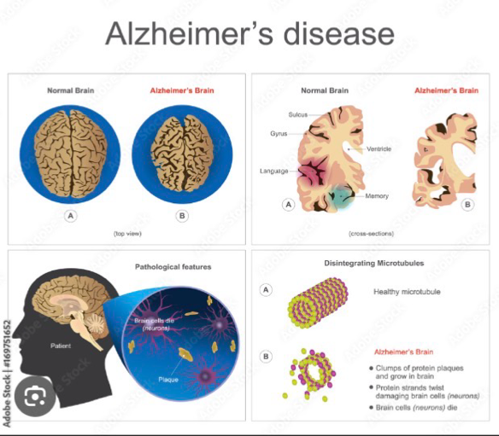
Figure 1: Brain changes in dementia
Figure1: Illustration showing brain shrinkage and damage to nerve cells associated with dementia, particularly Alzheimer’s disease (World Health Organisation, 2023).
Going forward, understanding of brain changes in dementia is consider likely to advance significantly, improving both diagnosis and management. In the UK, developments in neuroimaging and bio maker research may support earlier and more precise detection of structural and chemical changes in the brain. Globally, analogous progress, is consider likely although disparities in access to diagnostic technologies may persist. Increasing international collaboration and investment in research will be essential to ensure more congruent and prompt diagnosis, supporting better outcomes for individuals affected by dementia.
How Dementia Controlled
Although dementia is currently incurable, its progression and impact can be address through a combination of medical, psychological, and social interventions. Control strategies focus on risk reduction, symptom management, and supporting quality of life.
Primary prevention aims to reduce the risk of developing dementia by addressing modifiable risk factors. Public health initiatives promote healthy lifestyles, including regular physical activity, balanced diet, smoking cessation, and management of cardiovascular conditions such as hypertension and diabetes. Evidence suggests that up to 40% of dementia cases may be preventable through lifestyle changes (World Health Organisation, 2023). However, inequalities in access to healthcare and health education limit the effectiveness of these interventions.
Pharmacological treatments, such as cholinesterase inhibitors (e.g., donepezil), are utilised to manage symptoms in Alzheimer’s disease. While these medications do not cure dementia, they can slow cognitive decline in some individuals. Non-pharmacological interventions, including cognitive stimulation therapy and reminiscence therapy, are also effective in improving cognitive function and emotional wellbeing.
Care planning and regular monitoring are essential in managing dementia. Person centred care approaches ensure that care is customised o individual needs, preferences, and abilities. Despite these strategies, challenges stay in ensuring consistent access to high quality care across different regions.
Consequences of dementia on individuals and communities
Dementia has significant physical, psychological, social, and economic consequences. For individuals, the progressive nature of the condition leads to increasing contingency on others for daily activities. Memory loss and confusion can result in safety risks, such as wandering or medication errors.
Psychologically, dementia is associated with anxiety, depression, and behavioural changes. Individuals may experience frustration and loss of identity as their cognitive abilities wane. These emotional impacts can significantly reduce quality of life.
Socially, dementia affects relationships and social participation. Individuals may withdraw from social activities due to communication difficulties or stigma. Families and carers often experience emotional stress, financial strain, and reduced employment opportunities. Informal carers play a crucial role in supporting individuals with dementia, but this can lead to caregiver burnout.
Economically, dementia places a substantial burden on health and social care systems. In the UK, dementia costs an estimated £25 billion per year, including healthcare, social care, and unpaid care costs (Alzheimer’s Society, 2023). The increasing prevalence of dementia due to an ageing population are likely to further strain resources.
Health inequalities also influence dementia outcomes. Individuals from lower socioeconomic backgrounds may have reduced access to early diagnosis and support services, leading to poorer outcomes. This highlights the need for fair service provision.
Health and social care support services needed
High-quality dementia care requires a multidisciplinary approach involving health and social care services. Early diagnosis and intervention are essential in improving outcomes. Memory clinics provide specialist assessment and diagnosis, enabling individuals to access proper support.
Community based services play a vital role in supporting individuals with dementia. These include GP services, community mental health teams, and dementia specialist nurses. Social care services provide support with daily activities, personal care, and home adaptations to promote independence.
Day care centres and respite services provide opportunities for social interaction and give carers a break from caregiving responsibilities. Voluntary organisations such as the Alzheimer’s Society offer support groups, education, and advocacy services.
Integrated care models, which involve collaboration between health and social care providers, are essential in ensuring continuity of care. The NHS Long Term Plan emphasises the importance of personalised care and community-based support.
However, challenges such as workforce shortages, funding limitations, and regional disparities in service arrangement affect the quality of care. Addressing these issues is essential to meet the growing demand for dementia services.
Professional roles and practical steps
Healthcare professionals play a key role in improving dementia care. Early recognition of symptoms and prompt referral to specialist services are essential. Professionals must adopt a person-centred approach, respecting the dignity and preferences of individuals.
Practical steps include improving public awareness of dementia, promoting early diagnosis, and supporting carers through education and resources. Training healthcare professionals in dementia care is also essential to ensure high quality service delivery.
The use of assistive technologies, such as GPS tracking and reminder systems, can support independence and safety. Addressing health inequalities through targeted interventions is also important in improving outcomes for vulnerable populations.
- Conclusion
In conclusion, dementia is a significant and growing public health issue, with profound impacts on individuals, families, and healthcare systems. Although there are currently no cure, effective monitoring, early diagnosis, and person-centred care can improve quality of life and slow disease progression (World Health Organisation, 2023). The condition has wide ranging physical, psychological, social, and economic consequences, highlighting the need for comprehensive support services. While public health initiatives and national policies aim to improve dementia care, challenges such as under diagnosis, workforce shortages, and health inequalities persist (NICE, 2022). A multidisciplinary approach involving healthcare professionals, social care services, and community organisations is essential to meet the complex needs of individuals with dementia. Greater investment in prevention, early intervention, and integrated care necessary to reduce the burden of dementia and improve outcomes across the UK.

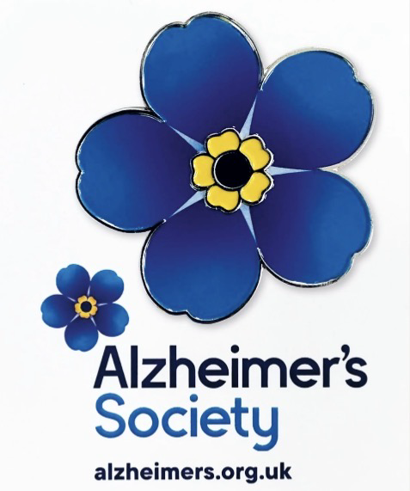
“I wear my Forget Me Not so people living with dementia can see they are not alone”

- References

Alzheimer’s Society (2023) Dementia statistics. Available at: https://www.alzheimers.org.uk (Accessed: 12 April 2026).

Alzheimer’s Society (2024) Types of dementia. Available at: https://www.alzheimers.or.uk/about-dementia/types-dementia (Accessed: 12 April 2026).

Dementia Statistics Hub (2024) Key dementia statistics. Available at: https://www.dementiastatisticshub.org (Accessed: 12 April 2026).

NHS England (2019) The NHS Long Term Plan. Available at: https://www.longtermplan.nhs.uk (Accessed: 12 April 2026).

NHS England (2023) Dementia care and support. Available at: https://www.nhs.uk (Accessed 12 April 2026).

NICE (2022) Dementia: assessment, management, and support. Available at: https://www.nice.org.uk (Accessed: 12 April 2026).

Public Health England (2021) Dementia profile. Available at: https://fingertips.phe.org.uk (Accessed: 12 April 2026).

World Health Organisation (2023) Dementia fact sheet. Available at: https://www.who.int (Accessed: 12 April 2026).

