Destination Management.
Cox’s Bazar, Bangladesh.
Fahima Chowdhury 2020783
Sustainable Hospitality & Tourism Management
BMIH5006
Huw Thomas

Content:
- Introduction
- Cox’s Bazar in three pillars of sustainability.
- Recommendations of Future Development/Sustainable future for Cox’s Bazar.
- Conclusion
- References

- Introduction
This report will try and evaluate the principles of sustainable tourism in Cox’s Bazar, which is in the developing country of Bangladesh (Bangladesh-embassy.2022).
It will also evaluate how Cox’s Bazar sector’s in with the three pillar of sustainability which are:
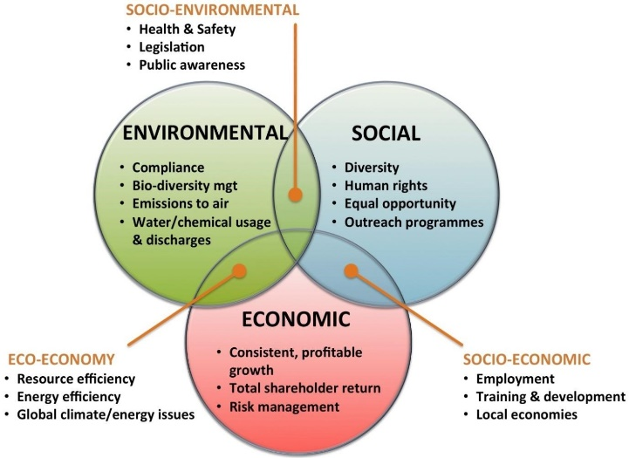
(Ingaldi,2015)

- Economic
- Socio-Cultural
- Environmental
(Molthan-Hill.2017, p.5).
Using different model theory including Butler’s life cycle (Butler.2006) and Doxey’s (1975) Irridex model, it will try and determine how Cox’s Bazar has evolved through various stages from past to present.
Cox’s Bazar is a town which is located on the southeast coast of Bangladesh.
It situated along the Bay of Bengal which is about sixty miles (100 km) south of Chittagong. Cox’s Bazar is a popular tourist resort, having known for its being the longest natural sandy sea beach but also including:
- Amazing hospitality
- Fresh seafood
- Marine drive
- Kutubdia Island
- Moheshkhali Island
- St Martin’s Island.
- Towering Cliffs
- Amazing Surf
- Rara Shells
- Beautiful Pagodas
(Gani-Adnan, Rahman, Ahmed, Ahmed.2020)

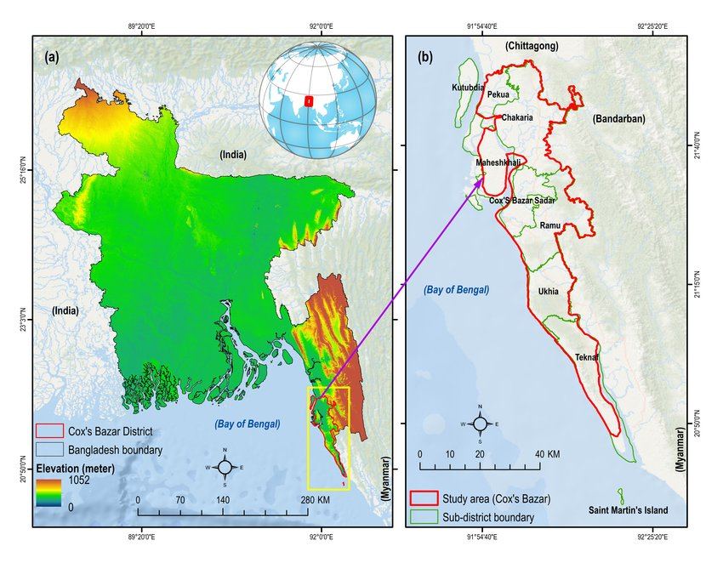
- Location of Cox’s Bazar District in Bangladesh
- Location of the Sub-District of Cox’s Bazar district.

Cox’s Bazar should be on the map as a popular international tourist destination, but this is not the case, with little known facts about the place especially the fascinating fishing port. The town named after Lieutenant Cox, who was a British officer and seek shelter during the British territory after the conquest of Abakan by Burmese. It has a mix population, with lots who are originally from Myanmar and has a diverse and cultural background of people.

- Cox’s Bazar in three pillars of sustainability.
With the three pillars of sustainability in mind, this report will firstly explore how Cox’s Bazar falls under each of these categories.
Tourism is one of the world's largest and most growing economic activity and international tourism can have major implication on a country. As well as the specific destination area, this can in fact cause stress on the natural habitats (Kalam, Hossen.2018).
When visiting a tourist spot, it is important to protect the natural environment of this location and making sure that you maintain tangible tourism resources and be responsible for preserving and inherit the nature scenic of that place (Alam, Nekmahmud, Hossain, Tan, Sahabuddin, (2021).

Cox’s Bazar falls under the nature-based/marine travel experience and when people come to place like Cox’s Bazar it is a natural environment, they are more likely to have environmentally friendly manner.
Cox’s Bazar sustainable approach to tourism would mean that it would need to consider the social growth and economic development and be mindful of local community.
This show the first stage of Doxey’s Irridex (1975) theory which is the Euphoria area, linking with Butler’s (1980), early stage of TALC (Tourism Area Life Cycle) theory, describing:
- Destination has few visitors and tourism is at preliminary stages and new to locals.
- Local communities happy that tourist want to visit their area.
- Welcoming the tourist.
- Having good, informal relationship between the local’s and tourist.
The local communities are dependent on the tourism it brings in the area as their main source of income (Ahammed.2010).
This is also example of Butler’s (1980), life cycle model stage of Consolidation, where local community and businesses rely on tourism as their main source of income.
This is applying to Doxey’s (1975) Irritation Index Model of Apathy because local community and business become too reliant on tourism as their main source of income and visitors are taken for granted and only seen as paycheck, and contact become more formal (Studocu,2021).

It also means that Marine tourism can help local communities as well the stakeholders such as BDRCS, IFRC UNDP and ISCG (Govt, Bangladesh,2022) in this case it is the governments improve their livelihoods and bring revenue to the city which well then enable them further to develop the destination spot. (Bhuiyan, Dadra, Habib, Hossain, 2020).

This is evident to Butlers (1980) life cycle model stage one which is exploration (GUWB, 2021), as the government have spotted gap in the market for people to see Cox’s Bazar for what it has to offer.
The Marine tourism aspect can create job opportunities, local communities able to develop local supply chains also highlight the local culture heritage (Papagergiou,2016).
Here are few images of the local’s selling and sampling their goods and fishery business to help boost the tourism development.

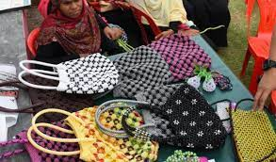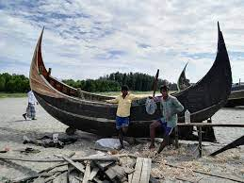
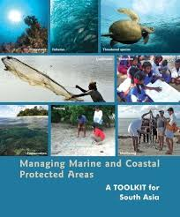

(IUCN.2020)

Economic
The next step of sustainable tourism in Cox’s Bazar, it clear to state that to move forward you would require to develop a common vision, at not only local, national, and regional level, to which It will pave for the economic development opportunities.
These opportunities would include such as:
- Fisheries
- Aquaculture
- Agriculture
- Handicraft
- Tourism Facilities
- Service Provider

Almost 80% tourist who are Bangladeshi nationals and originate from all part of Bangladesh visit Cox’s Bazar beach to get the beach experience (Zahra, 2013) and during the peak season between September and March, almost 30,000 visitors arrive which create overcrowding (Dey,2014).

This is a clear indication of Butler’s (1980) life cycle model stage of Development where tourism starts off well but then the demand becomes overwhelming.

It also clear that during the peak season servicer provider fail to produce the service required, which then lead to overcrowding issue as stated.

This is an example of Doxey’s (1975) Irritation Index model stage which is Annoyance as its clear due to the overcrowding, local people have misgiving and instead of controlling the situation, they attempt to increase plan on infrastructure, rather that limit growth (Studocu,2018).

As you can see Cox’s Bazar is an example of Butler’s (1980) life cycle theory as again it was the biggest tourist destination for Bangladesh, but it has a great deal of development to go (GUWB,2021).

In the figure contracted by Mamun (2013) 80% of these visitors will come either 2-6 nights per person or 75.4 % stay on for 2-10 days (Mamun, et al,2013).

Disadvantage

With the above positive to the area unfortunaly there are always the downside of tourism and with Cox’s Bazar their number of these factors, which is causing not only the locals’ problems but even the Cox’s Bazar Development Authority.

Commodore Mohammed Nural Absar was appointed as chairperson of this department for three-year term.

Mohammed Absar was offered the position by the stakeholders who are under the Ministry of Housing and Public works, which was established in July 2015, following the act by Parliament.

The Development Authority is responsible for developing the plan to turn Cox’s Bazar to be a major tourist city.

Also, one major stakeholder who implement the direct order was Prime Minister Sheikh Hasina (BangladeshPost,2022).

They were 229 unplanned construction building being built without permission; all were giving eviction notices as they did not comply with the guidelines of Development Authority (Bangladesh post,2021).

The Development Authority even issuing a ban with no one allow to build anything near three hundred meters of Cox’s Bazar Sea beach (Faruque.2021).

In 2019, the High Court was the ones who issued the ban, despite this many tourists’ accommodation went ahead and built these anyway, completely disregarding how this would affect the environment aspect.
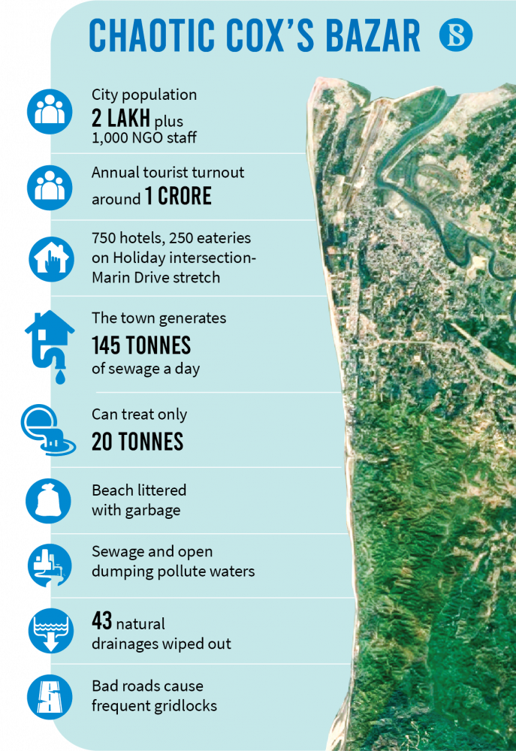
This date clearly gives a look at how Cox’s Bazar is far away from any form of sustainable future and has a long way to go. (Faruque.2021)

Social-Culture
The social-culture aspect would be to making sure that you are fully experiencing the beauty of that location, which would mean not eating:
- Pre-Package food
- Eating local food
- Littering less to none if possible

Other initiatives include facilitating the local sustainable seafood to the hotels and restaurants situated in Cox’s Bazar. Also, another initiative is producing local souvenir products development to hotels as well. This all contribute how tourist behaviour is towards the environment aspect of the three pillars.

Although this is also good news for locals as tourist get to sample their food and goods, however for local’s it become unliveable, this is due to many factors which has created many disadvantages such as:

- No central waste management causing over flooding onto the streets.
- No sewerage network, meaning its disposed into the beautiful river its known for.
- No good transportation
- Cramped area
- Too busy during the day and especially at night causing problems for locals.
- Household waste scattered anywhere and everywhere.
- Unplanned construction
- Over the last decade building were build without any form of urbanisation plan.

This is the stakeholder job who are the Hotel Association of Cox’s Bazar and its evident that they are clearly failing on their responsibilities (Hoque,2015)
In the certain position stakeholders like SWM (2022) have taken over management of the waste issue which clearly still a problem. However, they have better results in trying to control the issue facing Cox’s Bazar by installing a system called WASH sector, is supported by the Swiss Agency for Development and Cooperation (Relief, Web,2022).

Environment
The environmental aspect on how Cox’s Bazar has performed, unfortunately lacks a great deal to say the least.
However local community of Cox’s Bazar are not so concern about the impact of all such activities named above (Anwar,2014). The excessive pressure of tourism and local people is creating a threat to the overall sustainability as no such sustainable environmental management has yet to be implemented and it desperately requires one (Zahra,2013).
It was reported Khan, Kamal, Luthfa (2022) that due to the Rohingya camps being built in the area, it has taken a big hit on the environmental aspect, due to not only natural but also Man-made disaster.
These includes:
- Deforestation and soil Vulnerability, causing hills to have landslides.
- Cyclones, but due to trees and hills reducing it taken away the natural protection which they provide.
- People were killed by mud walls (Modola.2018).
- Air pollution is extremely high, caused by vehicle fumes, this was due the high volume of cars and jeeps within the area.
- Animals are becoming endangered because of the loss of habitat (IUCN.2021).

According to Aziz (2022) it states that Cox’s bazar was under severe environmental threat due to significant amount of plastic waste.
124 tons of wastes was being cleaned up daily from the city, and most of this was plastic.
Dr Farhina Ahmad (2022) who works at the Ministry of Environment, Forest and Climate change stated that due to the high volume of plastic waste, which is causing harm to the ocean and affecting marine life, the only way to change and be more sustainable presently would be making a great impact for the future, the citizen must change themselves which would mean society and country will follow.
There has been no study conducted on the environmental education and sustainable tourism on the growth in Cox’s Bazar to people for them to understand the importance of environmental, sustainable tourism and how it relates to sustainable growth for everyone involved (Bhuiyan, Darda, Habib, Hossain, 2020).

- Recommendations of Future Development/Sustainable future for Cox’s Bazar.
Positive Outcome
Overall, the Development Authority chairperson and stakeholders such as BDRCS, IFRC, UNDP and ISCG has produced a recommendation to redecorate Cox’s Bazar such as:(RelieWeb,2022)
- Widening roads and sidewalk
- Foot over bridge
- Drains
- Bridge-culvert
- Cycle ways on both side of the road.
- Will be streetlight
- CCTV cameras
- Wi-Fi connection
- Greenery on both sides.
- Trains and flights directly and indirectly
- The Marine drive road is ready for tourists and construction work of international airport.
- Installing of modern rail trucks are going on. (Bangladesh Post,2020).

4.Conclusion
To conclude it is evident that Cox’s Bazar should be considered an international tourist destination, as it’s a place enriched with history and culture. The cities department authority of Cox Bazar has taken measure to become more of a sustainable tourist spot in Bangladesh. They carried this out by creating a developing authority, hiring better waste management and while it is a long way to go it is an improvement which will benefit cox Bazar tourist features significantly. For example, they have been mindful of locals and working closely alongside them to expand income for those locals, which helps increase revenue to the city and allow more development of buildings such as hotels which can bring in more tourism.
.

5.Reference
Molthan-Hill, P. (2017) The Business Student’s Guide to sustainable Management.2nd edn. New York: Taylor & Francis.
Butler. R. (2006) The Tourism Area Life Cycle. Vol 1. England: Channel view publications.
Doxey, G. 1975 A Causation Theory of Visitor-Resident Irritants: Methodology and Research Inferences. The Impact of Tourism. In the Sixth Annual Conference Proceedings, pp.195-198. San Diego: The Travel Research Association.
Gani-Adnan, M, Rahman, S, Ahmed, N, Ahmed, B. (2020). Improving spatial Agreement in machine. Learning –Based landslide susceptibility mapping. Available at:
https://www.researchgate.net/figure/a-Location-map-of-Coxs-Bazar-district-in-Bangladesh-and-b-the-sub-districts-of_fig4_344646372 (Accessed 24th November 2022).

Ingaldi, M (2015). The three spheres of sustainability. Available at:
https://www.researchgate.net/figure/The-three-spheres-of-sustainability-Source-shanghaijillwordpresscom_fig1_324766379 (Accessed 24th November 2022).

Kalam, A, Hossen, A. (2018) Environmentally Sustainable Tourism Problem and Prospects in Bangladesh: A study on Coastal Region at Cox’s Bazar’, Journal of Environment and Earth Science. Vol.8, No 1. Available at:
https://core.ac.uk/download/pdf/234665082.pdf (Accessed 24 November 2022).
IUCN. (2020) Available at:
https://www.iucn.org/news/bangladesh/202004/host-and-refugee-communities-coxs-bazar-celebrate-world-wildlife-day-2020-0 (Accessed 25 November 2022).
Khan, M, Kamal, M, Luthfa, S (2022). The Bangladesh Environmental Humanities reader. Environmental Justice, Development Victimhood, and Resistance. P95-96. London: Lexington Books.
Aziz, A (2022). Plastic waste: Cox’s Bazar under threat. Bangladesh News.
Available at: https://www.dhakatribune.com/nation/2022/09/04/plastic-waste-coxs-bazar-under-threat
(Accessed 25th November 2022).
Ahmad, Dr F, (2022) Plastic waste: Cox’s Bazar under threat. Bangladesh News
https://www.dhakatribune.com/nation/2022/09/04/plastic-waste-coxs-bazar-under-threat (Accessed 25th November 2022).
Ahammed, S. (2010).” Impact of tourism in cox’s bazar, Bangladesh,” Master thesis, North South University Bangladesh.
Dey, P. (2014), STP strategies for promoting cox’s bazar sea beach in Bangladesh as a tourist destination, D.U. Journal of marketing, Vol.15 pp,207-229.
Bangladesh Post (2020). Facelift plan for Cox’s Bazar. Available at:
https://bangladeshpost.net/posts/facelift-plan-for-cox-s-bazar-46247
(Accessed 27th November 2022).

Bangladesh Post (2020) Ex-Commodore Absar made chairman of Cox's Bazar Development Authority. Available at:
https://bangladeshpost.net/posts/ex-commodore-absar-made-chairman-of-cox-s-bazar-development-authority-92994 (Accessed 27th November 2022).
Relief Web (2022). Proceedings of the Stakeholders’ Meeting – 2022 Multi-hazard Preparedness, Anticipatory Action, and Response in Cox’s Bazar. Available at:
https://reliefweb.int/report/bangladesh/proceedings-stakeholders-meeting-2022-multi-hazard-preparedness-anticipatory-action-and-response-coxs-bazar
(Accessed 1st December 2022).
Hoque,R. (2015). ENVIRONMENTAL EDUCATION AND SUSTAINABLE TOURISM: A MODEL TO FIT THE TOURISM GROWTH IN COX'S BAZAR
Available at:
https://www.researchgate.net/publication/317033044_ENVIRONMENTAL_EDUCATION_AND_SUSTAINABLE_TOURISM_A_MODEL_TO_FIT_THE_TOURISM_GROWTH_IN_COX'S_BAZAR (Accessed 1st December 2022).
Relief Web (2022) WASH Sector Cox’s Bazar Bangladesh - Solid Waste Management Strategy. Available at:
https://reliefweb.int/report/bangladesh/wash-sector-coxs-bazar-bangladesh-solid-waste-management-strategy (Accessed 30th November 2022).
Studocu (2021) Doxey's irritation index model (1975). Available at:
https://www.studocu.com/en-gb/document/london-south-bank-university/tourism-and-travel-industry-and-impacts/doxeys-irritation-index-model-1975/1493139

(Accessed 24th November 2022).

GUWB (2021) Tourism Life cycle and example in Bangladesh. ‘Identification of six different tourism destination for six different tourism life cycle stages. Available at:

https://www.growingupwithbd.com/2021/07/tourism-life-cycle-and-example-in.html
(Accessed 28th November 2022).
Bhuiyan,A, Darda, A, Habib, W, Hossain, B (2020). Marine Tourism for Sustainable Development in Cox’s Bazar, Bangladesh. Available at:
https://www.adb.org/publications/marine-tourism-sustainable-development-cox-bazar-bangladesh (Accessed 28th November 2022).
Faruque, O (2021). Cox’s Bazar: An idyll losing itself to unplanned urbanisation.
Available at: https://www.tbsnews.net/bangladesh/coxs-bazar-idyll-losing-itself-unplanned-urbanisation-305260 (Accessed 25th November 2022).
Sahabuddin, Tan,Q, Hossain, I, Alam, S, Nekmahmud (2021) Tourist Environmentally Responsible Behaviour and Satisfaction; Study on the World’s Longest Natural Sea Beach, Cox’s Bazar, Bangladesh.
Available at: https://www.mdpi.com/2071-1050/13/16/9383. (Accessed 30th November 2022).
Papageorgious, M (2016) Coastal and marine tourism: A challenging factor in Marine Spatial Planning. Available at: https://www.researchgate.net/publication/303599020_Coastal_and_marine_tourism_A_challenging_factor_in_Marine_Spatial_Planning (Accessed 29th November 2022).
Zahra, (2013) “Tourism and its impact in cox’s bazar, Bangladesh”, Journal of Tourism, Vol,15, pp12-18.

