
PROJECT PLANNING AND MANAGEMENT IN WORKPLACE
Module Code: BMSW 5104
Student Name: ASHRAF ALI
Student Number: 1715408
Lecturers Name: Paul Ranson
Assignment Title: PROJECT PLANNING AND MANAGEMENT IN WORKPLACE

1.Introduction 2
2.Project management 3
3.Tools and techniques for project management 4
4.Scope of the project 7
5.Calculation of the time to complete the project 8
6.Estimation of the cost/budget 11
7.Risk assessment using Iron triangle 11
8.Conclusion 15
9.References 16

Introduction
Project management is an extremely crucial process that needs to be conducted for achieving the goals of a specific project in a specific timescale. This process undoubtedly requires the skills and knowledge of every individual who are associated with it but apart from the other requirements without which the project management becomes baseless and ineffective are the project management tools and techniques. In this context, a project plan needs to be created for Vintners Antiques which owns a empty warehouse in Sparkhill where the assets of the business that are the antiques will be stored in a huge numbers, as its purpose is to conduct a project for organizing its warehouse which stores lots of antiques so that they can be securely stocked and the warehouse becomes suitable for working. The project plan has been made using the Agile project management methodology. This report consists of the importance of carrying out project management, the tools and techniques used to make the project plan for Vintners Antiques and all the factors in a project management Iron triangle that are scope, time and budget which get defined and calculated while running the project management process. Also the use of the user stories will be mentioned. Moreover, an assessment of risks associated to project management using the Iron triangle has also been included in this report.

Project management
There are two barriers to good planning. The first is prevailing paradigms, and the
second has to do with the nature of human beings (Heagney 2016).
Dealing with a project effectually signifies getting a scope of thriving in getting fruitful results for the betterment of the business. Managing projects effectively is a key role in every business for reducing the complexities and implement a proper strategy to carry out the project and accomplishing its goals in due time (Bogdanova et al., 2020). Project management is such a process that help to organize all the aspects of a project so that proper steps can be followed and proper techniques can be used by the project team for accomplishing the goals of the project. It is assumed by some businesses that conducting a project is also feasible even without project management but the purpose of this process is to get hold of the iron triangle of project management where scope, cost and time are checked while running a project. To meet the strategic goals of the business, project management is significant as it helps in developing an appropriate plan which when implemented properly bring about success in aligning the project goals with the business goals. The scope of the project, the budget required to conduct the project and the estimated time in which the project is to be delivered can be determined and maintained properly when project management is in place.

Tools and techniques for project management

size Complexity | LOW | MEDIUM | HIGH
Small
Medium
Large
The standard project/product technique
Source: (Robert.,P.,2011)
Selecting the right tool for project management to ensure that the right techniques are used to conduct a project. Project management tools provide an appropriate direction towards conducting a project for delivering it at right time and on an affordable budget. There is not a single tool for project management that is appropriate for all the types of project, rather the selection of the right tool is to be done based on the nature of the project, its objectives and scope, the capacity of the team members and several other aspects that determine the way of conducting the project. In the case of Vintners which have the purpose of organizing its warehouse in a good manner where all the antiques are stored (Dasović et al., 2020). The purpose of the business to execute this project is to store its antiques properly and securely so that they become accessible when needed to be transported and to ensure that working in the warehouse can become feasible for every individual. The members of the project that is to be conducted by Vintners for accomplishing all the tasks needed to accomplish the project goals are dedicated to giving their entire efforts for running the project but the most important thing that is not considered by the team is the right tool for project management so that they can ensure the project would be delivered in the right time and within the estimated budget. Organizing a warehouse requires a lot of efforts and a proper plan as various steps have to be followed to ensure that all the antiques are in place and are arranged properly so that any damage cannot be caused to them. Thus, a proper project management tool that would go with the project of Vintners need to be considered by the project team where specific roles and responsibilities are divided among team members. One of the famous project management technique is the Agile methodology for project management and this technique is to be used for managing the project of Vintners Antiques.
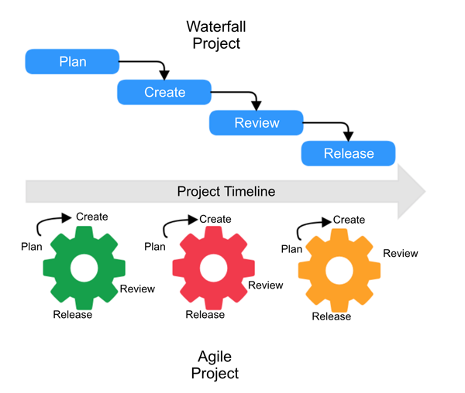
Fig: Agile vs Waterfall Project Methodology
Source: (Dasović et al., 2020)
This project management technique is appropriate to be used as how a project is managed and conducted through this technique work well and they do not match the traditional ways for project management. Agile technique for project management involves developing sprints to conduct the steps of the project so that analyzing the process in a comprehensive way become feasible. When this approach is followed, the team members of the project team become more dedicated and cooperative so that the desired outcome can result. Collaboration within the team is a crucial factor for using Agile methodology for project management. This approach helps to move forward in a structured manner for managing all the processes in project management and adaptation to change is promoted as well (Galli, 2020). The major benefits to using Agile methodology instead of any other traditional methodologies include the flexibility and iteration involved in the approach which enables the team members to adopt changes in any of the stages and the possibility of identifying deficiencies rapidly so that they can be controlled beforehand. The agile approach is chiefly suitable for a project which needs to accomplish in a less period and on which cooperative and skilled team members are working. One of the vital processes in project management is making a project plan that involves certain steps according to the Agile methodology for project management. As iterations are involved in the Agile approach, thus plan for every iteration is made to carry out the task in the particular iteration. The first steps that are followed include developing task planning when all the tasks that are required to be completed are divided and fragmented into smaller ones so that the members can carry out the task feasibly. At the next step, the time required to complete a task is assessed based on the previous records of task delivery. Then user stories are developed to estimate the value of the tasks to the customers (Gemino et al., 2020). After that product and iteration backlog which implies a list of priority where the requirements for a product and the iteration is included and feedback from customers are collected to determine which backlog item is providing more value. The last step is to make a schedule where budget and time are mainly estimated. Through continuous sprints or iterations, the whole process of project management is conducted by using the Agile project management technique.

Scope of the project
The scope of the project that is to be carried out by Vintners Antiques for organizing its warehouse where antiques are stocked can be defined following certain steps which determined the goals of the project. It is an important process to define the scope of the project so that the project manager can organize all the necessary aspects of project management like necessary tasks, deliverables, time limit, objectives and so on (Gogela et al., 2018).
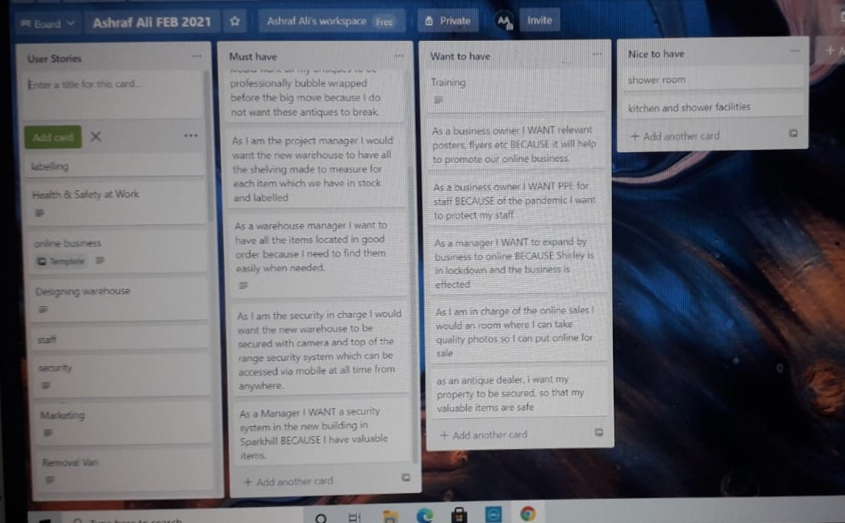
TRELLO BOARD
Source: ( Ashraf Ali 2021.,)
By using the user stories on the Trello board can help the business in lot of way as to priotorising the most important task which needs to be done and what is least important before the move to Sparkhill. The deliverables of the project are included in the project scope and they are required to be explained to all the team members so that they can perceive their roles and responsibilities. The project vision is created and a proper plan for the project scope is made. This planning phase for project scope defines the objectives and goals of the project and the necessities for achieving the project goals. In Agile methodology, the project scope is defined in every sprint in order to determine whether any changes have to made by the team to meet the goals. Reviews from employees and customers help to determine what are the requirements for delivering the project having high-value. Using the Agile approach is different from the traditional approach as the former involves an inverted triangle of project management where the project scope is signified to be a variable and the other two constraints namely time and cost are considered to remain fixed throughout the process of project management, but in the case of the latter opposite of agile approach is considered where the scope remains fixed but time and cost can vary so they are variables (Li, 2021). But as Vintners Antiques would use the Agile project management technique, thus the project scope would ever in every sprint throughout the project and it would help the project team to get a grip of the changes that occur while managing the project.

Calculation of the time to complete the project
The time span in which the project would come to its end by accomplishing its goals is estimated based on the work activities as the number of tasks determines how much time would be consumed to complete all of them. Not only the number of tasks decide the time frame but the velocity of the team is also a factor that determines at how much speed the team is going to complete all the tasks related to the project, as per the Agile methodology. Similarly, in the case of Vintners Antiques, the velocity of the project team can be calculated using the method of Agile approach where the tasks completed by the team in the iterations is considered as point values and summing up all the point values and then dividing the total with the number of iterations completed determine the average velocity of the team to complete the task in one iteration. When the velocity of the team to complete tasks at one iteration gets calculated, it becomes feasible to calculate the total number of iterations required to complete the entire project based on the point values required to be gained throughout the project (Zavyalova et al., 2020). By following this method, it has been calculated that total 135-point values are required to complete the project and the average velocity of the team is 15, therefore by dividing the total point values by average velocity it is calculated that 9 iterations are required to complete the project. As 2 weeks are needed for each iteration, the entire project would be completed in 18 weeks.
GANTT CHART
Activities | Month
Activities | 1 | 2 | 3 | 4 | 5 | 6 | 7 | 8 | 9 | 10
Initiation stage
Planning stage
Building team
Procuring Raw materials
Execution Phase
Monitoring the process
Feedback facilitation
Adjusting necessary changes
Project Delivery

Estimation of the cost/budget
The cost required for carrying out the project depends on the tasks and the time span. To estimate the cost to run the project can be done by determining the cost of the resources required for carrying out the tasks associated with the project. The cost for carrying out the project of Vintners Antiques has been estimated by the project manager through observing the previous records when a similar type of project was carried out using almost similar resources and estimating cost through this technique is called analogous estimating. According to Paul Robert Most plans have some sort of degree of flexibility from the start to the end dates and might also have a change of numbers of workers to do the task (2011). There are certain other techniques for estimating the cost for project management like parametric estimation and bottom-up estimation. Parametric estimation technique where historical data is used to calculate the cost of the resources required for completing the tasks of the project. The accuracy rate for parametric estimation is high but initial data is required in a high amount so that the cost can be calculated (Rew et al., 2020). In the bottom-up estimation process, the project manager fragments the entire project and make small constituents of it so that cost for the smaller constituents can be estimated easily and then summing up the costs of all the constituents the total cost for the project can be calculated.

Risk assessment using Iron triangle
While managing a project irrespective of its type, a project manager has to go through the three constraints which are included in project management and considered to form a triangle. This triangle consisting of three constraints is known as the Iron triangle of managing projects. The scope, time and cost are embedded in the Iron triangle which signifies the constraints within which the project manager is required to play his/her role and fulfil the responsibilities. Assessing the risk that is associated with carrying out a project is important to identify the factors that pose challenges for the project team to accomplish their tasks (Rowe, 2020). The constraints in the iron triangle can be facing risks that impede the process of project management. The three constraints are extremely required to be balanced in such a manner that the project can be delivered comprising of high-value. Comprehensive insight of the Iron triangle consisting of three constraints has extreme importance for running a project and accomplishing its goals.
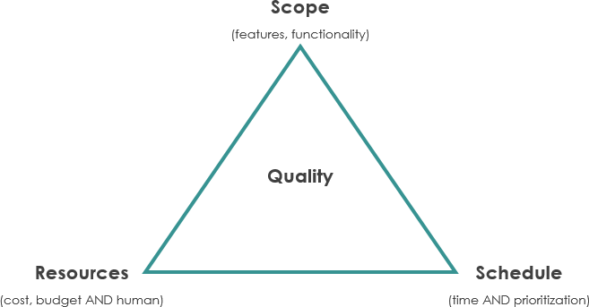
Fig: Iron Triangle
Source: (Rowe, 2020)
All three constraints tend to have an impact on each other, therefore properly adjusting in those constraints so that it can be ensured that neither of the three can impose a negative impact on the other while a project is conducted. For managing the project of Vintners Antiques so that it can thrive in achieving the project goals that lead to its business growth, the scope of the project needs to be defined and analyzed, the time required to deliver the project needs to be estimated and the cost required to run the project during the specific time span needs to be calculated so that the equilibrium among all the three constraints can be maintained by the project manager of Vintners Antiques.
Risk related to the scope
The scope is one of the constraints in which a project manager fulfils his/her duties while dealing with a project. Defining the scope of a project is included in the process of making planning for the project as it involves defining the goals of the projects. Project scope is such a constraint which have a significant impact on the other two constraints namely time and cost, as how much budget is required to run the project and how much time it is going to consume are entirely dependent on the scope of the project (Stanitsas et al., 2020). If the number of tasks required to be done while running the project increases then simultaneously the cost for completing the tasks and the time required for the same will increase in the same manner. Moreover, if the activities that are carried out for the project give rise to any ethical or legal issue then it can pose a risk to the project scope.
Risk related to cost
Cost refers to the financial resources required for the accomplishment of the project goals. Whenever a plan is made to conduct a project for a certain purpose, it is extremely required to look at the financial requirements or budget for the accomplishment of the project as it determines whether the business is economically capable of running the specific project. Cost estimation should be done beforehand by the project manager so that throughout all the processes in running the project the business does not have to deal with a lack of capitals (Zaman et al., 2020). The cost of a project can be remained fixed but sometimes can vary depending on the time constraint for conducting the project. Project managers must attempt to balance the cost as much increase in it can pose as a challenge for the business to cope up with it. Difficulty in getting access to financial resources due to changes in economic factors can give rise to a risk for the project team to generate the fund for carrying out the activities.
Risk related to time
Another constraint is the time required to complete the project in the sense of achieving the goals of the project after its completion. This factor is also considered to be a constraint as procrastination in delivering the project can lead to decreasing the value. More precisely, time is a success factor for any type of project and in any field as it determines whether the project has been able to get aligned with the strategic goals of the business (Papke-Shields and Boyer-Wright, 2017). Allocating time to a specific task is considered a vital decision as the risks related to it include time constraint that creates excessive pressure on the employees which can deteriorate their performances and the quality of work. Therefore, steps to allocate time and manage time is essential while managing a project. Task management and time management have an interrelation as generally a project is fragmented into several tasks and for every particular task, time is assigned which is managed efficiently to deliver the task (Radujković and Sjekavica, 2017). Every project management methodology has its time management process and strategy, similarly, Agile methodology also provide a structured method of managing time for project management.

Conclusion
As stated in the report that project management is a very vital process to be carried out in order to achieve project goals within a time frame. For the project management process, an appropriate technique to carry out the entire process is required to be used so that all the aspects of the project can stand up to the expectation of the project team. For the project of Vintners Antiques which have the purpose of organizing its warehouse, the Agile methodology for project management is considered to be relevant. The Agile approach is not similar to the traditional approaches as it follows different rules for planning and estimating, and in addition, all the team members work cooperatively and dedicatedly towards achieving the project goals. The project scope, time and cost are defined and estimated using the Agile approach as these three factors are significantly involved in managing a project effectively.

References
Bogdanova,M.,Parashkevova, E. and Stoyanova, M., 2020. Agile project management in governmental organizations–methodological issues. International E-Journal of Advances in Social Sciences, 6(16), pp.262-275.
Dasović, B., Galić, M. and Klanšek, U., 2020. A survey on integration of optimization and project management tools for sustainable construction scheduling. Sustainability, 12(8), p.3405.
Galli, B.J., 2020. An Evaluation of the Effectiveness of Statistical Tools in Project Management Environments. International Journal of System Dynamics Applications (IJSDA), 9(4), pp.1-23.
Gemino, A., Horner Reich, B. and Serrador, P.M., 2021. Agile, traditional, and hybrid approaches to project success: is hybrid a poor second choice?. Project Management Journal, 52(2), pp.161-175.
Gogela, S., Oke, A.E. and Aigbavboa, C.O., 2018, November. Utilization of Project Management Tools for Construction Project Success. In International Congress and Exhibition" Sustainable Civil Infrastructures: Innovative Infrastructure Geotechnology" (pp. 190-195). Springer, Cham.
Heagney, J., 2016 Fundamentals of Project Management. Vol. Fifth edition, chapter3
Li, X., 2021. Project Management Tools and Techniques in Predicting Project Management Performance for Strategic Projects (Doctoral dissertation, Capella University).
Papke-Shields, K.E. and Boyer-Wright, K.M., 2017. Strategic planning characteristics applied to project management. International Journal of Project Management, 35(2), pp.169-179.
Radujković, M. and Sjekavica, M., 2017. Project management success factors. Procedia engineering, 196, pp.607-615.
Rew, L., Cauvin, S., Cengiz, A., Pretorius, K. and Johnson, K., 2020. Application of project management tools and techniques to support nursing intervention research. Nursing outlook, 68(4), pp.396-405.
Robert, P., 2011 Effictive project management, how do I plan timescales and budgets pp. 131
Rowe, S.F., 2020. Project management for small projects. Berrett-Koehler Publishers.
Stanitsas, M., Kirytopoulos, K. and Leopoulos, V., 2020. Integrating sustainability indicators into project management: The case of construction industry. Journal of Cleaner Production, p.123774.
Zaman, U., Nawaz, S. and Nadeem, R.D., 2020. Navigating Innovation Success through Projects. Role of CEO Transformational Leadership, Project Management Best Practices, and Project Management Technology Quotient. Journal of Open Innovation: Technology, Market, and Complexity, 6(4), p.168.
Zavyalova, E., Sokolov, D. and Lisovskaya, A., 2020. Agile vs traditional project management approaches. International Journal of Organizational Analysis.

