
Skills for the Workplace
Module Assignment Submission
Student Name: | Louise Ricketts
Student Number: | 1910919
Module No: | BMSK4003
Module Title: | Digital Skills and Research Methods

Statement of Confirmation of Authenticity
By the act of making this submission, the student declares that this is the work of the student named above. The work has not, in whole or in part, been knowingly presented elsewhere for assessment, or where assessment has been built on a previous assessment, this has been identified. Where materials have been used from other sources it has been properly acknowledged. If this statement is untrue, the student acknowledges that an assessment offence has been committed.
Attention is drawn to the plagiarism and unfair practice policies of both the University and of ILM.
Permission for ILM to use this script
ILM uses learners’ submissions – on an anonymous basis – for assessment standardisation. By submitting, both the centre and the learner agree that ILM may use this script on condition that identifying information is removed. However, if you are unwilling to allow ILM use this script, please refuse by ticking the box: □

Table of Contents
What has been the impact of 21st Century Technologies on the modern workplace? 4
Introduction 4
An Overview of the 21st Century Workplace 4
WIFI 4
Cloud 6
Mobile 7
An in-depth look at technologies used in own workplace 7
My workplace 7
Part 2 9
An exploration of the use of social media in the workplace generally 9
Social media 9
Facebook 11
Instagram 11
Twitter 12
LinkedIn 12
Snapchat 12
Pinterest 12
Reddit 13
An in-depth look at the use of social media in own workplace 13
Social media in my workplace 13
The use of social media to enhance networking and career prospects 15
Using social media to enhance your career. 15
LinkedIn Profile 16
Conclusion 17
References 18
Appendix 1 23
Appendix 2 23
Appendix 3 24
Appendix 4 24
Appendix 5 24

What has been the impact of 21st Century Technologies on the modern workplace?

Introduction
Technology has changed dramatically in the last 20 years. We are living in a fast changing economy and we will look at how technology has changed in the workplace, and how our lives revolve around technology day to day in our homes and our personal lives.
The world has become increasingly technological and digital from choosing to use technology and having no choice in using it.

An Overview of the 21st Century Workplace
When applying for jobs in the early 2000s you would have had to go into businesses to pick up a paper application form, fill it out and take it back to the company and wait for a reply.
When you did get that reply inviting you to an interview you would attend and the employer would know nothing about you other than what you put on the application form. You would then tell the employer about yourself and they would let you know the decision by phone or letter in the post.
In the last 10 to 15 years the way we apply for jobs is very different. Not many placed do paper application forms as it’s all done online.
Before you’re even called for an interview employers will know a lot about you if you use social media.

WIFI
Today’s workplace is no longer confined to 1 place, i.e. an office or a shop etc. Due to the rise of telecommuting and the production of smart devises such as smart mobile phones, ipad’s and wifi enabled laptops, people can work from anywhere that suits them such as home, airports, cafes, trains or even sat in the street on a bench.
Gone are the days where you would sit at a monitor and input information off hundreds of forms as it is all automatically done on wifi devices now and uploaded straight to the office in seconds. Smaller laptops and ipad’s are used in offices and businesses nowadays so they can be picked up and taken anywhere.
With the use of WIFI people can run their businesses on the go and not have to carry loads of paperwork to do this. Using WIFI compatible devices people can access documents from cloud storage which can be shared between colleagues so they can all see the same documents no matter where you are, handy for conference calls which can also be done using Skype.
If you work in an office some offices have flexible working times and wifi devices such as laptops so you can work from home or once you have finished work for the day if you still have stuff you need to finish you can do this at home on your work laptop/device or if you cannot make it into the office for personal reasons you can still do your work as most documents will be in the cloud and keep in touch with the office via email Skype or mobile phone.
But you should be aware of your work/life balance. Sometimes you could let your work life interfere with your personal life if you don’t have the right balance.
In the early 2000s you would go to a shop, bar or restaurant and pay cash, cheque or with debit card, now you can pay using your mobile phone as long as you have set up the banking App, pay by contactless so you tap your card on machine or insert card into card reader enter pin and that’s it. You can also get cash back in a lot of shops if you need it.
Recently a small amount of businesses are now cashless, so you can only pay by card or mobile. The benefit of this is for security, no worrying about cash on the premises, walking to the bank with thousands in cash to bank takings and less for the staff to do such as no change errors and no cashing up at end of shift. On the down side, a loss of customers as a lot of customers especially the older generation like to use cash so they feel penalised for not having a smart phone with banking app or a debit card.(tonight-ITV)
Sweden, rich with technological advancement have introduced a technology where a small micro chip is inserted under the skin on your hand which can be used to enter your apartment block, store emergency contact details, pay for public transport as this is cashless, vending machines and much more. This was designed to make life easier and faster for people going about their day. (Cash free Britain- tonight ITV)
Sweden only has 6% cash transactions and are looking to soon be able to use the chip in shops and restaurants. Their train company has already started allowing travellers to pay by their chip. (NPR.org)
Amazon opened a supermarket without checkouts back in December 2016 to employees of Amazon and then opened its first Amazon Go store to the public in September 2018. You scan your QR code on your Amazon go app as you enter and the store uses hundreds of cameras and sensors to see what the customer is picking up and putting in there bag, they get a receipt on the way out and they are billed to their credit card when they leave the store.(BBC news Jan 2018)

Cloud
Before cloud space become available people would have to carry paperwork or store documents on memory sticks or SD cards and have to insert them into compatible devices. These cards and memory sticks were so easy to lose and could be a devastating loss to a company if they contained confidential information, not ideal as Data Protection would be breached if this information got into the wrong hands. With cloud storage as long as you keep your password safe you shouldn’t have this issue.
If your mobile device crashed or got lost and you lose all your work which is saved to the device this can be heartbreaking if you don’t have it backed up. With the cloud you can log into another device and your work is still available.
As all companies now store customer details on their systems, they have to have up to date security to keep this information private and Under the General Data Protection Regulation which came into force on 25th May 2018, they must inform the customer how they will use their data. GDPR gives the customer more control over what information a company can hold.
Companies have a legal obligation to maintain records of personal data and have a legal liability if there’s a breach. If a breach occurs the ICO (Information Commissioner’s Office) must be notified within 72 hours of becoming aware of the breach. (www.gov.co.uk)
The 4 best cloud storage companies are:
Dropbox, you get 2GB free and you can upgrade from £7.99 per month increasing in price with different packages and they have aprox 500million registered users. (www.dropbox.com) (www.computerworld.com)
Google drive, you get 15GB free and you can upgrade from £1.59 per month increasing in price with different packages and they have aprox 800 million active users.
Box cloud storage, you get 10GB free and can upgrade from £8.00 per month increasing in price with different packages and they have aprox 41 million registered users. (Lawrence Pines 2020)
Microsoft leads the market as it has more to offer such as office 365 and Azure. (Google.co.uk)

Microsoft one drive, you get 5GB free and you can upgrade from £7.99 per month increasing with different packages and they have aprox 1.2 billion registered users. (Appendix 1)

Mobile
Mobile phones were basic in 2000. You had a phone which you could make calls and text.
Sharp launched the first camera phone in November 2000. T-mobile offered a messaging service in 2002 but only had 1 phone available. Between 2002 and 2006, camera mobiles improved and camera quality started to get better.(Steven Braggs 2013)
The first iphone (mobile phone) was introduced in 2007 and android followed in 2008 and since then people have been using smart phones more and more for business use.(uswitch.co.uk)(2019)
The number of people using smart phones from 2016 has increased from 2.5 billion up to 3.2 billion by 2019 and the expected usage by 2021 is aprox 3.8 billion. (Arne Holst 2019)
(Appendix 2)

The quality on camera phones and the picture itself has hugely improved and people rely on them day to day.
There are many apps that are used by businesses, from apps for employees to apps to track how the business is doing, such as Workday, Yammer, QuickBooks, Skype, Cam scanner and many more.
Delivery drivers also use an app so customers can keep track on where their parcel is and they get customers to sign on their mobile device when the parcel is delivered to keep the business updated as to when and where the parcel was delivered.
By being able to work outside of the office, people with smaller businesses tend to work from home so don’t need office space, so they use virtual office technology meaning they no longer need to use a secretary to book appointments for their clients. This will save them money but also technically puts other people out of jobs as the virtual technology is doing it for them.
Some people believe over the next 10 years the skilled operatives roles will be under threat even further due to technology such as robots and drones which are replacing skilled operators on the production line.

An in-depth look at technologies used in own workplace

My workplace
I work for one of the biggest energy companies in the UK that provides energy and services to over 10 million homes.
We have call centres throughout the UK and overseas dealing with different sectors of the business such as Energy and services (which covers gas boiler breakdowns, Dyno rod for plumbing and drains and home electrical cover for the electrical wiring in the property).
Technology in our offices has changed for the better over the last 20 years. We no longer have to put information off bundles of forms into the system it’s all done automatically now because all engineers and field agents have wifi compatible devices and send the information straight through to the office.
In our offices the printers and scanners are connected to laptops and computers via WIFI.
In the last 15 years British gas has been encouraging its customers to manage their accounts online. This is an essential part of the Customer Service Agents’ role to encourage customers to set up online accounts so they can view bills, book appointments and even chat to online agents via web chat rather than call us on the phone.
The company believed this would reduce call volume and reduce paper usage.
To the customer service agents in the UK this was a worry that jobs wouldn’t be safe, which became a reality as there have been many job cuts over the last few years. This is mainly due to the new technologies being used within the company and out-sourcing. (Appendix 3)
A survey of ten people revealed agents believe the job is easier now than in 2000 and people do rely on the internet to do their job. (Appendix 4)
When you register an account online you can view your bills, update meter reads, view and amend payment plans, go onto web chat if you have a query about your bill, book appointments if you have a service agreement. You can also add products and services to your account if they benefit you.
British gas also has their own app which you can do all the things you would do on the website but when you book an appointment you can track where the engineer is. This is convenient as it saves you having to wait in for 5 or 6 hours.
There are few things the company are looking into, such as how deaf people communicate with us. They can chat on the web chat but when they need to do top up quotes if they already have a warranty with BG this has to be done over the phone. Employees have asked the company to find a way for these customers to be able to do this on the website. Also the 5 and 6 hour time slot waiting for an engineer is crazy. The company are looking into shortening this window.
you can also sign up to the British Gas loyalty scheme which is called ‘Rewards’ and receive offers and discounts on products from British gas.
One of the products British gas offer in the smart homes range is the Hive active heating which lets you control your heating, plugs and lights in your home from your smart phone via the hive app wherever you are.
British Gas uses a new technology called Boiler IQ. The sensors monitor the boiler and water system for leaks and boiler faults and will notify you there is an issue and to arrange an appointment to get an engineer out.
Smart meters are also new technology where the meter read is sent directly to your supplier so no need for meter read agents to call to the house anymore.

Part 2

An exploration of the use of social media in the workplace generally

Social media
There are several different social media platforms available.
The 7 biggest platforms are Facebook, Instagram, Twitter, LinkedIn, Reddit, Snapchat and pinterest.
- Facebook has aprox 2.38 Billion users.
- Twitter has aprox 321 Million users.
- LinkedIn has aprox 303 Million users.
- Instagram has aprox 1 Billion users.
- Snapchat has aprox 330 Million users.
- Pinterest has aprox 291 Million users.
- Reddit has aprox 330 Million users.
(Appendix 5)
People use social media worldwide to keep in touch with family and friends, to promote businesses, to keep up with trends and so on.
When you apply for jobs, potential employers look at the applicants social media platforms to see if they can get an idea of what the applicant is like. If a potential employer don’t like what they see that can result in losing the chance of getting to the first stage of the interview process.
It is advised to be careful what you share online. Think about personal brand. Think about how you would want people to see you as a person, Potential employees for instance. Changing your settings so only you can see what others have tagged you in before it is put on your platform is a wise idea. Everyone likes to go out let off steam and have a good time but with the use of camera phones and friends taking photos, if you are in a picture looking a bit worse for wear or doing silly things and this is put on your social media page for everyone to see then it’s not a good first impression.
If you work for a well known company and potential customers see you behaving badly on social media this could potentially cost the business customers and cost you your job.
As social media has billions of users, customers of businesses who have had a poor service or who are unhappy with an establishment in any way tend to air their views on social media like Twitter and Facebook and this can have a big impact on that business as once a bad comment has been posted it can be re-tweeted or shared by followers and before you know it, it has gone viral.

A lot of companies employ people to manage social media sites and advertise their business and to deal with negative situations and reply to such comments in a professional way so it does not escalate out of hand and turn into a nasty war of word which could damage that person or businesses reputation.
Employees who are not trained to manage the social media sites for the business are advised not to comment on customer’s reviews or complaints as this could escalate and could result in dismissal. A lot of businesses have banned the use of personal social media in working hours and many have blocked these sites from being accessed on work equipment.
For people using social media to promote business, they may find one social media platform is better than the other for selling and another is better for personal use. Also for example face book may be better for promoting and selling your dog grooming business and accessories yet you tube may be better for someone promoting their makeup and beauty services. (searchenginejournal.com)
Businesses should always have adverts proof read and potential legal issues checked before posting to save themselves from embarrassment or legal action if the Ad backfires in any way.
Most big businesses have a legal team who proof read everything before its posted online or sent in post.
Research done by Kristi Kellogg in June 2019 for a new Ebook on “how to dominate social media” suggests the best move is to have a presence on each of the major social media platforms and monitor how much business or sales each platform generates. (Kristi Kellogg) (June 2019)

Facebook
Facebook was founded by Mark Zuckerberg from his dorm at Harvard University with 2 of his roommates.
Facebook estimated worth is over 479 billion dollars. (Bary 2019)
Facebook was originally built for Harvard students to connect with one another. It was the launched on 4 February 2004 and up to 1500 people registered in the first 24 hours. Face book continued to grow and by the end of the year had spread across the globe and by 2019. (www.History.com)
Facebook is used as a social network for people to connect with family and friends and share photos and videos on their platform. It is ideal for families who have relatives living in different countries so they can keep in touch with one another.
Businesses use facebook to promote themselves as they know their pages will reach millions of people and generate business and sales for them.
When you look on a business website these days you will see social media icons on their page to tell people they have these social media platforms.

Instagram
Instagram was founded by Kevin Systrom and Mike Krieger (Sawe 2019) and is estimated to be worth more than 100 billion dollars. (McCormick 2018)
Instagram is like a pocket size version of Facebook, it lets you interact with others share photos and videos and lets you use filters and add captions.

Twitter
Twitter was founded by Evan Williams and Bizz Stone and was launched on 15th July 2006, and is worth over 26.41 billion dollars as of 22/01/2020. (Ycharts 2020)
Twitter started off as an online micro blogging service where you could send short messages of up to 140 characters but this was later extended to 280 characters.
As Twitter grew in popularity i.e. celebrities sending tweets and gaining followers in the millions, businesses saw this as an opportunity and started sending tweets wit promotions and offers.
In April 2010 Twitter announced the use of ‘promoted Tweets’, the main focus of this was to an intended revenue source.

LinkedIn
LinkedIn is a professional social media platform which was founded by Eric Ly, Allen Blue, Jean-luc Vaillant, Konstantin Guericke and Reid Hoffman.
Microsoft bought LinkedIn in 2016 for 26.2 billion dollars.
It is the largest network for professionals. You can look and apply for jobs on the LinkedIn site. You can display your CV on your LinkedIn profile for potential employees to view.
You can use the free version of LinkedIn or you can subscribe to the premium service where you can see who has searched for you and looked at your profile to looking at online classes and seminars.

Snapchat
Snapchat was founded by Bobby Murphy and Evan Spiegel in July 2011 and originally called Picaboo but was rebranded a few months later and called Snapchat.
Snap chat is worth over 9.7 billion dollars. (Eckstein 2019)
Snap chat allows you to post pictures and videos with one to one followers or a group and the picture or videos disappear after a few seconds. The idea of snap chat was about communicating a range of human emotions. (Spiegel 2012)

Pinterest
Pinterest was founded by Ben Silbermann, Evan Sharp and Paul Sciarra in March 2010.
Pinterest makes its money from advertising and is worth over 14 billion dollars. (Reiff 2019)
You can find recipes, decorating ideas, parenting tips and lots more. You can connect with other Pinner’s and share ideas.

Reddit
Reddit was founded by Alexis Ohanian, Aaron Swartz and Steve Huffman in June 2005, and is worth over 3 billion dollars.
Reddit is a collection of forums where you can share news and comment on other user’s posts.

An in-depth look at the use of social media in own workplace

Social media in my workplace

My workplace has a profile on Facebook for customers to communicate with us.
During the winter period we put help and advice posts up so if people are experiencing issues such as frozen pipes or a frozen condenser pipe on the boiler we can give then simple tips on how to thaw the pipes and get their boiler and pipes back up and running without needing an engineer.
They will also put posts up on how to keep your home warm in the coldest days and safety tips if weather is really bad.
During the summer months you will see post giving you tips on how to keep your home cool on the hottest days.
As British Gas are working together with carers UK they also put up post with help and advice and support for carers.
We see a lot of people who go onto social media to complain when they are not happy, whether it is with the price of the product or a member of staff. When they have an issue with a member of staff they will go on Facebook slate the company and slate all the staff, but you very rarely see people putting a status up praising the staff when things have gone right. On the British gas Facebook page the business will put up a status when a member of staff has gone above and beyond for a customer whether it be an engineer or a call centre agent. In the office we see agents going above and beyond every day for our customers but you don’t see that being put on face book only unhappy customers will put a post on the page. When this happens we have a dedicated team who will respond to the customer in a professional manner and then deal with the customer by calling them and getting a resolution to their complaint.
British Gas also has a twitter account and connects with thousands of people every day through tweets. They post about competitions and prize drawers on a regular basis.
There are advantages and disadvantages to using social media.
Advantages:
- Communicate with family and friends.
- Share pictures and videos.
- Let people know how your feeling.
- Promote your business.
- You can view ads which may interest you.
- You can build your brand.
- Social media is free.
- Connect to anyone in the world

Disadvantages:
- You can receive negative feedback which can damage reputation.
- You’re open to embarrassment.
- Backlash if something goes wrong.
- Bullying and cybercrime.
- Fake news.
- Isolation and depression.
- Fraud and identity theft.

The use of social media to enhance networking and career prospects

Using social media to enhance your career.

You should have a professional social media platform such as LinkedIn and create a professional profile, and connect with as many professionals as possible to enhance your chance of promotion.
Use social media to highlight your expertise. Take part in online career platforms to build your career.
Connect with people who have similar skills and knowledge as yourself and people who may have further skills and knowledge and get involved in discussions where you could pick up useful information to help you progress. Make sure the people you connect with can see your CV on your profile.
If you interact with people by email or phone and they are very pleased with the service or business you have provided to them, make sure they are aware of your professional profile, i.e. if interacting with someone by email, send them an invite to LinkedIn, they may want to see if you could be an asset to their business.

LinkedIn Profile
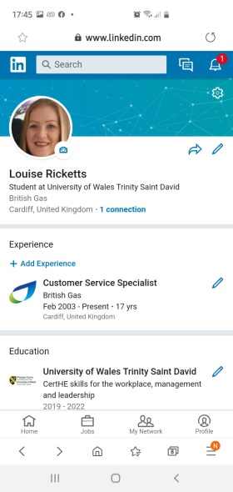
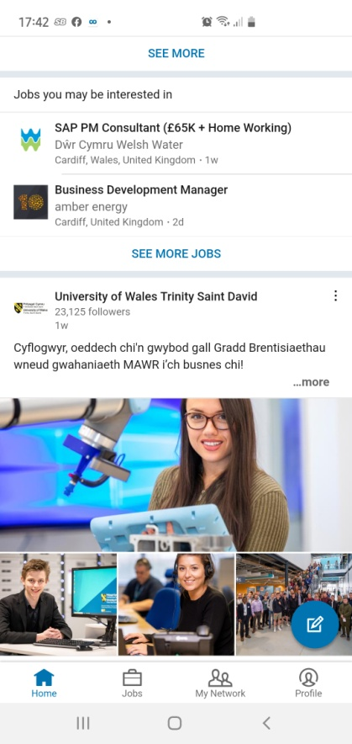
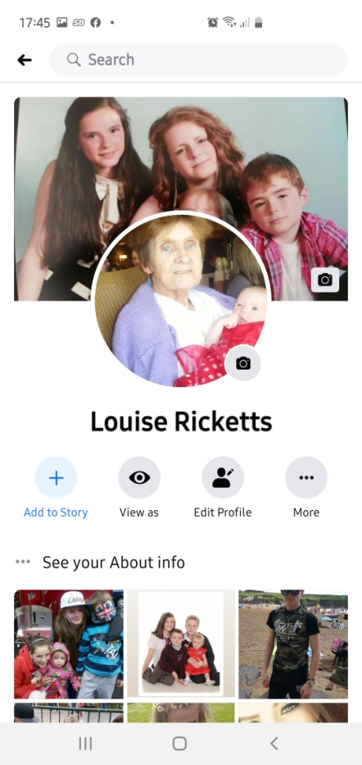

Conclusion
Looking at all the things you can do online, social media is a huge part of people’s lives, personally and professionally. You have more chance of going viral whether it is for a good or bad post than you ever had in the past. Back in the early 2000s if there was a bad review on something a few people may have picked up the phone to tell the next person but it wouldn’t have made too much of an impact, in today’s society it can financially ruin a person or business.
So before you hit send on that post think about the impact it could have on yourself or others.

References

Bary, E. (2019)
Available at: https://www.marketwatch.com/story/facebook-may-be-the-comeback-story-of-2019-as-stock-soars-higher-2019-01-31
(Accessed on 22/01/2020)

Bernazzani, S.(2019) 'A brief history of Snapchat'
Available at: https://blog.hubspot.com/marketing/history-of-snapchat
(Accessed on 23/01/2020)

Blake, M. Claywell, C, R.
Available at: https://socialnetworking.lovetoknow.com/Advantages_and_Disadvantages_of_Social_Networking
(Accessed on 24/01/2020)

Bragg, S.(2013)'The first camera phones'
Available at: https://www.mobilephonehistory.co.uk/history/camera_phones.php (Accessed on 17/01/2020)

Callaham, J. (2016)
Available at: https://www.windowscentral.com/there-are-now-12-billion-office-users-60-million-office-365-commercial-customers
(Accessed on 17/01/2020)

Eckstein, J. (2019)'how Snapchat makes money.
Available at: https://www.investopedia.com/articles/investing/061915/how-snapchat-makes-money.asp
(Accessed on 23/01/2020)

Erhart, k. (2018) '7 smart ways social media success'
Available at: https://careerenlightenment.com/7-smart-ways-social-media-can-boost-career-success
(Accessed on 24/01/2020)

Frank, B H. (2016) 'Dropbox has half a million users but needs more paying Businesses'
Available at: https://www.computerworld.com/article/3040484/dropbox-has-half-a-billion-users-but-needs-more-paying-businesses.html
(Accessed on 03/01/2020)

Holst, A.(2019)'Number of smart phone users from 2016 to 2021
https://www.statista.com/statistics/330695/number-of-smartphone-users-worldwide/ [online] (Accessed on 06/01/2020)

Johnston, C. (2018)'Amazon opens supermarket with no checkouts'
Available at: https://bbcnews.co.uk/news/business-42769096 (Chris Johnston) (22/01/2018) (Accessed on 17/01/2020)

Kellogg, K. (2019) 'The 7 biggest social media sites in 2019'
Available at: https://www.searchenginejournal.com/biggest-social-media-sites/308897/#close (Accessed 06/01/2020)

McCormick, E. (2018) 'Technology'
Available at: https://www.bloomberg.com/news/articles/2018-06-25/value-of-facebook-s-instagram-estimated-to-top-100-billion (Accessed on 20/01/2020)

Palermo, P. (2019) 'The best cloud storage'
Available at: https://www.reviews.com/cloud-storage (Accessed on 17/01/2020)

Pines, L. (2020)'Dropbox's top competitors'
Available at: https://www.investopedia.com/articles/company-insights/090116/dropboxs-
Top-3-competitors-box-goog.asp (Accessed on 17/01/2020)

Reiff, N. (2019) 'how pinterest makes money'
Available at: https://www.investopedia.com/articles/personal-finance/022415/how-pinterest-makes-money.asp
(Accessed on 23/01/2020)

Savage, M. (2018) 'Technology'. 'Thousands of Swedes are inserting microchips under their skin'.
Available at: https://www.npr.org/2018/10/22/658808705/thousands-of-swedes-are-inserting-microchips-under-their-skin
[Online](October 22 2018) (Accessed on 17/01/2020)

Sawar, A. (2020)
Available at: (Cash free Britain documentary-tonight)(series 21,episode 43) (viewed 7.30 ITV 02/01/2020)

Sawe, B E. (2019) 'who founded Instagram'
Available at: https://www.worldatlas.com/articles/who-founded-instagram.html
(Accessed on 20/01/20)

Tiseo, I. (2019)'Number of British Gas and Centrica UK energy supply employees 2010 to 2018'
Available at: https://www.statista.com/statistics/464063/british-gas-number-of-employess/ [online]
(Accessed on 03/01/2020)

Ycharts. (2020)'Twitter market cap'
Available at: https://ycharts.com/companies/TWTR/market_cap
(Accessed on 23/01/2020)

'Dropbox'
Available at: https//www.dropbox.com (Accessed on 03/01/2020)

'Guide to the General Data Protection Regulation'
Available at: https://www.gov.uk/government/publications/guide-to-the-general-data-protec (accessed on 17/01/2020)
(www.gov.co.uk) (published 25 may 2018) (Accessed on 17/01/2020)

History (2019) 'Twitter launches'
Available at: https://www.history.com/this-day-in-history/twitter-launches
Published (28/05/2019). Publisher, A&E Television networks. Author History.com Editors
(Accessed on 23/01/2020

'History of mobile phones and the first mobile phone' (2019)
Available at: https://www.uswitch.com/mobiles/guides/history-of-mobile-phones/
(Updated 21/02/2019) (Accessed on 19/01/2020)

History. 'Facebook launches'.
Available at: https://www.history.com/this-day-in-history/facebook-launches-mark-zuckerberg
(Author History.com Editor) (Publisher A&E Television Networks)(Published date 24th October 2019)
(Accessed on 20/01/2020)

'Resource centre'
Available at: https://www.box.com/en-gb/resources (Accessed on 17/01/2020)

'The relation between 21st century skills and digital skills'(2017)
Available at: https://www.sciencedirect.com/science/article/pii/S0747563217301590
[Online] (Google scholar)(Accessed on 17/01/2020)

Appendix 1

Appendix 2

Appendix 3

Appendix 4

- Agents believe there were more employees in the year 2000.
- Agreed technology has changed a great deal since the year 2000.
- Amount of agents advise they use the internet to do their job.
- Agents who use a laptop or mobile device.
- Agreed the job is easier today than in 2020.

Appendix 5

Bibliography

https://www.biography.com/business-figure/mark-zuckerberg
(Updated:Oct 24, 2019)· (Original:Apr 12, 2018)(Accessed on 20/01/20)

Carlson, N. (2010)
https://www.businessinsider.com/how-facebook-was-founded-2010-3?r=US&IR=T
(Accessed on 20/01/2020

Clements, J. (2019) 'Facebook:number of monthly active users worldwide 2008-2019'.
Available at: https://www.statista.com/statistics/264810/number-of-monthly-active-facebook-users-worldwide/
(Accessed on 20/01/2020

https://uk.finance.yahoo.com/topic/news
(no date)(Accessed on 20/01/2020)

https://mediakix.com/blog/how-much-is-instagram-worth-market-cap/
(no date) (Accessed on 20/01/2020)

