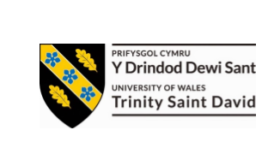

“Radical Dreams and Modernist Realities: The Visionaries of 1960s Architecture and the Future That Never Came”
School of Architecture, Built and Natural Environment
Course: BSc Architecture

Name: Carys Rhian Morris
Student Number: 2316510
Module code: ACAA5003
Word count: 2467
Date: 04/04/2025

The early decades of the twentieth century were both devastating and transformative for architecture and engineering. By the 1930s, the global situation was dire, unemployment was soaring, and the construction industry was in sharp decline (Bullock, 2002). Following the First World War, societies were forced to rebuild rapidly, rehoming millions displaced by conflict. This process was further disrupted by the onset of the Great Depression and ultimately shattered again by the Second World War.
By 1942, as the war neared its final stages, world leaders faced a singular and urgent question: how do we rebuild what we have lost? The response was pragmatic—reconstruct cities, hospitals, and housing on a mass scale, as quickly and affordably as possible. The architects charged with this task were largely born at the turn of the century, many of whom had been shaped by the avant-garde style, championing ideas drawn from figures such as Walter Gropius and Le Corbusier (Mgbemena, E.E, 2018).
Since the 1920s, the International Style had grown in influence: Walter Gropius had founded the Bauhaus, Mies van der Rohe honed spatial minimalism, and Frank Lloyd Wright had begun articulating organic architecture. As described by Mgbemena (2018),
“It was a new version abstracted from the populist-political contents of European modernism and united with the technical and commercial experience of American skyscraper architecture.”
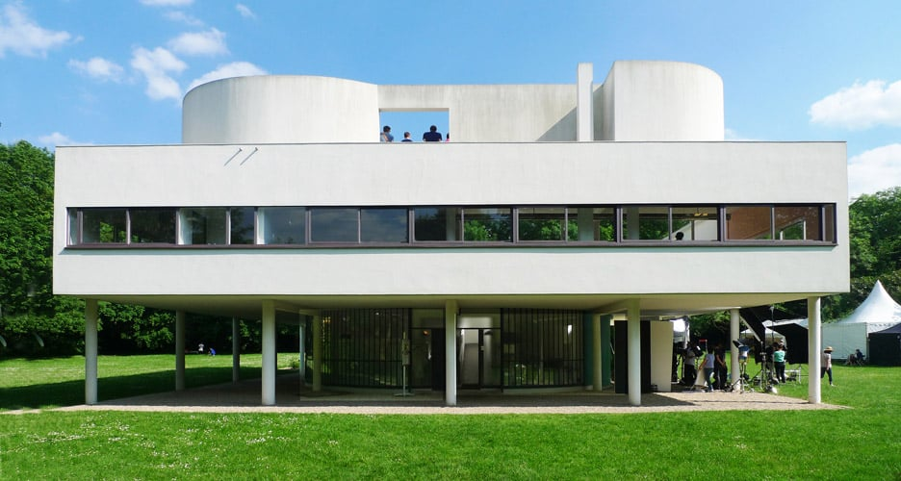
Figure 1: The Villa Savoye (August Fischer, 2016)
This style, with its emphasis on function over form, aligned perfectly with the post-war need for prefabricated, cost-effective architecture. In Vienna, this was especially visible, where architects like Franz Schuster, Karl Heinrich Brunner, and Roland Rainer were master planning in ways that prioritised technical performance over aesthetic expression. According to Diefendorf (1993), their integration of the International Style into a once architecturally pioneering city “failed to arouse much enthusiasm.”
By the 1960s, this widespread standardisation had sparked a growing desperation among younger architects to reintroduce meaning, sensation, and social vision into architecture. From this frustration, the radical collective Haus- Rucker-Co was born.
The Radical Architecture movement emerged in Italy during the 1960s and 70s, led by a generation of architects who sought to resist the growing dominance of standardised, minimalist design that had defined the post-war decades. Rooted in the University of Florence, collectives such as ‘Archizoom’ and ‘Superstudio’ began to produce provocative, anti-institutional designs that were both experimental and playful. Their work embraced an eclectic, even eccentric aesthetic—an intentional clash with the rigid rationalism of modernist architecture.
Their aim was to challenge the thinking of the past to create a future filled with innovation, so instead of continuing down the path of technical perfection and spatial efficiency, they infused architecture with irony, imagination, and critique. This approach was showcased in the 1966 ‘Superarchitettura’ exhibition in Pistoia, described by Dunbar (2016, pp. 1-10) as a pivotal moment in the Italian radical movement. The exhibition showcased manifestos and drawings that fused architecture with pop art, proposing a future built not on concrete and steel, but on cultural commentary and conceptual exploration.
As ‘Hans Hollein’ famously declared in his manifesto Alles ist Architektur (1968), “everything is architecture.” In this spirit, architecture in Italy was no longer understood as an autonomous discipline, but one deeply connected to contemporary life, consumer culture, and artistic expression (Melis, 2017). The radical movement blurred the boundaries between architecture and ideology, between physical form and utopian dreams.
This same radical energy echoed beyond Italy—most strikingly in Vienna, where a collective known as Haus-Rucker-Co took these ideas to surreal new heights. In comparison to their Italian counterparts who challenged architectural style through theory, Haus- Co- Rucker challenged it through bringing it into physical space.
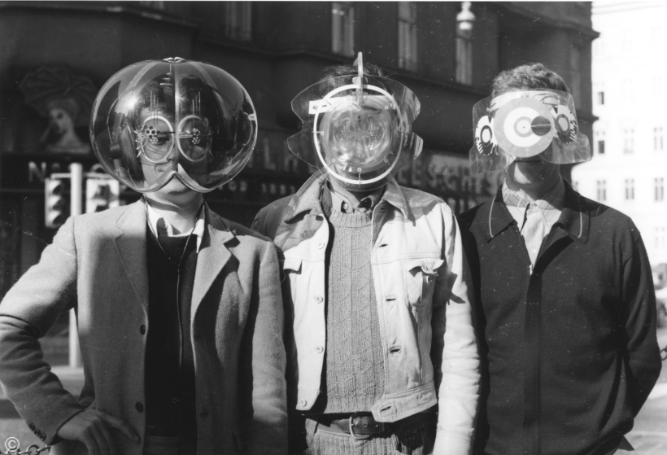
Haus-Rucker- Co, better known as HRC, was a collective group of Austrian architects that was founded by Gunter Zamp Kelp, Klaus Pinter and Laurids Ortner in 1967 in Vienna: with the addition of Manfred Ortner in 1971 (Schmiedeknecht, 1999). HCR was a vital turning point in European architecture during the late 1960s and early 1970’s due to their unconventional, experimental architectural practice and ideology.
Figure 2: Haus Rucker. (Gerald Zugmann,1968)

The collective was enthralled by the idea of ‘Urban intervention’, and ‘blurring the threshold between art and design (Something Curated, 2020). They were popularised by their futuristic inventions, and their iconic inflatable architectural environments. Their ideology encouraged participants to expand their social and cultural experience, and expand on what they perceived as nature, community, architecture and design in a broader and more innovative way. They intended to “extend people’s psycho-physical experiences through art and architecture (Something Curated, 2020).
HCR saw architecture critically, having distaste for the speculative standardised architecture that was seen post-World War 2 and as a result of this they constructed temporary installations within this context to show case the experimental cities and utopian environments society could have instead. It was a clear juxtaposition of rationalism and urban surrealism. To grip their audience, they drew inspiration from the philosophical group the ‘Situationists’ and used their “ideas of play as a means of engaging audiences” (Diefendorf, 1993). They created immersive installations where participants could enter and simply exist in these environments and form their own judgment and experience. A great example of this was the participatory ‘Mind Expander series’ in 1967, which sought visitors wearing inflatable helmets which had different environments in each one, subconsciously altering the mind of each participant in a slightly different way based on one’s personal experience (Diefendorf, 1993).
Whilst it is hard to define if HRC were architects, artists or designers, they always had architectural innovation at the forefront of their designs, and they concerned themselves with the space in between; where architecture and environment meet (Fernando Moral Andrés, 2022). This is best shown in their city proposals of ‘Palm Tree Island Oasis’, which features a protective dome encasing biodiversity planted in the middle of an industrial reality - radical intervention which would have been controversial at the time.
As said in an interview with ‘Gunther Zamp Kelp’, Fernando Moral Andrés (2022) explained how HRC had no ‘colour strategy’ and let their designs ‘emphasise each respective concept as clearly as possible’, with minimal artificial additions. Furthermore, Kelp, rejected Aldo Rossi’s minimalist, rigid buildings and aimed to make ‘complex simplicity shine’, as seen in their most iconic architectural intervention: Oase No. 7.
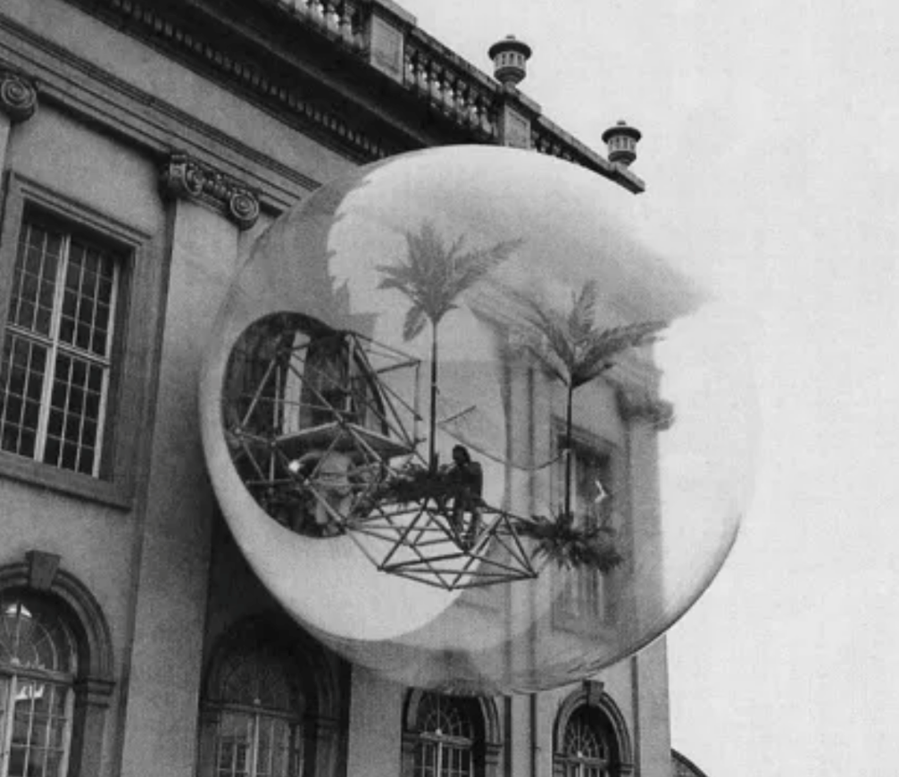

Figure 3: Oase No 7. (Ortner Baukunst 1972)
Oase No.7 was a temporary architectural installation created by Haus Rucker in 1972, for the Documenta 5 exhibition in Kassel. The 8-metre-wide orb was protruded from the classical façade of the eighteenth century of Kassel’s Fridericianum, dramatically juxtaposing the past and the present. The orb itself was created as an “artificial oasis”, acting as an “emergency exit leading people to another realm” (Moma, 2021). The interior experience consists of two plastic palm trees a red flag and a hammock.
“Our balloons will help you to discover an unknown feeling of tranquillity, of security, of relaxation. And love. We want to heighten your sensitivity. You will take a journey. Together with someone you love. Into inner space. Like Astronauts. Only an inward trip. You will attain a higher level of thinking and loving…” (Moma, 2021).
Architecturally, the orb was structurally supported by a steel framed rack which protruded in a cantilevered manner to overhang across the street. This frame could hold 2 people at a time, and these 2 people would enter through a window onto a tubular steel catwalk leading into the dome. The balloon itself was created from an inflatable PVC membrane which was entirely transparent to create a connection between those inside, and those outside and allowing the elements to become unified. In his book, Schmiedeknecht (1999), draws attention to the “architectonic surfaces” such as the PVC that was used in the design, highlighting how It is pivotal to the “conditioning of perception”. For an example, the structure of the orb does all the work within the design, yet people are drawn to the architectonic PVC layer more as the honest transparency is easier to perceive as an onlooker than the internal structural elements.
The aim behind the design was to make the visitors question things they thought that they knew, and to encourage them to develop a new way of thinking and perceiving things. This objective was inspired by astronauts, and the “unknown spatial situation” that they are suddenly thrust into, suddenly altering their world view upon seeing something unfathomable (Schmiedeknecht, 1999).
This intent was successfully achieved by harnessing a psychologic approach. They would shuffle people into the dome and manipulate their consciousness by alienating the senses aside from one key sensation, often sight. The philosophy that underpinned the design came from, “modern technology, innovation, metamorphosis and mass media” due to its rising involvement in architecture. (Schmiedeknecht, 1999).

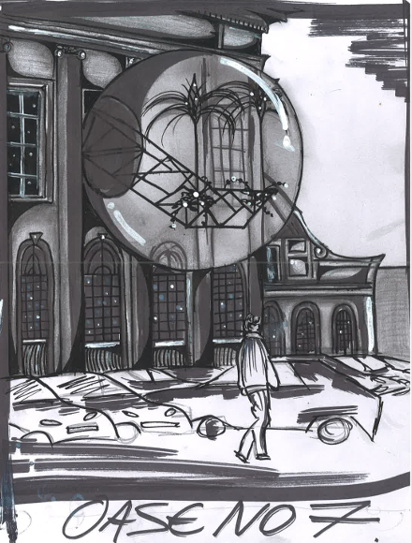

Figure 4: Oase No 7 (Carys Morris, 2025).
The legacy of Haus-Rucker-Co is difficult to define within the 1980s and 1990s, largely because their radical visions were never fully appreciated or understood in mainstream architecture. Their work and vision were primarily confined to temporary installations or concept images, so they never really gained the traction they deserved. Furthermore, their ideas were seen as too utopian and unrealistic for the rigid post-war years in which they took place.
The following decade, the 1980s, saw two prominent architectural shifts: the withdrawal of innovative design and a reversion to mass cost-effective architecture, and the rise of postmodernism. The former was a reaction to the current political situation of the world and the need for mass production due to the ever-increasing population. However, the latter, similarly to Haus-Rucker-Co’s ideology, was a societal reaction against the plain modernist buildings seen up until this point.
The postmodernist revival in the 1980s—earlier seen in the 1950s pushed back against the International Style and the rigidity and neutrality that it encompassed (Frow, 1991). Postmodernist architecture brought back the idea of colour, ornamentation, and aesthetic visual interest to design, and much like Haus-Rucker-Co aimed to do, took a more playful, creative approach. However, it was also a controversial period for architecture. As explained by McLeod (1989), postmodernism became a matter of focusing on “the pseudohistorical nostalgia, fabricated traditions and pandering to a nouveau riche clientele,” and ultimately lost all “social vision” within the design.
This is further emphasised in the popular book ‘Postmodernism, or the Cultural Logic of Late Capitalism’ by Frederick Jameson. Arkaraprasertkul (2009) explains how the cultural shift in society at the time—with the introduction of technology, new cultures, and a general distaste for the modernist architecture seen prior—led to architecture being seen “not as a style, but as a cultural dominant.” Architecture was now being used to subtly push ideals and agendas.
Because of this shift, Haus-Rucker-Co’s visions did not catch on in mainstream society, and their ideology dissolved alongside their group in 1992 (Schmiedeknecht, 1999). Not all hope was lost; however, the influence of Haus-Rucker-Co’s inflatable structures did occasionally reappear in other architects’ work. One example of this is Graham Stevens, who continued to create pneumatic structures up until the 1980s.
Following the continuation of radical ideas by architects such as Graham Stevens, a contemporary example of architecture which mirrors the ideology of Haus-Rucker- Co is the ‘BIOSPHERE’ created in 2022 at Tree hotel in North Sweden, by Danish architect firm BIG.
Nestled amongst the vast woodlands in Sweden, the Treehotel stands to appreciate and serve the ecological beauty of the country and preserve its natural habitats. The project was launched after the ornithologists and the County Administrative Board in Sweden noticed a dramatic decrease in the bird population amongst the Harads pines, and upon investigation it was discovered that the number of natural holes found within the trees has noticeably decreased, resulting in minimal areas for birds to nest and breed (Arch Daily, 2025).The aim of the ‘BIOSPHERE’ was to create an intervention to eliminate this problem, and to enhance the surrounding environment with hopes of increasing the bird population once more.

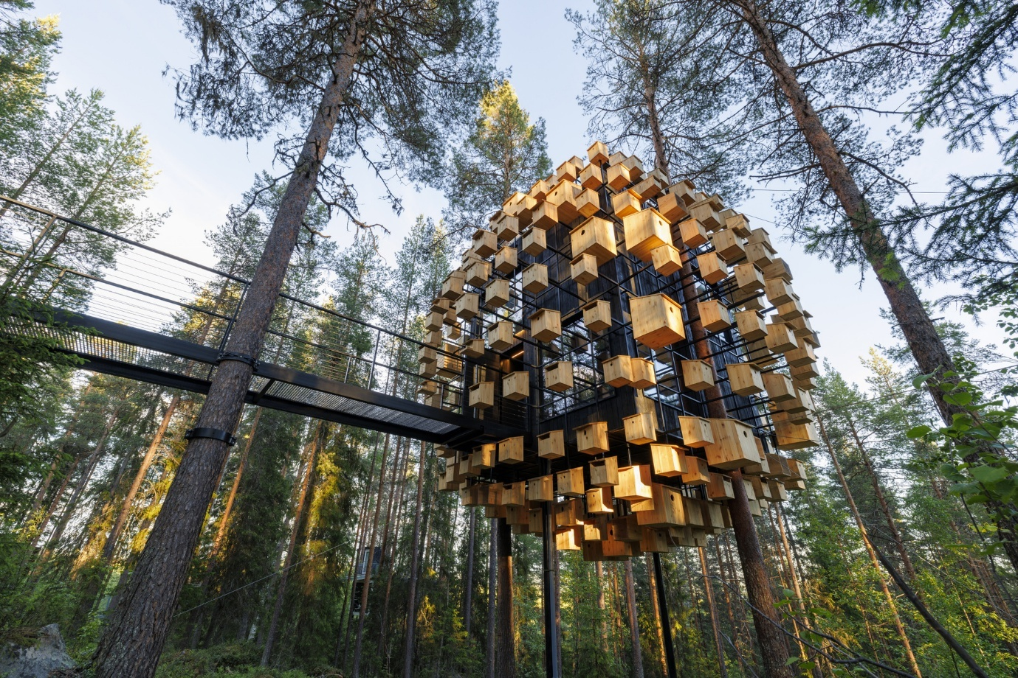

Figure 5: BIOSPHERE (BIG, 2023)
Similarly to ‘Oase No 7’, the ‘Biosphere’ is a suspended steel structural grid which is accessed via a tubular steel bridge. This bridge leads into a 34 m2 hotel room which is suspended in the air, situated between the Harads pines (Dezeen, 2022). Externally, the structural grid supports 350 bird boxes of different sizes that envelope the hotel within. The architect’s design objective was to inspire visitors to go home and install their own bird box, after having watched the birds and wildlife during the duration of their stay.
“Demonstrating the use of bird nests and feeding, not just at the Tree hotel but for people to install near their own homes, is valuable. An initiative from Tree hotel to take such measures may inspire their visitors to do the same” (Design boom, 2022).
The interior of the space, much like the Haus Rucker collective, isolates the visitors’ senses, and sharpens their visual focus by using contrasting dark interiors that guide the visitors’ line of sight to the triple glazing façade surrounding the hotel, manipulating their perception of space and encouraging them to see areas which they would usually neglect. There is also a 360* treetop canopy on the top of the hotel which encourages visitors to fully immerse themselves in the experience.
The ’Biosphere’ building is a visual and structural echo of Haus Ruckers ‘Oase No 7’. Structurally, both buildings have a bubble-like structure supported by a steel grid, which is suspended from another external element. But more so than this the core intent by Haus Rucker is clear. ‘Biosphere’, similarly to ‘Oase No 7’ isolate their visitors’ senses to expand their psycho-physical experiences through the design itself. They both aim to integrate into the experience between physical body and the external environment, adopting a heightened awareness of the world around them.
To conclude, it is important to consider that one singular example of architecture which is like Haus Rucker Is not enough to determine if such a legacy was withheld in modern day society, and more exploration is needed.
Haus Rucker Co, along with the radical movement of the 1960s and 1970s presented a fresh new, bold and innovative alternative to the minimalist and standardised architecture seen in the post war era. Even though their ideas and concepts were dismissed due to being too utopian and bold, many elements of their ideology and style such as sensitivity to biodiversity and user centred design can be seen today.
However, 21st century contemporary design can be seen to have no defined style, with an emphasis on designing for the climate crisis and the uncertainty of the global situation. The core values seen in radical architecture, such as imagination, critical thinking and a consideration on how we inhabit our spaces and our world is more relevant than ever. As architecture continues to develop, the question remains: Is radical architecture needed now?

References:

Arch Daily. Biosphere at Treehotel. Available at: Biosphere at Treehotel / BIG | ArchDaily (Accessed: 16 March 2025).

Arkaraprasertkul, N. (2009) ‘On Fredric Jameson: Marxism, Postmodernism, and Architecture’, Architectural theory review, 14(1), pp. 79–94. Available at: https://doi.org/10.1080/13264820902741011 (Accessed: 19 March 2025).

Bullock, N. (2002) Building the post-war world: modern architecture and reconstruction in Britain. Psychology Press.

Design boom (2022) Bjarke ingels biosphere treehouse hotel floats among 350 birdhouses. Available at: bjarke ingels' 'biosphere' treehouse hotel floats among 350 birdhouses (Accessed: 18 March 2025).

Dezeen (2022) BIG wraps Biosphere hotel room in 350 birdhouses. available at: BIG wraps Biosphere hotel room in 350 birdhouses (Accessed 19 March 2025).

Diefendorf, J.M., 1993. Planning Postwar Vienna. Planning Perspective, 8(1), pp.1-19. Available at: Planning postwar Vienna: Planning Perspectives: Vol 8, No 1 (Accessed: 29 March 2025).

Dunbar, J. (2016) The Making Of Italian Radical Architecture (Doctoral dissertation, Master Thesis) Dib C.(nd) Five Poetic and Philosophical Acts Of The Italian Radical Design Movement Available at: http://katarimag. com/en/five-acts-italian-radical-design (Accessed: 28 March).

Fernando Moral Andrés, Elena Merino Gómez and Eduardo A. Prieto González (2022) ‘Conversando con... Lauridis Ortner Haus-Rucker-Co (HRC)’, EGA : revista de expresión gráfica arquitectónica. Available at: https://doi.org/10.4995/ega.2022 (Accessed: 19 March 2025).

Frow, J. (1991) What was postmodernism? (pp. 139-52). Sydney: Local Consumption Publications. (Accessed: 15 March 2025).

McLeod, M. (1989) Architecture and politics in the Reagan era: From postmodernism to deconstructivism. pp.23-59. Available at: https://www-jstor-org.ezproxy.uwtsd.ac.uk/stable/3171013?seq=2 (Accessed: 16 March 2025).

Melis, A, Davis, M.J, and Balaara, A. (2017) The history and invocation of the Arche in Austrian Radical architecture thinking. Cogent social sciences, 3(1), p.1368366.
Mgbemena, E.E and Okonta, E. (2018) 'How International was International Style of Architecture?’, American Journal of Civil Engineering and Architecture, 6(1), pp. 30-37. Available at: How International was International Style of Architecture? (Accessed: 29 March 2025).

MOMA (2021) Radical Architecture. Available at:https://www.moma.org/collection/terms/radical-architecture#:~:text=A%20cohort%20of%20Italian%20architects,student%20uprisings%2C%20and%20social%20unrest. (Accessed: 20 March 2025).

Schmiedeknecht, T. (1999) Expanding Space: The Work of Haus-Rucker-Co and Zamp Kelp. The University of Liverpool (United Kingdom).

Something Curated (2020) From transportive Prosthetics to edible architecture - the story of Haus-Rucker and co. Available at: From Transportive Prosthetics To Edible Architecture — The Story Of Haus-Rucker-Co - Something Curated. (Accessed: 15 March 2025).

Figures:

Figure 1: August Fischer. (2016) Villa Savoye. Available at: Le Corbusier's Villa Savoye encapsulates the Modernist style (Accessed: 12 March 2025).

Figure 2: Gerald Zugmann. (1968) Haus Rucker. Available at: Haus-Rucker-Co: Architectural Utopia Reloaded | ArchDaily (Accessed:12 March 2025).

Figure 3: Ortner Baukunst (1972) Oase No 7. Available at: FAR (After Oase N.7) (Accessed: 12 March 2025).

Figure 4: Carys Morris (2025) Oase No 7.
Figure 5: BIG (2023) BIOSPHERE. Available at: Gallery of Biosphere at Treehotel / BIG - 1 ( Accessed : 12 March 2025).

Bibliography:

The Architectural Review (2014). Available at: https://www.architectural-review.com/archive/air-apparent-pneumatic-structures (Accessed: 20 March 2025).

Architectuul (2025) Oase No.7. Available at: Oase No. 7 | Architectuul
(Accessed: 17 March 2025).

Doucet, I. (2016) ‘Learning in the ‘Real’ World: encounters with radical architectures (1960s–1970s).’, Journal of Educational Administration and History, 49(1), pp. 7–21 (Accessed:15 March 2025).

Elfline, R. (2019) ‘Haus-Rucker-Co LIVE! and Commoning the Museum’, Architectural theory review, 23(1), pp. 39–58. Available at: https://doi.org/10.1080/13264826.2019.1616664. (Accessed: 15 March 2025).

MOMA (2021) Radical Architecture. Available at:https://www.moma.org/collection/terms/radical-architecture#:~:text=A%20cohort%20of%20Italian%20architects,student%20uprisings%2C%20and%20social%20unrest. (Accessed: 20 March 2025).

The Architectural Review (2014) Available at: https://www.architectural-review.com/archive/air-apparent-pneumatic-structures. (Accessed: 20 March 2025).

