Critical Incidents in Outdoor Adventurous Education - BMOE6001
Reflecting on critical incidents that occur in the outdoors has become a practice that is important for facilitators and governing body’s alike, incidents like the Lyme bay tragedy (Brookes, 2018) have been used to inform law and change the way facilitators work to avoid incidents re-occurring in future. Giving analysis on critical incidents is a way for individuals and organisations to learn from experience and reflect on their own practice. It has been identified by Hickman and Stokes (2015) that those who work in the outdoors are not reflecting enough on wider practice, “reflecting on the action in the critical incidents (is what) generated the potential for deeper learning” (Hickman and Stokes, 2015), this shows how vital it is for anyone engaging with the outdoors to reflect on wider incidents and learn from them within the context of personal practice. This essay will be evaluating on how a critical incident was dealt with by individuals involved.
This analysis will cover what happened on the 7th of March 2020 and will critically assess the situation as managed by the group of walkers. This essay will cover will only look critically at what happened after the casualty fell rather than preventative measures, it will provide analysis on how the rescuers searched and eventually located the casualty and from then what was done by the rescuers in managing hypothermia in themselves and the casualty. It is recognized that other elements of the situation are not mentioned however the aim of this essay was to provide an in depth analysis of the situation and as a result of the limitations in word count the search and hypothermia management were chosen as areas of high importance. This essay will first give an overview of what happened using the video and mountain rescue report of the incident. Then an analysis on the effectiveness and organization of the search for the casualty. Once the casualty is located, how hypothermia is managed by the group and mountain rescue will then be analysed.
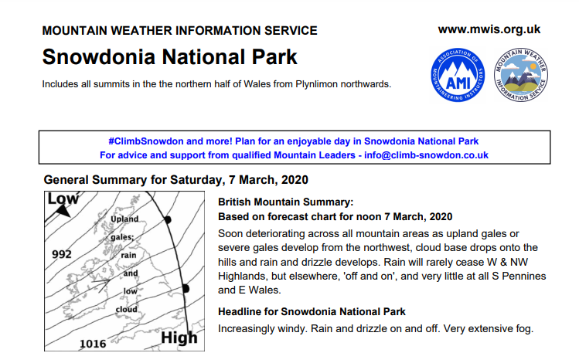
As mentioned above the scenario that will be analysed in this essay happened on the 7th of March 2020 on the side of Crib Goch (Mountain Rescue, 2020). According to the video, rescuer 1 (R1) and his friend, rescuer 2 (R2), were aiming to “do the Snowdon Horseshoe” (Brave Dave, 2020), in the video he describes the weather conditions as sub optimal but they went ahead and decided they would change the route depending on how bad conditions got (Brave Dave, 2020). This is consistent with the weather report on that day as can be seen above (Mountain Weather Information Service, 2020).
Figure 1(Mountain Weather Information Service, 2020)
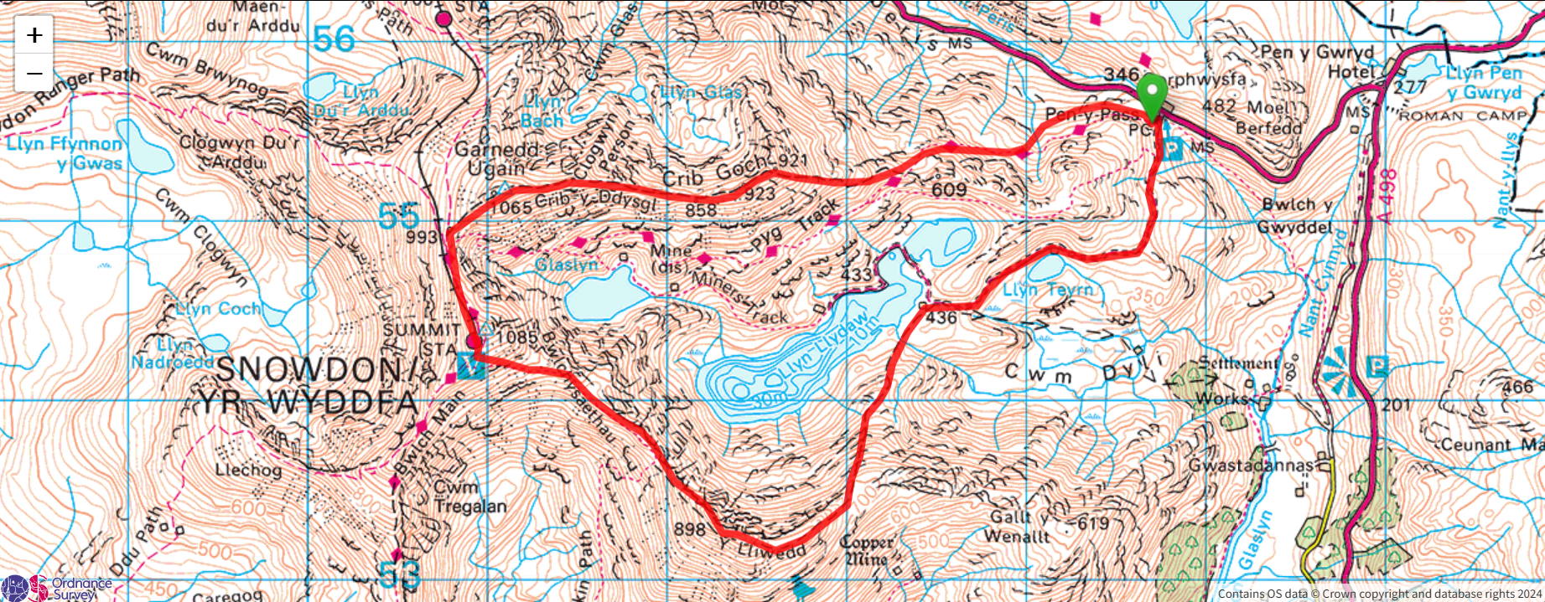
On the route, R1 and R2 meet two other walkers, casualty and rescuer 3 (R3) who are also attempting the Horseshoe, together they decide because of the wind they will cut down to the Pyg track. As viewers it isn’t known exactly where along Crib Goch the group is, however seeing as they are discussing going down to the Pyg track (Brave Dave, 2020) we know they were somewhere along the highlighted line.

They all made their way down this grassy path however seemingly not long after R1 describes hearing a shout then seeing casualty “sliding down the hill” (Brave Dave, 2020). According to the group in a matter of seconds he had completely “disappeared into the mist” (Brave Dave, 2020). The group start to as quickly as possible make their way down the hill, but they also began to lose footing and the video depicts the three men going between sliding and walking down the hill. R3 calls mountain rescue while R1 continues making his way down calling casualty’s name. Around three minutes of the video passed and R1 hears a response and slides down the hill eventually reaching the casualty. The time they were searching for the casualty is unknown. According to the mountain rescue report the casualty had “fallen over 200 metres” (Llanberis Mountain Rescue Team, 2020). Casualty was found lying conscious on the ground with his trousers and jacket partially ripped off, meaning his legs and back were exposed. R1 estimates they were waiting for mountain rescue for close to an hour (Brave Dave, 2020) and in that time they had covered the casualty with as many layers as possible as well as a shelter. As it was so foggy the mountain rescue report says multiple rescue teams had to be sent out (Llanberis Mountain Rescue Team, 2020) in order to find the casualty and once the casualty was found “some significant injuries were treated at the scene” and then he was stretchered down to the miners track (Llanberis Mountain Rescue Team, 2020). The casualty had sustained a broken wrist, nose, shoulder, two bones in his neck, one bone in his back and needed multiple blood transfusions but, according to R1 at the end of the video, has since recovered (Brave Dave, 2020).

As mentioned in the introduction this essay will only be analysing two aspects of the video, this section focuses on directly after casualty is gone from view and everything the group did in searching and locating him. We do not see what happens immediately but the video text says that they “instinctively started to rush down to try to find him” (Brave Dave, 2020). From past experience, this is unsurprising as an initial response, when faced with a crisis it can be common for humans to ignore risks and create a more higher risk situation (, R1 clearly admits it was instinct, implying this was not a conscious decision they made. It is clear that R1 realises rushing down was not the right choice though, the video shows him sliding down himself and once he stops, shouting to the others to take more care (Brave Dave, 2020). Obviously, at this point in time finding the casualty is vital, however it is good that R1 recognised the most important thing was that the three of them did not become casualties themselves(Langland Ambleside Mountain Rescue Team, 2023) . So the search for the casualty continued and what is about two minutes of footage passes and someone mentions phoning mountain rescue. The amount of time they were searching before calling is unknown but it could be argued that if R1 was feeling like it was likely the casualty would not be alive when they found him, calling mountain rescue should have been an instantaneous thing. They continue travelling for what seems like a while (bearing in mind the real length of time it took to find the casualty is not made clear in the video) between R1 making the statement “I think we are dealing with a dead person” (Brave Dave, 2020) and them calling mountain rescue. There could be a few explanations for this; the adrenaline may have been so overwhelming the thought just did not cross anyone’s mind before that point, R3 had gone ahead of R1 and R2 so maybe R1 was waiting until they were all together before making an executive decision just in case R3 had already done it. However, as is shown in the video the Hypothermia was one of the biggest threats to casualty’s survival and him having so many other injuries meant that the sooner the mountain rescue team got to them, the higher chance of the casualty surviving (Paal, 2021). So, in hindsight it probably would have been a better decision to have stopped and called mountain rescue before they did, even though it is maybe only an extra five or six minutes, that time can mean the difference between life and death. It could have also given them some reassurance and stopped some of the panic they admit they all were experiencing (Brave Dave, 2020) by them having the knowledge that someone else is aware of their general location and on the way. On the other hand, the logic they used when searching for the casualty was beneficial according to m, while searching R1 is explaining his thought processes essentially saying he could only have gone down so we need to keep going down. The significance of this is that although they could have stopped and decided on a search plan where one or two of them goes one way and the others another, identifying that the casualty could only have gone one way. While having a strategy may be beneficial in some cases, in this case R1 recognised that the quickest way to reach casualty was not to stop and organise but to just go with gravity.
St Johns ambulance (no date) outline the primary survey as DRABC (Danger, Response, airway, breathing and circulation), it is fairly clear in the video he reaches the casualty and as the GoPro is on his head we see him looking the casualty up and down so its fair to assume he is checking out for danger as well as getting response from the casualty. It is also important to note how critical it is to catch hypothermia as early as possible ((van Veelen and Maeder, 2021). Langdale Ambleside Mountain Rescue Team (2023) highlights that while going through the survey the first aider should “treat any condition which is an immediate threat to life” (Langdale Ambleside Mountain Rescue Team, 2023), R1 does this successfully by recognising the cuts on the casualty but choosing to prioritise warming him first “First things first lets get you off the (expletive) ground”, this shows an awareness of the immediate threats to the casualties life, which in this instance was hypothermia. Early treatment of hypothermia is critical in the casualties outcome (Paal, 2022; van Veelen and Maeder, 2021) so R1’s vigilance in gathering all the groups warm clothes and jacket’s as well as utilising what appears to be an emergency blanket is likely to have dramatically improved the chances of the casualties survival as “hyperthermia can cause a substantial increase in mortality” (Paal, 2021). As the casualty was laying on snow R1 attempts to help him roll over so that less heat is escaping, it could be argued this could have done more damage to the casualty as R1 did not know if the casualty had a spinal injury and moving him could cause more damage to that (Waghmare and Singh, 2024), however, it should again be recognised that although damage could have been caused by moving the casualty, lying on snow had the potential to severely worsen the casualties hypothermia (Haverkamp et al, 2018; van veelan and maeder, 2021).
R1’s management of the safety of the rest of the group after finding the casualty could be considered slightly unproductive, he spends time walking up and down from where the casualty is down to the Pyg track. Considering the conditions it was unlikely he would find other walkers (although he did find a few), weighing up the risk he was putting himself at with what benefit would finding someone provide may have been beneficial in that moment. In defense of this decision however, it is highlighted by Langland Ambleside Mountain Rescue Team (2023) that a first aider should always put themselves first and although R1 may have been at risk of falling in the same way as the casualty, by walking up and down the hill he was also keeping his internal temperature up which would have been very effective in fighting off hypothermia (Haverkamp et al, 2018; Davis and Byers, 2005; Van veleen, 2021).
This analysis will inform my future practice by causing me to reflect on whether I would have made the same decisions as the rescuers in this scenario. By recognising what decisions they did make and considering how those decisions impacted the eventual outcome I can improve my own decision making. A key takeaway from this incident is how critical mountain rescue were in ensuring the survival of the casualty, this demonstrates the flaw of timing within this specific incident. Calling mountain rescue immediately is something that I will personally take forward into my own practice, as much as the rescuers finding the casualty was important, it is clear to see in hindsight that it is worth doing if mountain rescue arrive quicker.

This critical incident demonstrates the importance of staying safe as the rescuer, especially in an increasingly unsafe situation. It also shows how logic in search and rescue can be a vital tool in locating a casualty, by using their knowledge of the area and logic the rescuers were able to locate the casualty without having to take time to stop and plan, time which was precious in ensuring the casualties survival. There were multiple moments where the rescuers were at risk of becoming casualties themselves. From what is portrayed in the video there are not many precautions taken to avoid this except occasionally slowing down, it could have been beneficial for the R2 and R3, who were less competent, to slow down more in order to prevent further casualties.
In terms of first aid, the casualty was wrapped and cold sources like snow were removed as much as possible, this will have made a big difference in the onset of hypothermia (Haverkamp et al, 2018; Davis and Byers, 2005; Van veleen, 2021). R1 who was first to reach the casualty also did an effective job in assessing the casualty and prioritising treatment.
By conducting this analysis I have been able to reflect on my own practice in the outdoors and will go into any critical incidents I face myself with wider perspective which will mean I can make better decisions and hopefully reach better outcomes that if I had not learned from this groups experiences.

References
Brave Dave. (2020) An Intense Day On Crib Goch (feat. Llanberis Mountain Rescue). Available at: https://www.youtube.com/watch?v=CRf7CnhOzXY&t=498s
Accessed on: 30th December 2024

Brookes, A. (2018). ‘Multiple Fatality Incidents on School and Youth Group Camps and Excursions – Water-Based Activities: Lessons for Prevention. In: Preventing Fatal Incidents in School and Youth Group Camps and Excursions’, International Explorations in Outdoor and Environmental Education. Springer, Cham. https://doi.org/10.1007/978-3-319-89882-7_4
Davis, P.R., Byers, M. (2005) ‘Accidental Hypothermia’, British Medical Journal of Military Health, 151 (4)pp. 223-233. DOI: 10.1136/jramc-151-04-03
Haverkamp, F.J.C., Giesbrecht, G.G., Tan, E.C.T.H. (2018), ‘The prehospital management of hypothermia – An upto-date overview’, International Journal of the Care of the Injured, 49(2), pp. 149-164.
DOI: 10.1016/j.injury.2017.11.001
Hickman, M., Stokes, P. (2015). ‘Beyond learning by doing: an exploration of critical incidents in outdoor leadership education’, Journal of Adventure Education and Outdoor Learning, 16(1), pp. 63–77. https://doi.org/10.1080/14729679.2015.1051564
Llanberis Mountain Rescue Team (2020) [Facebook]. Available at: https://www.facebook.com/watch/?v=2987899461231676
Accessed on: 30th December 2024
Langland Ambleside Mountain Rescue Team (2023). Available at: https://static1.squarespace.com/static/59ce5d052aeba517340b954c/t/648074e5e123600eca0e89fb/1686140234848/Casualty+Care+Revision+in+Mountain+Rescue+v8.0.n.pdf
Accessed on 22nd January 2025
Mountain Weather Information Services. (2020) Snowdonia National Park. Mountain Weather Information Service. Unpublished.
Paal, P., Pasquier, M., Darocha, T., Lechner, R., Kosinski, S., Wallner, B., Zafren, K., & Brugger, H. (2022). ‘Accidental Hypothermia: 2021 update’, International Journal of Environmental Research and Public Health, 19(1), pp. 501. https://doi.org/10.3390/ijerph19010501
St John’s Ambulance (No Date) How to do the Primar Survey (DR ABC). Available at: https://www.sja.org.uk/get-advice/how-to/how-to-do-the-primary-survey/
Accessed on: 24th January 2025
van Veelen, M. J., Maeder, M.B. (2021), ‘Hypothermia in Trauma’ International Journal of Environmental Research and Public Health, 18(16), pp. 8719.
https://doi.org/10.3390/ijerph18168719
Waghmare U.M.,Singh A.(2024)‘Prehospital Cervical Spine (C-spine) Stabilization and Airway Management in a Trauma Patient:A Review’, Cureus,16(2).doi: 10.7759/cureus.54815

