Intercultural Competence Report

Student Name: Constantin-Daniel Andronache
Student number: 2222788
Module Title: Foreign Languages &Cultural Awareness
Module code: BMIH5003
Lecturer: Heidi Prosser
Date: 26/02/2024
Word Count: 994

EXECUTIVE SUMMARY
The people from Britain are politer in nature. On the other hand, the people from Germany are more direct and open. As a result, they say what they mean, while people from Britain do not say what they mean. It is necessary to mention that a major source that has aggravated the challenges for the hospitality industry is cross culture service. The diverse nature of service offered by this industry leads to intercultural leadership challenges. The reliance of the hospitality organisations on the employees to satisfy customers can affect due to intercultural conflicts.

Table of Contents
Introduction 4
Main Body 4
The key differences between England and Germany 4
Analysis and comparison of above two countries based on culture and leadership study of GLOBE project 4
Critical discussion on the challenges of intercultural leadership in the hospitality industry 6
Recommendations for Hotel management team to overcome challenges 7
Conclusions 7
References 8
Appendix...................................................................................................................................9

Introduction
This paper identifies key differences between two countries such as England and Germany in order to understand how customs and cultural aspects can impact the service provided by the 5-star Inclusivity Hotel and Spa in London, England with its headquarter in Germany. The leadership and culture study of Globe project is incorporated to analyse these two countries. The challenges associated with intercultural leadership in relation to the hospitality industry is also discussed in this paper. Finally, it offers recommendations on how to overcome these challenges with the help of the hotel management team.

Main Body

The key differences between England and Germany
There exists a significant difference in culture between England and Germany. Most importantly, the English language has not created any difficulty for the population of Germany due to the inclusion of this language in their primary education (GLOBEPROJECT, 2020). However, some English terms in Germany and England have completely different meanings such as chef. In general, Germans are more direct, whereas British people are politer. People of German origin are known for their directness, punctuality, and diligence. On the other hand, the communication of British people is less direct and politer. British people are highly regarded for their office and workplace efficiency unlike the Germans (Eid and Agag, 2020).

Analysis and comparison of above two countries based on culture and leadership study of GLOBE project
According to Globe, Germany comes under the Germanic country cluster. On the other hand, England comes under the Anglo country cluster.
Source: (GLOBEPROJECT, 2021)
As a result, a significant difference in terms of leadership and culture of these countries can be observed. In the context of leadership, a more precise or deliberate approach to decision making comes from being decisive in the case of Germany. However, it is completely different in the case of England (GLOBEPROJECT, 2021).
Source: (GLOBEPROJECT, 2021)
The rank for the Anglo cluster, the performance-oriented leader style is highest, which covers England. Therefore, for countries like England this leadership style is more important compared to others. On the other hand, the rank for the Germanic cluster, the participation-oriented leader style is highest, which covers Germany. The legacy of autocratic rule has been dominant in the history of Germany. A significant transformation in the leadership style has been witnessed in this country. A shift towards consensus-driven management has been witnessed in this country. From a cultural perspective, it can be said that German people say what they mean, while British people do not say what they mean. They try to internalise their feelings and disinterest. In this context, German people remain more direct and open (Areiqata et al., 2020).

Critical discussion on the challenges of intercultural leadership in the hospitality industry
Intercultural leadership leads to huge challenges for the hospitality industry. The main reason behind intercultural leadership challenges facing the hospitality industry is their increasing international operation. As a result, one of the most daunting challenges of this industry for the employees and managers include effectively working and interacting with people from varied cultural environments (Ineta, 2023). In this context, it is necessary to mention that a major source that has aggravated the challenges for the hospitality industry is cross culture service. The reliance of the hospitality organisations on the employees to satisfy customers backfires amid intercultural conflicts (Hechavarría and Brieger, 2022). The inability to understand, wide range of customers and cultures results in failure of cross-cultural interactions from the side of employees and managers. It leads to cultural misunderstanding, which hampers the potential of intercultural leadership in the hospitality industry (Colocassides, 2021). The communication problems with hotel guests from various cultural and social backgrounds is a key issue. In addition to this, other misunderstandings can also occur due to language and other cultural barriers among employees, managers, and guests. It prevents employees and managers from offering superior service to the customers. Understanding of cultural differences is essential in order to prevent the workforce and markets of the hospitality industry to stay left behind due to various challenges linked with the intercultural leadership. Therefore, the cultural difference can be a source of success for the businesses in this industry if well utilised (Esquierdo-Leal and Houmanfar, 2021). In this regard, the human resource has an influential role in both aggravating the challenges and overcoming the challenges associated with intercultural leadership for the hospitality industry. Thus, special emphasis should be given on the employees.

Recommendations for Hotel management team to overcome challenges
- It is recommended for the hotel management team to overcome the challenges of intercultural leadership with the help of cultural awareness among managers and employees. In this regard, cultural differences must be addressed by employees and managers while working with guests from varied social and cultural backgrounds.
- It is suggested for the hotel management team to overcome the challenges of intercultural leadership with the help of cultural sensitivity. Focusing on diverse cultures while serving them can help employees and managers to be culturally sensitive and aware. In this regard, main areas that should be considered include customs, etiquettes, and cultural norms (Yang et al., 2022).
- The effective communication plays a vital role in solving the challenges of intercultural leadership in the hospitality industry as it helps in offering quality, competitiveness, and productivity (Liu et al., 2022). In addition to this, the strong interconnection between communication and culture will act in favour of this.

Conclusions
Culture and leadership style largely varies from country to country. Here, Germany and England have varied cultural perspectives. The English language has not resulted in any challenges for German people as they are being taught this language from privacy levels. Intercultural leadership leads to major challenges for the hospitality industry, which needs to be addressed in order to safeguard the workforce and markets of this industry. Both cultural sensitivity and awareness should be aligned in order to help hotel management teams. Moreover, focusing on diverse cultures while serving them can help employees and managers to be culturally sensitive and aware.

References
Areiqata, A.Y., Yacoub Hamdanb, A., Zamilc, M.A., Horanid, O. and Al-Khourye, A.F., (2020) Culture and leadership are simply two sides of the same coin. Culture, 13(4), pp.123-147.
Colocassides, E.M., (2021) The challenge of cultural diversity to an effective hospitality and tourism industry. Science and Education, 2(12), pp.876-888.
Eid, R. and Agag, G., (2020) Determinants of innovative behaviour in the hotel industry: a cross-cultural study. International Journal of Hospitality Management, 91, p.102642.
Esquierdo-Leal, J.L. and Houmanfar, R.A., (2021) Creating inclusive and equitable cultural practices by linking leadership to systemic change. Behaviour Analysis in Practice, 14, pp.499-512.
GLOBEPROJECT (2021) Available at: http://www.nnli.org/uploads/2/9/4/1/29412281/globesummary-by-michael-h-hoppe.pdf (Accessed: 1st February 2024).
GLOBEPROJECT (2020) Available at: https://globeproject.com/about%3Fpage_id=intro.html#globe2020_cci (Accessed: 1st February 2024).
Hechavarría, D.M. and Brieger, S.A., (2022) Practice rather than preach: cultural practices and female social entrepreneurship. Small Business Economics, pp.1-21.
Ineta, L., (2023) Eliminating Intergenerational and Intercultural Communication Problems in Tourism and Hospitality Enterprises. Acta Universitatis Sapientiae, Philologica, 15(2), pp.14-32.
Liu, Y., Liu, J. and King, B., (2022) Intercultural communicative competence: Hospitality industry and education perspectives. Journal of Hospitality, Leisure, Sport & Tourism Education, 30, p.100371.
Yang, H., Cheung, C. and Li, W., (2022) Intercultural communication competency practices in the hotel industry. Journal of China Tourism Research, 18(1), pp.162-184.

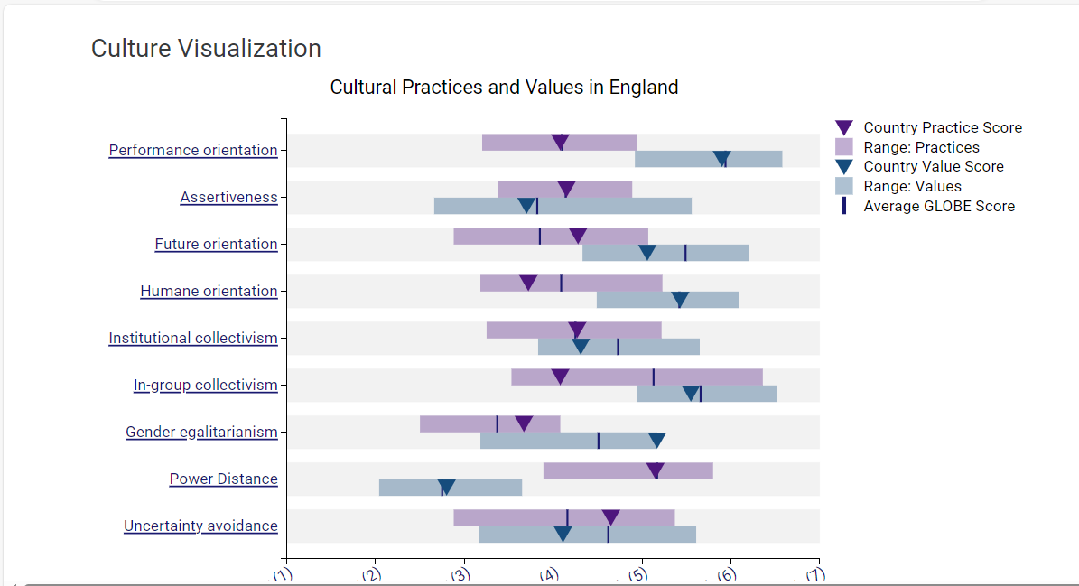
Appendix 1
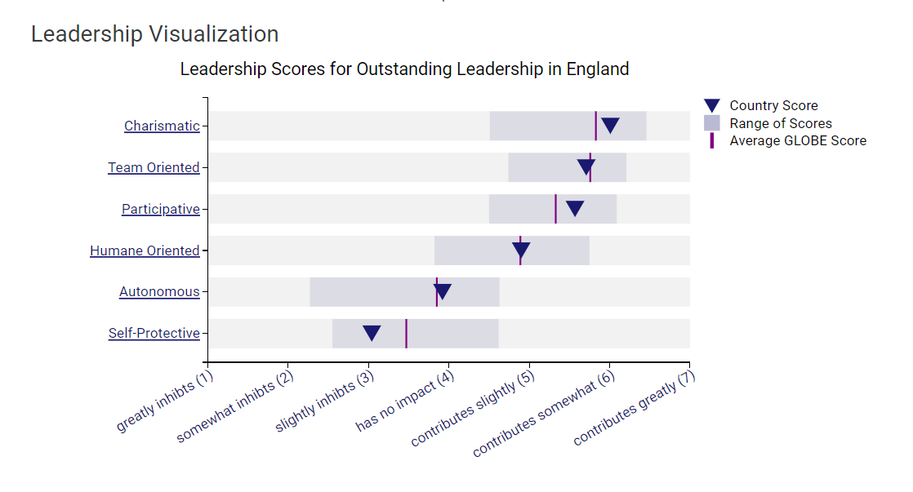
Appendix 2
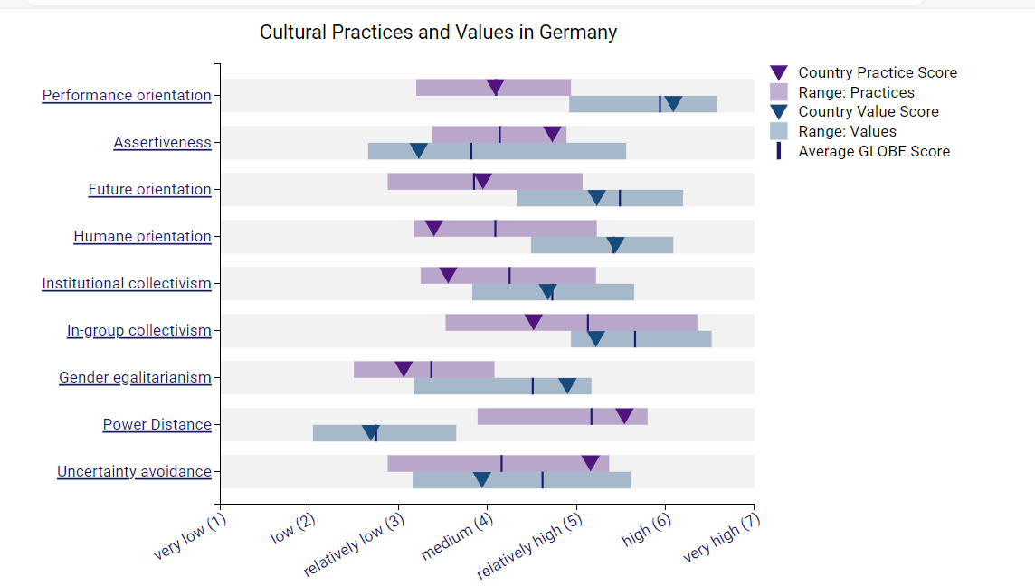
Appendix 3
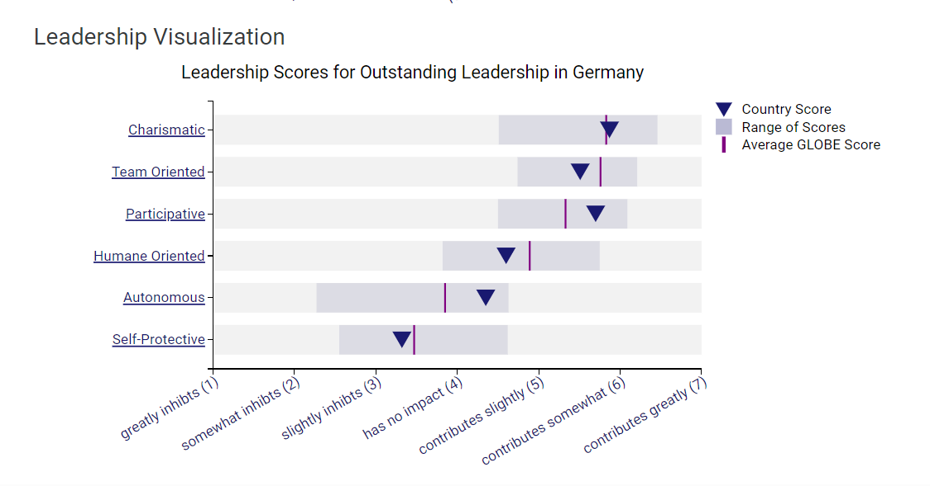
Appendix 4

